Reviewer #1: The authors have made a considerable effort to address all the comments raised during the previous review. The manuscript is now better structured, and the issues previously identified have been satisfactorily resolved. In my view, the article meets the quality standards required for acceptance in JSS, subject to the minor revisions outlined below:
Lines 37-38: Please provide an appropriate reference.
- References added: (Wotton et al. 2017; Copes-Gerbitz et al. 2022; Parisien et al. 2023).
Lines 50-53: I would like to reiterate that each "concern" should be supported by a reference (cite after each concern).
- Added specific references
Conclusion section: Please avoid including references in the Conclusions.
- References deleted, no adjustments made to the connected sentences.
Figure 1: Please number or label each subfigure and describe them clearly in the figure caption.
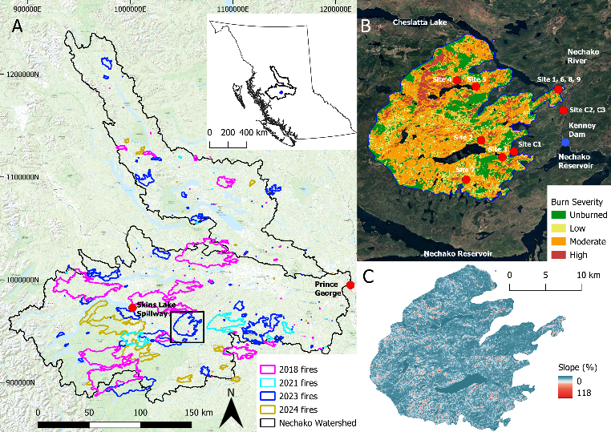

Fig. 1. Map of the Nechako watershed (A), black box denotes study area. Also shown are the city of Prince George, the location of the weather station at Skins Lake Spillway, and the area burnt across the watershed for the 4 most recent severe fire seasons, years are color coordinated. The inset map shows the location of the Nechako watershed within British Columbia. The 2023 North Lucas Lake wildfire (right): (B) the vegetation burn severity across the fire, field site locations, the Kenney Dam and relevant major lakes and rivers that are of concern to changes in surface runoff and erosion. (C) the slopes across the burnt area, with slopes steeper than 45% in red.

