Internet Appendix (not for publication)
This web appendix provides supplementary material and additional results for the paper: “The Impact of Monetary Policy on Stock Prices: Gaining Momentum or Losing Steam?”

List of Tables
Exhibit A1 - The response of stock prices to FOMC announcements: Speed 42
Exhibit A2 - The response of stock prices to FOMC announcements: Persistence 43
Exhibit A3 - The response of stock prices to FOMC announcements: Median regression 44
Exhibit A4 - The response of stock prices to FOMC announcements: Non-linear effects 45
Exhibit A5 - The response of stock prices to FOMC announcements: Cash ETFs 46

Exhibit A1 - The response of stock prices to FOMC announcements: Speed

The figure displays the speed of the response of intraday equity futures returns on a constant, target (TS), path (PS), and LSAP (LS) surprises on the DJIA, NASDAQ 100, Russell 2000 and S&P MidCap 400 stock indexes. The sample is from January 1999 to December 2022 (or determined by data availability). The dependent variable is the intraday percentage changes in the S&P 500 equity futures price from one hour before the release of the FOMC announcement to two hours after. The variable TS measures unanticipated changes in the current federal funds rate target. The variable PS measures changes in futures rates out to horizons of two years that are independent of changes in the current funds rate target. The variable LS measures unanticipated changes in large-scale asset purchases. The vertical line is placed at the time of the FOMC announcement (normalized to zero). The solid blue lines represent the point estimates and the dashed red lines represent two standard error confidence intervals. The econometric method is ordinary least squares with standard errors clustered by date. The interval spans from one hour before to two hours after the FOMC announcement, with tick units representing a 5-minute interval.

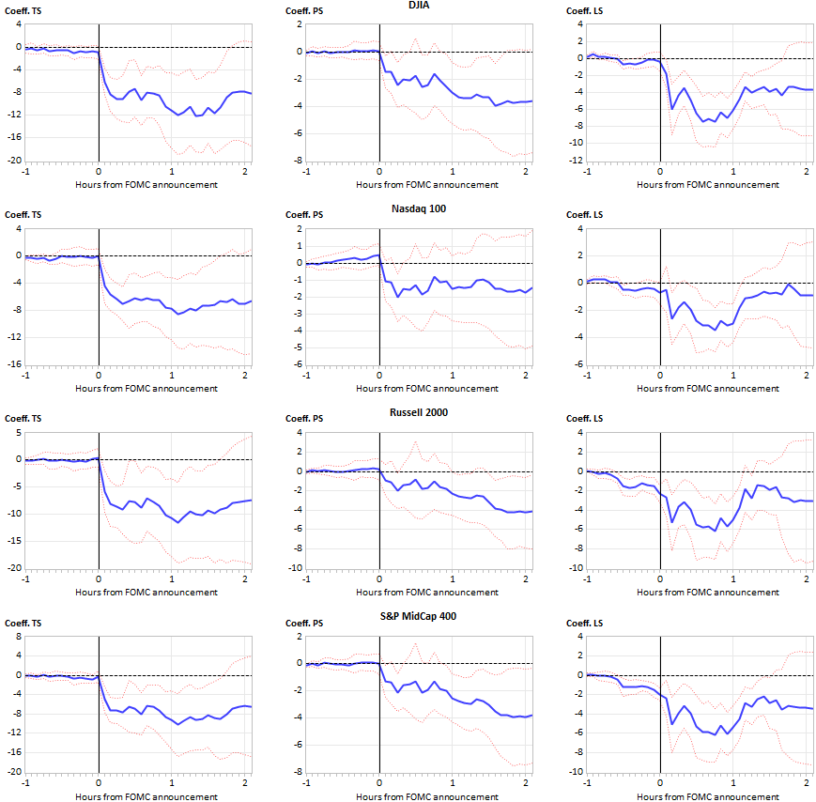

Exhibit A2 - The response of stock prices to FOMC announcements: Persistence

The figure displays the persistence of the effects of target (TS), path (PS) and LSAP (LS) surprises on the DJIA, NASDAQ 100, Russell 2000 and S&P MidCap 400 stock indexes. The sample period is January 1999 to December 2022 (or determined by data availability). The regression includes a constant. The dependent variable is the percentage changes in the stock price from five minutes before the FOMC announcement up to twenty days after. The solid blue lines represent the point estimates and the dashed red lines represent two standard error confidence intervals. The econometric method is ordinary least squares with standard errors clustered by date. The interval spans from the announcement day to twenty days after the FOMC meeting.
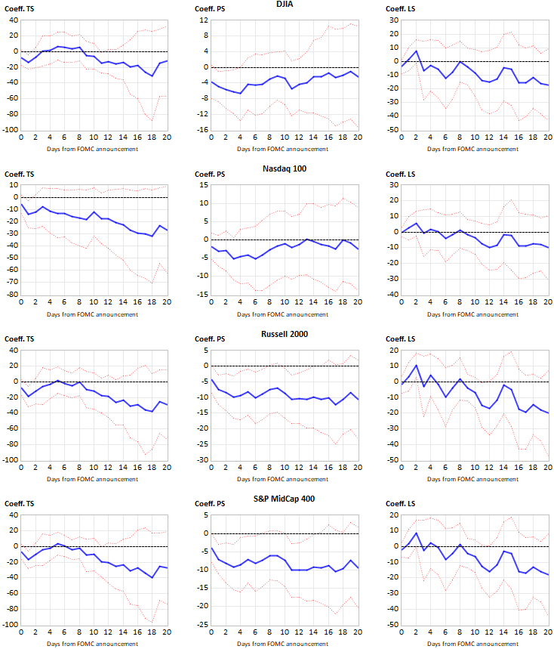

Exhibit A3 - The response of stock prices to FOMC announcements: Median regression

The table reports the results from a regression of intraday equity returns (from five minutes before the event to twenty-five minutes after) on a constant, TS, PS and LS:
$$R_{i,t}=β_{i,0}+β_{i,TS}{TS}_{t}+β_{i,PS}{PS}_{t}+β_{i,LS}{LS}_{t}+ε_{i,t}$$
The sample is from January 1999 to December 2022 (or determined by data availability). The variable TS measures unanticipated changes in the current federal funds rate target. The variable PS measures changes in futures rates out to horizons of two years that are independent of changes in the current funds rate target. The variable LS measures unanticipated changes in large-scale asset purchases. The econometric method is median regression with robust standard errors. The superscripts ***, **, and * indicate statistical significance at the 1%, 5%, and 10% levels, respectively.

 | S&P 500 | DJIA | Nasdaq 100 | Russell 2000 | S&P MidCap 400
Constant | 0.05 | 0.08** | 0.07 | 0.07 | 0.07*
TS | -3.83** | -9.09*** | -8.07*** | -6.96* | -5.16
PS | -3.06*** | -2.48*** | -2.71*** | -2.51** | -2.11**
LS | -4.93*** | -5.75*** | -1.80*** | -3.09*** | -3.06***
R² | 0.119 | 0.128 | 0.106 | 0.044 | 0.078
Observations | 191 | 165 | 187 | 168 | 166

Exhibit A4 - The response of stock prices to FOMC announcements: Non-linear effects

The table reports the results from a regression of intraday equity returns (from five minutes before the event to twenty-five minutes after) on a constant, TS, PS and LS interacted with period dummies:
$$R_{i,t}=β_{i,0}+β_{i,1}{TS}_{t}D_{t}+β_{i,2}{TS}_{t}\left(1-D_{t}\right)+β_{i,3}{PS}_{t}D_{t}+β_{i,4}{PS}_{t}\left(1-D_{t}\right)+β_{i,5}{LS}_{t}D_{t}+β_{i,6}{LS}_{t}\left(1-D_{t}\right)+ε_{i,t}$$
where $D_{t}$ is a dummy variable that distinguishes between different periods. The sample is from January 1999 to December 2022 (or determined by data availability). The variable TS measures unanticipated changes in the current federal funds rate target. The variable PS measures changes in futures rates out to horizons of two years that are independent of changes in the current funds rate target. The variable LS measures unanticipated changes in large-scale asset purchases. The NBER recession dummy in Panel A is a daily recession dummy indicator. The dummies D1, D2 and D3 in Panel B are set to 1 for observations when the Target, Path and LSAP factors are, respectively, negative, and zero otherwise. The econometric method is ordinary least squares. The superscripts ***, **, and * indicate statistical significance at the 1%, 5% and 10% level, respectively, and are based on standard errors clustered by date. The last rows “H₀: β₁ = β₂”, “H₀: β₃ = β₄” and “H₀: β₅ = β₆” report the p-value based on the F-statistics of the null hypotheses that the coefficients of the Target, Path and LSAP surprises are equal in both sub-periods.

Panel A: NBER recessions

 | S&P 500 | DJIA | Nasdaq 100 | Russell 2000 | S&P MidCap 400
Constant | -0.03 | -0.02 | -0.04 | 0.01 | 0.01
TS × (1 – D) (β₁) | -6.19* | -6.28 | -6.31* | -9.52** | -7.36*
TS × D (β₂) | -6.96*** | -8.65*** | -7.58*** | -5.86** | -4.89**
PS × (1 – D) (β₃) | -2.66*** | -2.11** | -2.17*** | -2.08** | -2.03**
PS × D (β₄) | 0.66 | -0.29 | 0.16 | 2.74 | 1.85
LS × (1 – D) (β₅) | -1.11 | -1.22 | -0.14 | -0.52 | -0.37
LS × D (β₆) | -5.50*** | -6.18*** | -2.33*** | -3.83*** | -3.69***
R² | 0.298 | 0.318 | 0.215 | 0.228 | 0.250
Observations | 191 | 165 | 187 | 168 | 166
H₀: β₁ = β₂ | 0.85 | 0.62 | 0.74 | 0.50 | 0.58
H₀: β₃ = β₄ | 0.17 | 0.50 | 0.19 | 0.08 | 0.09
H₀: β₅ = β₆ | 0.15 | 0.10 | 0.40 | 0.37 | 0.27

Panel B: Negative and positive monetary surprises

 | S&P 500 | DJIA | Nasdaq 100 | Russell 2000 | S&P MidCap 400
Constant | 0.14** | 0.16** | 0.12* | 0.22** | 0.18***
TS × D1 (β₁) | -11.07*** | -14.10*** | -11.45*** | -15.35*** | -12.18***
TS × (1 – D1) (β₂) | -3.82 | -3.84 | -4.27 | -3.70 | -2.94
PS × D2 (β₃) | -5.40*** | -4.98*** | -4.70*** | -5.22*** | -4.61***
PS × (1 – D2) (β₄) | -0.33 | -0.45 | -0.24 | 0.84 | 0.30
LS × D3 (β₅) | -0.57 | -1.27 | 0.39 | 0.02 | -0.43
LS × (1 – D3) (β₆) | -4.75*** | -5.46*** | -1.93*** | -2.98*** | -2.83***
R² | 0.358 | 0.388 | 0.276 | 0.308 | 0.327
Observations | 191 | 165 | 187 | 168 | 166
H₀: β₁ = β₂ | 0.15 | 0.13 | 0.15 | 0.12 | 0.13
H₀: β₃ = β₄ | 0.01 | 0.02 | 0.01 | 0.01 | 0.01
H₀: β₅ = β₆ | 0.25 | 0.27 | 0.44 | 0.48 | 0.46

Exhibit A5 - The response of stock prices to FOMC announcements: Cash ETFs

The table in Panel A reports the estimation results from a panel regression of intraday equity cash ETF returns (from five minutes before the event to twenty-five minutes after) on a constant, TS, PS and LS shocks:
$$R_{i,t}=β_{i,0}+β_{i,TS}{TS}_{t}+β_{i,PS}{PS}_{t}+β_{i,LS}{LS}_{t}+ε_{i,t}$$
The sample is from January 1999 to December 2022 (or determined by data availability). The variable TS measures unanticipated changes in the current federal funds rate target. The variable PS measures changes in futures rates out to horizons of two years that are independent of changes in the current funds rate target. The variable LS measures unanticipated changes in large-scale asset purchases. The econometric method is ordinary least squares. The superscripts ***, **, and * indicate statistical significance at the 1%, 5% and 10% level, respectively, and are based on standard errors clustered by date. The table in Panel B reports the p-values of the F-statistic of testing the null hypothesis $H_{0}:β_{i,TS}=β_{j,TS},β_{i,PS}=β_{j,PS},β_{i,LS}=β_{j,LS}$ for all stock index pairs $\left\{i,j\right\}$.

Panel A: Estimation results

 | S&P 500 | DJIA | Nasdaq 100 | Russell 2000 | S&P MidCap 400
Constant | -0.02 | -0.02 | -0.05 | -0.01 | -0.02
TS | -5.14*** | -5.13*** | -7.28*** | -5.78** | -4.85***
PS | -2.24*** | -2.14*** | -2.62*** | -1.22 | -1.73**
LS | -2.71*** | -2.70*** | -1.71** | -1.74* | -1.94*
R² | 0.247 | 0.261 | 0.219 | 0.152 | 0.200
Observations | 191 | 191 | 190 | 179 | 190

Panel B: Hypothesis testing

 | DJIA | Nasdaq 100 | Russell 2000 | S&P MidCap 400
S&P 500 | 0.90 | 0.00 | 0.00 | 0.00
DJIA |  | 0.00 | 0.00 | 0.00
Nasdaq 100 |  |  | 0.14 | 0.04
Russell 2000 |  |  |  | 0.14

