Supplementary information for
Note

Development of a low-cost, simple, and rapid identification method for Glycyrrhiza uralensis using PCR-RFLP and evaluation of seeds distributed on the market

Tomoyo Nishida¹, Shinichiro Sawa², Koji Sugimura^{1＊}

¹ Global Center for Natural Resources Sciences, Kumamoto University, 5-1, Oe Honmachi, Chuo-ku, Kumamoto 862-0973, Japan; sugimura@kumamoto-u.ac.jp (K.S.), neothiyo4649@kumamoto-u.ac.jp (T.N.)
² International Research Center for Agricultural and Environmental Biology, Kumamoto University, 2-39-1 Kumamoto, Japan; sawa@kumamoto-u.ac.jp (S.S.)

* Correspondence: sugimura@kumamoto-u.ac.jp
ORCID 0000-0002-4507-5749, Tel +81-96-371-4878

Supporting figure (Figure S1)

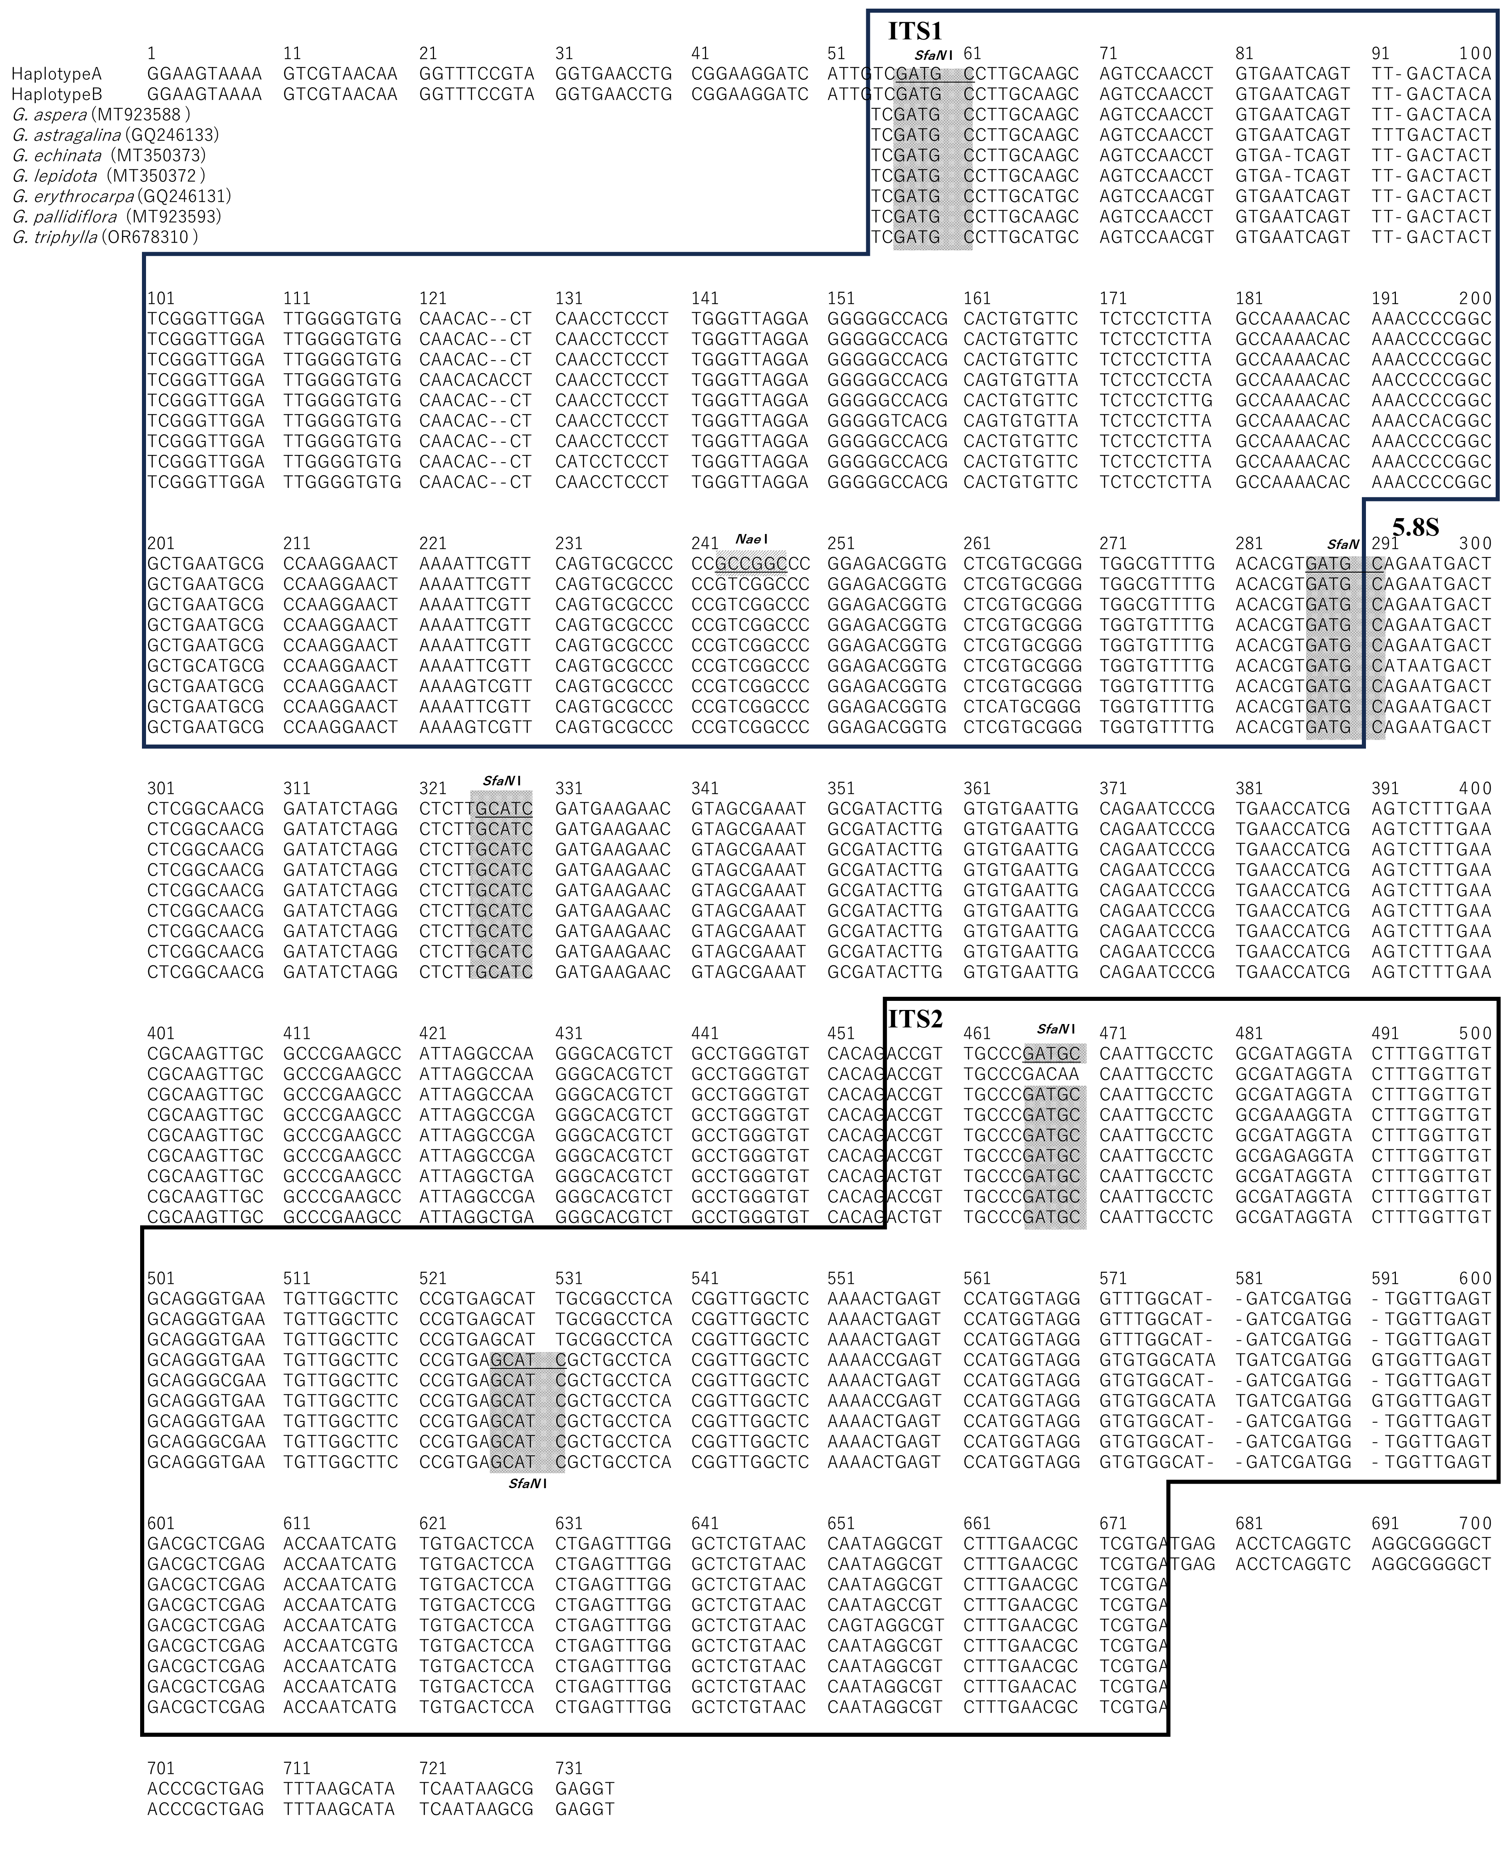
Fig. S1 Alignment of the DNA sequences of PCR products from Haplotype A (Glycyrrhiza uralensis) and Haplotype B (G. glabra or G. inflata), along with ITS region sequences of seven Glycyrrhiza species retrieved from NCBI. The alignment of Haplotypes A and B consists of the 3′-end of the 18S ribosomal DNA (rDNA) gene (which contains the ITS5 primer site), the complete ITS1 region, the highly conserved 5.8S rDNA gene sequence, the complete ITS2 region, and the 5′-end of the 28S rDNA gene (which contains the ITS4 primer site). Since some of the NCBI sequences lacked the 18S and/or 28S rDNA regions, only the complete ITS1 region, the 5.8S rDNA gene, and the complete ITS2 region were included for all sequences. Restriction sites for NaeI (GCC ▼ GGC) and SfaNI (GCATC(N)₅ ▼) are shown with shadows.

