SUPPORTING INFORMATION FOR

Analytical differentiation of quinolinyl- and isoquinolinyl-substituted
1-(5-fluoropentyl)-1H-indole-3-carboxylates: 5F-PB-22 and its ten isomers

Erina Kohyama^{1,}*, Takao Chikumoto¹, Hiroyuki Tada¹, Kiyoyuki Kitaichi², and Tetsuro Ito^{1,2,}*

¹Gifu Prefectural Research Institute for Health and Environmental Sciences, Naka-fudogaoka, Kakamigahara, Gifu 504-0838, Japan
²Gifu Pharmaceutical University, 1-25-4 Daigaku-nishi, Gifu 501-1196, Japan

* To whom correspondence should be addressed.
E-mail: koyama-erina@pref.gifu.lg.jp (E. Kohyama)
ito-tetsuro@pref.gifu.lg.jp, teito@gifu-pu.ac.jp (T. Ito)
Table of Contents

Fig. S1 Total ion chromatogram of (a) methanol extract and (b) acetonitrile extract for herbal-type product analyzed by GC–MS. EI mass spectra of (c) peak at 11.51 min, (d) peak at 20.91 min, and (e) peak at 31.58 min
S3

Fig. S2 EI mass spectra of authentic standards of 5F-PB-22 and its ten isomers. (a)–(k) correspond to 1–11
S4

Fig. S3 Product ion spectra of precursor ion at m/z 144 for 5F-PB-22 at CEs of (a) 5 V, (b) 15 V, (c) 25 V, and (d) 35 V on GC–MS-MS
S5

Fig. S4 Chromatographic peak of mixture of 5F-PB-22 and its isomers on GC analysis. (a) 5F-PB-22 only, (b) mixture of 5F-PB-22 and 5Q isomer, and (c) mixture of 5F-PB-22 and 4Q isomer
S6

Fig. S5 UV spectra of 5F-PB-22 and its ten isomers by LC–PDA. (a)–(k) correspond to 1–11
S7

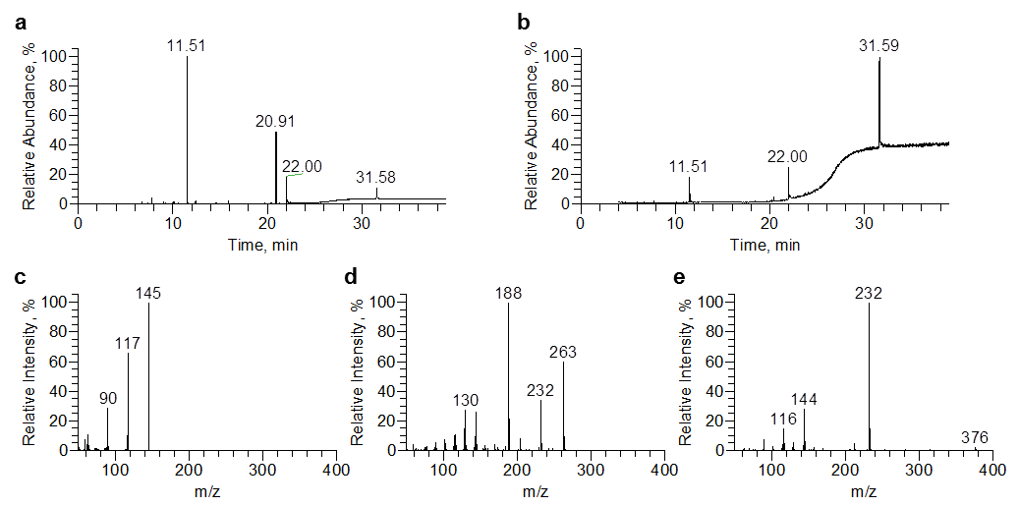

Fig. S1 Total ion chromatogram of (a) methanol extract and (b) acetonitrile extract for herbal-type product analyzed by GC–MS. EI mass spectra of (c) peak at 11.51 min, (d) peak at 20.91 min, and (e) peak at 31.58 min

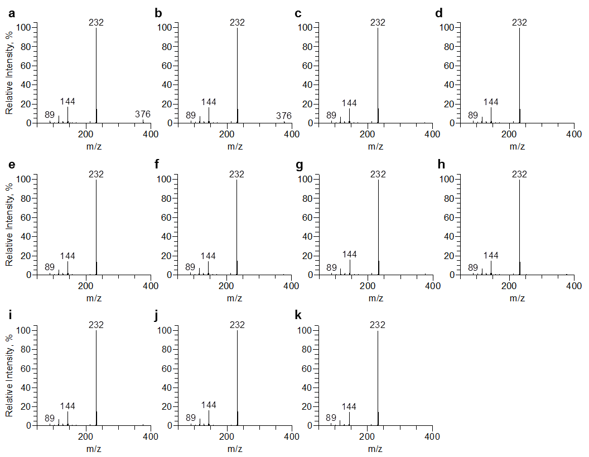

Fig. S2 EI mass spectra of authentic standards of 5F-PB-22 and its ten isomers. (a)–(k) correspond to 1–11

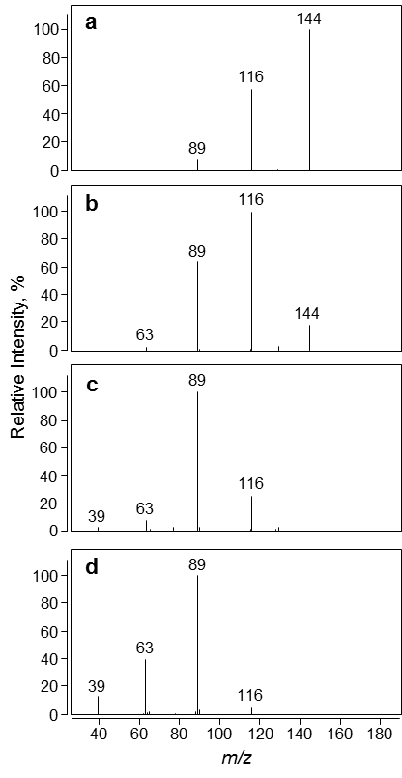
Fig. S3 Product ion spectra of precursor ion at m/z 144 for 5F-PB-22 at CEs of (a) 5 V, (b) 15 V, (c) 25 V, and (d) 35 V on GC–MS-MS

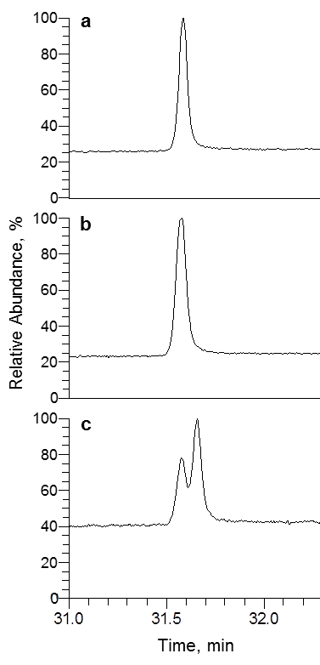

Fig. S4 Chromatographic peak of mixture of 5F-PB-22 and its isomers on GC analysis. (a) 5F-PB-22 only, (b) mixture of 5F-PB-22 and 5Q isomer, and (c) mixture of 5F-PB-22 and 4Q isomer

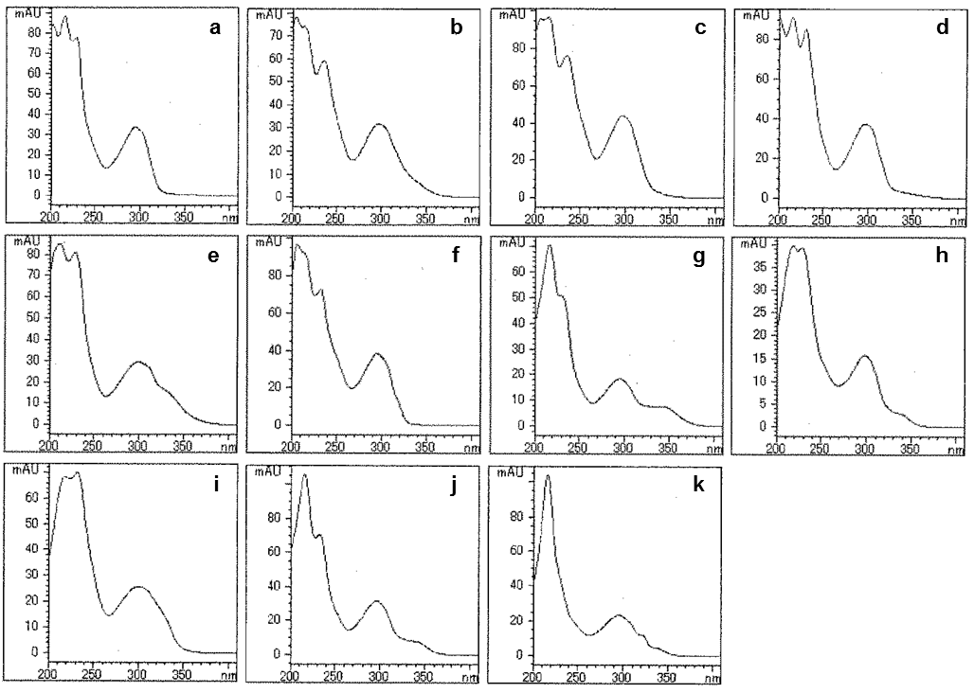

Fig. S5 UV spectra of 5F-PB-22 and its ten isomers by LC–PDA. (a)–(k) correspond to 1–11

