SUPPORTING INFORMATION
Can Cyanide Metabolite 2-Aminothiazoline-4-Carboxylic Acid Be Used to Verify Cyanide Poisoning in Postmortem Blood?
Authors: Abdullah H. Alluhaybª, Carter Severance^{b}, Tara Hendry-Hofer^{b}, Vikhyat S. Bebarta^{b}, and Brian A. Logueª*
ªDepartment of Chemistry and Biochemistry, South Dakota State University, Box 2202, Avera Health and Science Center 131, Brookings, SD, 57007, USA
^{b}Department of Emergency Medicine, University of Colorado School of Medicine, Aurora, CO 80045, USA

*Corresponding Author: Brian.Logue@sdstate.edu
Supplementary Figure S1A demonstrates the superior stability of ATCA compared to CN and SCN⁻ in postmortem swine (stored at 4 °C) following CN poisoning. While CN concentrations rapidly decreased to near zero by 120 h, and SCN⁻ declined to 70% and ATCA reduced to 82% of their initial concentrations by 168 h. These data highlight the relative stability of CN, SCN⁻, and ATCA in postmortem swine over extended storage times. The marked stability of ATCA supports its use as a reliable biomarker for CN poisoning confirmation.

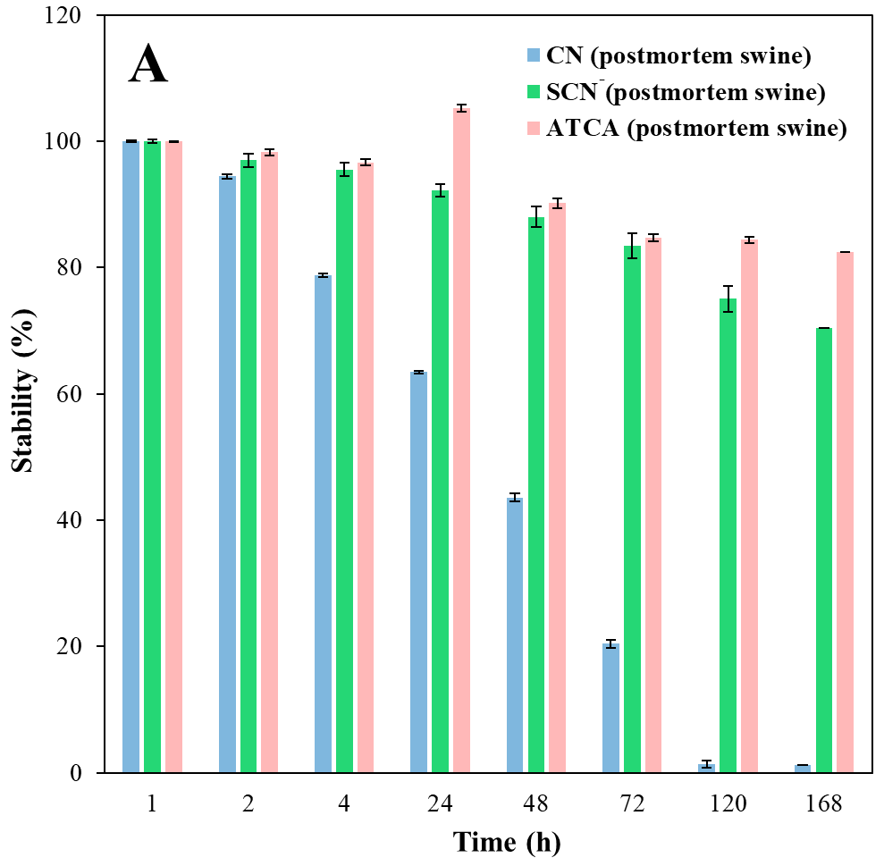
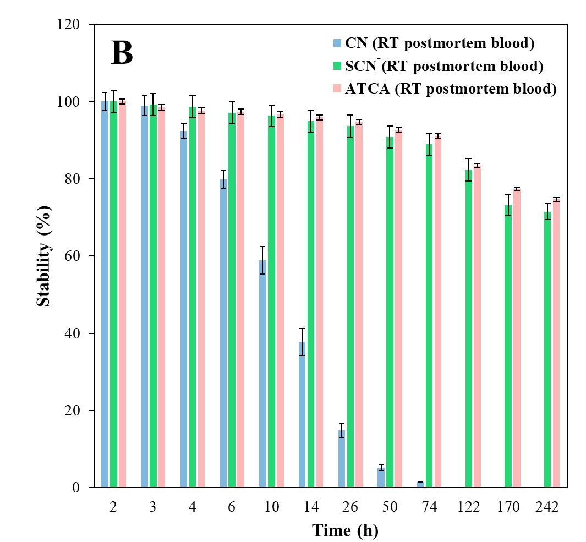
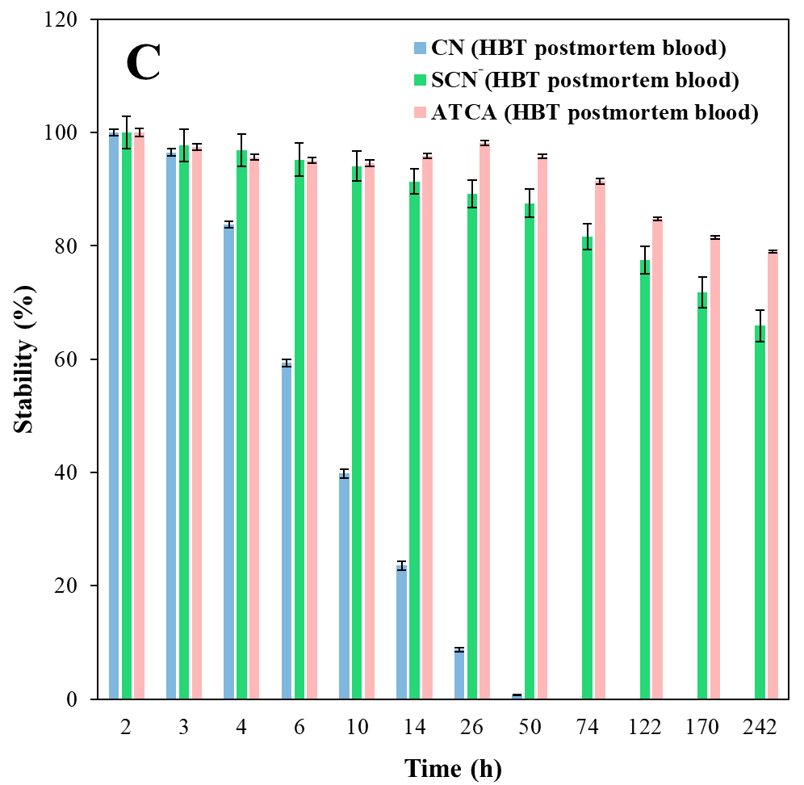
Figure S1. The stability of CN, SCN⁻, and ATCA in A) postmortem CN-exposed swine; B) room temperature; C) and typical body temperature. Error bars are plotted as standard error of mean (± SEM) (N = 8)

Supplementary Figures S1B and S1C show the stability of CN, SCN⁻, and ATCA over time in postmortem blood stored at RT and HBT, respectively. The rapid degradation of CN is clearly illustrated, with concentrations decreasing to near zero by 74 h and 50 h at RT and HBT, respectively. SCN⁻ and ATCA decline more slowly, however the stability of ATCA is markedly better than SCN⁻ at HBT. At RT, ATCA and SCN⁻ maintain concentrations at 74 h. After 74 h (at HBT), ATCA declined to 79% of its initial concentration but SCN⁻ dropped to 66%. Together these figures demonstrate the stability of SCN⁻ and ATCA under elevated storage conditions compared to the inherent instability of CN.
Figure S2A shows the calculation of t_{1/2} for CN, SCN⁻, and ATCA in postmortem swine blood stored at 4°C. It is clear that CN has the shortest t_{1/2} of 34.3 h. Though SCN⁻ is more stable than CN, ATCA exhibits the longest the t_{1/2} of 23 days nearly double that of SCN⁻ 15 days. These t_{1/2} values highlight the instability of CN versus the persistence of ATCA as a forensic biomarker.

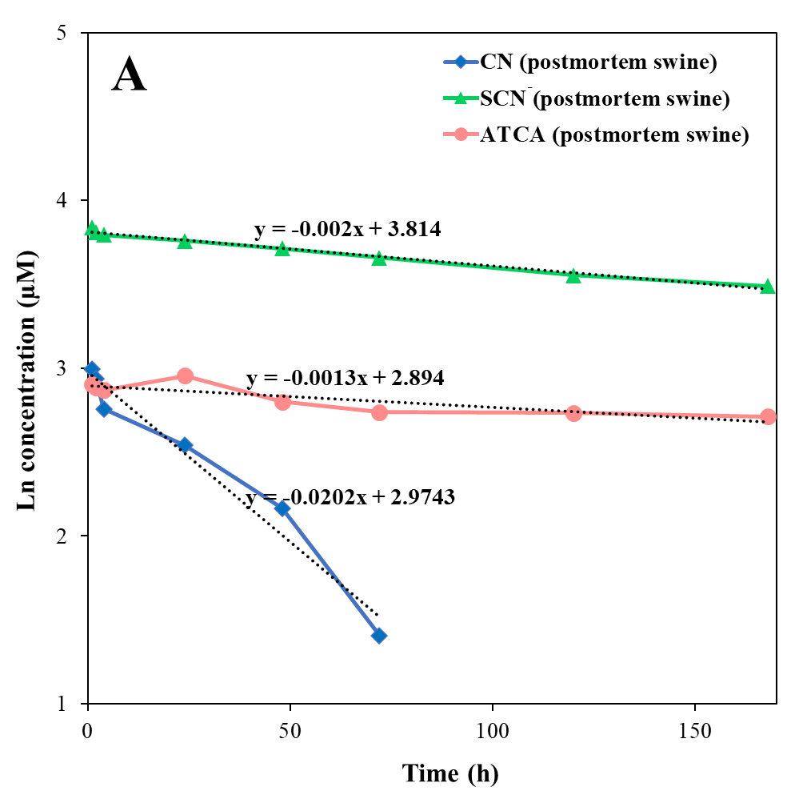
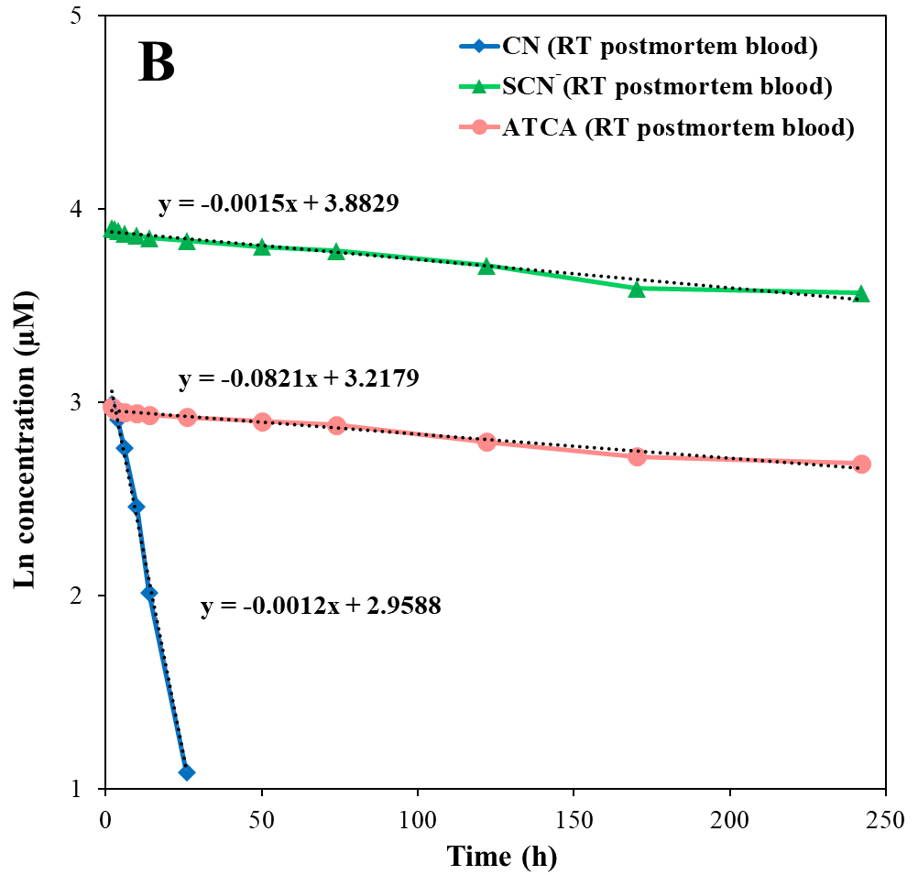
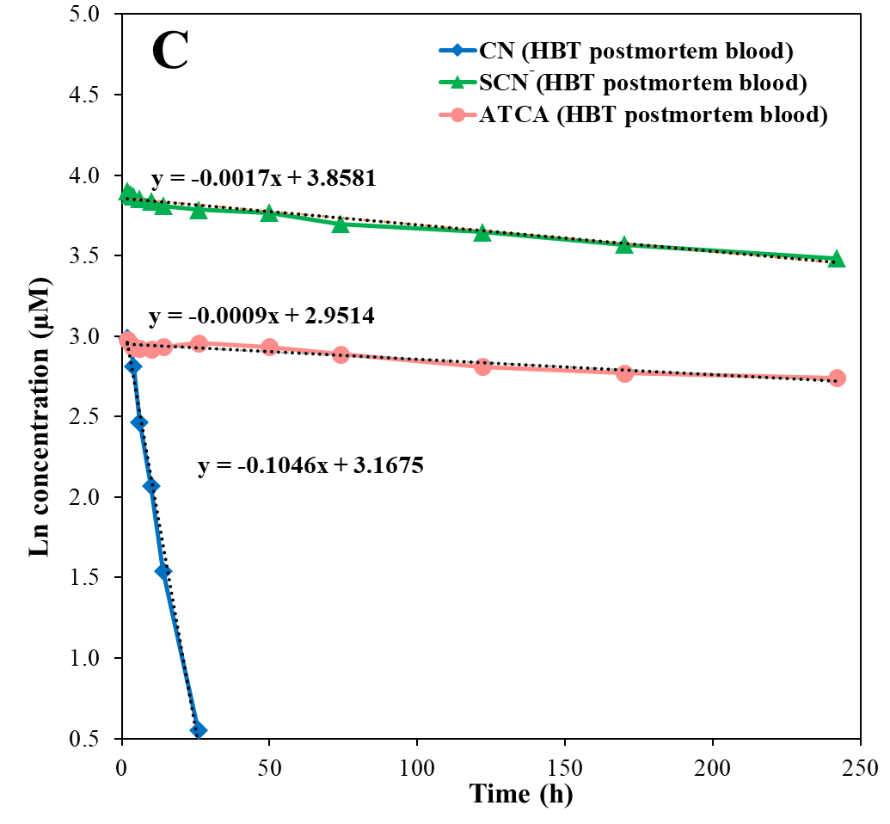
Figure S2. The t_{1/2}s for CN, SCN⁻, and ATCA in A) postmortem CN-exposed swine; B) room temperature; C) and typical body temperature.

The rapid degradation of CN is further demonstrated in Supplementary Fig S1B and C, which show the t_{1/2}s calculation for CN stored in postmortem blood at RT and HBT. As shown in Table 2 and Figures S2B and C, the t_{1/2} of CN drops to 10.7 h and 6.6 h at RT and HBT, respectively. Meanwhile, SCN⁻ and ATCA remain much more stable, with t_{1/2} values of 18 and 24 days (RT) and 19 and 27 days (HBT) (i.e., SCN⁻ is ≈40-68x and ATCA is ≈53-99x more stable than CN for these temperature conditions). This quantitative comparison of t_{1/2} values under different storage conditions highlights the advantages of ATCA as the most stable forensic marker of CN poisoning in postmortem swine.

