Supplemental materials

Analysis of cyanide exposure status in fire-related deaths using a physiologically-based pharmacokinetic model

Kazuo Harada, Yuri Tokugawa, Kazunari Henmi, Yohei Miyashita, Yuji Sakahashi, Taichi Nishihori, Yukari Sakamoto, Chihpin Yang, Yu Isobe, Kana Sugimoto, Kentaro Nakama, Ryuichi Katada, Hiroshi Matsumoto

Supplemental material 1 Python script for blood cyanide concentration simulation
Supplemental material 2 Conceptual image of the method for estimating inhaled hydrogen cyanide gas concentration and time
Supplemental material 3 Python script for estimating inhaled hydrogen cyanide gas concentration and time
Supplemental material 4 Sensitivity analysis results for inhaled hydrogen cyanide gas concentration and time

Supplemental material 1 Python script for blood cyanide concentration simulation

Note: By entering the inhaled cyanide gas concentration you want to simulate after “Ca=” in the following script and executing it, a graph showing the time-course changes of cyanide concentrations in the arterial (left cardiac) and venous (right cardiac) blood can be obtained.

# -*- coding: utf-8 -*-

# preparation of numpy and plot
import numpy as np
from scipy.integrate import solve_ivp
import matplotlib.pyplot as plt

# definition of parameters
Ppa = 281 # Ppa: Partition coefficients of plasma/air
Php = 5.1 # Php: Partition coefficients of liver/plasma
Pmp = 2.8 # Pmp: Partition coefficients of muscle/plasma
Pop = 5.4 # Pop: Partition coefficients of other tissues/plasma
Qalv = 16.5 # Qalv: Alveolar ventilation
Qtot = 10.7 # Qtot: Cardiac output
Qh = 1.6 # Qh: Liver blood flow
Qm = 4.9 # Qm: Muscle blood flow
Qo = 4.2 # Qo: Other tissues blood flow
Fp = 0.6 # Fp: Plasma fraction in whole blood
Cle = 65.9 # Cle: Clearance flow between blood and erythrocytes
Vp = 2.9 # Vp: Compartment volume of plasma
Ve = 1.9 # Ve: Compartment volume of erythrocytes
Vh = 1.6 # Vh: Compartment volume of liver
Vm = 35 # Vm: Compartment volume of muscle
Vo = 18 # Vo: Compartment volume of other tissues
Vb = 4.8 # Vb: Compartment volume in whole blood
Emax = 140 # Emax: Maximum binding to erythrocytes
Kaff = 1 # Kaff: Affinity constant to erythrocytes from plasma
Kscn = 0.01 #Kscn : second-order rate constant for thiocyanate formation
Kfs = 2.2 # Kfs: zero-order formation rate of sulfur donors
Kes = 0.0027 # Kes: first-order elimination rate constant
Clr = 0.0041 # Clr: first-order metabolic clearance of CN via remaining pathways
Ca = # CN conc. in air (umol/L), 1 umol/L = 27 ug/L = 24 ppm, 270 ppm = 0.30 mg/L = 11 umol/L

# definition of variables
# C = [0 Cp, 1 Ce, 2 Ch, 3 S, 4 Cm, 5 Co]
init = [0, 0, 0, 1, 0, 0]

#Cp: CN conc. in plasma
#Ce: CN conc. in erythrocytes
#Ch: CN conc. in liver
#S: sulfur donors conc.
#Cm: CN conc. in muscle
#Co: CN conc. in other tissues

# Setting of time span of simulation
t_span = [0.0, 10.0]
dt = 0.1
t_eval = np.arange(*t_span, dt)

# Definition of ordinary differential equation and initial values
def func(t,C):
Cp, Ce, Ch, S, Cm, Co = C
dCp = (Qalv*(Ca-(Cp/Ppa))+Cle*(Ce/(Emax/(Cp+Kaff))-Cp)+Fp*Qtot*(((Qh*Ch)/Php+(Qm*Cm)/Pmp+(Qo*Co)/Pop)/Qtot-Cp))/Vp
dCe = Cle*(Cp-(Ce/(Emax/(Cp+Kaff))))/Ve
dCh = (Fp*Qh*(Cp-(Ch/Php))-Kscn*Ch*S-(Kfs-Kscn*Ch*S-Kes*S))/Vh
dS = Kfs-Kscn*Ch*S-Kes*S
dCm = Fp*Qm*(Cp-Cm/Pmp)/Vm
dCo = Fp*Qo*(Cp-Co/Pop)/Vo
return np.array([dCp, dCe, dCh, dS, dCm, dCo])

sol = solve_ivp(func, t_span, init, method='RK45', t_eval=t_eval)

Cp, Ce, Ch, S, Cm, Co = sol.y

#Metscn: CN conc. metabolized via the SCN route
#Cb: CN conc. in whole blood
#Cv: CN conc. in vein (mixed venous plasma)
#Cvb: CN conc. in whole blood in vein

Metscn = Kscn*Ch*S
Cb = (Vp*Cp+Ve*Ce)/Vb
Cv = ((Qh*Ch)/Php+(Qm*Cm)/Pmp+(Qo*Co)/Pop)/Qtot
Cvb = (Vp*Cv+Ve*Ce)/Vb

# Display graph
# C : umol/L = X 27 ug/L = X 0.027 ug/mL

plt.plot(sol.t, Cb*0.027, label="Cb")
plt.plot(sol.t, Cvb*0.027, label="Cvb")
plt.legend()
plt.show()

Supplemental material 2 Conceptual image of the method for estimating inhaled hydrogen cyanide gas concentration and time
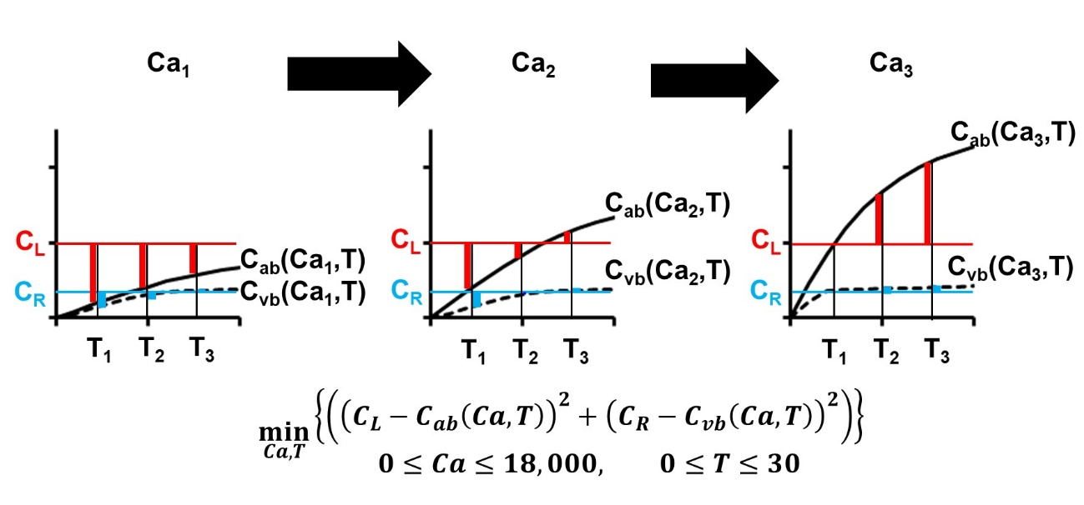

Supplemental material 3 Python script for estimating inhaled hydrogen cyanide gas concentration and time
Note: By entering the measured cyanide concentrations in the left and right cardiac blood after “Crh=” and “Clh=” in the following script, respectively, and executing it, the estimated inhaled hydrogen cyanide gas concentration and time can be obtained.

# -*- coding: utf-8 -*-

# preparation of numpy and plot
import numpy as np
from scipy.integrate import solve_ivp

Ca0 = []
Del_min = []
Del_min_time = []
for value in [i*0.5 for i in range(0,751)] :

# definition of parameters
Ppa = 281 # Ppa: Partition coefficients of plasma/air
Php = 5.1 # Php: Partition coefficients of liver/plasma
Pmp = 2.8 # Pmp: Partition coefficients of muscle/plasma
Pop = 5.4 # Pop: Partition coefficients of other tissues/plasma
Qalv = 16.5 # Qalv: Alveolar ventilation
Qtot = 10.7 # Qtot: Cardiac output
Qh = 1.6 # Qh: Liver blood flow
Qm = 4.9 # Qm: Muscle blood flow
Qo = 4.2 # Qo: Other tissues blood flow
Fp = 0.6 # Fp: Plasma fraction in whole blood
Cle = 65.9 # Cle: Clearance flow between blood and erythrocytes
Vp = 2.9 # Vp: Compartment volume of plasma
Ve = 1.9 # Ve: Compartment volume of erythrocytes
Vh = 1.6 # Vh: Compartment volume of liver
Vm = 35 # Vm: Compartment volume of muscle
Vo = 18 # Vo: Compartment volume of other tissues
Vb = 4.8 # Vb: Compartment volume in whole blood
Emax = 140 # Emax: Maximum binding to erythrocytes
Kaff = 1 # Kaff: Affinity constant to erythrocytes from plasma
Kscn = 0.01 #Kscn : second-order rate constant for thiocyanate formation
Kfs = 2.2 # Kfs: zero-order formation rate of sulfur donors
Kes = 0.0027 # Kes: first-order elimination rate constant
Clr = 0.0041 # Clr: first-order metabolic clearance of CN via remaining pathways
Ca = value # CN conc. in air (umol/L), 1 umol/L = 0.027 ug/mL = 24 ppm, 270 ppm = 0.30 ug/mL = 11 umol/L
Ca0.append(Ca)

# definition of variables
# C = [0 Cp, 1 Ce, 2 Ch, 3 S, 4 Cm, 5 Co]
init = [0, 0, 0, 1, 0, 0]

#Cp: CN conc. in plasma
#Ce: CN conc. in erythrocytes
#Ch: CN conc. in liver
#S: sulfur donors conc.
#Cm: CN conc. in muscle
#Co: CN conc. in other tissues

# Setting of time span of simulation
t_span = [0.0, 30.0]
dt = 0.05
t_eval = np.arange(*t_span, dt)

# Definition of ordinary differential equation and initial values
def func(t,C):
Cp, Ce, Ch, S, Cm, Co = C
dCp = (Qalv*(Ca-(Cp/Ppa))+Cle*(Ce/(Emax/(Cp+Kaff))-Cp)+Fp*Qtot*(((Qh*Ch)/Php+(Qm*Cm)/Pmp+(Qo*Co)/Pop)/Qtot-Cp))/Vp
dCe = Cle*(Cp-(Ce/(Emax/(Cp+Kaff))))/Ve
dCh = (Fp*Qh*(Cp-(Ch/Php))-Kscn*Ch*S-(Kfs-Kscn*Ch*S-Kes*S))/Vh
dS = Kfs-Kscn*Ch*S-Kes*S
dCm = Fp*Qm*(Cp-Cm/Pmp)/Vm
dCo = Fp*Qo*(Cp-Co/Pop)/Vo
return np.array([dCp, dCe, dCh, dS, dCm, dCo])

sol = solve_ivp(func, t_span, init, method='RK45', t_eval=t_eval)

Cp, Ce, Ch, S, Cm, Co = sol.y

#Metscn: CN conc. metabolized via the SCN route
#Cb: CN conc. in whole blood
#Cv: CN conc. in vein (mixed venous plasma)
#Cvb: CN conc. in whole blood in vein

Metscn = Kscn*Ch*S
Cb = (Vp*Cp+Ve*Ce)/Vb
Cv = ((Qh*Ch)/Php+(Qm*Cm)/Pmp+(Qo*Co)/Pop)/Qtot
Cvb = (Vp*Cv+Ve*Ce)/Vb
#print(Cb)
#print(Cvb)

#Measured blood CN value (input)
Crh =
Clh =
Del = np.empty(len(sol.y[0]))
Del = (Crh - Cvb*0.027)**2 + (Clh - Cb*0.027)**2

#Form list minimum sum of squares of differences, and the time on getting it
Del_min.append(min(Del))
Del_min_time.append(1/20 * np.argmin(Del))
print(min(Del))

Del_min_index = Del_min.index(min(Del_min))
#Estimated Ca on getting minimum sum of squares of differences
print(Ca0[Del_min_index])
print(24*Ca0[Del_min_index])
#Estimated HCN inhalation time on getting minimum sum of squares of differences
print(Del_min_time[Del_min_index])
#Minimum sum of squares of differences
print("Del =", min(Del_min))

Supplemental material 4 Sensitivity analysis results for inhaled hydrogen cyanide gas concentration and time
No. | CN conc. (μg/mL) |  | Estimated inhaled HCN gas conc. | Estimated inhalation time
No. | R | L | (ppm) | (min)
17 | 0.408 | 2.295 | 11,988 | 0.05
 | 0.408 | 2.700 | 14,112 | 0.05
 | 0.408 | 3.105 | 16,260 | 0.05
 | 0.480 | 2.295 | 12,072 | 0.05
 | 0.480 | 2.700 | 14,280 | 0.05
 | 0.480 | 3.105 | 16,632 | 0.05
 | 0.552 | 2.295 | 12,168 | 0.05
 | 0.552 | 2.700 | 14,268 | 0.05
 | 0.552 | 3.105 | 16,404 | 0.05
10 | 1.950 | 3.400 | 852 | 9.45
 | 1.950 | 4.000 | 1,200 | 6.70
 | 1.950 | 4.600 | 1,560 | 5.10
 | 2.300 | 3.400 | 648 | 22.10
 | 2.300 | 4.000 | 996 | 13.95
 | 2.300 | 4.600 | 1,356 | 10.05
 | 2.645 | 3.400 | 588 | 29.90
 | 2.645 | 4.000 | 804 | 25.10
 | 2.645 | 4.600 | 1,152 | 17.10
7 | 1.020 | 1.445 | 1,392 | 0.30
 | 1.020 | 1.700 | 2,424 | 0.20
 | 1.020 | 1.955 | 3,660 | 0.15
 | 1.200 | 1.445 | 468 | 0.95
 | 1.200 | 1.700 | 1,260 | 0.40
 | 1.200 | 1.955 | 2,268 | 0.25
 | 1.380 | 1.445 | 48 | 26.80
 | 1.380 | 1.700 | 336 | 1.70
 | 1.380 | 1.955 | 876 | 0.70

