Appendix 1. Lesson Plans
1.1 Lesson Plan of Teacher 1 (T1)
1. Profile
Subject | : | Mathematics
Class/Semester | : | VI/I
Topic | : | Addition and subtraction
Time | : | 2 x 35 minutes
Microgame | : | www.geogebra.org/m/eNyT6MUp
GeoGebra Classroom | : | www.geogebra.org/classroom/pndtkscp
Scenario | : | Beginning | Middle | Ending
2. Objective
Explain correctly the operations of addition and subtraction involving negative integers.
Perform addition and subtraction operations involving negative integers quickly and precisely.
3. Process
Opening session (5 minutes)
Teacher explains the learning objectives regarding addition and subtraction of integers and the learning activities that involve GeoGebra Classroom to students.
Main session (60 minutes)
Beginning (20 minutes):
Teacher gives examples of a real-life challenge related to the addition and subtraction of integers. For example, a diver is 20 meters underwater. It turned out that the conditions of the sea currents were swift. Therefore, the diver rose 8 meters from his original position. At what depth is the diver's current position? Students answer and discuss this question.
Middle (20 minutes):
Teacher explains the concept of adding negative integers using a number line. This activity aims to strengthen students' understanding.
Ending (20 minutes): Microgame-based Learning
Teacher introduces the GeoGebra classroom.
Briefing: Provide introductory text.
Playing: Play the selected user-generated microgames.
Debriefing: A submarine travels at a depth of 25 meters below sea level. However, due to a large number of corals, the depth of the ship was increased by 9 meters. How many meters below sea level is the ship's current position? Please explain how did you find the answer.
Closing session (5 minutes)
Teacher informs the topic and/or learning activity for the next meeting.
1.2 Lesson Plan of Teacher 2 (T2)
1. Profile
Subject | : | Mathematics
Class/Semester | : | IV/I
Topic | : | Fractions
Time | : | 2 x 35 minutes
Microgame | : | www.geogebra.org/m/m2RrAWsc
GeoGebra Classroom | : | www.geogebra.org/classroom/zsu7ytsc
Scenario | : | Beginning | Middle | Ending
2. Objective
Explain equivalent fractions using concrete objects.
Distinguish equivalent fractions using concrete objects.
Identify equivalent fractions using concrete objects.
3. Process
Opening session (10 minutes)
Teacher explains the learning objectives regarding equivalent fractions and the learning activities that involve GeoGebra Classroom to students. Teacher gives a simple question: can you tell which is bigger, an apple cut in half or an apple cut into quarters?
Main session (50 minutes)
Beginning (20 minutes):
Teacher explains the concept of equivalent fractions with examples of various concrete objects around students' everyday lives.
Middle (20 minutes): Microgame-based Learning
Teacher introduces the GeoGebra classroom.
Briefing: Provide introductory text.
Playing: Play the selected user-generated microgames.
Debriefing: Please answer the following questions: (1) Can you prove the size of the 1/2 fraction with an object around you? (2) How to prove that the numbers 1 and 2/2 are the same? (3) Can you determine which one is larger between 1/2 and 3/4 using concrete objects? Give your explanation logically.
Ending (10 minutes):
Teacher asks students to identify equivalent fractions using concrete objects.
Closing session (10 minutes)
Teacher informs the topic and/or learning activity for the next meeting.

1.3 Lesson Plan of Teacher 3 (T3)
1. Profile
Subject | : | Mathematics
Class/Semester | : | IV/I
Topic | : | Solid geometry
Time | : | 2 x 35 minutes
Microgame | : | www.geogebra.org/m/UNZKjguG
GeoGebra Classroom | : | www.geogebra.org/classroom/sfbm6kdm
Scenario | : | Beginning | Middle | Ending
2. Objective
Understand the characteristic of regular and irregular polygons.
Identify regular and irregular polygons.
3. Process
Opening session (5 minutes)
Teacher explains the learning objectives about regular and irregular polygons and the learning activities that involve GeoGebra Classroom to students.
Main session (60 minutes)
Beginning (30 minutes):
Teacher explains the concept of regular and irregular polygons.
Teacher provides examples of regular and irregular polygons in the real world such as houses, hotels, soccer fields, school yards, roofs, pine trees, etc. around the students' environment.
Teacher asks students to classify the objects presented earlier into regular and irregular polygons.
Middle (20 minutes): Microgame-based Learning
Teacher introduces the GeoGebra classroom.
Briefing: Provide introductory text.
Playing: Play the selected user-generated microgames.
Debriefing: Which of the following shapes is a regular polygon? (a) Square, (b) Rectangle, (c) Isosceles triangle, (d) Equilateral triangle. Write your answers in the column below.
Ending (10 minutes):
Teacher reinforces the concept of regular and irregular polygons to students.
Closing session (5 minutes)
Teacher informs the topic and/or learning activity for the next meeting.

1.4 Lesson Plan of Teacher 4 (T4)
1. Profile
Subject | : | Mathematics
Class/Semester | : | V/I
Topic | : | Line chart
Time | : | 2 x 35 minutes
Microgame | : | www.geogebra.org/m/rPz62pz9
GeoGebra Classroom | : | www.geogebra.org/classroom/xdgqh2eg
Scenario | : | Beginning | Middle | Ending
2. Objective
Explain how to read a line chart and turn it into a frequency table.
3. Process
Opening session (5 minutes)
Teacher explains the learning objectives about line charts and its conversion to a frequency table and the learning activities that involve GeoGebra Classroom to students.
Main session (55 minutes)
Beginning (10 minutes):
Teacher presents a line chart and asks students to read.
Middle (20 minutes): Microgame-based Learning
Teacher introduces the GeoGebra classroom.
Briefing: Provide introductory text
Playing: Play the selected user-generated microgames
Debriefing: What do you feel and get from playing the microgame?
Ending (25 minutes):
Teacher demonstrates how to accurately read a line chart and correctly turn it into a frequency table.
Teacher asks students to practice converting a line chart into a frequency table.
Closing session (10 minutes)
Teacher informs the topic and/or learning activity for the next meeting.

Note:
These lesson plans were translated by the first author from the original version written by teachers in Bahasa Indonesia.

Appendix 2. GeoGebra Classroom Screenshots
2.1 Teacher’s GeoGebra Classroom 1 (TGC1)
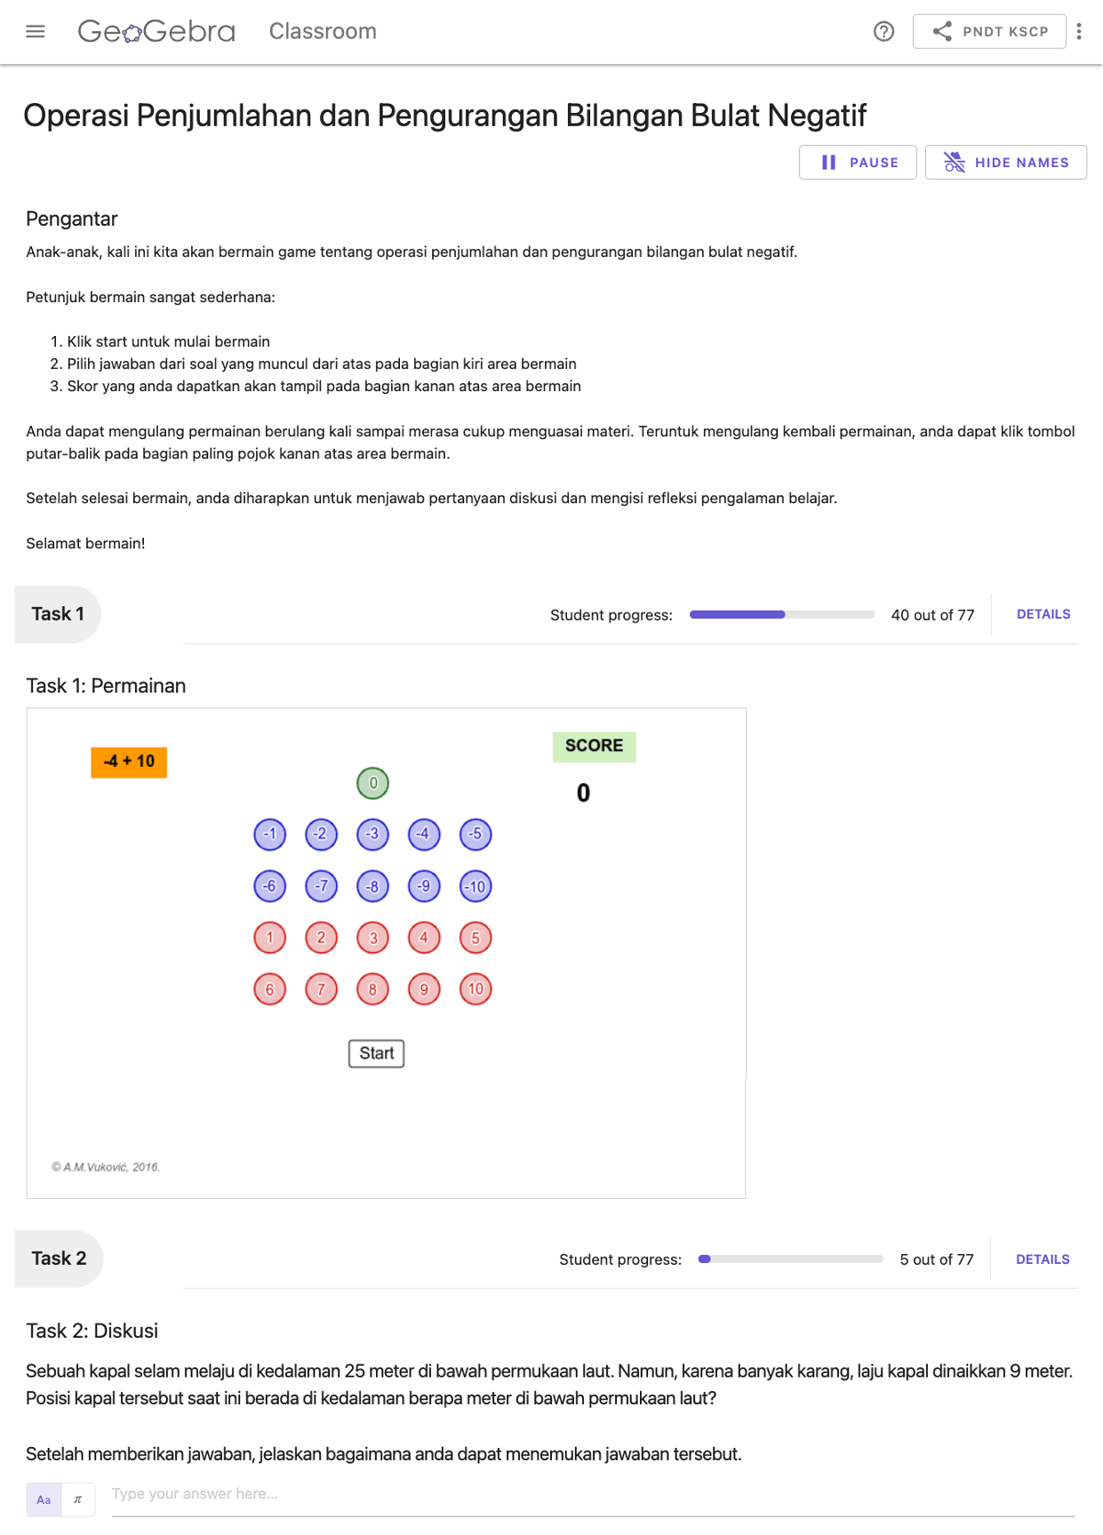
2.2 Teacher’s GeoGebra Classroom 2 (TGC2)
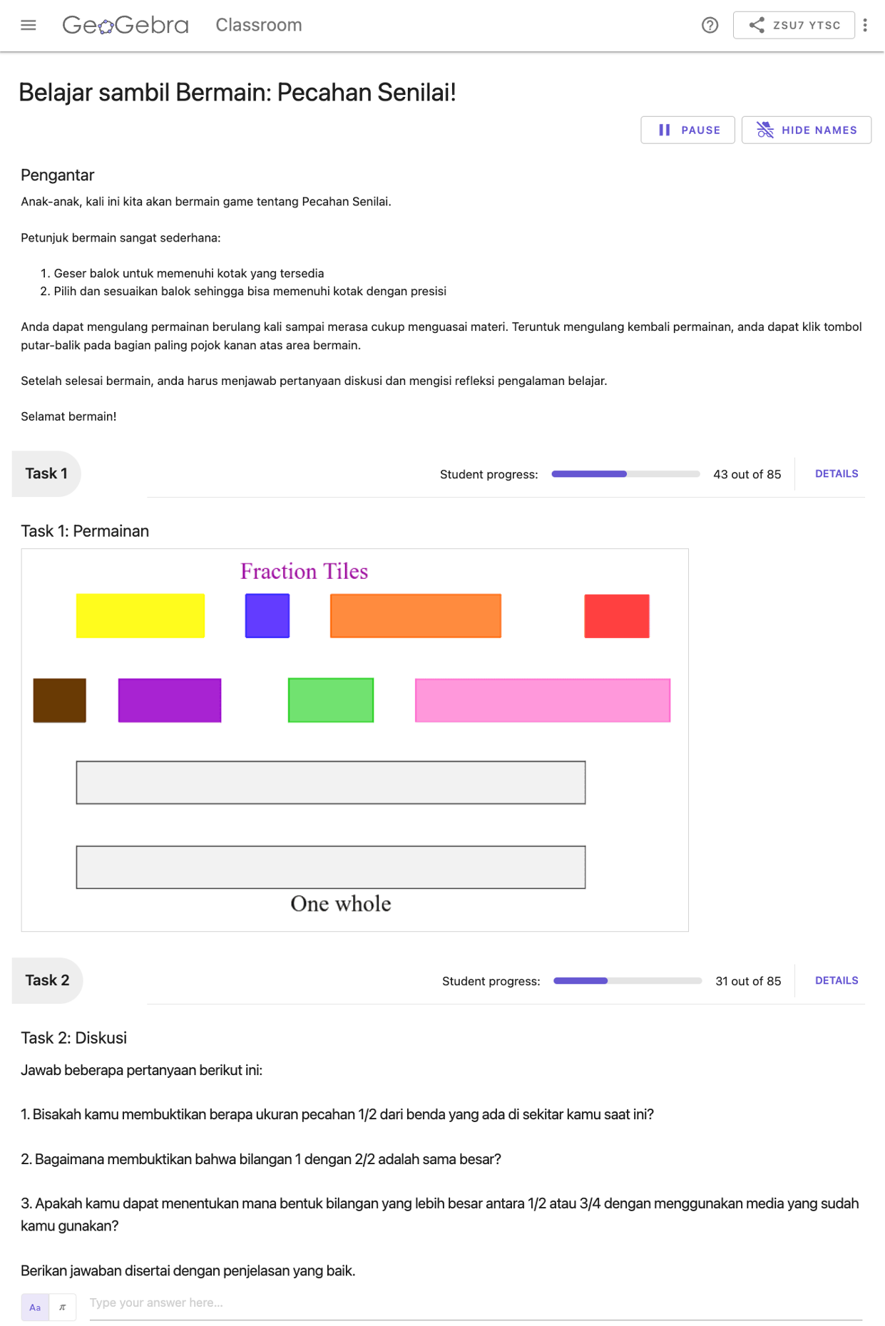
2.3 Teacher’s GeoGebra Classroom 3 (TGC3)
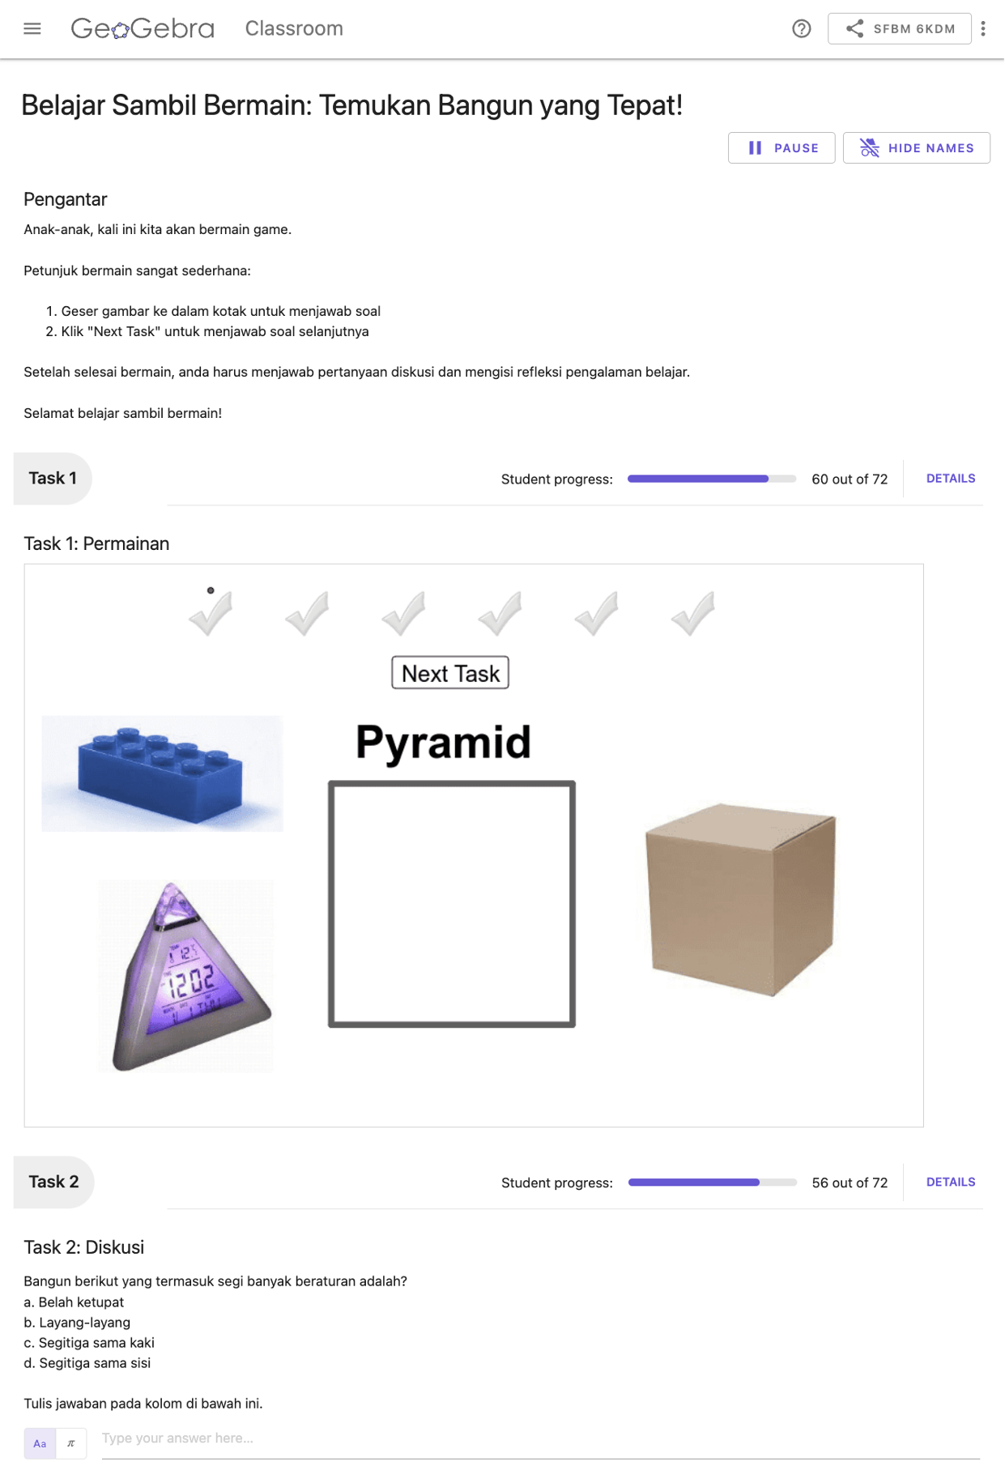
2.4 Teacher’s GeoGebra Classroom 4 (TGC4)
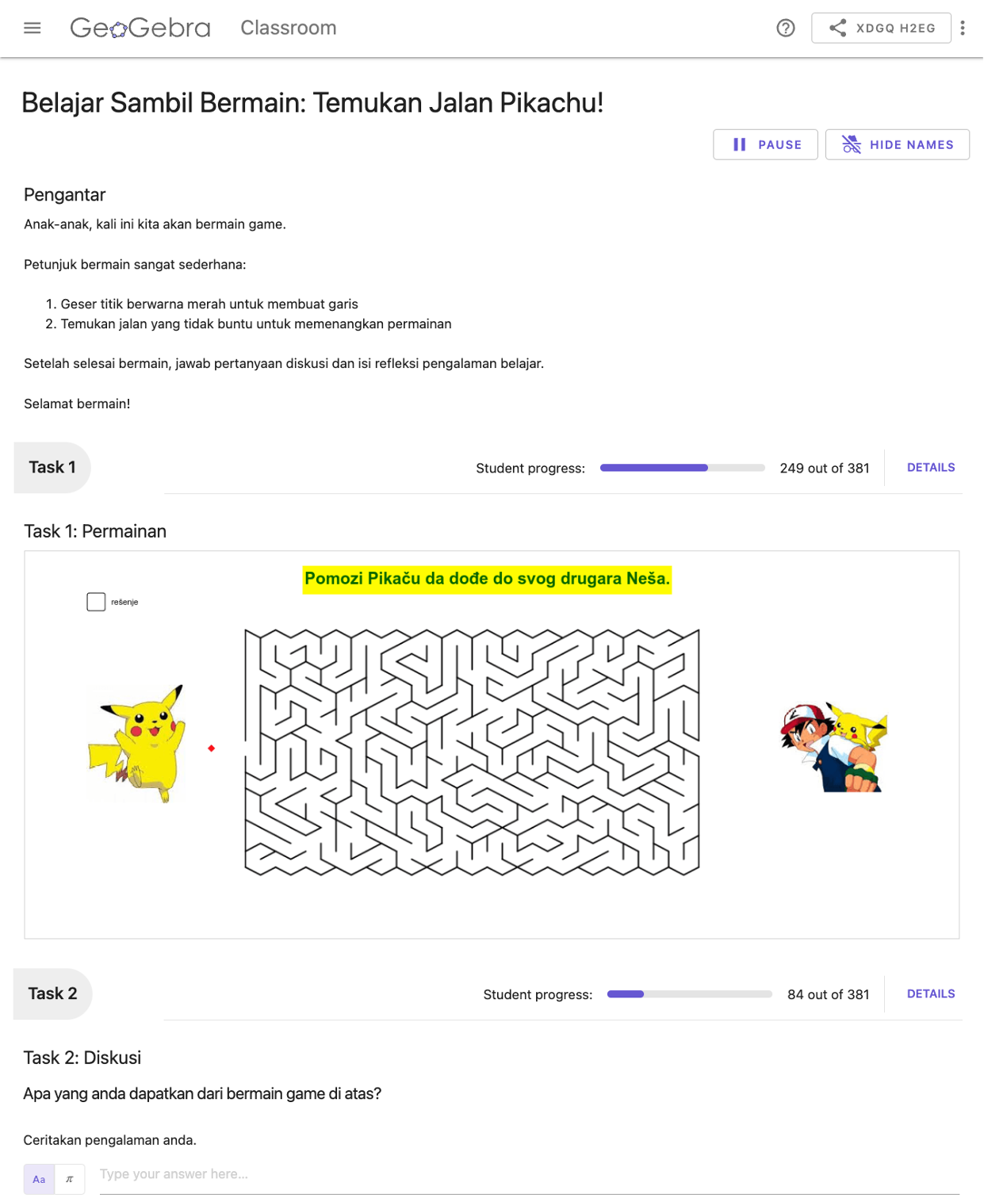

Note:
These GeoGebra Classroom screenshots were captured by the first author on 20 January 2023 upon the request of reviewers to promote a better understanding of the research setting and findings. Readers may see that the number of student progress is different from those presented in this article as teachers continue using them after the research was conducted in July 2021 until February 2022.

