Supplemental Materials
Video Design of Math Lesson
Figure 2.
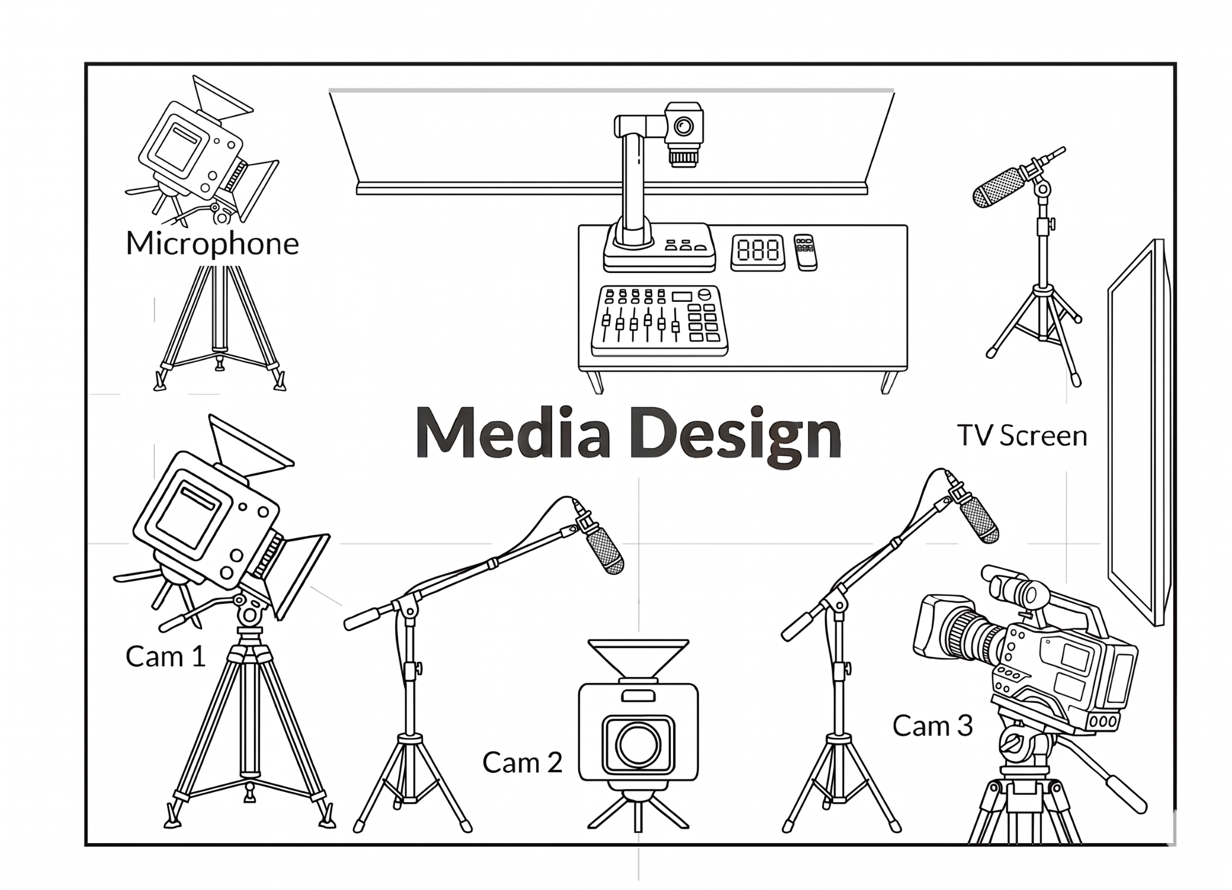
This figure illustrates the integrated media design and technology setup utilized for this study. To ensure comprehensive data collection, three professional-grade cameras (Cam 1, Cam 2, and Cam 3) are strategically positioned along the classroom's outer perimeter. The unlabeled camera at the top left is capturing behind-the-scenes footage. Each camera is paired with a 360° microphone to provide synchronized, high-fidelity spatial audio alongside the video capture. At the front of the room, a document camera is situated adjacent to the instructional board to facilitate real-time modeling; this device feeds directly to a large TV screen, enabling students to view teacher annotations and demonstrations clearly. This spatial arrangement is designed to maximize the visibility of teacher-student interactions within the central learning area while maintaining a non-intrusive footprint for the recording hardware. To view the media design in action, click on this video (https://youtu.be/3Y3iJjQbjqk), which shows the behind-the-scenes recording process (Supp. Materials Video).
Content Design of the Math Lesson
Equivalent Fraction Section
In the virtual classroom, after presenting the pretest problem, the teacher walked around the room and chose a student who used a target strategy – first the equivalent fraction strategy and asked the student to come to the board to describe the solution strategy to the class. Following, the teacher then led a discussion on the procedures and higher-level conceptual overview of the equivalent fraction strategy.
Students also compared two-word problems within each strategy to consolidate learning. Next, the teacher posed the juice problem: “Maria is making a fruit juice. To make a small pitcher of juice, the recipe calls for 3 apples and 7 oranges. Maria wants to make a big pitcher of juice, so she uses 16 apples. How many oranges will Maria need in order to make a big pitcher of juice?” Students were to solve the juice problem using the equivalent fraction strategy they just learned. After they solved the problem, the teacher explained how to solve the problem using the equivalent fraction strategy. Word problems were displayed simultaneously so that features of the strategies could be spatially aligned and easily compared (Richland et al., 2007). Following this, students were asked questions regarding the two problems. Finally, the teachers compared the cake and juice problem using the equivalent fraction strategy.
Here was the first instance of the experimental manipulation: in the relation-focused intervention, the teacher made explicit instruction to compare features of the two problems when using the equivalent fraction strategy. Students in the relation-focused intervention were also prompted with questions eliciting relational thinking. Students in the traditional intervention received procedural comparison from the teacher and procedural type questions.
Unit Ratio Section
To support structure mapping, the teacher introduced and compared two solution strategies to a single proportional reasoning word problem (e.g., Carpenter et al., 1999). The same procedures were employed, but now students were using the unit ratio to solve the same problems. So, the teacher brought a second student up to the board to describe the procedures of a second target strategy, the unit-ratio strategy. Following, the teacher then led a discussion about the procedures and a higher-level conceptual overview of the unit-ratio strategy. Students then completed the new problem a second time, now using the unit-ratio strategy. Again, the students in the relation-focused intervention received teacher instruction that supported relational thinking and questions to solve that elicited generating comparison, inference, abstraction and hierarchy.
Comparison Section
The lesson concluded by the teacher providing a conceptual overview of the two strategies (equivalent fraction and unit ratio strategies) and two problem types (cake and juice problems). The main learning objective of the lesson was to show students that both strategies can be used to solve any proportional reasoning problem, but that specific strategies are more efficient for specific problems based on the problem’s numerical features. Therefore, the teacher highlights that the efficiency of each strategy is determined by the numerical properties of the word problem. Again, the virtual lesson varied for those in the relation-focused intervention where students received more verbal instruction comparing the higher order conceptual features of the solution strategies.
To complete the lesson, students solved four new word problems: two near transfer word problems in which they were to use the equivalent fraction strategy and then the same problems in which they were to use the unit ratio strategy. Those assigned to the relation-focused intervention again received questions that elicited comparison, abstraction, hierarchy and inference.
Analysis of Math Assessment
The math pretest was administered prior to watching the video lesson on Day 1. Students solved an open-ended proportional reasoning problem on their own using any strategy they knew. The problem was as follows: “Alex is making a strawberry cake. To make a small cake, the recipe calls for 2 eggs and 6 strawberries. Alex wants to make a big cake, so he uses 8 eggs. How many strawberries will Alex need in order to make a big cake?” No feedback was provided after participants completed the item. Participants’ responses were coded as “1” for correct and “0” for incorrect.
Learning gains were assessed at two time points: on an immediate posttest after receiving the math lesson on Day 1 and on a delayed posttest on Day 2. The immediate posttest included two open-ended proportional reasoning items similar to the pretest item and the problems covered in the math lesson, which asked participants to reason through the proportional relations with calculations of up to two-digit numbers, but with different cover stories and numbers, for example, “An electric bike can go 5 miles in 7 minutes. How many minutes will it take for this bike to go 10 miles?” In addition, participants were instructed to solve each problem using a specific strategy (i.e., equivalent fraction or unit ratio). The delayed posttest included six additional similar proportional items with different cover stories and numbers (i.e., Biking, Reading, Toy Car, Smoothie, Train, Truck problems). We made sure that the topics of the cover stories are familiar to children of our age group. Participants were instructed to answer the first two items with the equivalent fraction strategy, the following two with the unit ratio strategy, and the last two with the better strategy between the two. No feedback was provided for any of the problems. Participants’ responses were coded as “1” and “0” for accuracy only, regardless of strategy use. Two summary scores of accuracies were calculated for the immediate and delayed posttests, respectively. The internal consistency reliability of the overall accuracy across these two assessment time points was acceptable (Cronbach’s α = 0.77).

