Supporting Information

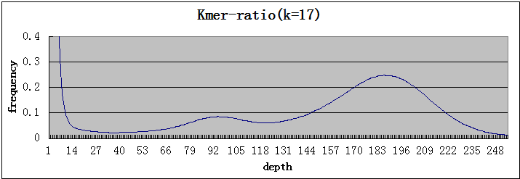
Figure S1 17-mer frequency distribution of reads data. A minor peak is at about half the depth of the main peak, indicating the heterozygosity of M. oleifera.

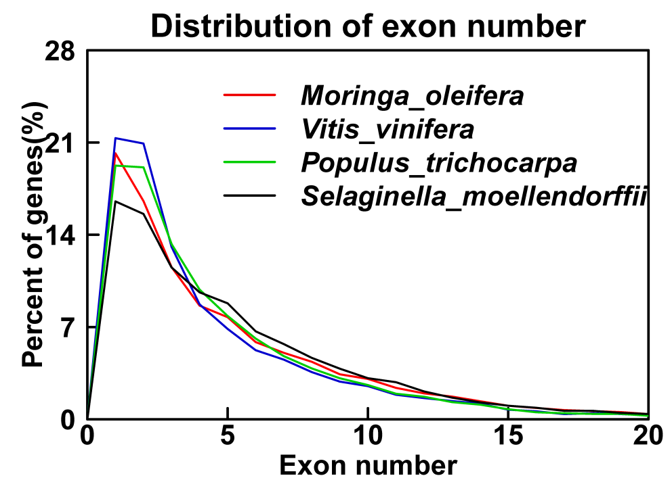
Figure S2 Distribution of exon numbers in annotated mRNA sequences. Annotation data of Vitis vinifera, Populus trichocarpa, Selaginella moellendorffii were used in parallel with Moringa oleifera’s annotation data.
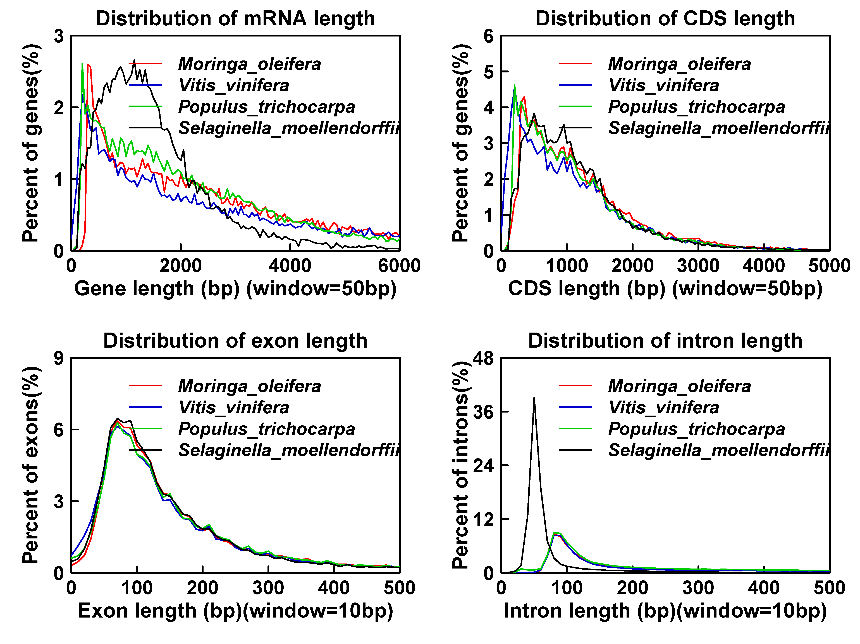
Figure S3 Distribution of mRNA length, CDS length, exon length and intron length. Alongside the genome annotation of Moringa oleifera, we used Vitis vinifera, Populus trichocarpa, Selaginella moellendorffii genome annotation as references.

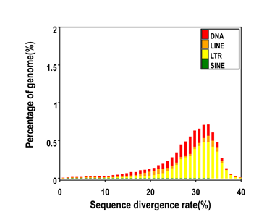
Figure S4 Distribution of Divergence Rate of each Type of Moringa oleifera’s TE. Divergence rate was calculated between the identified TE elements in the genome by homology-based method and the consensus sequence in the Repbase.

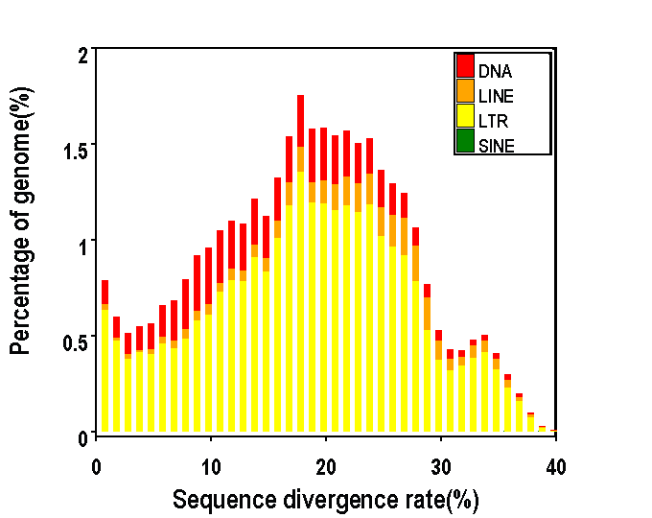
Figure S5 Distribution of Divergence Rate of each Type of Moringa oleifera’s TE. Divergence rate was calculated between the identified TE elements in the genome by de novo method and the consensus sequence in the predicted TE library.

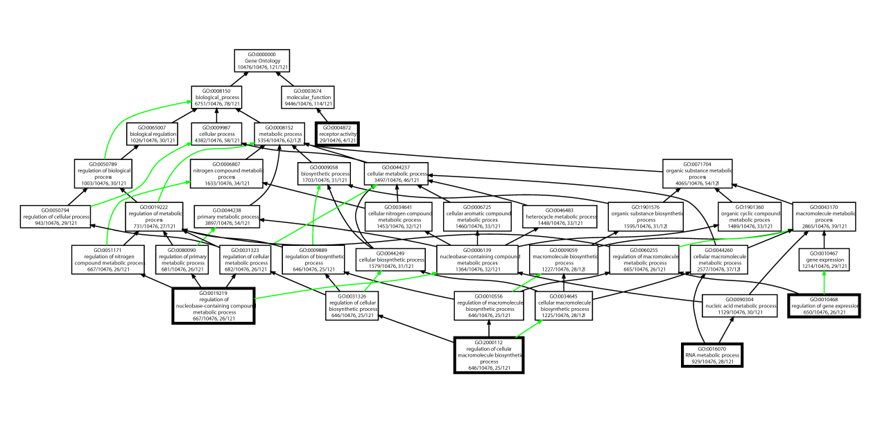
Figure S6 GO analysis of the miRNA targeted gene. Note: P-value cutoff was set at 0.0005 to optimize the image.

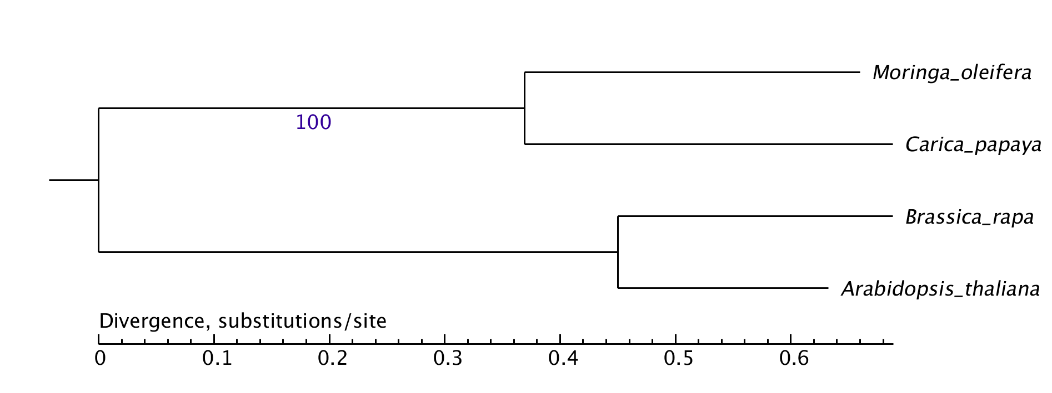
Figure S7 Phylogenetic tree of four Brassicales (Arabidopsis thaliana, Brassica rapa, Carica papaya, and Moringa oleifera).

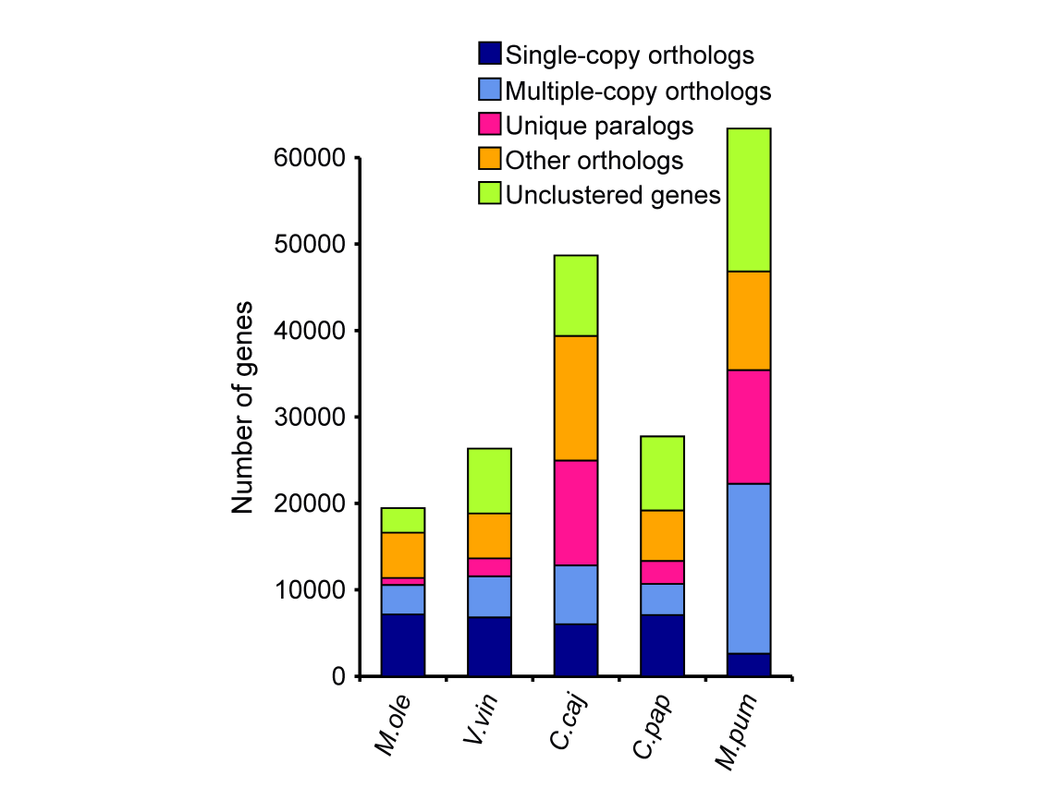
Figure S8 Orthologous gene distribution among five woody plants. Vitis vinifera, Cajanus cajan, Carica papaya, Malus pumila serve as the out group species to search the orthologous genes.

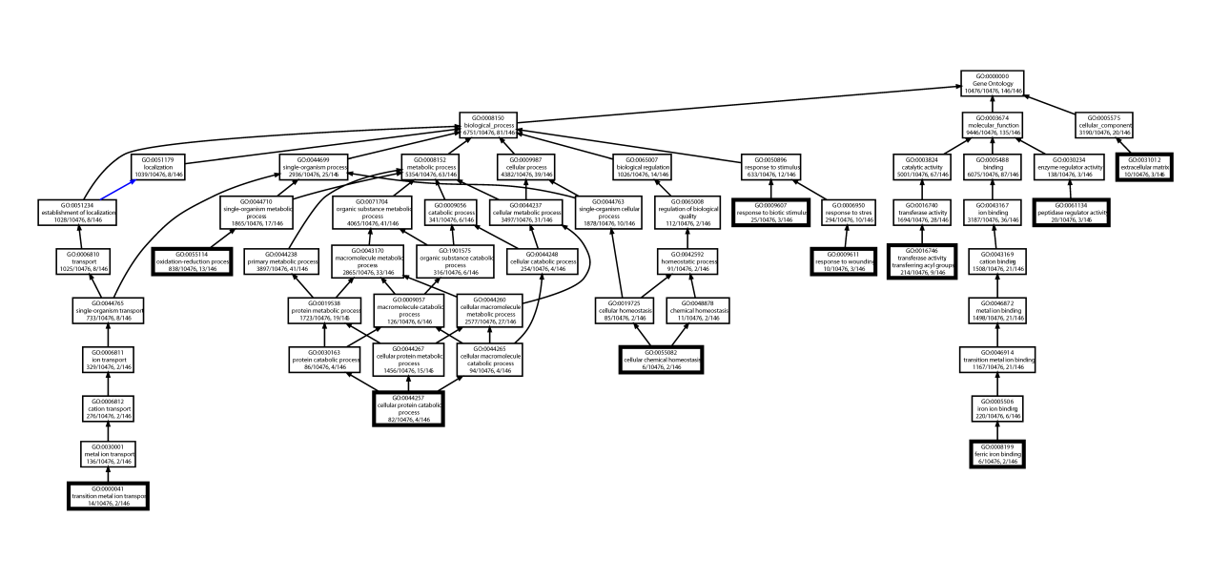
Figure S9 GO enrichment analysis of the M. oleifera specific gene family. These genes belong to the family that only exists in M. oleifera but not in Vitis vinifera, Cajanus cajan, Carica papaya, Malus pumila. P-value cutoff is set 0.01.

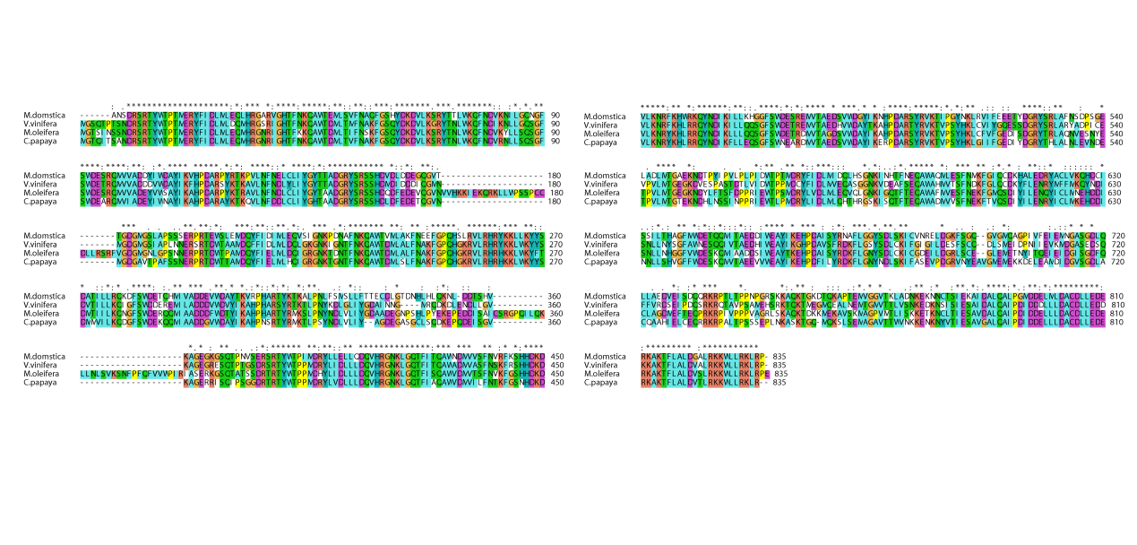
Figure S10 Alignment of M. oleifera gene lamu_GLEAN_10011614 and its orthologous in Vitis vinifera, Cajanus cajan, Carica papaya, Malus domestica. The central region has more variations and N terminal is highly conserved.
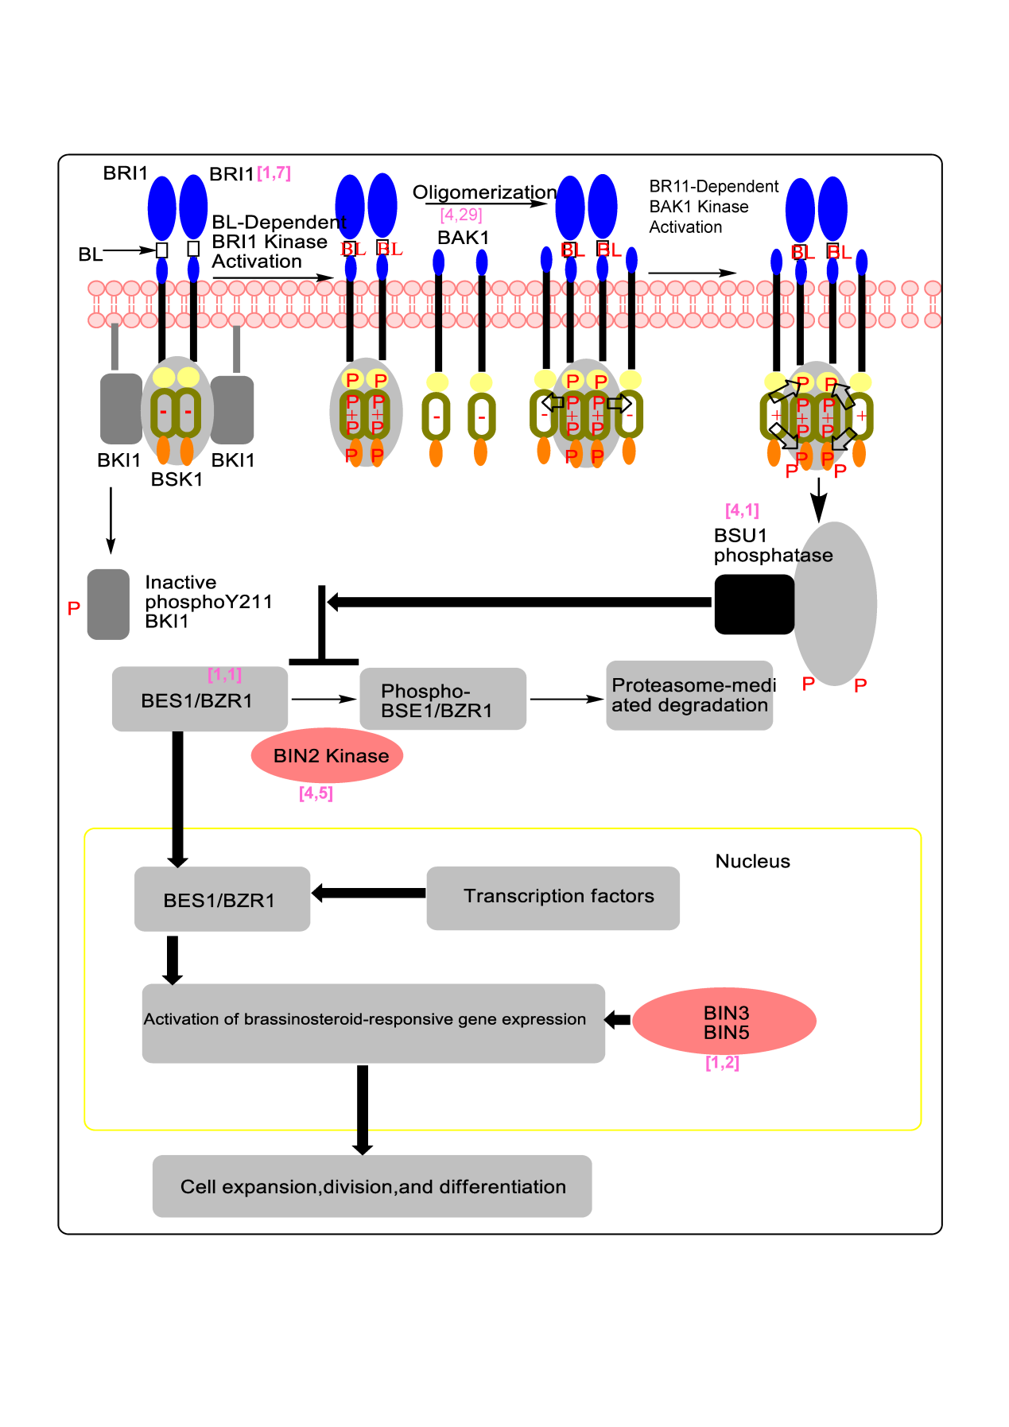
Figure S11 Brassinosteroid signal transduction pathway in M. oleifera and Arabidopsis thaliana. The number near the left square brackets indicates the copies of this gene in the Arabidopsis thaliana genome, while the other indicates the copy number in the M. oleifera genome.

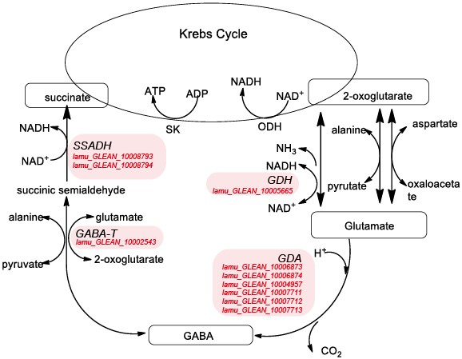
Figure S12 Simplified metabolic diagram the GABA shunt in relation to the Krebs cycle. GAD, glutamate decarboxylase; GABA-T, GABA transaminase; GDH, glutamate dehydrogenase; SSADH, succinic semialdehyde dehydrogenase.

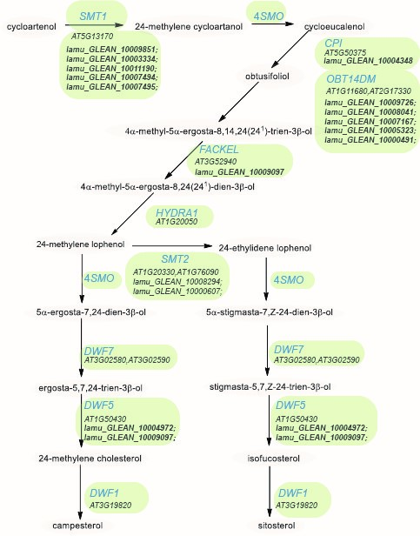
Figure S13 Biosynthesis of (24ξ)-24-methyl cholesterol (campesterol) and (24R)-24-ethyl cholesterol (sitosterol) in Arabidopsis thaliana and M. oleifera genome. CPI, cyclopropyl sterol isomerase; SMT, sterol methyltransferase; OBT14DM, obtusifoliol-14-demethylase; SMO, sterol 4-methyl oxidase; DWF1, gene encoding the ∆5-sterol-∆24-reductase. (isomerase); FACKEL, gene encoding the ∆8,14-sterol-∆14-reductase; HYDRA1, gene encoding the ∆8-∆7-sterol isomerase; DWF5, gene encoding the ∆5,7-sterol-∆7-reductase; DWF7, ∆7-sterol-C5(6)-desaturase.

