Figure S1. Annual changes in the proportion of KPC-2\NDM-1 dual-positive strains from various countries from 2012 to 2023.

Figure S2. Replicon types associated with key plasmid groups facilitating cross-species transmission of KPC-2 and NDM-1.

Figure S3. Geographic and sequence type distribution of key plasmids facilitating cross-species transmission in KPC-2\NDM-1 dual-positive strains. Different colors represent different types of resistance genes.

Figure S4. Distribution of KPC-2 and NDM-1 plasmid replicon types across different bacterial genera in KPC-2\NDM-1 dual-positive strains.

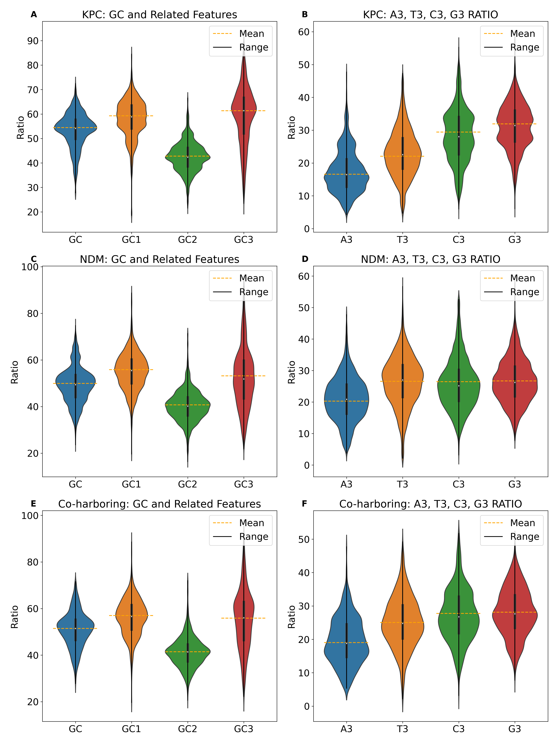
Figure S5. Violin plots of nucleotide content at each codon position for KPC-2 plasmids, NDM-1 plasmids, and co-carrying plasmids.

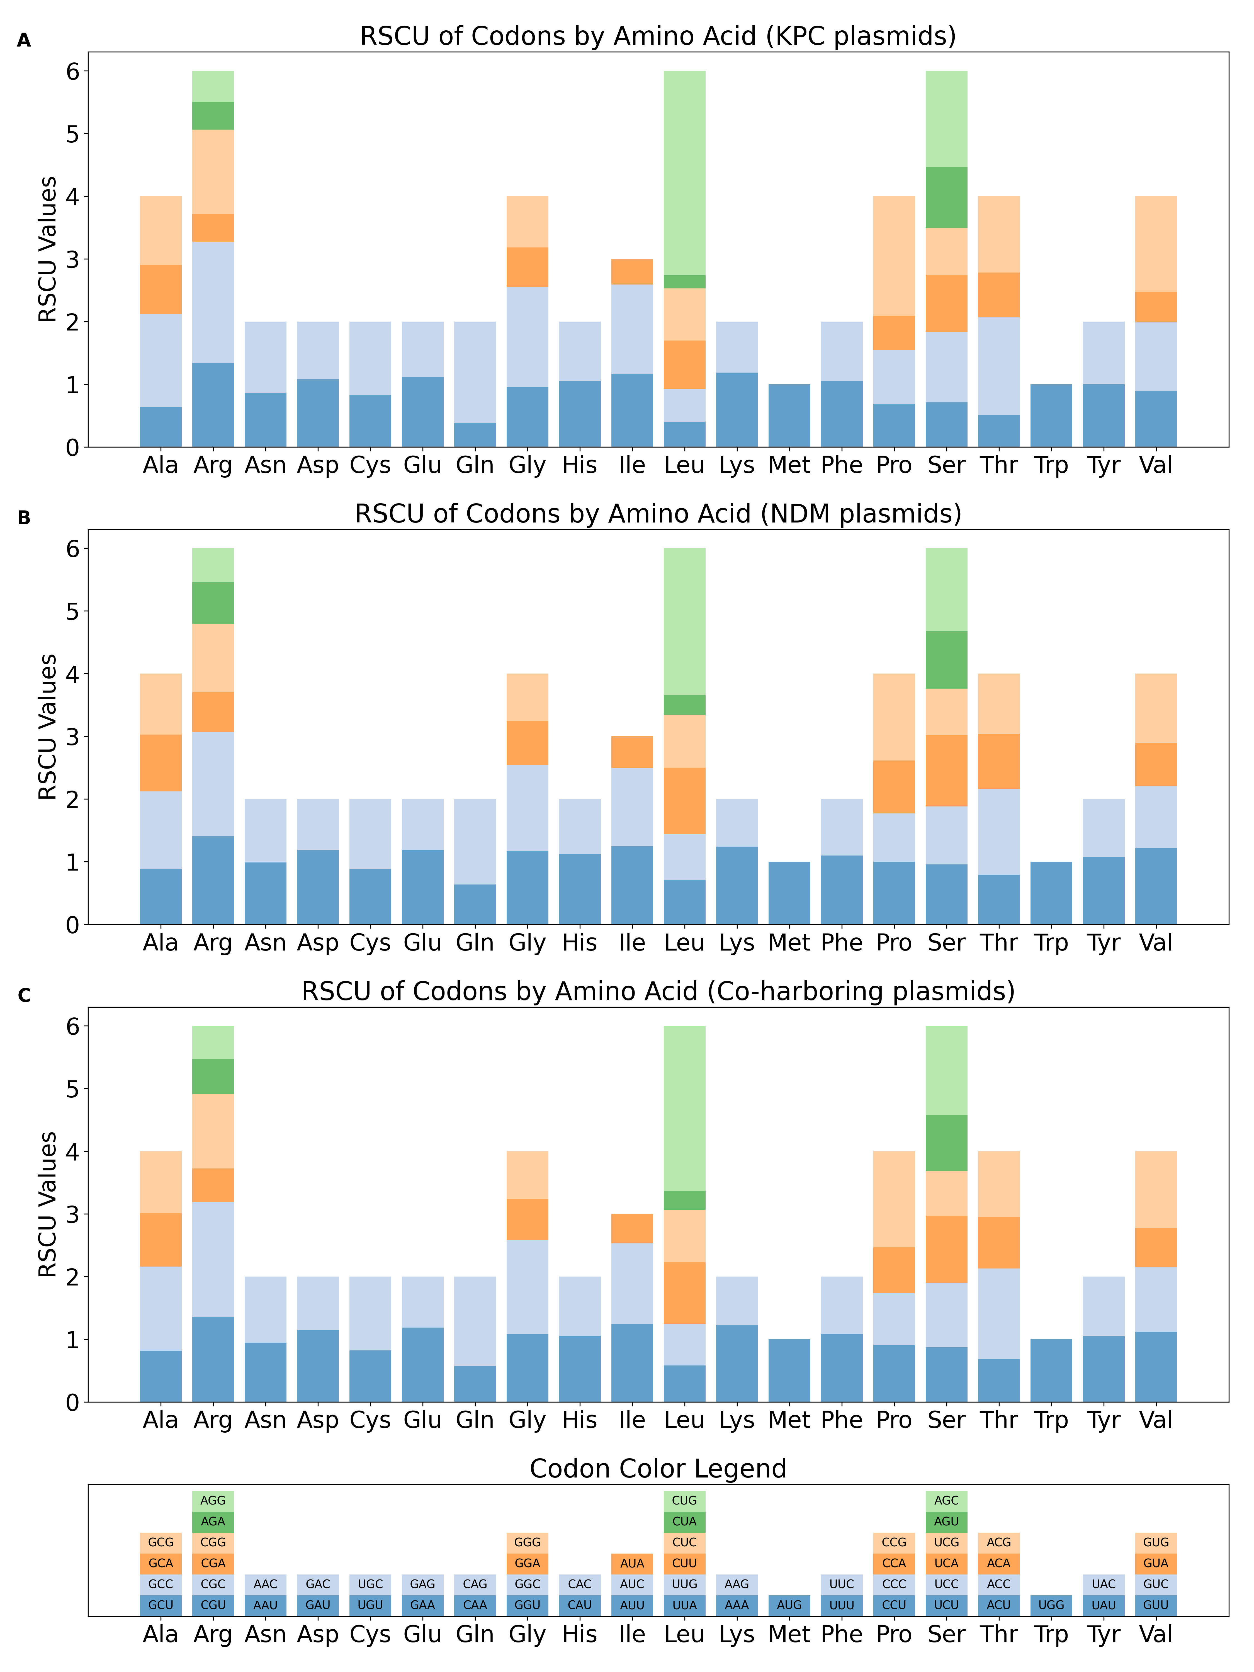
Figure S6. Relative synonymous codon usage (RSCU) patterns across three plasmid types. (A) KPC-2-carrying plasmids. (B) NDM-1-carrying plasmids. (C) Co-carrying plasmids.

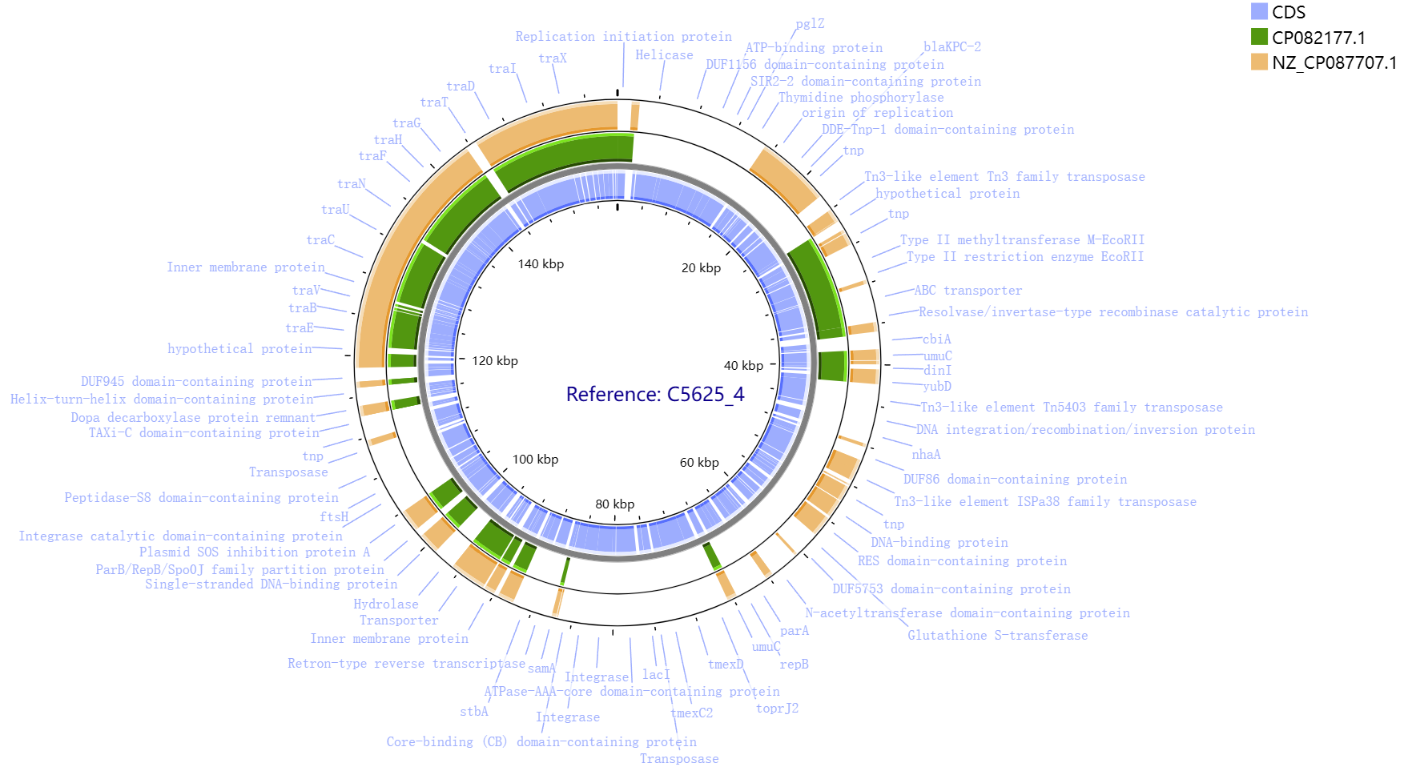
Figure S7. Circular sequence comparison of representative IncFII(p14) plasmids from PLSDB and the representative IncFII(p14) plasmid (C5625_4) from KPC-2\NDM-1 dual-positive strains sequenced in this study.

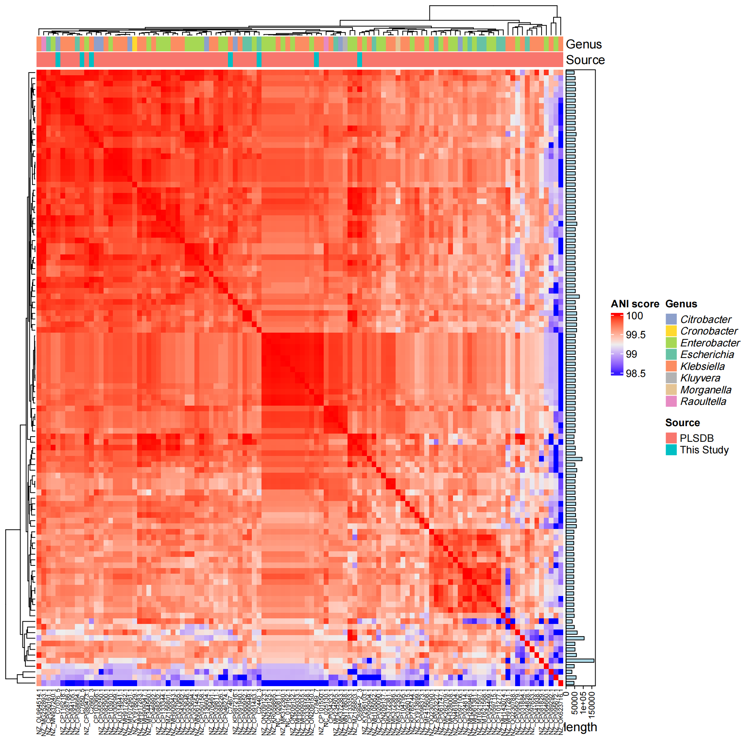
Figure S8. ANI-based distance clustering heatmap of IncX3 plasmids from PLSDB and IncX3 plasmids from KPC-2\NDM-1 dual-positive strains sequenced in this study.

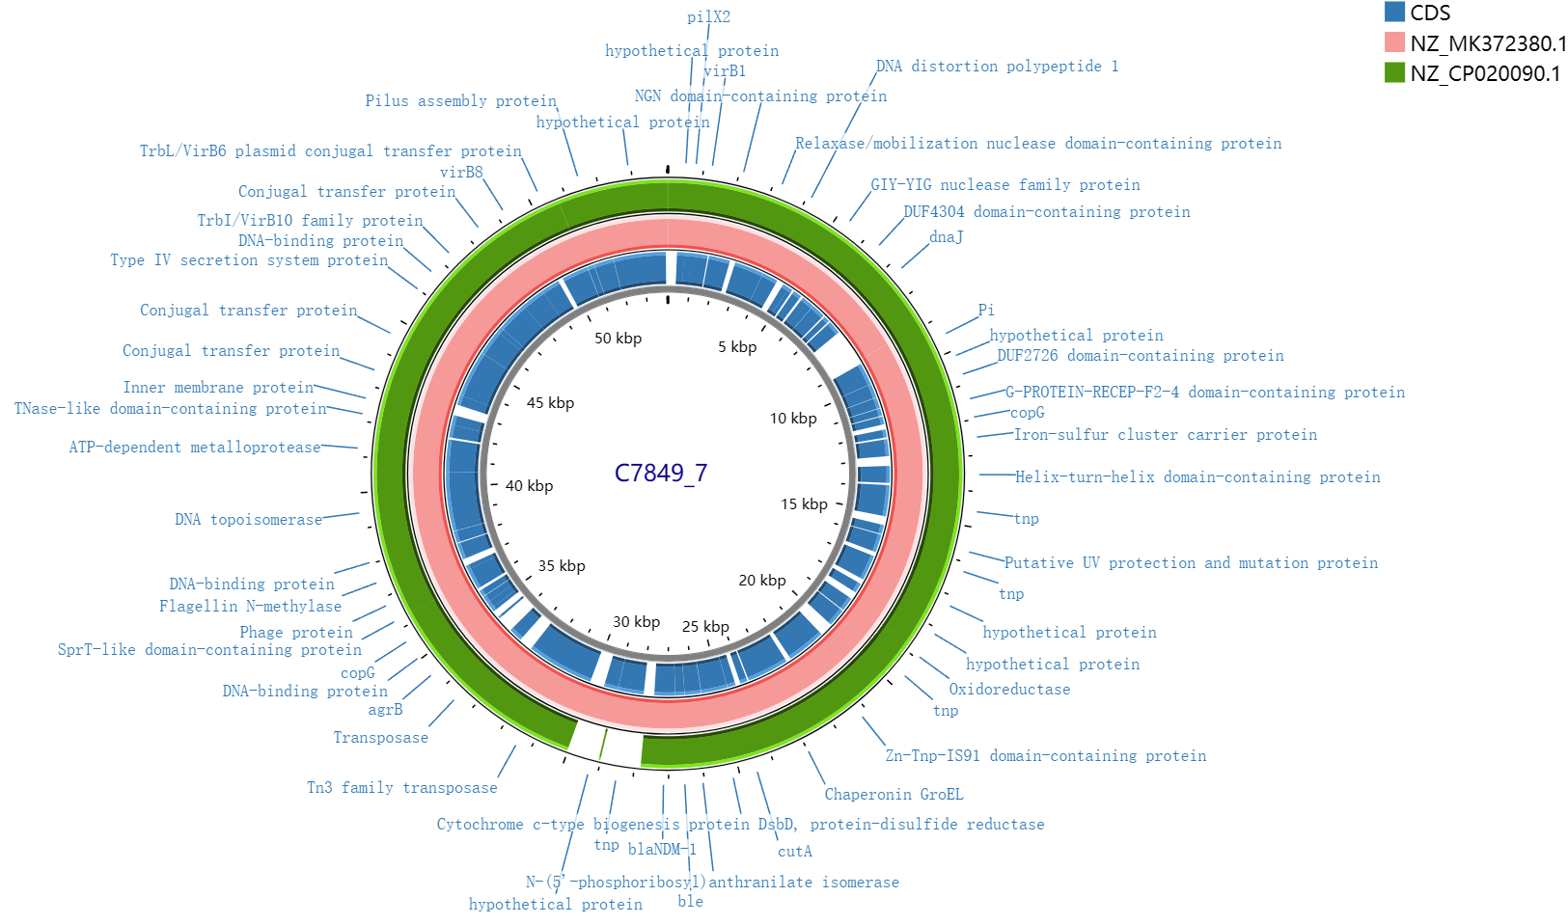
Figure S9. Circular sequence comparison of representative IncX3 plasmids from PLSDB and the representative IncX3 plasmid from KPC-2\NDM-1 dual-positive strains sequenced in this study.

Figure S10. Differences in virulence and resistance profiles between KPC-2\NDM-1 dual-positive strains and reference strains. (A) Differences in virulence scores. (B) Differences in resistance scores. (C) Differences in the number of resistance genes. (D) Differences in the number of resistance gene types.

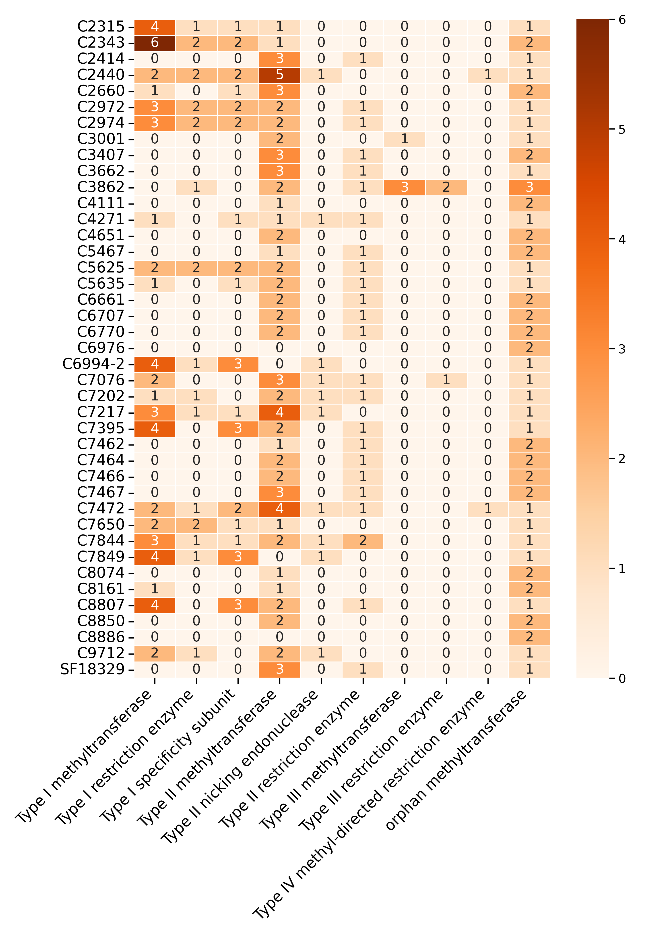
Figure S11. Restriction-modification (R-M) system enzymes identified in KPC-2\NDM-1 dual-positive strains sequenced in this study.

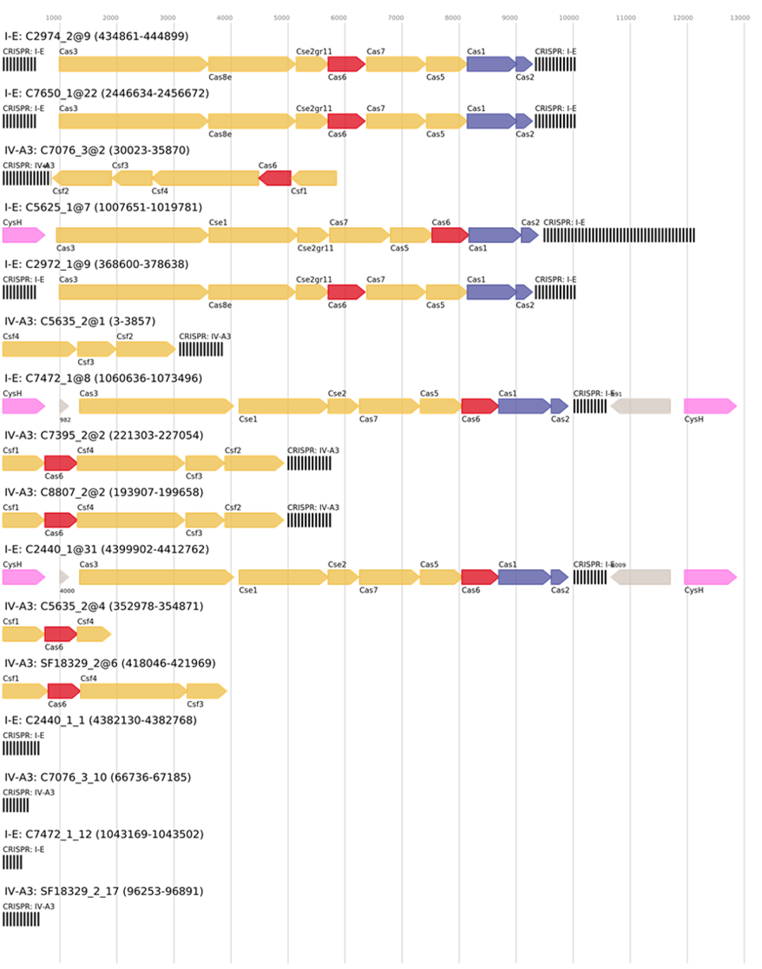
Figure S12. CRISPR-Cas systems identified in KPC-2\NDM-1 dual-positive strains sequenced in this study.

Figure S13. Codon Adaptation Index (CAI) of KPC-2 and NDM-1 plasmids in Klebsiella pneumoniae and Escherichia coli hosts among KPC-2\NDM-1 dual-positive strains sequenced in this study. KPC-2_Kpn represents the CAI values of KPC-2 plasmids in K. pneumoniae, NDM-1_Kpn represents the CAI values of NDM-1 plasmids in K. pneumoniae, and NDM-1_Ecoli represents the CAI values of NDM-1 plasmids in E. coli.

Figure S14. Schematic diagram of the formation mechanisms of KPC-2\NDM-1 dual-positive strains.

