Supplementary Material for
Effects of Shinrin-Yoku (Forest Bathing) and Nature Therapy on Mental Health: A Systematic Review and Meta-Analysis

Appendix 1. Systematic reviews examined for manual reference searches, and identified articles added to the shortlisted articles.
Author(s) and Year* | Title of Review | Additional Shortlisted Articles
Hansen et al., 2017 | Shinrin-yoku (forest bathing) and nature therapy: A state-of-the-art review | Chun, Chang & Lee, 2017; Han et al., 2016; McCaffrey, Hanson & McCaffrey, 2010; Shin, Shin & Yeoun, 2012; Stigsdotter, 2010; Ulrich et al., 1991
Tsunetsugu et al. 2010 | Trends in research related to 'Shinrin-yoku' (taking in the forest atmosphere or forest bathing) in Japan
Oh et al., 2017 | Health and well-being benefits of spending time in forests: systematic review | Shin, Shin, Yeoun & Kim, 2011
McMahan & Estes, 2015 | The effect of contact with natural environments on positive and negative affect: A meta-analysis | Berman et al., 2012; Hartig, Böök, Garvill, Olsson & Gärling, 1996; Johansson, Hartig & Staats, 2011
Payne & Delphinus 2019 | The most natural of natural therapies: A review of the health benefits derived from Shinrin-Yoku (Forest Bathing)
Meyer & Buerger-Arndt, 2014 | How forests foster human health - Present state of research-based knowledge (in the field of Forests and Human Health) | Horiuchi et al., 2013; Kondo et al., 2008; Shin et al., 2013; Song, Shin, Yeoun & Choi, 2009; Tsunetsugu, Park, Lee, Kagawa & Miyazaki, 2011
Bolwer et al., 2010 | A systematic review of evidence for the added benefits to health of exposure to natural environments
Kamioka et al., 2012 | A systematic review of randomized controlled trials on curative and health enhancement effects of forest therapy
Park, Tsunetsugu, Kasetani, Kagawa & Miyazaki, 2010 | The physiological effects of Shinrin-yoku (taking in the forest atmosphere or forest bathing): evidence from field experiments in 24 forests across Japan
Barton & Pretty, 2010 | What is the Best Dose of Nature and Green Exercise for Improving Mental Health? A Multi-Study Analysis
Bratman et al., 2012 | The impacts of nature experience on human cognitive function and mental health
Hartig et al., 2010 | Health Benefits of Nature Experience: Psychological, Social and Cultural Processes
Shin et al., 2009 | Forest experience and psychological health benefits: the state of the art and future prospect in Korea
Lee et al., 2017 | Effects of Forest Therapy on Depressive Symptoms among Adults: A Systematic Review | Hong, Kim & Cho, 2013
Frumkin, 2001 | Beyond toxicity: Human health and the natural environment
*Listed in order of our examination, therefore the same shortlisted articles found in later systematic reviews (lower rows of the table) were not noted to avoid duplicate.

Appendix 2. Excluded studies and reasons for exclusion (n=40)
Author(s) and Year | Title | Reason for Exclusion
Morita et al., 2019 | Frequency of forest walking is not associated with prevalence of hypertension based on cross-sectional studies of a general Japanese population | No mental health measures used.
Bielinis et al., 2019 | The restorative effect of staying in a broad-leaved forest on healthy young adults in winter and spring | Not shinrin-yoku
Zhou et al., 2019 | Effect of short-term forest bathing in urban parks on perceived anxiety of young-adults: A pilot study in Guiyang, Southwest China | Could not determine if intervention was shinrin-yoku
Arnberger et al., 2018 | Health-related effects of short stays at mountain meadows, a river and an urban site-results from a field experiment | Not shinrin-yoku
Ramshini et al., 2018 | The Effect of Family-Centered Nature Therapy on Interactions Between Parent and Child With Autism Spectrum Disorder | Not shinrin-yoku
Yu et al., 2018 | The effect of virtual reality forest and urban environments on physiological and psychological responses | Not shinrin-yoku
Zhao et al., 2018 | Effects of auditory-visual combinations on perceived restorative potential of urban green space | Not shinrin-yoku
Bang et al., 2017 | The effects of a campus forest-walking program on undergraduate and graduate students' physical and psychological health | Not shinrin-yoku
Korpela et al., 2017 | Nature exposure predicts well-being trajectory groups among employees across two years. | Not shinrin-yoku
Takayama, Fujiwara, Saito & Horiuchi, 2017 | Management effectiveness of a secondary coniferous forest for landscape appreciation and psychological restoration | Not shinrin-yoku
Takayama, Saito, Fujiwara & Horiuchi, 2017 | The effect of slight thinning of managed coniferous forest on landscape appreciation and psychological restoration | Not shinrin-yoku
Ohe et al., 2017 | Evaluating the relaxation effects of emerging forest-therapy tourism: A multidisciplinary approach | Combined with other approaches
Akpinar et al., 2016 | Does green space matter? Exploring relationships between green space type and health indicators | Not shinrin-yoku
Combs et al., 2016 | Adolescent self-assessment of an outdoor behavioral health program: Longitudinal outcomes and trajectories of change. | Combined with other approaches
Gladwell et al., 2016 | A lunchtime walk in nature enhances restoration of autonomic control during night-time sleep: results from a preliminary study | No mental health measures used.
Jakubec et al., 2016 | Mental well-being and quality-of-life benefits of inclusion in nature for adults with disabilities and their caregivers. | Combined with other approaches
Song et al., 2016 | Effects of VOCs from leaves of Acer truncatum Bunge and Cedrus deodara on human physiology and psychology | Not shinrin-yoku
Igarashi et al., 2015 | Physiological and psychological effects of viewing a kiwifruit (actinidia deliciosa 'hayward') orchard landscape in summer in Japan | Not shinrin-yoku
Joung et al., 2015 | The prefrontal cortex activity and psychological effects of viewing forest landscapes in autumn season | Not shinrin-yoku
Kim et al., 2015 | The influence of forest experience program on physiological and psychological states in psychiatric inpatients | Not in English
Rogerson & Barton, 2015 | Effects of the visual exercise environments on cognitive directed attention, energy expenditure and perceived exertion | Not shinrin-yoku
Sandifer et al., 2015 | Exploring connections among nature, biodiversity, ecosystem services, and human health and well-being: Opportunities to enhance health and biodiversity conservation | Not shinrin-yoku
Song et al., 2015 | Physiological and psychological effects of a walk in urban parks in fall | Not shinrin-yoku
Song et al., 2015 | Effect of forest walking on autonomic nervous system activity in middle-aged hypertensive individuals: A pilot study | Not shinrin-yoku
Horiuchi et al., 2014 | Impact of viewing vs. Not viewing a real forest on physiological and psychological responses in the same setting | Not shinrin-yoku
Song et al., 2014 | Physiological and psychological responses of young males during spring-time walks in urban parks | Not shinrin-yoku
Hong, Kim & Cho, 2013 | The effects of forests healing for cognitive function | Not in English
Shin et al., 2013 | Differences of psychological effects between meditative and athletic walking in a forest and gymnasium | Not shinrin-yoku
Berger & Tiry, 2012 | The enchanting forest and the healing sand—Nature therapy with people coping with psychiatric difficulties | Not empirical.
Berman et al., 2012 | Interacting with nature improves cognition and affect for individuals with depression | Could not determine if intervention was shinrin-yoku
Johansson, Hartig & Staats, 2011 | Psychological benefits of walking: moderation by company and outdoor environment | Not shinrin-yoku
Miyaura et al., 2011 | A before and after comparison of the effects of forest walking on the sleep of a community-based sample of people with sleep complaints | Not shinrin-yoku
Shin, Shin, Yeoun & Kim, 2011 | The influence of interaction with forest on cognitive function | Could not determine if intervention was shinrin-yoku
Tsunetsugu, Park, Lee, Kagawa & Miyazaki, 2011 | Psychological relaxation effect of forest therapy: results of field experiments in 19 forests in Japan involving 228 participants | Not in English
McCaffrey, Hanson & McCaffrey, 2010 | Garden walking for depression: A research report | Not shinrin-yoku
Stigsdotter et al., 2010 | Health promoting outdoor environments - Associations between green space, and health, health-related quality of life and stress based on a Danish national representative survey | Not shinrin-yoku
Kondo et al., 2008 | A physio-psychological research on shinrin-yoku | Not in English
Yamaguchi, Deguchi & Miyazaki, 2006 | The effects of exercise in forest and urban environments on sympathetic nervous activity of normal young adults | No mental health measures used.
Ulrich et al., 1991 | Stress recovery during exposure to natural and urban environments | Not shinrin-yoku
Hartig et al., 1996 | Environmental influences on psychological restoration | Not shinrin-yoku

Appendix 3: Funnel plot of Heterogeneity for the effects of shinrin-yoku on depression in RCTs
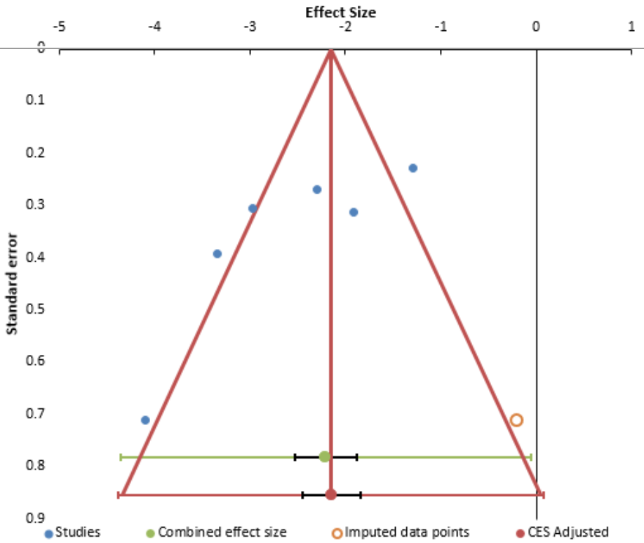
Possible evidence of publication bias was identified by an asymmetrical funnel plot of effect size against standard error. Further, the Begg test (Begg & Mazumdar 1994) and the Egger test (Egger et al., 1997) were used. Begg and Mazumdar adjusted rank correlation (z = -1.32, pz = 0.19) and Egger’s coefficient (intercept = -6.83, t = -2.48, p = 0.07) were both non-significant.

Appendix 4: Funnel plot of Heterogeneity for the effects of shinrin-yoku on depression in studies reported pre-post scores
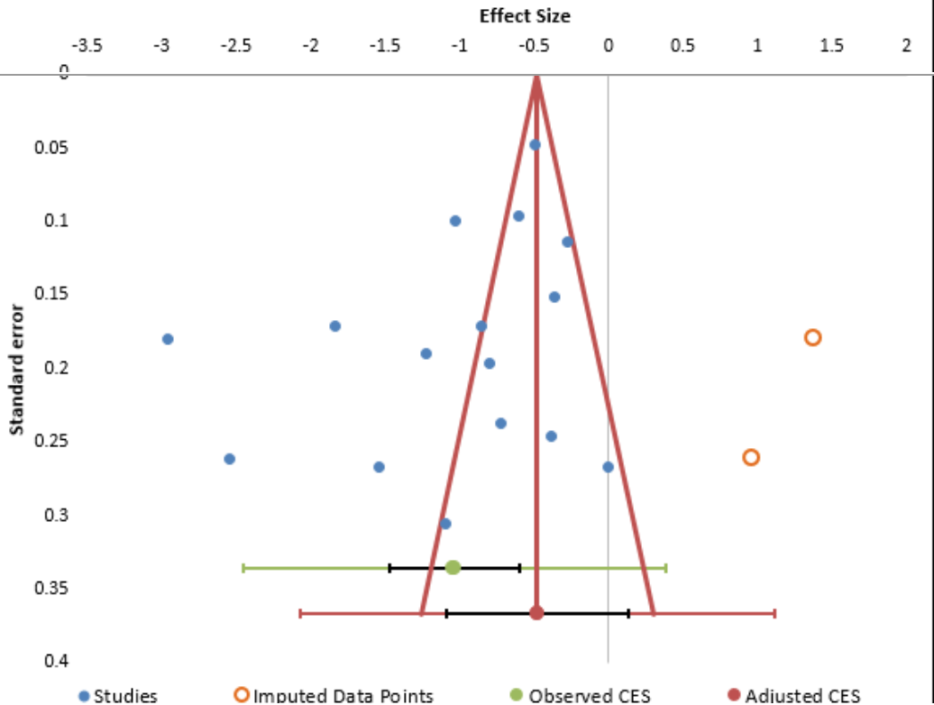
Possible evidence of publication bias was identified by an asymmetrical funnel plot of effect size against standard error. Begg and Mazumdar adjusted rank correlation (z = -0.99, pz = 0.32) and Egger’s coefficient (intercept = -7.27, t = -0.67, p = 0.51) were both non-significant.

Appendix 5: Funnel plot of Heterogeneity for the effects of shinrin-yoku on anxiety in RCTs
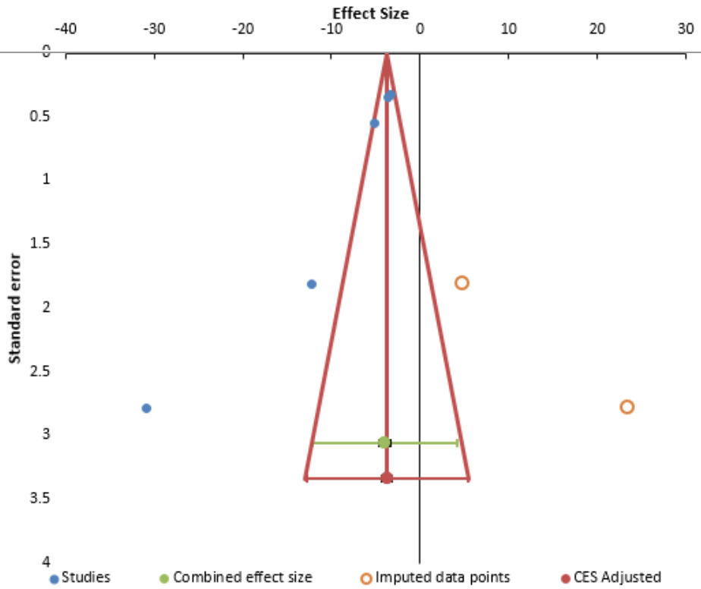
Possible evidence of publication bias was not identified by a symmetrical funnel plot of effect size against standard error. Begg and Mazumdar adjusted rank correlation (z = -2.45, pz = 0.01) and Egger’s coefficient (intercept = -8.75, t = -5.85, p = 0.01) were both significant.

Appendix 6: Funnel plot of Heterogeneity for the effects of shinrin-yoku on anxiety in studies reported pre-post scores.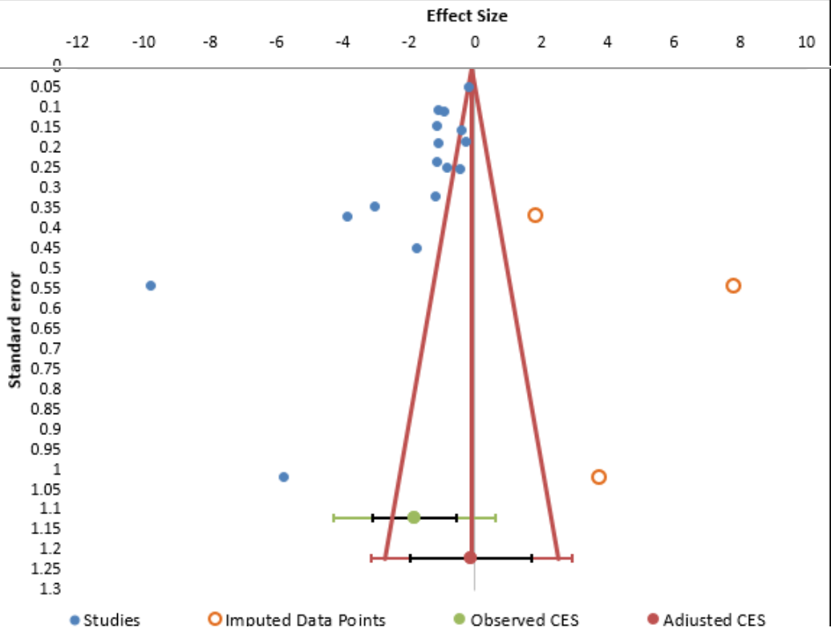
Possible evidence of publication bias was identified by an asymmetrical funnel plot of effect size against standard error. Begg and Mazumdar adjusted rank correlation was not significant (z = -1.62, pz = 0.11) whilst Egger’s coefficient (intercept = -18.28, t = -3.13, p = 0.01) was significant.
Appendix 7: Funnel plot of Heterogeneity for the effects of shinrin-yoku on anger in RCTs
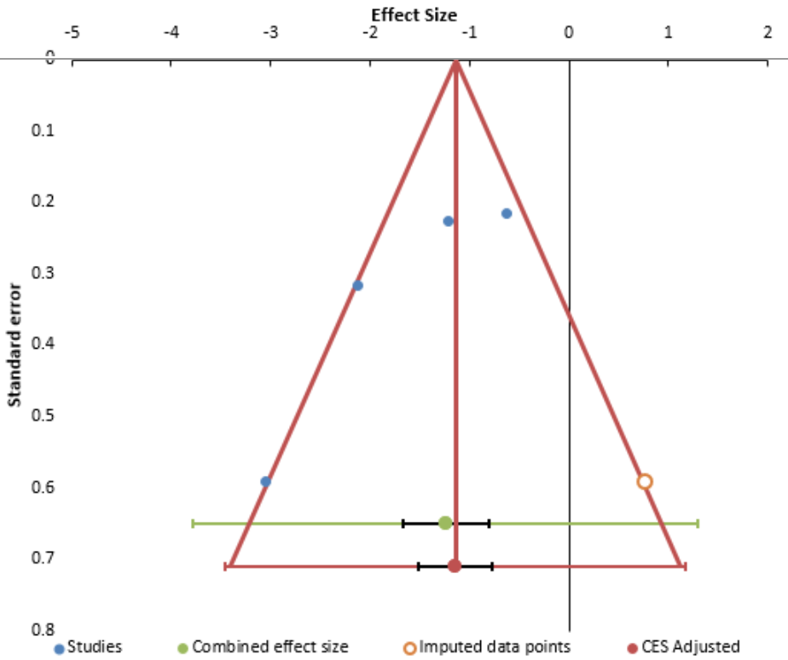
Possible evidence of publication bias was identified (asymmetrical funnel plot). Begg and Mazumdar adjusted rank correlation (z = -2.04, pz = 0.04) was significant, however Egger’s coefficient (intercept = -6.88, t = -2.57, p = 0.12) was not.

Appendix 8: Funnel plot of Heterogeneity for the effects of shinrin-yoku on anger in studies reported pre-post scores
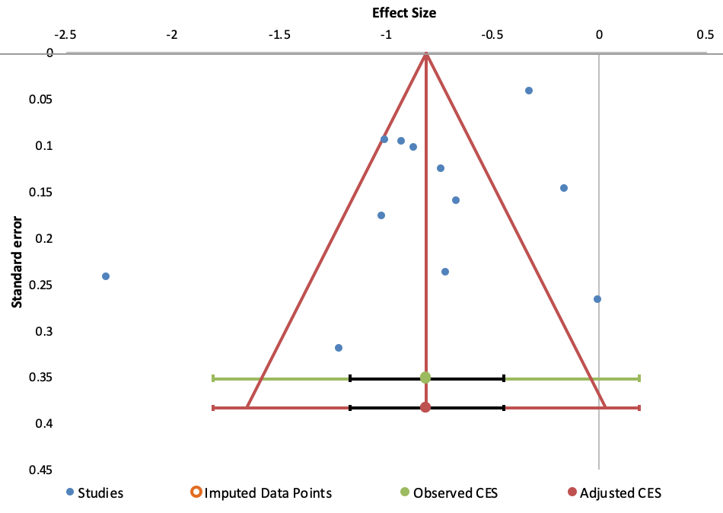
Possible evidence of publication bias was identified: while the funnel plot appeared symmetrical, Begg and Mazumdar adjusted rank correlation (z = 0.27, pz = 0.78) and Egger’s coefficient (intercept = -4.63, t = -0.82, p = 0.43) were both non-significant.
Appendix 9. List of Peer-Reviewed Journal Articles in Japanese, Measured Mental Health Outcomes 2009-2019.

Tsunetsugu, Y., Park, B., Lee, J., Kagawa, T. & Miyazaki, Y. (2011). Psychological relaxation effect of forest therapy: Results of field experiments in 19 forests in Japan involving 228 participants. Japanese Journal of Hygiene, 66, 670–676. https://doi.org/10.1265/jjh.66.670
Koyama, Y. (2007). Naganoken no shinrin niokeru shinrin-yoku no kouka [Effects of shinrin-yoku in a forest in Nagano Prefecture]. Research Report for Nagano Forestry Center, 22, 63-84.
Takayama, N., Tsutsui, S. & Nakano, H. (2010). Riyousha no kojintokusei ga shinrin-yoku no iyashikouka ni ataeru eikyou [Impacts of personality on the healing effects of shinrin-yoku]. Journal of Health Sciences of Mind and Body, 6(2), 42-51. https://doi.org/10.11427/jhas.6.2_42
Kondo, T., Takeda, A., Takeda, N., Shimomura, Y., Yagata, M. & Kobayashi, I. (2008). A physio-psychological research on shinrin-yoku. The Journal of Balneology, Climatology and Physical Medicine, 71(2), 131-138. https://doi.org/10.11390/onki1962.71.131

This list does not include conference papers.

References

Akpinar, A., Barbosa-Leiker, C., & Brooks, K. R. (2016). Does green space matter? Exploring relationships between green space type and health indicators. Urban Forestry & Urban Greening, 20, 407–418. https://doi.org/10.1016/J.UFUG.2016.10.013.

Arnberger, A., Eder, R., Allex, B., Ebenberger, M., Hutter, H.-P., Wallner, P., Bauer, N., Zaller, J., & Frank, T. (2018). Health-related effects of short stays at mountain meadows, a river and an urban site—Results from a field experiment. International Journal of Environmental Research and Public Health, 15(12), 2647. https://doi.org/10.3390/ijerph15122647.

Bang, K.-S., Lee, I., Kim, S., Lim, C. S., Joh, H.-K., Park, B.-J., & Song,M. K. (2017). The effects of a campus forestwalking programon undergraduate and graduate students’ physical and psychological health. International Journal of Environmental Research and Public Health, 14(7). https://doi.org/10.3390/ijerph14070728.

Berger, R., & Tiry, M. (2012). The enchanting forest and the healing sand—nature therapy with people coping with psychiatric difficulties. The Arts in Psychotherapy, 39(5), 412–416. https://doi.org/10.1016/J.AIP.2012.03.009.

Berman, M. G., Kross, E., Krpan, K. M., Askren, M. K., Burson, A., Deldin, P. J., Kaplan, S., Sherdell, L., Gotlib, I. H., & Jonides, J. (2012). Interacting with nature improves cognition and affect for individuals with depression. Journal of Affective Disorders, 140(3), 300–305. https://doi.org/10.1016/j.jad.2012.03.012.

Combs, K. M., Hoag, M. J., Javorski, S., & Roberts, S. D. (2016). Adolescent self-assessment of an outdoor behavioral health program: longitudinal outcomes and trajectories of change. Journal of Child and Family Studies, 25(11), 3322–3330. https://doi.org/10.1007/s10826-016-0497-3.

Frumkin, H. (2001). Beyond toxicity: human health and the natural environment. American Journal of Preventive Medicine, 20(3), 234–240. Retrieved from http://www.ncbi.nlm.nih.gov/pubmed/11275453.

Gladwell, V., Kuoppa, P., Tarvainen, M., & Rogerson, M. (2016). A lunchtime walk in nature enhances restoration of autonomic control during night-time sleep: results from a preliminary study. International Journal of Environmental Research and Public Health, 13(3), 280. https://doi.org/10.3390/ijerph13030280.

Hartig, T., Böök, A., Garvill, J., Olsson, T., & Gärling, T. (1996). Environmental influences on psychological restoration. Scandinavian Journal of Psychology, 37(4), 378–393. Retrieved from http://www.ncbi.nlm.nih.gov/pubmed/8931393.

Hartig, T., van den Berg, A. E., Hagerhall, C.M., Tomalak,M., Bauer, N., Hansmann, R., Ojala, A., Syngollitou, E., Carrus, G., van Herzele, A., Bell, S., Podesta, M. T. C., & Waaseth, G. (2010). Health benefits of nature experience: psychological, social and cultural processes. In Forests, trees and human health (pp. 127–168). Dordrecht: Springer Netherlands. https://doi.org/10.1007/978-90-481-9806-1_5.

Hong, S.-S., Kim, H.-C., & Cho, S.-H. (2013). The effects of forests healing for cognitive function. Journal of Oriental Neuropsychiatry, 24(1), 63–74. https://doi.org/10.7231/jon.2013.24.1.063.

Igarashi, M., Miwa, M., Ikei, H., Song, C., Takagaki, M., & Miyazaki, Y. (2015). Physiological and psychological effects of viewing a kiwifruit (Actinidia deliciosa ‘Hayward’) orchard landscape in summer in Japan. International Journal of Environmental Research and Public Health, 12(6), 6657–6668. https://doi.org/10.3390/ijerph120606657.

Jakubec, S. L., Carruthers Den Hoed, D., Ray, H., & Krishnamurthy, A. (2016). Mental well-being and quality-of-life benefits of inclusion in nature for adults with disabilities and their caregivers. Landscape Research, 41(6), 616–627. https://doi.org/10.1080/01426397.2016.1197190.

Johansson, M., Hartig, T., & Staats, H. (2011). Psychological benefits of walking: MODERATION by company and outdoor environment. Applied Psychology: Health and Well-Being, 3(3), 261–280. https://doi.org/10.1111/j.1758-0854.2011.01051.x.

Joung, D., Kim, G., Choi, Y., Lim, H., Park, S., Woo, J.-M., & Park, B.-J. (2015). The prefrontal cortex activity and psychological effects of viewing forest landscapes in autumn season. International Journal of Environmental Research and Public Health, 12(7), 7235–7243. https://doi.org/10.3390/ijerph120707235.

Kim, M.-H., Wi, A.-J., Yoon, B.-S., Shim, B.-S., Han, Y.-H., Oh, E.-M., & An, K.-W. (2015). The influence of forest experience program on physiological and psychological states in psychiatric inpatients. Journal of Korean Forest Society, 104(1), 133–139. https://doi.org/10.14578/jkfs.2015.104.1.133.
Kondo, T., Takeda, A., Takeda, N., Shimomura, Y., Yatagai,M., & Kobayashi, I. (2008). A physio-psychological research on shinrin-yoku. The Journal of The Japanese Society of Balneology, Climatology and Physical Medicine, 71(2), 131–138. https://doi.org/10.11390/onki1962.71.131.

Lee, I., Choi, H., Bang, K.-S., Kim, S., Song, M., & Lee, B. (2017). Effects of forest therapy on depressive symptoms among adults: a systematic review. International Journal of Environmental Research and Public Health, 14(3). https://doi.org/10.3390/ijerph14030321.

McCaffrey, R., Hanson, C., & McCaffrey, W. (2010). Garden walking for depression. Holistic Nursing Practice, 24(5), 252–259. https://doi.org/10.1097/HNP.0b013e3181f1acd7.

McMahan, E. A., & Estes, D. (2015). The effect of contact with natural environments on positive and negative affect: a meta-analysis. The Journal of Positive Psychology, 10(6), 507–519. https://doi.org/10.1080/17439760.2014.994224.

Meyer, K., & Bürger-Arndt, R. (2014). How forests foster human health – present state of research-based knowledge (in the field of forests and human health). International Forestry Review, 16(4), 421–446. https://doi.org/10.1505/146554814813484103.

Ministry of Health, Labour andWelfare. (2014). Revision of the laws about welfare for mental health and people with mental health disorders [Seishinhoken oyobi seishinshougaisha fukushi ni kansuru houritsuno ichibu wo kouseisuru houritsunado no sekoujikouno shousainitsuite]. Tokyo. Retrieved from https://www.mhlw.go.jp/seisakunitsuite/bunya/hukushi_kaigo/shougaishahukushi/kaisei_seisin/dl/shikou_gaiyo.pdf

Morita, E., Imai, M., Okawa, M., Miyaura, T., & Miyazaki, S. (2011). A before and after comparison of the effects of forest walking on the sleep of a community-based sample of people with sleep complaints. BioPsychoSocial Medicine, 5, 13. https://doi.org/10.1186/1751-0759-5-13.

Morita, E., Kadomatsu, Y., Tsukamoto, M., Kubo, Y., Okada, R., Sasakabe, T., et al. (2019). Frequency of forest walking is not associated with prevalence of hypertension based on cross-sectional studies of a general Japanese population. Nagoya Journal of MEdical Science, 81, 489–500. https://doi.org/10.18999/nagjms.81.3.489.

Oh, B., Lee, K. J., Zaslawski, C., Yeung, A., Rosenthal, D., Larkey, L., & Back, M. (2017). Health and well-being benefits of spending time in forests: systematic review. Environmental Health and Preventive Medicine, 22(1), 71. https://doi.org/10.1186/s12199-017-0677-9.

Ohe, Y., Ikei, H., Song, C., & Miyazaki, Y. (2017). Evaluating the relaxation effects of emerging forest-therapy tourism: a multidisciplinary approach. Tourism Management, 62, 322–334. https://doi.org/10.1016/J.TOURMAN.2017.04.010.

Park, B.-J., Tsunetsugu, Y., Kasetani, T., Kagawa, T., & Miyazaki, Y. (2010). The physiological effects of Shinrin-yoku (taking in the forest atmosphere or forest bathing): evidence from field experiments in 24 forests across Japan. Environmental Health and Preventive Medicine, 15(1), 18–26. https://doi.org/10.1007/s12199-009-0086-9.
Ramshini, M., Karimi, H., Hassan Zadeh, S., Afrooz, G., Hashemi Razini, H., & Shahrokhian, N. (2018). The effect of family-centered nature therapy on the sensory processing of children with autism spectrum. International Journal of Sport Studies for Health, 1(4). https://doi.org/10.5812/intjssh.85506.

Rogerson, M., & Barton, J. (2015). Effects of the visual exercise environments on cognitive directed attention, energy expenditure and perceived exertion. International Journal of Environmental Research and Public Health, 12(7), 7321–7336. https://doi.org/10.3390/ijerph120707321.

Sandifer, P. A., Sutton-Grier, A. E., & Ward, B. P. (2015). Exploring connections among nature, biodiversity, ecosystem services, and human health and well-being: opportunities to enhance health and biodiversity conservation. Ecosystem Services, 12, 1–15. https://doi.org/10.1016/J.ECOSER.2014.12.007.

Shin,W. S., Yeoun, P. S., Yoo, R.W., & Shin, C. S. (2010). Forest experience and psychological health benefits: the state of the art and future prospect in Korea. Environmental Health and Preventive Medicine, 15(1), 38– 47. https://doi.org/10.1007/s12199-009-0114-9.

Shin, W. S., Shin, C. S., Yeoun, P. S., & Kim, J. J. (2011). The influence of interaction with forest on cognitive function. Scandinavian Journal of Forest Research, 26(6), 595–598. https://doi.org/10.1080/02827581.2011.585996.

Song, C., Ikei, H., Igarashi, M., Miwa, M., Takagaki, M., & Miyazaki, Y. (2014). Physiological and psychological responses of young males during spring-time walks in urban parks. Journal of Physiological Anthropology, 33(1), 8. https://doi.org/10.1186/1880-6805-33-8.

Song, C., Ikei, H., Igarashi, M., Takagaki, M., & Miyazaki, Y. (2015a). Physiological and psychological effects of a walk in urban parks in fall. International Journal of Environmental Research and Public Health, 12(11), 14216–14228. https://doi.org/10.3390/ijerph121114216.

Song, C., Ikei, H., Kobayashi,M.,Miura, T., Taue,M., Kagawa, T., Li, Q., Kumeda, S., Imai,M., &Miyazaki, Y. (2015b). Effect of forest walking on autonomic nervous system activity in middle-aged hypertensive individuals: a pilot study. International Journal of Environmental Research and Public Health, 12(3), 2687–2699. https://doi.org/10.3390/ijerph120302687.

Song, C., Ikei, H., & Miyazaki, Y. (2016a). Physiological effects of nature therapy: a review of the research in Japan. International Journal of Environmental Research and Public Health, 13(8), 781. https://doi.org/10.3390/ijerph13080781.

Song, X., Li, H., Li, C., Xu, J., & Hu, D. (2016b). Effects of VOCs from leaves of Acer truncatum Bunge and Cedrus deodara on human physiology and psychology. Urban Forestry & Urban Greening, 19, 29–34. https://doi.org/10.1016/J.UFUG.2016.06.021.

Stigsdotter, U. K., Ekholm, O., Schipperijn, J., Toftager, M., Kamper-Jørgensen, F., & Randrup, T. B. (2010). Health promoting outdoor environments - associations between green space, and health, health-related quality of life and stress based on a Danish national representative survey. Scandinavian Journal of Public Health, 38(4), 411–417. https://doi.org/10.1177/1403494810367468.

Takayama, N., Fujiwara, A., Saito, H., & Horiuchi, M. (2017a). Management effectiveness of a secondary coniferous forest for landscape appreciation and psychological restoration. International Journal of Environmental Research and Public Health, 14(7). https://doi.org/10.3390/ijerph14070800.

Takayama, N., Saito, H., Fujiwara, A., & Horiuchi, M. (2017b). The effect of slight thinning of managed coniferous forest on landscape appreciation and psychological restoration. Progress in Earth and Planetary Science, 4(1), 17. https://doi.org/10.1186/s40645-017-0129-6.

Takeda, A., Kondo, T., Takeda, N., Okada, R., & Kobayashi, I. (2008). Good mind-healing and health keeping effects in the forest walking. Heart’s Original, 41(4). https://doi.org/10.11281/shinzo.41.405.

Tam, K.-P. (2013). Concepts and measures related to connection to nature: similarities and differences. Journal of Environmental Psychology, 34(34), 64–78. https://doi.org/10.1016/j.jenvp.2013.01.004.

The Biophilia Hypothesis, Stephen R. Kellert and Edward O. Wilson. 1993. Island Press, Washington, DC. (1995). Bulletin of science, Technology & Society, 15(1), 52–53. https://doi.org/10.1177/027046769501500125.

Tsunetsugu, Y., Park, B.-J., Lee, J., Kagawa, T., & Miyazaki, Y. (2011). Psychological relaxation effect of forest therapy: results of field experiments in 19 forests in Japan involving 228 participants. Nihon Eiseigaku Zasshi. Japanese Journal of Hygiene, 66(4), 670–676. https://doi.org/10.1265/JJH.66.670.

Yamaguchi, M., Deguchi, M., & Miyazaki, Y. (2006). The effects of exercise in forest and urban environments on sympathetic nervous activity of normal young adults. Journal of International Medical Research, 34(2), 152–159. https://doi.org/10.1177/147323000603400204.ijerph14080897.

Yu, C.-P., Lee, H.-Y., & Luo, X.-Y. (2018). The effect of virtual reality forest and urban environments on physiological and psychological responses. Urban Forestry & Urban Greening, 35, 106–114. https://doi.org/10.1016/J.UFUG.2018.08.013.

Zhao, J., Xu, W., & Ye, L. (2018a). Effects of auditory-visual combinations on perceived restorative potential of urban green space. Applied Acoustics, 141, 169–177. https://doi.org/10.1016/J.APACOUST.2018.07.001.

Zhao, J., Xu, W., & Ye, L. (2018b). Effects of auditory-visual combinations on perceived restorative potential of urban green space. Applied Acoustics, 141, 169–177. https://doi.org/10.1016/J.APACOUST.2018.07.001.

Zhou, C., Yan, L., Yu, L., Wei, H., Guan, H., Shang, C., Chen, F., & Bao, J. (2019). Effect of short-term forest bathing in urban parks on perceived anxiety of young-adults: a pilot study in Guiyang, Southwest China. Chinese Geographical Science, 29(1), 139–150. https://doi.org/10.1007/s11769-018-0987-x.

