Supplementary material
Figure S1
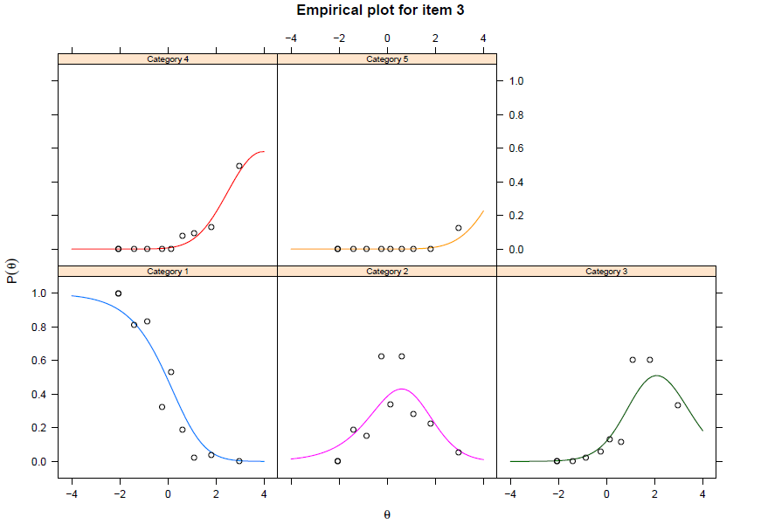
Empirical plot of item 3 of the Gaming Disorder Test (GDT)

Figure S2
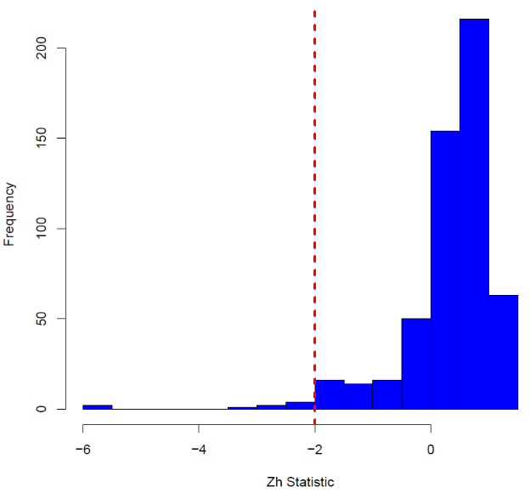
Histogram of person fit Z_{h} statistic (Drasgow et al., 1985)

