Supplementary table 1. Sociodemographic statistics
  Frequencies of Gender
  Levels |  | Counts |  | % of Total |  | Cumulative %
  Male |  | 924 |  | 80.4 % |  | 80.4 %
  Female |  | 225 |  | 19.6 % |  | 100.0 %
  Frequencies of Country
  Levels |  | Counts |  | % of Total |  | Cumulative %
  Albania |  | 1 |  | 0.1 % |  | 0.1 %
  Algeria |  | 1 |  | 0.1 % |  | 0.2 %
  Argentina |  | 1 |  | 0.1 % |  | 0.3 %
  Australia |  | 142 |  | 12.4 % |  | 12.6 %
  Austria |  | 5 |  | 0.4 % |  | 13.1 %
  Bangladesh |  | 1 |  | 0.1 % |  | 13.1 %
  Belgium |  | 7 |  | 0.6 % |  | 13.8 %
  Bosnia and Herzegovina |  | 1 |  | 0.1 % |  | 13.8 %
  Brazil |  | 7 |  | 0.6 % |  | 14.4 %
  Cambodia |  | 1 |  | 0.1 % |  | 14.5 %
  Canada |  | 80 |  | 7.0 % |  | 21.5 %
  Colombia |  | 2 |  | 0.2 % |  | 21.7 %
  Croatia |  | 2 |  | 0.2 % |  | 21.8 %
  Czech Republic |  | 2 |  | 0.2 % |  | 22.0 %
  Denmark |  | 7 |  | 0.6 % |  | 22.6 %
  Estonia |  | 1 |  | 0.1 % |  | 22.7 %
  Finland |  | 8 |  | 0.7 % |  | 23.4 %
  France |  | 8 |  | 0.7 % |  | 24.1 %
  Georgia |  | 1 |  | 0.1 % |  | 24.2 %
  Germany |  | 24 |  | 2.1 % |  | 26.3 %
  Greece |  | 1 |  | 0.1 % |  | 26.4 %
  India |  | 13 |  | 1.1 % |  | 27.5 %
  Indonesia |  | 3 |  | 0.3 % |  | 27.8 %
  Ireland |  | 9 |  | 0.8 % |  | 28.5 %
  Israel |  | 1 |  | 0.1 % |  | 28.6 %
  Italy |  | 4 |  | 0.3 % |  | 29.0 %
  Lebanon |  | 1 |  | 0.1 % |  | 29.1 %
  Lithuania |  | 2 |  | 0.2 % |  | 29.2 %
  Malaysia |  | 1 |  | 0.1 % |  | 29.3 %
  Malta |  | 1 |  | 0.1 % |  | 29.4 %
  Mexico |  | 3 |  | 0.3 % |  | 29.7 %
  Morocco |  | 1 |  | 0.1 % |  | 29.8 %
  Netherlands |  | 11 |  | 1.0 % |  | 30.7 %
  New Zealand |  | 13 |  | 1.1 % |  | 31.9 %
  Norway |  | 9 |  | 0.8 % |  | 32.6 %
  Pakistan |  | 2 |  | 0.2 % |  | 32.8 %
  Peru |  | 1 |  | 0.1 % |  | 32.9 %
  Philippines |  | 2 |  | 0.2 % |  | 33.1 %
  Poland |  | 2 |  | 0.2 % |  | 33.2 %
  Portugal |  | 6 |  | 0.5 % |  | 33.8 %
  Romania |  | 1 |  | 0.1 % |  | 33.9 %
  Russia |  | 1 |  | 0.1 % |  | 33.9 %
  Saudi Arabia |  | 2 |  | 0.2 % |  | 34.1 %
  Serbia |  | 2 |  | 0.2 % |  | 34.3 %
  Singapore |  | 3 |  | 0.3 % |  | 34.6 %
  Slovenia |  | 1 |  | 0.1 % |  | 34.6 %
  South Africa |  | 3 |  | 0.3 % |  | 34.9 %
  South Korea |  | 1 |  | 0.1 % |  | 35.0 %
  Spain |  | 3 |  | 0.3 % |  | 35.2 %
  Sri Lanka |  | 1 |  | 0.1 % |  | 35.3 %
  Sweden |  | 6 |  | 0.5 % |  | 35.9 %
  Switzerland |  | 2 |  | 0.2 % |  | 36.0 %
  Turkey |  | 2 |  | 0.2 % |  | 36.2 %
  United Arab Emirates |  | 1 |  | 0.1 % |  | 36.3 %
  United Kingdom |  | 117 |  | 10.2 % |  | 46.5 %
  United States |  | 613 |  | 53.4 % |  | 99.8 %
  Venezuela |  | 1 |  | 0.1 % |  | 99.9 %
  Zambia |  | 1 |  | 0.1 % |  | 100.0 %
Frequencies of Student
Levels |  | Counts |  | % of Total |  | Cumulative %
Yes |  | 526 |  | 45.8 % |  | 45.8 %
No |  | 623 |  | 54.2 % |  | 100.0 %

Frequencies of Education
Levels |  | Counts |  | % of Total |  | Cumulative %
Less than Year 10 |  | 11 |  | 1.0 % |  | 1.0 %
Completed Year 10 or equivalent |  | 33 |  | 2.9 % |  | 3.8 %
Completed Year 12 or equivalent |  | 343 |  | 29.9 % |  | 33.7 %
Completed tertiary certificate or diploma |  | 174 |  | 15.1 % |  | 48.8 %
University or college degree |  | 436 |  | 37.9 % |  | 86.8 %
Postgraduate degree (e g , Masters, PhD) |  | 152 |  | 13.2 % |  | 100.0 %

Frequencies of Religion
Levels |  | Counts |  | % of Total |  | Cumulative %
Agnosticism |  | 301 |  | 26.2 % |  | 26.2 %
Anglicanism |  | 9 |  | 0.8 % |  | 27.0 %
Atheism |  | 464 |  | 40.4 % |  | 67.4 %
Buddhism |  | 15 |  | 1.3 % |  | 68.7 %
Catholicism |  | 82 |  | 7.1 % |  | 75.8 %
Christianity |  | 149 |  | 13.0 % |  | 88.8 %
Hinduism |  | 14 |  | 1.2 % |  | 90.0 %
Islam |  | 16 |  | 1.4 % |  | 91.4 %
Judaism |  | 11 |  | 1.0 % |  | 92.3 %
Mormonism |  | 8 |  | 0.7 % |  | 93.0 %
Taoism |  | 4 |  | 0.3 % |  | 93.4 %
Other Religion |  | 76 |  | 6.6 % |  | 100.0 %

Frequencies of Sexual Preference
Levels |  | Counts |  | % of Total |  | Cumulative %
Straight (Heterosexual) |  | 814 |  | 70.8 % |  | 70.8 %
Gay/Lesbian |  | 109 |  | 9.5 % |  | 80.3 %
Bisexual |  | 183 |  | 15.9 % |  | 96.3 %
Other - Write In (Required) |  | 43 |  | 3.7 % |  | 100.0 %

Supplementary Table 2. Descriptive statistics
 |  | Gender |  | PHQ9 |  | GAD7 |  | PPUS
N |  | Male |  | 924 |  | 924 |  | 924
 |  | Female |  | 225 |  | 225 |  | 225
Missing |  | Male |  | 0 |  | 0 |  | 0
 |  | Female |  | 0 |  | 0 |  | 0
Mean |  | Male |  | 6.68 |  | 4.93 |  | 14.6
 |  | Female |  | 7.37 |  | 6.16 |  | 6.84
Median |  | Male |  | 5.00 |  | 3.00 |  | 11.0
 |  | Female |  | 5.00 |  | 4 |  | 4.00
Standard deviation |  | Male |  | 6.62 |  | 5.37 |  | 12.0
 |  | Female |  | 7.01 |  | 5.79 |  | 7.52
Minimum |  | Male |  | 0.00 |  | 0 |  | 0.00
 |  | Female |  | 0.00 |  | 0 |  | 0.00
Maximum |  | Male |  | 27.0 |  | 21 |  | 59.0
 |  | Female |  | 27.0 |  | 21 |  | 54.0
Skewness |  | Male |  | 1.18 |  | 1.29 |  | 1.20
 |  | Female |  | 1.11 |  | 0.986 |  | 2.58
Std. error skewness |  | Male |  | 0.0805 |  | 0.0805 |  | 0.0805
 |  | Female |  | 0.162 |  | 0.162 |  | 0.162
Kurtosis |  | Male |  | 0.633 |  | 0.942 |  | 1.01
 |  | Female |  | 0.326 |  | -0.0294 |  | 9.14
Std. error kurtosis |  | Male |  | 0.161 |  | 0.161 |  | 0.161
 |  | Female |  | 0.323 |  | 0.323 |  | 0.323

Supplementary Table 3. Possible combinations of within class variance-covariance structures specification from the least to the most restrictive model.
Model | Variances | Covariances | Interpretation
CVUP – Class varying unrestricted parametrization | Varying | Varying | All the indicators are allowed to co-vary within profiles, and the variances and covariances (i.e., residual correlations) are allowed to be different across profiles. In other words, this model assumes that there are relationships between PPUS items within and between latent profiles that should be estimated (i.e., varying covariances), and that different profiles will be qualitatively different (varying variances)
CIRP – Class invariant restricted parameterization | Equal | Equal | Indicators are allowed to co-vary within profiles, and the variances and covariances are restricted to be equal across different profiles. This model assumes that relationships between PPUS items should be the same across different profiles (equal covariances), and that different profiles will be qualitatively similar.
CVDP – Class varying diagonal parameterization | Varying | Zero | Covariances between indicators are fixed at zero (i.e., not estimated) and variances are allowed to be different across profiles. This model assumes that relationships between PPUS items should not be estimated (covariances fixed at zero), and that different profiles will be qualitatively different (varying variances).
CIDP – Class invariant diagonal parameterization | Equal | Zero | Covariances between indicators are fixed at zero and variances are restricted to be equal across different profiles. This model assumes that relationships between PPUS items should not be estimated (covariances fixed at zero) and that different profiles will be qualitatively different (equal variances.
Note = In this context, ‘diagonal’ indicates that the sum of elements in the variance-covariance matrix equals to zero, thus effectively preventing the model to estimate correlations between indicators.

Supplementary Figure 1. This scree plot illustrates how eigenvalues become smaller
as the number of components (or factors) increase.

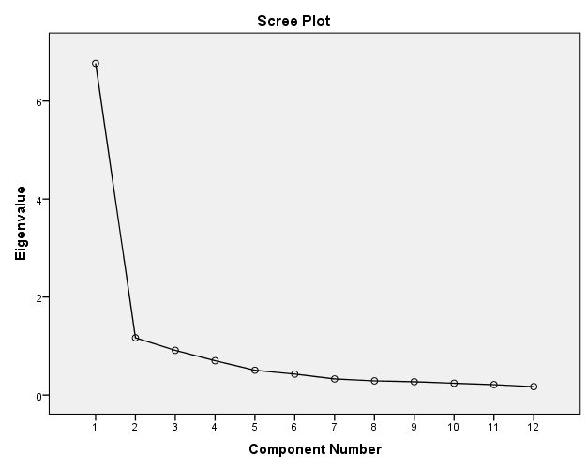

Supplementary Table 4. This table shows the % of explained variance by each component.
Component | Initial Eigenvalues |  |  | Extraction Sums of Squared Loadings |  |  | Rotation Sums of Squared Loadings
 | Total | % of Variance | Cumulative % | Total | % of Variance | Cumulative % | Total
1 | 6.769 | 56.406 | 56.406 | 6.769 | 56.406 | 56.406 | 5.512
2 | 1.168 | 9.734 | 66.140 | 1.168 | 9.734 | 66.140 | 4.913
3 | .912 | 7.596 | 73.736 | .912 | 7.596 | 73.736 | 3.214
4 | .701 | 5.842 | 79.578 | .701 | 5.842 | 79.578 | 4.016
5 | .505 | 4.211 | 83.789
6 | .428 | 3.566 | 87.356
7 | .329 | 2.740 | 90.096
8 | .290 | 2.415 | 92.511
9 | .272 | 2.263 | 94.774
10 | .242 | 2.014 | 96.788
11 | .213 | 1.775 | 98.563
12 | .172 | 1.437 | 100.000

Supplementary Table 5. This table shows the item loadings on each component
 | Component
 | 1 | 2 | 3 | 4
1. I often think about pornography | -.101 | -.052 | .925 | .050
2. I spend too much time being involved in thoughts about pornography | .359 | -.019 | .593 | .112
3. I spend too much time planning to use and using pornography | .475 | -.053 | .475 | -.009
4. I feel I cannot stop watching pornography | .819 | -.021 | .132 | -.043
5. I have been unsuccessful in my efforts to reduce or control the frequency I use pornography in my life | .866 | -.090 | -.016 | -.019
6. I keep on watching pornographic materials even though I intend to stop | .821 | -.051 | -.062 | .129
7. I use pornographic materials to escape my grief or to free myself from negative feelings | .017 | -.899 | .007 | .005
8. I watch pornographic materials when I am feeling despondent (i e , hopeless, low-spirited, downhearted) | -.041 | -.943 | -.009 | .045
9. I have used pornography while experiencing unpleasant or difficult feelings | .010 | -.925 | .003 | -.054
10. Using pornography has created significant problems in my personal relationships with other people, in social situations, at work or in other important aspects of my life | .199 | -.085 | .056 | .697
11. I risked or put in jeopardy a significant relationship, place of employment, educational or career opportunity because of the use of pornographic materials | -.077 | -.009 | .044 | .960
12. I continued using pornography despite the danger of harming myself physically (for example: difficulty getting an erection due to extensive use, difficulty reaching an orgasm in ways that do not include pornography) | .512 | -.062 | -.071 | .351

Supplementary Figure 2. Exploratory factorial structure and factor loadings with orthogonal rotation (left) and oblique rotation (right).

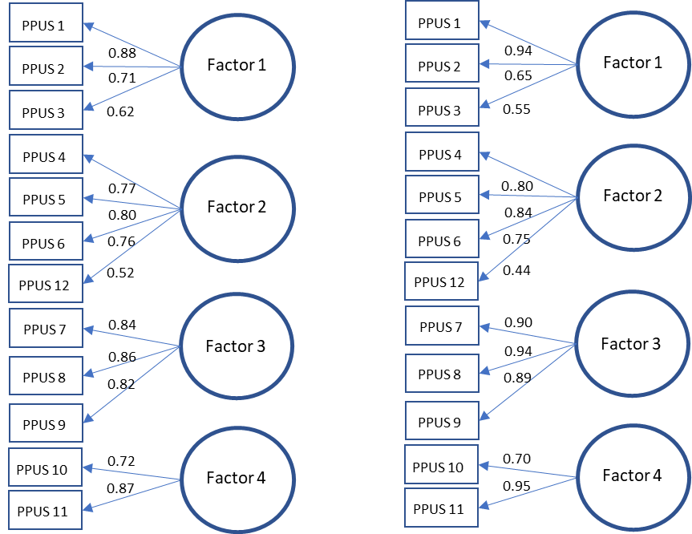

Supplementary Figure 3. This plot shows AIC, BIC and Entropy levels for CIRP models with 2 to 6 profiles
As seen here, CIRP models with 5 to 6 profiles show improved model errors (AIC, AWE, and BIC), with 5 profiles showing optimum values.

Supplementary Table 6. Multiple comparisons between latent profiles using Games-Howell post hoc.
(I) Class | (J) Class | Mean Difference (I-J) | Std. Error | Sig. | 95% Confidence Interval  Lower Bound Upper Bound
1 | 2 | 38.3763* | .82424 | .000 | 36.0366 | 40.7160
1 | 3 | 15.4962* | .92503 | .000 | 12.9067 | 18.0857
1 | 4 | 21.8472* | .97152 | .000 | 19.1384 | 24.5561
1 | 5 | 31.3290* | .85005 | .000 | 28.9272 | 33.7309
2 | 1 | -38.3763* | .82424 | .000 | -40.7160 | -36.0366
2 | 3 | -22.8801* | .45623 | .000 | -24.1427 | -21.6174
2 | 4 | -16.5291* | .54434 | .000 | -18.0345 | -15.0236
2 | 5 | -7.0472* | .27392 | .000 | -7.7978 | -6.2967
3 | 1 | -15.4962* | .92503 | .000 | -18.0857 | -12.9067
3 | 2 | 22.8801* | .45623 | .000 | 21.6174 | 24.1427
3 | 4 | 6.3510* | .68748 | .000 | 4.4603 | 8.2417
3 | 5 | 15.8328* | .50135 | .000 | 14.4511 | 17.2145
4 | 1 | -21.8472* | .97152 | .000 | -24.5561 | -19.1384
4 | 2 | 16.5291* | .54434 | .000 | 15.0236 | 18.0345
4 | 3 | -6.3510* | .68748 | .000 | -8.2417 | -4.4603
4 | 5 | 9.4818* | .58268 | .000 | 7.8753 | 11.0883
5 | 1 | -31.3290* | .85005 | .000 | -33.7309 | -28.9272
5 | 2 | 7.0472* | .27392 | .000 | 6.2967 | 7.7978
5 | 3 | -15.8328* | .50135 | .000 | -17.2145 | -14.4511
5 | 4 | -9.4818* | .58268 | .000 | -11.0883 | -7.8753

Supplementary Figure 4. Mean differences between at-risk users and the rest of the sample, with at-risk users scoring significantly higher in depression (left panel) and anxiety (right panel).

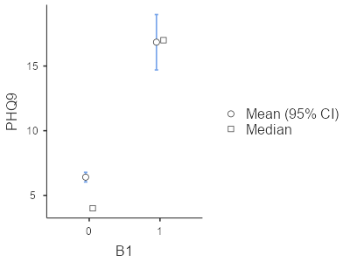 | 