Supplementary Materials
Table I: Degree of balance of outcome variables
 | % No |  | % Yes
Past month heroin use: Whether a person is likely to have used heroin in the past month at 1y, 5y, 10y post baseline
1-year post-baseline | 35.3 | 64.7
5-years post-baseline | 60.3 | 39.7
10-years post-baseline | 64.5 | 35.5
Overdose: Whether a person is likely to have overdosed up to 1, 5, or 10-years post-baseline
1-year post-baseline | 91.4 | 8.6
5-years post-baseline | 70.1 | 29.9
10-years post-baseline | 64.0 | 36.0
Mortality: Whether a person is likely to have died between baseline and 10 or 15-years post-baseline
10-years post-baseline | 92.7 | 7.3
15-years post-baseline | 87.2 | 12.9
Remission: Whether a person is likely to be in short-, medium- or long-term remission
Short-term: ≥3 and ≤1 year of continual abstinence from heroin use at 1, 5 or 10-years post-baseline
1-year post-baseline | 69.4 | 30.6
5-years post-baseline | 88.9 | 11.1
10-years post-baseline | 91.2 | 8.8
Medium-term: >1 year and ≤5 years of continual abstinence from heroin use
1-year post-baseline | 54.5 | 45.5
5-years post-baseline | 80.7 | 19.3
Long-term: >5 years continual abstinence from heroin use
10-years post-baseline | 64.7 | 35.3

Table II: Baseline cohort characteristics
Sociodemographic
Mean age (SD) | 29.3 (7.8)
% Australian born | 79.2
% Receiving government benefit as main source of income in past month | 45.7
% Past month criminal activity | 54.6
% Prison history | 40.8
% Male | 66.2
% Living in unstable accommodation† | 13.3
% Completed year 10 | 66.8
Psychopathology
% Antisocial personality disorder (ASPD) | 71.5
% Attempted suicide in past 12 months | 13.5
% Borderline personality disorder (BPD) | 45.5
% Experienced interpersonal trauma | 79.9
% Past month major depression | 24.6
% Post traumatic stress disorder (PTSD) | 41.1
% Severe mental health disability | 49.3
% Severe physical health disability | 8.6
% Experienced sexual trauma | 37.7
% Experienced trauma | 91.5
Drug use history
Overdosed in past 12 months | 24.1
Past month use of:
% Alcohol | 53.2
% Amphetamines | 29.6
% Antidepressants | 14.1
% Benzodiazepines | 47.8
% Cannabis | 68.1
% Cocaine | 40.0
% Hallucinogens | 9.4
% Other opiates | 29.4
% Tobacco | 95.9
% Polysubstance use‡ | 100.0
% Daily heroin use | 79.8
AOD Treatment history
% In detoxification | 32.7
% In methadone maintenance therapy | 32.7
% Not in treatment | 13.0
% In residential rehabilitation | 21.6
% Previous treatment | 88.9
†Unstable accommodation defined as living in boarding house/hostel, shelter/refuge, no fixed address/homeless; ‡Polysubstance use defined as the use of more than one class of drug (excluding antidepressants and tobacco)
Figures: AUC and ROC for each outcome
I: Past month heroin use
1-year: AUC = 0.78
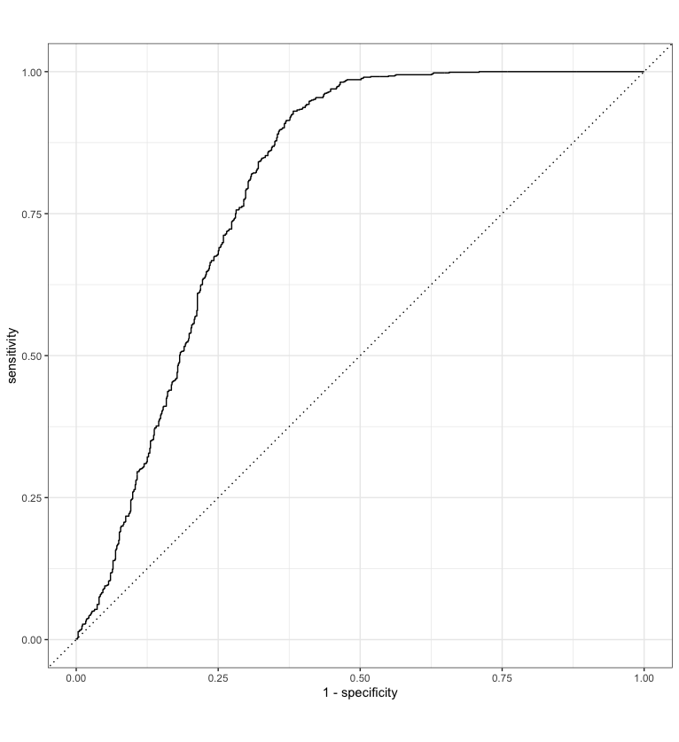
5-years: AUC = 0.80
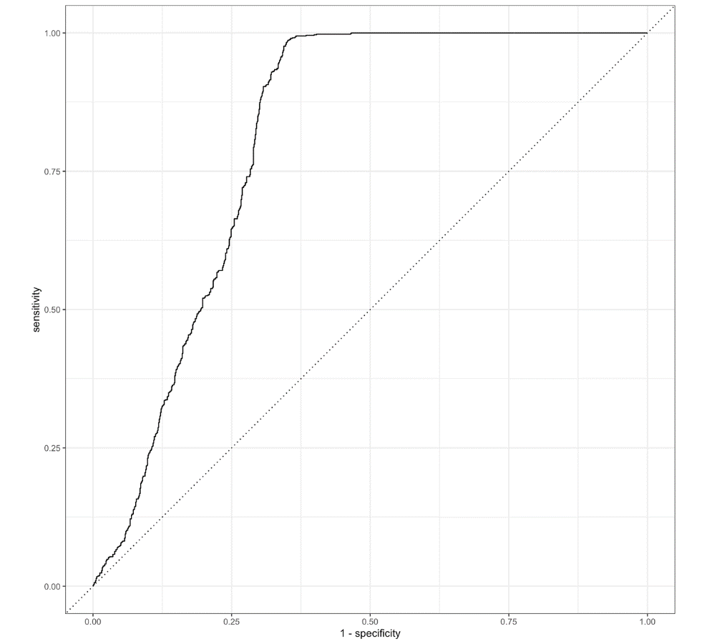
10-years: AUC = 0.84
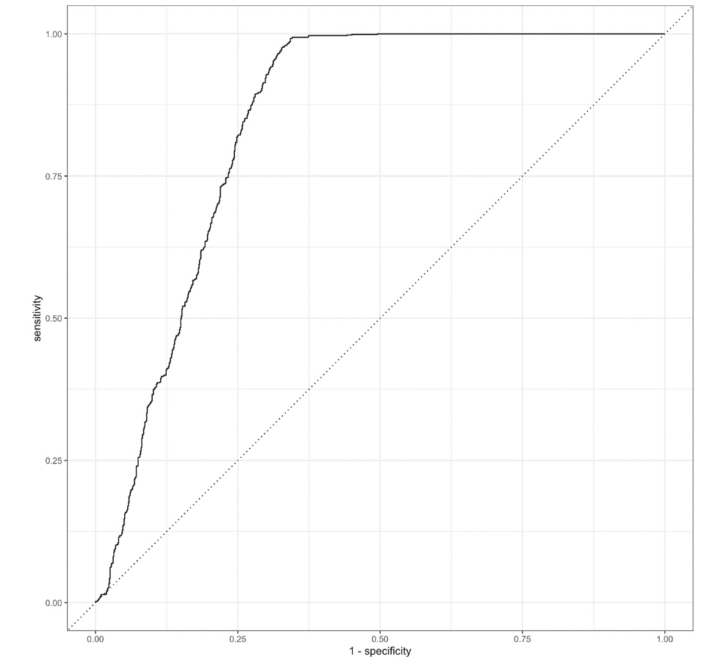
II: Overdose
1-year: AUC = 0.93
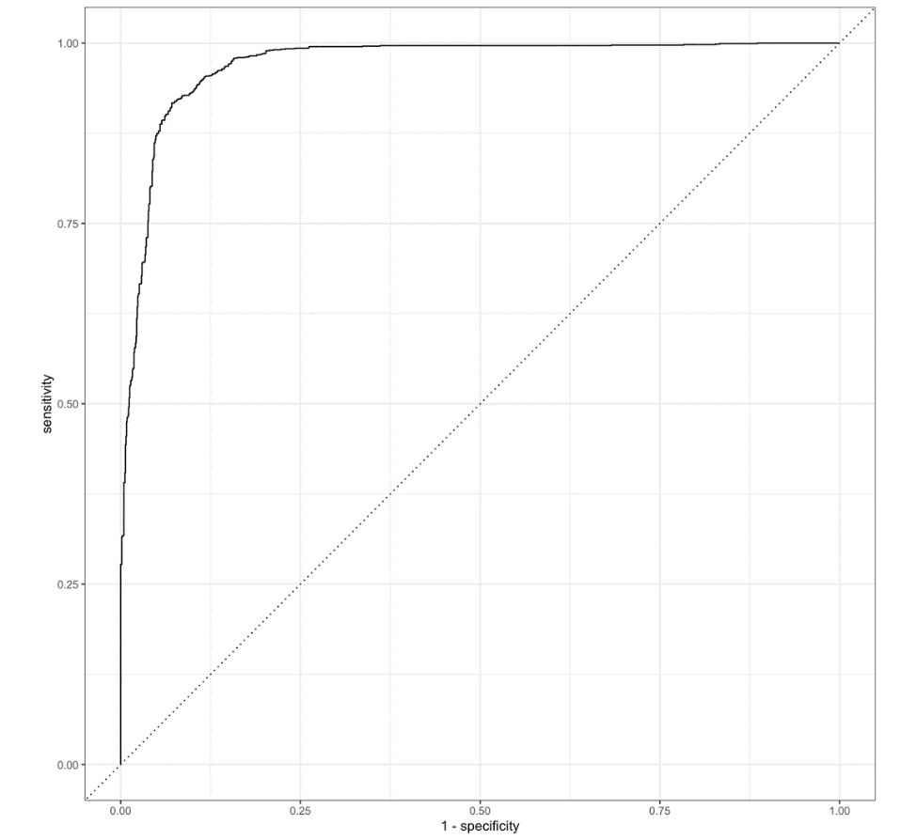

5-years: AUC = 0.89
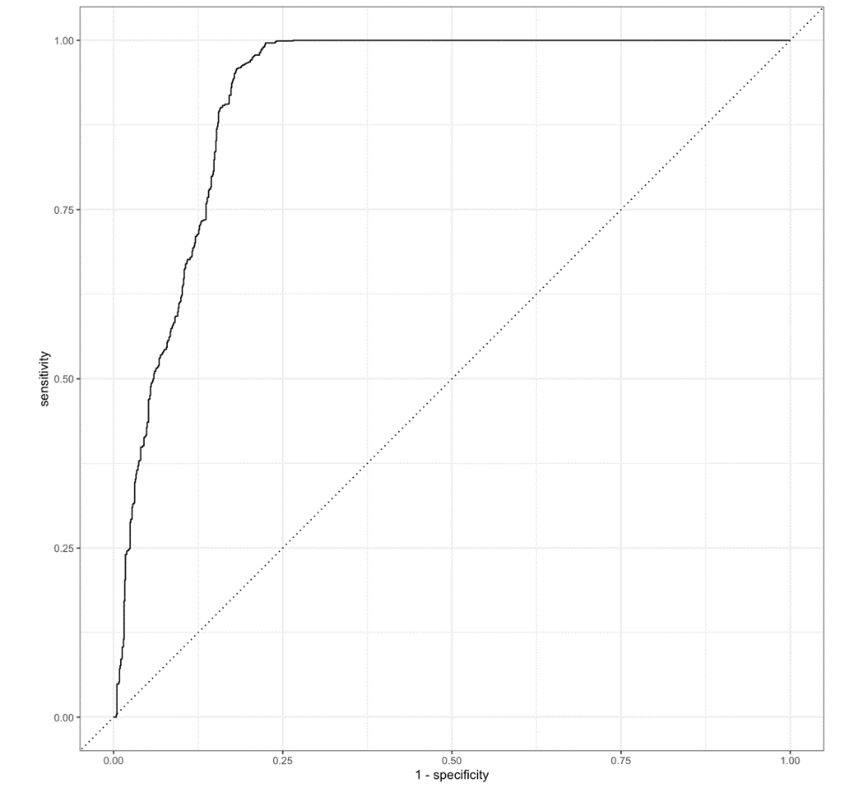
10-years: AUC = 0.82
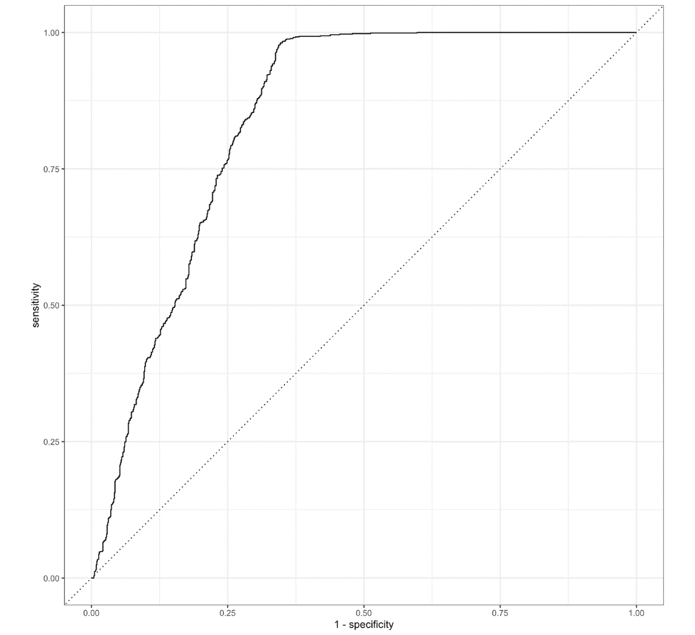

III: Mortality
10-years: AUC = 0.89
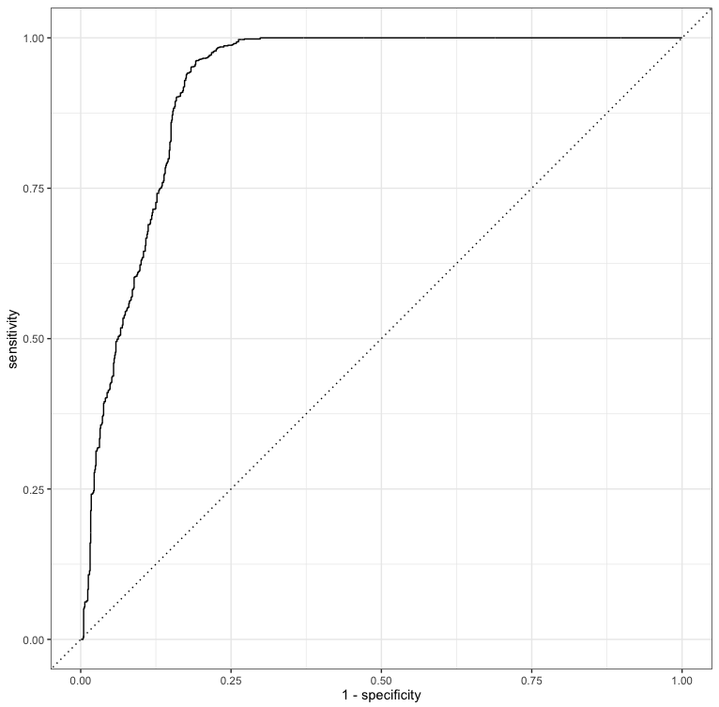
15-years: AUC = 0.87
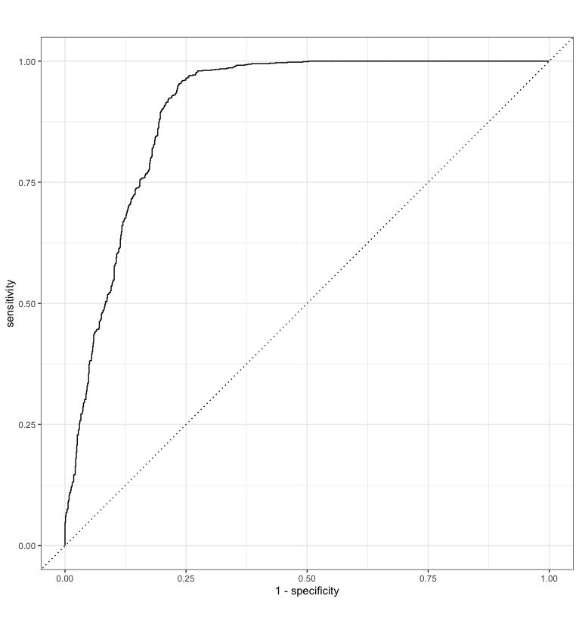

IV: Remission
Short-term remission
1-year: AUC = 0.81
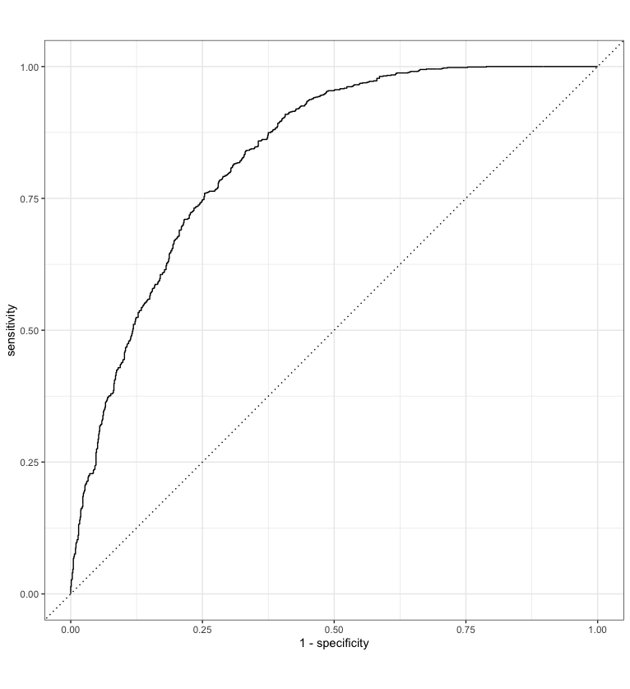
5-years: AUC = 0.85
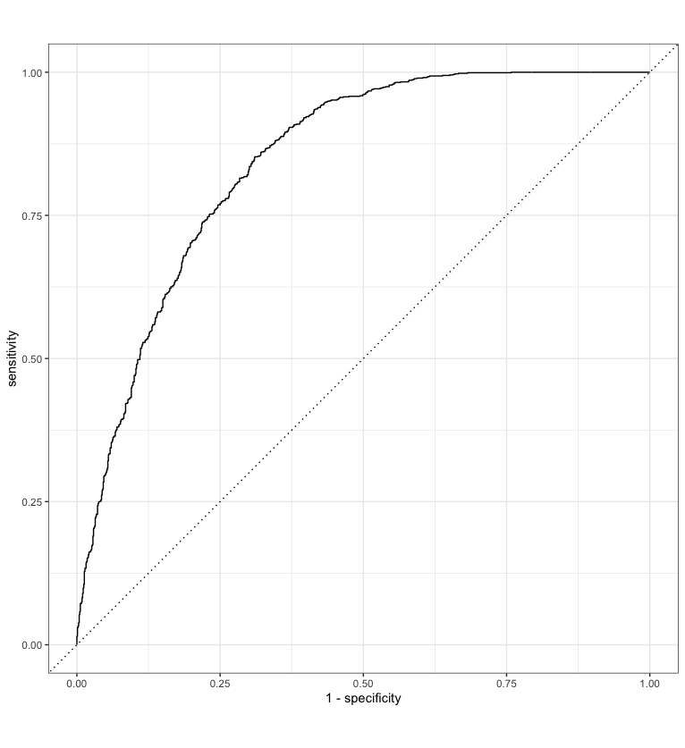
10-years: AUC = 0.90
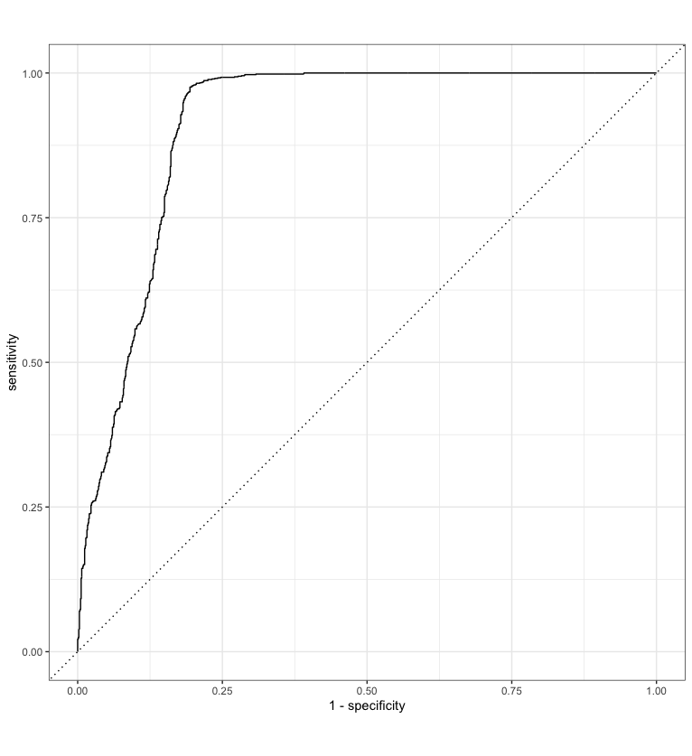
Medium-term remission
5-years: AUC = 0.75
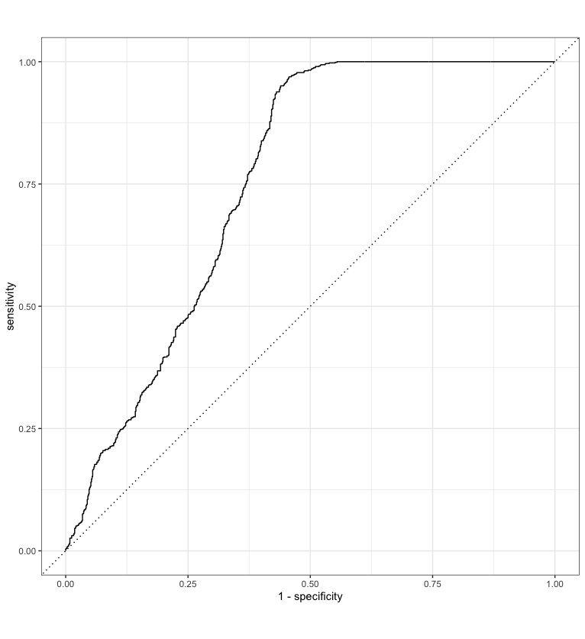

10-years: AUC = 0.82
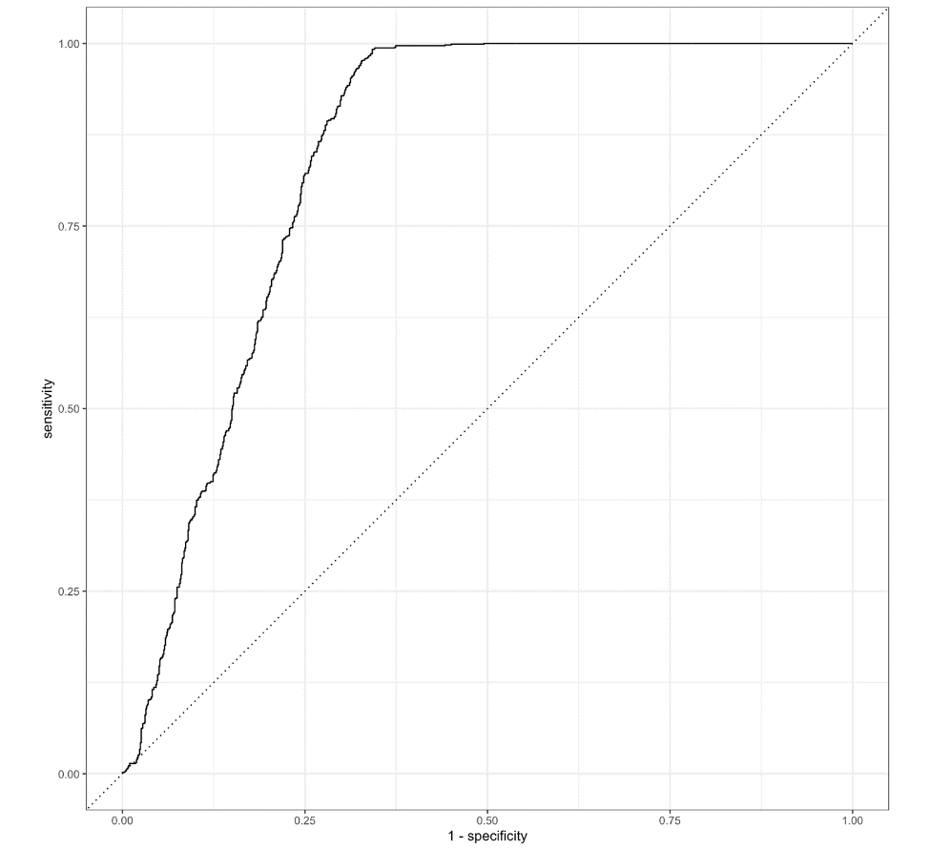
Long-term remission
10-years: AUC = 0.80
