Supplementary materials
Supplementary Table 1. Associations between sex, age, parental education, household composition and family origin with generalized anxiety symptom and heavy episodic drinking (HED).
Control variable | Generalized anxiety GAD-7 (mean (SD)) | p value for the ANOVA test | No HED (%) | HED (%)) | p value for the chi-square test
Sex |  | <0.001 |  |  | <0.001
Females | 6.12 (5.30) |  | 52.8 | 48.2
Males | 2.65 (3.82) |  | 47.2 | 51.8
Age |  | <0.001 |  |  | <0.001
13-15 | 4.36 (5.02) |  | 46.6 | 24.5
16-17 | 4.47 (4.90) |  | 45.3 | 55.4
18-20 | 4.78 (5.00) |  | 8.1 | 20.1
Parental education |  | 0.061 |  |  | <0.001
High | 4.47 (4.91) |  | 52.9 | 47.7
Low | 4.45 (4.99) |  | 47.1 | 52.3
Household composition |  | <0.001 |  |  | <0.001
Living with both parents | 4.13 (4.75) |  | 68.3 | 55.8
Other | 5.10 (5.28) |  | 31.7 | 44.2
Family origin |  | <0.001 |  |  | <0.001
Finnish origin | 4.37 (4.88) |  | 88.2 | 88.2
One parent of foreign origin | 5.20 (5.30) |  | 6.8 | 6.9
Foreign origin, born in Finland | 4.91 (5.34) |  | 2.0 | 1.2
Foreign origin, not born in Finland | 5.19 (5.73) |  | 3.0 | 3.7

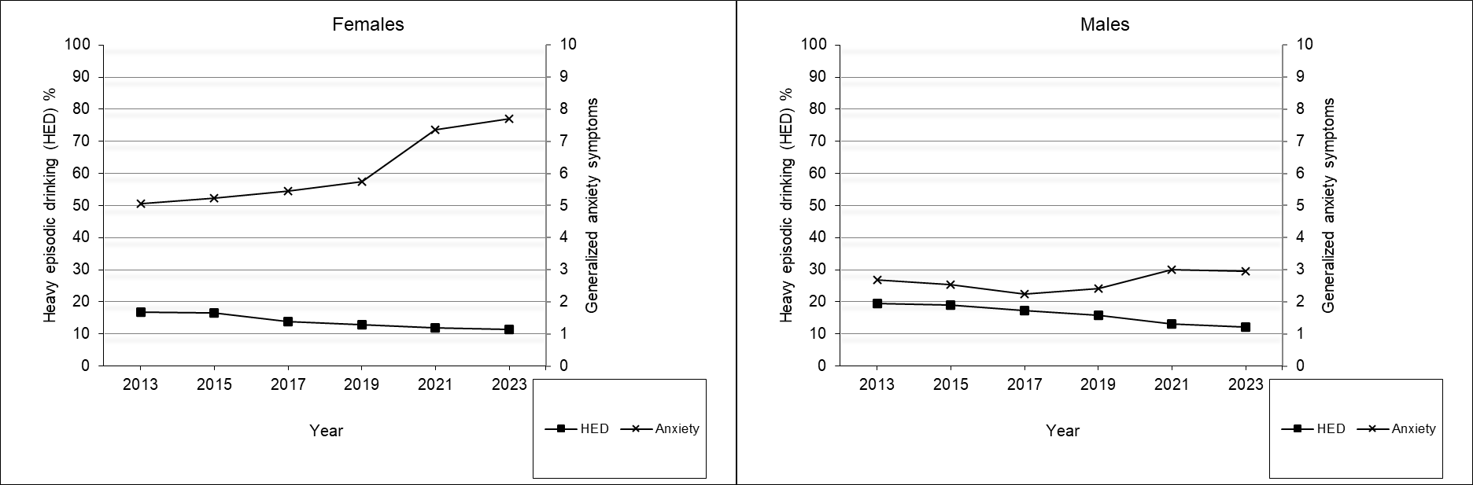
Supplementary Figure 1. Prevalence of heavy episodic drinking (HED) (left axis) and mean generalized anxiety symptoms (GAD-7) (right axis) by sex.
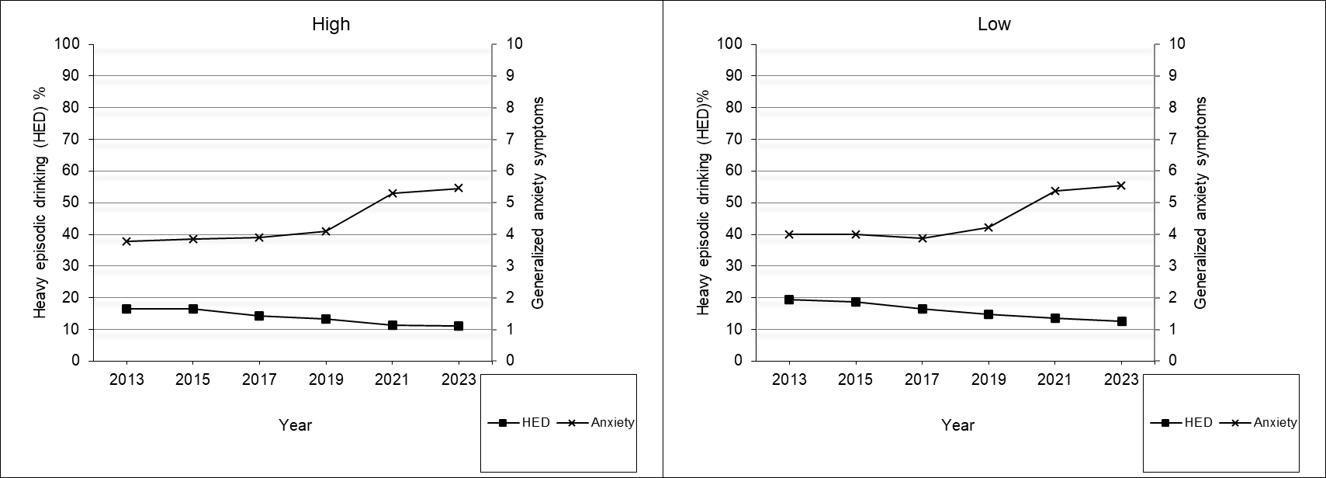
Supplementary Figure 2. Prevalence of heavy episodic drinking (HED) (left axis) and mean generalized anxiety symptoms (GAD-7) (right axis) by parental education.
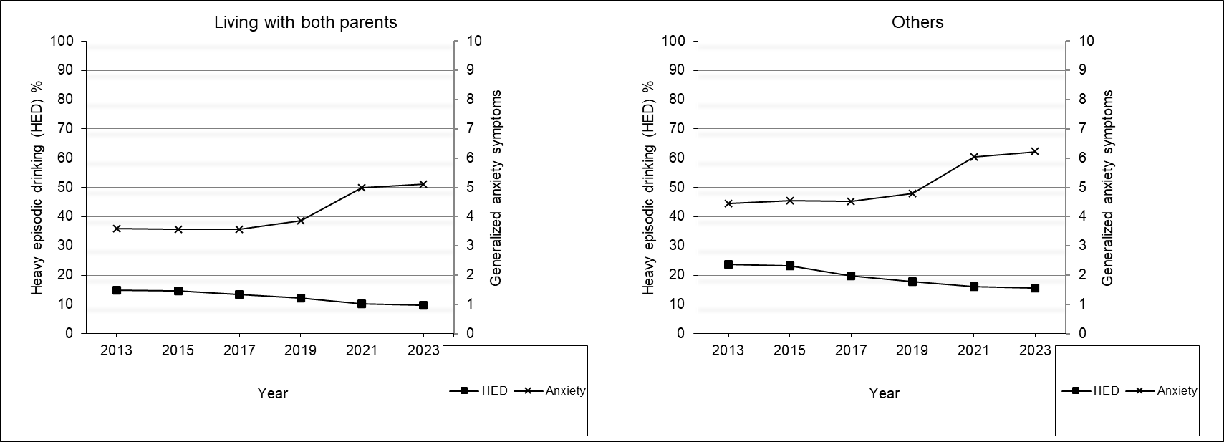
Supplementary Figure 3. Prevalence of heavy episodic drinking (HED) (left axis) and mean generalized anxiety symptoms (GAD-7) (right axis) by household composition.
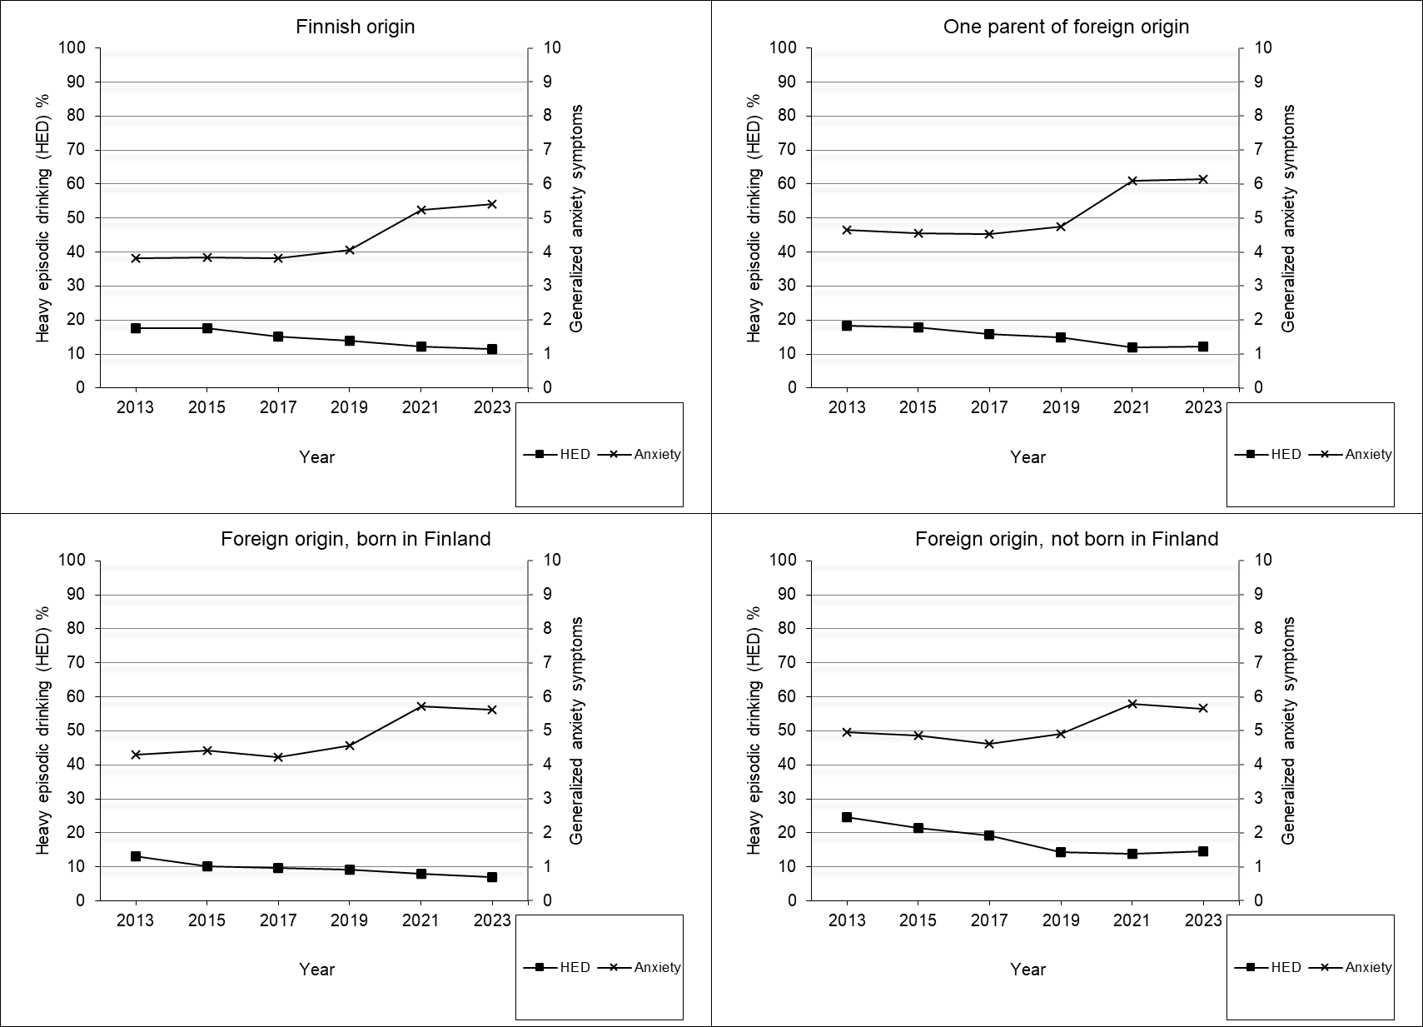
Supplementary Figure 4. Prevalence of heavy episodic drinking (HED) (left axis) and mean generalized anxiety symptoms (GAD-7) (right axis) by origin.
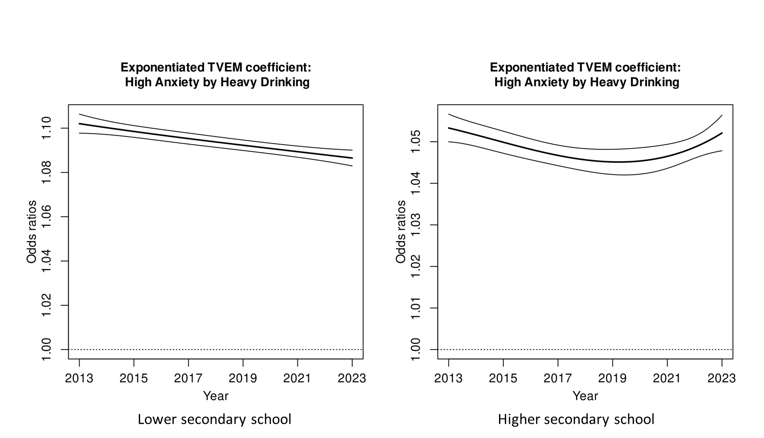
Supplementary Figure 5. Time-varying associations by school level between generalized anxiety symptoms and heavy episodic drinking (HED) in 2013-2023. The gray lines indicate 95% confidence intervals.
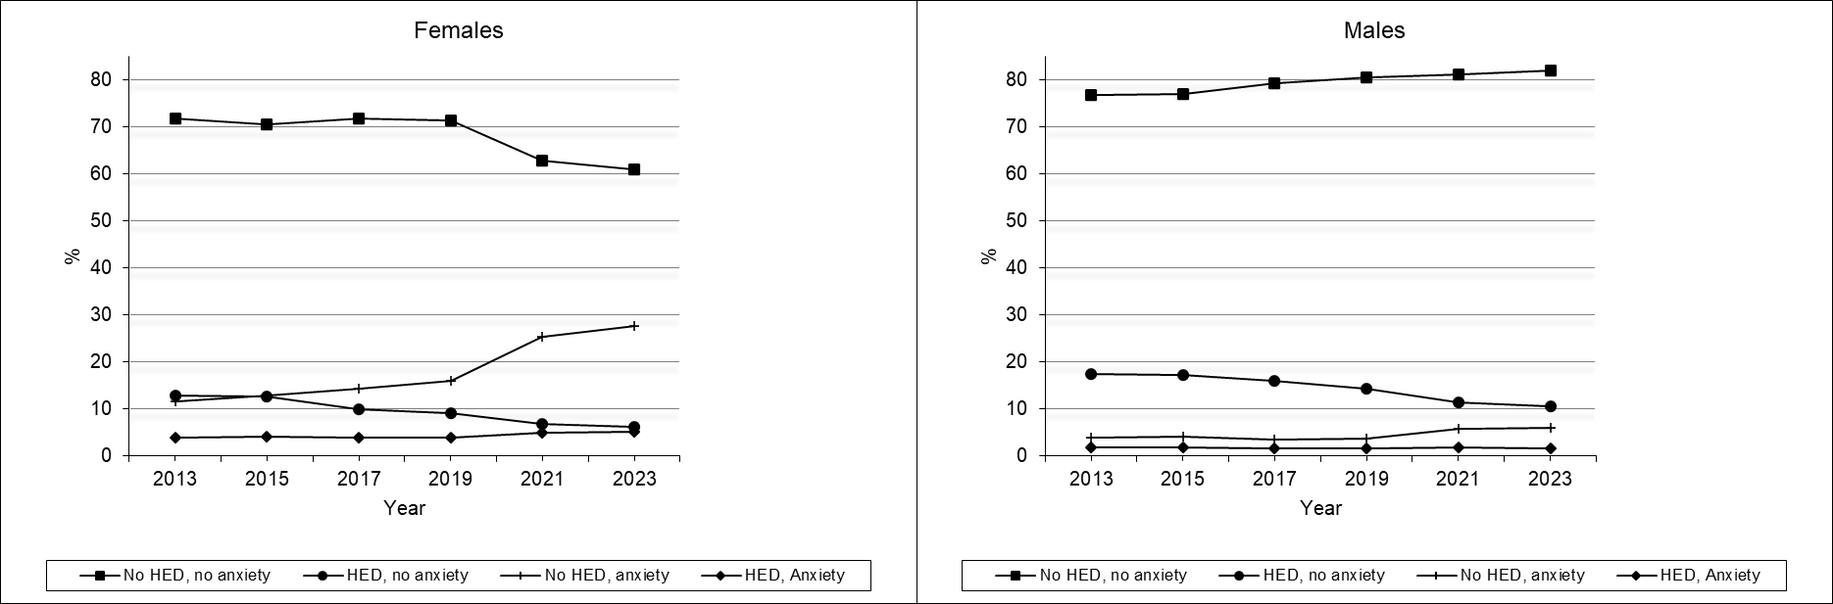
Supplementary Figure 6. Prevalence of co-occurrence of heavy episodic drinking (HED) and generalized anxiety (GAD-7 >10) by sex.
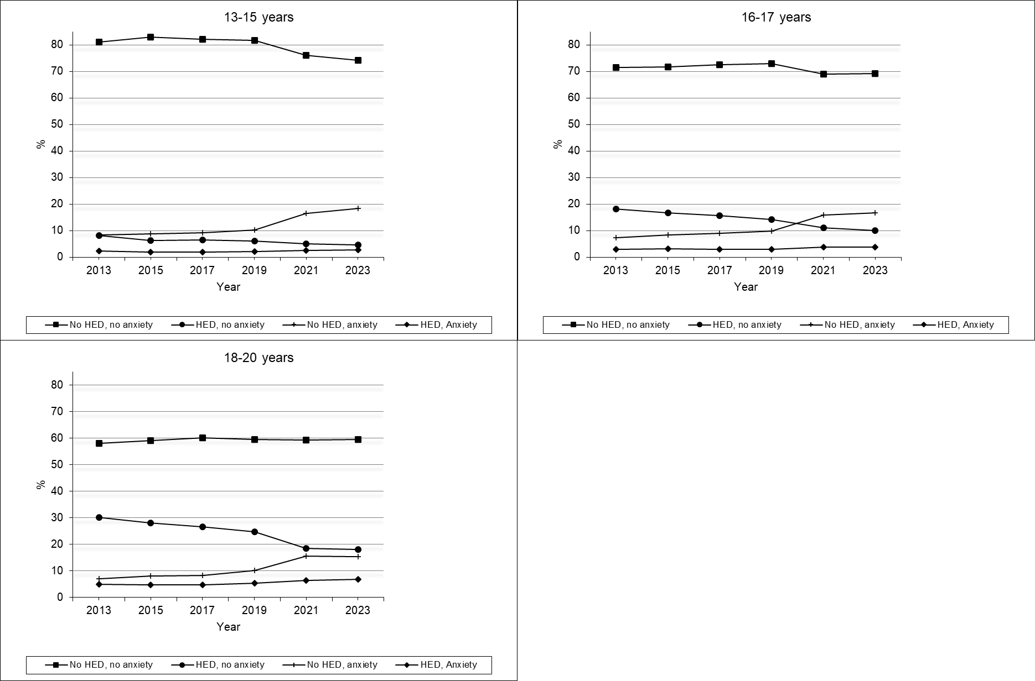
Supplementary Figure 7. Prevalence of co-occurrence of heavy episodic drinking (HED) and generalized anxiety by age.

Supplementary Table 2. Effects of Generalized anxiety (GAD-7) on heavy episodic drinking (HED) by study year, sex and school level from logistic regression models.
 | 2013 | 2015 | 2017 | 2019 | 2021 | 2023
 | OR (95% CI) | OR (95% CI) | OR (95% CI) | OR (95% CI) | OR (95% CI) | OR (95% CI)
Sexª
Females
GAD-7 | 1.070 (1.066-1.074)* | 1.057 (1.053-1.062)* | 1.068 (1.064-1.073) | 1.069 (1.065-1.074) | 1.059 (1.055-1.063) | 1.064 (1.060-1.069)
Males
GAD-7 | 1.072 (1.067-1.077) | 1.054 (1.048-1.060)*** | 1.062 (1.056-1.068) | 1.076 (1.070-1.081) | 1.063 (1.057-1.068) | 1.068 (1.063-1.074)
School level^{b}
Lower secondary
GAD-7 | 1.102 (1.097-1.106)*** | 1.090 (1.083-1.096) | 1.096 (1.090-1.101)* | 1.102 (1.097-1.107)*** | 1.088 (1.083-1.093) | 1.089 (1.084-1.094)
Upper secondary
GAD-7 | 1.052 (1.048-1.056) | 1.046 (1.042-1.050)* | 1.049 (1.044-1.054)* | 1.055 (1.050-1.059) | 1.042 (1.038-1.046)*** | 1.052 (1.047-1.056)
ªModels adjusted for age group, parental education, household composition, and family origin.
^{b} Models adjusted for sex, parental education, household composition, and family origin.
*/**/***The effect is significantly different from the corresponding effect in 2023 (using year × anxiety variable interaction terms in the sample), * p < 0.05, ** p < 0.01, *** p < 0.001

