SUPPLEMENTARY MATERIALS
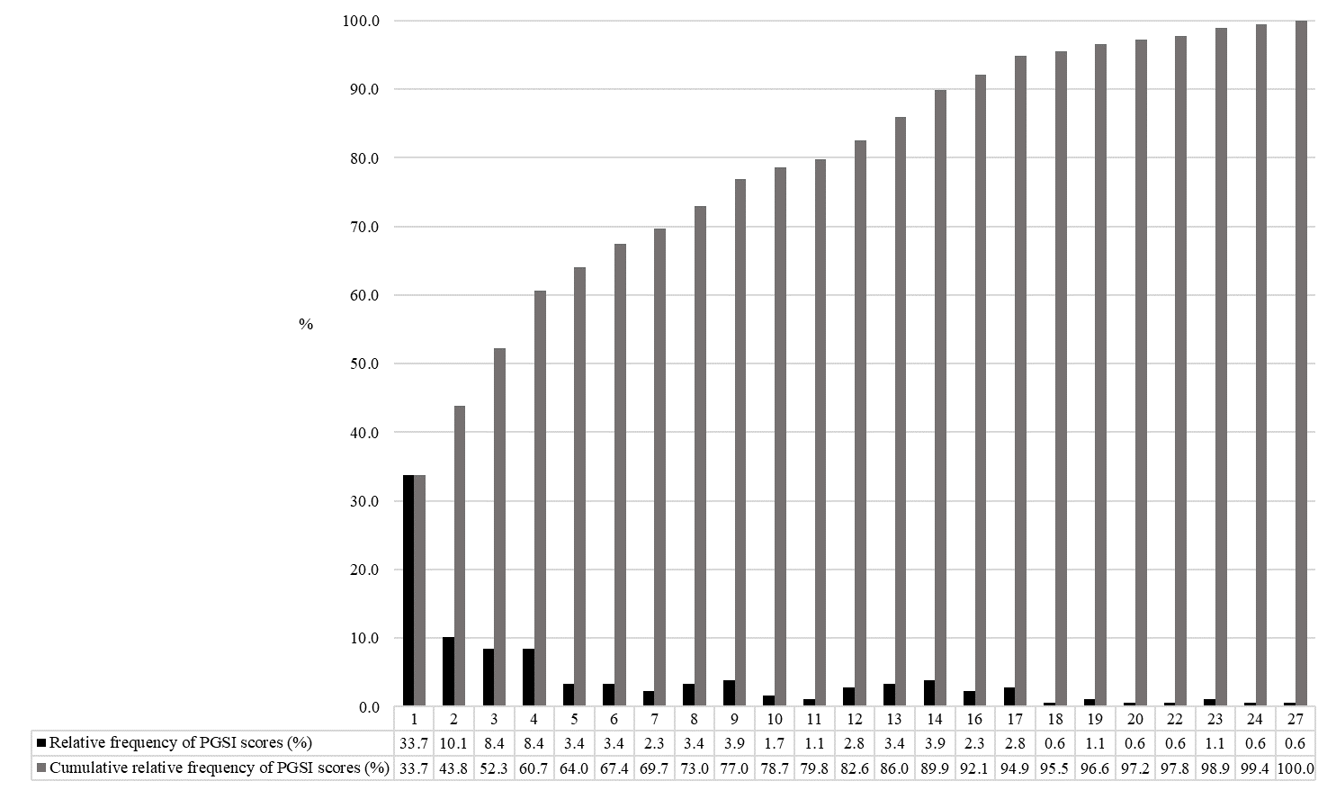
Supplementary figure 1. Relative frequency and cumulative relative frequency of Problem Gambling Severity Index (PGSI) scores in 1,060 Italian recent gamblers (gambling in the previous 12 months) aged 18 or over. Italy, 2022-2023.

Supplementary figure 2. Distribution (%) of self-reported problem gambling behaviors and negative consequences as assessed by the Problem Gambling Severity Index (PGSI) among 1,060 Italian recent gamblers (gambling in the previous 12 months) aged ≥ 18. Italy, 2022-2023.
