Supplementary material

Evolution of the risk of problematic alcohol use in university students: a longitudinal study based on the uniHcos cohort data

Table 5. Comparison of sample characteristics at Baseline (T1) of only baseline participants and baseline and follow-up participants. Data from a longitudinal analysis of a sample of Spanish University Students
 | Only Baseline Participants |  |  | Baseline and follow-up participants
 | n=9,702) | % | 95%CI | n=1181 |  | % |  | 95%CI |  | p-value^{(b)}
Sociodemographics (T1)
Age (Mean/SD) | 19.0 (1.6) | - | - |  | 18.8 (1.5) |  | - |  | - |  | <0.001
Sex
Male | 2627 | 27.1 | 26.2-27.0 |  | 275 |  | 23.3 |  | 20.9-25.8 |  | <0.001
Female | 7075 | 72.9 | 72.0-73.0 |  | 906 |  | 76.7 |  | 74.2-79.0
Co-Habitants
Parents/Family | 4376 | 45.1 | 44.1-46.1 |  | 556 |  | 47.1 |  | 44.2-49.9 |  | 0.124
Roommates/Friends | 4197 | 43.2 | 42.2-44.2 |  | 491 |  | 41.6 |  | 38.8-44.4
Alone | 789 | 8.1 | 7.6-8.7 |  | 105 |  | 6.9 |  | 7.4-10.7
Partner | 340 | 3.5 | 3.2-3.9 |  | 29 |  | 2.5 |  | 1.7-3.5
Field of knowledge^{(a)}
Social sciences | 3935 | 40.6 | 39.6-41.6 |  | 424 |  | 35.9 |  | 33.2-36.7 |  | <0.001
Health sciences | 2023 | 20.9 | 20.1-21.7 |  | 364 |  | 30.8 |  | 28.2-33.5
Science | 1545 | 16.0 | 15.2-16.7 |  | 161 |  | 13.6 |  | 11.8-15.7
Engineering and architecture | 975 | 10.1 | 9.5-10.7 |  | 118 |  | 9.9 |  | 8.4-11.8
Art and humanities | 1215 | 12.5 | 11.8-13.2 |  | 114 |  | 9.6 |  | 8.1-11.5
Footnote: ^{(a)}The Field of knowledge variable presented 9 missing values (<0.1% of the total). Given the low percentage, it was decided to exclude these cases only in the specific analyses involving this variable. ^{(b)}p-value for Pearson’s chi square test in categorical variables and Mann-Whitney U test for continuous variables (age)

Table 6. Prevalence in the baseline (T1) and follow-up (T2), incidence and persistence of the moderate-high risk of problematic alcohol use, with same cut-off points of AUDIT
 | Moderate-high risk of problematic alcohol use (AUDIT)
 |  | n | Reference group (n) | % | 95%CI | p-value^{(a)}
Prevalence
Baseline (T1) |  | 230 | 1181 | 19.5 | 17.3-21.8 | 0.764
Follow- up (T2) |  | 235 | 1181 | 19.8 | 17.7-22.3 | 0.764
Incidence |  | 122 | 951 | 12.8 | 10.8-15.1 | -
Persistence |  | 113 | 230 | 49.1 | 42.7-55.6 | -
Footnote. Moderate- high risk of problematic alcohol use was considered if AUDIT score was ≥ 8 points for both sexes (positive AUDIT). Prevalence T1: positive AUDIT in T1 among total sample (n=1181); Prevalence T2: positive AUDIT in T2 among total sample (n=1181); Incidence: positive AUDIT in T2 among those with negative with negative AUDIT in T1 (n=951); Persistence: positive AUDIT in T2 among those with Positive AUDIT in T1 (n=230). Abbreviations: AUDIT Alcohol Use Disorder Identification Test, CI Confidence Interval, T1 baseline data, T2 follow-up data. ^{(a)}p-value data for McNemar’s test for paired data.

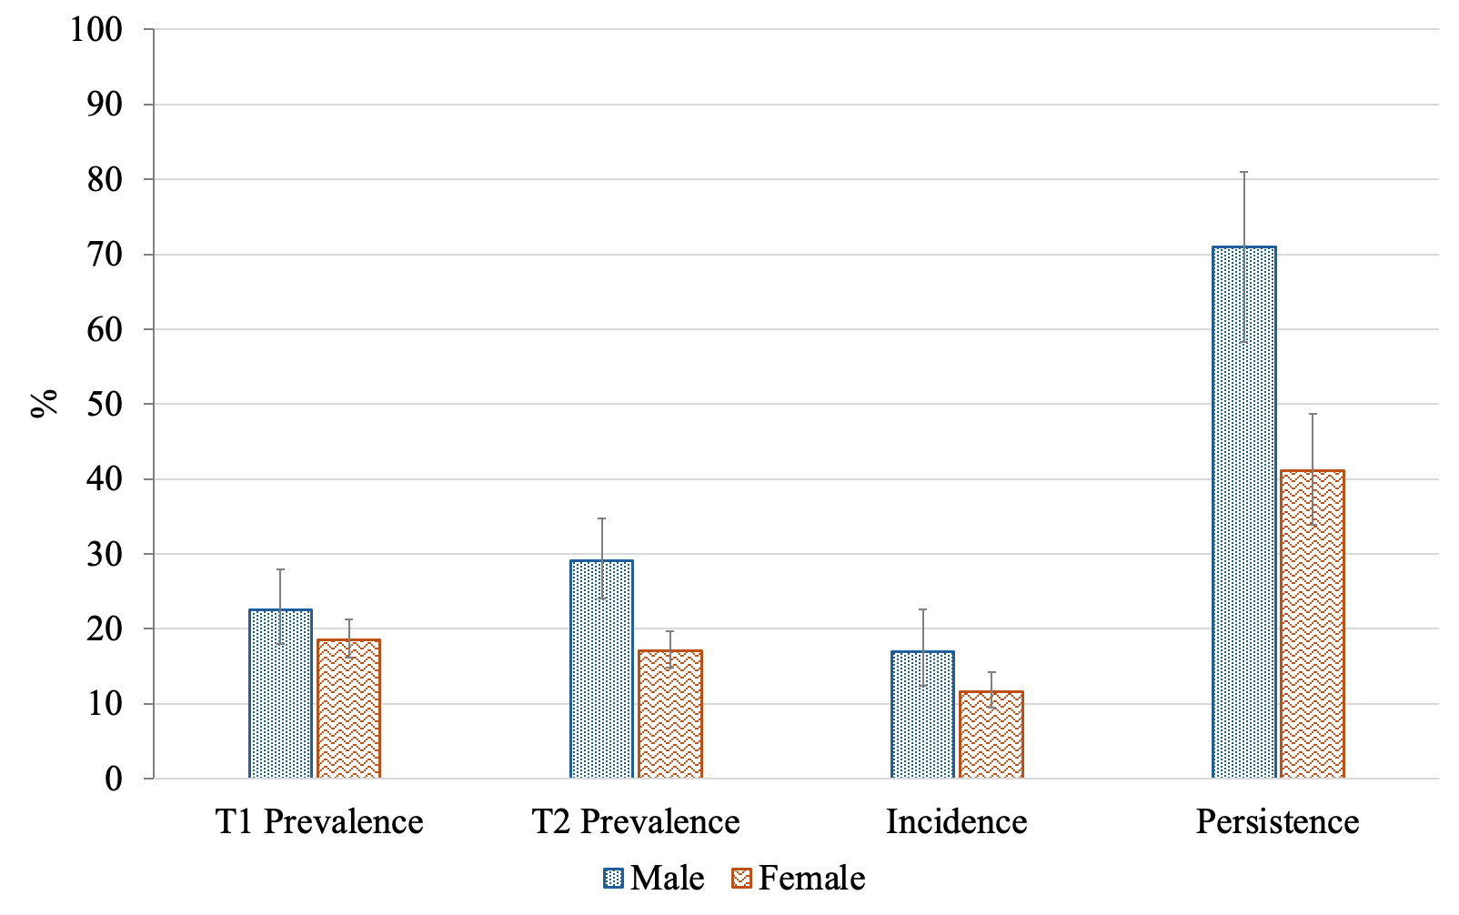

Figure 3. Prevalence in T1 and T2, incidence and persistence of risk of problematic alcohol use (AUDIT score ≥ 8 points) in Spanish university students, by sex. T1: baseline data (first-year of university), T2: follow-up data, (2-3 years after baseline), Prevalence T1: positive AUDIT in T1 among total sample (n=1181); Prevalence T2: positive AUDIT in T2 among total sample (n=1181); Incidence: positive AUDIT in T2 among those with negative with negative AUDIT in T1 (n=951); Persistence: positive AUDIT in T2 among those with Positive AUDIT in T1 (n=230). *shows statistically significant differences (p-value<0.05) by sex for chi-square test

Table 7. Multivariable associations of risk factors under study with prevalence, incidence and persistence of risk of problematic alcohol use at 2-3 years follow-up in Spanish university students. With the same cut-off point in AUDIT for males and females (≥8)
 | Prevalence (T2) |  |  | Incidence |  |  |  | Persistence
 | aOR | 95%CI | p-value | aOR | 95%CI | p-value |  | aOR | 95%CI |  | p-value
T1 variables
Sex (ref=female) | 2.02 | 1.47-2.78 | <0.001 | 1.52 | 0.99-2.33 | 0.056 |  | 2.35 | 1.54-3.59 |  | <0.001
Age (ref=17 yo) | 0.93 | 0.85-1.04 | 0.228 | 0.89 | 0.77-1.04 | 0.137 |  | 0.98 | 0.86-1.13 |  | 0.835
Co-habitants (ref=family) | 2.18 | 1.60-2.96 | <0.001 | 1.87 | 1.26-2.77 | 0.002 |  | 2.93 | 1.88-4.55 |  | <0.001
Positive screening in:
GHQ12 test | 1.53 | 1.13-2.06 | 0.005 | 1.51 | 1.02-2.23 | 0.039 |  | 1.77 | 1.17-2.68 |  | 0.007
APGAR test
Low dysfunctional | 0.99 | 0.68-1.46 | 0.985 | 1.15 | 0.70-1.88 | 0.590 |  | 0.92 | 0.54-1.60 |  | 0.777
Severe dysfunctional | 1.68 | 0.99-2.86 | 0.054 | 1.63 | 0.83-3.19 | 0.157 |  | 1.55 | 0.74-3.22 |  | 0.243
Relative with AUD | 0.85 | 0.49-1.46 | 0.549 | 0.82 | 0.39-1.70 | 0.597 |  | 0.84 | 0.40-1.76 |  | 0.643
Substance use
Binge drinking | 5.58 | 3.98-7.85 | <0.001 | 3.41 | 2.28-5.10 | <0.001 |  | 34.68 |  | 15.75-76.36 |  | <0.001
Smoker | 3.21 | 2.31-4.47 | <0.001 | 2.78 | 1.77-4.38 | <0.001 |  | 6.29 | 4.00-9.92 |  |  | <0.001
Number of other substances
tried ever in life (ref=0)
1 | 4.20 | 3.04-5.79 | <0.001 | 3.78 | 2.52-5.69 | <0.001 |  | 7.82 | 4.82-12.71 |  |  | <0.001
≥2 | 12.13 | 5.23-28.12 | <0.001 | 6.66 | 1.58-28.13 | 0.010 | 42.49 |  | 14.25-126.70 |  |  | <0.001
Footnote. Multivariable logistic models adjusted by: Sex, Age, university, field of knowledge and coliving (0.family or 1.roommates/friends/other) (basal variables (T1). Problematic alcohol use defined as: score ≥8 in AUDIT. Prevalence T1: positive AUDIT in T1 among total sample (n=1181); Prevalence T2: positive AUDIT in T2 among total sample (n=1181); Incidence: positive AUDIT in T2 among those with negative with negative AUDIT in T1 (n=951); Persistence: positive AUDIT in T2 among those with Positive AUDIT in T1 (n=230); reference category (0): Prevalence: negative screening in AUDIT T2, Incidence and Persistence: negative screening in AUDIT T1 and T2. GHQ-12 positive screening was considered as 3 or more points assessed with a 2-point scoring method, assigning 0 points to answers 0 and 1, and 1 point to answers 2 and 3. APGAR was measured as: 7–10 points, normal support; 3–6 points, slightly dysfunctional; and 0–2 points, severely dysfunctional. Abbreviations: AUD Alcohol Use Disorder, AUDIT Alcohol Use Disorder Identification Test, GHQ-12 General Health Questionnaire, APGAR Adaptability, Partnership, Growth, Affection, and Resolve, aOR adjusted Odds Ratio, T1 baseline data, T2 follow-up data.

