Supplementary materials
Table S1. Network descriptive information of depressive and Internet addiction symptoms
Figure S1. Bootstrapped confidence intervals of edge weights
Figure S2. Estimation of edge weight difference by bootstrapped difference test
Figure S3. Estimation of node expected influence difference by bootstrapped difference test

Table S1. Network descriptive information of depressive and Internet addiction symptoms
Item Abbreviation | Item Content | Mean (SD) | EI* | Predictability
IAT1 | Stay online longer than you intend | 2.91(1.22) | 0.71 | 0.51
IAT2 | Neglect chores to spend more time online | 2.56(1.14) | 1.06 | 0.61
IAT3 | Prefer the excitement online to the time with others | 2.03(1.05) | 0.76 | 0.48
IAT4 | Form new relationships with online users | 1.76(0.95) | 0.48 | 0.21
IAT5 | Others complain about your time spent online | 2.19(1.05) | 0.66 | 0.43
IAT6 | School grades suffer due to internet use | 2.29(1.06) | 1.00 | 0.58
IAT7 | Check email/SNS before doing things you need to do | 1.76(0.96) | 0.74 | 0.44
IAT8 | Job performance or productivity suffer | 1.92(1.00) | 1.04 | 0.61
IAT9 | Become defensive/secretive about the internet use | 2.42(1.17) | 0.56 | 0.33
IAT10 | Soothe disturbing thoughts using the Internet | 2.33(1.17) | 0.66 | 0.48
IAT11 | Anticipation for future online activities | 2.05(1.11) | 0.96 | 0.58
IAT12 | Life boring and empty without the Internet | 2.27(1.16) | 0.97 | 0.56
IAT13 | Snap or act annoyed if bothered while being online | 1.69(0.91) | 0.90 | 0.53
IAT14 | Sleep loss | 2.05(1.09) | 0.78 | 0.54
IAT15 | Preoccupation with the Internet | 2.04(1.01) | 0.99 | 0.61
IAT16 | Request an extension for longer time spent online | 2.34(1.16) | 1.05 | 0.65
IAT17 | Failure to cut down the time spent online | 2.10(1.08) | 0.99 | 0.63
IAT18 | Conceal the amount of time spent online | 1.70(0.95) | 0.78 | 0.49
IAT19 | Spend more time online over going out with others | 1.74(0.96) | 1.03 | 0.59
IAT20 | Depressed/moody/nervous only while being offline | 1.61(0.89) | 1.02 | 0.58
PHQ1 | Little interest or pleasure in doing things | 0.78(0.78) | 0.84 | 0.52
PHQ2 | Feeling down, depressed, or hopeless | 0.71(0.71) | 0.95 | 0.55
PHQ3 | Trouble falling or staying asleep, or sleeping too much | 0.71(0.83) | 0.67 | 0.40
PHQ4 | Feeling tired or having little energy | 0.84(0.80) | 1.03 | 0.58
PHQ5 | Poor appetite or overeating | 0.63(0.79) | 0.75 | 0.43
PHQ6 | Feeling bad about yourself—or that you are a failure or have let yourself or your family down | 0.60(0.77) | 0.91 | 0.52
PHQ7 | Trouble concentrating on things, such as reading the newspaper or watching television | 0.68(0.80) | 0.87 | 0.51
PHQ8 | Moving or speaking so slowly that other people could have noticed? Or the opposite—being so fidgety or restless that you have been moving around a lot more than usual? | 0.41(0.68) | 0.89 | 0.48
PHQ9 | Thoughts that you would be better off dead or of hurting yourself in some way? | 0.26(0.58) | 0.57 | 0.37
Note: * The value of EI was shown as raw data.
EI: expected influence; PHQ-9: the 9-item Patient Health Questionnaire;
IAT: the Internet Addiction Scale; SD: standard deviation.

Figure S1. Bootstrapped confidence intervals of edge weights
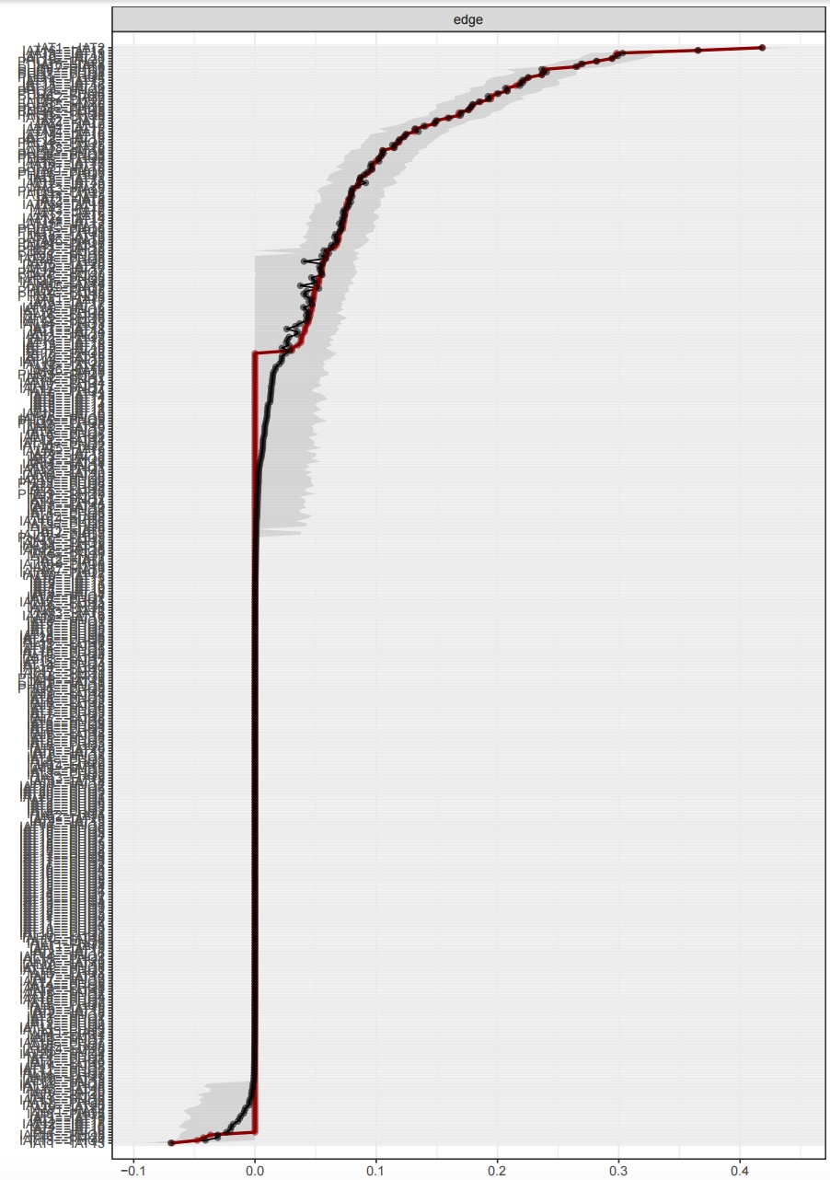
Notes: Each horizontal line indicates the 95% quantile range of the parameter values when the parameter was included in the model. The transparency of each line indicates the proportion of times the edge was included in the model (more transparent lines indicate edges that were included less often). The red dots within the plot indicate the sample values for the analyzed data, while the grey areas indicate bootstrapped confidence intervals.

Figure S2. Estimation of edge weight difference by bootstrapped difference test
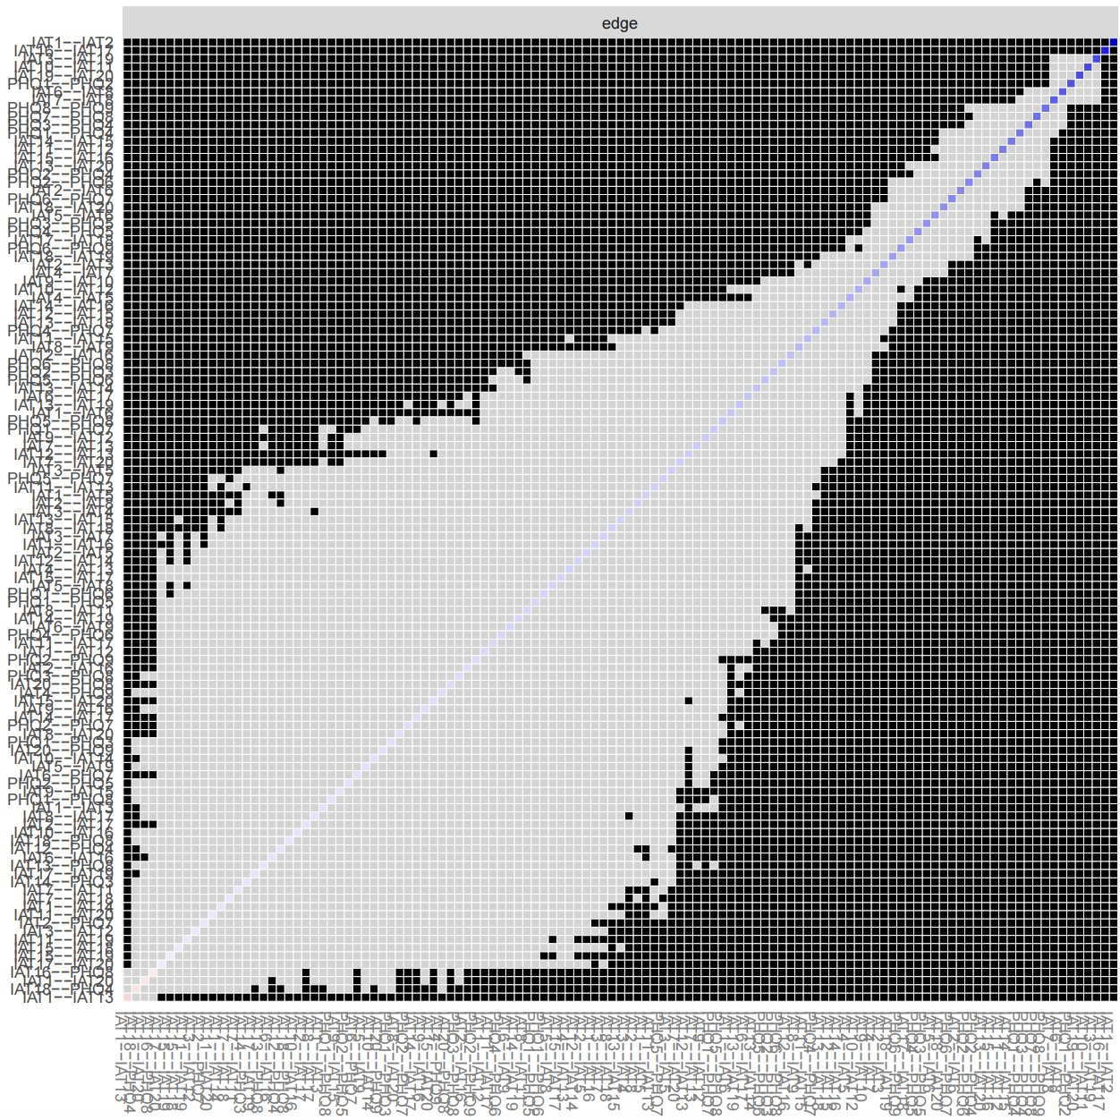
Notes: Bootstrapped difference tests between edge weights in the network. Gray boxes indicate edges that do not significantly differ from one-another. Black boxes represent edges with significant difference from one another (α = 0.05). Blue boxes in the edge-weight plot indicate positive correlation

Figure S3. Estimation of node expected influence difference by bootstrapped difference test

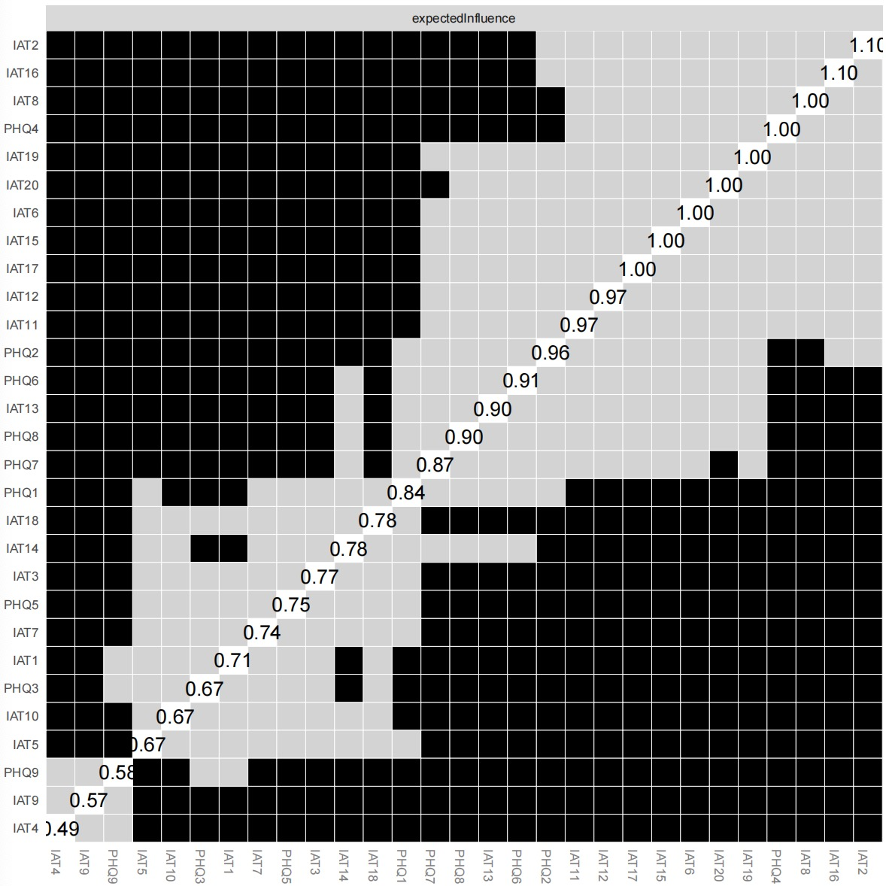
Notes: Gray boxes indicate nodes that do not differ significantly from one-another and black boxes represent nodes that do differ significantly from one-another in Expected Influence. Here, we can observe many nodes that significantly differ from each other, meaning our network stability can be interpreted as high

