Online Appendix
Figure A1: Proportion of Missing Values for all Variables
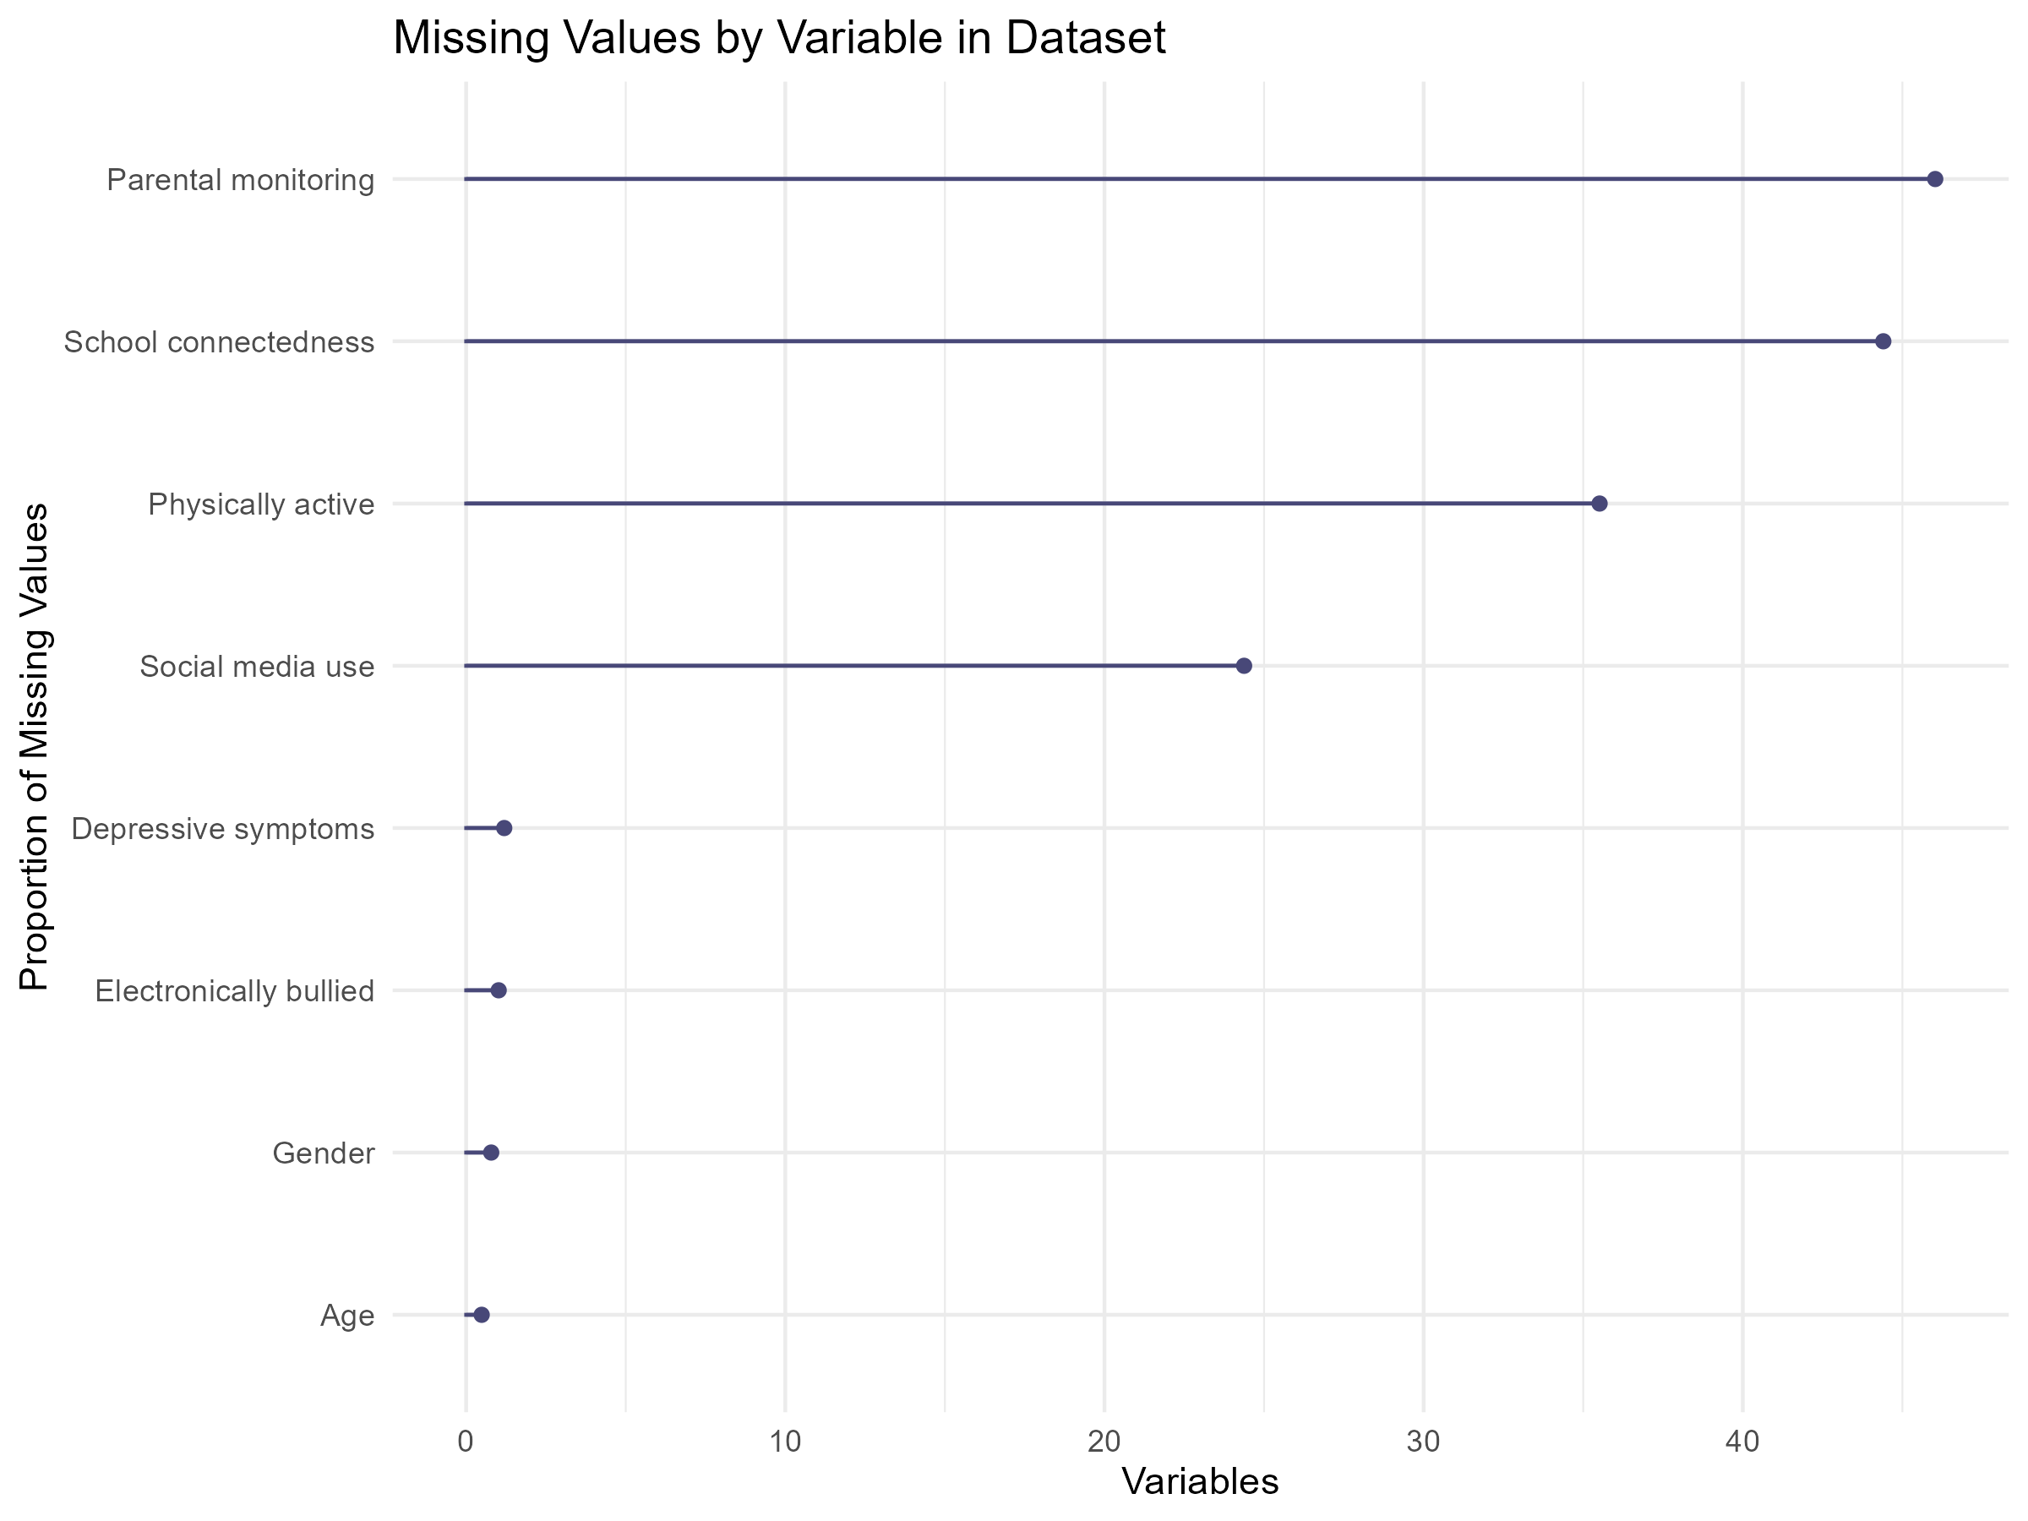

Figure A2: Visualisation of interaction effect with all categories of Social Media Use
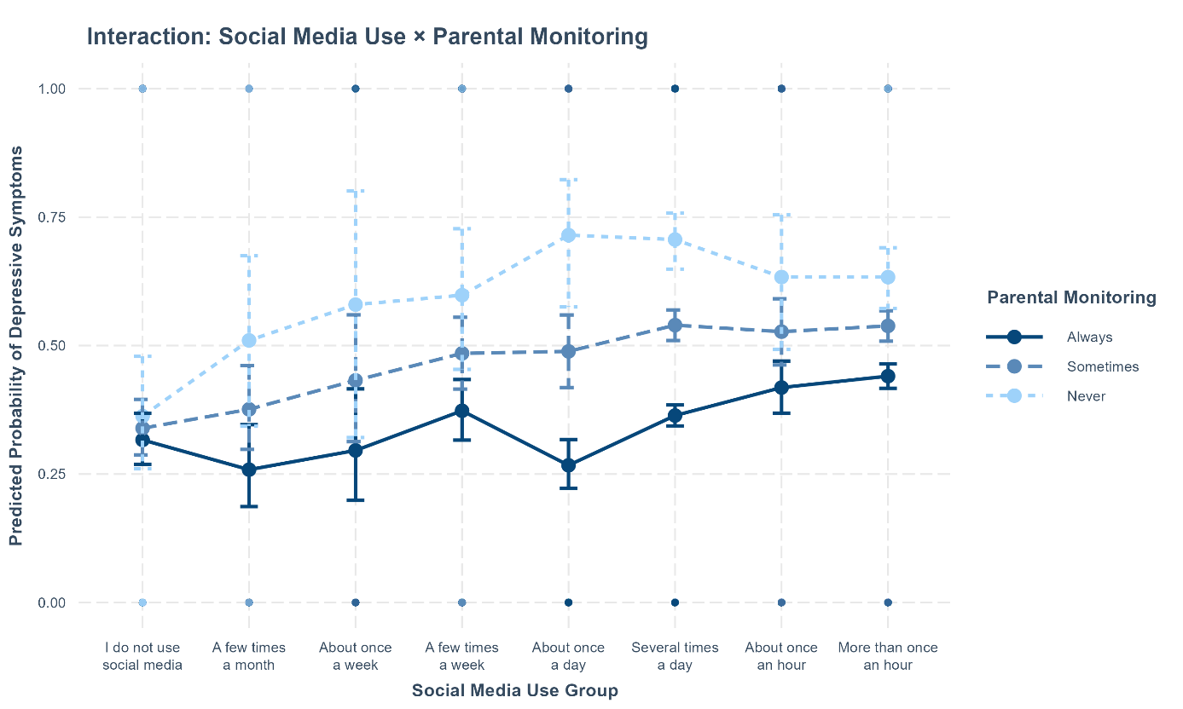
Table A1: Logistic Regression Predicting Missingness on Key Variables
 | Missingness Depressive symptoms | Missingness Social media use | Missingness Parental monitoring | Missingness Gender
(Intercept) | 0.694 | 0.004* | 0.326 | 1.010
 | [0.016, 27.847] | [0.000, 0.266] | [0.074, 1.418] | [0.009, 102.160]
Male (ref: Female) | 1.164 | 1.238 | 0.850
 | [0.681, 2.027] | [0.682, 2.280] | [0.679, 1.064]
Age | 0.858 | 1.101 | 0.924+ | 0.868
 | [0.691, 1.065] | [0.870, 1.399] | [0.846, 1.008] | [0.662, 1.139]
Parental monitoring | 0.625*** | 0.754* |  | 0.675**
 | [0.516, 0.764] | [0.598, 0.970] |  | [0.527, 0.881]
Moderate social media use (vs. Low) | 0.237* |  | 0.351*** | 0.773
 | [0.054, 0.735] |  | [0.227, 0.528] | [0.226, 2.462]
High social media use (vs. Low) | 0.462* |  | 0.322*** | 0.483
 | [0.251, 0.900] |  | [0.248, 0.422] | [0.210, 1.255]
Electronically bullied (Yes) | 0.449+ | 0.452 | 2.111*** | 1.620
 | [0.155, 1.038] | [0.153, 1.072] | [1.646, 2.694] | [0.681, 3.563]
Physically active (days/week) | 0.906 | 1.156 | 1.046 | 0.751
 | [0.687, 1.170] | [0.878, 1.499] | [0.942, 1.159] | [0.494, 1.077]
School connectedness | 1.114 | 0.801+ | 0.935 | 0.776+
 | [0.883, 1.424] | [0.629, 1.026] | [0.851, 1.027] | [0.585, 1.033]
Depressive Symptoms |  | 1.394 | 1.052 | 0.779
 |  | [0.755, 2.571] | [0.830, 1.334] | [0.368, 1.615]
Num.Obs. | 10392 | 10383 | 10694 | 10369
AIC | 698.4 | 623.7 | 3059.3 | 464.3
BIC | 763.7 | 681.7 | 3124.8 | 529.5
+ p < 0.1, * p < 0.05, ** p < 0.01, *** p < 0.001
Table A2: Pooled Logistic Regression Predicting Depressive Symptoms
 | Baseline | SM × Gender | SM × Monitoring
(Intercept) | 2.843*** | 2.815** | 2.018*
 | [1.539, 5.251] | [1.504, 5.268] | [1.025, 3.971]
Moderate social media use (vs. Low) | 1.186* | 1.177 | 2.035*
 | [1.016, 1.385] | [0.942, 1.471] | [1.112, 3.726]
High social media use (vs. Low) | 1.640*** | 1.661*** | 2.477***
 | [1.461, 1.842] | [1.396, 1.977] | [1.548, 3.961]
Male (ref: Female) | 0.388*** | 0.395*** | 0.387***
 | [0.362, 0.416] | [0.317, 0.492] | [0.361, 0.415]
Age | 1.041** | 1.041** | 1.041**
 | [1.012, 1.070] | [1.012, 1.070] | [1.012, 1.070]
Electronically bullied (Yes) | 3.842*** | 3.842*** | 3.846***
 | [3.518, 4.197] | [3.518, 4.197] | [3.521, 4.201]
Physically active (days/week) | 0.839*** | 0.839*** | 0.839***
 | [0.804, 0.875] | [0.804, 0.875] | [0.804, 0.875]
School connectedness | 0.754*** | 0.754*** | 0.755***
 | [0.707, 0.805] | [0.707, 0.805] | [0.707, 0.805]
Parental monitoring | 0.793*** | 0.793*** | 0.868**
 | [0.746, 0.845] | [0.746, 0.845] | [0.792, 0.952]
Moderate SM × Male |  | 1.015
 |  | [0.750, 1.373]
High SM × Male |  | 0.977
 |  | [0.772, 1.236]
Moderate SM × Monitoring |  |  | 0.872+
 |  |  | [0.756, 1.006]
High SM × Monitoring |  |  | 0.900+
 |  |  | [0.804, 1.007]
Num.Obs. | 20103 | 20103 | 20103
Num.Imp. | 50 | 50 | 50
+ p < 0.1, * p < 0.05, ** p < 0.01, *** p < 0.001; Notes: SM = Social media use

Table A3: Logistic Regression Predicting Depressive Symptoms with all categories of social media use
 | Baseline | SM × Gender | SM × Monitoring
(Intercept) | 6.793*** | 7.262*** | 2.939*
 | [3.486, 13.256] | [3.608, 14.635] | [1.219, 7.017]
Social media use: few times a month (vs. none) | 0.940 | 0.729 | 2.284
 | [0.653, 1.342] | [0.409, 1.288] | [0.771, 6.808]
Social media use: About once a week (vs. none) | 1.158 | 0.589 | 3.098
 | [0.742, 1.787] | [0.289, 1.160] | [0.666, 14.166]
Social media use: A few times a week (vs. none) | 1.536** | 1.334 | 3.123*
 | [1.167, 2.023] | [0.890, 2.002] | [1.192, 8.314]
Social media use: About once a day (vs. none) | 1.160 | 0.967 | 6.781***
 | [0.893, 1.508] | [0.642, 1.458] | [2.496, 18.671]
Social media use: Several times a day (vs. none) | 1.631*** | 1.537** | 5.747***
 | [1.337, 1.995] | [1.135, 2.083] | [2.872, 11.692]
Social media use: About once an hour (vs. none) | 1.846*** | 1.850** | 3.588**
 | [1.445, 2.361] | [1.280, 2.680] | [1.373, 9.475]
Social media use: More than once an hour (vs. none) | 1.987*** | 1.809*** | 3.506***
 | [1.624, 2.439] | [1.332, 2.463] | [1.759, 7.106]
Male (ref: Female) | 0.357*** | 0.310*** | 0.354***
 | [0.327, 0.390] | [0.211, 0.454] | [0.324, 0.387]
Age | 1.010 | 1.011 | 1.010
 | [0.974, 1.047] | [0.975, 1.048] | [0.974, 1.047]
Electronically bullied (Yes) | 3.644*** | 3.642*** | 3.648***
 | [3.232, 4.115] | [3.230, 4.113] | [3.235, 4.120]
Physically active (days/week) | 0.843*** | 0.843*** | 0.842***
 | [0.808, 0.880] | [0.808, 0.880] | [0.807, 0.879]
School connectedness | 0.717*** | 0.716*** | 0.718***
 | [0.689, 0.745] | [0.689, 0.745] | [0.690, 0.747]
Parental monitoring | 0.771*** | 0.771*** | 0.950
 | [0.737, 0.807] | [0.737, 0.806] | [0.823, 1.099]
SM: A few times a month x Male (ref: Female) |  | 1.524
 |  | [0.732, 3.175]
SM: About once a week x Male (ref: Female) |  | 3.194*
 |  | [1.323, 7.819]
SM: A few times a week x Male (ref: Female) |  | 1.296
 |  | [0.746, 2.251]
SM: About once a day x Male (ref: Female) |  | 1.359
 |  | [0.798, 2.317]
SM: Several times a day x Male (ref: Female) |  | 1.095
 |  | [0.732, 1.643]
SM: About once an hour x Male (ref: Female) |  | 0.980
 |  | [0.597, 1.608]
SM: More than once an hour x Male (ref: Female) |  | 1.182
 |  | [0.785, 1.784]
SM: A few times a month x Parental monitoring |  |  | 0.801
 |  |  | [0.612, 1.045]
SM: About once a week x Parental monitoring |  |  | 0.782
 |  |  | [0.542, 1.129]
SM: A few times a week x Parental monitoring |  |  | 0.837
 |  |  | [0.666, 1.049]
SM: About once a day x Parental monitoring |  |  | 0.650***
 |  |  | [0.513, 0.821]
SM: Several times a day x Parental monitoring |  |  | 0.735***
 |  |  | [0.623, 0.865]
SM: About once an hour x Parental monitoring |  |  | 0.846
 |  |  | [0.675, 1.059]
SM: More than once an hour x Parental monitoring |  |  | 0.865+
 |  |  | [0.734, 1.017]
Num.Obs. | 10334 | 10334 | 10334
AIC | 12178.1 | 12181.8 | 12168.9
BIC | 12279.5 | 12333.9 | 12321.0
+ p < 0.1, * p < 0.05, ** p < 0.01, *** p < 0.001; Notes: SM = Social media use; reference category = “I do not use social media”.
Table A4: Logistic Regression Predicting Depressive Symptoms with mean centered parental monitoring variable

 | Baseline | SM × Monitoring
(Intercept) | 2.226* | 2.299**
 | [1.200, 4.130] | [1.239, 4.267]
Moderate social media use (vs. Low) | 1.308** | 1.256*
 | [1.070, 1.600] | [1.026, 1.538]
High social media use (vs. Low) | 1.772*** | 1.711***
 | [1.516, 2.076] | [1.463, 2.007]
Male (ref: Female) | 0.355*** | 0.354***
 | [0.325, 0.388] | [0.324, 0.386]
Age | 1.011 | 1.011
 | [0.975, 1.048] | [0.976, 1.049]
Electronically bullied (Yes) | 3.689*** | 3.690***
 | [3.272, 4.164] | [3.273, 4.166]
Physically active (days/week) | 0.845*** | 0.845***
 | [0.810, 0.882] | [0.810, 0.882]
School connectedness | 0.718*** | 0.718***
 | [0.690, 0.746] | [0.690, 0.747]
Parental monitoring (centered) | 0.769*** | 0.874*
 | [0.735, 0.804] | [0.781, 0.979]
Moderate SM × Monitoring (centered) |  | 0.803*
 |  | [0.677, 0.952]
High SM × Monitoring (centered) |  | 0.869*
 |  | [0.767, 0.983]
Num.Obs. | 10334 | 10334
AIC | 12187.8 | 12184.6
BIC | 12253.0 | 12264.3
+ p < 0.1, * p < 0.05, ** p < 0.01, *** p < 0.001; Notes: SM = Social media use

