SUPPLEMENTARY MATERIAL

TITLE: Legal and Illegal Sources of Cannabis in Germany Shortly After Legalisation

Supplementary Information 1:
We compare the 2024 prevalence of cannabis, alcohol, and tobacco use in this study to another survey below. While the current study relies on an online access panel, the ‘Epidemiological Survey on Addiction’ (ESA) has employed a two-stage probability sampling strategy with a response rate of 22% (Olderbak et al., 2025).
Prevalence among 18-64-year-olds | Current study | ‘Epidemiological Survey on Addiction’ (ESA)
Cannabis use | 15.7% | 9.8%
Alcohol use¹ | 77.1% | 68.6%
Tobacco use¹ | 36.4% | 21.8%
¹ 12-month prevalence in the current study, but 30-day prevalence in ESA

The current study arrives at consistently higher substance use prevalence rates; however, for alcohol and tobacco, this could in part be explained by only 30-day prevalence being available from ESA. For tobacco, a systematic comparison found ESA prevalence estimates to be below those of other surveys, with the estimates of the current study being close to the estimate of the population-based DEBRA study (Kotz et al., 2025). For alcohol, the 12-month use prevalence in 2021 (84.7%) was similar to the estimate of the current study (Rauschert et al., 2022).
For cannabis, the sample from the current study was compared to the probability samples recruited in ESA and DEBRA in a recent report (Table 4 of Manthey et al. (2025) is reproduced below). While the current study yielded a higher use prevalence, the distribution of use frequency among users was broadly similar across the three surveys.
 | Current study | DEBRA 2024¹ | ESA 2024¹
Cannabis use frequency
Less than monthly | 36.7% | 46.3% | 57.7%
At least monthly | 23.4% | 24.9% | 14.0%
At least weekly | 22.3% | 19.8% | 12.1%
(near) daily | 17.6% | 9.0% | 16.2%
DEBRA: Deutsche Befragung zum Rauchverhalten
ESA: Epidemiological Survey of Substance Use
¹ Information reproduced from Table 4 of Manthey et al. (2025)

Overall, the available data suggest that the recruited sample can be considered a broad representation of people using cannabis in Germany.

SUPPLEMENTAL TABLE 1. Description of the total sample and by past-year cannabis use status
 | Total sample (n=11,578) | No past-year cannabis use (n=9,758) | Past-year cannabis use  (n=1,478)
Gender: n (%)
women | 6,535 (49.2%) | 5,924 (52.6%) | 611 (30.8%)
men | 5,016 (50.5%) | 4,156 (47.1%) | 860 (68.8%)
other | 27 (0.3%) | 20 (0.3%) | 7 (0.4%)
Age: mean (SD) | 43.10 (13.26) | 44.58 (13.13) | 35.22 (11.00)
Age group: n (%)
18-24 | 700 (8.5%) | 539 (7.7%) | 161 (13.3%)
25-34 | 1,943 (22.2%) | 1,442 (18.5%) | 501 (42.3%)
35-44 | 2,541 (22.1%) | 2,134 (21.7%) | 407 (24.5%)
45-54 | 2,519 (19.7%) | 2,295 (21.2%) | 224 (11.5%)
55-64 | 3,875 (27.4%) | 3,690 (31.0%) | 185 (8.5%)
Education grouping: n (%)
Low | 551 (4.3%) | 453 (4.1%) | 98 (5.5%)
Medium | 7,182 (56.7%) | 6,436 (59.0%) | 746 (44.3%)
High | 3,833 (39.0%) | 3,200 (36.9%) | 633 (50.2%)
Unknown | 10 | 9 | 1
Regional deprivation (GISD): n (%)
Low | 3,340 (31.7%) | 2,874 (31.1%) | 466 (34.8%)
Medium | 6,207 (52.2%) | 5,441 (52.6%) | 766 (50.1%)
High | 2,024 (16.1%) | 1,780 (16.3%) | 244 (15.1%)
Unknown | 7 | 5 | 2
Urbanicity (DEGURBA): n (%)
Cities | 4,809 (43.1%) | 4,037 (41.2%) | 772 (53.4%)
Towns or suburbs | 4,686 (40.3%) | 4,172 (41.5%) | 514 (34.2%)
Rural | 2,061 (16.6%) | 1,872 (17.3%) | 189 (12.4%)
Unknown | 19 | 16 | 3
Past-year cannabis use prevalence: n (%) | 1,478 (15.7%) | 0 (0.0%) | 1,478 (100.0%)
Past-year alcohol use prevalence: n (%) | 8,741 (77.1%) | 7,451 (74.8%) | 1,290 (89.4%)
Past-year tobacco use prevalence: n (%) | 4,085 (36.4%) | 2,948 (28.5%) | 1,137 (78.8%)
Note. For categorical variables, unweighted counts (n) and weighted percentages are presented. For continuous variables, the weighted mean and standard deviation (SD) are presented.

Supplementary Information 2:
Original item assessing cannabis sources and a priori classification (item code SOURCE):
Question:
German: Woher beziehen Sie die Cannabisprodukte, die Sie in den letzten 12 Monaten konsumiert haben? Mehrfachnennungen möglich!
English: Where do you obtain the cannabis products that you have consumed in the last 12 months? Multiple answers possible!
SUPPLEMENTAL TABLE 2. Question for cannabis sources
# | German response (randomised) | English response (randomised) | A priori classification
1 | Apotheke (auch Online-Apotheken) | Pharmacy (including online pharmacies) | Pharmacy
2 | Von Freund:innen/Bekannten/Familie | From friends/acquaintances/family | Social
3 | Von mir unbekannten Personen (auf der Straße/Festival/Club) | From people I don't know (on the street/festival/club) | Illegal
4 | Von einem mir bekannten Dealer | From a dealer I know | Illegal
5 | Eigenanbau (eigene Pflanzen) | Home-cultivation (own plants) | Cultivation
6 | Eigenanbau (Pflanzen einer mir bekannten Person) | Home-cultivation (plants from a person I know) | Cultivation
7 | Von Anbauvereinigungen („Cannabis Clubs“) | From cultivation associations (“cannabis clubs”) | Cultivation
8 | Über Onlinehandel (z. B. Darknet) | Via online purchases (e.g. darknet) | Illegal
9 | Über Soziale Medien (z. B. WhatsApp, Signal, Telegram, Facebook, Instagram etc.) | Via social media (e.g. WhatsApp, Signal, Telegram, Facebook, Instagram, etc.) | Illegal
10 | Ich besitze selbst kein Cannabis, sondern konsumiere nur bei anderen mit | I do not possess cannabis myself, but only use it with others | Other
11 | Anderes: [FREITEXT] | Other: [FREE TEXT] | Other

Supplementary Information 3:
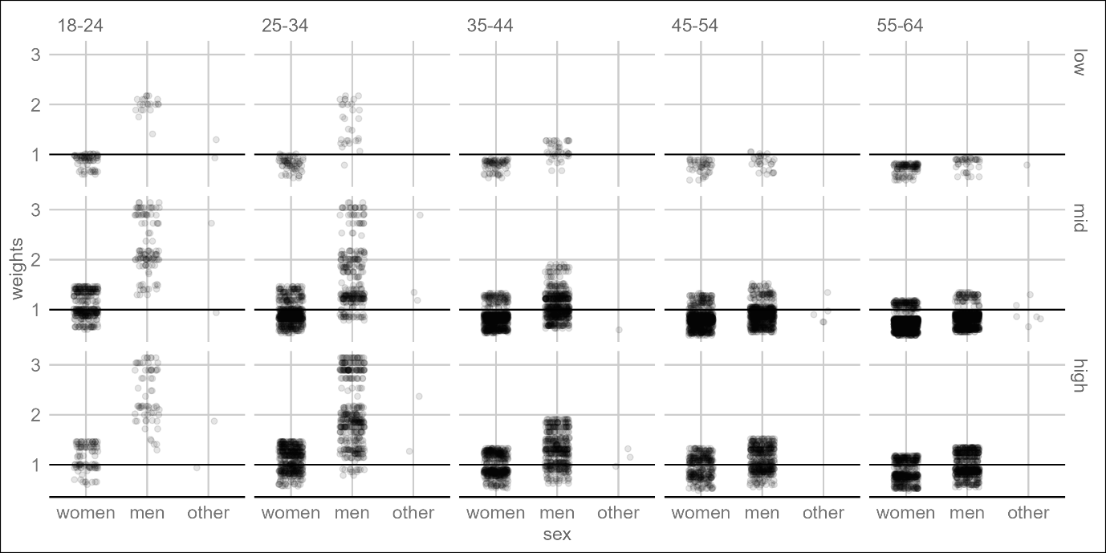
Supplementary Figure 1. Distribution of post-stratification weights by sex (x axis), educational levels (rows), and age groups (columns). Each point represents the weight of one respondent.

Supplementary Information 4:
SUPPLEMENTAL TABLE 3. Model fit indices of latent class analyses
Models | LL | AIC | BIC | Entropy | Smallest n | Lowest ALCPP
2 Class | -5865.947 | 11777.89 | 11899.76 | 1.0000000 | 159 | 1.0000000
3 Class | -5715.226 | 11500.45 | 11685.90 | 0.8483223 | 159 | 0.8520524
4 Class | -5651.860 | 11397.72 | 11646.75 | 0.8971505 | 159 | 0.8592341
5 Class | -5599.650 | 11317.30 | 11629.91 | 0.8306091 | 159 | 0.7667442
6 Class | -5547.908 | 11237.82 | 11614.01 | 0.8544093 | 159 | 0.8360462
7 Class | -5500.115 | 11166.23 | 11606.00 | 0.8620904 | 25 | 0.8565403
8 Class | -5458.832 | 11107.66 | 11611.02 | 0.8759903 | 25 | 0.8340073
Note. LL = Log-Likelihood; AIC = Akaike Information Criterion; BIC = Bayesian Information Criterion; Smallest n = number of respondents in the smallest class; Lowest ALCPP = taken from the matrix of the average latent class posterior probability (ALCPP), the smallest value in the diagonal refers to the class with the least good fit.

As shown in Supplementary Table 4, the usual model fit indices did not suggest a single best LCA solution. The lowest AIC suggested an 8-class solution, while the BIC suggested a 7-class solution. However, the entropy and ALCPP indicators suggested a 4-class solution. The best model was finally decided on the basis of interpretative considerations. In the 2-class solution, people who did not possess cannabis were distinguished from all others. Additional classes identified people with social sources (3-class solution), medical access (4-class solution), home cultivation (5-class solution) and illegal access (6-class solution). The 7-class solution only separated people with other sources from the (later called) MIX class. With the 8-class solution, we observed two home-growing classes: one largely restricted to own plants, and another class relying mostly on other people's plants, but also a mix of other sources (including friends).
Supplementary Figures 2 to 8 show the response probabilities per class for the seven candidate models. We chose the 6-class solution as it allowed a granular yet sufficient separation of respondents, while showing excellent model fit indices.

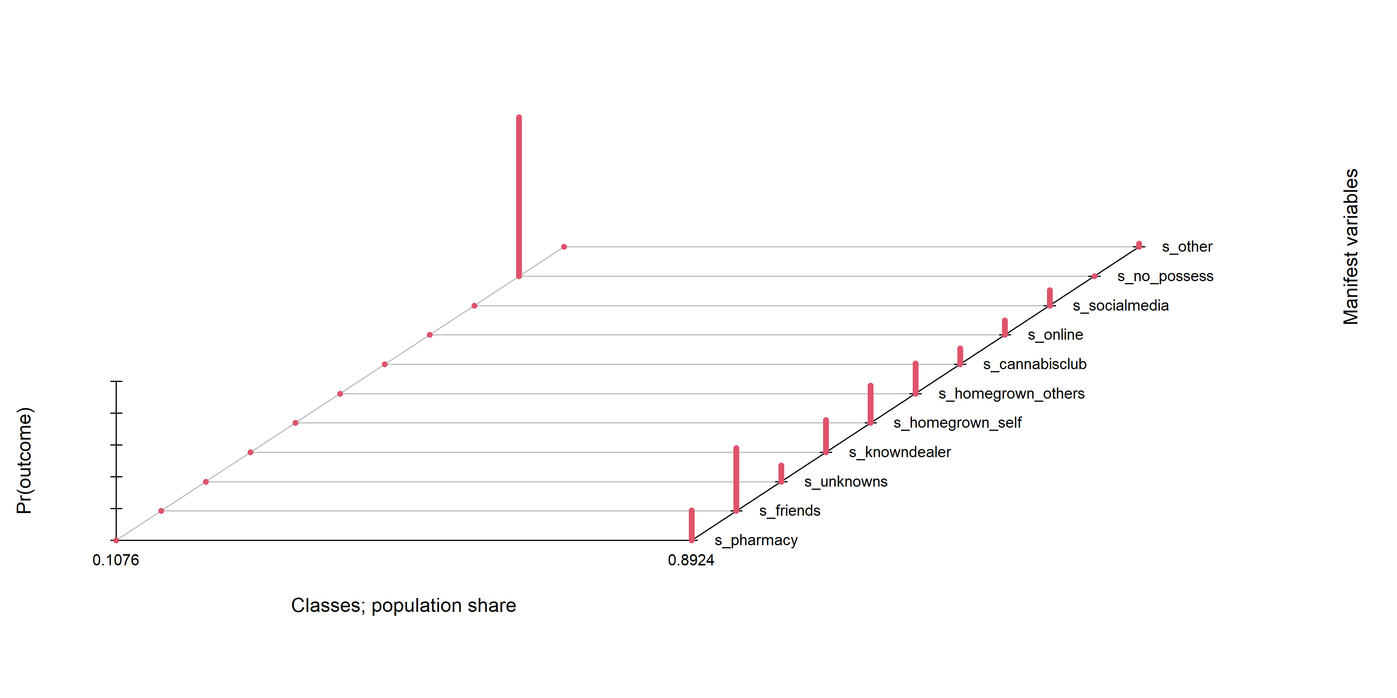
Supplementary Figure 2. Response probabilities for each manifest variable in a 2-class solution from a latent class analysis
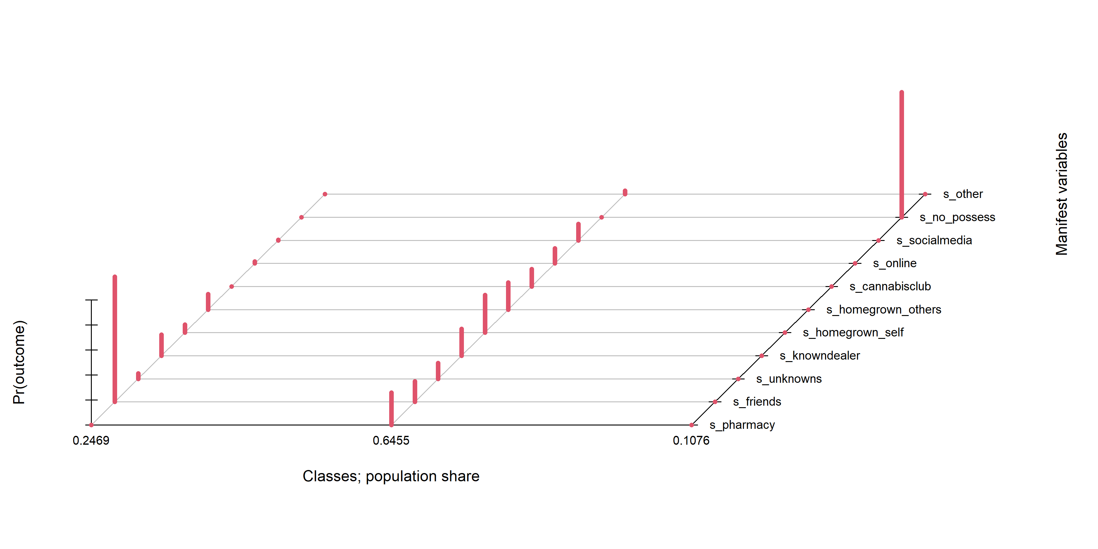
Supplementary Figure 3. Response probabilities for each manifest variable in a 3-class solution from a latent class analysis
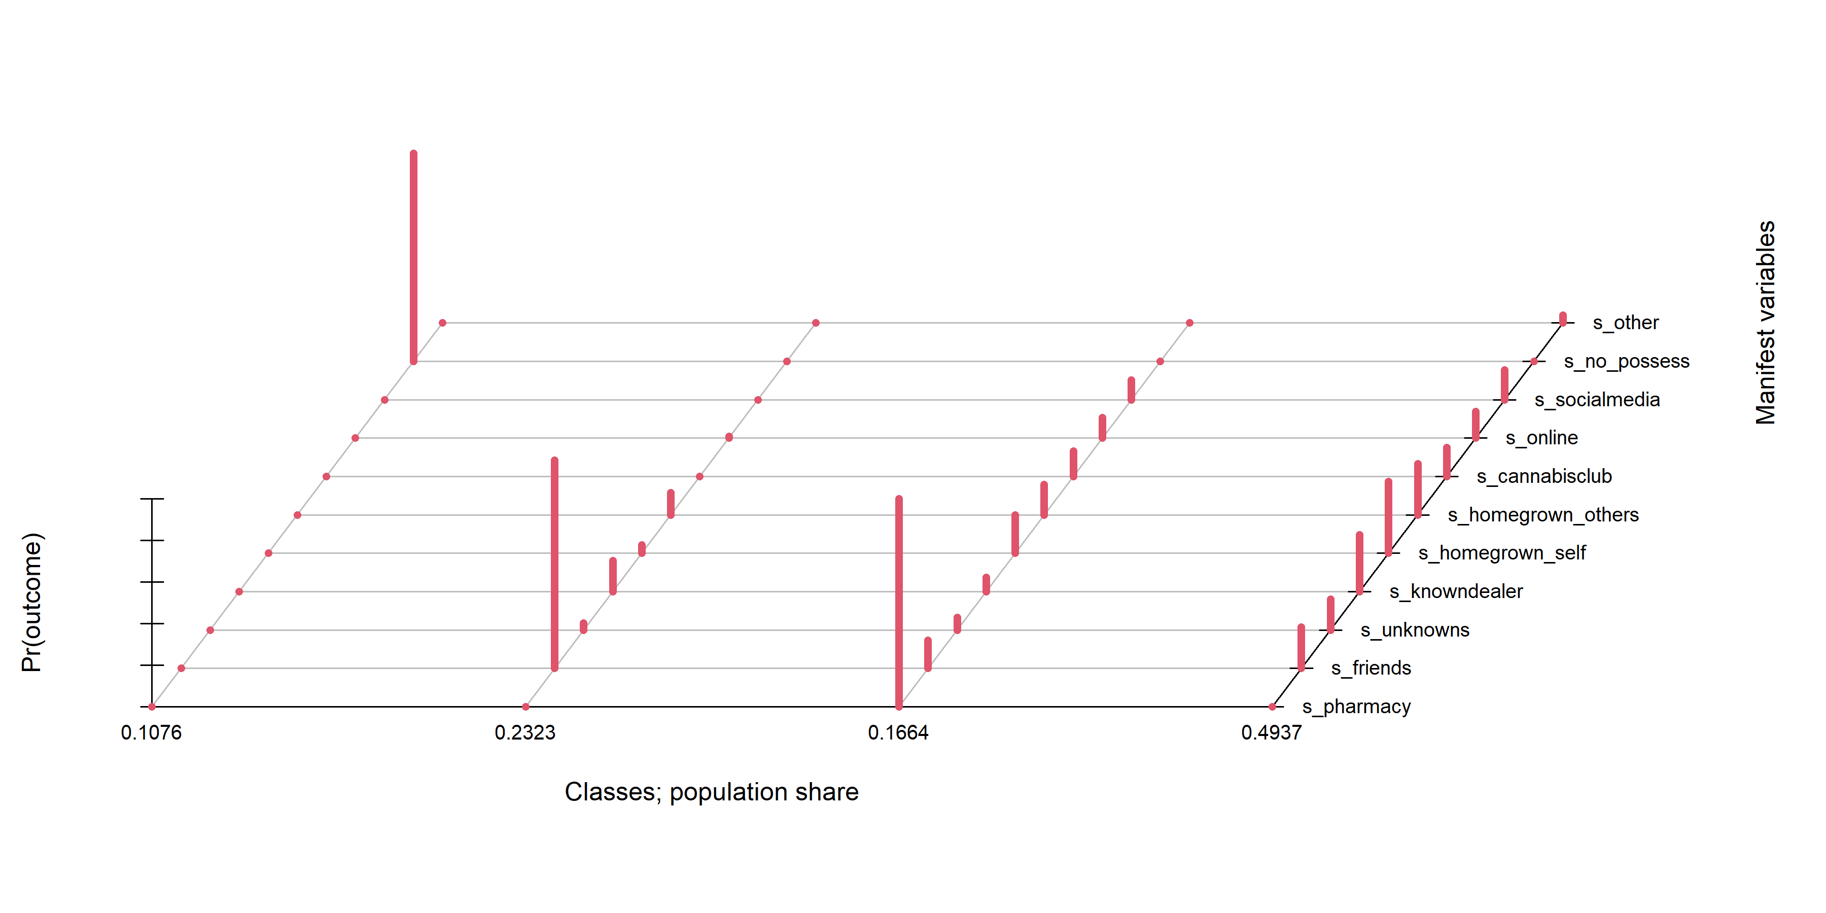
Supplementary Figure 4. Response probabilities for each manifest variable in a 4-class solution from a latent class analysis
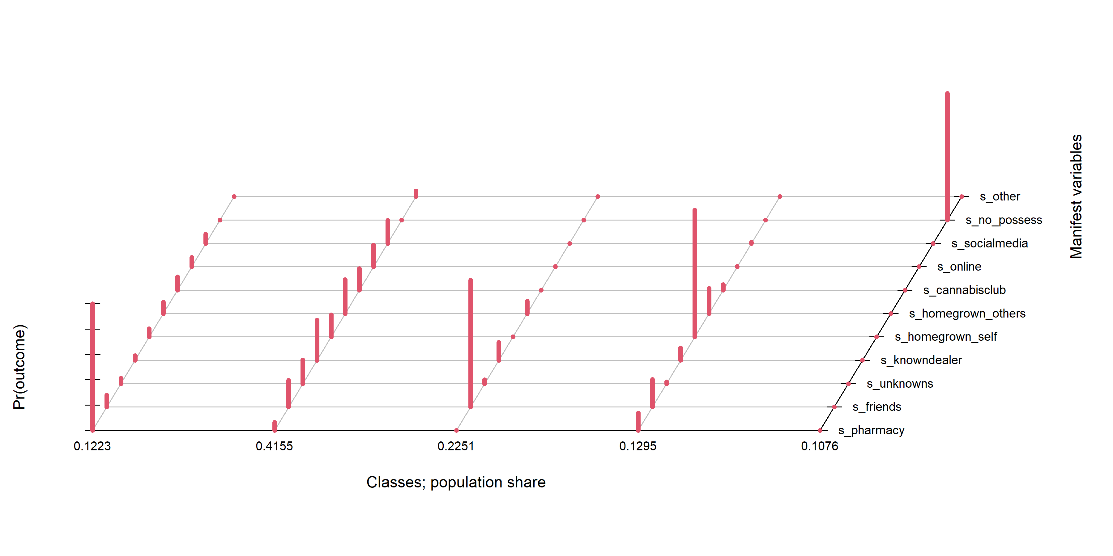
Supplementary Figure 5. Response probabilities for each manifest variable in a 5-class solution from a latent class analysis
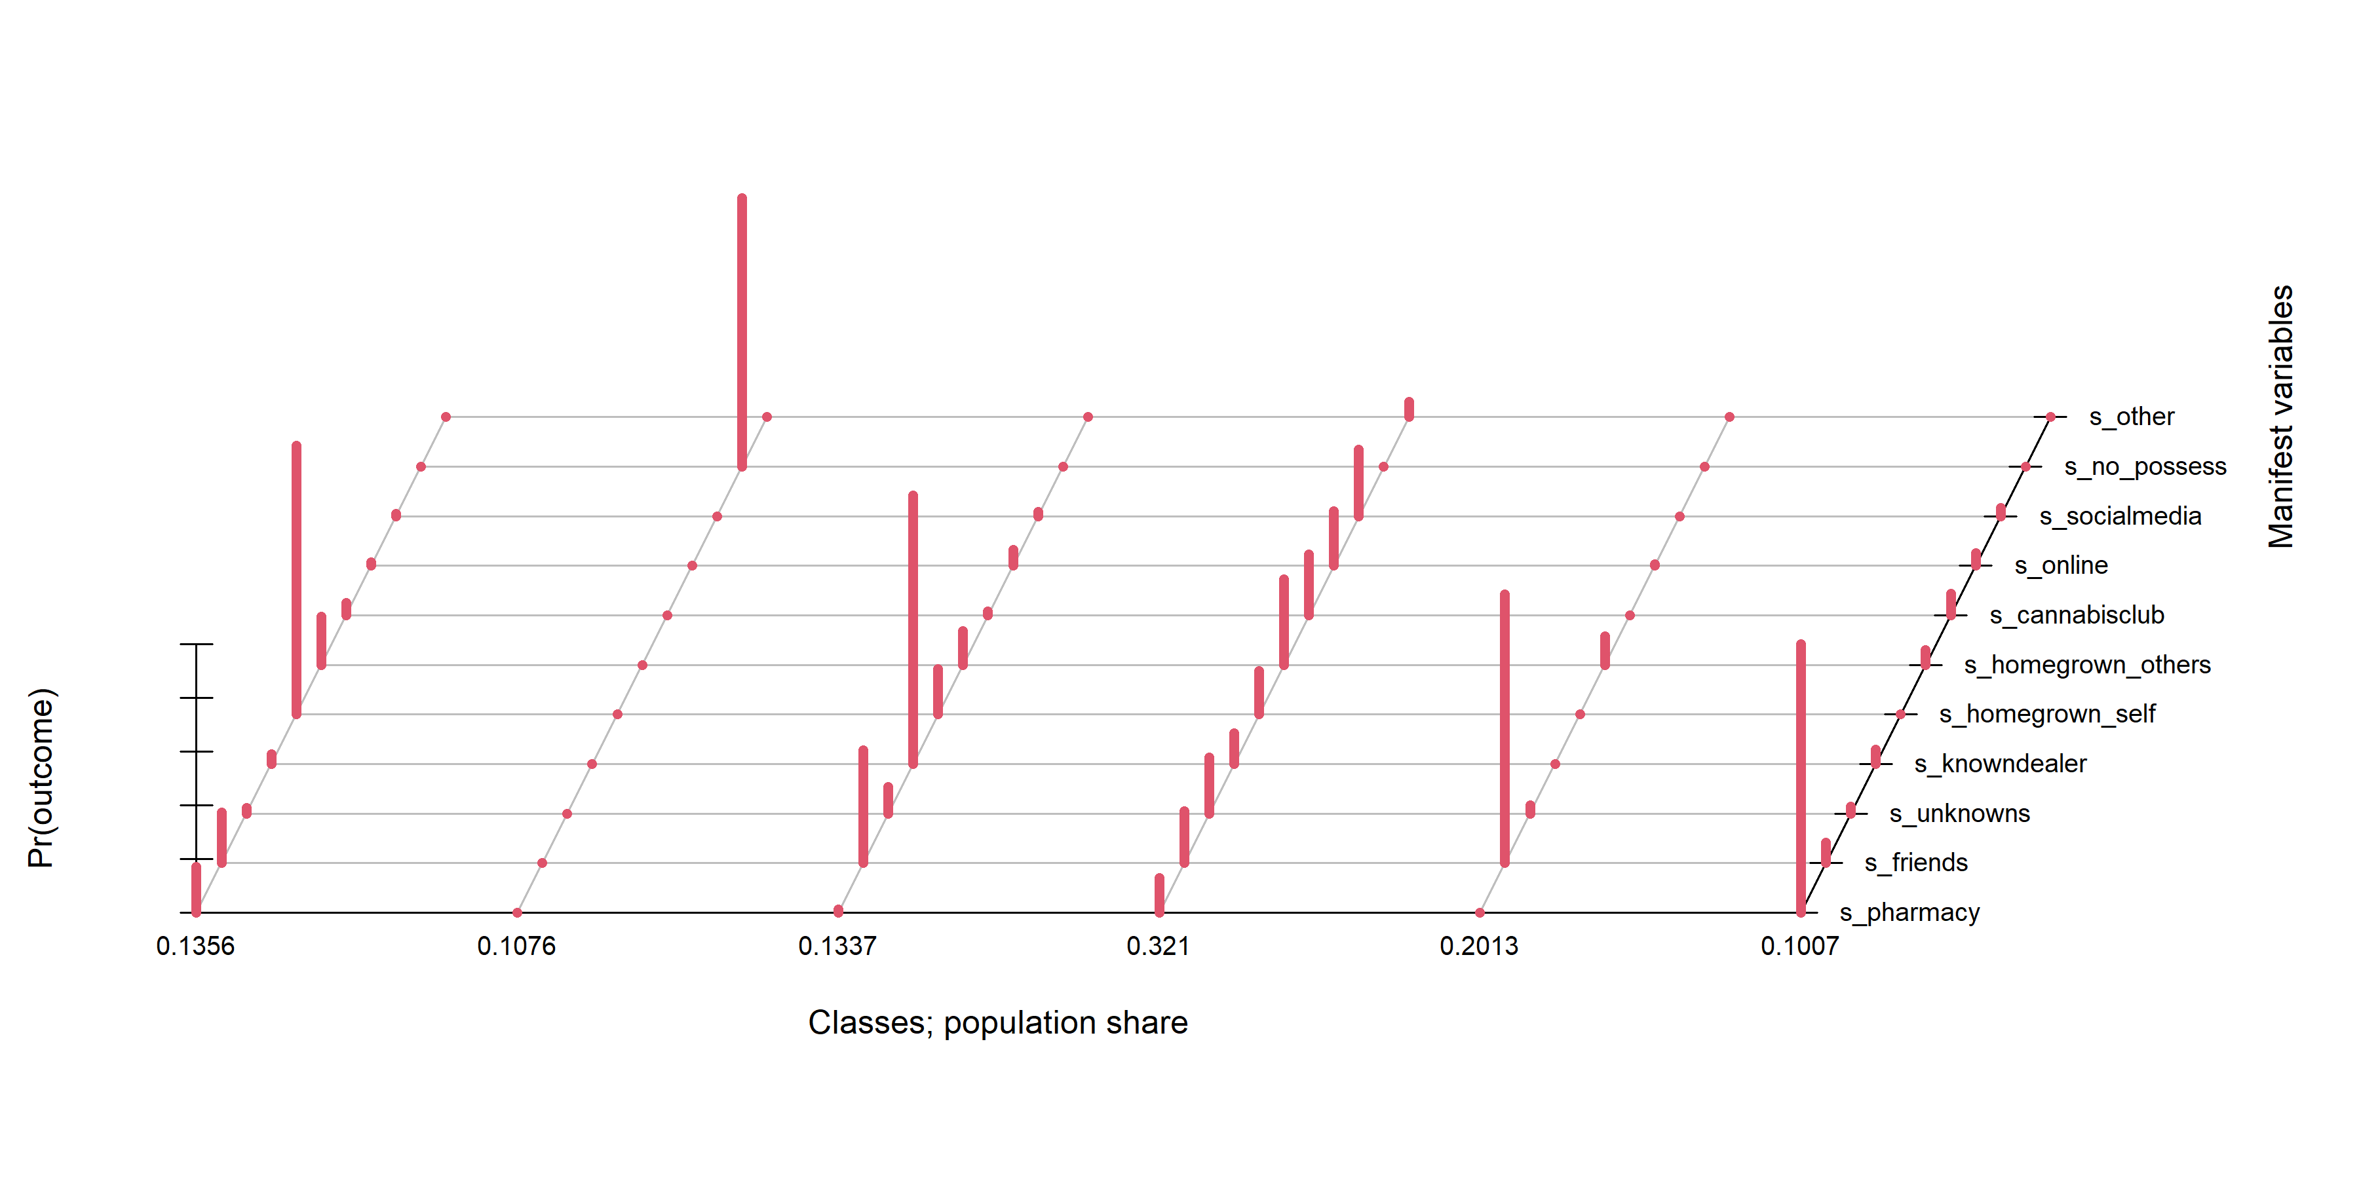
Supplementary Figure 6. Response probabilities for each manifest variable in a 6-class solution from a latent class analysis
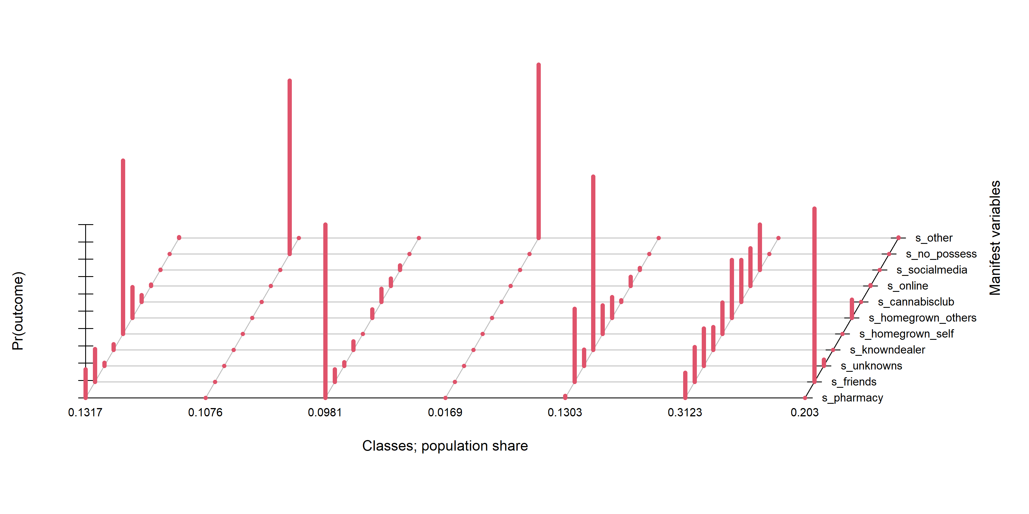
Supplementary Figure 7. Response probabilities for each manifest variable in a 7-class solution from a latent class analysis
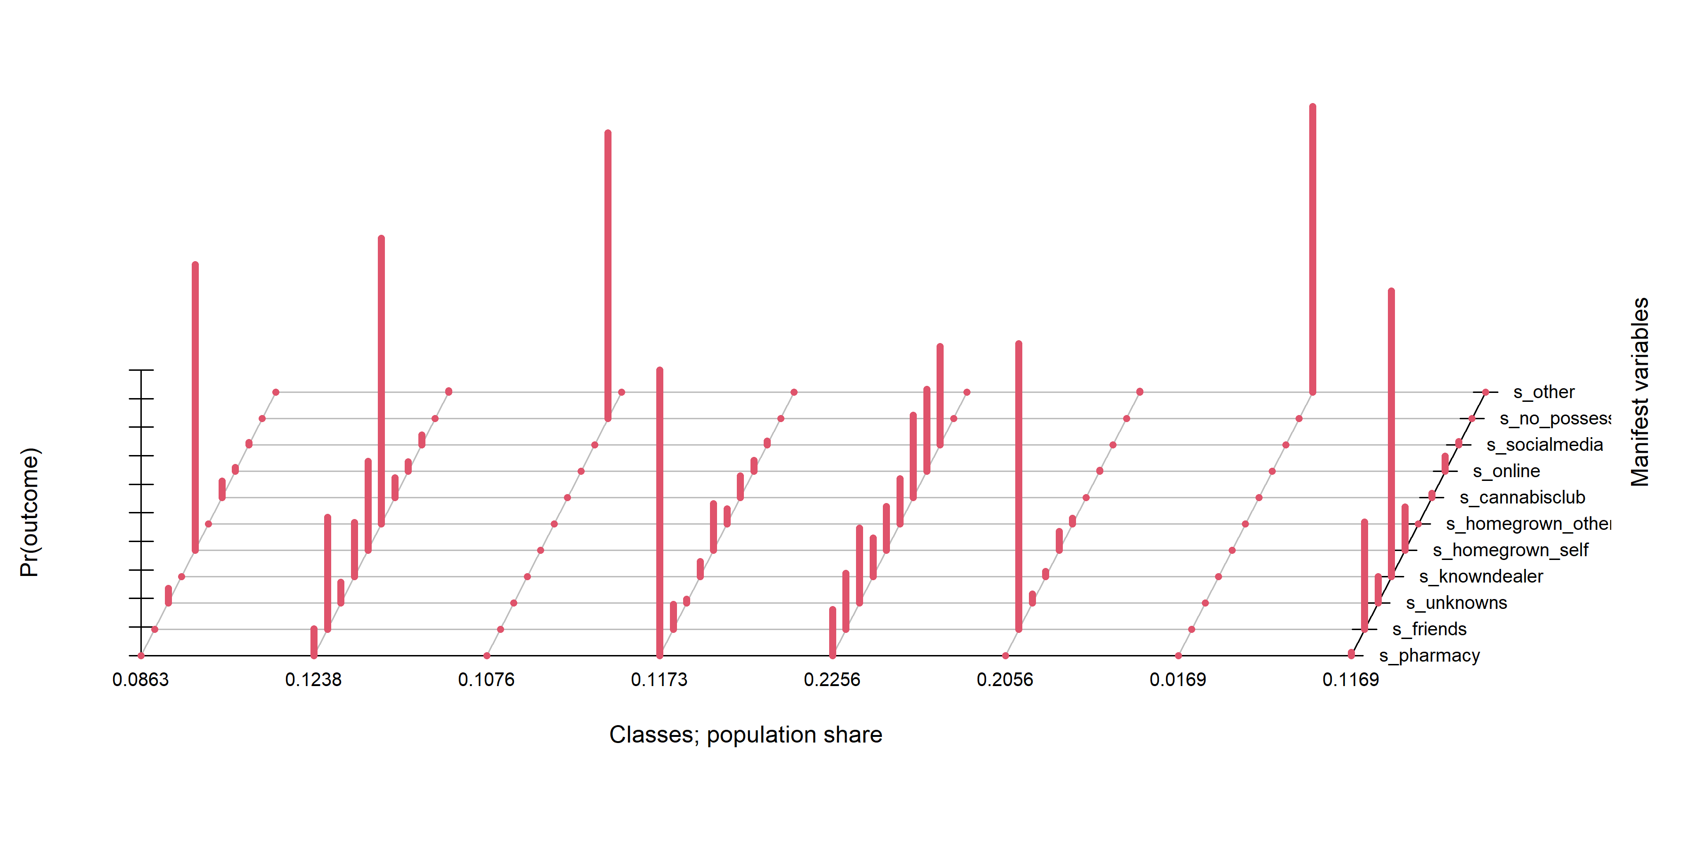
Supplementary Figure 8. Response probabilities for each manifest variable in an 8-class solution from a latent class analysis

Supplementary Information 5:
SUPPLEMENTAL TABLE 4. Results of a multinomial regression model (dependent variable: class assignment)
Class (Ref: MIX) | Variable | Risk Ratio | 95 % confidence interval | p-value
HOME CULTIVATION | Intercept | 0.5070602 | 0.172 to 1.496 | 0.2185948
 | Sex: men | 1.1063354 | 0.757 to 1.617 | 0.6018133
 | Age: 25-34 | 2.0320914 | 0.932 to 4.43 | 0.0745666
 | Age: 35-44 | 3.1156104 | 1.432 to 6.776 | 0.0041506
 | Age: 45-54 | 2.5877677 | 1.113 to 6.017 | 0.0272034
 | Age: 55-64 | 3.2786950 | 1.345 to 7.993 | 0.0090044
 | Education: mid | 0.7609749 | 0.362 to 1.601 | 0.4717663
 | Education: high | 0.6768137 | 0.311 to 1.472 | 0.3248837
 | Regional deprivation: mid | 1.3048604 | 0.864 to 1.971 | 0.2059974
 | Regional deprivation: high | 0.6679399 | 0.382 to 1.168 | 0.1569447
 | DEGURBA: rural | 1.3238097 | 0.773 to 2.266 | 0.3063302
 | DEGURBA: towns and suburbs | 1.3348716 | 0.899 to 1.982 | 0.1522654
 | Use frequency: at least monthly | 1.3494698 | 0.826 to 2.205 | 0.2315354
 | Use frequency: at least weekly | 1.0731328 | 0.639 to 1.802 | 0.7895141
 | Use frequency: (near) daily | 2.8441061 | 1.651 to 4.9 | 0.0001656
 | Use purpose: medical and non-medical | 1.3544944 | 0.853 to 2.152 | 0.1988048
 | Use purpose: only medical | 0.6610345 | 0.376 to 1.163 | 0.1506780
 | Has prescription for medical cannabis | 0.6586472 | 0.404 to 1.073 | 0.0938019
 | CAST: high CUD risk | 0.2590971 | 0.168 to 0.399 | 0.0000000
 | K6: high distress | 0.5926110 | 0.375 to 0.937 | 0.0253468
 | Self-reported good health | 0.6717943 | 0.448 to 1.008 | 0.0544515
 | Self-reported chronic disease | 0.8819339 | 0.587 to 1.325 | 0.5454398
ILLEGAL | Intercept | 0.7998225 | 0.307 to 2.084 | 0.6476384
 | Sex: men | 1.5031387 | 1.015 to 2.227 | 0.0421413
 | Age: 25-34 | 0.6067561 | 0.344 to 1.07 | 0.0842974
 | Age: 35-44 | 0.7226571 | 0.404 to 1.293 | 0.2738124
 | Age: 45-54 | 0.6619328 | 0.331 to 1.324 | 0.2435274
 | Age: 55-64 | 1.0315228 | 0.485 to 2.192 | 0.9356725
 | Education: mid | 1.1709738 | 0.561 to 2.444 | 0.6742400
 | Education: high | 0.9614798 | 0.445 to 2.08 | 0.9205035
 | Regional deprivation: mid | 1.1555215 | 0.769 to 1.736 | 0.4864084
 | Regional deprivation: high | 0.7494048 | 0.443 to 1.267 | 0.2818223
 | DEGURBA: rural | 0.6999657 | 0.387 to 1.265 | 0.2374804
 | DEGURBA: towns and suburbs | 0.9877667 | 0.668 to 1.46 | 0.9508128
 | Use frequency: at least monthly | 0.8795004 | 0.521 to 1.486 | 0.6312104
 | Use frequency: at least weekly | 0.9544555 | 0.574 to 1.587 | 0.8574115
 | Use frequency: (near) daily | 3.1296088 | 1.852 to 5.288 | 0.0000202
 | Use purpose: medical and non-medical | 1.0306020 | 0.662 to 1.604 | 0.8938099
 | Use purpose: only medical | 0.2907484 | 0.149 to 0.567 | 0.0002936
 | Has prescription for medical cannabis | 0.3001913 | 0.174 to 0.518 | 0.0000155
 | CAST: high CUD risk | 0.9996893 | 0.659 to 1.517 | 0.9988344
 | K6: high distress | 0.7959683 | 0.523 to 1.212 | 0.2876495
 | Self-reported good health | 0.7891114 | 0.529 to 1.177 | 0.2458235
 | Self-reported chronic disease | 1.1051675 | 0.74 to 1.65 | 0.6246411
OTHERS' SUPPLY | Intercept | 1.7934371 | 0.577 to 5.572 | 0.3125566
 | Sex: men | 0.6833777 | 0.451 to 1.036 | 0.0728482
 | Age: 25-34 | 1.7257363 | 0.82 to 3.633 | 0.1507861
 | Age: 35-44 | 1.8448360 | 0.859 to 3.964 | 0.1165675
 | Age: 45-54 | 1.6020723 | 0.692 to 3.711 | 0.2714110
 | Age: 55-64 | 1.3874754 | 0.551 to 3.495 | 0.4872145
 | Education: mid | 0.8097892 | 0.335 to 1.955 | 0.6390278
 | Education: high | 1.0099948 | 0.408 to 2.499 | 0.9828312
 | Regional deprivation: mid | 1.1343923 | 0.719 to 1.79 | 0.5879264
 | Regional deprivation: high | 0.7875878 | 0.436 to 1.421 | 0.4278113
 | DEGURBA: rural | 0.7425968 | 0.392 to 1.405 | 0.3605463
 | DEGURBA: towns and suburbs | 0.8369578 | 0.538 to 1.301 | 0.4294331
 | Use frequency: at least monthly | 0.5749988 | 0.327 to 1.012 | 0.0551476
 | Use frequency: at least weekly | 0.7644684 | 0.445 to 1.313 | 0.3306744
 | Use frequency: (near) daily | 1.0394340 | 0.537 to 2.013 | 0.9086826
 | Use purpose: medical and non-medical | 0.7174630 | 0.401 to 1.283 | 0.2629074
 | Use purpose: only medical | 0.9520722 | 0.52 to 1.744 | 0.8736606
 | Has prescription for medical cannabis | 0.3939768 | 0.2 to 0.775 | 0.0070180
 | CAST: high CUD risk | 0.1877683 | 0.11 to 0.322 | 0.0000000
 | K6: high distress | 0.5689305 | 0.334 to 0.969 | 0.0379548
 | Self-reported good health | 0.6172033 | 0.39 to 0.977 | 0.0396535
 | Self-reported chronic disease | 0.7254749 | 0.46 to 1.144 | 0.1676369
PHARMACY | Intercept | 0.2245039 | 0.067 to 0.758 | 0.0160606
 | Sex: men | 0.8878398 | 0.58 to 1.36 | 0.5846694
 | Age: 25-34 | 1.3590836 | 0.653 to 2.83 | 0.4121943
 | Age: 35-44 | 0.8393231 | 0.385 to 1.829 | 0.6593653
 | Age: 45-54 | 1.2222212 | 0.525 to 2.847 | 0.6418113
 | Age: 55-64 | 1.4030573 | 0.557 to 3.531 | 0.4720617
 | Education: mid | 0.7717327 | 0.311 to 1.914 | 0.5761819
 | Education: high | 1.0467646 | 0.415 to 2.639 | 0.9228402
 | Regional deprivation: mid | 0.8283651 | 0.532 to 1.29 | 0.4044720
 | Regional deprivation: high | 0.6101993 | 0.319 to 1.167 | 0.1351478
 | DEGURBA: rural | 0.9279816 | 0.483 to 1.783 | 0.8224621
 | DEGURBA: towns and suburbs | 1.1798605 | 0.754 to 1.846 | 0.4689832
 | Use frequency: at least monthly | 1.4976572 | 0.828 to 2.708 | 0.1813742
 | Use frequency: at least weekly | 1.8219210 | 1.007 to 3.295 | 0.0472598
 | Use frequency: (near) daily | 2.4094633 | 1.248 to 4.654 | 0.0088300
 | Use purpose: medical and non-medical | 2.7065064 | 1.498 to 4.891 | 0.0009739
 | Use purpose: only medical | 2.8648740 | 1.554 to 5.281 | 0.0007441
 | Has prescription for medical cannabis | 3.8734719 | 2.378 to 6.31 | 0.0000001
 | CAST: high CUD risk | 0.2757918 | 0.174 to 0.438 | 0.0000001
 | K6: high distress | 0.2771884 | 0.162 to 0.474 | 0.0000028
 | Self-reported good health | 0.9271945 | 0.584 to 1.471 | 0.7483401
 | Self-reported chronic disease | 0.8665404 | 0.556 to 1.351 | 0.5272787
SOCIAL | Intercept | 4.4932410 | 1.839 to 10.978 | 0.0009781
 | Sex: men | 0.8729731 | 0.614 to 1.241 | 0.4488908
 | Age: 25-34 | 1.4921447 | 0.842 to 2.643 | 0.1700220
 | Age: 35-44 | 1.3470778 | 0.743 to 2.443 | 0.3266107
 | Age: 45-54 | 1.2383844 | 0.632 to 2.427 | 0.5334781
 | Age: 55-64 | 1.5321217 | 0.745 to 3.151 | 0.2460852
 | Education: mid | 0.8864843 | 0.441 to 1.783 | 0.7353949
 | Education: high | 0.5601203 | 0.269 to 1.168 | 0.1221503
 | Regional deprivation: mid | 0.9959000 | 0.682 to 1.454 | 0.9830228
 | Regional deprivation: high | 0.5865416 | 0.358 to 0.962 | 0.0344976
 | DEGURBA: rural | 0.9358252 | 0.564 to 1.553 | 0.7973944
 | DEGURBA: towns and suburbs | 0.8079081 | 0.557 to 1.172 | 0.2616062
 | Use frequency: at least monthly | 0.5779833 | 0.369 to 0.905 | 0.0164916
 | Use frequency: at least weekly | 0.3358605 | 0.202 to 0.558 | 0.0000257
 | Use frequency: (near) daily | 0.7837581 | 0.455 to 1.349 | 0.3793944
 | Use purpose: medical and non-medical | 0.9346259 | 0.6 to 1.455 | 0.7647453
 | Use purpose: only medical | 0.5045178 | 0.284 to 0.897 | 0.0197875
 | Has prescription for medical cannabis | 0.1622907 | 0.081 to 0.324 | 0.0000003
 | CAST: high CUD risk | 0.2970083 | 0.195 to 0.452 | 0.0000000
 | K6: high distress | 0.7400192 | 0.487 to 1.124 | 0.1582299
 | Self-reported good health | 0.7350553 | 0.501 to 1.079 | 0.1164238
 | Self-reported chronic disease | 0.9161316 | 0.628 to 1.336 | 0.6489168

References
Kotz, D., Möckl, J., Orth, B., Olderbak, S., Klosterhalfen, S., & Starker, A. (2025). Rauchverhalten in Deutschland: ein Vergleich verschiedener bundesweiter Studien (Vol. 71). Hogrefe AG. https://doi.org/10.1024/0939-5911/a000938
Manthey, J., Jacobsen, B., Kalke, J., Kraus, L., Radas, S., Schranz, A., Verthein, U., Kotz, D., Klosterhalfen, S., Steinhoff, P., Kinzig, J., Iberl, B., Rebmann, F., & Schreier, S. (2025). Evaluation des Konsumcannabisgesetzes (EKOCAN): 1. Zwischenbericht. Retrieved 29 September 2025, from https://www.fdr.uni-hamburg.de/record/17993
Olderbak, S., Hollweck, R., Krowartz, E. M., Möckl, J., & Hoch, E. (2025). Psychoactive Substance Use in Germany: Findings From the Epidemiological Survey of Substance Abuse (ESA) in 2024. Dtsch Arztebl Int(Forthcoming). https://doi.org/10.3238/arztebl.m2025.0157
Rauschert, C., Mockl, J., Seitz, N. N., Wilms, N., Olderbak, S., & Kraus, L. (2022). The Use of Psychoactive Substances in Germany. Dtsch Arztebl Int, 119(31-32), 527-534. https://doi.org/10.3238/arztebl.m2022.0244

