ESM 1: PRISMA 2020 Checklist
Section and Topic | Item # | Checklist item | Location where item is reported
TITLE
Title | 1 | Identify the report as a systematic review. | Title page
ABSTRACT
Abstract | 2 | See the PRISMA 2020 for Abstracts checklist. | Abstract
INTRODUCTION
Rationale | 3 | Describe the rationale for the review in the context of existing knowledge. | p. 2-4
Objectives | 4 | Provide an explicit statement of the objective(s) or question(s) the review addresses. | p. 4-5
METHODS
Eligibility criteria | 5 | Specify the inclusion and exclusion criteria for the review and how studies were grouped for the syntheses. | p. 5-6
Information sources | 6 | Specify all databases, registers, websites, organisations, reference lists and other sources searched or consulted to identify studies. Specify the date when each source was last searched or consulted. | p. 5
Search strategy | 7 | Present the full search strategies for all databases, registers and websites, including any filters and limits used. | p. 5
Selection process | 8 | Specify the methods used to decide whether a study met the inclusion criteria of the review, including how many reviewers screened each record and each report retrieved, whether they worked independently, and if applicable, details of automation tools used in the process. | p. 5-6
Data collection process | 9 | Specify the methods used to collect data from reports, including how many reviewers collected data from each report, whether they worked independently, any processes for obtaining or confirming data from study investigators, and if applicable, details of automation tools used in the process. | p. 6
Data items | 10a | List and define all outcomes for which data were sought. Specify whether all results that were compatible with each outcome domain in each study were sought (e.g. for all measures, time points, analyses), and if not, the methods used to decide which results to collect. | p. 7
Data items | 10b | List and define all other variables for which data were sought (e.g. participant and intervention characteristics, funding sources). Describe any assumptions made about any missing or unclear information. | p. 7
Study risk of bias assessment | 11 | Specify the methods used to assess risk of bias in the included studies, including details of the tool(s) used, how many reviewers assessed each study and whether they worked independently, and if applicable, details of automation tools used in the process. | p. 7
Effect measures | 12 | Specify for each outcome the effect measure(s) (e.g. risk ratio, mean difference) used in the synthesis or presentation of results. | p. 7
Synthesis methods | 13a | Describe the processes used to decide which studies were eligible for each synthesis (e.g. tabulating the study intervention characteristics and comparing against the planned groups for each synthesis (item #5)). | Figure 1
Synthesis methods | 13b | Describe any methods required to prepare the data for presentation or synthesis, such as handling of missing summary statistics, or data conversions. | p. 7
Synthesis methods | 13c | Describe any methods used to tabulate or visually display results of individual studies and syntheses. | ESM2, ESM4
Synthesis methods | 13d | Describe any methods used to synthesize results and provide a rationale for the choice(s). If meta-analysis was performed, describe the model(s), method(s) to identify the presence and extent of statistical heterogeneity, and software package(s) used. | p. 8
Synthesis methods | 13e | Describe any methods used to explore possible causes of heterogeneity among study results (e.g. subgroup analysis, meta-regression). | p. 8 (moderator analysis)
Synthesis methods | 13f | Describe any sensitivity analyses conducted to assess robustness of the synthesized results. | Correction for outliers (p. 8)
Reporting bias assessment | 14 | Describe any methods used to assess risk of bias due to missing results in a synthesis (arising from reporting biases). | p. 8
Certainty assessment | 15 | Describe any methods used to assess certainty (or confidence) in the body of evidence for an outcome. | Confidence intervals in Table 1, 2
RESULTS
Study selection | 16a | Describe the results of the search and selection process, from the number of records identified in the search to the number of studies included in the review, ideally using a flow diagram. | Figure 1
Study selection | 16b | Cite studies that might appear to meet the inclusion criteria, but which were excluded, and explain why they were excluded. | Figure 1 (no full text available)
Study characteristics | 17 | Cite each included study and present its characteristics. | ESM 2-3
Risk of bias in studies | 18 | Present assessments of risk of bias for each included study. | p.9 (pooled data)
Results of individual studies | 19 | For all outcomes, present, for each study: (a) summary statistics for each group (where appropriate) and (b) an effect estimate and its precision (e.g. confidence/credible interval), ideally using structured tables or plots. | Table 1
Results of syntheses | 20a | For each synthesis, briefly summarise the characteristics and risk of bias among contributing studies. | Pooled data p. 9
Results of syntheses | 20b | Present results of all statistical syntheses conducted. If meta-analysis was done, present for each the summary estimate and its precision (e.g. confidence/credible interval) and measures of statistical heterogeneity. If comparing groups, describe the direction of the effect. | Table 1
Results of syntheses | 20c | Present results of all investigations of possible causes of heterogeneity among study results. | Table 2
Results of syntheses | 20d | Present results of all sensitivity analyses conducted to assess the robustness of the synthesized results. | p. 10-11
Reporting biases | 21 | Present assessments of risk of bias due to missing results (arising from reporting biases) for each synthesis assessed. | p. 10-11
Certainty of evidence | 22 | Present assessments of certainty (or confidence) in the body of evidence for each outcome assessed. | Confidence intervals in Table 1, 2
DISCUSSION
Discussion | 23a | Provide a general interpretation of the results in the context of other evidence. | p. 11-13
Discussion | 23b | Discuss any limitations of the evidence included in the review. | p. 14
Discussion | 23c | Discuss any limitations of the review processes used. | p. 14
Discussion | 23d | Discuss implications of the results for practice, policy, and future research. | p. 14-15
OTHER INFORMATION
Registration and protocol | 24a | Provide registration information for the review, including register name and registration number, or state that the review was not registered. | p. 6
Registration and protocol | 24b | Indicate where the review protocol can be accessed, or state that a protocol was not prepared. | p. 6
Registration and protocol | 24c | Describe and explain any amendments to information provided at registration or in the protocol. | Does not apply (no amendments)
Support | 25 | Describe sources of financial or non-financial support for the review, and the role of the funders or sponsors in the review. | Title page
Competing interests | 26 | Declare any competing interests of review authors. | There were no competing interests. See Conflict of Interest Statement
Availability of data, code and other materials | 27 | Report which of the following are publicly available and where they can be found: template data collection forms; data extracted from included studies; data used for all analyses; analytic code; any other materials used in the review. | ESM2

Electronic Supplement ESM 2: Selected Study Characteristics

Authors | N | Age | % female | Expectancy measure
Aarons et al. (2001) | 254 | 15.90 | 57 | Marijuana Effects Expectancy Questionnaire (MEEQ)
Ali et al. (2022) | 260 | 20.35 | 53 | MEEQ-B
Altman et al. (2019) | 311 | 42.39 | 45 | ad-hoc measure
Altman & Earleywine (2023) | 748 | 35.03 | 50 | MEEQ
Anthenien et al. (2021) | 54 | 24.33 | 37 | MEEQ;
Arterberry et al. (2013) | 506 | 18.30 | 48 | MEEQ
Aston et al. (2016) | 151 | 21.54 | 36 | MEEQ
Barkus et al. (2015) | 137 | 22.01 | 76 | MEEQ
Barnwell & Earleywine (2006) | 2637 | 34.00 | 34 | MEEQ
Beraha et al. (2013) | 59 | 21.30 | 39 | ad-hoc measure
Berey et al. (2022) | 250 | 19.93 | 62 | MEEQ-B
Berry et al. (2022) | 1012 | 19.63 | 71 | MEEQ
Berry et al. (2024) | 660 | 19.69 | 72 | MEEQ
Boden et al. (2013) | 100 | 50.89 | 5 | MEEQ
Bolles et al. (2014) | 5996 | 29.53 | 19 | MEEQ
Buckner (2013) | 223 | 19.70 | 64 | MEEQ
Buckner & Zvolensky (2014) | 123 | 20.90 | 34 | MEEQ
Buckner & Schmidt (2008) | 337 | 18.80 | 59 | MEEQ
Buckner et al. (2013) | 925 | 19.50 | 73 | MEEQ
Čanković et al. (2025) | 1643 | 16.40 | 52 | MEEQ
Chabrol et al. (2002) | 285 | 17.50 | 43 | ad-hoc measure
Chabrol et al. (2008) | 559 | 15.45 | 50 | ad-hoc measure
Collins et al. (2007) | 639 | 22.90 | 29 | MEEQ
Connor et al. (2011) | 501 | 27.45 | 22 | Cannabis Expectancy Questionnaire (CEQ)
Curry et al. (2018) | 312 | 23.50 | 48 | adapted MEEQ
Davis et al. (2024) | 169 | 23.22 | 70 | ad-hoc measure
de Dios et al. (2010) | 332 | 20.47 | 100 | MEEQ
De Pino (2008) | 465 | 20.94 | 76 | CEQ
Dekker et al. (2010) | 100 | 22.90 | 0 | ad-hoc measure
Di Blasi et al. (2015) | 1305 | 16.39 | 51 | MEEQ-B
Di Blasi et al. (2017) | 343 | 23.32 | 26 | MEEQ
Dieterich et al. (2013, Amerrican Indian) | 984 | 16.04 | 40 | ad-hoc measure
Dieterich et al. (2013; White) | 1350 | 16.04 | 40 | ad-hoc measure
DiGuiseppi et al. (2023) | 2411 | 23.60 | 56 | ad-hoc measure
Egerton et al. (2021) | 246 | 19.02 | 54 | CEQ
Elliott & Carey (2013) | 149 | 20.04 | 57 | Marijuana Decisional Balance Scales
Elliott et al. (2011, Phase III) | 75 | 20.00 | 49 | Decisional Balance Scale
Elliott et al. (2011, Phase IV) | 101 | 19.00 | 66 | Decisional Balance Scale
Elsaid et al. (2024) | 26 | 27.92 | 54 | MEEQ
Falco et al. (2021) | 478 | 19.42 | 63 | MEEQ
Farris et al. (2014) | 100 | 50.80 | 5 | MEEQ
Foster et al. (2015) | 149 | 21.01 | 36 | MEEQ
Foster et al. (2016) | 149 | 21.01 | 36 | MEEQ
Frohe et al. (2018) | 270 | 21.40 | 81 | MEEQ
Frone (2003) | 319 | 17.71 | 60 | ad-hoc measure
Gaher & Simons (2007) | 804 | 19.67 | 68 | Marijuana Effect Expectancies Quest. (Aarons et al., 2001)
Galen & Henderson (1999) | 149 | 39.00 | 0 | MEEQ
Giberson et al. (2023) | 199 | 20.70 | 69 | MEEQ
Goodhines et al. (2025) | 287 | 19.07 | 53 | Sleep-Related Cannabis Expectancies Questionnaire (SR-CEQ)
Granda Seminario (2021) | 72 | 20.28 | 56 | MEEQ
Green et al. (2007) | 92 | 30.01 | 0 | ad-hoc measure
Gringsby et al. (2024) | 768 | 29.08 | 37 | MEEQ-B
Guillem et al. (2011) | 264 | 33.20 | 44 | MEEQ
Hapsari (2017) | 1401 | 14.81 | 60 | MEEQ-B
Haroon (2016) | 1685 | 13.28 | 47 | ad-hoc measure
Hawkins (2006) | 398 | 19.00 | 60 | MEEQ
Hayaki et al. (2010) | 332 | 20.47 | 100 | MEEQ
Hayaki et al. (2011) | 332 | 20.47 | 100 | MEEQ
Hides et al. (2009) | 101 | 25.70 | 21 | CEQ
Kannan et al. (2024) | 405 | 20.16 | 55 | MEEQ-B
Kataria et al. (2025) | 360 | 21.76 | 65 | MEEQ-B
King et al. (2020) | 85 | 21.50 | 67 | MEEQ-B
Kingree & Thompson (2007) | 272 | 16.20 | 38 | instrument by Dermen & Cooper (1994)
Kristjansson et al. (2012) | 430 | 15.15 | 46 | ad-hoc measure
Linkovich-Kyle & Dunn (2001) | 272 | 20.99 | 71 | Memory Model-Based Marijuana Expectancy Questionnaire
Lloret et al. (2018) | 1011 | 15.18 | 56 | MEEQ
Malmberg et al. (2012) | 1023 | 12.91 | 50 | ad-hoc measure
Martens & Gilbert (2008) | 89 | 20.40 | 48 | Tobacco and marijuana expectancy scale
Martin-Willett et al. (2022) | 549 | 29.40 | 46 | MEEQ
Mechammil (2020) | 244 | 26.67 | 59 | MEEQ-B
Mian (2022) | 557 | 36.90 | 50 | MEEQ
Miller et al. (2013) | 1399 | 13.56 | 50 | ad-hoc measure
Morales et al. (2008) | 2043 | 14.60 | 49 | 6 items from MEEQ
Morell-Gomis et al. (2018, Italy) | 1487 | . | 59 | CEQ
Morell-Gomis et al. (2018, Portugal) | 824 | . | 55 | CEQ
Morell-Gomis et al. (2018, Romania) | 1136 | . | 47 | CEQ
Morrison et al. (2002) | 170 | 20.46 | 100 | ad-hoc measure
Mullens et al. (2010) | 180 | 34.00 | 0 | Cannabis Expectancy Questionnaire for Men who have Sex with Men
Musher-Eizenman et al. (2003. older girls) | 145 | 18.94 | 100 | ad-hoc measure
Neighbors et al. (2008) | 312 | 17.97 | 55 | MEEQ
Ninnemann (2016) | 277 | 15.13 | 44 | MEEQ-B
Paige et al. (2022) | 314 | 19.13 | 52 | CEQ
Pant (2023) | 125 | 22.82 | 34 | MEEQ-B
Papinczak et al. (2018) | 252 | 19.28 | 49 | CEQ
Papinczak et al. (2019) | 273 | 26.31 | 22 | CEQ-P
Pedroso et al. (2007) | 400 | 25.48 | 46 | MEEQ – Brazilian Adaptation
Plancherel et al. (2005) | 128 | 18.49 | 41 | ad-hoc measure
Ramer et al. (2021) | 314 | . | 81 | CEQ
Rivarola-Montejano et al. (2022) | 353 | 22.32 | 73 | CEQ
Romero et al. (2024) | 975 | 15.18 | . | MEEQ-B
Schafer & Brown (1991) | 303 | 19.23 | 63 | MEEQ
Schmits et al. (2016) | 1343 | 15.70 | 50 | MEEQ
Schmits et al. (2018) | 1246 | 16.88 | 48 | MEEQ
Schmits, Mathys et al. (2015) | 693 | 15.52 | 52 | MEEQ
Schmitts, Maurage et al. (2015) | 130 | 16.70 | 42 | MEEQ;
Schuster et al. (2019) | 76 | 21.79 | 45 | MEEQ
Seddon (2012) | 61 | 23.62 | 86 | MEEQ
Shrier et al. (2018) | 34 | 21.96 | 47 | MEEQ
Simons & Arens (2007) | 809 | 19.67 | 68 | MEEQ
Skenderian (2009) | 192 | 18.96 | 60 | Marijuana Expectancy-Value Questionnaire
Slavin et al. (2017) | 137 | . | 80 | MEEQ
Smith et al. (2024) | 472 | 35.37 | 42 | ad-hoc measure
Spinella et al. (2023) | 345 | 47.90 | 50 | modified MEEQ-B
Stacy (1997) | 306 | 20.50 | 67 | ad-hoc measure
Stonienė (2023) | 373 | 29.31 | 63 | MEEQ
Tolou-Shams et al. (2021) | 391 | 14.60 | 43 | MEEQ-B
Torrealday et al. (2008) | 125 | 17.00 | 10 | MEEQ-B: '
Vedelago | 748 | 33.76 | 51 | MEEQ-B
Voelkl & Frone (2000) | 208 | 17.50 | 63 | ad-hoc measure
Waddell et al. (2021) | 431 | 18.88 | 61 | Anticipated Effects of Cannabis Scale (AECS)
Wedel et al. (2022) | 355 | 15.94 | 56 | MEEQ-B
Weinstein (1977) | 240 | 20.00 | 47 | ad-hoc measure
Willner (2001) | 4544 | 13.48 | 50 | Adolescent Cannabis Expectancies Questionnaire (ACEQ)
Willoughby et al. (2022, female) | 512 | 21.25 | 100 | ad-hoc measure
Willoughby et al. (2022, male) | 368 | 21.25 | 0 | ad-hoc measure

Electronic Supplement ESM 3: References of the Included Studies
Aarons, G. A., Brown, S. A., Stice, E., & Coe, M. T. (2001). Psychometric evaluation of the marijuana and stimulant effect expectancy questionnaires for adolescents. Addictive Behaviors, 26(2), 219-236. https://doi.org/10.1016/S0306-4603(00)00103-9
Ali, E., Sachdeva, A., Gupta, S., Kumar, M., Singh, J. M., & Kardam, L. (2022). Marijuana use experiences and expectancies of urban youth in India. Journal of Family Medicine and Primary Care, 11(2), 685-690. https://doi.org/10.4103/jfmpc.jfmpc_1752_21
Altman, B. R., Mian, M. N., Slavin, M., & Earleywine, M. (2019). Cannabis expectancies for sleep. Journal of Psychoactive Drugs, 51(5), 405-412. https://doi.org/10.1080/ 02791072.2019.1643053
Altman, B. R., & Earleywine, M. (2023). Induced negative affect’s impact on self-reported cannabis use, expectancies, and problems. Addictive Behaviors, 141, 107652. https://doi.org/10.1016/j.addbeh.2023.107652
Anthenien, A. M., Prince, M. A., Wallace, G., Jenzer, T., & Neighbors, C. (2021). Cannabis outcome expectancies, cannabis use motives, and cannabis use among a small sample of frequent using adults. Cannabis, 4(1), 69-84. https://doi.org/ 10.26828/cannabis/2021.01.005
Arterberry, B. J., Treloar, H. R., Smith, A. E., Martens, M. P., Pedersen, S. L., & McCarthy, D. M. (2013). Marijuana use, driving, and related cognitions. Psychology of Addictive Behaviors, 27(3), 854-870. https://doi.org/10.1037/a0030877
Aston, E. R., Merrill, J. E., McCarthy, D. M., & Metrik, J. (2016). Risk factors for driving after and during marijuana use. Journal of Studies on Alcohol and Drugs, 77(2), 309-316. https://doi.org/10.15288/jsad.2016.77.309
Barkus, E., Muddle, T., Stirling, J., & Lewis, S. (2015). Are cannabis expectancies related to subjective drug experiences and schizotypy. Journal of Addiction Research and Therapy, 6(4), 100249-1. http://dx.doi.org/10.4172/2155-6105.1000249
Barnwell, S. S., & Earleywine, M. (2006). Simultaneous alcohol and cannabis expectancies predict simultaneous use. Substance Abuse Treatment, Prevention, and Policy, 1, 29. https://doi.org/10.1186/1747-597X-1-29
Beraha, E. M., Cousijn, J., Hermanides, E., Goudriaan, A. E., & Wiers, R. W. (2013). Implicit associations and explicit expectancies toward cannabis in heavy cannabis users and controls. Frontiers in Psychiatry, 4, 59. https://doi.org/10.3389/fpsyt.2013.00059
Berey, B. L., Frohe, T. M., Pritschmann, R. K., & Yurasek, A. M. (2022). An examination of the acquired preparedness model among college student marijuana users. Journal of American College Health, 70(7), 2050-2060. https://doi.org/10.1080/07448481.2020. 1842419
Berry, K. A., Livingston, N. R., Briles, E., Looby, A., & Norms, S. (2024). Examining the relation between social anxiety and cannabis problems among college students through coping-related expectancies and motives. Cannabis, 6(4), 67-81. https://doi.org/ 10.26828/cannabis/2023/000189
Berry, K. A., Livingston, N. R., Looby, A., & Stimulant Norms and Prevalence (SNAP) Study Team. (2023). Relations between higher-and lower-order alcohol and cannabis expectancies and simultaneous use frequency among undergraduate dual users. Addiction Research & Theory, 31(1), 45-51. https://doi.org/10.1080/16066359.2022. 2101641
Boden, M.T., McKay, J.R., Long, W.R., Bonn-Miller, M.O. (2013). The effects of cannabis use expectancies on self-initiated cannabis cessation. Addiction, 108, 1649–1657. http://dx.doi.org/10.1111/add.12233
Bolles, J. R., Earleywine, M., & Gordis, E. (2014). Acquired preparedness model and impulsivity moderated expectancies: Examining predictors of marijuana use. Addiction Research & Theory, 22(6), 490-497. https://doi.org/10.3109/16066359.2014.892929
Buckner, J. D. (2013). College cannabis use: The unique roles of social norms, motives, and expectancies. Journal of Studies on Alcohol and Drugs, 74(5), 720-726. https://doi.org/ 10.15288/jsad.2013.74.720
Buckner, J. D., Ecker, A. H., & Welch, K. D. (2013). Psychometric properties of a valuations scale for the Marijuana Effect Expectancies Questionnaire. Addictive Behaviors, 38(3), 1629-1634. http://dx.doi.org/10.1016/j.addbeh.2012.10.010
Buckner, J. D., & Schmidt, N. B. (2008). Marijuana effect expectancies: Relations to social anxiety and marijuana use problems. Addictive Behaviors, 33(11), 1477-1483. http://dx.doi. org/10.1016/j.addbeh.2008.06.017
Buckner, J. D., & Zvolensky, M. J. (2014). Cannabis and related impairment: The unique roles of cannabis use to cope with social anxiety and social avoidance. The American Journal on Addictions, 23(6), 598-603. https://doi.org/10.1111/j.1521-0391.2014. 12150.x
Čanković, D., Dinić, B., Bokan, D., Ukropina, S., & Čanković, S. (2025). Validation and adaptation of the Serbian adaptation of the Marijuana Effect Expectancies Questionnaire among adolescents. Vojnosanitetski Pregled, 82(2), 94-100. https://doi.org/ 10.2298/VSP240826003C
Chabrol, H., Mabila, J. D., Chauchard, E., Mantoulan, R., & Rousseau, A. (2008). Contribution des influences parentales et sociales à la consommation de cannabis chez des adolescents scolarisés [Contribution of parental and social influences on cannabis use in school-going adolescents]. L'Encéphale, 34(1), 8-16. https://doi.org/10.1016/ j.encep.2007.01.002
Chabrol, H., Massot, E., Montovany, A., Chouicha, K., & Armitage, J. (2002). Modes de consommation, représentations du cannabis et dépendance : étude de 159 adolescents consommateurs [Patterns of cannabis use, cannabis-related beliefs and dependence: Study of 159 adolescent users]. Archives de Pédiatrie, 9(8), 780-788. https://doi.org/ 10.1016/S0929-693X(01)00989-7
Collins, R. L., Bradizza, C. M., & Vincent, P. C. (2007). Young-adult malt liquor drinkers: prediction of alcohol problems and marijuana use. Psychology of Addictive Behaviors, 21(2), 138-146. https://doi.org/10.1037/0893-164X.21.2.138
Connor, J.P., Gullo, M.J., Feeney, G.F.X., & Young, R.M. (2011). Validation of the Cannabis Expectancy Questionnaire (CEQ) in adult cannabis users in treatment. Drug Alcohol Depend. 115, 167–174. http://dx.doi.org/10.1016/j.drugalcdep.2010.10.025
Curry, I., Trim, R. S., Brown, S. A., Hopfer, C. J., Stallings, M. C., & Wall, T. L. (2018). Positive expectancies mediate the association between sensation seeking and marijuana outcomes in at‐risk young adults: A test of the acquired preparedness model. The American Journal on Addictions, 27(5), 419-424. https://doi.org/10.1111/ajad.12754
Davis, R. E., Becnel, J., Olatunde, O. E., Stokowski, S. E., Terrell, A., Brown, S., ... & Nahar, V. K. (2024). Salient beliefs associated with unsanctioned adult cannabis use in an evolving socio-political environment. Substance Use & Misuse, 59(5), 716-726. https://doi.org/10.1080/10826084.2023.2294980
de Dios MA, Hagerty CE, Herman DS, Hayaki J, Anderson BJ, Budney AJ, & Stein M. (2010). General anxiety disorder symptoms, tension reduction, and marijuana use among young adult females. Journal of Women’s Health, 19(9), 1635–1642. https://doi.org/ 10.1089/jwh2010.1973
Dekker, N., Smeerdijk, A. M., Wiers, R. W., Duits, J. H., Van Gelder, G., Houben, K., ... & De Haan, L. (2010). Implicit and explicit affective associations towards cannabis use in patients with recent-onset schizophrenia and healthy controls. Psychological Medicine, 40(8), 1325-1336. https://doi.org/10.1017/S0033291709991814
De Pino, V. M. (2008). Reward sensitivity and outcome expectancies predict both alcohol and cannabis use in young adults (Unpublished doctoral dissertation, RMIT University).
Di Blasi, M., Pavia, L., Cavani, P., Lo Verso, G., & Schimmenti, A. (2015). Cannabis use and social anxiety in adolescence: The role of facilitation expectancies. Journal of Child & Adolescent Substance Abuse, 24(6), 397-404. https://doi.org/10.1080/1067828X. 2013.87206
Di Blasi, M., Cavani, P., Pavia, L., Tosto, C., La Grutta, S., Lo Baido, R., ... & Schimmenti, A. (2017). Mediating effects of global negative effect expectancies on the association between problematic cannabis use and social anxiety. Frontiers in Psychiatry, 8, 249. https://doi.org/10.3389/fpsyt.2017.00249
Dieterich, S. E., Swaim, R. C., & Beauvais, F. (2013). The normative environment for drug use: Comparisons among American Indian and white adolescents. Journal of Ethnicity in Substance Abuse, 12(2), 107-123. https://doi.org/10.1080/15332640.2013.788892
DiGuiseppi, G. T., Dunbar, M. S., Tucker, J. S., Rodriguez, A., Messan Setodji, C., Davis, J. P., & D'Amico, E. J. (2023). Examining indirect effects of advertising exposure on young adults’ cannabis and nicotine vaping. Psychology of Addictive Behaviors, 37(8), 996-1005. https://doi.org/10.1037/adb0000921
Egerton, G. A., Colder, C. R., & Lee, Y. (2021). Testing the dual process model of adolescent cannabis use with prospective three-way interactions between self-regulation, negative outcome expectancies, and implicit cannabis attitudes. Addictive Behaviors, 118, 106902. https://doi.org/10.1016/j.addbeh.2021.106902
Elliott, J. C., & Carey, K. B. (2013). Pros and cons: Prospective predictors of marijuana use on a college campus. Psychology of Addictive Behaviors, 27(1), 230-235. https://doi.org/ 10.1037/a0029835
Elliott, J. C., Carey, K. B., & Scott-Sheldon, L. A. (2011). Development of a decisional balance scale for young adult marijuana use. Psychology of Addictive Behaviors, 25(1), 90-100. https://doi.org/10.1037/a0021743
Elsaid, S., Wang, R., Kloiber, S., Haines-Saah, R., Hassan, A. N., & Le Foll, B. (2024). Expectancies of the effects of cannabis use in individuals with social anxiety disorder (SAD). Brain Sciences, 14(3), 246. https://doi.org/ 10.3390/brainsci14030246
Falco, C. A., De Young, K. P., Livingston, N. R., Kilwein, T. M., & Looby, A. (2021). Cannabis use is differentially associated with individual facets of impulsivity through expectancy effects: a comprehensive application of the acquired preparedness model. Journal of Psychoactive Drugs, 53(4), 302-311. https://doi.org/10.1080/02791072.2021.1880034
Farris, S. G., Zvolensky, M. J., Boden, M. T., & Bonn-Miller, M. O. (2014). Cannabis use expectancies mediate the relation between depressive symptoms and cannabis use among cannabis-dependent veterans. Journal of Addiction Medicine, 8(2), 130-136. https://doi.org/10.1097/ADM.0000000000000010
Foster, D. W., Jeffries, E. R., Zvolensky, M. J., & Buckner, J. D. (2016). The interactive influence of cannabis-related negative expectancies and coping motives on cannabis use behavior and problems. Substance Use & Misuse, 51(11), 1504-1511. https://doi.org/10.1080/10826084.2016.1188947
Foster, D. W., Ecker, A. H., Zvolensky, M. J., & Buckner, J. D. (2015). Social anxiety and cannabis cravings: The influences of parent injunctive norms and tension reduction expectancies. Journal of Social and Clinical Psychology, 34(9), 731-746. https://doi.org/10.1521/jscp.2015.34.9.731
Frohe, T., Leeman, R.F., Patock-Peckham, J., Ecker, A., Kraus, S., & Foster, D.W. (2018). Correlates of cannabis vape-pen use and knowledge among U.S. college students. Addictive Behaviors Reports, 7, 32–39. https://doi.org/10.1016/j.abrep.2017.11.004
Frone, M. R. (2003). Predictors of overall and on-the-job substance use among young workers. Journal of Occupational Health Psychology, 8(1), 39-54. https://doi.org/ 10.1037/1076-8998.8.1.39
Gaher, R. M., & Simons, J. S. (2007). Evaluations and expectancies of alcohol and marijuana problems among college students. Psychology of Addictive Behaviors, 21, 545−554. https://doi.org/10.1037/0893-164X.21.4.545
Galen, L.W., & Henderson, M.J., (1999). Validation of cocaine and marijuana effect expectancies in a treatment setting. Addictive Behaviors, 24, 719–724. https://doi.org/ 10.1016/S0306-4603(98)00110-5
Giberson, E. R., Olthuis, J. V., & Connell, E. M. (2023). Investigating the relation between anxiety sensitivity and substance use: What are the roles of social anxiety and outcome expectancies? Substance Use & Misuse, 58(13), 1634-1642. https://doi.org/10.1080/ 10826084.2023.2236221
Goodhines, P. A., Rathod, K., Schwarz, A. A., LaRowe, L. R., & Wedel, A. V. (2025). Sleep-Related Cannabis Expectancy Questionnaire (SR-CEQ): Factor analysis replication, internal reliability, and construct validity. Journal of Psychoactive Drugs, 57(1), 84-98. https://doi.org/10.1080/02791072.2024.2308803
Granda Seminario, C. P. (2021). Rol del Estrés y Expectativas en consumo problemático de marihuana en universitarios(as) [Role of stress and expectations in problematic marijuana use in college students].(Unpublished bachelor thesis, Pontificia Universidad Catolica del Peru).
Green, B., Kavanagh, D. J., & Young, R. M. (2007). Predictors of cannabis use in men with and without psychosis. Addictive Behaviors, 32(12), 2879-2887. https://doi.org/ 10.1016/j.addbeh. 2007.04.024
Grigsby, T. J., Lopez, A., & Guo, Y. (2024). Development and preliminary validation of the positive consequences of cannabis (PCOC) scale. Addictive Behaviors, 152, 107977. https://doi.org/10.1016/j.addbeh.2024.107977
Guillem, E., Notides, C., Vorspan, F., Debray, M., Nieto, I., Leroux, M., & Lépine, J. P. (2011). Cannabis expectancies in substance misusers: French validation of the marijuana effect expectancy questionnaire. The American Journal on Addictions, 20(6), 543-554. https://doi.org/10.1111/j.1521-0391.2011.00171.x
Hapsari, A. P. (2017). Exploring the relationship between cannabis use expectancies and the initiation of cannabis use among Canadian adolescents (Unpublished master thesis, University of British Columbia).
Haroon, M. (2016). The influence of marijuana expectancy change on drug use in adolescence (Unpublished master thesis, University of North Carolina at Chapel Hill).
Hawkins, L. W. (2006). The impact of personality and affect on college students' motives for marijuana use (Unpublished doctoral dissertation, Indiana State University Sycamore Scholar)
Hayaki, J., Hagerty, C.E., Herman, D.S., de Dios, M.A., Anderson, B.J., Stein, M.D. (2010). Expectancies and marijuana use frequency and severity among young females. Addictive Behaviors, 35, 995–1000. http://dx.doi.org/10.1016/j.addbeh.2010.06.017
Hayaki, J., Herman, D. S., Hagerty, C. E., De Dios, M. A., Anderson, B. J., & Stein, M. D. (2011). Expectancies and self-efficacy mediate the effects of impulsivity on marijuana use outcomes: An application of the acquired preparedness model. Addictive Behaviors, 36(4), 389-396. https://doi.org/10.1016/j.addbeh.2010.12.018 Both papers by Hayaki et al. are based on the same sample, but assess different outcomes
Hides, L., Kavanagh, D. J., Dawe, S., & Young, R. M. (2009). The influence of cannabis use expectancies on cannabis use and psychotic symptoms in psychosis. Drug and Alcohol Review, 28(3), 250-256. https://doi.org/10.1080/09595230802130158
Kannan, K., Nattala, P., Mahadevan, J., & Meena, K. S. (2024). Knowledge, attitude, and expectancies related to cannabis use: A cross-sectional community study among college students from Bangalore, Karnataka. Indian Journal of Psychological Medicine, 46(3), 221-227. https://doi.org/10.1177/02537176231210681
Kataria, L. R., Patel, N. M., Shah, D. K., Raval, D. R., & Bhatt, J. A. (2025). Study of prevalence and assessment of knowledge, attitude, and beliefs of cannabis use in college students. Annals of Indian Psychiatry, 10-4103. https://doi.org/10.4103/aip.aip_64_23
King, S. A., Elder, S. N., & Teeters, J. B. (2020). Negative cannabis expectancies are associated with driving after cannabis use. Cannabis, 3(2), 173-179. https://doi.org/10.26828/cannabis.2020.02.004
Kingree, J. B., & Thompson, M. (2007). Sexually-related expectancies for alcohol use and marijuana use among juvenile detainees. Addictive Behaviors, 32(9), 1936-1942. doi:10.1016/j.addbeh.2006.12.020
Kristjansson, S. D., Agrawal, A., Lynskey, M. T., & Chassin, L. A. (2012). Marijuana expectancies and relationships with adolescent and adult marijuana use. Drug and Alcohol Dependence, 126(1-2), 102-110. https://doi.org/10.1016/j.drugalcdep.2012. 04.024
Linkovich-Kyle, T. L., & Dunn, M. E. (2001). Consumption-related differences in the organization and activation of marijuana expectancies in memory. Experimental and Clinical Psychopharmacology, 9(3), 334. https://doi.org/10.1037//1064-1297.9.3.334
Lloret, D., Morell-Gomis, R., Laguía, A., & Moriano, J. A. (2018). Design and validation of a Cannabis Use Intention Questionnaire (CUIQ) for adolescents. Adicciones, 30(1), 54–65. https://doi.org/10.20882/adicciones.865
Malmberg, M., Overbeek, G., Vermulst, A. A., Monshouwer, K., Vollebergh, W. A., & Engels, R. C. (2012). The theory of planned behavior: Precursors of marijuana use in early adolescence? Drug and Alcohol Dependence, 123(1-3), 22-28. https://doi.org/ 10.1016/j.drugalcdep.2011.10.011
Martens, K. M., & Gilbert, D. G. (2008). Marijuana and tobacco exposure predict affect-regulation expectancies in dual users. Addictive Behaviors, 33(11), 1484-1490. https://doi.org/10.1016/j.addbeh.2008.07.002
Martin-Willett, R., Garza, E. Z., & Bidwell, L. C. (2022). Cannabis use patterns and related health outcomes among Spanish speakers in the United States and internationally. The Yale Journal of Biology and Medicine, 95(3), 327-341.
Mechammil, L. (2020). Cultural and contextual influences on mental health, stigma, and substance use among MENA U.S. college students (Unpublished doctoral dissertation, Utah State University).
Mian, M. N. (2022). Savoring as a protective behavioral strategy for cannabis use (Unpublished dissertation, State University of New York at Albany).
Miller, S. M., Siegel, J. T., Hohman, Z., & Crano, W. D. (2013). Factors mediating the association of the recency of parent’s marijuana use and their adolescent children’s subsequent initiation. Psychology of Addictive Behaviors, 27(3), 848-853. https://doi.org/10.1037/a0032201
Morales, E., Ariza, C., Nebot, M., Pérez, A., & Sánchez, F. (2008). Consumo de cannabis en los estudiantes de secundaria de Barcelona: inicio en el consumo, efectos experimentados y expectativas [Cannabis consumption among secondary school pupils of Barcelona [Spain]: initial use, reported effects and expectancies]. Gaceta Sanitara, 22(4), 321–329. https://doi.org/10.1157/13125353
Morell-Gomis, R., Moriano, J.A., Laguía, A., Dias, P., & Lloret, D. (2019) Adolescents cannabis use intention: Validating a theory of planned behavior questionnaire in four European countries, Journal of Substance Use, 24(1), 66-72. https://doi.org/10.1080/ 14659891.2018.1510050
Morrison, D. M., Golder, S., Keller, T. E., & Gillmore, M. R. (2002). The theory of reasoned action as a model of marijuana use: tests of implicit assumptions and applicability to high-risk young women. Psychology of Addictive Behaviors, 16(3), 212-224. https://doi.org/10.1037//0893-164X.16.3.212
Mullens, A. B., Young, R. M., Dunne, M., & Norton, G. (2010). The cannabis expectancy questionnaire for men who have sex with men (CEQ-MSM): A measure of substance-related beliefs. Addictive Behaviors, 35(6), 616-619. https://doi.org/10.1016/ j.addbeh.2010.01.006
Musher-Eizenman, D. R., Holub, S. C., & Arnett, M. (2003). Attitude and peer influences on adolescent substance use: The moderating effect of age, sex, and substance. Journal of Drug Education, 33(1), 1-23. https://doi.org/10.2190/YED0-BQA8-5RVX-95JB
Neighbors C, Geisner IM, & Lee CM (2008). Perceived marijuana norms and social expectancies among entering college student marijuana users. Psychology of Addictive Behaviors, 22(3), 433– 438. https://doi.org/10.1037/0893-164X.22.3.433
Ninnemann, A. L. (2016). A comprehensive longitudinal test of the Acquired Preparedness Model for marijuana use among adolescents (Unpublished master thesis, University of Maryland, College Park).
Paige, K. J., Egerton, G. A., Ramer, N. E., Page, J. L., Kiss, N., & Colder, C. R. (2022). The acquired preparedness model of cannabis use in emerging adulthood: comparing within-person and between-person effects. Journal of Studies on Alcohol and Drugs, 83(3), 430-438. https://doi.org/10.15288/jsad.2022.83.430
Pant, D. (2023). Social anxiety and substance use in college students: Understanding the potential role of substance use expectancies and fear of evaluation (Unpublished master thesis, Eastern Illinois University).
Papinczak, Z. E., Connor, J. P., Feeney, G. F., Harnett, P., Young, R. M., & Gullo, M. J. (2019). Testing the biosocial cognitive model of substance use in cannabis users referred to treatment. Drug and Alcohol Dependence, 194, 216-224. https://doi.org/10.1016/ j.drugalcdep.2018.09.032
Papinczak, Z. E., Connor, J. P., Harnett, P., & Gullo, M. J. (2018). A biosocial cognitive model of cannabis use in emerging adulthood. Addictive Behaviors, 76, 229-235. http://dx.doi.org/ 10.1016/j.addbeh.2017.08.011
Pedroso, R. S., Oliveira, M. D. S., & Moraes, J. F. D. (2007). Tradução, adaptação e validação da versão brasileira da escala Marijuana Expectancy Questionnaire [Translation, adaptation and validation of the Brazilian version of the Marijuana Expectancy Questionnaire]. Cadernos de Saúde Pública, 23, 63-73.
Plancherel, B., Bolognini, M., Stephan, P., Laget, J., Chinet, L., Bernard, M., & Halfon, O. (2005). Adolescents' beliefs about marijuana use: A comparison of regular users, past users and never/occasional users. Journal of Drug Education, 35(2), 131-146.
Ramer, N. E., Read, J. P., & Colder, C. R. (2020). Parents’ cannabis-related attitudes and emerging adult offspring cannabis use: testing the mediating effect of perceived parental approval. Substance Use & Misuse, 56(2), 308-317. https://doi.org/ 10.1080/10826084.2020.1868004
Rivarola Montejano, G. B., Michelini, Y. N., & Pilatti, A. (2022). Modelo de predisposición adquirida para el consumo de marihuana: Estudio basado en una muestra de estudiantes universitarios argentines [Acquired preparedness model for marijuana use: A study based on a sample of Argentinian college students]. Revista de Psicopatología y Psicología Clínica, 27(1), 35-45. https://doi.org/10.5944/rppc.29249
Romero, S., Olivo, D., Otiniano, F., & Chau, C. (2024). Factores de riesgo para el consumo de marihuana en adolescentes de Lima. Liberabit, 30(2), e813. https://doi.org/ 10.24265/liberabit.2024.v30 n2.813
Schafer, J., & Brown, S. A. (1991). Marijuana and cocaine effect expectancies and drug use patterns. Journal of Consulting and Clinical Psychology, 59(4), 558-565. https://doi.org/10.1037/0022- 006X.59.4.558
Schmits, E., Mathys, C., & Quertemont, E. (2015). A longitudinal study of cannabis use initiation among high school students: Effects of social anxiety, expectancies, peers and alcohol. Journal of Adolescence, 41, 43-52. http://dx.doi.org/10.1016/ j.adolescence.2015.02.009
Schmits, E., Maurage, P., Thirion, R., & Quertemont, E. (2015). Dissociation between implicit and explicit expectancies of cannabis use in adolescence. Psychiatry Research, 230(3), 783-791. http://dx.doi.org/10.1016/j.psychres.2015.11.005
Schmits, E., Quertemont, E., & Boulard, A. (2018). Cannabis use and depressive mood in adolescence: The mediating/moderating role of anxiety, cannabis effect expectancies, and peer users. Journal of Child & Adolescent Substance Abuse, 27(5-6), 322-333. https://doi.org/10.1080/1067828X.2018.1531097
Schmits, E., Quertemont, E., Guillem, E., & Mathys, C. (2016). Validation of the Marijuana Effect Expectancies Questionnaire (MEEQ) in a non-clinical French-speaking adolescent sample. Psychologica Belgica, 56(1), 23-41. https://doi.org/10.5334/pb.263
Schuster, R.M., Hareli, M., Moser, A.D., Lowman, K., Gilman, J., Ulysse, C., . . . & Evins, A.E. (2019). Cross-domain correlates of cannabis use disorder severity among young adults. Addictive Behaviors, 93, 212–218. https://doi.org/10.1016/j.addbeh.2019.01. 029
Seddon, J. L. (2012). Cannabis use in first-episode psychosis: motivation for use, change in use, and the impact of cannabis use on symptomatic outcome (Unpublished doctoral dissertation, University of Birmingham).
Shrier, L. A., Sarda, V., Jonestrask, C., & Harris, S. K. (2018). Momentary factors during marijuana use as predictors of lapse during attempted abstinence in young adults. Addictive Behaviors, 83, 167-174. https://doi.org/10.1016/j.addbeh.2017.12. 032
Simons, J. S., & Arens, A. M. (2007). Moderating effects of sensitivity to punishment and sensitivity to reward on associations between marijuana effect expectancies and use. Psychology of Addictive Behaviors, 21(3), 409–414. https://doi.org/10.1037/0893-164X.21.3.409
Skenderian, J. J. (2009). An expectancy-value approach to understanding marijuana use (Unpublished doctoral dissertation, Claremont Graduate University).
Slavin, M.N., Kraus, S.W., Ecker, A., Sartor, C., Blycker, C.R., Potenza, M.N., Dukes, K., Foster, D.W. (2017). Marijuana use, marijuana expectancies, and hypersexuality among college students, Sexual Addiction & Compulsivity, 24(4), 248-256, https://doi.org/10.1080/10720162.2017.1388203
Smith, E. H., McPhail, A., Lerma, M., Pfund, R. A., & Whelan, J. P. (2024). Expectations of how acute cannabis use affects gambling experiences and behaviors. Cannabis, 7(2), 150-162. https://doi.org/10.26828/cannabis/2024/000231
Spinella, T. C., Bartholomeusz, J., Stewart, S. H., & Barrett, S. P. (2023). Perceptions about THC and CBD effects among adults with and without prior cannabis experience. Addictive Behaviors, 137, 107508. https://doi.org/10.1016/j.addbeh.2022. 107508
Stacy, A. W. (1997). Memory activation and expectancy as prospective predictors of alcohol and marijuana use. Journal of Abnormal Psychology, 106(1), 61-73. https://doi.org/10.101610.1037/0021-843X.106.1.61
Stonienė, A. (2023). Jaunų suaugusiųjų elgesio slopinimo bei elgesio aktyvavimo sistemų sąsajos su marihuanos vartojimo lūkesčiais [Links between behavioural suppression and behavioural activation systems in young adults and marijuana use expectations] (Unpublished bachelor thesis, Vytautas Magnus University).
Tolou-Shams, M., Folk, J. B., Marshall, B. D., Dauria, E. F., Kemp, K., Li, Y., ... & Brown, L. K. (2021). Predictors of cannabis use among first-time justice-involved youth: A cohort study. Drug and Alcohol Dependence, 225, 108754. https://doi.org/10.1016/ j.drugalcdep.2021.108754
Torrealday, O., Stein, L. A. R., Barnett, N., Golembeske, C., Lebeau, R., Colby, S. M., & Monti, P. M. (2008). Validation of the Marijuana Effect Expectancy Questionnaire-Brief. Journal of Child & Adolescent Substance Abuse, 17(4), 1-17. https://doi.org/10.1080/15470650802231861
Vedelago, L., Morris, A., Naish, K., Patel, H., Metrik, J., Aston, E., MacKillop, J., & Amlung, M. (undated). Comparison of cannabis use patterns, motives, and expectancies among medicinal and recreational users (Unpublished poster, McMaster University).
Voelkl, K. E., & Frone, M. R. (2000). Predictors of substance use at school among high school students. Journal of Educational Psychology, 92(3), 583-592. https://doi.org/10.1037/ 0022-0663.92.3.583
Waddell, J. T., Corbin, W. R., Meier, M. H., Morean, M. E., & Metrik, J. (2021). The Anticipated Effects of Cannabis Scale (AECS): Initial development and validation of an affect-and valence-based expectancy measure. Psychological Assessment, 33(2), 180-194. https://doi.org/10.1037/pas0000881
Wedel, A. V., Cabot, E. P., Zaso, M. J., & Park, A. (2022). Alcohol and cannabis use milestones in diverse urban adolescents: associations with demographics, parental rule setting, sibling and peer deviancy, and outcome expectancies. Substance Use & Misuse, 57(11), 1708-1719. https://doi.org/10.1080/10826084.2022.2108547
Weinstein, R. M. (1977). Interpersonal expectations for marijuana behavior. International Journal of the Addictions, 12(1), 121-136. https://doi.org/10.3109/10826087709027213
Willner, P. (2001). A view through the gateway: Expectancies as a possible pathway from alcohol to cannabis. Addiction, 96(5), 691-703. http://dx.doi.org/10.1080/ 09652140020039062
Willoughby, J. F., Hust, S. J., Li, J., & Couto, L. (2022). Social media, marijuana and sex: An exploratory study of adolescents’ intentions to use and college students’ use of marijuana. The Journal of Sex Research, 59(1), 85-97. https://doi.org/10.1080/ 00224499.2020.1827217

ESM 4: Funnel Plots

4.1: General Positive OE

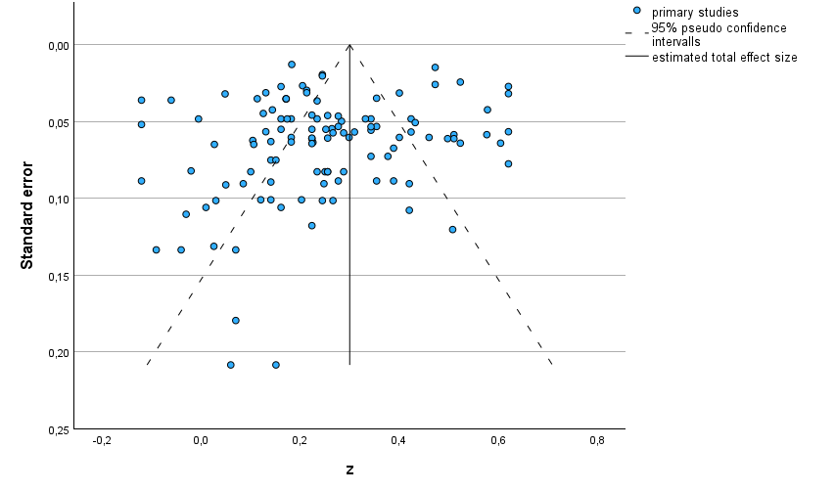
4.2: Perceptual and Cognitive Enhancement

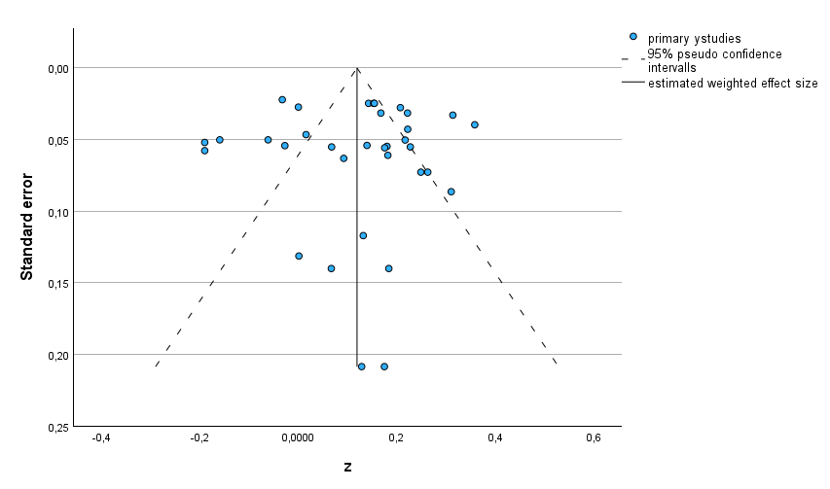

4.3 Social and Sexual Enhancement

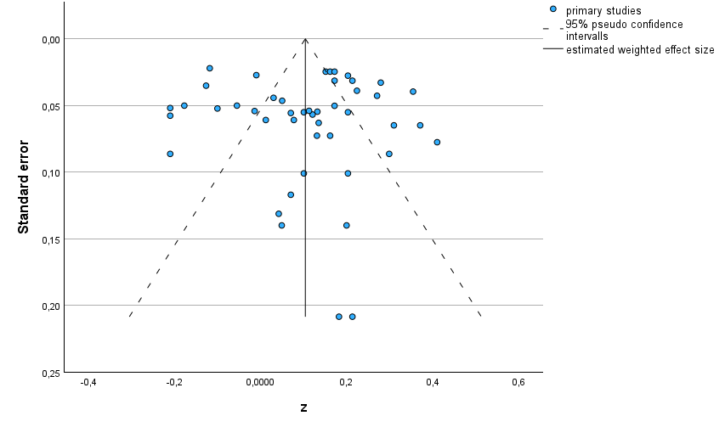
4.4 Tension Reduction
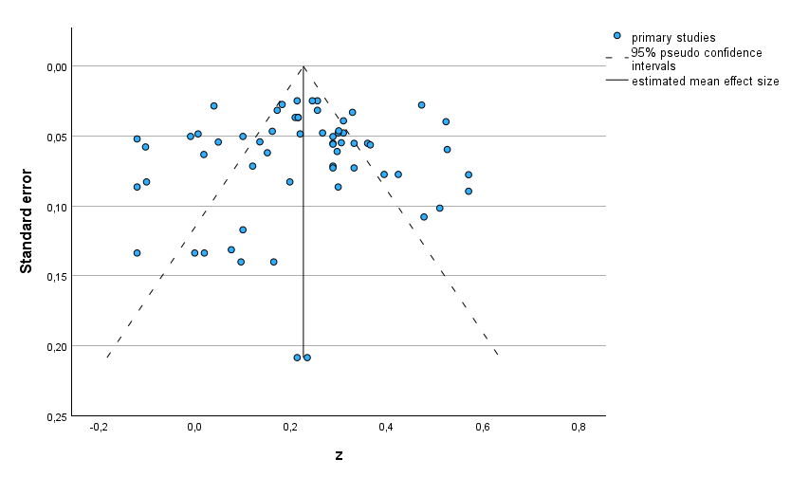

4.5 Expected Global Negative Effects

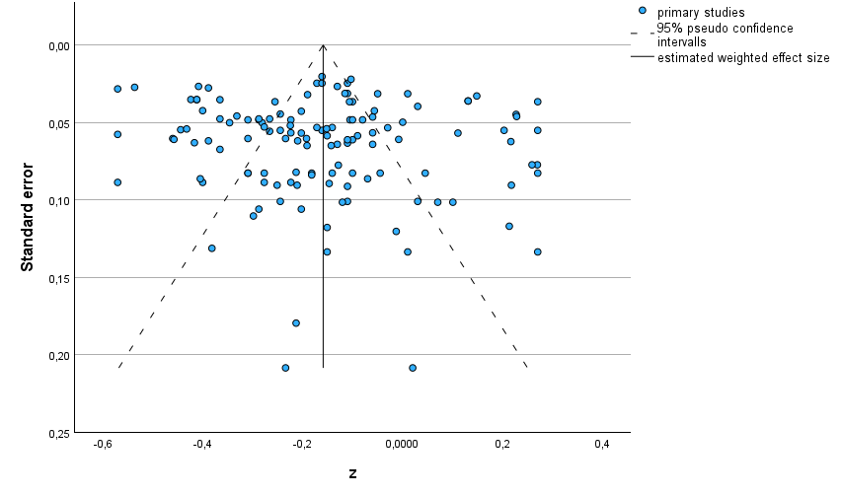
4.6 Cognitive and Behavioral Impairment

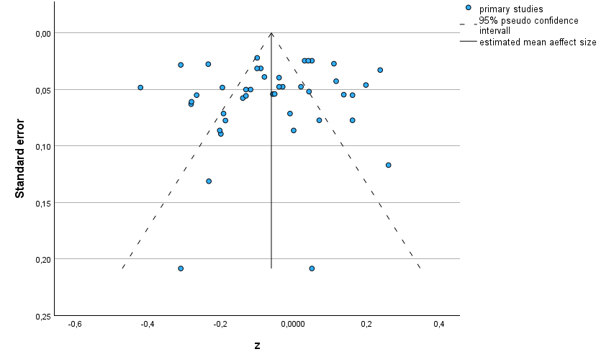

4.7 Craving and Physical Effects

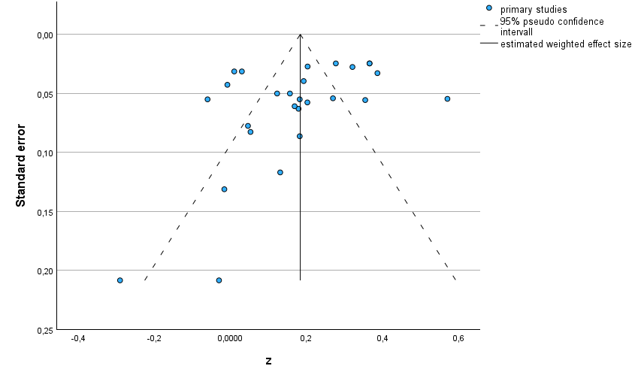
4.8 Association of Initial Global Positive OE with Change in Cannabis Use

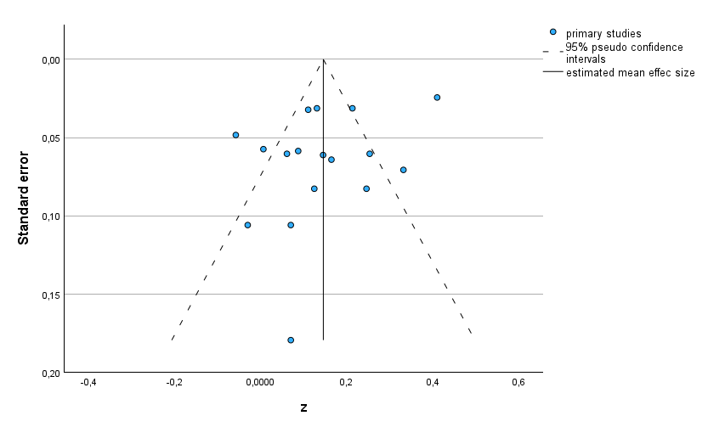

4.9 Association of Initial Global Negative OE with Change in Cannabis Use

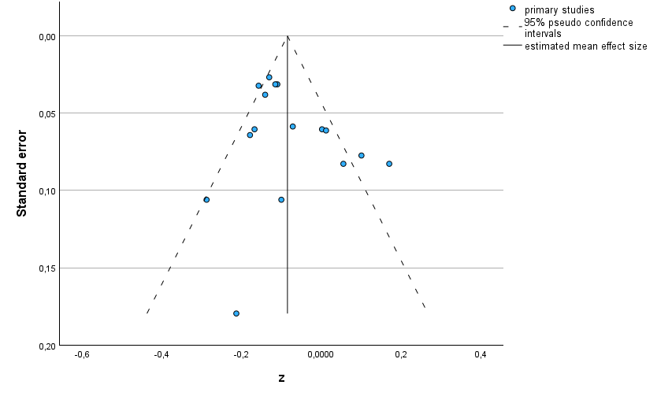

4.11. Associations of General Positive OE with Cannabis Use in Community Samples (Left) Versus Clinical Samples (Right)
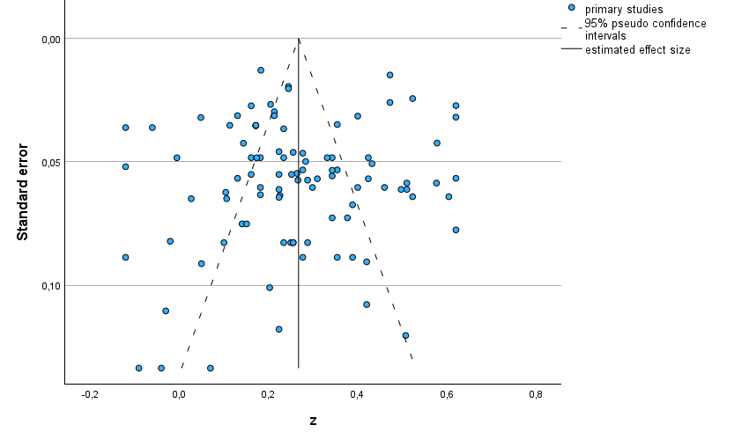 | 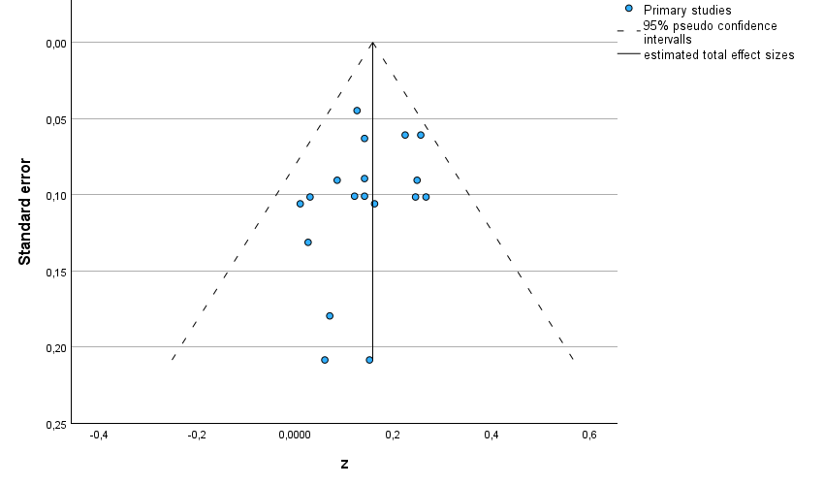

4.12. Associations of General Positive OE with Measures of Cannabis Use versus Cannabis Use Disorder
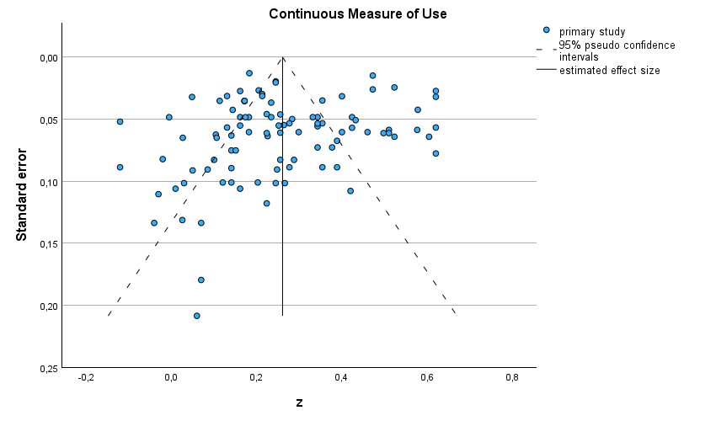 | 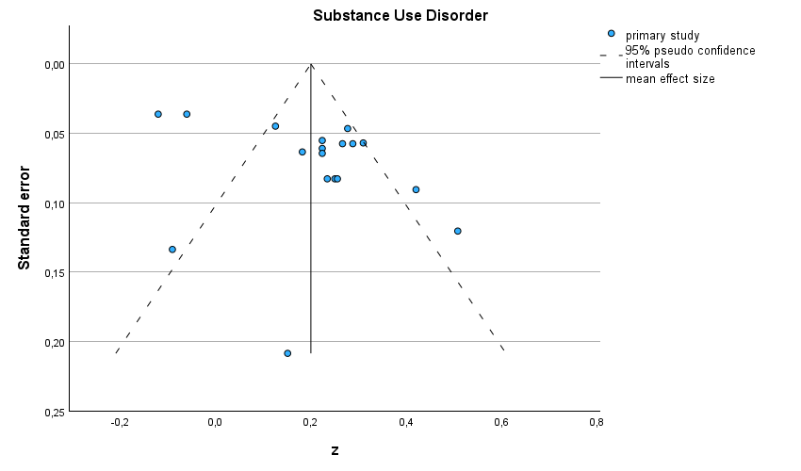

4.13 Associations of Validated Versus Non-Validated Measures General Positive OE with Cannabis Use

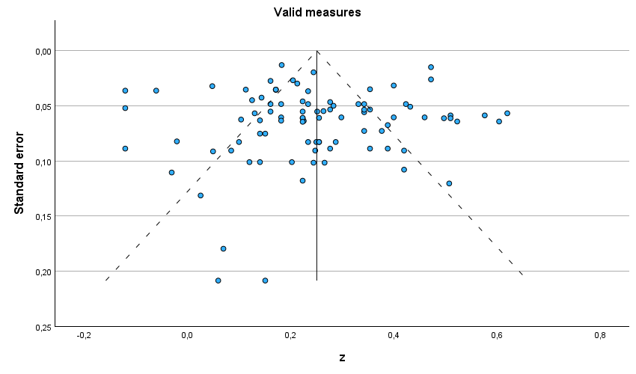 | 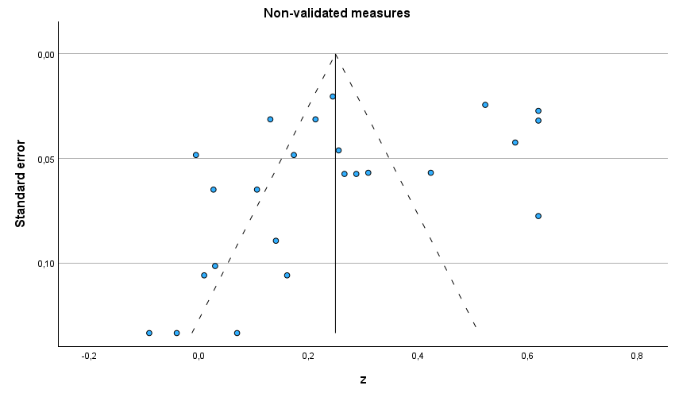

4.14 Associations of General Positive OE with Cannabis Use in Studies with High (80+) versus Low Response Rate

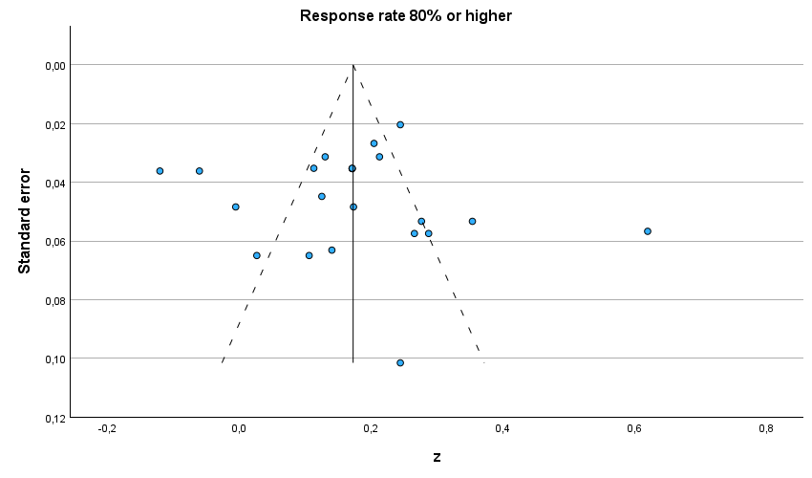 | 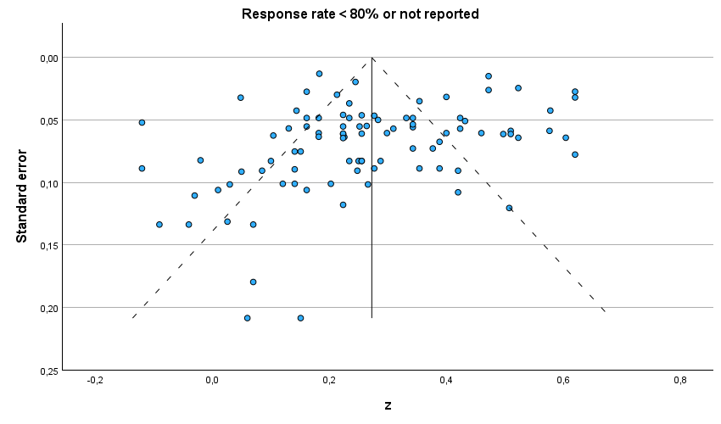

4.15 Associations of General Positive OE with Cannabis Use in Published and Unpublished Studies

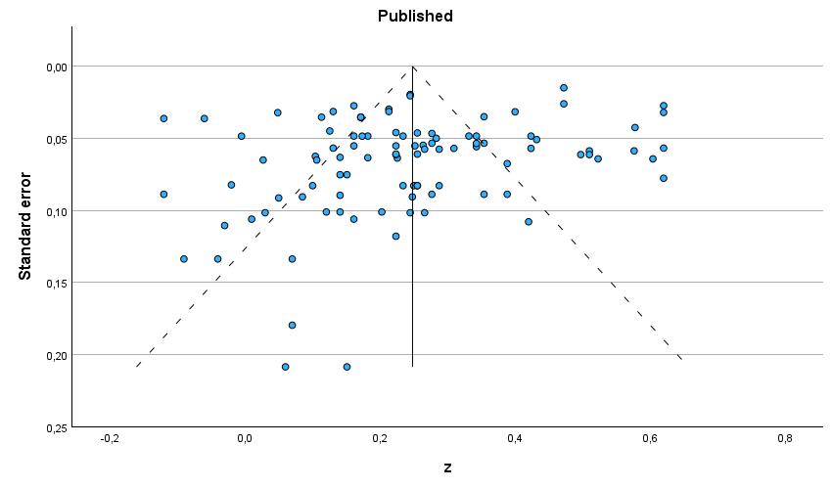 | 