Supplementary Material (S1)
The Burnout Syndrome Test (BST).

Instructions: Please rate the extent to which the statements below have been reflecting your experiences at work recently:
Item | Strongly disagree | Disagree | Neither agree nor disagree | Agree | Strongly agree | ICD-11 burnout criteria
1. I have felt exhausted about my work | 1 | 2 | 3 | 4 | 5 | “Feelings of energy depletion or exhaustion”
2. I have felt without energy to do my job | 1 | 2 | 3 | 4 | 5 | “Feelings of energy depletion or exhaustion”
3. I have felt worn out at work | 1 | 2 | 3 | 4 | 5 | “Feelings of energy depletion or exhaustion”
4. I have felt disconnected from my work | 1 | 2 | 3 | 4 | 5 | “Increased mental distance from one’s job, or feelings of negativism or cynicism related to one's job”
5. I have lost interest in my job | 1 | 2 | 3 | 4 | 5
6. I have felt mentally distant from my work | 1 | 2 | 3 | 4 | 5
7. I have felt less productive at work | 1 | 2 | 3 | 4 | 5 | “A sense of ineffectiveness and lack of accomplishment”
8. I have felt less accomplished at work | 1 | 2 | 3 | 4 | 5 | “A sense of ineffectiveness and lack of accomplishment”
9. I have felt unable to do my job effectively | 1 | 2 | 3 | 4 | 5 | “A sense of ineffectiveness and lack of accomplishment”
Note. Items 1-3 assess Energy Depletion, items 4-6 assess Mental Distance, and items 7-9 assess Professional Ineffectiveness, which are core symptoms of burnout syndrome, as defined in the ICD-11 (WHO, 2025).
Scoring information: Total scores are obtained by summing participants’ responses to all items of the BST (range from 9 to 45 points), with higher scores indicating greater levels of burnout syndrome symptoms. If necessary, disordered burnout syndrome can be identified by inspecting if participants endorsed all nine items of the BST (i.e., answering 4: Agree or 5: Strongly agree to all nine items).
Supplementary Material (S2)
Sample One: The sociodemographic characteristics and levels of burnout in the UK non-representative sample (n = 245).
Variable | Statistic | Minimum | Maximum
Age (years) (mean, SD) | 28.93 (8.31) | 18 | 69
Gender (n, %)
Male | 50 (20.41)
Female | 195 (79.59)
Education level (n, %)
Secondary school | 5 (2.04)
High school | 4 (1.63)
Vocational or technical training (after high school) | 5 (2.04)
Undergraduate degree (e.g., BSc, BA) | 96 (39.18)
Postgraduate degree (e.g., MSc, MA) | 124 (50.61)
Doctoral degree (e.g., PhD, Professional Doctorate) | 11 (4.49)
Relationship status (n, %)
Single | 86 (35.10)
In a relationship | 104 (42.45)
Married | 50 (20.41)
Separated | 3 (1.22)
Divorced | 2 (0.82)
Work contract (n, %)*
Full-time | 121 (49.59)
Part-time | 123 (50.41)
Work arrangement (n, %)*
Fully onsite | 122 (50.00)
Fully remote | 26 (10.66)
Hybrid | 96 (39.34)
Management position (n, %)
Top-lever manager | 11 (4.49)
Mid-level manager | 39 (15.92)
Other manager functions | 29 (11.84)
No managerial duties | 166 (67.76)
Work sector (n, %)
Public | 95 (38.78)
Private | 134 (54.69)
Self-employed/franchise | 16 (6.53)
Overtime (Do you usually work more hours than what is expected of you?) (n, %)*
Yes | 124 (50.82)
No | 120 (49.18)
Income (n, %)*
£0 - £9,999 | 53 (21.72)
£10,000 - £19,999 | 50 (20.49)
£20,000 - £29,999 | 45 (18.44)
£30,000 - £39,999 | 26 (10.66)
£40,000 - £49,999 | 21 (8.61)
£50,000 - £59,999 | 13 (5.33)
£60,000 - £69,999 | 6 (2.46)
£70,000 - £79,999 | 4 (1.64)
£80,000 - £89,999 | 5 (2.05)
£90,000 - £99,999 | 1 (0.41)
£100,000 or more | 9 (3.69)
Prefer to not say | 11 (4.51)
Organisational tenure (years) (mean, SD) | 3.77 (4.61) | 0 | 35
Weekly working hours (mean, SD) | 30.03 (13.07) | 0 | 60
Burnout levels (mean, SD)
Burnout Syndrome Test (BST) | 27.38 (8.67) | 9 | 45
Bergen Burnout Index (BBI) | 27.88 (9.87) | 9 | 54
Occupational burnout prevalence (BST; n, %) | 48 (19.59)
Note. * Work contract, work arrangement, overtime and income have one missing case, totalling (n = 244).

Supplementary Material (S3)
Sample One: The measurement model for the Burnout Syndrome Test (n = 245).
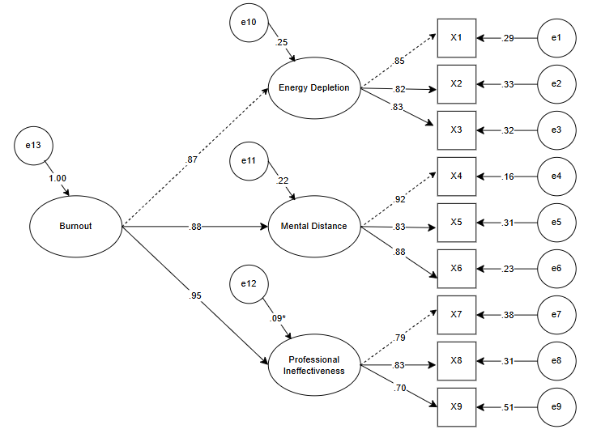
This diagram shows the standardised parameter estimates for the factorial structure of the Burnout Syndrome Test (BST). Circles indicate three latent factors energy depletion, mental distance and professional ineffectiveness, which are the subconstructs of burnout syndrome. Squares correspond to the nine items of the BST. S3 illustrates the findings of confirmatory factor analysis (CFA) of occupational burnout as measured by the BST (n = 245). All factor loadings are significant except for e12 to the Professional Ineffectiveness dimension. All residual variances are significant (p < .05). Dashed lines represent factor loadings that are fixed to 1.00 in the CFA model.

Supplementary Material (S4)
Sample Two: Item Response Theory (IRT) Analysis for the Burnout Syndrome Test (n = 758)
In response to reviewer feedback, Item Response Theory (IRT) analysis was conducted along with a Classical Test Theory (CTT) approach to provide a more comprehensive psychometric evaluation of the Burnout Syndrome Test (BST). IRT allows superior precision in estimating individual ability levels across different trait levels and provides detailed item-level information regarding the discrimination and difficulty parameters that complement the scale-level information provided by CTT methods.
To test that the BST demonstrates adequate item-level psychometric properties, a Graded Response Model (GRM) was applied to Sample Two (n = 758) to assess individual item functioning using IRT. The GRM is appropriate for ordinal Likert-type scales and estimates two key parameters: discrimination parameters (a; indicating how effectively items differentiate between burnout levels) and difficulty parameters (b; representing trait levels where respondents transition between response categories). The discrimination parameter criteria were: 1.35-1.69 = high, > 1.70 = very high (Baker, 2001). Difficulty parameters were evaluated based on the criterion that b values should range from -3 to 3 and need not increase monotonically due to parameter separability (Toland, 2013). This method provides a comprehensive evaluation of item performance across differing levels of burnout, allowing for detailed assessment of both research applications and clinical assessments where accurate gradation of symptom severity is essential for screening, diagnosis, and treatment planning. Moreover, Item Information Curves (IICs) and Test Information Curves (TICs) with Standard Error functions were generated to evaluate scale precision and reliability across different burnout levels. The area under each IIC indicates the precision of item-level burnout estimation (DeMars, 2010).
All analyses were conducted in R version 4.4.2 “Pile of Leaves” (R Core Team, 2024) and utilised the following package: mirt (v1.44; Chalmers, 2012) for IRT analysis using the GRM model (itemtype = "graded").
The findings of the IRT analysis provided strong evidence for the psychometric robustness of the BST. A unidimensional GRM demonstrated satisfactory convergence after 157 iterations (log-likelihood = -7,354.190). Standardised factor loadings (λ) ranged from .810 to .934, with high communalities (h² = .656 – .873), indicating that each item was strongly associated with the underlying burnout construct. The unidimensional model explained 77% of the total variance (SS loadings = 6.93), providing substantial support for the scale’s unidimensional structure (see S4 Table 1).
Item-level fit statistics based on S-X² indices indicated acceptable fit, with most items showing non-significant misfit (p > .05) and low item-level RMSEA values (.006 – .028). A small number of items evidenced marginally significant misfit (e.g., Items 1, 3, 5, 6, and 9), though effect sizes were minimal and did not raise substantive concerns regarding item performance (see S4 Table 2).
Discrimination (a) parameters ranged from 2.35 to 4.45, reflecting strong to very strong discrimination across all items, with Items 4 and 6 exhibiting the highest levels of precision in differentiating individuals along the burnout continuum (see Supplemental Table 2). Threshold (b) parameters were well-ordered and spanned broad θ ranges, with earlier thresholds (b1-b2) occurring at lower burnout levels (approximately -1.30 to -0.08) and later thresholds (b3-b4) reflecting endorsement of more severe burnout symptoms (approximately 0.16 to 2.22). This pattern indicates that the items are well-tuned to capture the increasing severity of burnout.
Inspection of IICs revealed that Items 4, 6, and 7 contributed the highest information peaks (approximately I(θ) ≈ 2.8-3.2) within the moderate to high trait range (θ ≈ 0.5-2.0). Item 2 also demonstrated comparatively high information across this range, while Items 1 and 3 provided broader but lower-intensity information, peaking around θ ≈ 0 to 1.5. The TIC demonstrated that the BST offers optimal measurement precision at moderate to above-average levels of burnout (θ ≈ 0–2.5), with diminishing precision toward lower and extremely high levels of burnout (see S4. Figures 1 and 2).
In sum, the IRT findings suggest that the BST is a psychometrically robust instrument that effectively differentiates individuals across varying levels of burnout severity. The scale demonstrates its greatest precision within moderate to high trait ranges, making it particularly well-suited for screening and assessment in clinical or occupational contexts where burnout symptoms are prevalent, although measurement precision tapers slightly at the extreme ends of the burnout continuum.
S4. Table 1
Factor Loadings and Communalities for the BST Items in the Graded Response Model (GRM) (n = 758).
Item | Factor Loading (λ) | Communality (h²)
1 | .812 | .660
2 | .901 | .811
3 | .810 | .656
4 | .927 | .860
5 | .883 | .780
6 | .934 | .873
7 | .909 | .826
8 | .897 | .805
9 | .814 | .662
Note. Sum of Squared Loadings = 6.932; Proportion of Variance Explained = .77.
S4. Table 2
Item Fit Statistics and Item Parameter Estimates (Graded Response Model) for the BST (n = 758).
Item | S-χ² | df | RMSEA | p-value | a | b₁ | b₂ | b₃ | b₄
1 | 95.369 | 63 | .026 | .005 | 2.371 | -1.229 | -0.072 | 0.435 | 1.584
2 | 58.311 | 48 | .017 | .146 | 3.525 | -1.211 | -0.083 | 0.342 | 1.543
3 | 94.699 | 64 | .025 | .008 | 2.348 | -1.302 | -0.283 | 0.162 | 1.419
4 | 49.097 | 43 | .014 | .242 | 4.223 | -0.982 | 0.034 | 0.455 | 1.523
5 | 86.968 | 55 | .028 | .004 | 3.206 | -0.993 | 0.049 | 0.549 | 1.416
6 | 65.702 | 42 | .027 | .011 | 4.454 | -0.908 | 0.026 | 0.443 | 1.463
7 | 45.314 | 44 | .006 | .417 | 3.703 | -1.095 | 0.038 | 0.446 | 1.585
8 | 59.528 | 44 | .022 | .059 | 3.458 | -1.159 | 0.036 | 0.528 | 1.731
9 | 88.529 | 59 | .026 | .008 | 2.384 | -0.883 | 0.527 | 1.086 | 2.218
Note: S-χ²= item-fit statistic; df = degrees of freedom; RMSEA = Root Mean Square Error of Approximation; p = value associated with item-fit statistic; a = item slope (discrimination) parameter; b = item threshold (difficulty, location) parameter.

S4. Figure 1
Item Information Curves for BST Items (n = 758).
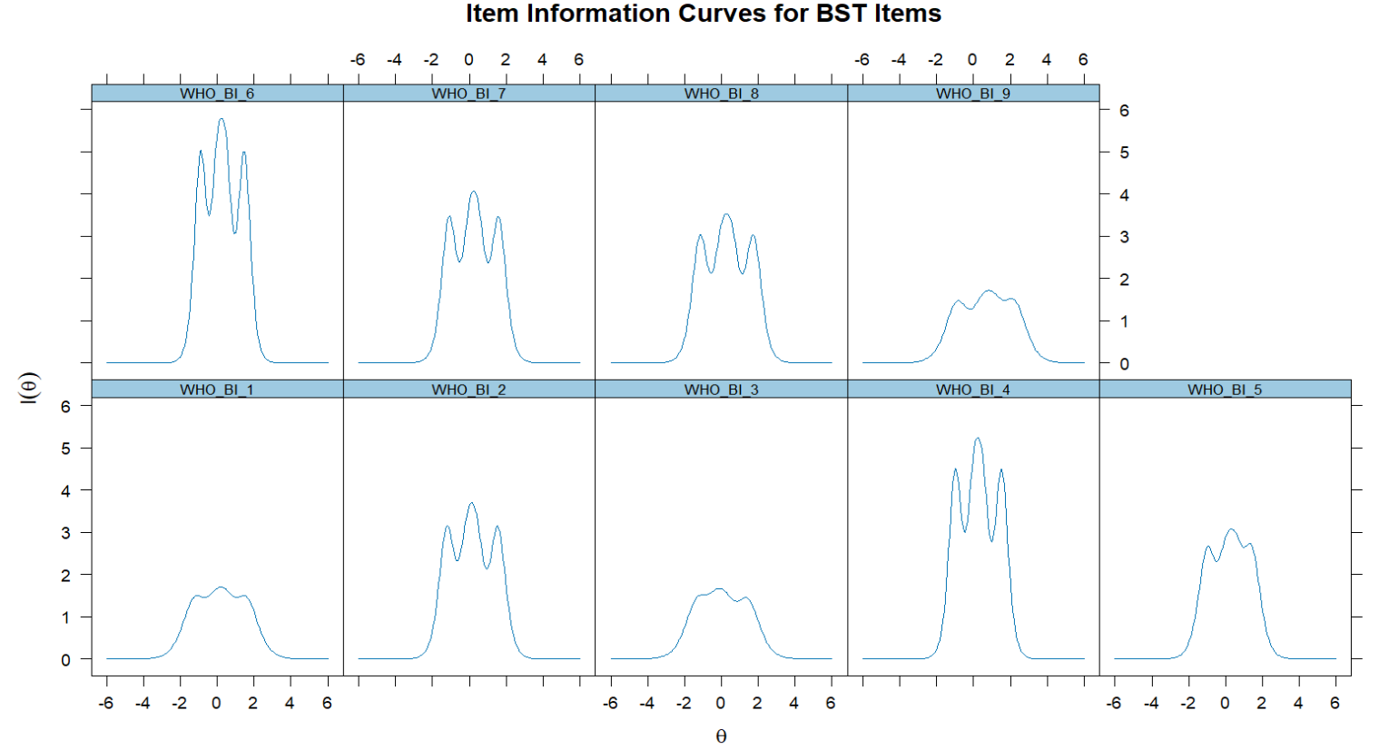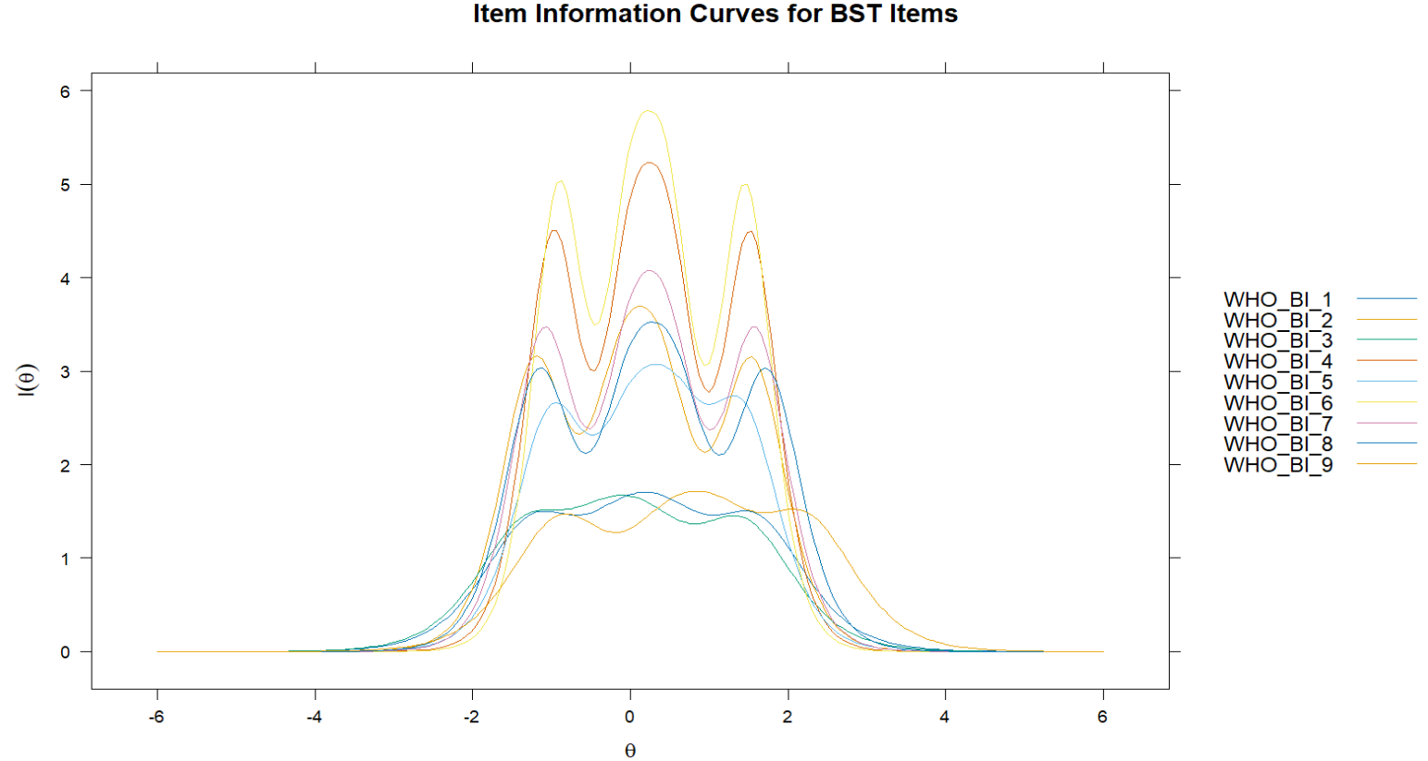
Each curve represents the information contribution of a single item across levels of θ.

S4. Figure 2
Test Information Curve with Standard Error for BST (n = 758)
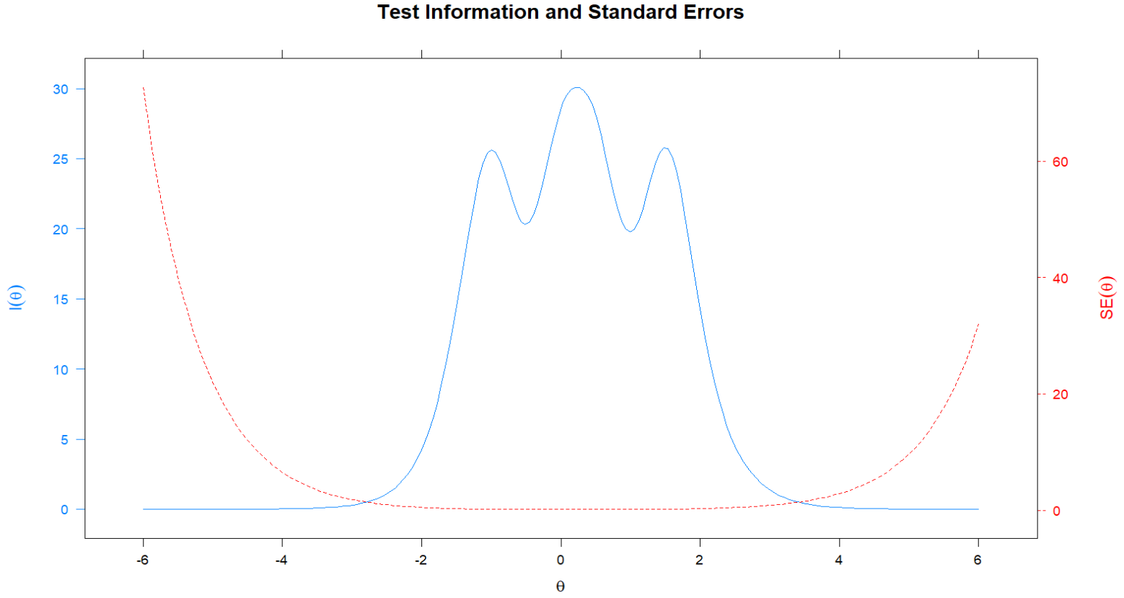Test information (blue) and standard error (red) plotted across the latent trait continuum.

References
Baker, F. B. (2001). The basics of item response theory (2nd ed). ERIC Clearinghouse on Assessment and Evaluation. https://eric.ed.gov/?id=ED458219
Chalmers, R. P. (2012). mirt: A Multidimensional Item Response Theory Package for the R Environment. Journal of Statistical Software, 48(6), 1–29. https://doi.org/10.18637/jss.v048.i06
DeMars, C. (2010). Item Response Theory. Oxford University Press. https://doi.org/10.1093/acprof:oso/9780195377033.001.0001
Toland, M. D. (2014). Practical Guide to Conducting an Item Response Theory Analysis. The Journal of Early Adolescence, 34(1), 120–151. https://doi.org/10.1177/0272431613511332
R Core Team. (2024). R: A language and environment for statistical computing. R Foundation for Statistical Computing. https://www.R-project.org/
World Health Organization. (2025). ICD-11: International classification of diseases (11th revision). https://icd.who.int/

