Supplemental Figure and Legends

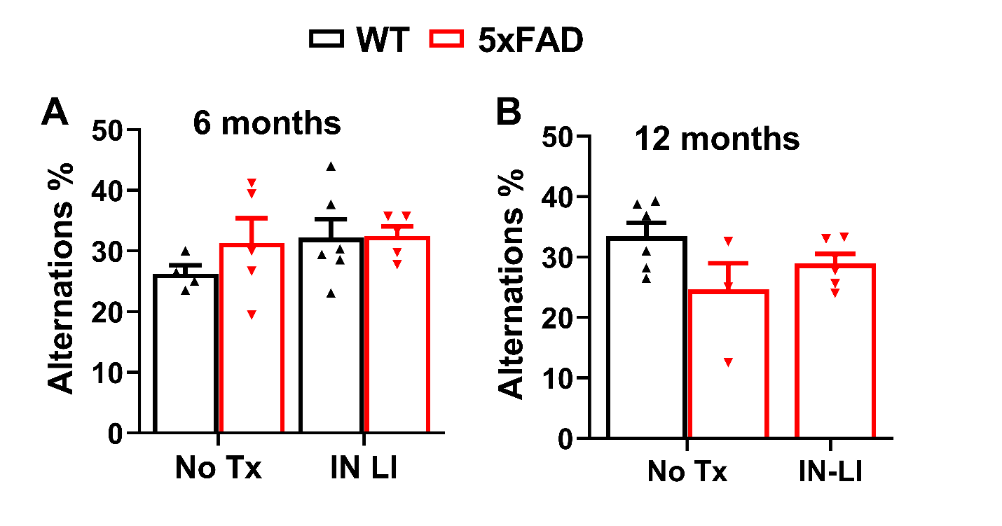

Supplemental Figure 1. Effects of intranasal LiCl in RFV on cognitive function assessed by Y-maze test in 5xFAD mice. Wild type (WT) or 5xFAD mice at 2 or 9 months of age received either no treatment (No Tx) or intranasal LiCl (IN LI, 3 mmol/kg) dissolved in RFV daily, Monday to Friday, for 12 consecutive weeks. Y-maze tests were performed at 6 (A) and 12 months of age (B), after completion of treatments. Data represents Means±SD from 4-6 mice (N=4-6) and was analyzed using the 2-way ANOVA followed by Tukey’s multiple comparison test.

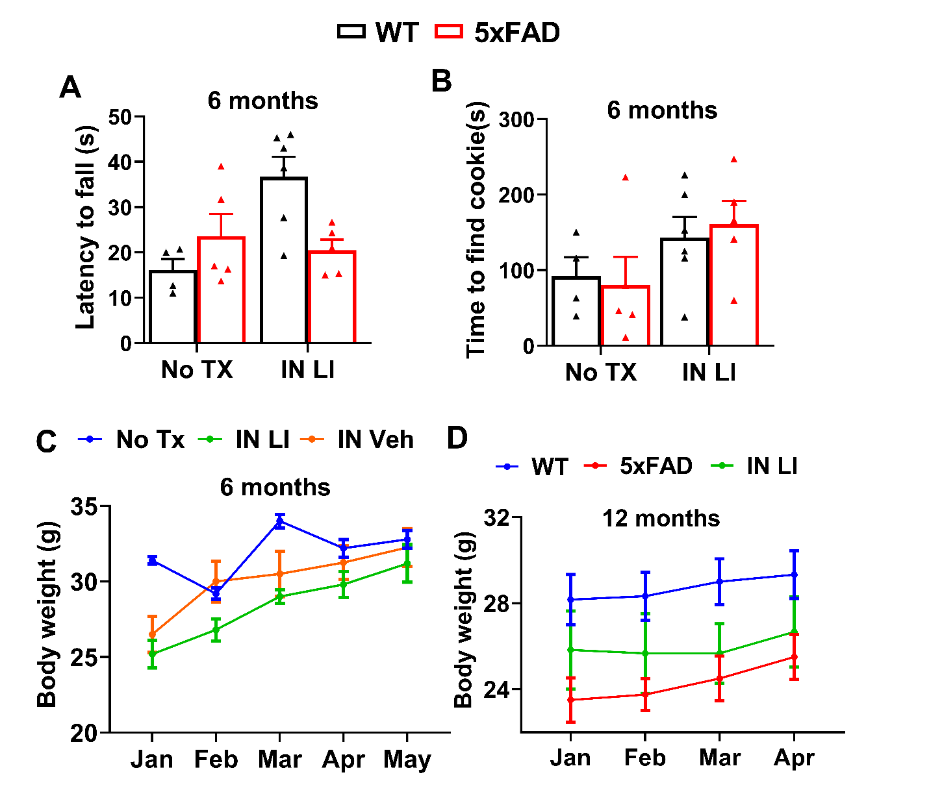
Supplemental Figure 2: Effects of intranasal LiCl in RFV on motor and smell functions and body weight. Wild type (WT) or 5xFAD mice received either no treatment (No Tx) or intranasal LiCl in RFV (INLI, 3 mmol/kg) for 12 consecutive weeks from 2 to 5 months of age. Motor (A) and olfactory (B) functions were determined by rotarod test and buried food test, respectively at 6 months of age. Body weights were determined monthly from the initiation of lithium treatment at 2 months of age (C) until the end of all behavioral tests at 12 months of age(D). Data are Means±SEM from 4-6 mice in each group.

