Electronic Supplementary Materials
Exploring the Relationship between Social Class and Quality of Life:
The Mediating Role of Power and Status
We conducted three additional, non-preregistered sets of analyses to assess the robustness of our findings. In these analyses, we a) controlled for potential effects of age and gender, b) addressed the overrepresentation of men in our sample using poststratification, and c) utilized income and education as more objective measures of social class (Dubois et al., 2015), compared to the social class ladder (Adler et al., 2000). Our results proved to be robust: Across all analyses status, but not power, significantly mediated the positive relationship between Quality of life and social class. Detailed results for these robustness checks are presented below. We also share our data, materials, and analyses at https://osf.io/jn7ze/?view_only=94d04b7b9ced49c8b737924df4b5ce31.

Controlling for Age and Gender
First, we reran our main analyses controlling for age and gender (women vs. men, excluding two non-binary participants from these analyses), by including their direct effects on social class in the mediation model (see Supplemental Figure 1). We observed similar results to our main analyses.
In all analyses, status was a highly significant mediator (see Supplemental Figure 1). This was indicated by the CIs not including zero: for physical health (b = 0.11, 95%-CI [0.08, 0.15]), mental health (b = 0.14, 95%-CI [0.10, 0.19]), social relationships (b = 0.16, 95%-CI [0.11, 0.22]), and environment (b = 0.11, 95%-CI [0.08, 0.15]). These positive indirect effects reflect that, in line with our main analysis, social class was positively associated with status, which in turn was positively associated with the different Quality of Life facets, even after controlling for power.
As in our main analysis, we found the opposite pattern for power. Whilst power was positively associated with social class, power was negatively associated with all four investigated Quality of Life facets, after controlling for status (see Supplemental Figure 1). The resulting negative indirect effects were significant for physical health (b = -0.06, 95%-CI [-0.09, -0.04]), but not for mental health (b = -0.02, 95%-CI [-0.06, 0.004]), nor social relationships (b = -0.02, 95%-CI [-0.06, 0.02]), nor environment (b = -0.03, 95%-CI [-0.07, -0.003]). Overall, these results mirror the findings of our main analyses (i.e., status, but not power, significantly mediated the positive relationship between Quality of life and social class) and thus suggest that our findings are robust to controlling for age and gender.
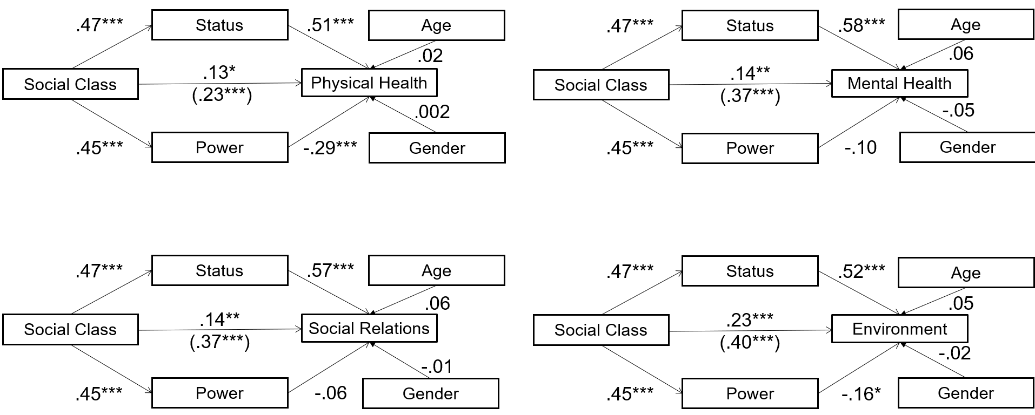
Supplemental Figure 1. Parallel mediation analyses involving power and status as dual, simultaneous mediators for the link between social class and physical health, mental health, social relations, and environment, controlling for effects of age and gender (0 = male, 1 = female). Values represent standardized path coefficients. Total effects are presented in parentheses.
Using Poststratification to Correct for the Overrepresentation of Men
Second, since male respondents were over-represented in our sample compared to the US-population, we tested whether this sample bias affected our results. Therefore, we utilized poststratification, a statistical adjustment technique that assigns different weights to observations from different groups (in this case men and women, excluding two non-binary participants from these analyses). The resulting weighted dataset is then used in analyses and thereby reconciles known differences between sample and population (Peress, 2010; Winship & Radbill, 1994). We weighted our dataset to match the gender distribution in the US general population, using the R-package survey (Lumley, 2020) and repeated our main analyses using this weighted dataset and the R-package lavaan.survey (Oberski, 2014). Since bootstrapped confidence intervals, which we used in our main analyses, were not available in the R-package lavaan.survey, we utilized default p-values for these analyses.
In all analyses, status was a highly significant mediator (see Supplemental Figure 2). This was indicated by significant indirect effects: for physical health (b = 0.10, p < .001) mental health (b = 0.13, p < .001), social relationships (b = 0.16, p < .001), and environment (b = 0.11, p < .001),
As in our main analysis, we found the opposite pattern for power. Whilst power was positively associated with social class, power was negatively associated with all four investigated Quality of Life facets, after controlling for status (see Supplemental Figure 2). The resulting negative indirect effects were significant for all facets: physical health (b = -0.06, p < .001), mental health (b = -0.03, p = .009), social relationships (b = -0.03, p = .016), and environment (b = -0.04, p < .001). The results were in line with our main findings and again indicated that status, but not power, significantly mediated the positive relationship between. Interestingly, in these analyses power not only had a negative indirect effect on physical health and environment (as in our main analyses) but even on mental health and social relations.
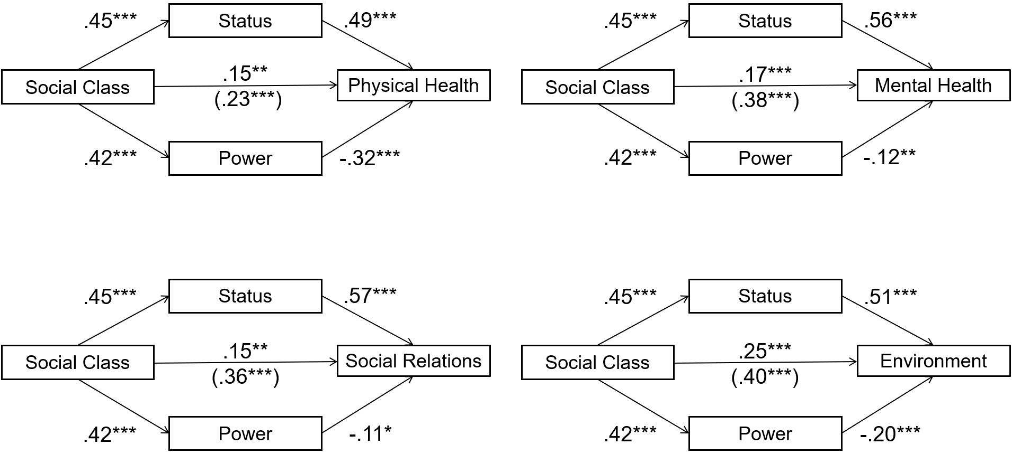
Supplemental Figure 2. Parallel mediation analyses involving power and status as dual, simultaneous mediators for the link between social class and physical health, mental health, social relations, and environment. Analyses were conducted after weighting the dataset to account for the overrepresentation of men. Values represent standardized path coefficients. Total effects are presented in parentheses.

Using a More Objective Measure of Social Class
Third, whereas we relied on the subjective social class ladder (Adler et al., 2000) to measure social class in our main analyses, social class can also be construed more objectively through education and household income (Dubois et al., 2015). One benefit of relying on these more objective scales is that it allows reducing common method variance, which could have artificially inflated the correlation between Quality of Life and social class (Lindell & Whitney, 2001). Therefore, we constructed a more objective social class measure, by summing the standardized scores of education and income. This objective social class measure correlated strongly with our subjective social class measure, r(380) = .53, p < 001. We then repeated our central analyses using this objective measure of social class. However, we again observed similar results to our main analyses.
In all analyses, status was a highly significant mediator (see Supplemental Figure 3). This was indicated by the CIs not including zero: for physical health (b = 0.08, 95%-CI [0.04, 0.12]), mental health (b = 0.10, 95%-CI [0.06, 0.15]), social relationships (b = 0.11, 95%-CI [0.07, 0.17]), and environment (b = 0.08, 95%-CI [0.05, 0.12]). These positive indirect effects reflect that objective social class was positively associated with status, which in turn was positively associated with the different Quality of Life facets, even after controlling for power.
As in our main analyses, we found the opposite pattern for power. Whilst power was positively associated with objective social class, power was negatively associated with all four investigated Quality of Life facets, after controlling for status (see Supplemental Figure 3). The resulting negative indirect effects were significant for physical health (b = -0.03, 95%-CI [-0.06, -0.01]), but not for mental health (b = -0.01, 95%-CI [-0.03, 0.01]), social relationships (b = -0.01, 95%-CI [-0.03, 0.02]), nor environment (b = -0.01, 95%-CI [-0.04, 0.01]). The results were in line with our main findings and again indicated that status, but not power, significantly mediated the positive relationship between.

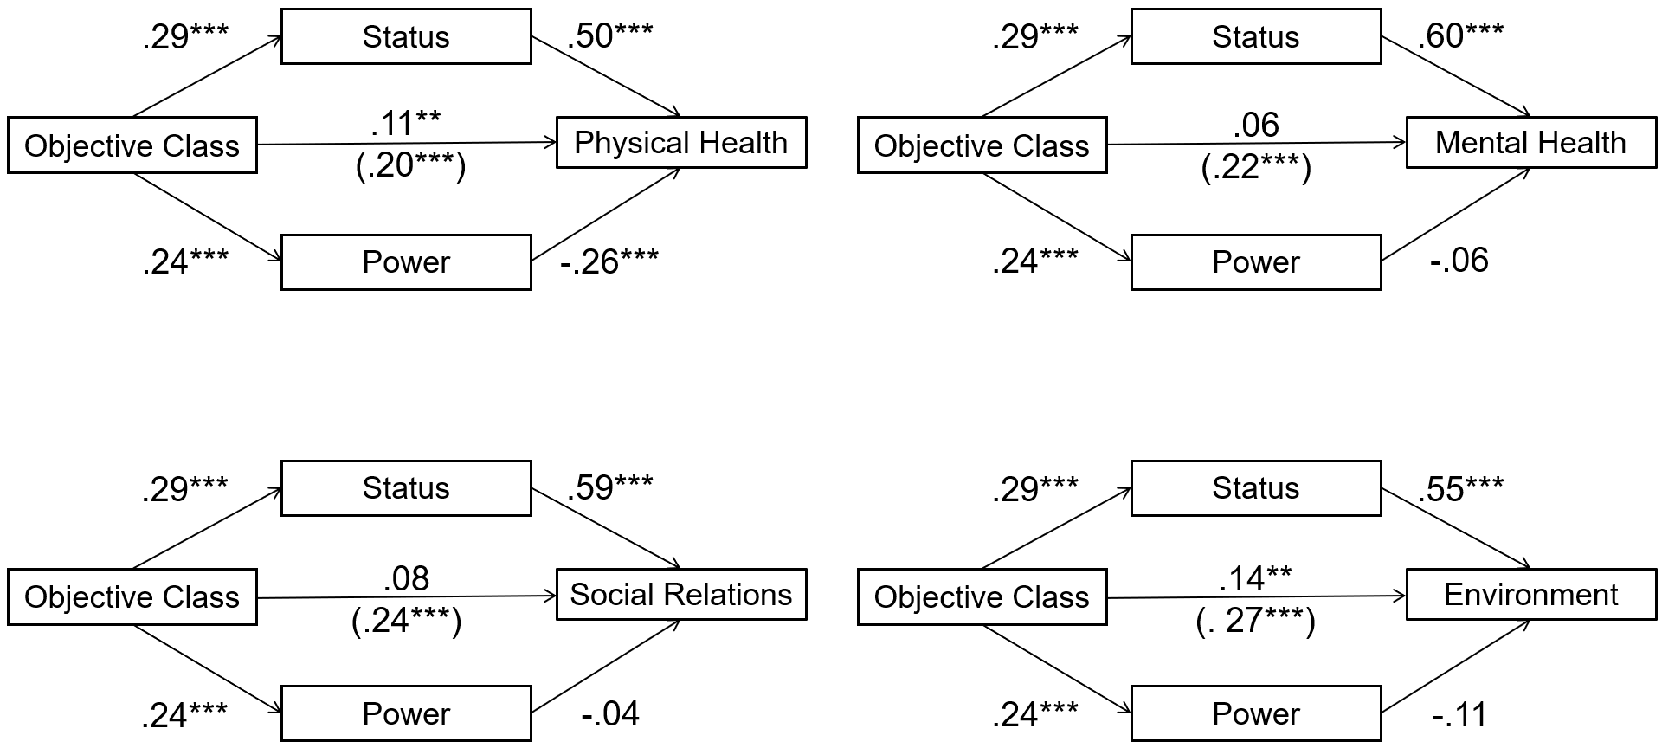
Supplemental Figure 3. Parallel mediation analyses involving power and status as dual, simultaneous mediators for the link between objective social class and physical health, mental health, social relations, and environment. Values represent standardized path coefficients. Total effects are presented in parentheses.

Supplemental References
Adler, N. E., Epel, E. S., Castellazzo, G., & Ickovics, J. R. (2000). Relationship of subjective and objective social status with psychological and physiological functioning: Preliminary data in healthy, White women. Health Psychology, 19, 586.
Dubois, D., Rucker, D. D., & Galinsky, A. D. (2015). Social class, power, and selfishness: When and why upper and lower class individuals behave unethically. Journal of Personality and Social Psychology, 108, 436.
Lindell, M. K., & Whitney, D. J. (2001). Accounting for common method variance in cross-sectional research designs. Journal of Applied Psychology, 86, 114.
Lumley, T. (2020). Package ‘survey’. In 2014-04-06]. Http://faculty. Washington. Edu/tlumley/survey.
Oberski, D. (2014). lavaan. survey: An R package for complex survey analysis of structural equation models. Journal of Statistical Software, 57, 1–27.
Peress, M. (2010). Correcting for survey nonresponse using variable response propensity. Journal of the American Statistical Association, 105, 1418–1430.
Winship, C., & Radbill, L. (1994). Sampling weights and regression analysis. Sociological Methods & Research, 23, 230–257.

