Online Resource

Article Title: Measuring Regional Variations in US Population-Level Health-Related Quality of Life During COVID-19 Using the EQ-5D-5L

Journal Name: Applied Research in Quality of Life

Contents

A1. Supplemental Methods 2
A1.1 Pre-Imputation Data Processing 2
A1.2 Multiple Imputation Method 2
A1.3 Multiple Imputation Predictor Selection 2
A1.4 Multiple Imputation Model Forms 3
A1.5 Final Imputation 3
A.1.6 Weighting 3
A2. Supplemental Results 11
A2.1 Imputation and Weighting 11
A2.2 Survey Demographics and COVID-19 Responses 14
A2.3 Supplemental EQ-5D-5L Results 18
A2.3 Sensitivity Analysis Results 25
A3. Online Resource References 32

A1. Supplemental Methods

A1.1 Pre-Imputation Data Processing

Survey subjects could participate in one, two, or all three survey waves. Thus, observations from the three timepoints are nested within respondents, thereby generating data with a multilevel (i.e., clustered by unique respondent) structure. Let’s define level-1 variables as those that can vary both between respondents and within respondents over time (time-varying). Level-2 variables are those at the respondent level that can vary only between respondents, but are not expected to vary over time (time-invariant). Although self-reported gender can change over time (as opposed to biological sex), it was assumed to be time-invariant within the ~10-month study period. Race and ethnicity are also level-2 while all other variables are level-1.

Missing level-2 variables were filled with information from other waves where possible. In some cases, respondents provided inconsistent responses to level-2 variables across waves. For 6 (0.1%) respondents with inconsistent self-reported gender across waves, their gender was assigned to the “Transgender or Non-Binary” category in all waves, thereby permitting the variable to be time-invariant while maintaining the possibility of having changed genders between waves.

For 233 (4.9%) respondents who identified themselves as “multi-race” in one wave and another race in others, “multi-race” was assigned for all waves. For 18 (0.4%) respondents who identified themselves as “Hispanic” ethnicity in one wave and “non-Hispanic” in others, “Hispanic” was assigned for all waves to prevent underrepresentation of Hispanic individuals in the sample. This assumes that respondents who considered themselves Hispanic at any point in the survey period are likely to be at least partially Hispanic.

Positive indications in earlier waves of history of chronic disease, diagnosis of COVID-19 in self, symptoms of COVID-19 in self, and diagnosis of COVID-19 in another were carried forward to fill missing values in these level-1 variables in later waves.

A1.2 Multiple Imputation Method

Fully conditional specification (FCS) was employed to impute the missing data on a variable-by-variable basis.^{1,2} The FCS method requires specification of an imputation model for each incomplete variable and creates imputations per variable in an iterative fashion.

FCS was chosen over joint modeling (JM), an alternative MI method based on the assumption that the data can be described by a multivariate distribution, whereby imputations are created as draws from the fitted multivariate distribution of the incomplete variables.³

While JM is said to have a better theoretical basis and is less computationally intensive than FCS,³ FCS allows for great flexibility in creating multivariate models and was shown to be more robust under misspecification than JM.⁴ FCS was also found to outperform JM on every metric when the variable to be imputed is categorical,⁵ a notable benefit given that most variables to be imputed in this study (i.e., imputation target variables) are of nominal and ordinal scales.

A1.3 Multiple Imputation Predictor Selection

As a general rule, using all available information yields multiple imputations that have minimal bias and maximal efficiency, so it is often beneficial to choose as large a number of predictors as possible.^{6,7} Including as many predictors as possible also tends to make the missing at random (MAR) assumption more plausible.⁸ The MAR assumption for MI posits that the missing data mechanism is unrelated to the unobserved values after accounting for the observed data.

Conditioning on all data is often reasonable for small to medium datasets containing up to 20–30 variables. However, for datasets containing hundreds or thousands of variables, using all predictors may not be feasible due to multicollinearity and computational problems.³

The survey data contained a total of 100 variables (353 columns in the model contrast matrix), including several other HRQoL measures in addition to the EQ-5D-5L and the potential effect modifiers in Online Resource Table 2. The correlation matrix of all variables in the data revealed that some additional HRQoL measures were moderately to strongly correlated with one another and with the EQ-5D-5L. Given the relatively large number of variables and increased likelihood of multicollinearity, predictors were selected for each target variable’s imputation model based on the strategy proposed by Stef van Buuren.³

Van Buuren’s imputation methodology recommends that selected predictors include (1) all non-collinear, non-combination, and non-administrative covariates and outcomes of interest appearing in the complete-data model, (2) variables known to have influenced occurrence of missing data, and (3) variables that explain a considerable amount of variance in the imputation target variable, excluding (4) variables selected in steps 2 and 3 that have too many missing values within the subgroup of incomplete cases.

All covariates and outcomes of interest were included as predictors except for “state” and “occupation”, which are collinear with “region-division” and “currently employed”, respectively, and “survey date”, which is an administrative variable.

While including outcomes as predictors in the imputation of covariates may seem counterintuitive and like a “self-fulfilling prophecy,” excluding outcomes in MI will yield biased estimates.^{9,10} This follows from Bayes rule: if the outcome is conditionally dependent on the covariates, then the imputation model for the covariates will be incorrect unless it includes the outcome as a predictor.

No variables were known a priori to directly influence the occurrence of missing data, so all variables not appearing in the complete-data model were additionally eligible for inclusion.

To reduce the likelihood of multicollinearity, variables not appearing in the complete-data model that were at least moderately correlated with others were excluded as predictors, identified via pairwise Spearman's correlation of |0.6| or greater among complete cases. The remaining eligible variables were included if their proportion of complete cases did not fall below 0.6. At this point, all imputation models included 50 or fewer predictors, so step 3 of van Buuren’s selection strategy was not applied.

The correlated nature of some observations, resulting from respondents participating in more than one survey wave, was accounted for in the imputation models via the clustering variable, respondent unique ID.

For imputation models of level-1 (time-varying) targets, predictors include the clustering variable, respondent ID, in addition to the selected level-1 and level-2 variables. This is equivalent to formulating separate regression models for each cluster (i.e., unique respondent) and imputing within clusters from these models.

For imputation models of level-2 (time-invariant) targets, predictors include selected level-2 variables and cluster means of selected level-1 variables. Rather than including respondent ID as a predictor, it is denoted as the clustering indicator to instruct the imputation software to perform imputation at the cluster (respondent) level, whereby the same imputed value is assigned to all missing observations within the cluster.

A1.4 Multiple Imputation Model Forms

The imputation algorithm requires the model form to be specified for each incomplete variable. Model form is largely determined by the measurement scale, or class, of the variable to be imputed. For binary, ordinal, and nominal variables, the default forms are logistic, proportional odds, and polytomous logistic, respectively. Other available methods can impute incomplete variables of any class, such as predictive mean matching (PMM), a hot deck method, and classification and regression trees (CART) or random forest (RF), machine learning methods.³ The advantages and disadvantages of the various options for model form are listed in Online Resource Table 3.

To compare model form options, each target variable was imputed five times for each of the four methodologies: first using its class-specific default, then using PMM, then using CART, and last using RF. Each imputation resulted in five multiply-imputed datasets (MIDS) generated in 20 iterations per dataset. Each method was assessed based on algorithm convergence via trace plots and distributional fit to the observed data via Kullback-Leibler (KL) divergence scores. The method with the closest distributional fit and good convergence was selected for a final imputation to generate the complete dataset to be used in analysis moving forward.

A1.5 Final Imputation

Following selection of predictors, model specification, and model form (i.e., methodology) for each target variable, the final imputation algorithm was run (Online Resource Tables 4 and 5). Since both the point estimates and standard errors of imputation were of primary interest and overall missingness was moderate, 100 MIDS generated in 20 iterations per dataset was determined to be sufficient.^{3,11,12}

A.1.6 Weighting

By opting in to participate in the survey, respondents were sampled on the basis of their accessibility and availability via MTurk. Despite establishment of informal sampling quotas, some demographics of respondents were found to be dissimilar to the US adult population. Individuals underrepresented in the survey included respondents aged 18-24 and 65+, of Hispanic ethnicity, of Black, American Indian/Alaska Native, Asian, and White races, with annual incomes less than $20,000/year, $35,000-$49,999/year, and $100,000+/year, with education levels equivalent to some college or less, and with overweight and obese BMIs. Conversely, individuals overrepresented in the survey included respondents with multiple or other races, with annual incomes $20,000-$34,000/year and $50,000-$99,999/year, with associate, bachelor’s, and graduate degrees, with underweight BMI, and with self-reported history of chronic diseases.

Weighting of survey responses was performed to improve the representativeness of the sample and mitigate biases from sampling and data collection.¹³ Specifically, raking (a.k.a., iterative proportional fitting), a nonparametric method, was employed to iteratively adjust response weights until the sample distribution of selected characteristics aligned with the US adult population. Raking was chosen over other parametric weighting methods such as matching or propensity weighting as it is relatively simple to implement and requires only the marginal proportions of categorical weighting characteristics in the target population rather than case-level data.^{14,15}

Weights derived from raking can reduce the discrepancy between the sample and target population, thereby improving representativeness, but are likely to be problematic if too large, causing overweighting of sparse groups and increasing variance in the data. Arbitrary trimming of weights can decrease variance but may introduce selection bias.¹⁵ In other words, raking necessitates a trade-off between representativeness and detection of significant effects.

The raking algorithm generates a cross-classification table of the categories of weighting characteristics in the sample and iteratively adjusts the weights on each cell until their marginal proportions equal the marginal proportions in the target population. To ensure algorithm convergence, the cross-classification must not contain empty cells. Raking should be configured in a manner that avoids imposing too many marginal constraints on the sample, avoids defining marginal categories containing very small proportions of the sample, and avoids imposing contradictory constraints on the sample.¹⁶ In this sense, selection of a few key weighting characteristics is consequential to successful raking.

Ideally, weighting characteristics should be related to nonresponse and/or noncoverage and exhibit an association with outcome variables to minimize bias. In practice, variables not strongly related to outcomes, nonresponse, or noncoverage may also be desirable to preserve the “face validity” of the sample.¹⁵

Because both sampling probability and HRQoL were postulated to be a function of demographics and socioeconomic status, variables age, gender, race, ethnicity, and education were chosen as weighting characteristics. These variables had low nonresponse rates and did not contain many categories. Their marginal distributions were easily attainable, drawn from the Public Use Microdata Sample (PUMS) files of the Current Population Survey Annual Social and Economic Supplement (CPS ASEC) fielded in March 2020.¹⁷

At the time of analysis, there was no available data on the US distribution of self-reported gender categorized as “Female”, “Male” and “Transgender or Non-Binary” as in the survey. For the purposes of raking, the marginal proportions of these categories were derived from the estimate of 1.6% transgender/non-binary adults in the US from the Pew Research Center’s American Trends Panel,^{18,19} and the estimate of 51.3% females and 48.7% males in the US from the CPS ASEC. The proportion of females and males was applied to the 98.4% assumed to be neither transgender nor non-binary, resulting in target marginal proportions of 50.5% females, 47.9% males, and 1.6% transgender/non-binary for weighting.

Raking was performed on each of the 100 MIDS generated from imputation (i.e., the “within” approach) using the R package ANESRAKE.²⁰ Following imputation and weighting, the 100 MIDS were pooled for analysis using Rubin’s rules.^{8,21} To inspect the impact of imputation and raking on outcomes, KL divergence scores and plots were generated for EQ-5D-5L measures comparing their distributions in the observed (unimputed and unweighted) data versus in the pooled and weighted MIDS.

Online Resource Figure 1. Map of US Region-Divisions
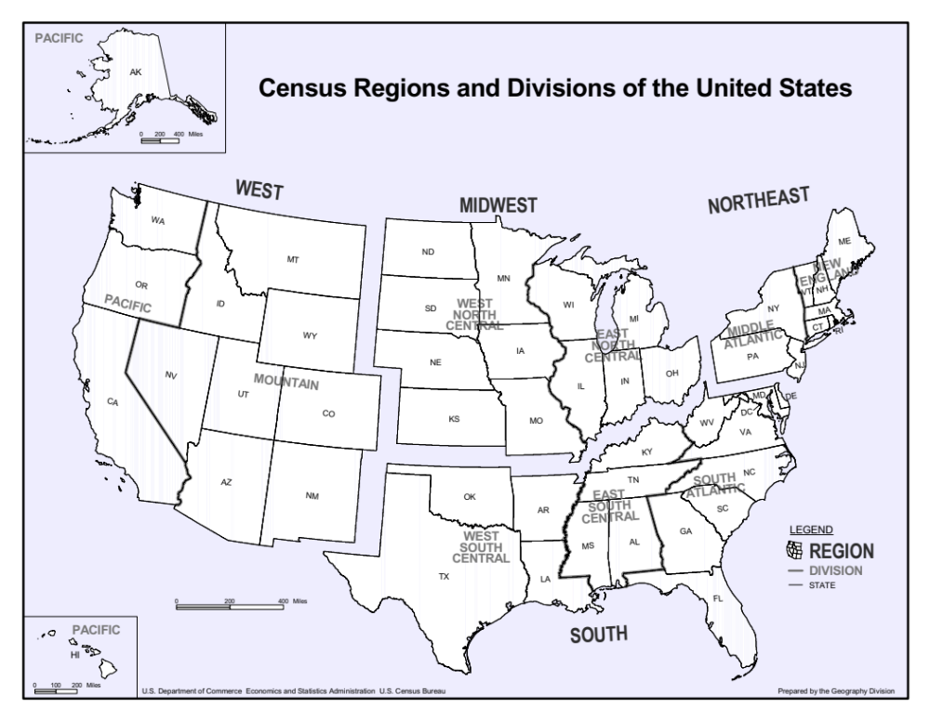

Online Resource Table 1. Missingness in Outcomes of Interest
Outcomes of Interest | Missingness [n (%)]
Outcomes of Interest | Wave 1 (n=2734)* | Wave 2 (n=2454)* | Wave 3 (n=2252)*
EQ-5D-5L Mobility | 0 (0) | 3 (0.12) | 0 (0)
EQ-5D-5L Self-Care | 0 (0) | 3 (0.12) | 0 (0)
EQ-5D-5L Usual Activities | 0 (0) | 0 (0) | 0 (0)
EQ-5D-5L Pain & Discomfort | 2 (0.07) | 3 (0.12) | 0 (0)
EQ-5D-5L Anxiety & Depression | 0 (0) | 0 (0) | 0 (0)
EQ-5D-5L VAS | 4 (0.15) | 0 (0) | 0 (0)
Total | 6 (0.22) | 7 (0.29) | 0 (0)
*Counts are unweighted

Online Resource Table 2. Missingness in Covariates of Interest
Covariates of Interest |  | Missingness [n (%)]
Name | Levels | Wave 1 (n=2734)* | Wave 2 (n=2454)* | Wave 3 (n=2252)*
State | 50 US states and Washington DC | 2 (0.07) | 0 (0) | 0 (0)
Region-Division | New England; Middle Atlantic; East North Central; West North Central; South Atlantic; East South Central; West South Central; Mountain; Pacific | 2 (0.07) | 0 (0) | 0 (0)
Age | (continuous) | 0 (0) | 0 (0) | 0 (0)
Gender | Male; Female; Transgender or Non-Binary | 24 (0.88) | 18 (0.73) | 22 (0.98)
Race | American Indian or Alaska Native; Asian; Black or African American; Native Hawaiian or Other Pacific Islander; White; Multi-race; Other | 11 (0.4) | 9 (0.37) | 122 (5.42)
Ethnicity | Hispanic; Non-Hispanic | 15 (0.55) | 23 (0.94) | 9 (0.4)
Education | Less than high school degree; High school degree or equivalent; Some college but no degree; Associate degree; Bachelor’s degree; Graduate degree | 0 (0) | 0 (0) | 3 (0.13)
Marital Status | Divorced; Married; Separated; Single; Widowed | 25 (0.91) | 11 (0.45) | 19 (0.84)
Annual Income | Less than $20,000; $20,000 to $34,999; $35,000 to $49,999; $50,000 to $74,999; $75,000 to $99,999; $100,000 to $149,999; Over $150,000 | 2 (0.07) | 1 (0.04) | 0 (0)
Health Insurance** | Yes; No | 1943 (71.07) | 22 (0.9) | 26 (1.15)
Political Affiliation | Democrat; Republican; Independent/Other | 89 (3.26) | 67 (2.73) | 57 (2.53)
Live Alone | Yes; No | 461 (16.86) | 1 (0.04) | 0 (0)
Tobacco Smoking | Never; In the past; Currently | 545 (19.93) | 2 (0.08) | 0 (0)
BMI | Underweight; Normal weight; Overweight; Obesity | 545 (19.93) | 1 (0.04) | 1 (0.04)
Diagnosis of COVID-19 in Self | Yes; No | 0 (0) | 0 (0) | 0 (0)
Symptoms of COVID-19 in Self | Yes; No | 92 (3.37) | 0 (0) | 0 (0)
Diagnosis of COVID-19 in Another | Yes; No | 3 (0.11) | 1 (0.04) | 0 (0)
Fear of COVID-19’s Health Impact | Scale of 0-10 (0=no fear; 10=extreme fear) | 0 (0) | 0 (0) | 0 (0)
Fear of COVID-19’s Financial Impact | Scale of 0-10 (0=no fear; 10=extreme fear) | 0 (0) | 0 (0) | 0 (0)
Under Mandatory Social Distancing | Yes; No | 461 (16.86) | 0 (0) | 0 (0)
Support for Social Distancing | Scale of 0-10 (0=no support; 10=full support) | 461 (16.86) | 0 (0) | 0 (0)
Income Change | Reduced; No change; Increased | 451 (16.5) | 0 (0) | 0 (0)
Currently Employed | Yes; No | 8 (0.29) | 0 (0) | 0 (0)
Occupation | Management, Business, Science, and Arts; Military; Natural Resources, Construction, and Maintenance; Production, Transportation, and Material Moving; Sales and Office; Service; Unemployed | 47 (1.72) | 20 (0.81) | 25 (1.11)
Essential Worker | Yes; No | 67 (2.45) | 0 (0) | 0 (0)
Employment Change | No change; Temporarily or permanently laid-off; Working from home or other change | 1 (0.04) | 0 (0) | 0 (0)
History of Chronic Disease | Yes; No | 121 (4.43) | 0 (0) | 0 (0)
*Counts are unweighted
*Given its substantial missingness, insurance was excluded from analyses following imputation

Online Resource Table 3. Comparison of Multiple Imputation Model Form Alternatives
Method | Class | Advantages | Disadvantages
Logistic | binary | - Can preserve main effects well if parameters are identified and can be reasonably well-estimated³ | - Must define explicit model for distribution of missing values³  - Not robust against model misspecification³  - Estimation problems when ratio of number of fitted parameters relative to number of events is less than 10^{3,22}
Proportional Odds | ordinal
Polytomous Logistic | nominal
Predictive Mean Matching | any | - Allows discrete target variables³  - Robust to target variable transformations³  - Realistic imputations based on observed values³  - No need to define explicit model for distribution of missing values^{3,23} | - Recurrent duplication of same donor value likely if sample is small or proportion of incomplete cases is high^{3,24}  - If the imputation model is misspecified and there are strong relations in the data that are not modeled, performance can be poor ^{3,25}
Classification and Regression Trees | any | - Allows for discrete target variables³  - Robust against outliers^{3,26}  - Handles multicollinearity and skewed distributions^{3,26}  - Flexible enough to fit interactions and nonlinear relations^{3,26}  - Many aspects of model fitting are automated, so little tuning needed by imputer^{3,26}  - No need to define explicit model for distribution of missing values³ | - Large sample size requirements²⁷  - If the imputation model is misspecified and there are strong relations in the data that are not modeled, performance can be poor³
Random Forest | any

Online Resource Table 4. Final Imputation Model Forms and Pooled KL Divergence Scores
Target Variable | Class | Methodology | Pooled KL Divergence
Gender | nominal | CART | 0.0000003224
Race | nominal | PMM | 0.0000009968
Ethnicity | binary | CART | 0.0000008556
Education | ordinal | RF | 0.0000000093
Marital Status | nominal | PMM | 0.0000080536
Annual Income | ordinal | RF | 0.0000000088
Health Insurance | binary | CART | 0.0000005953
Political Affiliation | nominal | PMM | 0.0000001833
Live Alone | binary | CART | 0.0000011717
Tobacco Smoking | ordinal | PMM | 0.0000398336
BMI | ordinal | RF | 0.0001964245
Symptoms of COVID-19 in Self | binary | RF | 0.0001339789
Under Mandatory Social Distancing | binary | PMM | 0.0003067098
Support for Social Distancing | ordinal | PMM | 0.0000572396
Income Change | ordinal | CART | 0.0000101026
Currently Employed | binary | RF | 0.0000000045
Occupation | nominal | RF | 0.0000028986
Essential Worker | binary | CART | 0.0000000005
Employment Change | nominal | PMM | 0.0000000048
History of Chronic Disease | binary | PMM | 0.0000245834
Diagnosis of COVID-19 in Another | binary | RF | 0.0000000456
Abbreviations: CART—Classification and Regression Trees; KL—Kullback-Leibler; RF—Random Forest; PMM—Predictive Mean Matching

Online Resource Table 5. Matrix of Predictors for Imputation of Incomplete Target Variables
 | Imputation Targets
Imputation Predictors | Gender | Race | Ethnicity | Education | Marital Status | Annual Income | Health Insurance | Political Affiliation | Live Alone | Tobacco Smoking | BMI | Symptoms of COVID-19 in Self | Under Mandatory Social Distancing | Support for Social Distancing | Income Change | Currently Employed | Occupation | Essential Worker | Employment Change | History of Chronic Disease | Diagnosis of COVID-19 in Another
Respondent ID (Cluster Variable) | -2 | -2 | -2 | 1 | 1 | 1 | 1 | 1 | 1 | 1 | 1 | 1 | 1 | 1 | 1 | 1 | 1 | 1 | 1 | 1 | 1
Survey Wave | 1 | 1 | 1 | 1 | 1 | 1 | 1 | 1 | 1 | 1 | 1 | 1 | 1 | 1 | 1 | 1 | 1 | 1 | 1 | 1 | 1
Survey Date | 0 | 0 | 0 | 0 | 0 | 0 | 0 | 0 | 0 | 0 | 0 | 0 | 0 | 0 | 0 | 0 | 0 | 0 | 0 | 0 | 0
State | 0 | 0 | 0 | 0 | 0 | 0 | 0 | 0 | 0 | 0 | 0 | 0 | 0 | 0 | 0 | 0 | 0 | 0 | 0 | 0 | 0
Region-Division | 1 | 1 | 1 | 1 | 1 | 1 | 1 | 1 | 1 | 1 | 1 | 1 | 1 | 1 | 1 | 1 | 1 | 1 | 1 | 1 | 1
Age | 1 | 1 | 1 | 1 | 1 | 1 | 1 | 1 | 1 | 1 | 1 | 1 | 1 | 1 | 1 | 1 | 1 | 1 | 1 | 1 | 1
Gender | 0 | 1 | 1 | 1 | 1 | 1 | 1 | 1 | 1 | 1 | 1 | 1 | 1 | 1 | 1 | 1 | 1 | 1 | 1 | 1 | 1
Race | 1 | 0 | 1 | 1 | 1 | 1 | 1 | 1 | 1 | 1 | 1 | 1 | 1 | 1 | 1 | 1 | 1 | 1 | 1 | 1 | 1
Ethnicity | 1 | 1 | 0 | 1 | 1 | 1 | 1 | 1 | 1 | 1 | 1 | 1 | 1 | 1 | 1 | 1 | 1 | 1 | 1 | 1 | 1
Education | 1 | 1 | 1 | 0 | 1 | 1 | 1 | 1 | 1 | 1 | 1 | 1 | 1 | 1 | 1 | 1 | 1 | 1 | 1 | 1 | 1
Marital Status | 1 | 1 | 1 | 1 | 0 | 1 | 1 | 1 | 1 | 1 | 1 | 1 | 1 | 1 | 1 | 1 | 1 | 1 | 1 | 1 | 1
Annual Income | 1 | 1 | 1 | 1 | 1 | 0 | 1 | 1 | 1 | 1 | 1 | 1 | 1 | 1 | 1 | 1 | 1 | 1 | 1 | 1 | 1
Health Insurance | 1 | 1 | 1 | 1 | 1 | 1 | 0 | 1 | 1 | 1 | 1 | 1 | 1 | 1 | 1 | 1 | 1 | 1 | 1 | 1 | 1
Political Affiliation | 1 | 1 | 1 | 1 | 1 | 1 | 1 | 0 | 1 | 1 | 1 | 1 | 1 | 1 | 1 | 1 | 1 | 1 | 1 | 1 | 1
Live Alone | 1 | 1 | 1 | 1 | 1 | 1 | 1 | 1 | 0 | 1 | 1 | 1 | 1 | 1 | 1 | 1 | 1 | 1 | 1 | 1 | 1
Tobacco Smoking | 1 | 1 | 1 | 1 | 1 | 1 | 1 | 1 | 1 | 0 | 1 | 1 | 1 | 1 | 1 | 1 | 1 | 1 | 1 | 1 | 1
BMI | 1 | 1 | 1 | 1 | 1 | 1 | 1 | 1 | 1 | 1 | 0 | 1 | 1 | 1 | 1 | 1 | 1 | 1 | 1 | 1 | 1
Diagnosis of COVID-19 in Self | 1 | 1 | 1 | 1 | 1 | 1 | 1 | 1 | 1 | 1 | 1 | 1 | 1 | 1 | 1 | 1 | 1 | 1 | 1 | 1 | 1
Symptoms of COVID-19 in Self | 1 | 1 | 1 | 1 | 1 | 1 | 1 | 1 | 1 | 1 | 1 | 0 | 1 | 1 | 1 | 1 | 1 | 1 | 1 | 1 | 1
Fear COVID-19’s Health Impact | 1 | 1 | 1 | 1 | 1 | 1 | 1 | 1 | 1 | 1 | 1 | 1 | 1 | 1 | 1 | 1 | 1 | 1 | 1 | 1 | 1
Fear COVID-19’s Financial Impact | 1 | 1 | 1 | 1 | 1 | 1 | 1 | 1 | 1 | 1 | 1 | 1 | 1 | 1 | 1 | 1 | 1 | 1 | 1 | 1 | 1
Under Mandatory Social Distancing | 1 | 1 | 1 | 1 | 1 | 1 | 1 | 1 | 1 | 1 | 1 | 1 | 0 | 1 | 1 | 1 | 1 | 1 | 1 | 1 | 1
Support for Social Distancing | 1 | 1 | 1 | 1 | 1 | 1 | 1 | 1 | 1 | 1 | 1 | 1 | 1 | 0 | 1 | 1 | 1 | 1 | 1 | 1 | 1
Income Change | 1 | 1 | 1 | 1 | 1 | 1 | 1 | 1 | 1 | 1 | 1 | 1 | 1 | 1 | 0 | 1 | 1 | 1 | 1 | 1 | 1
Currently Employed | 1 | 1 | 1 | 1 | 1 | 1 | 1 | 1 | 1 | 1 | 1 | 1 | 1 | 1 | 1 | 0 | 1 | 1 | 1 | 1 | 1
Occupation | 0 | 0 | 0 | 0 | 0 | 0 | 0 | 0 | 0 | 0 | 0 | 0 | 0 | 0 | 0 | 0 | 0 | 0 | 0 | 0 | 0
Essential Worker | 1 | 1 | 1 | 1 | 1 | 1 | 1 | 1 | 1 | 1 | 1 | 1 | 1 | 1 | 1 | 1 | 1 | 0 | 1 | 1 | 1
Employment Change | 1 | 1 | 1 | 1 | 1 | 1 | 1 | 1 | 1 | 1 | 1 | 1 | 1 | 1 | 1 | 1 | 1 | 1 | 0 | 1 | 1
History of Chronic Disease | 1 | 1 | 1 | 1 | 1 | 1 | 1 | 1 | 1 | 1 | 1 | 1 | 1 | 1 | 1 | 1 | 1 | 1 | 1 | 0 | 1
Diagnosis of COVID-19 in Another | 1 | 1 | 1 | 1 | 1 | 1 | 1 | 1 | 1 | 1 | 1 | 1 | 1 | 1 | 1 | 1 | 1 | 1 | 1 | 1 | 0
Spending Change | 1 | 1 | 1 | 1 | 1 | 1 | 1 | 1 | 1 | 1 | 1 | 1 | 1 | 1 | 1 | 1 | 1 | 1 | 1 | 1 | 1
Deferred Medical Care | 1 | 1 | 1 | 1 | 1 | 1 | 1 | 1 | 1 | 1 | 1 | 1 | 1 | 1 | 1 | 1 | 1 | 1 | 1 | 1 | 1
Practicing Social Distancing | 1 | 1 | 1 | 1 | 1 | 1 | 1 | 1 | 1 | 1 | 1 | 1 | 1 | 1 | 1 | 1 | 1 | 1 | 1 | 1 | 1
EQ-5D-5L Mobility | 1 | 1 | 1 | 1 | 1 | 1 | 1 | 1 | 1 | 1 | 1 | 1 | 1 | 1 | 1 | 1 | 1 | 1 | 1 | 1 | 1
EQ-5D-5L Self-Care | 1 | 1 | 1 | 1 | 1 | 1 | 1 | 1 | 1 | 1 | 1 | 1 | 1 | 1 | 1 | 1 | 1 | 1 | 1 | 1 | 1
EQ-5D-5L Usual Activities | 1 | 1 | 1 | 1 | 1 | 1 | 1 | 1 | 1 | 1 | 1 | 1 | 1 | 1 | 1 | 1 | 1 | 1 | 1 | 1 | 1
EQ-5D-5L Pain & Discomfort | 1 | 1 | 1 | 1 | 1 | 1 | 1 | 1 | 1 | 1 | 1 | 1 | 1 | 1 | 1 | 1 | 1 | 1 | 1 | 1 | 1
EQ-5D-5L Anxiety & Depression | 1 | 1 | 1 | 1 | 1 | 1 | 1 | 1 | 1 | 1 | 1 | 1 | 1 | 1 | 1 | 1 | 1 | 1 | 1 | 1 | 1
EQ-5D-5L VAS | 1 | 1 | 1 | 1 | 1 | 1 | 1 | 1 | 1 | 1 | 1 | 1 | 1 | 1 | 1 | 1 | 1 | 1 | 1 | 1 | 1
Rate EQ-5D-5L Difficulty | 1 | 1 | 1 | 1 | 1 | 1 | 1 | 1 | 1 | 1 | 1 | 1 | 1 | 1 | 1 | 1 | 1 | 1 | 1 | 1 | 1
Rate EQ-5D-5L Usefulness | 1 | 1 | 1 | 1 | 1 | 1 | 1 | 1 | 1 | 1 | 1 | 1 | 1 | 1 | 1 | 1 | 1 | 1 | 1 | 1 | 1
VR-12 Q3Aª | 1 | 1 | 1 | 1 | 1 | 1 | 1 | 1 | 1 | 1 | 1 | 1 | 1 | 1 | 1 | 1 | 1 | 1 | 1 | 1 | 1
VR-12 Q6B^{b} | 1 | 1 | 1 | 1 | 1 | 1 | 1 | 1 | 1 | 1 | 1 | 1 | 1 | 1 | 1 | 1 | 1 | 1 | 1 | 1 | 1
VR-12 Q8^{c} | 1 | 1 | 1 | 1 | 1 | 1 | 1 | 1 | 1 | 1 | 1 | 1 | 1 | 1 | 1 | 1 | 1 | 1 | 1 | 1 | 1
VR-12 Q9^{d} | 1 | 1 | 1 | 1 | 1 | 1 | 1 | 1 | 1 | 1 | 1 | 1 | 1 | 1 | 1 | 1 | 1 | 1 | 1 | 1 | 1
WPAI Q2e | 1 | 1 | 1 | 1 | 1 | 1 | 1 | 1 | 1 | 1 | 1 | 1 | 1 | 1 | 1 | 1 | 1 | 1 | 1 | 1 | 1
WPAI Q6^{f} | 1 | 1 | 1 | 1 | 1 | 1 | 1 | 1 | 1 | 1 | 1 | 1 | 1 | 1 | 1 | 1 | 1 | 1 | 1 | 1 | 1
PHQ-4 Q1^{g} | 1 | 1 | 1 | 1 | 1 | 1 | 1 | 1 | 1 | 1 | 1 | 1 | 1 | 1 | 1 | 1 | 1 | 1 | 1 | 1 | 1
CD-RISC 2 Q1^{h} | 1 | 1 | 1 | 1 | 1 | 1 | 1 | 1 | 1 | 1 | 1 | 1 | 1 | 1 | 1 | 1 | 1 | 1 | 1 | 1 | 1
PTSD Q1^{i} | 1 | 1 | 1 | 1 | 1 | 1 | 1 | 1 | 1 | 1 | 1 | 1 | 1 | 1 | 1 | 1 | 1 | 1 | 1 | 1 | 1
BRFSS Q1^{j} | 1 | 1 | 1 | 1 | 1 | 1 | 1 | 1 | 1 | 1 | 1 | 1 | 1 | 1 | 1 | 1 | 1 | 1 | 1 | 1 | 1
BRFSS Q3^{k} | 1 | 1 | 1 | 1 | 1 | 1 | 1 | 1 | 1 | 1 | 1 | 1 | 1 | 1 | 1 | 1 | 1 | 1 | 1 | 1 | 1
BRFSS Q4^{l} | 1 | 1 | 1 | 1 | 1 | 1 | 1 | 1 | 1 | 1 | 1 | 1 | 1 | 1 | 1 | 1 | 1 | 1 | 1 | 1 | 1
Columns correspond to the incomplete target variables. A value of 1 indicates that the row variable is a predictor to impute the target (column) variable, and a 0 means that it is not used. A value of -2 denotes the clustering variable for imputation of level-2 (time-invariant) targets.
ª During the past 4 weeks, have you had any of the following problems with your work or other regular daily activities as a result of your physical health: Accomplished less than you would like?²⁸
^{b} How much of the time during the past 4 weeks: Did you have a lot of energy?²⁸
^{c} Compared to one year ago, how would you rate your physical health in general now?²⁸
^{d} Compared to one year ago, how would you rate your emotional problems (such as feeling anxious, depressed or irritable) now?²⁸
^{e} During the past seven days, how many hours did you miss from work due to COVID-19?²⁹
^{f} During the past seven days, how much did COVID-19 affect your ability to do your regular daily activities, other than work at a job?²⁹
^{g} Over the last 2 weeks, how often have you been bothered by the following problems: Feeling nervous, anxious, or on edge?³⁰
^{h} How much do you agree with the following statement as it applies to you over the last month: I am able to bounce back when changes occur?³¹
^{i} Sometimes things happen to people that are unusually or especially frightening, horrible, or traumatic. Have you ever experienced this kind of event?³²
^{j} Please tell us whether the following statement was often true, sometimes true, or never true for you in the last 12 months: "The food that I bought just didn't last, and I didn't have money to get more."³³
^{k} In general, how do your finances usually work out at the end of the month?³³
^{l} Stress means a situation in which a person feels tense, restless, nervous, or anxious, or is unable to sleep at night because his/her mind is troubled all the time. Within the last 30 days, how often have you felt this kind of stress?³³

A2. Supplemental Results

A2.1 Imputation and Weighting

Bar and kernel density plots in Online Resource Figure 2 show the unweighted distributions of imputation target variables in the imputed and pooled data match well with their distributions in the observed data.

Raking reduced the discrepancy between the distributions of weighting characteristics in the nationally representative CPS data and the survey data to effectively zero, but increased variance in the survey data by 6.36%. The distribution of weights generated via raking ranged from 0.03 for non-Hispanic multi-/other race transgender/non-binary individuals aged 30-34 with a bachelor’s degree to 85.14 for Hispanic White transgender/non-binary individuals aged 18-24 with less than a high school degree, with a median of 0.54.

The KL divergence scores and plots in Online Resource Figure 3 indicate no substantial differences in the weighted distributions of EQ-5D-5L measures between the observed data and the pooled and weighted MIDS.

Online Resource Figure 2. Distribution of Imputed Variables in Observed versus Imputed Data
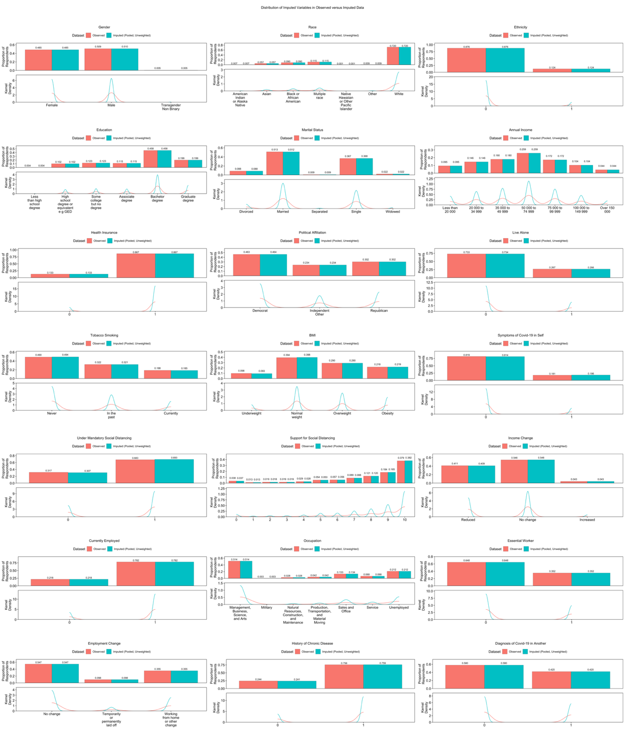

Online Resource Figure 3. Impact of Imputation and Weighting on EQ-5D-5L Responses
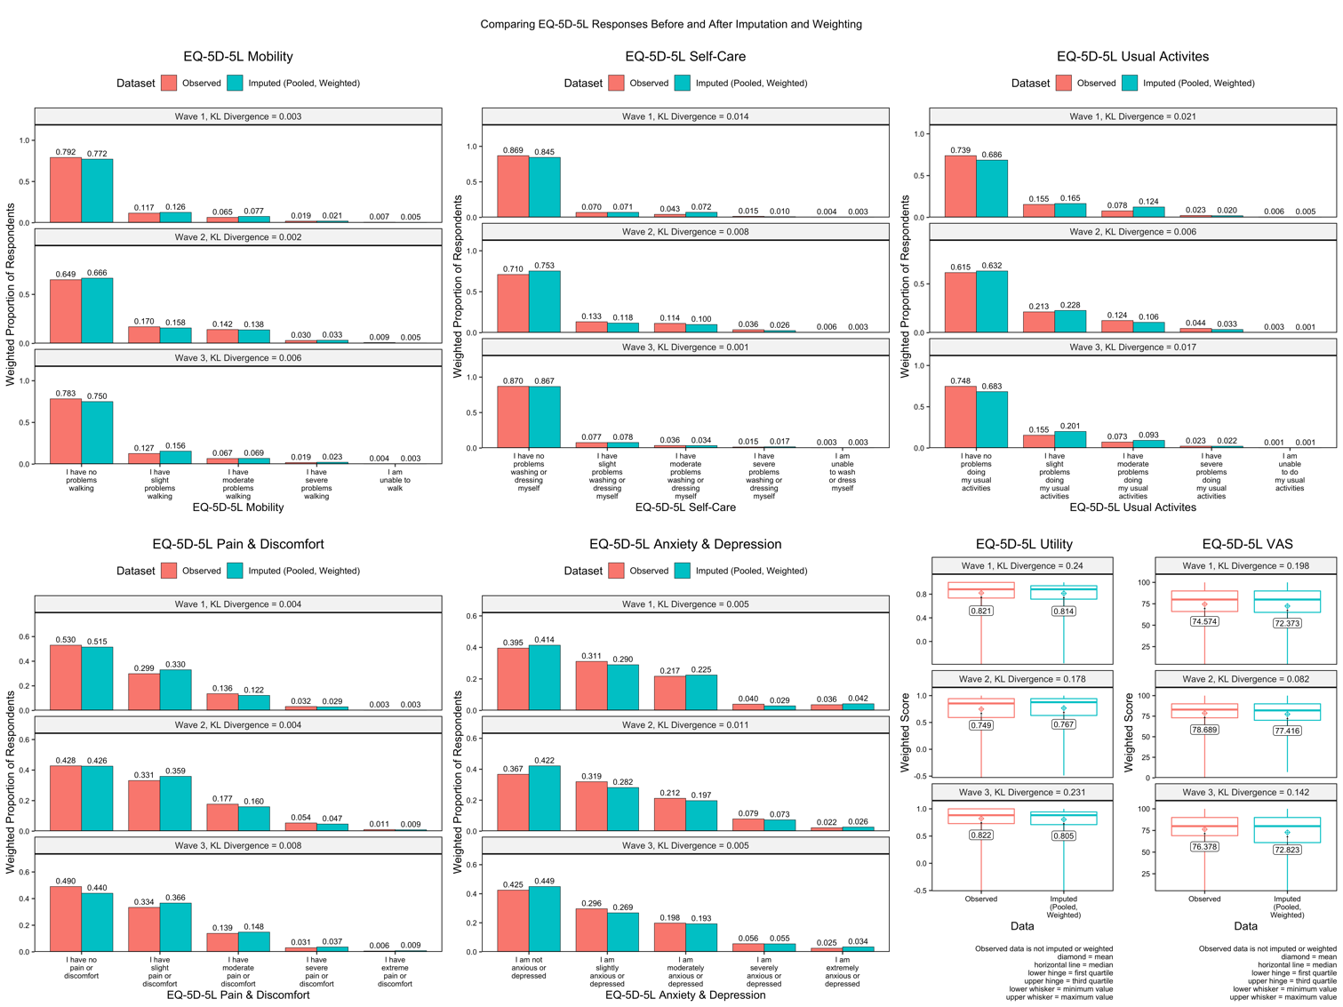

A2.2 Survey Demographics and COVID-19 Responses

The overall pooled (across 100 multiply-imputed data sets) and weighted distributions of age, gender, race, ethnicity, education, marital status, health insurance, living alone, current tobacco smoking, state, and region-division in the survey aligned well with distributions in the adult US population (Table 1).^{17-19,34-37} However, some distributional differences did remain after raking. Annual incomes of less than $20,000 to $74,999 were still somewhat overrepresented in the survey sample while annual incomes of $100,000 to $149,999 were approximately half as common and those of $150,000 or more approximately six times less common in the sample than among US adults.³⁸ Democrats were overrepresented in the sample as were Republicans to a lesser degree, while Independent/other political affiliations were underrepresented.³⁹ Underweight and normal BMIs were also overrepresented in the sample while overweight and obese BMIs remained underrepresented.⁴⁰ Nearly eight in 10 survey respondents reported a history of chronic disease versus six in 10 US adults.^{40,41}

Between waves, the (pooled and weighted) proportion of respondents with a high school degree or associate degree increased over time while the proportion of respondents with less than a high school degree or some college with no degree decreased (Table 1). The proportion of respondents with a bachelor’s degree or graduate degree was greatest in wave 2, as was the proportion of Hispanic respondents. The proportion of underweight BMI in wave 2 was more than double that in waves 1 and 3. Nearly all respondents in wave 1 reported a history of chronic disease versus around two-thirds of respondents in waves 2 and 3. The proportion of respondents reporting COVID-19 symptoms doubled between waves 1 and 2, with little change from wave 2 to 3, while the proportion diagnosed with COVID-19 quadrupled between waves 1 and 2 and then decreased by half in wave 3. The proportion reporting a COVID-19 diagnosis in someone they know also doubled between waves 1 and 2 and doubled again in wave 3. Approximately half of respondents scored their fear of COVID-19’s health impact as 5 or more out of 10 in wave 1, increasing to around two-thirds in waves 2 and 3. The proportion of respondents scoring their fear of COVID-19’s financial impact as 5 or more out of 10 remained around two-thirds in all waves. The proportion of respondents under mandatory social distancing decreased over time from over four-fifths in wave 1 to two-thirds in wave 2 to half in wave 3.

The proportion of respondents scoring their support for social distancing as 5 or more out of 10 was consistently high over time, ranging between 86% and 90% in all waves. Notably, the proportion scoring a 10 (full support) for social distancing decreased from over half in wave 1 to 13% in wave 2, and then increased again to half in wave 3. The share of employed respondents was greatest in wave 2 compared to waves 1 and 3 while the proportion temporarily or permanently laid off decreased over time. Around one-third of respondents were COVID-19 “essential workers” in wave 2 versus one-quarter in waves 1 and 3.

Across all waves combined, over half (pooled and weighted) of respondents in region-divisions MA, ENC, and ESC were female while over half in NE, WNC, WSC, M and P were male (Online Resource Table 6). The largest share of transgender or non-binary respondents resided in NE and SA. P had the greatest proportions of American Indian/Alaska Native (4%) and Asian respondents (14%), WSC the greatest proportion of Black respondents (19%), WNC the greatest proportion of White respondents (88%), NE the greatest proportions of Native Hawaiian/Pacific Islander respondents (5%), and ENC the greatest proportion of multi-/other race respondents (4%). P had the largest shares with a bachelor’s or greater degree (48%) and income $100,000+/year (15%) while ESC had the smallest shares with a bachelor’s or greater degree (20%) and income $100,000+/year (5%). Most respondents in MA, ENC, SA, and P identified as Democrats, most in WNC and ESC identified as Republicans, and most in MA identified as Independent/other. WSC and M had equal proportions of Democrat and Republican respondents. In all region-divisions besides P, over half of respondents had overweight or obese BMIs. The proportion of respondents diagnosed with COVID-19 was two to three times greater in P (15%) compared to NE, MA, ENC, WNC, SA, ESC and M. Among region-divisions, NE had the smallest proportion of respondents reporting reduced income yet had the greatest proportion scoring their fear of COVID-19’s impact on health and finances a 10 out of 10 . At least three-quarters of respondents in NE, MA, ENC, and P were under mandatory social distancing versus around two-thirds in SA, ESC, WSC, and M, and less than half in WNC. Scores indicating support for social distancing were skewed towards greater support in all region-divisions.

Online Resource Table 6. Imputed and Weighted Survey Demographics and COVID-19 Responses by Region-Division
Variable | New England (n=351.3) | Middle Atlantic (n=859.2) | East North Central (n=1126.2) | West North Central (n=369.8) | South Atlantic (n=1665.9) | East South Central (n=555) | West South Central (n=771.9) | Mountain (n=558.9) | Pacific (n=1145.7) | Overall (n=7404)
Age (years) [mean (sd)] | 51.23 (20.87) | 45.33 (17.81) | 51.76 (17.01) | 49.62 (14.94) | 46.58 (17.52) | 46.53 (16.23) | 41.36 (16.98) | 49.32 (17.65) | 44.15 (16.15) | 46.88 (17.47)
Gender [n (%)]
Female | 131.6 (37.5) | 463.8 (54) | 683.2 (60.7) | 135.2 (36.6) | 847.8 (50.9) | 395.2 (71.2) | 321.1 (41.6) | 258.3 (46.2) | 503.6 (44) | 3739.9 (50.5)
Male | 203.8 (58) | 389.3 (45.3) | 435.9 (38.7) | 234.6 (63.4) | 731.4 (43.9) | 158.4 (28.5) | 450.5 (58.4) | 300.2 (53.7) | 641.6 (56) | 3545.7 (47.9)
Transgender or Non-Binary | 15.9 (4.5) | 6.1 (0.7) | 7 (0.6) | 0 (0) | 86.7 (5.2) | 1.5 (0.3) | 0.4 (0) | 0.4 (0.1) | 0.5 (0) | 118.5 (1.6)
Race [n (%)]
American Indian or Alaska Native | 3.3 (0.9) | 1.9 (0.2) | 3.8 (0.3) | 0 (0) | 16.7 (1) | 1 (0.2) | 9.7 (1.3) | 2.6 (0.5) | 40.8 (3.6) | 79.7 (1.1)
Asian | 20.1 (5.7) | 73.6 (8.6) | 21.8 (1.9) | 19.2 (5.2) | 73.4 (4.4) | 15.1 (2.7) | 56.2 (7.3) | 33.4 (6) | 161.1 (14.1) | 474 (6.4)
Black or African American | 16.5 (4.7) | 134.2 (15.6) | 109.7 (9.7) | 21.3 (5.8) | 311.4 (18.7) | 53.2 (9.6) | 131.9 (17.1) | 27.7 (5) | 144.9 (12.6) | 950.9 (12.8)
Multi-race or Other | 12.5 (3.6) | 12.2 (1.4) | 44.4 (3.9) | 5.5 (1.5) | 19.3 (1.2) | 4.7 (0.8) | 9.9 (1.3) | 11.3 (2) | 24.7 (2.2) | 144.3 (1.9)
Native Hawaiian or Other Pacific Islander | 17.7 (5) | 0.5 (0.1) | 1.7 (0.2) | 0 (0) | 0 (0) | 0 (0) | 0 (0) | 0 (0) | 5.8 (0.5) | 25.7 (0.3)
White | 281.3 (80.1) | 637 (74.1) | 944.7 (83.9) | 323.8 (87.5) | 1245.1 (74.7) | 481 (86.7) | 564.1 (73.1) | 483.8 (86.6) | 768.4 (67.1) | 5729.2 (77.4)
Hispanic Ethnicity [n (%)] | 19.5 (5.6) | 124.3 (14.5) | 84.7 (7.5) | 20.7 (5.6) | 267 (16) | 45.2 (8.1) | 212.9 (27.6) | 82.1 (14.7) | 391.4 (34.2) | 1248 (16.9)
Education [n (%)]
Less than high school degree | 15 (4.3) | 0 (0) | 191.5 (17) | 82.6 (22.3) | 239.5 (14.4) | 101.7 (18.3) | 60.4 (7.8) | 18 (3.2) | 0 (0) | 708.7 (9.6)
High school degree or equivalent | 155.8 (44.3) | 298.8 (34.8) | 265.9 (23.6) | 73.9 (20) | 387.5 (23.3) | 227.4 (41) | 230.8 (29.9) | 142.4 (25.5) | 264.7 (23.1) | 2047.3 (27.7)
Some college but no degree | 41 (11.7) | 160.3 (18.7) | 225.9 (20.1) | 77.3 (20.9) | 295.1 (17.7) | 68.4 (12.3) | 133.5 (17.3) | 113.9 (20.4) | 185.9 (16.2) | 1301.4 (17.6)
Associate degree | 13.8 (3.9) | 72.3 (8.4) | 118.2 (10.5) | 45.8 (12.4) | 198.8 (11.9) | 46.4 (8.4) | 49.5 (6.4) | 62.5 (11.2) | 147.8 (12.9) | 755.2 (10.2)
Bachelor's degree | 70.9 (20.2) | 192.1 (22.4) | 206 (18.3) | 60.7 (16.4) | 351.3 (21.1) | 77 (13.9) | 179.4 (23.2) | 121.2 (21.7) | 389.8 (34) | 1648.4 (22.3)
Graduate degree | 54.8 (15.6) | 135.6 (15.8) | 118.6 (10.5) | 29.5 (8) | 193.7 (11.6) | 34.1 (6.2) | 118.4 (15.3) | 100.8 (18) | 157.5 (13.8) | 942.9 (12.7)
Marital Status [n (%)]
Divorced | 16.6 (4.7) | 81 (9.4) | 99.4 (8.8) | 40 (10.8) | 262.3 (15.7) | 88.4 (15.9) | 94.3 (12.2) | 49.3 (8.8) | 95.3 (8.3) | 826.6 (11.2)
Married | 137.6 (39.2) | 333.2 (38.8) | 575.3 (51.1) | 110.5 (29.9) | 655.6 (39.4) | 241.6 (43.5) | 326.2 (42.3) | 293.8 (52.6) | 548.9 (47.9) | 3222.7 (43.5)
Separated | 2.4 (0.7) | 12.1 (1.4) | 123.6 (11) | 10.4 (2.8) | 20 (1.2) | 0 (0) | 5.1 (0.7) | 4.9 (0.9) | 12.7 (1.1) | 191.2 (2.6)
Single | 108.5 (30.9) | 361.9 (42.1) | 278.6 (24.7) | 187.3 (50.7) | 653 (39.2) | 195.7 (35.3) | 320.8 (41.6) | 188.6 (33.7) | 485.7 (42.4) | 2780.2 (37.5)
Widowed | 86.2 (24.5) | 71.1 (8.3) | 49.2 (4.4) | 21.6 (5.8) | 75 (4.5) | 29.3 (5.3) | 25.5 (3.3) | 22.2 (4) | 3.2 (0.3) | 383.3 (5.2)
Annual Income (2020 USD) [n (%)]
Less than $20 000 | 15.3 (4.4) | 125.4 (14.6) | 223.7 (19.9) | 128.9 (34.9) | 330.5 (19.8) | 163.1 (29.4) | 83.3 (10.8) | 70.7 (12.6) | 138.2 (12.1) | 1279.1 (17.3)
$20 000 to $34 999 | 132.6 (37.7) | 111.4 (13) | 199 (17.7) | 67.7 (18.3) | 251.3 (15.1) | 112.2 (20.2) | 169.3 (21.9) | 107 (19.1) | 211.9 (18.5) | 1362.4 (18.4)
$35 000 to $49 999 | 46.2 (13.1) | 145 (16.9) | 174.1 (15.5) | 49.4 (13.3) | 409.7 (24.6) | 97 (17.5) | 128.5 (16.6) | 127.7 (22.8) | 179.5 (15.7) | 1357.1 (18.3)
$50 000 to $74 999 | 67.2 (19.1) | 228.3 (26.6) | 242.8 (21.6) | 58.7 (15.9) | 327.2 (19.6) | 98.1 (17.7) | 153.6 (19.9) | 132.9 (23.8) | 296.5 (25.9) | 1605.4 (21.7)
$75 000 to $99 999 | 48.7 (13.9) | 144.6 (16.8) | 182.3 (16.2) | 36.2 (9.8) | 195.6 (11.7) | 59.6 (10.7) | 128.2 (16.6) | 65 (11.6) | 151.3 (13.2) | 1011.5 (13.7)
$100 000 to $149 999 | 35.7 (10.2) | 61.4 (7.1) | 85.3 (7.6) | 22.2 (6) | 106.3 (6.4) | 19.1 (3.4) | 59.5 (7.7) | 40.1 (7.2) | 114.8 (10) | 544.4 (7.4)
Over $150 000 | 5.6 (1.6) | 43.1 (5) | 19 (1.7) | 6.7 (1.8) | 45.3 (2.7) | 5.9 (1.1) | 49.4 (6.4) | 15.5 (2.8) | 53.5 (4.7) | 244.1 (3.3)
Health Insurance [n (%)] | 312.4 (88.9) | 753.8 (87.7) | 1006.2 (89.3) | 279.4 (75.6) | 1381 (82.9) | 448.4 (80.8) | 630.8 (81.7) | 477.3 (85.4) | 1003.9 (87.6) | 6293.3 (85)
Political Affiliation [n (%)]
Democrat | 118.6 (33.8) | 419 (48.8) | 553.8 (49.2) | 144.9 (39.2) | 837.5 (50.3) | 203.3 (36.6) | 269.5 (34.9) | 209.9 (37.6) | 523.2 (45.7) | 3279.8 (44.3)
Independent/Other | 184.4 (52.5) | 211.8 (24.7) | 214.4 (19) | 66.5 (18) | 376 (22.6) | 121.2 (21.8) | 239.4 (31) | 139.8 (25) | 219.7 (19.2) | 1773.2 (23.9)
Republican | 48.3 (13.8) | 228.4 (26.6) | 358 (31.8) | 158.4 (42.8) | 452.4 (27.2) | 230.6 (41.5) | 263 (34.1) | 209.2 (37.4) | 402.8 (35.2) | 2351 (31.8)
Live Alone [n (%)] | 70.3 (20) | 257.3 (29.9) | 201 (17.9) | 139 (37.6) | 385.4 (23.1) | 108.6 (19.6) | 251.9 (32.6) | 132.6 (23.7) | 384.6 (33.6) | 1930.8 (26.1)
Tobacco Smoking [n (%)]
Never | 130.6 (37.2) | 385.8 (44.9) | 463.4 (41.1) | 151.2 (40.9) | 675.4 (40.5) | 241.4 (43.5) | 386.8 (50.1) | 248 (44.4) | 521.1 (45.5) | 3203.7 (43.3)
In the past | 163.8 (46.6) | 325.1 (37.8) | 472.5 (42) | 111.6 (30.2) | 639 (38.4) | 153.1 (27.6) | 243.4 (31.5) | 219.3 (39.2) | 383.4 (33.5) | 2711.2 (36.6)
Currently | 56.9 (16.2) | 148.2 (17.3) | 190.3 (16.9) | 107 (28.9) | 351.5 (21.1) | 160.6 (28.9) | 141.7 (18.4) | 91.6 (16.4) | 241.3 (21.1) | 1489.1 (20.1)
BMI [n (%)]
Underweight | 16.4 (4.7) | 88.9 (10.3) | 72.1 (6.4) | 11.8 (3.2) | 85.3 (5.1) | 22.3 (4) | 109 (14.1) | 50 (8.9) | 167.5 (14.6) | 623.4 (8.4)
Normal weight | 104.7 (29.8) | 341.3 (39.7) | 289.8 (25.7) | 135.7 (36.7) | 643.3 (38.6) | 198.4 (35.8) | 267 (34.6) | 214.5 (38.4) | 488.4 (42.6) | 2683.2 (36.2)
Overweight | 83.7 (23.8) | 220.2 (25.6) | 466.5 (41.4) | 131.1 (35.5) | 476.7 (28.6) | 73.6 (13.3) | 239.6 (31) | 181.5 (32.5) | 309.3 (27) | 2182.3 (29.5)
Obesity | 146.5 (41.7) | 208.8 (24.3) | 297.7 (26.4) | 91.1 (24.6) | 460.7 (27.7) | 260.7 (47) | 156.2 (20.2) | 112.9 (20.2) | 180.5 (15.8) | 1915.2 (25.9)
History of Chronic Disease [n (%)] | 294.1 (83.7) | 666.3 (77.6) | 916.8 (81.4) | 255.1 (69) | 1329 (79.8) | 459.3 (82.8) | 583.1 (75.5) | 452.4 (81) | 897.4 (78.3) | 5853.5 (79.1)
Diagnosis of COVID-19 in Self [n (%)] | 16.1 (4.6) | 45.5 (5.3) | 58.6 (5.2) | 24.3 (6.6) | 78.7 (4.7) | 30.1 (5.4) | 84.5 (10.9) | 38.4 (6.9) | 177.3 (15.5) | 553.4 (7.5)
Symptoms of COVID-19 in Self [n (%)] | 34.5 (9.8) | 118.3 (13.8) | 223.9 (19.9) | 104.9 (28.4) | 183.5 (11) | 90.1 (16.2) | 164.2 (21.3) | 100.2 (17.9) | 274.8 (24) | 1294.4 (17.5)
Diagnosis of COVID-19 in Another [n (%)] | 107.4 (30.6) | 402.9 (46.9) | 454.2 (40.3) | 113 (30.5) | 505.5 (30.3) | 199.7 (36) | 354.2 (45.9) | 195.6 (35) | 450.9 (39.4) | 2783.3 (37.6)
Fear of COVID-19’s Health Impact [n (%)]
0 | 12.8 (3.6) | 35.1 (4.1) | 40.5 (3.6) | 100.6 (27.2) | 146.7 (8.8) | 46.7 (8.4) | 68.4 (8.9) | 44.4 (7.9) | 73.8 (6.4) | 569 (7.7)
1 | 38.5 (10.9) | 46.4 (5.4) | 84.1 (7.5) | 19 (5.1) | 104.4 (6.3) | 21.5 (3.9) | 71.5 (9.3) | 63.9 (11.4) | 94 (8.2) | 543.3 (7.3)
2 | 30.4 (8.7) | 74.3 (8.6) | 109.1 (9.7) | 22.8 (6.2) | 157.6 (9.5) | 79.7 (14.4) | 76.6 (9.9) | 41.9 (7.5) | 94.1 (8.2) | 686.5 (9.3)
3 | 27 (7.7) | 50.2 (5.8) | 108.2 (9.6) | 23.9 (6.5) | 129.5 (7.8) | 55.6 (10) | 101 (13.1) | 61.7 (11) | 87.4 (7.6) | 644.6 (8.7)
4 | 23.9 (6.8) | 40.4 (4.7) | 86.9 (7.7) | 35.3 (9.6) | 91.9 (5.5) | 23.9 (4.3) | 29.2 (3.8) | 25.3 (4.5) | 50.5 (4.4) | 407.3 (5.5)
5 | 23.5 (6.7) | 102.4 (11.9) | 133.8 (11.9) | 19.1 (5.2) | 107.9 (6.5) | 55.5 (10) | 62.4 (8.1) | 48.5 (8.7) | 86.6 (7.6) | 639.7 (8.6)
6 | 24.9 (7.1) | 116 (13.5) | 81.6 (7.3) | 42 (11.4) | 117.6 (7.1) | 41.6 (7.5) | 59.9 (7.8) | 40.8 (7.3) | 117.4 (10.2) | 642 (8.7)
7 | 30.6 (8.7) | 120.3 (14) | 152.3 (13.5) | 31.6 (8.5) | 283.5 (17) | 52.5 (9.5) | 83.9 (10.9) | 71.5 (12.8) | 130.5 (11.4) | 956.7 (12.9)
8 | 27.9 (7.9) | 136.1 (15.8) | 170.4 (15.1) | 30 (8.1) | 173.7 (10.4) | 62.7 (11.3) | 106.1 (13.7) | 76.8 (13.7) | 172 (15) | 955.6 (12.9)
9 | 15.4 (4.4) | 55.8 (6.5) | 70.1 (6.2) | 19.2 (5.2) | 131.1 (7.9) | 50.7 (9.1) | 46.1 (6) | 43.1 (7.7) | 110.3 (9.6) | 541.8 (7.3)
10 | 96.6 (27.5) | 82.4 (9.6) | 89.1 (7.9) | 26.3 (7.1) | 222 (13.3) | 64.5 (11.6) | 66.7 (8.6) | 40.9 (7.3) | 129.1 (11.3) | 817.6 (11)
Fear of COVID-19’s Financial Impact [n (%)]
0 | 14.7 (4.2) | 59.2 (6.9) | 93.1 (8.3) | 27.9 (7.5) | 148.2 (8.9) | 42.6 (7.7) | 66.8 (8.7) | 45.3 (8.1) | 114.6 (10) | 612.3 (8.3)
1 | 53.3 (15.2) | 69.4 (8.1) | 67.3 (6) | 37.2 (10.1) | 101.8 (6.1) | 33.4 (6) | 73.9 (9.6) | 31.3 (5.6) | 68.2 (6) | 535.9 (7.2)
2 | 21.1 (6) | 64.3 (7.5) | 137 (12.2) | 23.4 (6.3) | 131.1 (7.9) | 56.6 (10.2) | 56.2 (7.3) | 39 (7) | 70.4 (6.1) | 599 (8.1)
3 | 31 (8.8) | 64.9 (7.6) | 70.2 (6.2) | 23.7 (6.4) | 126.5 (7.6) | 24.7 (4.5) | 47 (6.1) | 30.5 (5.5) | 75.8 (6.6) | 494.2 (6.7)
4 | 13.1 (3.7) | 49.5 (5.8) | 83.7 (7.4) | 22.3 (6) | 83.2 (5) | 24.4 (4.4) | 82.3 (10.7) | 45.1 (8.1) | 52.8 (4.6) | 456.4 (6.2)
5 | 20.4 (5.8) | 92.5 (10.8) | 99.1 (8.8) | 23.5 (6.3) | 156.3 (9.4) | 79.6 (14.4) | 59.1 (7.7) | 53.3 (9.5) | 116.7 (10.2) | 700.6 (9.5)
6 | 31.7 (9) | 66.8 (7.8) | 111 (9.9) | 27.7 (7.5) | 184 (11) | 46.6 (8.4) | 77.8 (10.1) | 37.7 (6.7) | 108.4 (9.5) | 691.6 (9.3)
7 | 21.7 (6.2) | 117.6 (13.7) | 154 (13.7) | 19.1 (5.2) | 173.6 (10.4) | 60.5 (10.9) | 83.3 (10.8) | 74.1 (13.3) | 146 (12.7) | 850 (11.5)
8 | 24.8 (7.1) | 83.7 (9.7) | 132.8 (11.8) | 75.7 (20.5) | 139.3 (8.4) | 63.6 (11.5) | 75.8 (9.8) | 76.1 (13.6) | 117.9 (10.3) | 789.7 (10.7)
9 | 46.8 (13.3) | 84.5 (9.8) | 84.8 (7.5) | 62.6 (16.9) | 114.7 (6.9) | 31.1 (5.6) | 54.6 (7.1) | 52.4 (9.4) | 123.7 (10.8) | 655.2 (8.8)
10 | 72.7 (20.7) | 106.7 (12.4) | 93.2 (8.3) | 26.8 (7.3) | 307.3 (18.4) | 91.7 (16.5) | 95.1 (12.3) | 74 (13.2) | 151.4 (13.2) | 1019 (13.8)
Under Mandatory Social Distancing [n (%)] | 263.8 (75.1) | 655.9 (76.3) | 819.4 (72.8) | 163.5 (44.2) | 1049.7 (63) | 358.9 (64.7) | 480.2 (62.2) | 347.6 (62.2) | 965.2 (84.2) | 5104.4 (68.9)
Support for Social Distancing [n (%)]
0 | 21.9 (6.2) | 14.3 (1.7) | 51.3 (4.6) | 66.8 (18.1) | 47.4 (2.8) | 43.2 (7.8) | 27.7 (3.6) | 56.9 (10.2) | 61.5 (5.4) | 391.1 (5.3)
1 | 2.1 (0.6) | 4.8 (0.6) | 9.7 (0.9) | 6 (1.6) | 18.4 (1.1) | 3.9 (0.7) | 24.7 (3.2) | 8.9 (1.6) | 23 (2) | 101.4 (1.4)
2 | 1.2 (0.3) | 11.1 (1.3) | 20.7 (1.8) | 6.8 (1.8) | 28.2 (1.7) | 3.9 (0.7) | 10.3 (1.3) | 6.3 (1.1) | 12.8 (1.1) | 101.2 (1.4)
3 | 6.1 (1.7) | 7 (0.8) | 11.8 (1) | 11.8 (3.2) | 45.7 (2.7) | 6.3 (1.1) | 20.7 (2.7) | 9.9 (1.8) | 18.9 (1.7) | 138.2 (1.9)
4 | 6.5 (1.9) | 20.6 (2.4) | 25.1 (2.2) | 8.3 (2.2) | 46.9 (2.8) | 8.8 (1.6) | 39.2 (5.1) | 18.9 (3.4) | 28 (2.4) | 202.3 (2.7)
5 | 11 (3.1) | 34.7 (4) | 54.3 (4.8) | 21 (5.7) | 49.4 (3) | 33.3 (6) | 41.4 (5.4) | 27.2 (4.9) | 62.3 (5.4) | 334.7 (4.5)
6 | 13.4 (3.8) | 41.5 (4.8) | 41.3 (3.7) | 12.8 (3.5) | 59.9 (3.6) | 16.7 (3) | 56.8 (7.4) | 19.5 (3.5) | 63.3 (5.5) | 325.2 (4.4)
7 | 24.6 (7) | 47.4 (5.5) | 87.2 (7.7) | 22.3 (6) | 105.1 (6.3) | 51.9 (9.4) | 69.4 (9) | 57.3 (10.3) | 103.1 (9) | 568.3 (7.7)
8 | 37 (10.5) | 88.8 (10.3) | 146.4 (13) | 49.4 (13.4) | 167.5 (10.1) | 47.6 (8.6) | 67.3 (8.7) | 73.6 (13.2) | 145.9 (12.7) | 823.5 (11.1)
9 | 70.9 (20.2) | 181 (21.1) | 187.6 (16.7) | 45.6 (12.3) | 335.2 (20.1) | 106.5 (19.2) | 105 (13.6) | 79.8 (14.3) | 185.9 (16.2) | 1297.6 (17.5)
10 | 156.5 (44.5) | 408 (47.5) | 490.9 (43.6) | 118.9 (32.2) | 762.3 (45.8) | 232.9 (42) | 309.3 (40.1) | 200.6 (35.9) | 441.1 (38.5) | 3120.5 (42.1)
Income Change [n (%)]
Reduced | 89.2 (25.4) | 343.8 (40) | 326.9 (29) | 147.4 (39.8) | 581.2 (34.9) | 279.9 (50.4) | 295.3 (38.3) | 202.3 (36.2) | 514.2 (44.9) | 2780 (37.5)
No change | 249.4 (71) | 476 (55.4) | 703.7 (62.5) | 205.9 (55.7) | 1031.5 (61.9) | 261.3 (47.1) | 453.6 (58.8) | 342.9 (61.4) | 590.3 (51.5) | 4314.6 (58.3)
Increased | 12.7 (3.6) | 39.5 (4.6) | 95.5 (8.5) | 16.6 (4.5) | 53.2 (3.2) | 13.8 (2.5) | 23 (3) | 13.7 (2.5) | 41.3 (3.6) | 309.4 (4.2)
Currently Employed [n (%)] | 183.9 (52.4) | 603 (70.2) | 716.2 (63.6) | 274.3 (74.2) | 995 (59.7) | 352.2 (63.4) | 509.3 (66) | 342.5 (61.3) | 818.7 (71.5) | 4795.1 (64.8)
Employment Change [n (%)]
No change | 247.8 (70.5) | 503.7 (58.6) | 807.8 (71.7) | 245.3 (66.3) | 1144.5 (68.7) | 403 (72.6) | 439.2 (56.9) | 365.9 (65.5) | 573.8 (50.1) | 4731.1 (63.9)
Temporarily or permanently laid off | 19.4 (5.5) | 106.7 (12.4) | 74.2 (6.6) | 15.6 (4.2) | 129.3 (7.8) | 59.4 (10.7) | 99.5 (12.9) | 41.3 (7.4) | 167.4 (14.6) | 712.6 (9.6)
Working from home or other change | 84.1 (24) | 248.8 (29) | 244.2 (21.7) | 109 (29.5) | 392.1 (23.5) | 92.6 (16.7) | 233.2 (30.2) | 151.7 (27.1) | 404.5 (35.3) | 1960.2 (26.5)
Occupation [n (%)]
Management, Business, Science, and Arts | 101.6 (28.9) | 346.9 (40.4) | 416.5 (37) | 190 (51.4) | 553.7 (33.2) | 138.3 (24.9) | 284.1 (36.8) | 175.2 (31.3) | 529 (46.2) | 2735.3 (36.9)
Military | 0 (0) | 0 (0) | 0.4 (0) | 0 (0) | 5.6 (0.3) | 1 (0.2) | 3.7 (0.5) | 0.3 (0.1) | 3.9 (0.3) | 14.9 (0.2)
Natural Resources, Construction, and Maintenance | 15.6 (4.4) | 33.2 (3.9) | 32.4 (2.9) | 4.3 (1.2) | 36.6 (2.2) | 4 (0.7) | 39.6 (5.1) | 27.6 (4.9) | 41.9 (3.7) | 235 (3.2)
Production, Transportation, and Material Moving | 10.5 (3) | 27.7 (3.2) | 57.2 (5.1) | 14.6 (4) | 43.3 (2.6) | 19.5 (3.5) | 36.9 (4.8) | 15.8 (2.8) | 36.7 (3.2) | 262.3 (3.5)
Sales and Office | 41.1 (11.7) | 129 (15) | 156.9 (13.9) | 39.1 (10.6) | 233.3 (14) | 168.8 (30.4) | 86.2 (11.2) | 59.8 (10.7) | 147.8 (12.9) | 1062 (14.3)
Service | 19 (5.4) | 67.5 (7.9) | 54.7 (4.9) | 27.4 (7.4) | 124.3 (7.5) | 48.6 (8.8) | 58.5 (7.6) | 64.8 (11.6) | 65.3 (5.7) | 530.1 (7.2)
Unemployed | 163.5 (46.5) | 254.8 (29.7) | 408.1 (36.2) | 94.4 (25.5) | 669.1 (40.2) | 174.9 (31.5) | 263 (34.1) | 215.3 (38.5) | 321.2 (28) | 2564.4 (34.6)
Essential Worker [n (%)] | 78.4 (22.3) | 244.3 (28.4) | 301.6 (26.8) | 101.4 (27.4) | 421.2 (25.3) | 148.2 (26.7) | 254.5 (33) | 154.1 (27.6) | 404.7 (35.3) | 2108.4 (28.5)
State [n (%)]
Alabama | 0 (0) | 0 (0) | 0 (0) | 0 (0) | 0 (0) | 99.8 (18) | 0 (0) | 0 (0) | 0 (0) | 99.8 (1.3)
Alaska | 0 (0) | 0 (0) | 0 (0) | 0 (0) | 0 (0) | 0 (0) | 0 (0) | 0 (0) | 18.7 (1.6) | 18.7 (0.3)
Arizona | 0 (0) | 0 (0) | 0 (0) | 0 (0) | 0 (0) | 0 (0) | 0 (0) | 174.7 (31.3) | 0 (0) | 174.7 (2.4)
Arkansas | 0 (0) | 0 (0) | 0 (0) | 0 (0) | 0 (0) | 0 (0) | 64.4 (8.3) | 0 (0) | 0 (0) | 64.4 (0.9)
California | 0 (0) | 0 (0) | 0 (0) | 0 (0) | 0 (0) | 0 (0) | 0 (0) | 0 (0) | 846.8 (73.9) | 846.8 (11.4)
Colorado | 0 (0) | 0 (0) | 0 (0) | 0 (0) | 0 (0) | 0 (0) | 0 (0) | 148 (26.5) | 0 (0) | 148 (2)
Connecticut | 154.4 (44) | 0 (0) | 0 (0) | 0 (0) | 0 (0) | 0 (0) | 0 (0) | 0 (0) | 0 (0) | 154.4 (2.1)
Delaware | 0 (0) | 0 (0) | 0 (0) | 0 (0) | 21.6 (1.3) | 0 (0) | 0 (0) | 0 (0) | 0 (0) | 21.6 (0.3)
District of Columbia | 0 (0) | 0 (0) | 0 (0) | 0 (0) | 48.6 (2.9) | 0 (0) | 0 (0) | 0 (0) | 0 (0) | 48.6 (0.7)
Florida | 0 (0) | 0 (0) | 0 (0) | 0 (0) | 714.6 (42.9) | 0 (0) | 0 (0) | 0 (0) | 0 (0) | 714.6 (9.7)
Georgia | 0 (0) | 0 (0) | 0 (0) | 0 (0) | 233.8 (14) | 0 (0) | 0 (0) | 0 (0) | 0 (0) | 233.8 (3.2)
Hawaii | 0 (0) | 0 (0) | 0 (0) | 0 (0) | 0 (0) | 0 (0) | 0 (0) | 0 (0) | 27.1 (2.4) | 27.1 (0.4)
Idaho | 0 (0) | 0 (0) | 0 (0) | 0 (0) | 0 (0) | 0 (0) | 0 (0) | 13.7 (2.5) | 0 (0) | 13.7 (0.2)
Illinois | 0 (0) | 0 (0) | 304.4 (27) | 0 (0) | 0 (0) | 0 (0) | 0 (0) | 0 (0) | 0 (0) | 304.4 (4.1)
Indiana | 0 (0) | 0 (0) | 122.5 (10.9) | 0 (0) | 0 (0) | 0 (0) | 0 (0) | 0 (0) | 0 (0) | 122.5 (1.7)
Iowa | 0 (0) | 0 (0) | 0 (0) | 55.3 (15) | 0 (0) | 0 (0) | 0 (0) | 0 (0) | 0 (0) | 55.3 (0.7)
Kansas | 0 (0) | 0 (0) | 0 (0) | 27 (7.3) | 0 (0) | 0 (0) | 0 (0) | 0 (0) | 0 (0) | 27 (0.4)
Kentucky | 0 (0) | 0 (0) | 0 (0) | 0 (0) | 0 (0) | 234.4 (42.2) | 0 (0) | 0 (0) | 0 (0) | 234.4 (3.2)
Louisiana | 0 (0) | 0 (0) | 0 (0) | 0 (0) | 0 (0) | 0 (0) | 90.5 (11.7) | 0 (0) | 0 (0) | 90.5 (1.2)
Maine | 36.1 (10.3) | 0 (0) | 0 (0) | 0 (0) | 0 (0) | 0 (0) | 0 (0) | 0 (0) | 0 (0) | 36.1 (0.5)
Maryland | 0 (0) | 0 (0) | 0 (0) | 0 (0) | 121 (7.3) | 0 (0) | 0 (0) | 0 (0) | 0 (0) | 121 (1.6)
Massachusetts | 95.7 (27.2) | 0 (0) | 0 (0) | 0 (0) | 0 (0) | 0 (0) | 0 (0) | 0 (0) | 0 (0) | 95.7 (1.3)
Michigan | 0 (0) | 0 (0) | 209.1 (18.6) | 0 (0) | 0 (0) | 0 (0) | 0 (0) | 0 (0) | 0 (0) | 209.1 (2.8)
Minnesota | 0 (0) | 0 (0) | 0 (0) | 55.9 (15.1) | 0 (0) | 0 (0) | 0 (0) | 0 (0) | 0 (0) | 55.9 (0.8)
Mississippi | 0 (0) | 0 (0) | 0 (0) | 0 (0) | 0 (0) | 39.1 (7.1) | 0 (0) | 0 (0) | 0 (0) | 39.1 (0.5)
Missouri | 0 (0) | 0 (0) | 0 (0) | 203.4 (55) | 0 (0) | 0 (0) | 0 (0) | 0 (0) | 0 (0) | 203.4 (2.7)
Montana | 0 (0) | 0 (0) | 0 (0) | 0 (0) | 0 (0) | 0 (0) | 0 (0) | 17.4 (3.1) | 0 (0) | 17.4 (0.2)
Nebraska | 0 (0) | 0 (0) | 0 (0) | 12.3 (3.3) | 0 (0) | 0 (0) | 0 (0) | 0 (0) | 0 (0) | 12.3 (0.2)
Nevada | 0 (0) | 0 (0) | 0 (0) | 0 (0) | 0 (0) | 0 (0) | 0 (0) | 92.2 (16.5) | 0 (0) | 92.2 (1.2)
New Hampshire | 11.1 (3.2) | 0 (0) | 0 (0) | 0 (0) | 0 (0) | 0 (0) | 0 (0) | 0 (0) | 0 (0) | 11.1 (0.2)
New Jersey | 0 (0) | 177.2 (20.6) | 0 (0) | 0 (0) | 0 (0) | 0 (0) | 0 (0) | 0 (0) | 0 (0) | 177.2 (2.4)
New Mexico | 0 (0) | 0 (0) | 0 (0) | 0 (0) | 0 (0) | 0 (0) | 0 (0) | 28.7 (5.1) | 0 (0) | 28.7 (0.4)
New York | 0 (0) | 393.9 (45.8) | 0 (0) | 0 (0) | 0 (0) | 0 (0) | 0 (0) | 0 (0) | 0 (0) | 393.9 (5.3)
North Carolina | 0 (0) | 0 (0) | 0 (0) | 0 (0) | 229.2 (13.8) | 0 (0) | 0 (0) | 0 (0) | 0 (0) | 229.2 (3.1)
North Dakota | 0 (0) | 0 (0) | 0 (0) | 7.6 (2.1) | 0 (0) | 0 (0) | 0 (0) | 0 (0) | 0 (0) | 7.6 (0.1)
Ohio | 0 (0) | 0 (0) | 363.7 (32.3) | 0 (0) | 0 (0) | 0 (0) | 0 (0) | 0 (0) | 0 (0) | 363.7 (4.9)
Oklahoma | 0 (0) | 0 (0) | 0 (0) | 0 (0) | 0 (0) | 0 (0) | 123.4 (16) | 0 (0) | 0 (0) | 123.4 (1.7)
Oregon | 0 (0) | 0 (0) | 0 (0) | 0 (0) | 0 (0) | 0 (0) | 0 (0) | 0 (0) | 86.4 (7.5) | 86.4 (1.2)
Pennsylvania | 0 (0) | 288.1 (33.5) | 0 (0) | 0 (0) | 0 (0) | 0 (0) | 0 (0) | 0 (0) | 0 (0) | 288.1 (3.9)
Rhode Island | 45.1 (12.8) | 0 (0) | 0 (0) | 0 (0) | 0 (0) | 0 (0) | 0 (0) | 0 (0) | 0 (0) | 45.1 (0.6)
South Carolina | 0 (0) | 0 (0) | 0 (0) | 0 (0) | 78.8 (4.7) | 0 (0) | 0 (0) | 0 (0) | 0 (0) | 78.8 (1.1)
South Dakota | 0 (0) | 0 (0) | 0 (0) | 8.2 (2.2) | 0 (0) | 0 (0) | 0 (0) | 0 (0) | 0 (0) | 8.2 (0.1)
Tennessee | 0 (0) | 0 (0) | 0 (0) | 0 (0) | 0 (0) | 181.6 (32.7) | 0 (0) | 0 (0) | 0 (0) | 181.6 (2.5)
Texas | 0 (0) | 0 (0) | 0 (0) | 0 (0) | 0 (0) | 0 (0) | 493.7 (64) | 0 (0) | 0 (0) | 493.7 (6.7)
Utah | 0 (0) | 0 (0) | 0 (0) | 0 (0) | 0 (0) | 0 (0) | 0 (0) | 72.1 (12.9) | 0 (0) | 72.1 (1)
Vermont | 8.9 (2.5) | 0 (0) | 0 (0) | 0 (0) | 0 (0) | 0 (0) | 0 (0) | 0 (0) | 0 (0) | 8.9 (0.1)
Virginia | 0 (0) | 0 (0) | 0 (0) | 0 (0) | 159.1 (9.5) | 0 (0) | 0 (0) | 0 (0) | 0 (0) | 159.1 (2.1)
Washington | 0 (0) | 0 (0) | 0 (0) | 0 (0) | 0 (0) | 0 (0) | 0 (0) | 0 (0) | 166.8 (14.6) | 166.8 (2.3)
West Virginia | 0 (0) | 0 (0) | 0 (0) | 0 (0) | 59.3 (3.6) | 0 (0) | 0 (0) | 0 (0) | 0 (0) | 59.3 (0.8)
Wisconsin | 0 (0) | 0 (0) | 126.4 (11.2) | 0 (0) | 0 (0) | 0 (0) | 0 (0) | 0 (0) | 0 (0) | 126.4 (1.7)
Wyoming | 0 (0) | 0 (0) | 0 (0) | 0 (0) | 0 (0) | 0 (0) | 0 (0) | 12.1 (2.2) | 0 (0) | 0 (0)
Wave [n (%)]
1 | 138.6 (39.4) | 307.7 (35.8) | 439.3 (39) | 146.1 (39.5) | 689.7 (41.4) | 235.1 (42.4) | 291.1 (37.7) | 194.7 (34.8) | 443.7 (38.7) | 2886 (39)
2 | 99.3 (28.3) | 253 (29.4) | 284.5 (25.3) | 117.9 (31.9) | 501.7 (30.1) | 159.3 (28.7) | 228 (29.5) | 187 (33.5) | 417 (36.4) | 2247.6 (30.4)
3 | 113.4 (32.3) | 298.5 (34.7) | 402.3 (35.7) | 105.8 (28.6) | 474.5 (28.5) | 160.7 (28.9) | 252.8 (32.8) | 177.2 (31.7) | 285.1 (24.9) | 2270.4 (30.7)

A2.3 Supplemental EQ-5D-5L Results

Online Resource Table 7. Unadjusted and Adjusted Probabilities and Means of HRQoL Outcomes by Region-Division and Wave
Outcome | Wave | Unadjusted
Outcome | Wave | New England | Middle Atlantic | East North Central | West North Central | South Atlantic | East South Central | West South Central | Mountain | Pacific
EQ-5D-5L Mobility [% (SE)]* | 1 | 22.4 (3.6) | 16.6 (2.1) | 22.5 (2.0) | 19.7 (3.3) | 19.3 (1.5) | 34.0 (3.1) | 23.9 (2.5) | 25.6 (3.1) | 26.5 (2.1)
EQ-5D-5L Mobility [% (SE)]* | 2 | 28.5 (4.5) | 29.7 (2.9) | 31.7 (2.8) | 18.4 (3.6) | 27.9 (2.0) | 28.2 (3.6) | 44.6 (3.3) | 37.6 (3.6) | 43.0 (2.4)
EQ-5D-5L Mobility [% (SE)]* | 3 | 16.4 (3.5) | 31.3 (2.7) | 18.8 (2.0) | 25.9 (4.3) | 27.1 (2.0) | 40.4 (3.9) | 24.5 (2.7) | 16.0 (2.8) | 24.3 (2.6)
EQ-5D-5L Self-Care [% (SE)]* | 1 | 20.4 (3.4) | 10.7 (1.8) | 9.9 (1.4) | 9.1 (2.4) | 19.8 (1.5) | 11.0 (2.0) | 13.3 (2.0) | 20.5 (2.9) | 20.2 (1.9)
EQ-5D-5L Self-Care [% (SE)]* | 2 | 24.5 (4.3) | 20.4 (2.5) | 19.6 (2.4) | 7.2 (2.4) | 17.4 (1.7) | 15.4 (2.9) | 37.6 (3.2) | 30.4 (3.4) | 38.3 (2.4)
EQ-5D-5L Self-Care [% (SE)]* | 3 | 8.4 (2.6) | 14.1 (2.0) | 6.8 (1.2) | 18.7 (3.8) | 14.3 (1.6) | 30.2 (3.6) | 14.4 (2.2) | 6.6 (1.9) | 13.4 (2.1)
EQ-5D-5L Usual Activities [% (SE)]* | 1 | 24.0 (3.6) | 26.5 (2.5) | 30.9 (2.2) | 22.4 (3.5) | 30.7 (1.8) | 53.1 (3.3) | 23.5 (2.5) | 33.5 (3.4) | 34.5 (2.3)
EQ-5D-5L Usual Activities [% (SE)]* | 2 | 31.1 (4.7) | 30.2 (2.9) | 49.5 (3.0) | 13.8 (3.2) | 29.6 (2.0) | 30.2 (3.7) | 43.2 (3.3) | 39.7 (3.6) | 46.5 (2.4)
EQ-5D-5L Usual Activities [% (SE)]* | 3 | 19.8 (3.8) | 38.2 (2.8) | 29.4 (2.3) | 34.4 (4.6) | 31.9 (2.2) | 40.2 (3.9) | 31.3 (2.9) | 22.0 (3.1) | 33.1 (2.8)
EQ-5D-5L Pain & Discomfort [% (SE)]* | 1 | 49.0 (4.3) | 45.6 (2.8) | 59.3 (2.4) | 42.8 (4.1) | 42.7 (1.9) | 55.4 (3.2) | 43.1 (2.9) | 56.9 (3.6) | 46.6 (2.4)
EQ-5D-5L Pain & Discomfort [% (SE)]* | 2 | 50.1 (5.0) | 50.4 (3.2) | 72.9 (2.6) | 44.6 (4.6) | 56.9 (2.2) | 51.1 (4.0) | 57.7 (3.3) | 60.0 (3.6) | 58.2 (2.4)
EQ-5D-5L Pain & Discomfort [% (SE)]* | 3 | 50.9 (4.7) | 58.3 (2.9) | 58.2 (2.5) | 58.5 (4.8) | 49.6 (2.3) | 80.0 (3.2) | 53.0 (3.2) | 51.2 (3.8) | 54.2 (3.0)
EQ-5D-5L Anxiety & Depression [% (SE)]* | 1 | 43.1 (4.2) | 55.0 (2.8) | 59.5 (2.4) | 67.7 (3.9) | 58.3 (1.9) | 58.2 (3.2) | 62.3 (2.8) | 56.6 (3.6) | 61.1 (2.3)
EQ-5D-5L Anxiety & Depression [% (SE)]* | 2 | 48.7 (5.0) | 56.6 (3.1) | 71.4 (2.7) | 28.3 (4.2) | 50.1 (2.2) | 66.6 (3.8) | 60.3 (3.2) | 62.9 (3.5) | 62.1 (2.4)
EQ-5D-5L Anxiety & Depression [% (SE)]* | 3 | 45.8 (4.7) | 51.5 (2.9) | 52.9 (2.5) | 64.9 (4.7) | 56.1 (2.3) | 67.5 (3.7) | 54.9 (3.1) | 47.3 (3.8) | 58.0 (3.0)
EQ-5D-5L Utility [mean (SE)] | 1 | 0.810 (0.019) | 0.843 (0.013) | 0.814 (0.011) | 0.851 (0.019) | 0.819 (0.009) | 0.762 (0.015) | 0.833 (0.013) | 0.794 (0.016) | 0.800 (0.011)
EQ-5D-5L Utility [mean (SE)] | 2 | 0.781 (0.023) | 0.797 (0.014) | 0.738 (0.014) | 0.884 (0.021) | 0.806 (0.010) | 0.772 (0.018) | 0.719 (0.015) | 0.722 (0.017) | 0.731 (0.011)
EQ-5D-5L Utility [mean (SE)] | 3 | 0.855 (0.021) | 0.808 (0.013) | 0.835 (0.011) | 0.786 (0.022) | 0.801 (0.010) | 0.711 (0.018) | 0.795 (0.014) | 0.839 (0.017) | 0.798 (0.014)
EQ VAS [mean (SE)] | 1 | 73.3 (1.72) | 74.8 (1.15) | 66.7 (0.97) | 67.3 (1.67) | 76.0 (0.77) | 63.1 (1.32) | 75.2 (1.184) | 74.5 (1.45) | 74.1 (0.96)
EQ VAS [mean (SE)] | 2 | 77.0 (2.03) | 78.9 (1.27) | 74.1 (1.20) | 70.3 (1.86) | 77.9 (0.90) | 73.5 (1.61) | 79.5 (1.34) | 79.6 (1.48) | 79.7 (0.99)
EQ VAS [mean (SE)] | 3 | 73.0 (1.90) | 73.5 (1.18) | 68.4 (1.01) | 72.6 (1.97) | 73.2 (0.93) | 65.8 (1.59) | 75.0 (1.27) | 77.8 (1.52) | 76.8 (1.22)
Outcome | Wave | Adjusted**
Outcome | Wave | New England | Middle Atlantic | East North Central | West North Central | South Atlantic | East South Central | West South Central | Mountain | Pacific
EQ-5D-5L Mobility [% (SE)]* | 1 | 23.3 (4.4) | 16.1 (2.8) | 23.2 (3.2) | 22.4 (4.7) | 20.2 (2.5) | 37.8 (4.8) | 26.9 (4.0) | 22.5 (3.8) | 23.0 (3.1)
EQ-5D-5L Mobility [% (SE)]* | 2 | 27.2 (5.6) | 31.9 (4.3) | 33.7 (4.3) | 23.9 (5.4) | 31.7 (3.7) | 31.6 (5.2) | 42.7 (5.0) | 39.0 (5.1) | 37.0 (4.0)
EQ-5D-5L Mobility [% (SE)]* | 3 | 20.4 (4.9) | 39.9 (4.6) | 23.1 (3.4) | 32.1 (6.0) | 35.3 (3.9) | 51.8 (5.6) | 30.7 (4.4) | 20.6 (4.1) | 30.2 (4.3)
EQ-5D-5L Self-Care [% (SE)]* | 1 | 42.7 (7.6) | 32.1 (5.5) | 36.5 (5.5) | 36.3 (8.4) | 33.4 (4.3) | 37.9 (6.6) | 37.0 (5.8) | 53.4 (6.3) | 42.3 (5.0)
EQ-5D-5L Self-Care [% (SE)]* | 2 | 58.3 (7.8) | 49.0 (5.9) | 47.2 (5.9) | 25.0 (8.2) | 47.8 (5.2) | 46.4 (7.6) | 59.7 (5.5) | 62.4 (5.7) | 60.1 (4.7)
EQ-5D-5L Self-Care [% (SE)]* | 3 | 42.6 (9.4) | 49.8 (6.0) | 32.9 (5.8) | 61.7 (7.3) | 50.6 (5.3) | 78.5 (4.1) | 44.4 (6.3) | 31.9 (7.6) | 39.5 (6.2)
EQ-5D-5L Usual Activities [% (SE)]* | 1 | 31.3 (5.6) | 39.3 (4.6) | 46.5 (4.4) | 39.3 (6.7) | 33.6 (3.6) | 65.5 (4.5) | 36.7 (4.7) | 47.8 (5.3) | 46.3 (4.3)
EQ-5D-5L Usual Activities [% (SE)]* | 2 | 51.4 (6.9) | 50.2 (5.0) | 69.3 (4.0) | 32.9 (7.1) | 48.8 (4.3) | 48.7 (5.9) | 60.0 (4.9) | 58.3 (5.2) | 62.8 (4.0)
EQ-5D-5L Usual Activities [% (SE)]* | 3 | 45.7 (7.0) | 69.0 (4.1) | 55.4 (4.4) | 64.7 (6.0) | 61.9 (4.1) | 68.0 (4.9) | 58.4 (5.0) | 48.3 (5.9) | 62.3 (4.6)
EQ-5D-5L Pain & Discomfort [% (SE)]* | 1 | 37.9 (4.9) | 33.4 (3.7) | 44.4 (4.0) | 33.3 (5.2) | 32.0 (2.9) | 40.8 (4.6) | 35.4 (4.0) | 41.4 (4.7) | 33.2 (3.4)
EQ-5D-5L Pain & Discomfort [% (SE)]* | 2 | 38.5 (5.9) | 43.7 (4.3) | 66.6 (4.1) | 42.8 (5.8) | 49.4 (3.8) | 41.6 (5.0) | 50.3 (4.6) | 51.7 (5.0) | 47.8 (3.8)
EQ-5D-5L Pain & Discomfort [% (SE)]* | 3 | 44.0 (5.8) | 58.2 (4.2) | 51.5 (4.0) | 56.1 (5.9) | 47.0 (3.8) | 79.0 (4.0) | 52.5 (4.5) | 47.0 (4.9) | 54.1 (4.2)
EQ-5D-5L Anxiety & Depression [% (SE)]* | 1 | 50.8 (6.3) | 60.4 (5.1) | 71.6 (4.1) | 79.9 (5.0) | 60.8 (4.5) | 58.0 (5.6) | 64.3 (5.1) | 66.2 (5.3) | 65.2 (4.6)
EQ-5D-5L Anxiety & Depression [% (SE)]* | 2 | 66.9 (6.4) | 71.1 (4.5) | 82.6 (3.2) | 45.9 (7.1) | 65.1 (4.4) | 77.4 (4.4) | 69.9 (4.7) | 73.9 (4.6) | 73.9 (3.8)
EQ-5D-5L Anxiety & Depression [% (SE)]* | 3 | 70.6 (5.7) | 69.6 (4.5) | 74.0 (3.9) | 81.7 (4.2) | 73.9 (3.8) | 80.2 (4.0) | 72.6 (4.3) | 68.7 (5.1) | 75.7 (3.9)
EQ-5D-5L Utility [mean (SE)] | 1 | 0.748 (0.020) | 0.787 (0.015) | 0.739 (0.014) | 0.767 (0.024) | 0.785 (0.012) | 0.711 (0.018) | 0.774 (0.016) | 0.739 (0.018) | 0.768 (0.014)
EQ-5D-5L Utility [mean (SE)] | 2 | 0.695 (0.023) | 0.714 (0.016) | 0.665 (0.016) | 0.766 (0.022) | 0.718 (0.013) | 0.693 (0.019) | 0.675 (0.016) | 0.657 (0.018) | 0.693 (0.013)
EQ-5D-5L Utility [mean (SE)] | 3 | 0.723 (0.022) | 0.691 (0.015) | 0.714 (0.014) | 0.676 (0.022) | 0.685 (0.014) | 0.606 (0.019) | 0.689 (0.016) | 0.717 (0.018) | 0.689 (0.015)
EQ VAS [mean (SE)] | 1 | 81.0 (1.81) | 81.0 (1.42) | 75.8 (1.34) | 78.9 (2.18) | 86.4 (1.11) | 75.4 (1.60) | 83.5 (1.48) | 81.3 (1.66) | 79.0 (1.28)
EQ VAS [mean (SE)] | 2 | 81.3 (2.09) | 81.2 (1.46) | 80.8 (1.42) | 77.5 (2.00) | 83.7 (1.22) | 80.8 (1.76) | 81 (1.50) | 84.6 (1.64) | 80.8 (1.23)
EQ VAS [mean (SE)] | 3 | 77.5 (2.00) | 76.0 (1.40) | 74.8 (1.30) | 76.6 (2.03) | 75.6 (1.23) | 72.1 (1.74) | 76.5 (1.46) | 80.9 (1.66) | 77.8 (1.40)
*Estimated probability of reporting any problems in domain (includes domain levels 2, 3, 4, and 5)
**Probabilities (weighted) are adjusted for age, gender, race, ethnicity, annual income, education, chronic disease history, currently employed, employment change, essential worker, live alone, tobacco smoking, and COVID-19 diagnosis using logistic regression
**Means (weighted) are adjusted for age, gender, race, ethnicity, annual income, education, chronic disease history, currently employed, employment change, essential worker, live alone, tobacco smoking, and COVID-19 diagnosis using ordinary least squares (OLS) regression
Abbreviations: SE -- standard error; VAS -- visual analog scale

Online Resource Table 8. Pairwise Comparisons of Adjusted Odds* and Means** of HRQoL Outcomes Between Region-Divisions in Each Wave
Comparison | Wave 1 |  | Wave 2 |  | Wave 3
Mobility† | OR (SE) | p | OR (SE) | p | OR (SE) | p
New England / Middle Atlantic | 1.588 (0.431) | 1 | 0.798 (0.238) | 1 | 0.386 (0.118) | 0.068
New England / East North Central | 1.008 (0.252) | 1 | 0.734 (0.215) | 1 | 0.853 (0.26) | 1
New England / West North Central | 1.056 (0.339) | 1 | 1.19 (0.443) | 1 | 0.542 (0.197) | 1
New England / South Atlantic | 1.202 (0.288) | 1 | 0.806 (0.225) | 1 | 0.469 (0.139) | 0.3746
New England / East South Central | 0.501 (0.133) | 0.3337 | 0.81 (0.262) | 1 | 0.239 (0.078) | 0.0004
New England / West South Central | 0.826 (0.22) | 1 | 0.501 (0.152) | 0.819 | 0.578 (0.184) | 1
New England / Mountain | 1.052 (0.294) | 1 | 0.585 (0.18) | 1 | 0.987 (0.343) | 1
New England / Pacific | 1.022 (0.255) | 1 | 0.637 (0.18) | 1 | 0.593 (0.188) | 1
Middle Atlantic / East North Central | 0.635 (0.13) | 0.9473 | 0.92 (0.196) | 1 | 2.209 (0.441) | 0.0026
Middle Atlantic / West North Central | 0.665 (0.191) | 1 | 1.491 (0.465) | 1 | 1.404 (0.395) | 1
Middle Atlantic / South Atlantic | 0.757 (0.147) | 1 | 1.01 (0.194) | 1 | 1.216 (0.225) | 1
Middle Atlantic / East South Central | 0.316 (0.07) | <.0001 | 1.015 (0.256) | 1 | 0.618 (0.144) | 1
Middle Atlantic / West South Central | 0.52 (0.116) | 0.1252 | 0.628 (0.141) | 1 | 1.497 (0.33) | 1
Middle Atlantic / Mountain | 0.662 (0.158) | 1 | 0.734 (0.171) | 1 | 2.558 (0.668) | 0.0116
Middle Atlantic / Pacific | 0.644 (0.13) | 1 | 0.798 (0.157) | 1 | 1.537 (0.335) | 1
East North Central / West North Central | 1.047 (0.278) | 1 | 1.621 (0.496) | 1 | 0.636 (0.178) | 1
East North Central / South Atlantic | 1.192 (0.193) | 1 | 1.098 (0.201) | 1 | 0.551 (0.1) | 0.0372
East North Central / East South Central | 0.497 (0.096) | 0.0112 | 1.104 (0.272) | 1 | 0.28 (0.065) | <.0001
East North Central / West South Central | 0.819 (0.162) | 1 | 0.683 (0.15) | 1 | 0.678 (0.149) | 1
East North Central / Mountain | 1.043 (0.222) | 1 | 0.798 (0.181) | 1 | 1.158 (0.3) | 1
East North Central / Pacific | 1.014 (0.176) | 1 | 0.868 (0.165) | 1 | 0.696 (0.15) | 1
West North Central / South Atlantic | 1.138 (0.294) | 1 | 0.678 (0.198) | 1 | 0.866 (0.233) | 1
West North Central / East South Central | 0.475 (0.133) | 0.2755 | 0.681 (0.229) | 1 | 0.44 (0.134) | 0.2556
West North Central / West South Central | 0.782 (0.22) | 1 | 0.421 (0.133) | 0.2262 | 1.066 (0.315) | 1
West North Central / Mountain | 0.996 (0.291) | 1 | 0.492 (0.158) | 0.9856 | 1.822 (0.594) | 1
West North Central / Pacific | 0.968 (0.256) | 1 | 0.535 (0.159) | 1 | 1.095 (0.321) | 1
South Atlantic / East South Central | 0.417 (0.077) | 0.0001 | 1.005 (0.231) | 1 | 0.508 (0.111) | 0.0693
South Atlantic / West South Central | 0.687 (0.128) | 1 | 0.622 (0.124) | 0.6136 | 1.231 (0.253) | 1
South Atlantic / Mountain | 0.875 (0.179) | 1 | 0.726 (0.15) | 1 | 2.104 (0.521) | 0.0961
South Atlantic / Pacific | 0.851 (0.137) | 1 | 0.79 (0.132) | 1 | 1.264 (0.254) | 1
East South Central / West South Central | 1.648 (0.356) | 0.7451 | 0.619 (0.16) | 1 | 2.421 (0.605) | 0.0144
East South Central / Mountain | 2.098 (0.486) | 0.05 | 0.723 (0.192) | 1 | 4.137 (1.184) | <.0001
East South Central / Pacific | 2.039 (0.398) | 0.0093 | 0.786 (0.185) | 1 | 2.486 (0.615) | 0.0083
West South Central / Mountain | 1.273 (0.296) | 1 | 1.168 (0.279) | 1 | 1.709 (0.472) | 1
West South Central / Pacific | 1.237 (0.24) | 1 | 1.27 (0.257) | 1 | 1.027 (0.241) | 1
Mountain / Pacific | 0.972 (0.206) | 1 | 1.088 (0.232) | 1 | 0.601 (0.164) | 1
Self-Care† | OR (SE) | p | OR (SE) | p | OR (SE) | p
New England / Middle Atlantic | 1.579 (0.548) | 1 | 1.453 (0.493) | 1 | 0.747 (0.299) | 1
New England / East North Central | 1.296 (0.43) | 1 | 1.563 (0.527) | 1 | 1.513 (0.626) | 1
New England / West North Central | 1.307 (0.563) | 1 | 4.181 (2.095) | 0.1553 | 0.46 (0.205) | 1
New England / South Atlantic | 1.488 (0.466) | 1 | 1.526 (0.482) | 1 | 0.723 (0.278) | 1
New England / East South Central | 1.223 (0.444) | 1 | 1.616 (0.626) | 1 | 0.203 (0.082) | 0.0027
New England / West South Central | 1.272 (0.436) | 1 | 0.943 (0.314) | 1 | 0.928 (0.378) | 1
New England / Mountain | 0.651 (0.224) | 1 | 0.843 (0.286) | 1 | 1.586 (0.75) | 1
New England / Pacific | 1.017 (0.32) | 1 | 0.926 (0.289) | 1 | 1.134 (0.47) | 1
Middle Atlantic / East North Central | 0.821 (0.22) | 1 | 1.076 (0.281) | 1 | 2.027 (0.575) | 0.4616
Middle Atlantic / West North Central | 0.828 (0.318) | 1 | 2.877 (1.3) | 0.6967 | 0.616 (0.203) | 1
Middle Atlantic / South Atlantic | 0.942 (0.234) | 1 | 1.051 (0.243) | 1 | 0.968 (0.231) | 1
Middle Atlantic / East South Central | 0.775 (0.237) | 1 | 1.113 (0.359) | 1 | 0.272 (0.072) | <.0001
Middle Atlantic / West South Central | 0.806 (0.226) | 1 | 0.649 (0.164) | 1 | 1.243 (0.34) | 1
Middle Atlantic / Mountain | 0.412 (0.116) | 0.0609 | 0.58 (0.153) | 1 | 2.124 (0.776) | 1
Middle Atlantic / Pacific | 0.644 (0.158) | 1 | 0.637 (0.144) | 1 | 1.519 (0.432) | 1
East North Central / West North Central | 1.009 (0.37) | 1 | 2.675 (1.205) | 1 | 0.304 (0.105) | 0.0201
East North Central / South Atlantic | 1.148 (0.258) | 1 | 0.977 (0.223) | 1 | 0.478 (0.124) | 0.1643
East North Central / East South Central | 0.944 (0.268) | 1 | 1.034 (0.331) | 1 | 0.134 (0.038) | <.0001
East North Central / West South Central | 0.982 (0.255) | 1 | 0.604 (0.152) | 1 | 0.613 (0.18) | 1
East North Central / Mountain | 0.502 (0.132) | 0.3111 | 0.539 (0.141) | 0.6468 | 1.048 (0.398) | 1
East North Central / Pacific | 0.785 (0.175) | 1 | 0.592 (0.133) | 0.6962 | 0.749 (0.227) | 1
West North Central / South Atlantic | 1.138 (0.403) | 1 | 0.365 (0.158) | 0.7312 | 1.573 (0.487) | 1
West North Central / East South Central | 0.935 (0.369) | 1 | 0.387 (0.189) | 1 | 0.442 (0.146) | 0.4909
West North Central / West South Central | 0.973 (0.366) | 1 | 0.226 (0.101) | 0.0308 | 2.019 (0.683) | 1
West North Central / Mountain | 0.498 (0.188) | 1 | 0.202 (0.091) | 0.0143 | 3.45 (1.433) | 0.1032
West North Central / Pacific | 0.778 (0.274) | 1 | 0.221 (0.096) | 0.017 | 2.467 (0.854) | 0.3287
South Atlantic / East South Central | 0.822 (0.219) | 1 | 1.059 (0.316) | 1 | 0.281 (0.068) | <.0001
South Atlantic / West South Central | 0.855 (0.205) | 1 | 0.618 (0.137) | 1 | 1.284 (0.32) | 1
South Atlantic / Mountain | 0.437 (0.106) | 0.024 | 0.552 (0.128) | 0.3729 | 2.193 (0.762) | 0.8585
South Atlantic / Pacific | 0.684 (0.136) | 1 | 0.607 (0.115) | 0.2979 | 1.568 (0.409) | 1
East South Central / West South Central | 1.04 (0.309) | 1 | 0.583 (0.184) | 1 | 4.568 (1.265) | <.0001
East South Central / Mountain | 0.532 (0.16) | 1 | 0.521 (0.169) | 1 | 7.803 (2.868) | <.0001
East South Central / Pacific | 0.832 (0.222) | 1 | 0.573 (0.169) | 1 | 5.579 (1.607) | <.0001
West South Central / Mountain | 0.512 (0.14) | 0.5248 | 0.894 (0.228) | 1 | 1.708 (0.636) | 1
West South Central / Pacific | 0.799 (0.187) | 1 | 0.982 (0.211) | 1 | 1.221 (0.355) | 1
Mountain / Pacific | 1.563 (0.373) | 1 | 1.099 (0.251) | 1 | 0.715 (0.272) | 1
Usual Activities† | OR (SE) | p | OR (SE) | p | OR (SE) | p
New England / Middle Atlantic | 0.705 (0.193) | 1 | 1.049 (0.305) | 1 | 0.379 (0.108) | 0.0235
New England / East North Central | 0.526 (0.138) | 0.5123 | 0.468 (0.132) | 0.252 | 0.679 (0.189) | 1
New England / West North Central | 0.705 (0.241) | 1 | 2.158 (0.827) | 1 | 0.459 (0.155) | 0.7618
New England / South Atlantic | 0.901 (0.231) | 1 | 1.111 (0.3) | 1 | 0.519 (0.142) | 0.5919
New England / East South Central | 0.24 (0.066) | <.0001 | 1.115 (0.348) | 1 | 0.396 (0.122) | 0.0973
New England / West South Central | 0.789 (0.222) | 1 | 0.707 (0.208) | 1 | 0.601 (0.178) | 1
New England / Mountain | 0.498 (0.143) | 0.5452 | 0.756 (0.224) | 1 | 0.902 (0.285) | 1
New England / Pacific | 0.53 (0.139) | 0.5457 | 0.626 (0.171) | 1 | 0.51 (0.148) | 0.7489
Middle Atlantic / East North Central | 0.746 (0.133) | 1 | 0.446 (0.093) | 0.004 | 1.792 (0.33) | 0.0541
Middle Atlantic / West North Central | 1 (0.283) | 1 | 2.057 (0.684) | 1 | 1.212 (0.321) | 1
Middle Atlantic / South Atlantic | 1.278 (0.219) | 1 | 1.059 (0.202) | 1 | 1.37 (0.241) | 1
Middle Atlantic / East South Central | 0.341 (0.068) | <.0001 | 1.063 (0.264) | 1 | 1.045 (0.237) | 1
Middle Atlantic / West South Central | 1.119 (0.228) | 1 | 0.673 (0.151) | 1 | 1.586 (0.333) | 1
Middle Atlantic / Mountain | 0.706 (0.15) | 1 | 0.721 (0.165) | 1 | 2.379 (0.566) | 0.0096
Middle Atlantic / Pacific | 0.751 (0.132) | 1 | 0.597 (0.117) | 0.3058 | 1.346 (0.272) | 1
East North Central / West North Central | 1.342 (0.364) | 1 | 4.608 (1.491) | 0.0001 | 0.676 (0.175) | 1
East North Central / South Atlantic | 1.714 (0.258) | 0.0126 | 2.373 (0.417) | <.0001 | 0.764 (0.126) | 1
East North Central / East South Central | 0.457 (0.082) | 0.0005 | 2.382 (0.562) | 0.0085 | 0.583 (0.127) | 0.4782
East North Central / West South Central | 1.501 (0.282) | 1 | 1.509 (0.322) | 1 | 0.885 (0.179) | 1
East North Central / Mountain | 0.947 (0.186) | 1 | 1.615 (0.35) | 0.9659 | 1.327 (0.305) | 1
East North Central / Pacific | 1.008 (0.16) | 1 | 1.337 (0.245) | 1 | 0.751 (0.145) | 1
West North Central / South Atlantic | 1.278 (0.343) | 1 | 0.515 (0.161) | 1 | 1.13 (0.286) | 1
West North Central / East South Central | 0.341 (0.097) | 0.0058 | 0.517 (0.181) | 1 | 0.862 (0.251) | 1
West North Central / West South Central | 1.118 (0.324) | 1 | 0.327 (0.11) | 0.031 | 1.308 (0.364) | 1
West North Central / Mountain | 0.706 (0.208) | 1 | 0.35 (0.118) | 0.0678 | 1.963 (0.588) | 0.8715
West North Central / Pacific | 0.751 (0.203) | 1 | 0.29 (0.092) | 0.0033 | 1.111 (0.302) | 1
South Atlantic / East South Central | 0.267 (0.046) | <.0001 | 1.004 (0.223) | 1 | 0.763 (0.162) | 1
South Atlantic / West South Central | 0.875 (0.159) | 1 | 0.636 (0.125) | 0.7717 | 1.158 (0.225) | 1
South Atlantic / Mountain | 0.553 (0.106) | 0.0692 | 0.681 (0.136) | 1 | 1.737 (0.389) | 0.4951
South Atlantic / Pacific | 0.588 (0.088) | 0.0151 | 0.564 (0.092) | 0.0161 | 0.983 (0.182) | 1
East South Central / West South Central | 3.284 (0.678) | <.0001 | 0.633 (0.16) | 1 | 1.518 (0.367) | 1
East South Central / Mountain | 2.073 (0.448) | 0.0266 | 0.678 (0.173) | 1 | 2.277 (0.606) | 0.0723
East South Central / Pacific | 2.206 (0.4) | 0.0005 | 0.561 (0.128) | 0.4118 | 1.289 (0.303) | 1
West South Central / Mountain | 0.631 (0.14) | 1 | 1.07 (0.249) | 1 | 1.5 (0.377) | 1
West South Central / Pacific | 0.672 (0.124) | 1 | 0.886 (0.176) | 1 | 0.849 (0.184) | 1
Mountain / Pacific | 1.064 (0.208) | 1 | 0.828 (0.17) | 1 | 0.566 (0.139) | 0.7254
Pain & Discomfort† | OR (SE) | p | OR (SE) | p | OR (SE) | p
New England / Middle Atlantic | 1.217 (0.265) | 1 | 0.808 (0.211) | 1 | 0.563 (0.137) | 0.664
New England / East North Central | 0.763 (0.16) | 1 | 0.315 (0.083) | 0.0005 | 0.737 (0.172) | 1
New England / West North Central | 1.222 (0.339) | 1 | 0.837 (0.256) | 1 | 0.614 (0.182) | 1
New England / South Atlantic | 1.296 (0.257) | 1 | 0.64 (0.156) | 1 | 0.884 (0.202) | 1
New England / East South Central | 0.885 (0.204) | 1 | 0.88 (0.246) | 1 | 0.208 (0.062) | <.0001
New England / West South Central | 1.112 (0.247) | 1 | 0.619 (0.167) | 1 | 0.709 (0.177) | 1
New England / Mountain | 0.862 (0.204) | 1 | 0.585 (0.16) | 1 | 0.883 (0.23) | 1
New England / Pacific | 1.228 (0.256) | 1 | 0.684 (0.17) | 1 | 0.665 (0.163) | 1
Middle Atlantic / East North Central | 0.627 (0.1) | 0.1241 | 0.39 (0.078) | 0.0001 | 1.309 (0.225) | 1
Middle Atlantic / West North Central | 1.004 (0.242) | 1 | 1.036 (0.26) | 1 | 1.09 (0.272) | 1
Middle Atlantic / South Atlantic | 1.065 (0.156) | 1 | 0.793 (0.134) | 1 | 1.569 (0.259) | 0.2255
Middle Atlantic / East South Central | 0.727 (0.135) | 1 | 1.089 (0.239) | 1 | 0.37 (0.092) | 0.0024
Middle Atlantic / West South Central | 0.914 (0.16) | 1 | 0.766 (0.157) | 1 | 1.259 (0.242) | 1
Middle Atlantic / Mountain | 0.709 (0.136) | 1 | 0.725 (0.154) | 1 | 1.568 (0.324) | 1
Middle Atlantic / Pacific | 1.009 (0.158) | 1 | 0.847 (0.15) | 1 | 1.18 (0.219) | 1
East North Central / West North Central | 1.601 (0.375) | 1 | 2.658 (0.674) | 0.0041 | 0.833 (0.2) | 1
East North Central / South Atlantic | 1.698 (0.226) | 0.0026 | 2.035 (0.356) | 0.0017 | 1.198 (0.181) | 1
East North Central / East South Central | 1.16 (0.201) | 1 | 2.796 (0.625) | 0.0002 | 0.282 (0.068) | <.0001
East North Central / West South Central | 1.457 (0.241) | 0.8272 | 1.966 (0.414) | 0.0478 | 0.962 (0.174) | 1
East North Central / Mountain | 1.13 (0.207) | 1 | 1.86 (0.404) | 0.1523 | 1.198 (0.234) | 1
East North Central / Pacific | 1.608 (0.236) | 0.0432 | 2.174 (0.4) | 0.0009 | 0.901 (0.157) | 1
West North Central / South Atlantic | 1.06 (0.24) | 1 | 0.765 (0.176) | 1 | 1.439 (0.339) | 1
West North Central / East South Central | 0.724 (0.184) | 1 | 1.052 (0.283) | 1 | 0.339 (0.102) | 0.012
West North Central / West South Central | 0.91 (0.224) | 1 | 0.74 (0.191) | 1 | 1.155 (0.296) | 1
West North Central / Mountain | 0.706 (0.182) | 1 | 0.7 (0.185) | 1 | 1.438 (0.383) | 1
West North Central / Pacific | 1.005 (0.234) | 1 | 0.818 (0.194) | 1 | 1.082 (0.272) | 1
South Atlantic / East South Central | 0.683 (0.111) | 0.6828 | 1.374 (0.27) | 1 | 0.236 (0.056) | <.0001
South Atlantic / West South Central | 0.858 (0.132) | 1 | 0.966 (0.175) | 1 | 0.803 (0.14) | 1
South Atlantic / Mountain | 0.666 (0.115) | 0.6615 | 0.914 (0.172) | 1 | 1 (0.189) | 1
South Atlantic / Pacific | 0.948 (0.126) | 1 | 1.068 (0.16) | 1 | 0.752 (0.125) | 1
East South Central / West South Central | 1.256 (0.238) | 1 | 0.703 (0.161) | 1 | 3.407 (0.87) | 0.0001
East South Central / Mountain | 0.974 (0.201) | 1 | 0.665 (0.156) | 1 | 4.243 (1.132) | <.0001
East South Central / Pacific | 1.387 (0.242) | 1 | 0.778 (0.16) | 1 | 3.192 (0.802) | 0.0001
West South Central / Mountain | 0.775 (0.154) | 1 | 0.946 (0.21) | 1 | 1.245 (0.266) | 1
West South Central / Pacific | 1.104 (0.18) | 1 | 1.106 (0.207) | 1 | 0.937 (0.181) | 1
Mountain / Pacific | 1.424 (0.259) | 1 | 1.169 (0.23) | 1 | 0.752 (0.156) | 1
Anxiety & Depression† | OR (SE) | p | OR (SE) | p | OR (SE) | p
New England / Middle Atlantic | 0.677 (0.162) | 1 | 0.822 (0.228) | 1 | 1.048 (0.265) | 1
New England / East North Central | 0.409 (0.095) | 0.0043 | 0.425 (0.118) | 0.0727 | 0.846 (0.204) | 1
New England / West North Central | 0.26 (0.082) | 0.0007 | 2.377 (0.788) | 0.3255 | 0.539 (0.169) | 1
New England / South Atlantic | 0.667 (0.148) | 1 | 1.082 (0.277) | 1 | 0.849 (0.202) | 1
New England / East South Central | 0.747 (0.19) | 1 | 0.591 (0.178) | 1 | 0.594 (0.168) | 1
New England / West South Central | 0.574 (0.141) | 0.8596 | 0.87 (0.245) | 1 | 0.908 (0.234) | 1
New England / Mountain | 0.527 (0.138) | 0.5111 | 0.712 (0.207) | 1 | 1.095 (0.297) | 1
New England / Pacific | 0.55 (0.128) | 0.3622 | 0.714 (0.188) | 1 | 0.771 (0.197) | 1
Middle Atlantic / East North Central | 0.604 (0.102) | 0.1057 | 0.518 (0.107) | 0.0508 | 0.807 (0.141) | 1
Middle Atlantic / West North Central | 0.384 (0.105) | 0.0169 | 2.893 (0.789) | 0.0036 | 0.514 (0.137) | 0.4469
Middle Atlantic / South Atlantic | 0.986 (0.153) | 1 | 1.316 (0.233) | 1 | 0.81 (0.138) | 1
Middle Atlantic / East South Central | 1.104 (0.218) | 1 | 0.72 (0.171) | 1 | 0.567 (0.13) | 0.4702
Middle Atlantic / West South Central | 0.849 (0.158) | 1 | 1.059 (0.224) | 1 | 0.866 (0.17) | 1
Middle Atlantic / Mountain | 0.779 (0.16) | 1 | 0.867 (0.194) | 1 | 1.045 (0.225) | 1
Middle Atlantic / Pacific | 0.813 (0.136) | 1 | 0.869 (0.162) | 1 | 0.736 (0.142) | 1
East North Central / West North Central | 0.636 (0.169) | 1 | 5.59 (1.521) | <.0001 | 0.637 (0.163) | 1
East North Central / South Atlantic | 1.631 (0.23) | 0.0182 | 2.544 (0.449) | <.0001 | 1.003 (0.154) | 1
East North Central / East South Central | 1.827 (0.339) | 0.0422 | 1.39 (0.331) | 1 | 0.702 (0.151) | 1
East North Central / West South Central | 1.404 (0.247) | 1 | 2.046 (0.437) | 0.0291 | 1.073 (0.196) | 1
East North Central / Mountain | 1.29 (0.253) | 1 | 1.675 (0.377) | 0.7818 | 1.294 (0.262) | 1
East North Central / Pacific | 1.346 (0.211) | 1 | 1.68 (0.317) | 0.2122 | 0.912 (0.163) | 1
West North Central / South Atlantic | 2.566 (0.664) | 0.0097 | 0.455 (0.114) | 0.062 | 1.574 (0.397) | 1
West North Central / East South Central | 2.874 (0.818) | 0.0075 | 0.249 (0.074) | 0.0001 | 1.102 (0.325) | 1
West North Central / West South Central | 2.21 (0.616) | 0.1602 | 0.366 (0.102) | 0.011 | 1.684 (0.457) | 1
West North Central / Mountain | 2.029 (0.59) | 0.5354 | 0.3 (0.086) | 0.001 | 2.031 (0.578) | 0.4602
West North Central / Pacific | 2.118 (0.564) | 0.1733 | 0.301 (0.078) | 0.0001 | 1.431 (0.383) | 1
South Atlantic / East South Central | 1.12 (0.195) | 1 | 0.547 (0.117) | 0.1723 | 0.7 (0.149) | 1
South Atlantic / West South Central | 0.861 (0.14) | 1 | 0.804 (0.149) | 1 | 1.07 (0.19) | 1
South Atlantic / Mountain | 0.791 (0.146) | 1 | 0.659 (0.13) | 1 | 1.29 (0.255) | 1
South Atlantic / Pacific | 0.825 (0.117) | 1 | 0.66 (0.103) | 0.2748 | 0.909 (0.157) | 1
East South Central / West South Central | 0.769 (0.156) | 1 | 1.471 (0.361) | 1 | 1.529 (0.358) | 1
East South Central / Mountain | 0.706 (0.157) | 1 | 1.205 (0.308) | 1 | 1.844 (0.462) | 0.5238
East South Central / Pacific | 0.737 (0.138) | 1 | 1.208 (0.271) | 1 | 1.299 (0.301) | 1
West South Central / Mountain | 0.918 (0.196) | 1 | 0.819 (0.189) | 1 | 1.206 (0.267) | 1
West South Central / Pacific | 0.958 (0.167) | 1 | 0.821 (0.158) | 1 | 0.85 (0.168) | 1
Mountain / Pacific | 1.043 (0.204) | 1 | 1.003 (0.208) | 1 | 0.704 (0.153) | 1
EQ-5D-5L Utility | MD (SE) | p | MD (SE) | p | MD (SE) | p
New England - Middle Atlantic | -0.039 (0.021) | 1 | -0.019 (0.025) | 1 | 0.032 (0.023) | 1
New England - East North Central | 0.009 (0.021) | 1 | 0.031 (0.024) | 1 | 0.009 (0.022) | 1
New England - West North Central | -0.019 (0.028) | 1 | -0.071 (0.029) | 0.5001 | 0.047 (0.028) | 1
New England - South Atlantic | -0.037 (0.02) | 1 | -0.022 (0.023) | 1 | 0.038 (0.022) | 1
New England - East South Central | 0.037 (0.023) | 1 | 0.002 (0.027) | 1 | 0.118 (0.026) | 0.0001
New England - West South Central | -0.026 (0.022) | 1 | 0.02 (0.025) | 1 | 0.034 (0.024) | 1
New England - Mountain | 0.009 (0.023) | 1 | 0.038 (0.026) | 1 | 0.006 (0.025) | 1
New England - Pacific | -0.02 (0.02) | 1 | 0.002 (0.023) | 1 | 0.035 (0.023) | 1
Middle Atlantic - East North Central | 0.048 (0.016) | 0.0892 | 0.049 (0.018) | 0.2297 | -0.023 (0.016) | 1
Middle Atlantic - West North Central | 0.02 (0.025) | 1 | -0.052 (0.024) | 0.9715 | 0.015 (0.024) | 1
Middle Atlantic - South Atlantic | 0.002 (0.014) | 1 | -0.004 (0.016) | 1 | 0.006 (0.015) | 1
Middle Atlantic - East South Central | 0.076 (0.018) | 0.0011 | 0.021 (0.021) | 1 | 0.086 (0.02) | 0.0009
Middle Atlantic - West South Central | 0.013 (0.017) | 1 | 0.039 (0.019) | 1 | 0.003 (0.018) | 1
Middle Atlantic - Mountain | 0.048 (0.019) | 0.4288 | 0.057 (0.02) | 0.1626 | -0.026 (0.02) | 1
Middle Atlantic - Pacific | 0.019 (0.016) | 1 | 0.021 (0.017) | 1 | 0.003 (0.017) | 1
East North Central - West North Central | -0.027 (0.024) | 1 | -0.101 (0.023) | 0.0004 | 0.038 (0.023) | 1
East North Central - South Atlantic | -0.045 (0.013) | 0.0202 | -0.053 (0.015) | 0.0206 | 0.029 (0.014) | 1
East North Central - East South Central | 0.029 (0.017) | 1 | -0.029 (0.02) | 1 | 0.108 (0.019) | <.0001
East North Central - West South Central | -0.034 (0.016) | 1 | -0.01 (0.019) | 1 | 0.025 (0.017) | 1
East North Central - Mountain | 0 (0.018) | 1 | 0.008 (0.02) | 1 | -0.003 (0.019) | 1
East North Central - Pacific | -0.028 (0.014) | 1 | -0.029 (0.016) | 1 | 0.025 (0.016) | 1
West North Central - South Atlantic | -0.018 (0.024) | 1 | 0.048 (0.022) | 0.9089 | -0.009 (0.022) | 1
West North Central - East South Central | 0.056 (0.026) | 1 | 0.073 (0.026) | 0.1618 | 0.07 (0.026) | 0.2408
West North Central - West South Central | -0.007 (0.026) | 1 | 0.091 (0.024) | 0.0057 | -0.013 (0.024) | 1
West North Central - Mountain | 0.028 (0.027) | 1 | 0.109 (0.025) | 0.0004 | -0.041 (0.025) | 1
West North Central - Pacific | -0.001 (0.024) | 1 | 0.073 (0.022) | 0.0388 | -0.013 (0.024) | 1
South Atlantic - East South Central | 0.074 (0.016) | 0.0001 | 0.024 (0.019) | 1 | 0.079 (0.019) | 0.001
South Atlantic - West South Central | 0.011 (0.015) | 1 | 0.043 (0.017) | 0.387 | -0.004 (0.016) | 1
South Atlantic - Mountain | 0.046 (0.017) | 0.2718 | 0.061 (0.018) | 0.0227 | -0.032 (0.018) | 1
South Atlantic - Pacific | 0.017 (0.013) | 1 | 0.024 (0.014) | 1 | -0.004 (0.016) | 1
East South Central - West South Central | -0.063 (0.018) | 0.0236 | 0.018 (0.022) | 1 | -0.083 (0.021) | 0.0027
East South Central - Mountain | -0.028 (0.02) | 1 | 0.036 (0.022) | 1 | -0.112 (0.023) | <.0001
East South Central - Pacific | -0.057 (0.017) | 0.0338 | 0 (0.02) | 1 | -0.083 (0.021) | 0.0021
West South Central - Mountain | 0.035 (0.019) | 1 | 0.018 (0.02) | 1 | -0.028 (0.02) | 1
West South Central - Pacific | 0.006 (0.016) | 1 | -0.018 (0.017) | 1 | 0 (0.018) | 1
Mountain - Pacific | -0.028 (0.018) | 1 | -0.036 (0.018) | 1 | 0.028 (0.02) | 1
EQ VAS | MD (SE) | p | MD (SE) | p | MD (SE) | p
New England - Middle Atlantic | 0.062 (1.95) | 1 | 0.111 (2.25) | 1 | 1.566 (2.1) | 1
New England - East North Central | 5.236 (1.87) | 0.186 | 0.569 (2.21) | 1 | 2.698 (2.02) | 1
New England - West North Central | 2.158 (2.51) | 1 | 3.841 (2.63) | 1 | 0.921 (2.56) | 1
New England - South Atlantic | -5.402 (1.78) | 0.0851 | -2.376 (2.09) | 1 | 1.886 (1.98) | 1
New England - East South Central | 5.603 (2.07) | 0.2408 | 0.505 (2.43) | 1 | 5.428 (2.33) | 0.7102
New England - West South Central | -2.509 (1.99) | 1 | 0.358 (2.28) | 1 | 0.996 (2.15) | 1
New England - Mountain | -0.271 (2.12) | 1 | -3.289 (2.35) | 1 | -3.347 (2.27) | 1
New England - Pacific | 2.028 (1.87) | 1 | 0.567 (2.13) | 1 | -0.316 (2.12) | 1
Middle Atlantic - East North Central | 5.173 (1.43) | 0.0107 | 0.458 (1.64) | 1 | 1.132 (1.46) | 1
Middle Atlantic - West North Central | 2.096 (2.2) | 1 | 3.731 (2.16) | 1 | -0.646 (2.15) | 1
Middle Atlantic - South Atlantic | -5.464 (1.32) | 0.0013 | -2.486 (1.46) | 1 | 0.32 (1.4) | 1
Middle Atlantic - East South Central | 5.541 (1.67) | 0.0331 | 0.394 (1.92) | 1 | 3.862 (1.86) | 1
Middle Atlantic - West South Central | -2.572 (1.57) | 1 | 0.247 (1.73) | 1 | -0.571 (1.62) | 1
Middle Atlantic - Mountain | -0.334 (1.74) | 1 | -3.4 (1.83) | 1 | -4.913 (1.8) | 0.2243
Middle Atlantic - Pacific | 1.966 (1.41) | 1 | 0.457 (1.52) | 1 | -1.882 (1.59) | 1
East North Central - West North Central | -3.077 (2.13) | 1 | 3.272 (2.11) | 1 | -1.777 (2.08) | 1
East North Central - South Atlantic | -10.638 (1.19) | <.0001 | -2.945 (1.4) | 1 | -0.812 (1.29) | 1
East North Central - East South Central | 0.367 (1.55) | 1 | -0.064 (1.88) | 1 | 2.73 (1.76) | 1
East North Central - West South Central | -7.745 (1.47) | <.0001 | -0.212 (1.69) | 1 | -1.703 (1.54) | 1
East North Central - Mountain | -5.507 (1.64) | 0.0287 | -3.858 (1.78) | 1 | -6.045 (1.71) | 0.0148
East North Central - Pacific | -3.207 (1.31) | 0.5205 | -0.002 (1.47) | 1 | -3.014 (1.49) | 1
West North Central - South Atlantic | -7.56 (2.07) | 0.0092 | -6.217 (1.98) | 0.0606 | 0.966 (2.04) | 1
West North Central - East South Central | 3.445 (2.3) | 1 | -3.336 (2.34) | 1 | 4.508 (2.37) | 1
West North Central - West South Central | -4.667 (2.23) | 1 | -3.484 (2.2) | 1 | 0.075 (2.2) | 1
West North Central - Mountain | -2.43 (2.34) | 1 | -7.131 (2.27) | 0.0607 | -4.268 (2.32) | 1
West North Central - Pacific | -0.13 (2.13) | 1 | -3.274 (2.03) | 1 | -1.236 (2.17) | 1
South Atlantic - East South Central | 11.005 (1.46) | <.0001 | 2.881 (1.73) | 1 | 3.542 (1.73) | 1
South Atlantic - West South Central | 2.893 (1.36) | 1 | 2.733 (1.52) | 1 | -0.891 (1.48) | 1
South Atlantic - Mountain | 5.13 (1.55) | 0.0349 | -0.914 (1.62) | 1 | -5.233 (1.66) | 0.0592
South Atlantic - Pacific | 7.43 (1.19) | <.0001 | 2.943 (1.27) | 0.7491 | -2.202 (1.43) | 1
East South Central - West South Central | -8.112 (1.69) | 0.0001 | -0.147 (1.97) | 1 | -4.433 (1.92) | 0.7444
East South Central - Mountain | -5.875 (1.86) | 0.0566 | -3.794 (2.05) | 1 | -8.775 (2.06) | 0.0008
East South Central - Pacific | -3.575 (1.57) | 0.8259 | 0.062 (1.79) | 1 | -5.744 (1.89) | 0.0838
West South Central - Mountain | 2.238 (1.78) | 1 | -3.647 (1.87) | 1 | -4.342 (1.86) | 0.6954
West South Central - Pacific | 4.538 (1.45) | 0.0626 | 0.21 (1.56) | 1 | -1.311 (1.65) | 1
Mountain - Pacific | 2.3 (1.64) | 1 | 3.857 (1.67) | 0.764 | 3.031 (1.82) | 1
*Odds (weighted) are estimated using logistic regression, adjusted for age, gender, race, ethnicity, annual income, education, chronic disease history, currently employed, employment change, essential worker, live alone, tobacco smoking, and COVID-19 diagnosis
**Means (weighted) are estimated using ordinary least squares (OLS) regression, adjusted for age, gender, race, ethnicity, annual income, education, chronic disease history, currently employed, employment change, essential worker, live alone, tobacco smoking, and COVID-19 diagnosis
†No (0: response level 1) vs any (1: levels 2-5) problems in domain
P-values adjusted for multiple pairwise comparisons using the Bonferroni method applied to the 0.05 significance level
Abbreviations: MD -- difference in adjusted means; OR – adjusted odds ratio; SE -- standard error; VAS -- visual analog scale

Online Resource Table 9. Pairwise Comparisons of Adjusted Odds* and Means** of HRQoL Outcomes Between Waves in Each Region-Division
Comparison | New England |  | Middle Atlantic |  | East North Central |  | West North Central |  | South Atlantic |  | East South Central |  | West South Central |  | Mountain |  | Pacific
Mobility† | OR (SE) | p | OR (SE) | p | OR (SE) | p | OR (SE) | p | OR (SE) | p | OR (SE) | p | OR (SE) | p | OR (SE) | p | OR (SE) | p
wave1 / wave2 | 0.815 (0.271) | 1 | 0.41 (0.092) | 0.0002 | 0.594 (0.113) | 0.0183 | 0.919 (0.329) | 1 | 0.547 (0.085) | 0.0003 | 1.318 (0.33) | 0.8127 | 0.495 (0.112) | 0.0056 | 0.454 (0.112) | 0.0041 | 0.508 (0.087) | 0.0002
wave1 / wave3 | 1.188 (0.411) | 1 | 0.289 (0.063) | <.0001 | 1.005 (0.186) | 1 | 0.61 (0.207) | 0.4326 | 0.464 (0.075) | <.0001 | 0.566 (0.136) | 0.0524 | 0.831 (0.19) | 1 | 1.115 (0.313) | 1 | 0.69 (0.141) | 0.2063
wave2 / wave3 | 1.457 (0.537) | 0.9215 | 0.705 (0.149) | 0.2927 | 1.693 (0.339) | 0.0256 | 0.664 (0.241) | 0.7778 | 0.848 (0.139) | 0.9434 | 0.429 (0.116) | 0.0054 | 1.68 (0.394) | 0.0809 | 2.458 (0.687) | 0.0039 | 1.358 (0.276) | 0.3994
Self-Care† | OR (SE) | p | OR (SE) | p | OR (SE) | p | OR (SE) | p | OR (SE) | p | OR (SE) | p | OR (SE) | p | OR (SE) | p | OR (SE) | p
wave1 / wave2 | 0.534 (0.214) | 0.352 | 0.491 (0.136) | 0.0309 | 0.644 (0.163) | 0.2484 | 1.708 (0.896) | 0.9226 | 0.548 (0.11) | 0.008 | 0.706 (0.246) | 0.9534 | 0.396 (0.104) | 0.0012 | 0.692 (0.188) | 0.5226 | 0.486 (0.092) | 0.0004
wave1 / wave3 | 1.006 (0.456) | 1 | 0.476 (0.132) | 0.023 | 1.175 (0.324) | 1 | 0.354 (0.15) | 0.0429 | 0.489 (0.104) | 0.0022 | 0.167 (0.05) | <.0001 | 0.734 (0.205) | 0.8034 | 2.451 (0.911) | 0.0475 | 1.122 (0.285) | 1
wave2 / wave3 | 1.883 (0.852) | 0.4843 | 0.968 (0.255) | 1 | 1.824 (0.511) | 0.0961 | 0.207 (0.102) | 0.0044 | 0.892 (0.183) | 1 | 0.237 (0.077) | <.0001 | 1.854 (0.491) | 0.0589 | 3.545 (1.299) | 0.0017 | 2.307 (0.573) | 0.0023
Usual Activities† | OR (SE) | p | OR (SE) | p | OR (SE) | p | OR (SE) | p | OR (SE) | p | OR (SE) | p | OR (SE) | p | OR (SE) | p | OR (SE) | p
wave1 / wave2 | 0.431 (0.146) | 0.0398 | 0.642 (0.134) | 0.1003 | 0.384 (0.068) | <.0001 | 1.319 (0.506) | 1 | 0.532 (0.08) | 0.0001 | 2.002 (0.477) | 0.0108 | 0.386 (0.086) | 0.0001 | 0.655 (0.152) | 0.2053 | 0.51 (0.082) | 0.0001
wave1 / wave3 | 0.542 (0.186) | 0.2224 | 0.291 (0.057) | <.0001 | 0.7 (0.116) | 0.093 | 0.353 (0.119) | 0.0058 | 0.312 (0.048) | <.0001 | 0.894 (0.207) | 1 | 0.413 (0.091) | 0.0002 | 0.981 (0.249) | 1 | 0.522 (0.097) | 0.0014
wave2 / wave3 | 1.257 (0.436) | 1 | 0.454 (0.094) | 0.0004 | 1.823 (0.333) | 0.003 | 0.268 (0.099) | 0.0012 | 0.587 (0.093) | 0.0024 | 0.446 (0.118) | 0.0065 | 1.069 (0.243) | 1 | 1.499 (0.385) | 0.3457 | 1.024 (0.195) | 1
Pain & Discomfort† | OR (SE) | p | OR (SE) | p | OR (SE) | p | OR (SE) | p | OR (SE) | p | OR (SE) | p | OR (SE) | p | OR (SE) | p | OR (SE) | p
wave1 / wave2 | 0.973 (0.278) | 1 | 0.646 (0.119) | 0.0524 | 0.401 (0.073) | <.0001 | 0.666 (0.198) | 0.5123 | 0.481 (0.063) | <.0001 | 0.967 (0.213) | 1 | 0.541 (0.109) | 0.007 | 0.66 (0.146) | 0.182 | 0.542 (0.082) | 0.0002
wave1 / wave3 | 0.777 (0.212) | 1 | 0.359 (0.065) | <.0001 | 0.75 (0.116) | 0.1896 | 0.39 (0.117) | 0.005 | 0.53 (0.072) | <.0001 | 0.183 (0.047) | <.0001 | 0.495 (0.096) | 0.0009 | 0.796 (0.176) | 0.9068 | 0.42 (0.071) | <.0001
wave2 / wave3 | 0.798 (0.24) | 1 | 0.557 (0.106) | 0.0062 | 1.87 (0.341) | 0.0018 | 0.586 (0.175) | 0.2205 | 1.102 (0.156) | 1 | 0.189 (0.051) | <.0001 | 0.915 (0.19) | 1 | 1.205 (0.274) | 1 | 0.775 (0.134) | 0.426
Anxiety & Depression† | OR (SE) | p | OR (SE) | p | OR (SE) | p | OR (SE) | p | OR (SE) | p | OR (SE) | p | OR (SE) | p | OR (SE) | p | OR (SE) | p
wave1 / wave2 | 0.511 (0.16) | 0.095 | 0.621 (0.121) | 0.0438 | 0.532 (0.098) | 0.0017 | 4.677 (1.621) | <.0001 | 0.829 (0.112) | 0.5006 | 0.405 (0.098) | 0.0006 | 0.775 (0.163) | 0.6737 | 0.691 (0.163) | 0.3521 | 0.664 (0.108) | 0.0344
wave1 / wave3 | 0.43 (0.128) | 0.0133 | 0.666 (0.125) | 0.0916 | 0.89 (0.14) | 1 | 0.892 (0.303) | 1 | 0.547 (0.078) | 0.0001 | 0.342 (0.082) | <.0001 | 0.679 (0.138) | 0.1696 | 0.892 (0.21) | 1 | 0.602 (0.108) | 0.0146
wave2 / wave3 | 0.841 (0.266) | 1 | 1.072 (0.212) | 1 | 1.673 (0.305) | 0.0143 | 0.191 (0.062) | <.0001 | 0.659 (0.096) | 0.0132 | 0.844 (0.222) | 1 | 0.877 (0.184) | 1 | 1.292 (0.31) | 0.8593 | 0.908 (0.164) | 1
EQ-5D-5L Utility | MD (SE) | p | MD (SE) | p | MD (SE) | p | MD (SE) | p | MD (SE) | p | MD (SE) | p | MD (SE) | p | MD (SE) | p | MD (SE) | p
wave1 - wave2 | 0.053 (0.027) | 0.1606 | 0.073 (0.018) | 0.0001 | 0.075 (0.016) | <.0001 | 0.001 (0.03) | 1 | 0.067 (0.013) | <.0001 | 0.018 (0.022) | 1 | 0.099 (0.019) | <.0001 | 0.082 (0.021) | 0.0003 | 0.074 (0.014) | <.0001
wave1 - wave3 | 0.025 (0.026) | 1 | 0.096 (0.017) | <.0001 | 0.025 (0.015) | 0.2524 | 0.091 (0.03) | 0.0078 | 0.1 (0.013) | <.0001 | 0.105 (0.022) | <.0001 | 0.085 (0.018) | <.0001 | 0.022 (0.022) | 0.9149 | 0.079 (0.016) | <.0001
wave2 - wave3 | -0.028 (0.028) | 0.9805 | 0.023 (0.018) | 0.6127 | -0.049 (0.016) | 0.0066 | 0.09 (0.028) | 0.0041 | 0.033 (0.013) | 0.0439 | 0.088 (0.023) | 0.0004 | -0.014 (0.019) | 1 | -0.06 (0.022) | 0.0173 | 0.005 (0.016) | 1
EQ VAS | MD (SE) | p | MD (SE) | p | MD (SE) | p | MD (SE) | p | MD (SE) | p | MD (SE) | p | MD (SE) | p | MD (SE) | p | MD (SE) | p
wave1 - wave2 | -0.323 (2.5) | 1 | -0.275 (1.63) | 1 | -4.989 (1.47) | 0.0022 | 1.36 (2.7) | 1 | 2.703 (1.15) | 0.057 | -5.421 (1.97) | 0.0175 | 2.544 (1.73) | 0.4226 | -3.341 (1.94) | 0.2563 | -1.784 (1.32) | 0.5324
wave1 - wave3 | 3.497 (2.41) | 0.4418 | 5.001 (1.57) | 0.0043 | 0.96 (1.35) | 1 | 2.26 (2.69) | 1 | 10.785 (1.2) | <.0001 | 3.322 (1.96) | 0.2716 | 7.002 (1.68) | 0.0001 | 0.422 (1.98) | 1 | 1.153 (1.49) | 1
wave2 - wave3 | 3.82 (2.59) | 0.4219 | 5.276 (1.62) | 0.0034 | 5.949 (1.47) | 0.0002 | 0.899 (2.58) | 1 | 8.082 (1.22) | <.0001 | 8.743 (2.11) | 0.0001 | 4.458 (1.73) | 0.0305 | 3.762 (1.99) | 0.1745 | 2.937 (1.48) | 0.1407
*Odds (weighted) are estimated using logistic regression, adjusted for age, gender, race, ethnicity, annual income, education, chronic disease history, currently employed, employment change, essential worker, live alone, tobacco smoking, and COVID-19 diagnosis
**Means (weighted) are estimated using ordinary least squares (OLS) regression, adjusted for age, gender, race, ethnicity, annual income, education, chronic disease history, currently employed, employment change, essential worker, live alone, tobacco smoking, and COVID-19 diagnosis
†No (0: response level 1) vs any (1: levels 2-5) problems in domain
P-values adjusted for multiple pairwise comparisons using the Bonferroni method applied to the 0.05 significance level
Abbreviations: MD -- difference in adjusted means; OR – adjusted odds ratio; SE -- standard error; VAS -- visual analog scale

Online Resource Table 10. Regressions for Prediction of Adjusted Marginal Probabilities and Means
 | Dependent Variable: | Mobility† | Self-Care† | Usual Activities† | Pain/Discomfort† | Anxiety/Depression† | EQ-5D-5L Utility | EQ-VAS
Independent Variable: |  | Estimate (SE) | Estimate (SE) | Estimate (SE) | Estimate (SE) | Estimate (SE) | Estimate (SE) | Estimate (SE)
(Intercept) |  | -3.647 (0.227)*** | -2.435 (0.264)*** | -2.34 (0.209)*** | -1.468 (0.18)*** | 1.151 (0.186)*** | 0.86 (0.017)*** | 76.271 (1.536)***
Wave | 1
 | 2 | -0.122 (0.244) | -0.004 (0.321) | 0.433 (0.243) | 0.179 (0.193) | 0.597 (0.21)** | -0.018 (0.019) | -2.473 (1.706)
 | 3 | -0.237 (0.25) | -0.514 (0.296) | -0.437 (0.243) | 0.081 (0.212) | -0.203 (0.226) | 0.033 (0.02) | -1.691 (1.832)
Region-Division | New England
 | Middle Atlantic | 0.238 (0.171) | -0.179 (0.212) | 0.424 (0.166)* | 0.197 (0.141) | 0.18 (0.15) | 0.009 (0.013) | -0.58 (1.227)
 | East North Central | 0.154 (0.167) | -0.373 (0.211) | 0.596 (0.161)*** | 0.577 (0.138)*** | 0.639 (0.147)*** | -0.016 (0.013) | -2.834 (1.193)*
 | West North Central | 0.128 (0.206) | -0.307 (0.268) | 0.119 (0.207) | 0.155 (0.171) | 0.366 (0.185)* | 0.014 (0.016) | -2.307 (1.486)
 | South Atlantic | 0.263 (0.16) | -0.165 (0.198) | 0.218 (0.156) | 0.103 (0.131) | 0.164 (0.14) | 0.007 (0.013) | 1.964 (1.142)
 | East South Central | 0.778 (0.18)*** | 0.304 (0.224) | 0.748 (0.176)*** | 0.606 (0.159)*** | 0.446 (0.164)** | -0.052 (0.015)*** | -3.846 (1.337)**
 | West South Central | 0.477 (0.174)** | -0.036 (0.212) | 0.365 (0.17)* | 0.239 (0.145) | 0.264 (0.153) | -0.01 (0.014) | 0.385 (1.253)
 | Mountain | 0.166 (0.182) | 0.047 (0.226) | 0.36 (0.174)* | 0.269 (0.149) | 0.296 (0.159) | -0.018 (0.014) | 2.303 (1.306)
 | Pacific | 0.317 (0.168) | -0.022 (0.205) | 0.592 (0.162)*** | 0.194 (0.138) | 0.398 (0.147)** | -0.006 (0.013) | -0.76 (1.201)
Age |  | 0.016 (0.002)*** | -0.015 (0.003)*** | -0.005 (0.002)* | 0.014 (0.002)*** | -0.046 (0.002)*** | 0.002 (0)*** | 0.097 (0.015)***
Gender | Female
 | Male | -0.123 (0.064) | 0.064 (0.079) | -0.346 (0.061)*** | -0.366 (0.055)*** | -0.627 (0.058)*** | 0.032 (0.005)*** | 0.469 (0.474)
 | Transgender/Non-Binary | 0.258 (0.323) | 3.362 (0.387)*** | 2.087 (0.34)*** | -1.336 (0.287)*** | 0.83 (0.461) | -0.08 (0.024)*** | 1.013 (2.158)
Race | Non-white
 | White | 0.134 (0.078) | 0.024 (0.09) | 0.176 (0.072)* | 0.062 (0.064) | 0.575 (0.068)*** | -0.023 (0.006)*** | -3.865 (0.556)***
Hispanic Ethnicity |  | 0.329 (0.091)*** | 0.987 (0.094)*** | 0.778 (0.086)*** | 0.187 (0.082)* | 0.316 (0.09)*** | -0.068 (0.008)*** | 2.776 (0.705)***
Annual Income | Less than $20 000
 | $20 000 to $34 999 | -0.881 (0.17)*** | -1.461 (0.235)*** | -0.929 (0.14)*** | -0.549 (0.114)*** | -0.68 (0.114)*** | 0.094 (0.01)*** | 8.084 (0.945)***
 | $35 000 to $49 999 | -0.46 (0.154)** | -1.021 (0.216)*** | -0.332 (0.127)** | -0.334 (0.102)** | -0.092 (0.101) | 0.029 (0.009)** | -1.246 (0.85)
 | $50 000 to $74 999 | -0.279 (0.131)* | -0.061 (0.182) | -0.132 (0.111) | -0.156 (0.09) | 0.138 (0.09) | 0.003 (0.008) | 1.722 (0.757)*
 | $75 000 to $99 999 | -0.074 (0.106) | -0.105 (0.149) | 0.036 (0.096) | -0.191 (0.08)* | -0.088 (0.082) | 0.006 (0.008) | -0.009 (0.687)
 | $100 000 to $149 999 | -0.025 (0.089) | 0.238 (0.118)* | -0.092 (0.084) | 0.152 (0.072)* | -0.238 (0.075)** | -0.003 (0.007) | -0.704 (0.624)
 | Over $150 000 | -0.072 (0.073) | 0.072 (0.09) | -0.025 (0.07) | 0.096 (0.063) | 0.078 (0.065) | 0.001 (0.006) | 0.97 (0.545)
Education | Less than high school degree
 | High school degree or equivalent | 0.785 (0.118)*** | 0.747 (0.138)*** | 0.062 (0.102) | 0.143 (0.092) | 0.122 (0.097) | -0.038 (0.009)*** | 8.752 (0.797)***
 | Some college but no degree | -0.518 (0.106)*** | 0.466 (0.128)*** | 0.184 (0.092)* | -0.203 (0.084)* | 0.205 (0.089)* | 0.002 (0.008) | -5.239 (0.728)***
 | Associate degree | 0.213 (0.084)* | -0.211 (0.103)* | -0.059 (0.075) | -0.126 (0.068) | -0.19 (0.072)** | 0.005 (0.006) | 4.037 (0.589)***
 | Bachelor's degree | -0.117 (0.074) | -0.019 (0.095) | 0.103 (0.069) | 0.045 (0.063) | 0.097 (0.065) | -0.008 (0.006) | -2.478 (0.542)***
 | Graduate degree | -0.139 (0.077) | -0.387 (0.106)*** | -0.294 (0.075)*** | 0.073 (0.068) | -0.131 (0.07) | 0.028 (0.006)*** | 3.769 (0.59)***
History of Chronic Disease |  | 1.206 (0.099)*** | 0.896 (0.116)*** | 1.582 (0.096)*** | 1.027 (0.079)*** | 1.168 (0.09)*** | -0.13 (0.007)*** | -8.904 (0.722)***
Diagnosis of Covid-19 in Self |  | 1.101 (0.122)*** | 1.154 (0.127)*** | 0.702 (0.12)*** | 0.606 (0.123)*** | 0.278 (0.136)* | -0.11 (0.011)*** | 1.418 (1.001)
Currently Employed |  | -0.193 (0.083)* | -0.371 (0.105)*** | -0.464 (0.077)*** | -0.213 (0.069)** | -0.205 (0.072)** | 0.025 (0.007)*** | 1.572 (0.6)**
Employment Change | No change
 | Temporarily or permanently laid off | 0.227 (0.11)* | 0.425 (0.127)*** | 0.451 (0.102)*** | 0.183 (0.096) | 0.539 (0.106)*** | -0.044 (0.009)*** | 1.641 (0.836)*
 | Working from home or other change | 0.402 (0.081)*** | 0.217 (0.098)* | 0.284 (0.078)*** | 0.219 (0.069)** | 0.359 (0.072)*** | -0.031 (0.007)*** | 1.598 (0.595)**
Essential Worker |  | 0.38 (0.077)*** | 0.411 (0.092)*** | 0.143 (0.076) | 0.291 (0.069)*** | -0.153 (0.071)* | -0.009 (0.006) | 1.727 (0.599)**
Live Alone |  | 0.088 (0.074) | 0.155 (0.088) | -0.093 (0.074) | -0.118 (0.071) | -0.053 (0.076) | -0.01 (0.006) | 1.389 (0.584)*
Tobacco Smoking | Never
 | In the past | 0.494 (0.062)*** | 0.201 (0.077)** | 0.458 (0.062)*** | 0.34 (0.059)*** | 0.307 (0.068)*** | -0.042 (0.005)*** | -3.533 (0.51)***
 | Currently | -0.01 (0.054) | -0.135 (0.067)* | -0.09 (0.055) | -0.135 (0.054)* | -0.07 (0.058) | 0.001 (0.005) | 1.168 (0.455)*
Wave 2 x Middle Atlantic |  | 1 (0.288)*** | 0.529 (0.374) | 0.439 (0.278) | 0.545 (0.23)* | -0.309 (0.246) | -0.05 (0.022)* | -1.063 (2.016)
Wave 3 x Middle Atlantic |  | 0.016 (0.293) | 0.238 (0.35) | 0.578 (0.285)* | -0.02 (0.25) | -0.02 (0.266) | -0.012 (0.024) | -0.575 (2.163)
Wave 2 x East North Central |  | 0.119 (0.276) | -0.11 (0.374) | -0.182 (0.268) | 0.024 (0.22) | -0.514 (0.235)* | 0 (0.021) | 1.794 (1.935)
Wave 3 x East North Central |  | -0.191 (0.286) | 0.089 (0.348) | -0.199 (0.275) | -0.709 (0.25)** | -0.265 (0.262) | 0.018 (0.023) | -2.774 (2.111)
Wave 2 x West North Central |  | 0.472 (0.341) | 0.739 (0.437) | 0.303 (0.338) | 0.487 (0.285) | -0.516 (0.315) | -0.047 (0.028) | 0.875 (2.533)
Wave 3 x West North Central |  | 0.37 (0.36) | 1.376 (0.479)** | 1.088 (0.367)** | -0.029 (0.298) | 1.509 (0.326)*** | -0.069 (0.029)* | 1.879 (2.599)
Wave 2 x South Atlantic |  | 0.665 (0.267)* | 0.51 (0.349) | 0.39 (0.263) | 0.271 (0.213) | -0.17 (0.229) | -0.053 (0.021)** | -5.154 (1.871)**
Wave 3 x South Atlantic |  | 0.058 (0.273) | 0.315 (0.326) | 0.396 (0.266) | -0.419 (0.232) | 0.296 (0.246) | -0.019 (0.022) | -0.505 (2.006)
Wave 2 x East South Central |  | 0.525 (0.296) | 1.269 (0.381)*** | -0.354 (0.291) | 1.024 (0.263)*** | 0.162 (0.267) | -0.057 (0.024)* | 0.123 (2.181)
Wave 3 x East South Central |  | 0.695 (0.313)* | 0.96 (0.384)* | 1.05 (0.303)*** | 0.586 (0.273)* | -0.097 (0.29) | -0.062 (0.026)* | -4.091 (2.338)
Wave 2 x West South Central |  | 0.252 (0.292) | 0.223 (0.374) | 0.192 (0.287) | 0.318 (0.235) | -0.324 (0.251) | -0.042 (0.023) | -2.478 (2.058)
Wave 3 x West South Central |  | -0.262 (0.297) | -0.116 (0.346) | 0.021 (0.29) | -0.295 (0.257) | 0.152 (0.27) | 0.013 (0.024) | 0.91 (2.198)
Wave 2 x Mountain |  | 0.045 (0.314) | -0.63 (0.413) | -0.42 (0.301) | -0.017 (0.248) | -0.516 (0.266) | 0.002 (0.024) | 2.175 (2.192)
Wave 3 x Mountain |  | -0.453 (0.309) | -0.153 (0.365) | 0.099 (0.297) | -0.326 (0.265) | -0.053 (0.282) | 0.025 (0.025) | -1.209 (2.292)
Wave 2 x Pacific |  | 0.384 (0.283) | -0.077 (0.365) | 0.026 (0.275) | 0.434 (0.225) | -0.239 (0.242) | -0.038 (0.022) | 1.657 (1.982)
Wave 3 x Pacific |  | -0.164 (0.28) | -0.121 (0.329) | 0.152 (0.271) | -0.227 (0.239) | 0.075 (0.255) | -0.005 (0.023) | -0.236 (2.063)
† No (0: response level 1) vs any (1: levels 2-5) problems in domain
Significant at (P-value): ***=0.001, **=0.01, *=0.05
Abbreviations: SE – Standard Error, VAS -- Visual Analog Scale

A2.3 Sensitivity Analysis Results

Online Resource Figure 4. Comparison of State-Level and Region-Division Pairwise Differences in EQ-5D-5L Utility, Wave 1
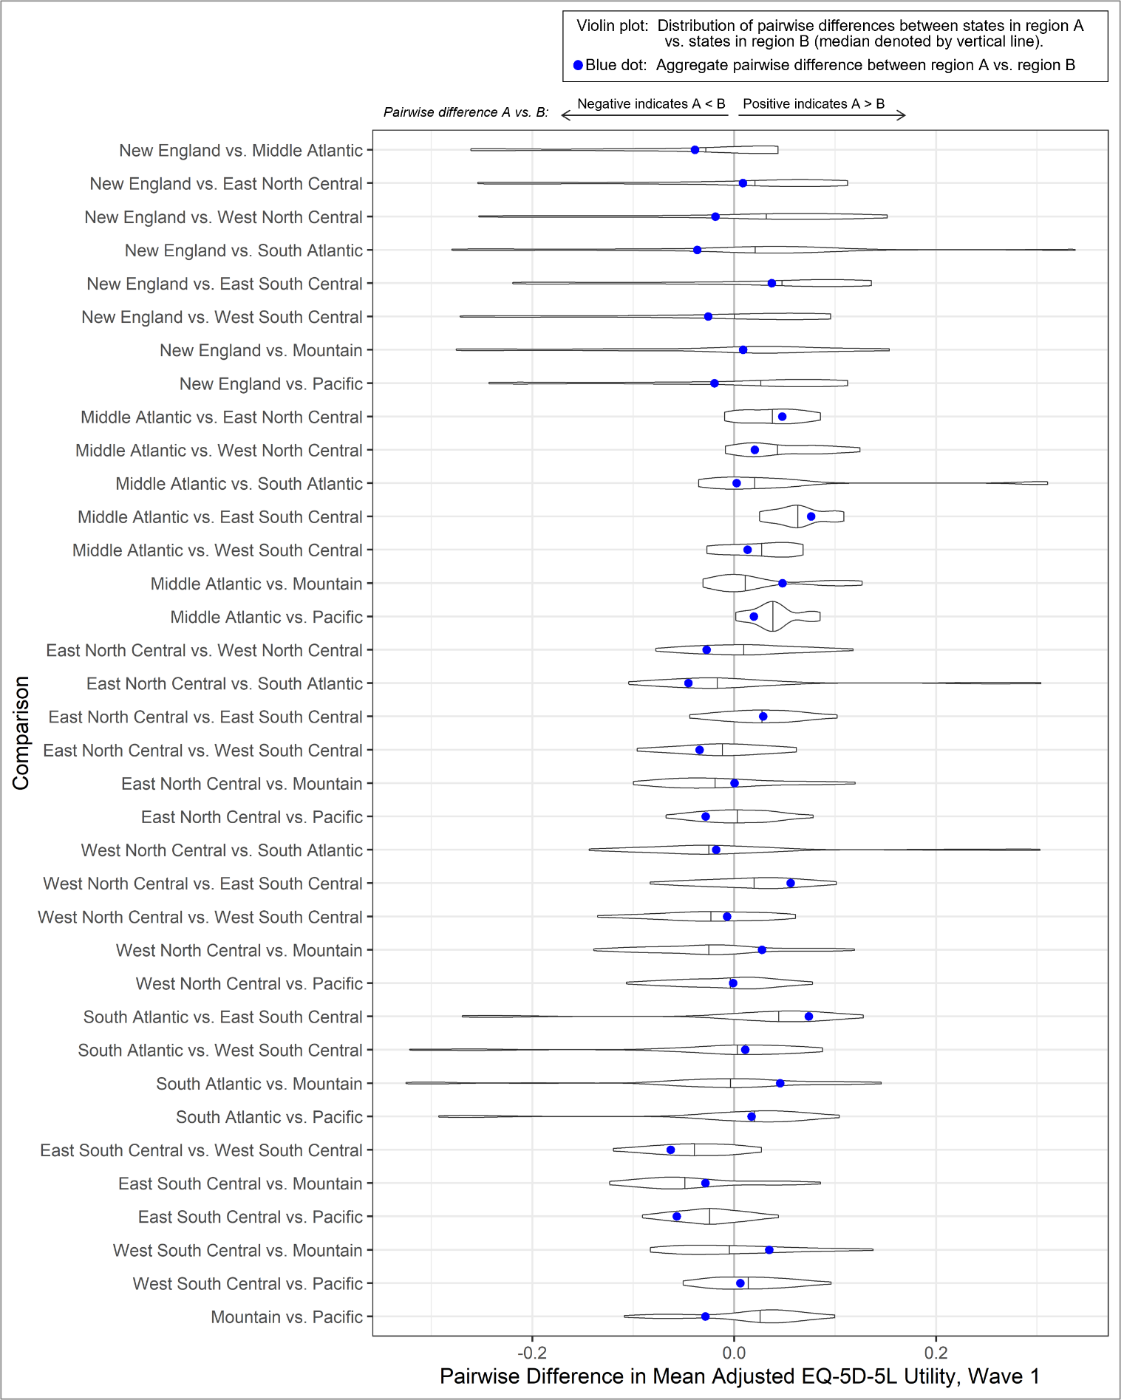

Online Resource Figure 5. Comparison of State-Level and Region-Division Pairwise Differences in EQ-5D-5L Utility, Wave 2
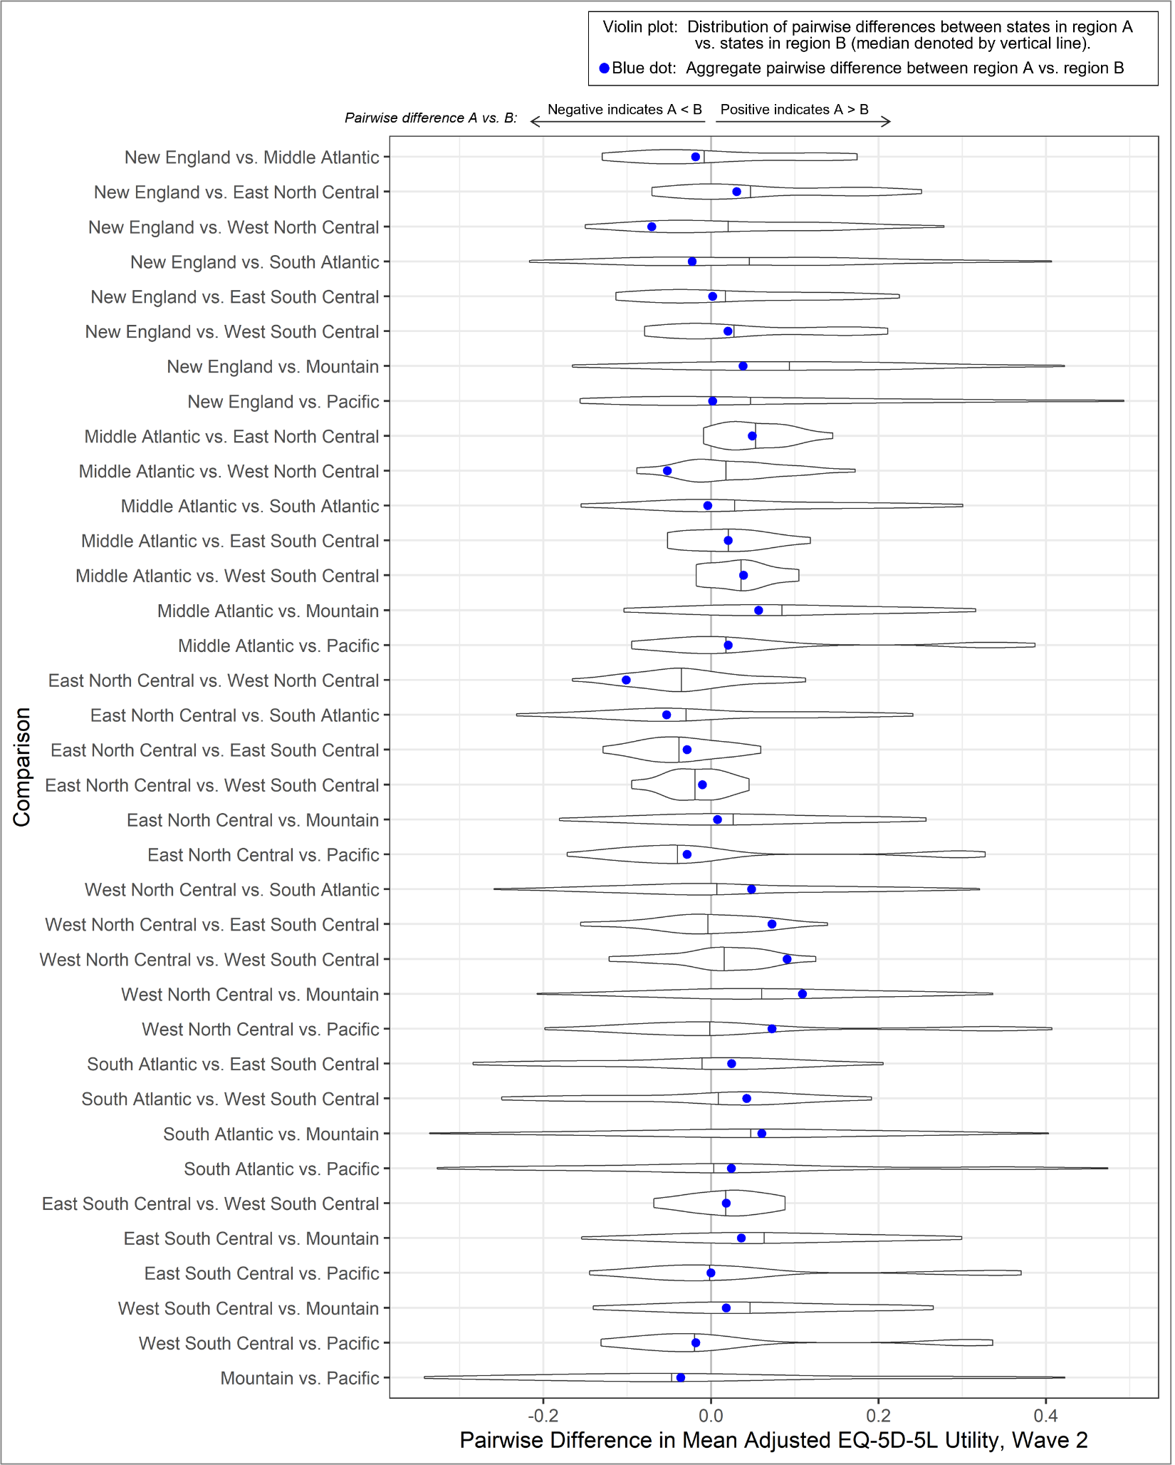
Online Resource Figure 6. Comparison of State-Level and Region-Division Pairwise Differences in EQ-5D-5L Utility, Wave 3
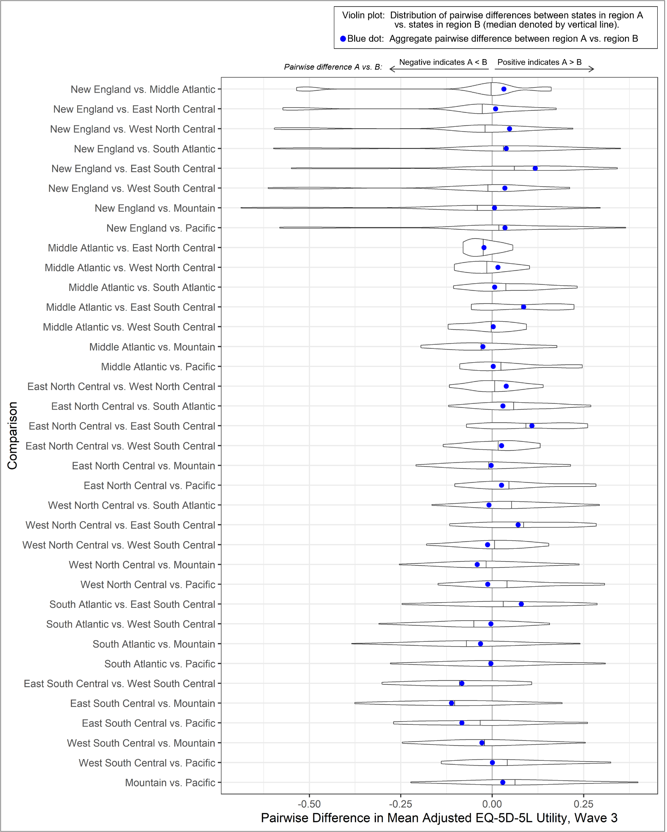
Online Resource Figure 7. Comparison of State-Level and Region-Division Pairwise Differences in EQ-VAS, Wave 1
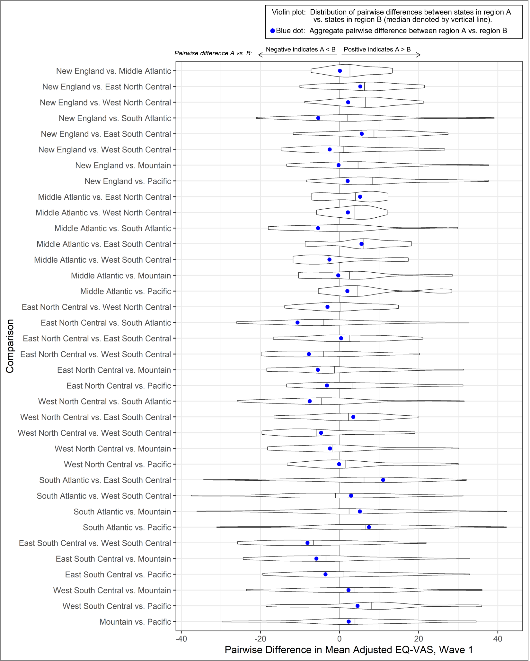
Online Resource Figure 8. Comparison of State-Level and Region-Division Pairwise Differences in EQ-VAS, Wave 2
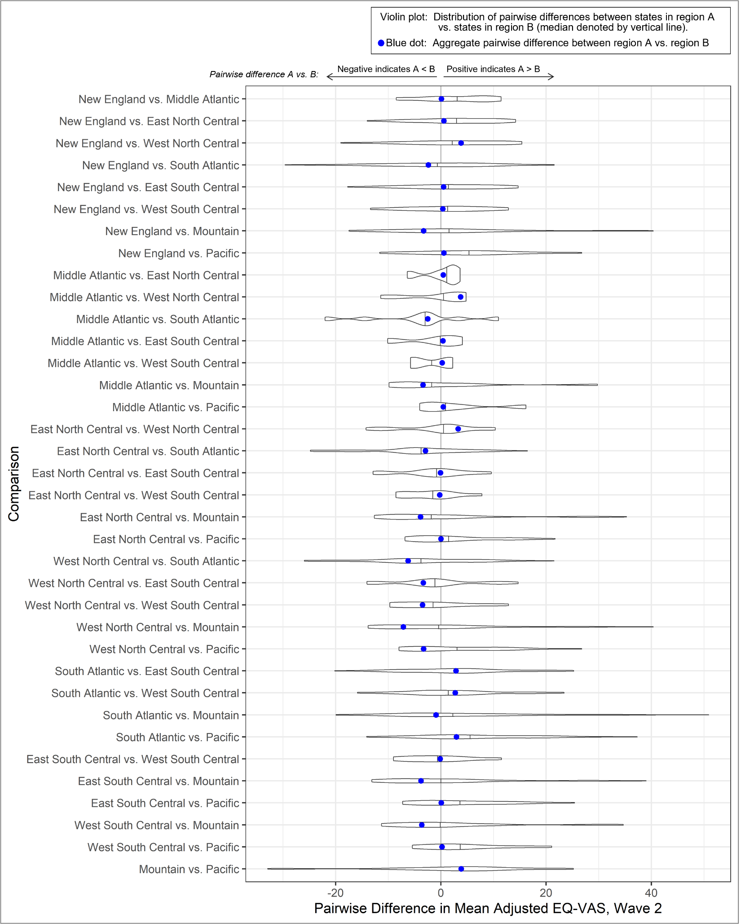
Online Resource Figure 9. Comparison of State-Level and Region-Division Pairwise Differences in EQ-VAS, Wave 3
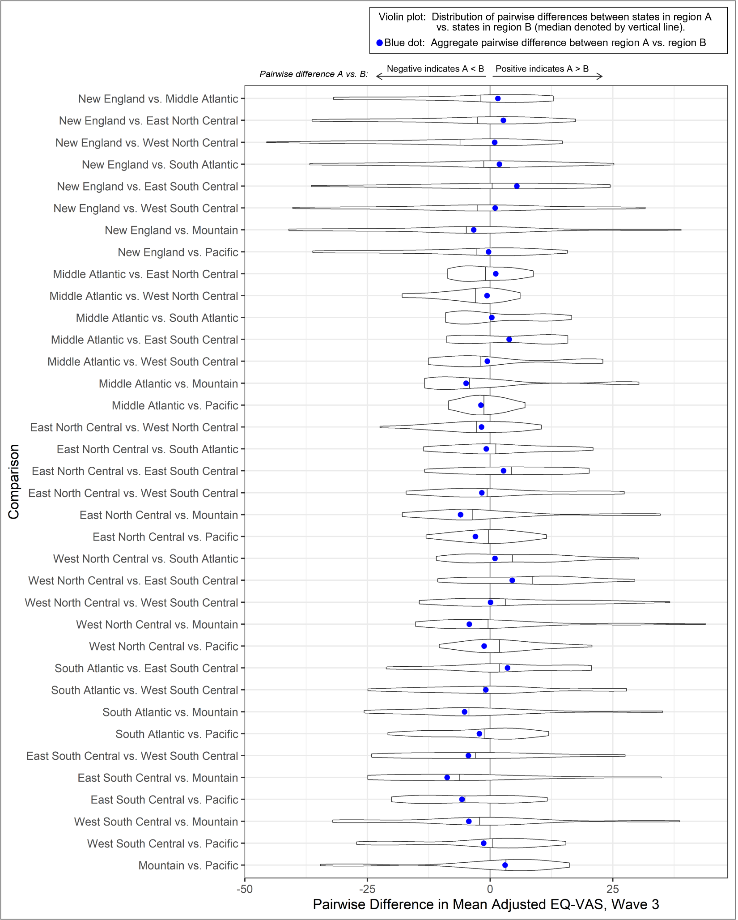

Online Resource Figure 10. Univariate Correlation Between Respondent HRQoL and COVID-19 Case Rate at the Time of Survey
A simple preliminary examination of the univariate correlation between respondents’ reported HRQoL and the statewide case rate at time of survey showed a less-than-clear relationship. In spring 2020 and winter 2021, there was no correlation between HRQoL and case rates, yet in summer 2020, utility was negatively correlated with case rates while EQ-VAS was positively correlated.
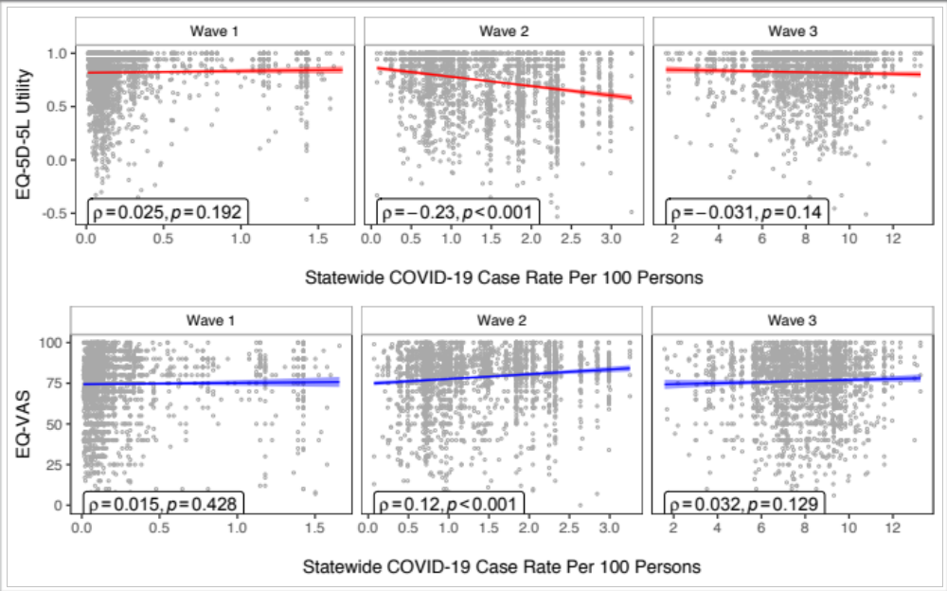

A3. Online Resource References

1. Van Buuren S, Brand JPL, Groothuis-Oudshoorn CGM, Rubin DB. Fully conditional specification in multivariate imputation. Journal of Statistical Computation and Simulation. 2006;76(12):1049-1064.
2. van Buuren S. Multiple imputation of discrete and continuous data by fully conditional specification. Stat Methods Med Res. 2007;16(3):219-242.
3. van Buuren S. Flexible Imputation of Missing Data. 2nd ed. New York: Chapman and Hall/CRC; 2018.
4. Seaman SR, Hughes RA. Relative efficiency of joint-model and full-conditional-specification multiple imputation when conditional models are compatible: The general location model. Statistical Methods in Medical Research. 2016;27(6):1603-1614.
5. Kropko J, Goodrich B, Gelman A, Hill J. Multiple Imputation for Continuous and Categorical Data: Comparing Joint Multivariate Normal and Conditional Approaches. Political Analysis. 2017;22(4):497-519.
6. Meng X-L. Multiple-Imputation Inferences with Uncongenial Sources of Input. Statistical Science. 1994;9(4):538-558, 521.
7. Collins LM, Schafer JL, Kam CM. A comparison of inclusive and restrictive strategies in modern missing data procedures. Psychol Methods. 2001;6(4):330-351.
8. Schafer JL. Analysis of Incomplete Multivariate Data. 1st ed. New York: Chapman and Hall/CRC; 1997.
9. Moons KG, Donders RA, Stijnen T, Harrell FE, Jr. Using the outcome for imputation of missing predictor values was preferred. J Clin Epidemiol. 2006;59(10):1092-1101.
10. Sterne JAC, White IR, Carlin JB, et al. Multiple imputation for missing data in epidemiological and clinical research: potential and pitfalls. BMJ. 2009;338:b2393.
11. Brand JPL. Development, Implementation and Evaluation of Multiple Imputation Strategies for the Statistical Analysis of Incomplete Data Sets. 1999.
12. van Buuren S, Boshuizen HC, Knook DL. Multiple imputation of missing blood pressure covariates in survival analysis. Stat Med. 1999;18(6):681-694.
13. Mercer A, Lau A, Kennedy C. For Weighting Online Opt-In Samples, What Matters Most? Pew Research Center. https://www.pewresearch.org/methods/2018/01/26/for-weighting-online-opt-in-samples-what-matters-most/. Published 2018. Accessed Jan 4, 2022.
14. Lavrakas P. Sampling, Coverage, And Weighting. In. Encyclopedia of Survey Research Methods. Thousand Oaks, California: SAGE Publications Ltd; 2008.
15. Battaglia MP, Hoaglin DC, Frankel MR. Practical Considerations in Raking Survey Data. Survey Practice. 2009;2(5).
16. Oh H, Scheuren F. Some unresolved application issues in raking ratio estimation. 1978 Proceedings of the Section on Survey Research Methods, American Statistical Association, Washington, DC. 1978:723-728.
17. Flood S, King M, Rodgers R, Ruggles S, Warren JR, Westberry M. Integrated Public Use Microdata Series, Current Population Survey: Version 9.0 [dataset]. In: Minnesota Uo, ed. Minneapolis, MN: IPUMS; 2022.
18. Brown A. About 5% of young adults in the U.S. say their gender is different from their sex assigned at birth. Pew Research Center. https://www.pewresearch.org/fact-tank/2022/06/07/about-5-of-young-adults-in-the-u-s-say-their-gender-is-different-from-their-sex-assigned-at-birth/. Published 2022. Accessed.
19. Pew Research Center for the People & the Press. Pew Research Center: American Trends Panel Wave May 16 to May 22, 2022. In:2022.
20. anesrake: ANES Raking Implementation [computer program]. 2018.
21. Rubin DB. Multiple Imputation for Nonresponse in Surveys. John Wiley & Sons, Inc; 1987.
22. van Belle G. Statistical Rules of Thumb. New York: John Wiley & Sons; 2002.
23. Little RJA, Rubin DB. Statistical Analysis with Missing Data. 2nd ed. New York: John Wiley & Sons; 2002.
24. Heitjan DF, Roderick JAL. Multiple Imputation for the Fatal Accident Reporting System. Journal of the Royal Statistical Society Series C (Applied Statistics). 1991;40(1):13-29.
25. Morris TP, White IR, Royston P. Tuning multiple imputation by predictive mean matching and local residual draws. BMC Medical Research Methodology. 2014;14(1):75.
26. Burgette LF, Reiter JP. Multiple Imputation for Missing Data via Sequential Regression Trees. American Journal of Epidemiology. 2010;172(9):1070-1076.
27. van der Ploeg T, Austin PC, Steyerberg EW. Modern modelling techniques are data hungry: a simulation study for predicting dichotomous endpoints. BMC Medical Research Methodology. 2014;14(1):137.
28. Kazis LE, Miller DR, Skinner KM, et al. Applications of methodologies of the Veterans Health Study in the VA healthcare system: conclusions and summary. J Ambul Care Manage. 2006;29(2):182-188.
29. Reilly MC, Zbrozek AS, Dukes EM. The validity and reproducibility of a work productivity and activity impairment instrument. Pharmacoeconomics. 1993;4(5):353-365.
30. Kroenke K, Spitzer RL, Williams JB, Löwe B. An ultra-brief screening scale for anxiety and depression: the PHQ-4. Psychosomatics. 2009;50(6):613-621.
31. Connor KM, Davidson JRT. Development of a new resilience scale: The Connor-Davidson Resilience Scale (CD-RISC). Depression and Anxiety. 2003;18(2):76-82.
32. Prins A, Bovin MJ, Smolenski DJ, et al. The Primary Care PTSD Screen for DSM-5 (PC-PTSD-5): Development and Evaluation Within a Veteran Primary Care Sample. J Gen Intern Med. 2016;31(10):1206-1211.
33. Centers for Disease Control and Prevention (CDC). Behavioral Risk Factor Surveillance System Survey Questionnaire. Atlanta, Georgia: U.S2020.
34. U.S. Census Bureau. Marital Status. 2016-2020 American Community Survey 5-Year Estimates. 2020.
35. U.S. Census Bureau. Selected Characteristics of Health Insurance Coverage in the United States. 2016-2020 American Community Survey 5-Year Estimates. 2020.
36. Cornelius ME, Loretan CG, Wang TW, Jamal A, Homa DM. Tobacco Product Use Among Adults - United States, 2020. MMWR Morb Mortal Wkly Rep. 2022;71(11):397-405.
37. U.S. Census Bureau. Annual Estimates of the Resident Population for the United States, Regions, States, District of Columbia, and Puerto Rico: April 1, 2020 to July 1, 2021 (NST-EST2021-POP). Population and Housing Unit Estimates. 2021.
38. U.S. Census Bureau. Selected Characteristics of Households by Total Money Income in 2020. Current Population Survey, 2021 Annual Social and Economic Supplement. 2021.
39. Gallup. Party Affiliation - Trend since 2004. https://news.gallup.com/poll/15370/party-affiliation.aspx. Published 2022. Accessed 2022.
40. National Center for Health Statistics. [Public-use data file and documentation]. National Health Interview Survey, 2020. 2021.
41. National Center for Chronic Disease Prevention and Health Promotion. Chronic Diseases in America. Centers for Disease Control and Prevention. https://www.cdc.gov/chronicdisease/resources/infographic/chronic-diseases.htm. Published 2022. Accessed.

