A cross-cultural study on the association between societal conditions and the idealization of happiness

Supplementary Materials

Table S1. Demographics across countries/regions
Countries/regions | N | Age | Gender (%Female) | Student (%Students)
Canada | 240 | 21.89 ± 4.77 | 71% | 100%
Bhutan | 119 | 22.62 ± 2.43 | 61% | 100%
Indonesia | 198 | 26.7 ± 11.90 | 51% | 100%
USA | 446 | 21.37 ± 5.81 | 70% | 100%
Brazil | 604 | 27.43 ± 10.13 | 54% | 55%
Italy | 288 | 25.14 ± 4.52 | 54% | 100%
Serbia | 210 | 20.11 ± 1.58 | 51% | 100%
Australia | 340 | 37.85 ± 16.86 | 57% | 43%
China | 199 | 20.58 ± 4.70 | 70% | 100%
Malaysia | 190 | 20.82 ± 1.62 | 68% | 100%
Argentina | 175 | 32.43 ± 11.35 | 74% | 100%
Japan | 198 | 19.56 ± 1.23 | 39% | 100%
South Korea | 208 | 22.43 ± 3.52 | 48% | 100%
Hungary | 831 | 20.89 ± 2.40 | 73% | 100%
Romania | 290 | 22.30 ± 6.12 | 50% | 100%
France | 216 | 31.75 ± 10.45 | 82% | 100%
Russia | 270 | 19.76 ± 1.55 | 63% | 100%
UK | 146 | 20.71 ± 3.04 | 30% | 100%
Switzerland | 334 | 25.93 ± 6.00 | 20% | 93%
Ireland | 244 | 20.96 ± 3.18 | 58% | 100%
Chile | 221 | 21.55 ± 3.11 | 55% | 100%
Salvador | 240 | 26.90 ± 8.72 | 58% | 100%
Poland | 472 | 32.51 ± 14.77 | 69% | 52%
Portugal | 260 | 28.62 ± 12.61 | 65% | 60%
Slovakia | 311 | 21.55 ± 1.95 | 52% | 100%
Greece | 427 | 24.69 ± 5.75 | 60% | 54%
Norway | 250 | 22.66 ± 4.83 | 78% | 100%
Lithuania | 296 | 25.65 ± 10.93 | 73% | 76%
Iran | 199 | 34.42 ± 9.44 | 46% | 100%
Croatia | 140 | 30.69 ± 11.12 | 84% | 100%
Nigeria | 137 | 19.82 ± 1.51 | 78% | 100%
Turkey | 202 | 31.99 ± 11.68 | 53% | 100%
Mexico | 175 | 20.80 ± 3.91 | 56% | 100%
Guatemala | 111 | 20.51 ± 2.37 | 69% | 100%
Czech Republic | 201 | 22.23 ± 3.48 | 50% | 100%
Germany | 106 | 22.43 ± 3.40 | 77% | 92%
Austria | 320 | 28.59 ± 10.14 | 80% | 68%
Estonia | 200 | 28.80 ± 10.53 | 71% | 100%
Ukraine | 210 | 19.02 ± 2.26 | 54% | 100%
Netherlands | 194 | 19.41 ± 1.85 | 10% | 100%
Pakistan | 240 | 21.79 ± 3.46 | 50% | 100%
Georgia | 234 | 20.05 ± 2.56 | 53% | 100%
Ghana | 266 | 22.21 ± 2.36 | 51 | 100%
Note. Age is presented as mean ± sd.

Table S2. Internal consistencies (Cronbach's α) for each idealized happiness across all countries included in the main analysis
Countries | LS | IHS | LS-family | IHS-family
Canada | .93 | .93 | .97 | .96
Bhutan | .89 | .90 | .89 | .91
Indonesia | .81 | .85 | .79 | .84
USA | .94 | .93 | .96 | .95
Brazil | .90 | .88 | .93 | .91
Italy | .92 | .90 | .95 | .92
Serbia | .89 | .82 | .93 | .88
Australia | .95 | .94 | .95 | .95
China | .89 | .82 | .89 | .90
Malaysia | .90 | .88 | .90 | .91
Argentina | .79 | .87 | .84 | .88
Japan | .92 | .90 | .94 | .93
South Korea | .92 | .91 | .94 | .95
Hungary | .87 | .84 | .91 | .88
Romania | .89 | .86 | .94 | .90
France | .89 | .82 | .92 | .88
Russia | .90 | .87 | .92 | .92
UK | .89 | .90 | .93 | .92
Switzerland | .89 | .80 | .92 | .82
Ireland | .89 | .89 | .92 | .93
Chile | .82 | .83 | .88 | .87
El Salvador | .83 | .80 | .85 | .83
Poland | .96 | .94 | .97 | .96
Portugal | .93 | .83 | .94 | .86
Slovakia | .89 | .87 | .92 | .91
Greece | .91 | .83 | .94 | .88
Norway | .92 | .91 | .94 | .94
Lithuania | .91 | .90 | .94 | .92
Iran | .92 | .93 | .93 | .95
Croatia | .92 | .88 | .94 | .92
Nigeria | .93 | .95 | .96 | .97
Turkey | .92 | .84 | .93 | .90
Mexico | .91 | .86 | .92 | .90
Guatemala | .85 | .84 | .89 | .86
Czech Republic | .84 | .78 | .87 | .80
Germany | .88 | .73 | .93 | .86
Austria | .91 | .83 | .94 | .88
Estonia | .87 | .82 | .90 | .87
Ukraine | .86 | .80 | .88 | .85
Netherlands | .92 | .89 | .93 | .87
Pakistan | .82 | .83 | .81 | .86
Georgia | .88 | .80 | .90 | .87
Ghana | .87 | .88 | .92 | .90
Note. LS = Life satisfaction; IHS = Interdependent happiness

Table S3. Source details for all societal and cultural indicators of happiness idealization
Existential security
Construct | Sources
Religiosity | Cultural Religiosity Score (Joshanloo & Gebauer, 2019) | Joshanloo & Gebauer (2019)
Resource scarcity | Renewable internal freshwater resources per capita (Gu et al., 2020) | https://data.worldbank.org/indicator/ER.H2O.INTR.PC
Natural disaster frequency | Disaster frequency/national land area (Santos et al., 2017) | The frequency of the natural disaster event (1960- 2016): https://www.emdat.be/guidelines.
Natural disaster frequency | Disaster frequency/national land area (Santos et al., 2017) | Land area data: https://data.worldbank.org/indicator/AG.LND.TOTL.K2
Pathogen threat | Historical Disease Prevalence (Murray & Schaller, 2010) | Murray & Schaller (2010)
Climate stress | Climatic demands score (Van de Vliert, 2013) | Van de Vliert (2013)
Population density | Population density data (Gelfand, 2011) | https://data.worldbank.org/indicator/EN.POP.DNST
Ethnic fractionalization | Ethnic Fractionalization Index (Alesina et al., 2003) | Alesina et al. (2003)
Armed conflict threat | Uppsala Conflict Data Program (1946-2016) | UCDP/PRIO Armed Conflict Dataset
Armed conflict threat | Uppsala Conflict Data Program (1946-2016) | https://ucdp.uu.se/downloads/index.html#armedconflict
Unemployment | Unemployment rate (Bianchi, 2020) | https://data.worldbank.org/indicator/SL.UEM.TOTL.ZS
Economic affluence | GDP per capita (World Bank) | https://data.worldbank.org/indicator/NY.GDP.PCAP.CD
Human development | Human Development Index (UNDP, 2017) | https://hdr.undp.org/data-center/human-development-index#/indicies/HDI
State capacity | Index of State Capacity (O'Reilly & Murphy, 2022) | http://www.colinworeilly.com/state-capacity-index.html
Institutionalization
Construct | Sources
Market capitalism | Economic Freedom Index (The Heritage Foundation, 2023) | https://www.heritage.org/index/
Political rights | Political rights index (Freedom House, 2023) | https://freedomhouse.org/report/freedom-world
Civil rights | Civil liberty index (Freedom House, 2023) | https://freedomhouse.org/report/freedom-world
Social rights | Commitment to Reducing Inequality Index (Oxfam, 2023) | https://policy-practice.oxfam.org/resources/the-commitment-to-reducing-inequality-index-2022-621419/
Link to world society | INGO Network Country Score (Paxton et al., 2015) | Paxton et al. (2015)
Illiberal intergovernment | Illiberable intergovernmental Affiliation (Schofer et al. 2022)

Measurement Invariance across Countries
We performed a multigroup confirmatory factor analysis (MGCFA) to test for configural, metric, and scalar invariance of the four happiness idealization measurements using ‘lavaan’ package in R. Configural invariance represents how similar the overall pattern of factors is across countries, and was evaluated by calculating fit indices when the multigroup model was estimated freely. Metric invariance represents how similar factor loadings are across countries, and was evaluated by comparing resultant fit indices calculated when the model was estimated freely to the fit indices calculated when the model was fully constrained. Scalar invariance represents how similar the latent structure is across countries, and was evaluated by comparing resultant fit indices calculated from the metric model to fit indices when all item intercepts are constrained to be equal.

Table S4. Multigroup confirmatory factor analysis across 43 societies.
 | CFI |  |  |  | RMSEA |  |  |  | SRMR
 | config | metric (Δ) | scalar (Δ) |  | config | metric (Δ) | scalar (Δ) |  | config | metric (Δ) | scalar (Δ)
Idealization of life satisfactionª | 0.976 | 0.969 (0.007) | 0.956 (0.013) |  | 0.127 | 0.109 (0.018) | 0.113 (0.004) |  | 0.023 | 0.058 (0.035) | 0.066 (0.008)
Idealization of Interdependent happiness^{b} | 0.872 | 0.853 (0.019) | 0.823 (0.030) |  | 0.162 | 0.153 (0.009) | 0.157 (0.004) |  | 0.061 | 0.096 (0.035) | 0.104 (0.043)
Idealization of family life satisfactionª | 0.985 | 0.979 (0.006) | 0.972 (0.007) |  | 0.112 | 0.100 (0.012) | 0.100 (0) |  | 0.017 | 0.056 (0.039) | 0.061 (0.044)
Idealization of family interdependent happiness^{b} | 0.875 | 0.863 (0.012) | 0.844 (0.019) |  | 0.180 | 0.166 (0.014) | 0.166 (0) |  | 0.058 | 0.088 (0.030) | 0.095 (0.037)
Note. CFI = comparative fit index, RMSEA = root mean square error of approximation, SRMR = standardized root mean square residual, config = configural model, metric = metric model, scalar = scalar model, Δ = fit difference between the two models, ª For idealization of (family) life satisfaction, we reported fit indices when the restraint to a single item (#5) was relaxed. ^{b} For idealization of (family) interdependent happiness, we reported fit indices when the restraint to three items (#4, #5, #6) was relaxed.
We determined configural, metric, and scalar invariance using commonly accepted thresholds used for MGCFA, for research using a large number of groups (~ > 20) (configural: CFI > .95, RMSEA < .10, SRMR < .10) (metric: ΔCFI ≤ .02, ΔRMSEA < .03, ΔSRMR < .03) (scalar: ΔCFI < .01, ΔRMSEA < .01, ΔSRMR < .15) (Jang et. Al., 2017; Putnick & Bornstein, 2016; Rutkowski, & Svetina, 2014). Across a total of 36 invariance tests, we found considerable evidence of configural, metric, and scalar invariances (> 55%; 20 out of 36). It is important to note that our evidence of measurement invariance is imperfect. This is consistent with former experiences showing that detecting non-invariance in large-scale studies across many countries is extremely rare (Marsh et al., 2018; Robitzsch & Lüdtke, 2023; Rutkowski & Svetina, 2024; Welzel et al., 2021; Zercher et al., 2015). Within the context of research on large numbers of groups (~ > 20) (Rutkowski & Svetina, 2014; Welzel et al., 2021), this finding does provide some support for the equivalence and fidelity of these measures across cultural contexts.
References:
Jang, S., Kim, E., Cao, C., Allen, T. D., Cooper, C. L., Lapierre, L. M.,...Woo, J. (2017). Measurement invariance of the Satisfaction with Life Scale across 26 countries. Journal of Cross-Cultural Psychology, 48,560–576.
Marsh, H. W., Guo, J., Parker, P. D., Nagengast, B., Asparouhov, T., Muthén, B., & Dicke, T. (2018). What to do when scalar invariance fails: The extended alignment method for multi-group factor analysis comparison of latent means across many groups. Psychological Methods, 23(3), 524–545.
Putnick, D. L., & Bornstein, M. H. (2016). Measurement invariance conventions and reporting: The state of the art and future directions for psychological research. Developmental Review, 41, 71-90.
Robitzsch, A., & Lüdtke, O. (2023). Why full, partial, or approximate measurement invariance are not a prerequisite for meaningful and valid group comparisons. Structural Equation Modeling: A Multidisciplinary Journal, 30(6), 859-870.
Rutkowski, L., & Svetina, D. (2014). Assessing the hypothesis of measurement invariance in the context of large-scale international surveys. Educational and Psychological Measurement, 74(1), 31-57.
Tsai, J. L., Knutson, B., & Fung, H. H. (2006). Cultural variation in affect valuation. Journal of Personality and Social Psychology, 90(2), 288-307.
Welzel, C., Brunkert, L., Kruse, S., & Inglehart, R. F. (2021). Non-invariance? An overstated problem with misconceived causes. Sociological Methods & Research, 52(3) 1368–1400.
Zercher, F., Schmidt, P., Cieciuch, J., & Davidov, E. (2015). The comparability of the universalism value over time and across countries in the European Social Survey: Exact versus approximate measurement invariance. Frontiers in Psychology, 6, 722.

Table S5. Variable selection results across outcomes (Models with demographic covariates)
Outcome | ‘Prediction’ variables | Predictivity of ‘prediction’ variables | ‘Interpretation’ variables | Predictivity of ‘interpretation’ variables
Idealization of life satisfaction | Religiosity | 13.62% | Religiosity, pathogen prevalence, age, GDP, climate stress, ethnic fractionalization, social rights, unemployment rate, water scarcity. Economic freedom, disaster frequency, human development index, sample type, state capacity, population density, armed conflict threat, gender | 15.32%
Idealization of Interdependent happiness | Religiosity | 11.66% | Religiosity, age, pathogen prevalence, climate stress, GDP, ethnic fractionalization, water scarcity, disaster prevalence, social rights, economic freedom, human development index, population density, armed conflict threat, gender, sample type, state capacity | 13.2%
Idealization of family life satisfaction | Religiosity | 12.44% | Religiosity, age, pathogen prevalence, GDP, climate stress, ethnic fractionalization, water scarcity, social rights, sample type, population density, disaster prevalence, unemployment rate, economic freedom, human development index, state capacity, armed conflict threat, gender | 14.35%
Idealization of family interdependent happiness | Religiosity | 11.36% | Religiosity, age, climate stress, pathogen prevalence, GDP, ethnic fractionalization, disaster prevalence, water scarcity, population density, sample type, human development index, gender, social rights, armed conflict threat | 13.02%

Table S6. Random forests model performance across different model parameters
Outcome | Predictivity of religiosity (default parameters) | training/testing ratio = 1:1 | training/testing ratio = 1:2 | Ntree = 300 /700 | Predictivity of all 18 social indicators (default parameters) | training/testing ratio = 1:1 | training/testing ratio = 1:2 | Ntree = 300/700 | Mtry = 3/9
Idealization of life satisfaction | 13.67% | 13.67% | 13.67% | 13.67%/13.67% | 15.27% | 15.27% | 15.27% | 15.22%/15.32% | 15.21%/14.69%
Idealization of interdependent happiness | 11.82% | 11.82% | 11.82% | 11.80%/11.81% | 13.31% | 13.31% | 13.31% | 13.32%/13.32% | 13.21%/12.80%
Idealization of family life satisfaction | 12.42% | 12.42% | 12.42% | 12.41%/12.41% | 14.20% | 14.20% | 14.20% | 14.15%/14.21% | 14.18%/13.68%
Idealization of family interdependent happiness | 11.46% | 11.46% | 11.46 | 11.44%/11.45% | 13.05% | 13.05% | 12.98% | 12.97%/13.01% | 13.00%/12.36%

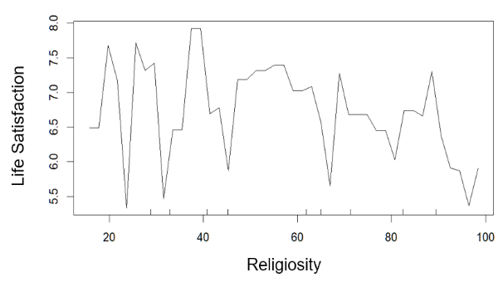 | 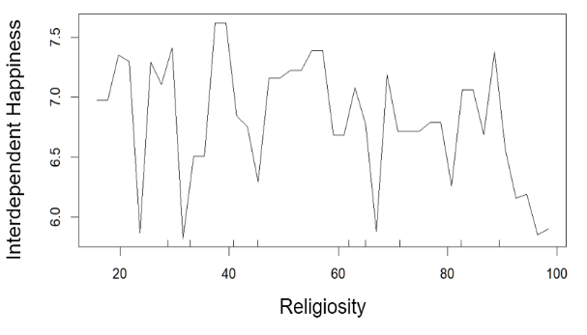
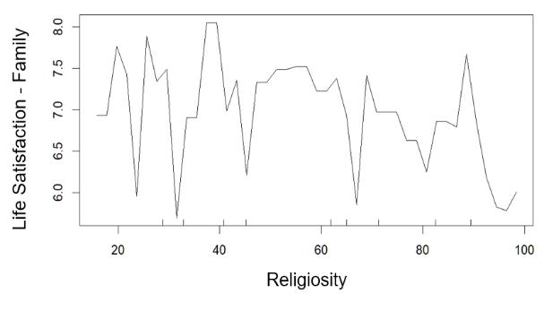 | 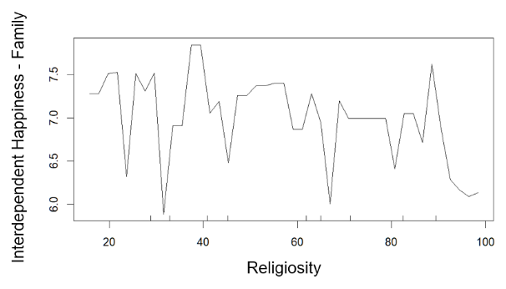
Figure S1. Partial dependency plots of religiosity and the idealization of happiness (based upon the random forests model with all 18 social indicators). Patterns of covariation between in cultural religiosity and idealized happiness are elusive in these cases. We plotted these plots according to the random forests models with religiosity only in the main manuscript.

