Appendix 5
Some examples of design based on design strategies
Design strategies | Design examples
The design of the facilities in front of the seats avoids semi-enclosed or fully enclosed baffles, thereby preventing the line of sight from being completely blocked by the facilities. | 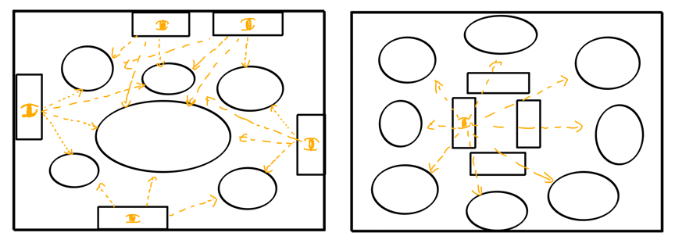
Popular facilities (such as swings and seesaws) need to have more facilities or shared play areas to avoid long queues. | 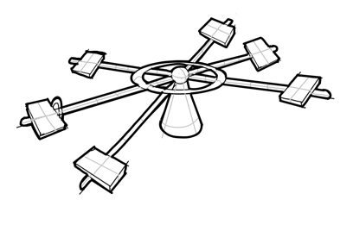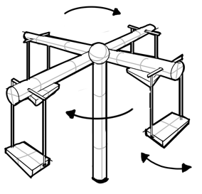
Avoid placing seats too close to plants and having places to hang school bags and clothes next to the seats (to prevent insects). | 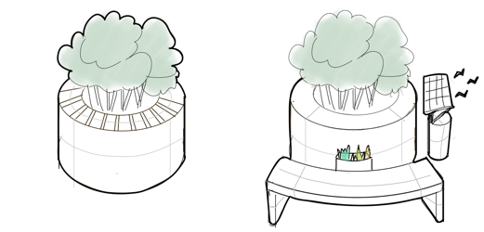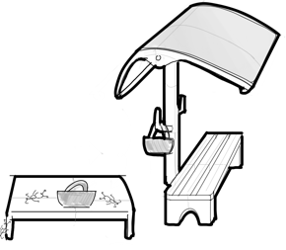
The seats in the rest area need to be designed with sun and rain protection according to local weather conditions. | 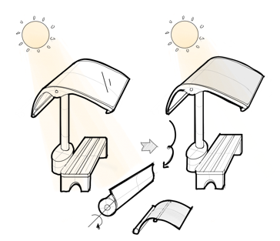
Add more interesting parent-child interactive facilities (caregivers also find it interesting rather than just assisting children). | 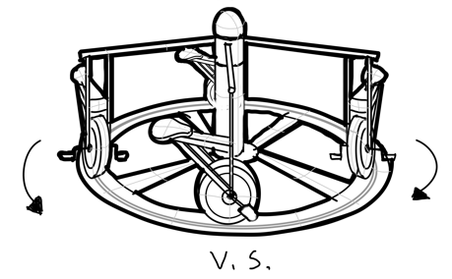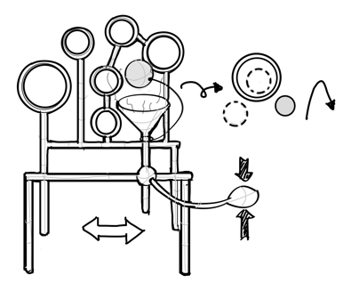
Add facilities that can develop children's different abilities. | 