Supplementary analysis
Figure S1: Test of assumptions behind the Cox model. Attractiveness and mortality. Hazard functions for attractive, average and unattractive individuals based on Model 3, Table 1. Number of observations: 16554.

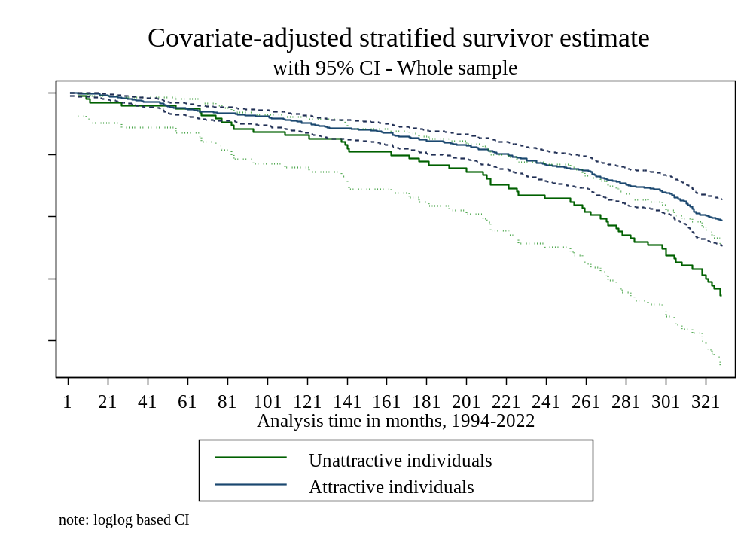
Figure S2: Physical attractiveness (Wave 1) and mortality. Survival functions for attractive and unattractive individuals based on Model 3, Table 1. Number of observations: 16554.

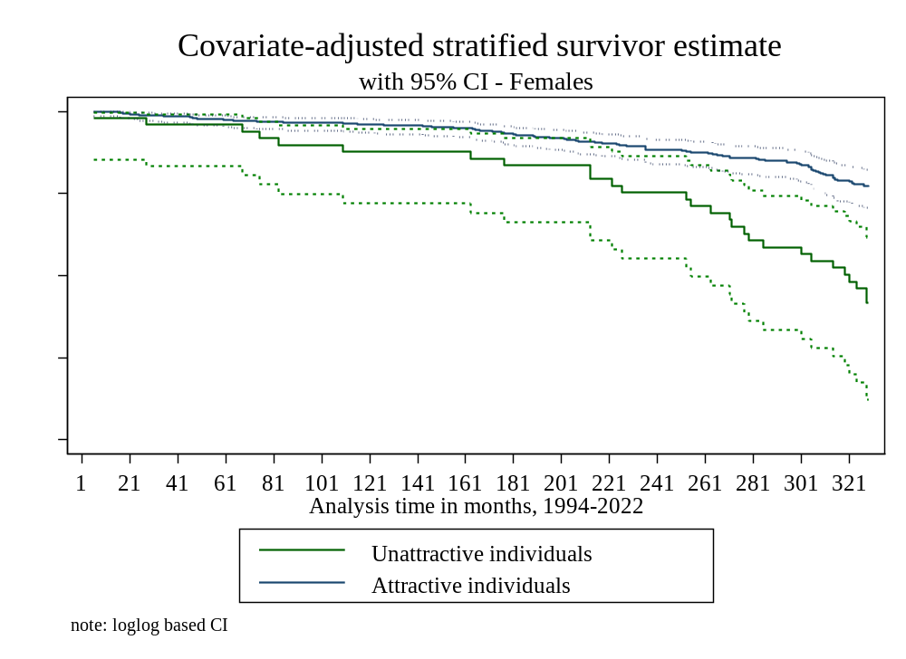
Figure S3: Physical attractiveness (Wave 1) and mortality. Survival functions for attractive and unattractive females based on Model 2, Table 2. Number of observations: 8397.

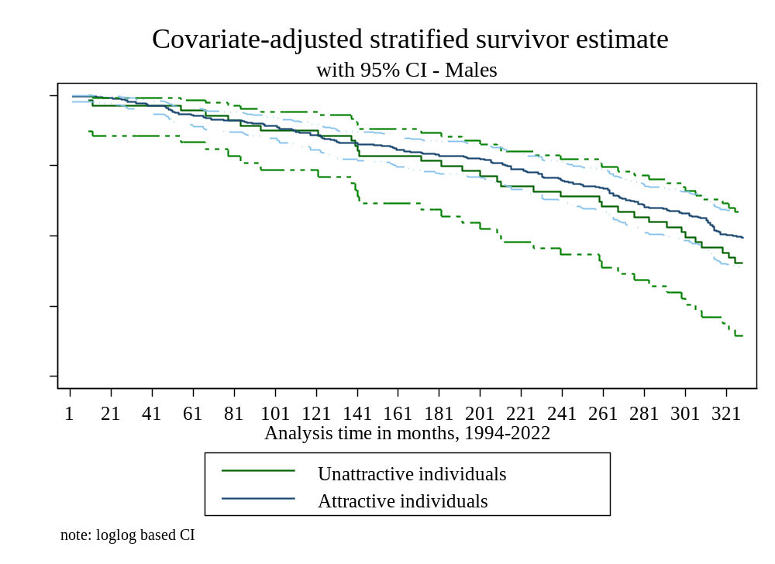
Figure S4: Physical attractiveness (Wave 1) and mortality. Survival functions for attractive and unattractive females based on Model 1, Table 2. Number of observations: 8157
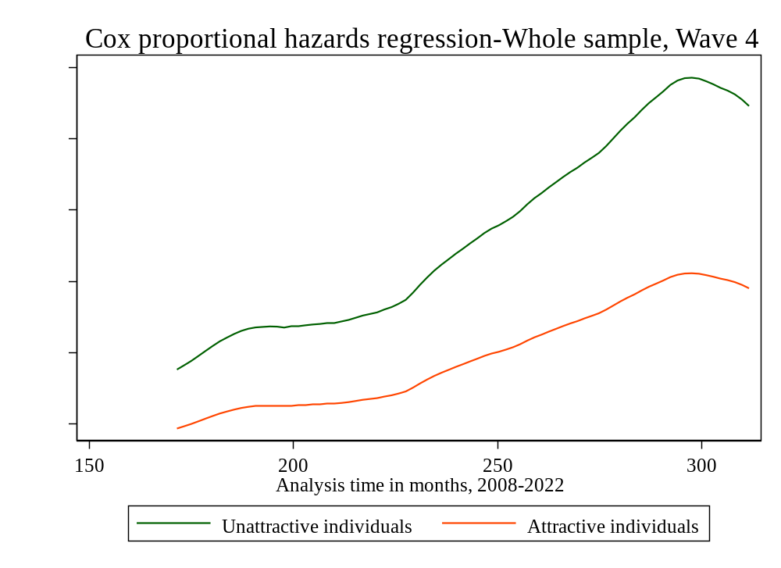
Figure S5: Adulthood attractiveness (Wave 4) and mortality. Hazard functions for attractive and unattractive individuals based on Model 1, Table S5. Number of observations: 13346.

Table S1: Descriptive statistics
 | Whole sample | Dead | Alive
 | Mean | Mean | Mean
Mortality | 0.04
Physical attractiveness | 2.44 | 2.34*** | 2.45***
 |  | (0.03) | (0.01)
Age | 14.91 | 14.99*** | 14.91***
 |  | (0.18) | (0.12)
Male | 0.51 | 0.63*** | 0.51***
Race/ethnicity (ref.= White) |  | (0.03) | (0.01)
Hispanic | 0.11 | 0.08*** | 0.12***
 |  | (0.02) | (0.02)
Black (non-Hispanic) | 0.15 | 0.19*** | 0.15***
 |  | (0.04) | (0.02)
Asian (non-Hispanic) | 0.03 | 0.01* | 0.04***
 |  | (0.00) | (0.01)
Other (non-Hispanic) | 0.01 | 0.01 | 0.01***
 |  | (0.00) | (0.00)
IQ proxy | 0.12 | -0.12 | 0.13***
 |  | (0.08) | (0.04)
Single family | 0.20 | 0.29*** | 0.20***
 |  | (0.03) | (0.01)
Parental education | 2.88 | 2.65*** | 2.89***
 |  | (0.07) | (0.05)
Evidence of drinking | 0.04 | 0.06*** | 0.04***
 |  | (0.01) | (0.00)
Safety concern-interviewer | 0.04 | 0.04*** | 0.04***
 |  | (0.01) | (0.00)
Poor health self-rated | 0.32 | 0.43*** | 0.31***
 |  | (0.04) | (0.01)
High BMI | 0.38 | 0.45*** | 0.37***
 |  | (0.03) | (0.01)
Mental health | 2.31 | 2.77*** | 2.30***
 |  | (0.17) | (0.04)
Observations | 16554 | 562 | 15992
Note: Standard errors in parentheses
* p < 0.05, ** p < 0.01, *** p < 0.001
Table S2: Attractiveness and mortality accounting for BMI and birth weight. Cox proportional hazard models predicting mortality.
Model: | (1) |  | (2) |  | (3) |  | (4)
Attractiveness (ref.=attractive) | Hazard | S.E. | Hazard | S.E. | Hazard | S.E. | Hazard | S.E.
Unattractive | 1.44* | (0.26) | 1.43 | (0.27) | 1.64* | (0.31) | 1.63* | (0.32)
Average | 1.00 | (0.10) | 1.00 | (0.11) | 1.00 | (0.12) | 1.00 | (0.12)
Age | 1.00 | (.) | 1.00 | (.) | 1.00 | (.) | 1.00 | (.)
Male | 0.99 | (0.04) | 0.99 | (0.04) | 1.02 | (0.04) | 1.02 | (0.04)
Race/ethnicity (ref.= White) | 1.73*** | (0.23) | 1.73*** | (0.23) | 1.67*** | (0.22) | 1.69*** | (0.22)
Hispanic | 0.50** | (0.12) | 0.50** | (0.12) | 0.43** | (0.11) | 0.43** | (0.11)
Black (non-Hispanic) | 0.87 | (0.16) | 0.87 | (0.16) | 0.80 | (0.17) | 0.79 | (0.17)
Asian (non-Hispanic) | 0.23*** | (0.08) | 0.23*** | (0.08) | 0.12*** | (0.04) | 0.13*** | (0.04)
Other (non-Hispanic) | 0.57 | (0.40) | 0.57 | (0.39) | 0.59 | (0.46) | 0.58 | (0.46)
IQ proxy | 0.77*** | (0.06) | 0.77*** | (0.06) | 0.76** | (0.06) | 0.76** | (0.07)
Single family | 1.38* | (0.21) | 1.38* | (0.21) | 1.36 | (0.22) | 1.36 | (0.22)
Parental education | 0.95 | (0.05) | 0.95 | (0.05) | 0.97 | (0.05) | 0.97 | (0.05)
Evidence of drinking | 1.39 | (0.38) | 1.40 | (0.38) | 1.54 | (0.44) | 1.54 | (0.43)
Safety concern-interviewer | 0.70 | (0.21) | 0.70 | (0.21) | 0.56 | (0.19) | 0.56 | (0.19)
Poor health self-rated | 1.42* | (0.21) | 1.41* | (0.21) | 1.50* | (0.26) | 1.50* | (0.26)
Mental health | 1.07* | (0.03) | 1.07* | (0.03) | 1.05 | (0.03) | 1.05 | (0.03)
High BMI | 1.23 | (0.13)
BMI quintiles (ref.=middle)
BMI bottom 20% |  |  | 0.95 | (0.17)
BMI 20%-40% |  |  | 0.90 | (0.18)
BMI 60%-80% |  |  | 1.14 | (0.19)
BMI top 20% |  |  | 1.20 | (0.17)
Birth weight pounds |  |  |  |  | 0.95 | (0.04)
Birth weight deciles (ref.=5)
1 |  |  |  |  |  |  | 0.65 | (0.30)
2 |  |  |  |  |  |  | 0.89 | (0.33)
3 |  |  |  |  |  |  | 1.63* | (0.33)
4 |  |  |  |  |  |  | 0.90 | (0.14)
6 |  |  |  |  |  |  | 0.89 | (0.15)
7 |  |  |  |  |  |  | 0.82 | (0.20)
8 |  |  |  |  |  |  | 0.90 | (0.45)
10 |  |  |  |  |  |  | 1.72 | (1.33)
Number of observations | 16554 |  | 16554 |  | 13994 |  | 13994
Note: Exponentiated coefficients from Cox regression models; Standard errors in parentheses * p < 0.05, ** p < 0.01, *** p < 0.001. Covariates from Add Health data from Wave 1, 1994-95. All models include survey weights.
Table S3: Accounting for early disadvantage, attractiveness and mortality. Cox proportional hazard models predicting mortality.
Model: | (1) |  | (2) |  | (3) |  | (4)
Attractiveness (ref.=attractive) | Hazard | S.E. | Hazard | S.E. | Hazard | S.E. | Hazard | S.E.
Unattractive | 1.57* | (0.29) | 1.61** | (0.28) | 1.60* | (0.34) | 1.62* | (0.35)
Average | 1.00 | (0.10) | 1.06 | (0.11) | 1.00 | (0.12) | 1.00 | (0.12)
Age | 1.01 | (0.04) | 1.02 | (0.04) | 1.01 | (0.05) | 1.01 | (0.05)
Male | 1.62*** | (0.20) | 1.68*** | (0.21) | 1.58** | (0.22) | 1.58** | (0.22)
Race/ethnicity (ref.= White)
Hispanic | 0.44** | (0.11) | 0.51** | (0.12) | 0.44** | (0.13) | 0.46* | (0.14)
Black (non-Hispanic) | 0.84 | (0.16) | 0.86 | (0.16) | 0.92 | (0.17) | 0.93 | (0.17)
Asian (non-Hispanic) | 0.11*** | (0.04) | 0.23*** | (0.08) | 0.12*** | (0.04) | 0.12*** | (0.04)
Other (non-Hispanic) | 0.58 | (0.44) | 0.57 | (0.39) | 0.71 | (0.55) | 0.73 | (0.57)
IQ proxy | 0.77*** | (0.06) | 0.78*** | (0.06) | 0.78** | (0.07) | 0.77** | (0.06)
Single family | 1.35* | (0.20) | 1.33 | (0.21) | 1.37* | (0.19) | 1.32 | (0.19)
Parental education | 0.95 | (0.05) | 0.95 | (0.05) | 0.96 | (0.06) | 0.96 | (0.06)
Evidence of drinking | 1.46 | (0.43) | 1.41 | (0.37) | 1.61 | (0.49) | 1.62 | (0.50)
Safety concern-interviewer | 0.60 | (0.20) | 0.68 | (0.20) | 0.58 | (0.19) | 0.58 | (0.19)
Poor health self-rated | 1.49* | (0.24) | 1.48* | (0.22) | 1.56** | (0.24) | 1.57** | (0.24)
Mental health | 1.06 | (0.03) | 1.06 | (0.03) | 1.04 | (0.04) | 1.04 | (0.04)
No health insurance | 0.95 | (0.15) |  |  |  |  | 0.96 | (0.18)
Number of siblings |  |  | 0.94 | (0.04) |  |  | 0.95 | (0.05)
Household income |  |  |  |  | 1.00 | (0.00) | 1.00 | (0.00)
Number of observations | 14800 |  | 16724 |  | 12700 |  | 12613
Note: Exponentiated coefficients from Cox regression models; Standard errors in parentheses
* p < 0.05, ** p < 0.01, *** p < 0.001. Covariates from Add Health data from Wave 1, 1994-95. All models include survey weights.

Table S4: Accounting for interviewers’ fixed effects and the original self-rated health. Attractiveness and mortality. Cox proportional hazard models predicting mortality.
Model: | (1) |  | (2)
 | Hazard | S.E. | Hazard | S.E.
Attractiveness (ref.=attractive)
Unattractive | 1.76** | (0.37) | 1.72* | (0.37)
Average | 1.08 | (0.13) | 1.07 | (0.13)
Age | 1.02 | (0.04) | 1.00 | (.)
Male | 1.62*** | (0.20) | 1.02 | (0.04)
Race/ethnicity (ref.= White) |  |  | 1.63*** | (0.20)
Hispanic | 0.64* | (0.14) | 0.64 | (0.15)
Black (non-Hispanic) | 0.79 | (0.20) | 0.79 | (0.20)
Asian (non-Hispanic) | 0.31** | (0.14) | 0.31** | (0.14)
Other (non-Hispanic) | 0.75 | (0.58) | 0.77 | (0.60)
IQ proxy | 0.80** | (0.06) | 0.80** | (0.06)
Single family | 1.35 | (0.22) | 1.35 | (0.22)
Parental education | 1.01 | (0.06) | 1.01 | (0.06)
Evidence of drinking | 1.38 | (0.38) | 1.39 | (0.39)
Safety concern-interviewer | 0.57 | (0.19) | 0.57 | (0.19)
Poor health self-rated | 1.42* | (0.22)
Mental health | 1.07* | (0.04) | 1.06 | (0.03)
Inter. Fixed effects | yes |  | yes
Self-rated health (ref.= Excellent)
Very good |  |  | 1.23 | (0.19)
Average |  |  | 1.56** | (0.26)
Fair |  |  | 1.78* | (0.43)
Poor |  |  | 2.70 | (1.74)
Number of observations | 16631 |  | 16631
Note: Exponentiated coefficients from Cox regression models; Standard errors in parentheses
* p < 0.05, ** p < 0.01, *** p < 0.001. Covariates from Add Health data from Wave 1, 1994-95. All models include survey weights.

Table S5: Adulthood (Wave 4) physical attractiveness, self-rated attractiveness and mortality. Cox proportional hazard models predicting mortality.
Model: | (1) |  | (2)  Males |  | (3) Females |  | (4) |  | (5)  Males |  | (6) Females
Attractiveness Wave 4 (ref.=attractive) | Hazard | S.E. | Hazard | S.E. | Hazard | S.E. | Hazard | S.E. | Hazard | S.E. | Hazard | S.E.
Unattractive | 1.81* | (0.50) | 1.23 | (0.41) | 2.68* | (1.22) | 1.69* | (0.45) | 1.14 | (0.39) | 2.46* | (1.02)
Average | 1.36 | (0.23) | 1.24 | (0.27) | 1.54 | (0.40) | 1.35 | (0.23) | 1.23 | (0.26) | 1.50 | (0.38)
Age | 1.03 | (0.05) | 1.03 | (0.05) | 1.02 | (0.07) | 1.02 | (0.05) | 1.03 | (0.06) | 1.01 | (0.07)
Male | 1.41* | (0.24) |  |  |  |  | 1.38 | (0.23) | 1.00 | (.) | 1.00 | (.)
Race/ethnicity (ref.= White)
Hispanic | 0.52* | (0.16) | 0.67 | (0.27) | 0.37* | (0.16) | 0.51* | (0.15) | 0.67 | (0.27) | 0.36* | (0.15)
Black (non-Hispanic) | 0.73 | (0.17) | 1.06 | (0.24) | 0.48* | (0.16) | 0.60 | (0.16) | 0.86 | (0.22) | 0.41* | (0.18)
Asian (non-Hispanic) | 0.13*** | (0.05) | 0.21** | (0.10) | 0.04*** | (0.02) | 0.13*** | (0.05) | 0.22** | (0.10) | 0.04*** | (0.02)
Other (non-Hispanic) | 0.90 | (0.69) | 0.00*** | (0.00) | 2.43 | (1.94) | 0.89 | (0.68) | 0.00*** | (0.00) | 2.56 | (2.05)
IQ proxy | 0.83* | (0.07) | 0.89 | (0.09) | 0.77* | (0.09) | 0.85* | (0.07) | 0.90 | (0.09) | 0.80 | (0.09)
Single family | 1.32 | (0.26) | 1.02 | (0.26) | 1.69* | (0.42) | 1.31 | (0.26) | 1.01 | (0.26) | 1.66* | (0.41)
Parental education | 0.94 | (0.06) | 0.91 | (0.07) | 0.98 | (0.09) | 0.94 | (0.06) | 0.91 | (0.07) | 0.99 | (0.09)
Evidence of drinking | 1.11 | (0.36) | 0.66 | (0.39) | 1.62 | (0.65) | 1.14 | (0.37) | 0.67 | (0.39) | 1.62 | (0.65)
Safety concern-interviewer | 0.77 | (0.27) | 0.42 | (0.20) | 1.20 | (0.53) | 0.77 | (0.27) | 0.42 | (0.21) | 1.20 | (0.52)
Poor health self-rated Wave 1 | 1.42 | (0.29) | 1.26 | (0.30) | 1.61 | (0.48) | 1.41 | (0.30) | 1.26 | (0.31) | 1.60 | (0.49)
Mental health Wave 1 | 1.01 | (0.03) | 1.04 | (0.06) | 0.99 | (0.04) | 1.01 | (0.03) | 1.04 | (0.06) | 0.99 | (0.05)
Good health Wave 4 | 0.60** | (0.10) | 0.60* | (0.12) | 0.60 | (0.17) | 0.59** | (0.09) | 0.57** | (0.11) | 0.62 | (0.17)
Mental health Wave 4 | 1.06* | (0.03) | 1.08* | (0.04) | 1.05 | (0.05) | 1.06* | (0.03) | 1.07 | (0.04) | 1.04 | (0.05)
Self-rated Attractiveness Wave 4 (ref.=attractive)
Moderately attractive |  |  |  |  |  |  | 0.49** | (0.12) | 0.51* | (0.14) | 0.47 | (0.20)
Slightly attractive |  |  |  |  |  |  | 0.63* | (0.15) | 0.62 | (0.19) | 0.66 | (0.26)
Not attractive |  |  |  |  |  |  | 0.77 | (0.27) | 0.41 | (0.24) | 1.10 | (0.49)
Number of observations | 13346 |  | 6220 |  | 7126 |  | 13346 |  | 6220 |  | 7126
Note: Exponentiated coefficients from Cox regression models; Standard errors in parentheses * p < 0.05, ** p < 0.01, *** p < 0.001. Covariates from Add Health data from Wave 1 and 4, 1994-95 and 2007-8. All models include survey weights.

Table S6: Cox proportional hazard models predicting mortality with grooming accounted for.
 | - Whole sample |  | (2) Females |  | (3) Males
Attractiveness (ref.=attractive) | Hazard | S.E. | Hazard | S.E. | Hazard | S.E.
Unattractive | 1.33 | (0.25) | 1.96* | (0.53) | 1.06 | (0.28)
Average | 0.91 | (0.10) | 0.99 | (0.23) | 0.88 | (0.15)
Age | 1.01 | (0.04) | 0.97 | (0.06) | 1.03 | (0.04)
Male | 1.63*** | (0.21)
Race/ethnicity (ref.= White)
Hispanic | 0.51** | (0.12) | 0.55 | (0.19) | 0.47* | (0.15)
Black (non-Hispanic) | 0.89 | (0.16) | 0.75 | (0.19) | 0.98 | (0.20)
Asian (non-Hispanic) | 0.22*** | (0.07) | 0.07*** | (0.04) | 0.33** | (0.13)
Other (non-Hispanic) | 0.58 | (0.40) | 1.22 | (0.95) | 0.02*** | (0.02)
IQ proxy | 0.79*** | (0.06) | 0.75** | (0.08) | 0.82* | (0.08)
Single family | 1.35* | (0.20) | 1.51* | (0.30) | 1.26 | (0.22)
Parental education | 0.96 | (0.04) | 0.94 | (0.07) | 0.97 | (0.05)
Evidence of drinking | 1.40 | (0.38) | 1.48 | (0.57) | 1.34 | (0.49)
Safety concern-interviewer | 0.64 | (0.19) | 0.74 | (0.36) | 0.57 | (0.20)
Poor health self-rated Wave 1 | 1.45* | (0.21) | 1.82** | (0.40) | 1.25 | (0.22)
Mental health Wave 1 | 1.05 | (0.03) | 1.04 | (0.05) | 1.06 | (0.03)
Grooming (ref.=average)
Poor | 1.07 | (0.27) | 0.69 | (0.26) | 1.33 | (0.40)
Good | 0.68* | (0.10) | 0.69 | (0.17) | 0.67* | (0.12)
Very good | 0.78 | (0.19) | 0.77 | (0.26) | 0.81 | (0.23)
Number of observations | 16554 |  | 8397 |  | 8157
Note: Exponentiated coefficients from Cox regression models; Standard errors in parentheses * p < 0.05, ** p < 0.01, *** p < 0.001. Covariates from Add Health data from Wave 1, 1994-95. All models include survey weights.

Table S7: Five categories of attractiveness and mortality. Cox proportional hazard models predicting mortality.
Model: | (1) |  | (2) |  | (3) |  | (4) |  | (5)
Attractiveness | Hazard | S.E. | Hazard | S.E. | Hazard |  | Hazard | S.E. | Hazard | S.E.
Very unattractive | 0.81 | (0.32) | 0.89 | (0.36) | 0.85 | (0.35) | 0.91 | (0.36) | 0.89 | (0.42)
Unattractive | 1.77** | (0.33) | 1.83** | (0.36) | 1.74** | (0.35) | 1.84** | (0.34) | 1.80* | (0.47)
Average | Reference |  | Reference |  | Reference |  | 1.06 | (0.12) | 1.04 | (0.20)
Attractive | 0.85 | (0.10) | 0.91 | (0.10) | 0.94 | (0.11) | Reference |  | 0.98 | (0.22)
Very attractive | 0.82 | (0.15) | 0.92 | (0.18) | 0.96 | (0.19) | 1.02 | (0.23) | Reference
Age | 1.03 | (0.04) | 1.02 | (0.04) | 1.01 | (0.04) | 1.01 | (0.04) | 1.01 | (0.04)
Male | 1.55*** | (0.18) | 1.56*** | (0.19) | 1.67*** | (0.20) | 1.67*** | (0.20) | 1.67*** | (0.20)
Race/ethnicity (ref.= White)
Hispanic | 0.71 | (0.14) | 0.51** | (0.12) | 0.50** | (0.12) | 0.50** | (0.12) | 0.50** | (0.12)
Black (non-Hispanic) | 1.23 | (0.15) | 0.87 | (0.16) | 0.87 | (0.16) | 0.87 | (0.16) | 0.87 | (0.16)
Asian (non-Hispanic) | 0.24*** | (0.08) | 0.23*** | (0.08) | 0.22*** | (0.07) | 0.22*** | (0.07) | 0.22*** | (0.07)
Other (non-Hispanic) | 1.10 | (0.61) | 0.57 | (0.40) | 0.56 | (0.39) | 0.56 | (0.39) | 0.56 | (0.39)
IQ proxy |  |  | 0.78*** | (0.05) | 0.78*** | (0.06) | 0.78*** | (0.06) | 0.78*** | (0.06)
Single family |  |  | 1.40* | (0.21) | 1.37* | (0.20) | 1.37* | (0.20) | 1.37* | (0.20)
Parental education |  |  | 0.93 | (0.04) | 0.95 | (0.04) | 0.95 | (0.04) | 0.95 | (0.04)
Evidence of drinking |  |  | 1.51 | (0.38) | 1.47 | (0.38) | 1.47 | (0.38) | 1.47 | (0.38)
Safety concern-interviewer |  |  | 0.67 | (0.19) | 0.66 | (0.19) | 0.66 | (0.19) | 0.66 | (0.19)
Poor health self-rated |  |  |  |  | 1.46* | (0.22) | 1.46* | (0.22) | 1.46* | (0.22)
Mental health |  |  |  |  | 1.06* | (0.03) | 1.06* | (0.03) | 1.06* | (0.03)
Number of observations | 16554 |  | 16554 |  | 16554 |  | 16554 |  | 16554
Note: Exponentiated coefficients from Cox regression models; Standard errors in parentheses * p < 0.05, ** p < 0.01, *** p < 0.001. Covariates from Add Health data from Wave 1, 1994-95. All models include survey weights.

Table S8: Attractiveness and mortality-Interactions. Cox proportional hazard models predicting mortality.
Interactions
 | Hazard | S.E.
Very Unattractive | 1.03 | (0.54)
Unattractive | 1.29 | (0.30)
Average | 0.94 | (0.14)
Attractive | Reference | Reference
Very attractive | 0.80 | (0.22)
Female | 0.45*** | (0.09)
Interactions: Reference = Attractiveness # Male
Very Unattractive # Female | 0.69 | (0.54)
Unattractive # Female | 2.49** | (0.83)
Average # Female | 1.37 | (0.44)
Very attractive # Female | 1.65 | (0.54)
Age | 1.01 | (0.04)
Hispanic | 0.50** | (0.12)
Black (non-Hispanic) | 0.85 | (0.16)
Asian (non-Hispanic) | 0.22*** | (0.07)
Other (non-Hispanic) | 0.55 | (0.39)
IQ proxy | 0.78*** | (0.06)
Single family | 1.38* | (0.20)
Parental education | 0.95 | (0.04)
Evidence of drinking | 1.47 | (0.37)
Safety concern-interviewer | 0.67 | (0.20)
Poor health self-rated | 1.46* | (0.22)
Mental health | 1.06* | (0.03)
Number of observations | 16554
Note: Exponentiated coefficients from Cox regression models; Standard errors in parentheses * p < 0.05, ** p < 0.01, *** p < 0.001. Covariates from Add Health data from Wave 1, 1994-95. All models include survey weights.

Table S9:Cox proportional hazard models predicting mortality with restricted sample excluding individuals with disability (n=474).
Model: | (1) |  | (2) Males |  | (3) Females
Attractiveness (ref.=attractive) | Hazard | S.E. | Hazard | S.E. | Hazard | S.E.
Unattractive | 1.58** | (0.27) | 1.36 | (0.32) | 2.02** | (0.46)
Average | 1.05 | (0.10) | 1.02 | (0.16) | 1.10 | (0.23)
Age | 1.01 | (0.04) | 1.03 | (0.04) | 0.97 | (0.06)
Male | 1.69*** | (0.21) | 1.00 | (.) | 1.00 | (.)
Race/ethnicity (ref.= White)
Hispanic | 0.49** | (0.12) | 0.44* | (0.14) | 0.56 | (0.20)
Black (non-Hispanic) | 0.87 | (0.16) | 0.95 | (0.19) | 0.75 | (0.19)
Asian (non-Hispanic) | 0.22*** | (0.07) | 0.31** | (0.13) | 0.07*** | (0.04)
Other (non-Hispanic) | 0.56 | (0.39) | 0.02*** | (0.02) | 1.20 | (0.94)
IQ proxy | 0.78*** | (0.06) | 0.81* | (0.08) | 0.74** | (0.08)
Single family | 1.35* | (0.20) | 1.28 | (0.23) | 1.46 | (0.29)
Parental education | 0.95 | (0.05) | 0.96 | (0.05) | 0.93 | (0.07)
Evidence of drinking | 1.44 | (0.37) | 1.39 | (0.50) | 1.52 | (0.57)
Safety concern-interviewer | 0.66 | (0.19) | 0.61 | (0.22) | 0.73 | (0.35)
Poor health self-rated Wave 1 | 1.49** | (0.22) | 1.29 | (0.23) | 1.88** | (0.42)
Mental health Wave 1 | 1.06 | (0.03) | 1.07 | (0.04) | 1.04 | (0.05)
Number of observations | 16107 |  | 7912 |  | 8145
Note: Exponentiated coefficients from Cox regression models; Standard errors in parentheses * p < 0.05, ** p < 0.01, *** p < 0.001. Covariates from Add Health data from Wave 1, 1994-95. All models include survey weights.

