Supplementary Material 1: Extended Methods and R Code
The population based synthetic control (PBSC) method
The PBSC is based on synthetic and virtual control groups (Schwarz & Brockstedt, 2023; Strayhorn, 2021; Thorlund et al., 2020). By leveraging extant population data, including mean and variance estimates, a control group is simulated to estimate trajectories across time for any sub-group of the population, given no intervention but accounting for regression towards the mean.
Figure S1a shows a hypothetical simulated example with standardized wellbeing scores measured at time1 and time2. These two scores are correlated at r=0.7 (test-retest correlation). The regression line (with beta=0.7) is visualized in red. As shown, respondents scoring -1.0 at time1, will on average score -0.7 at time2 (blue lines). The dotted orange lines represent the population mean. The figure is a simple illustration of regression to the mean.
The same scenario is depicted in figure S1b, however, with time along the x-axis, and lines showing development across time. The flat orange line represents the mean-level stability of the population, and the blue line shows the sub-group starting at -1.0 at time1 and ending at -0.7 at time2.

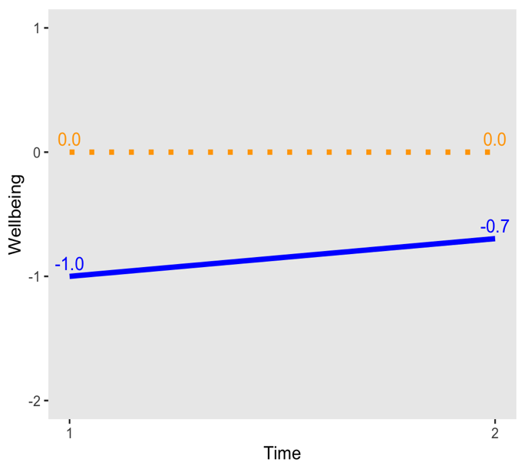
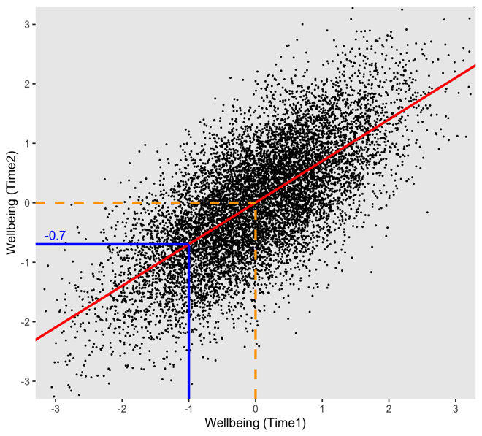
Figure S1a Figure S1b

By knowing the population mean, SD and stability (test-retest correlation), and the time1 mean of any sub-group, for example an intervention group, the predicted score of this group at time2 can be estimated with basic linear models. The time2 scores for the population are given by this formula:
X2_{i} = 𝛽0 + 𝛽1*X1 _{i} + ∈ _{i}
Where X2 is the outcome (time2), 𝛽0 is the intercept, 𝛽1 is the slope (here stability coefficient), X1 the predictor (time1 score) and ∈ is the random error term. For any individual (i), the expected outcome value at time 2 (X2 _{i}) can be predicted by inserting the wellbeing score of time 1 (X1 _{i}) into the equation. Correspondingly, a sub-group with known mean score can predicted the same way.
Thus, given standardized scores and the example values used in figure 1, the formula translates into: X2 = 0 + 0.7*-1.0 = -0.7
The population based synthetic method requires the following input elements:
Population mean scores, and standard deviations, based on large representative surveys, and qualified estimates of stability across the relevant time spans. With this information, the model predicts the outcome score for a subgroup (for example with initial scores identical to the intervention group in focus). Thus, the synthetic control group mimics the contrafactual situation of an intervention group not being exposed to the intervention and thereby accounts for naturally occurring change due to regression towards the mean.
When comparing the synthetic control group with the actual intervention group, the confidence intervals of the latter can be used to determine whether the two groups follow different or the same trajectories. As the synthetic group typically will have a large sample size (we used N=1,000,000) the standard errors will be minimal and negligible, but the standard errors of the intervention group will be informative.

Correlations across time
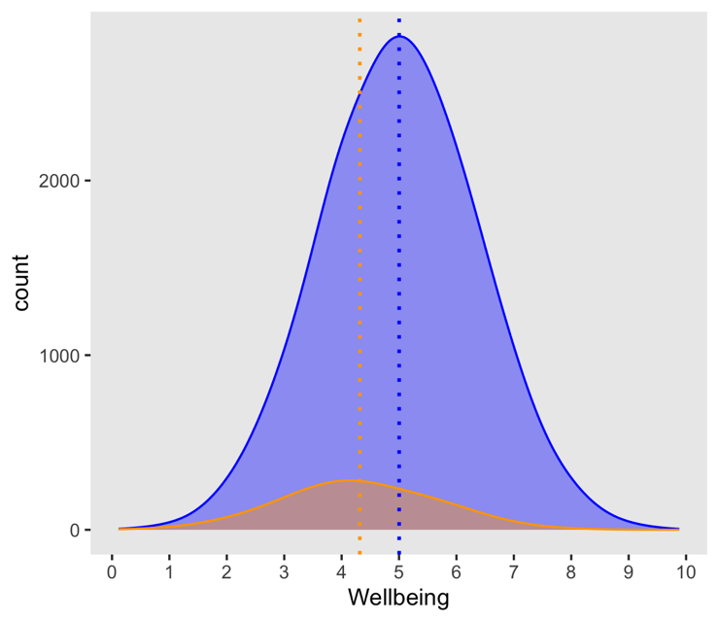
While the available population data provide solid estimates of cross-sectional means and standard deviations, the input correlations across time involve some uncertainty. We used the correlations from the intervention study sample as proxies for the population parameters. Here follows an elaboration of the rationale and validity of this approach.
The density plot shows the distribution of a simulated population, in blue (N=100,000), including a subsample, in orange (N=10,000), with the means (5.09 and 4.32, respectively) and SD’s (1.33 and 1.31, respectively) used in the current study, to illustrate the place of the study sample within a larger population. (Note that in this simulation, we used N=100,000 to be able to visualize both the full population and the sub-sample in the same figure, but that in the main simulations we used N=1,000,000).
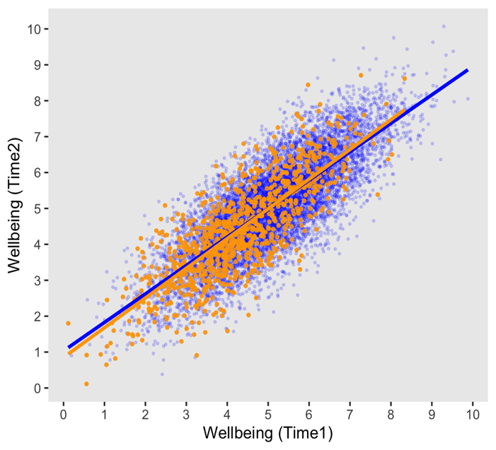
The scatter plot shows the association between wellbeing at time 1 and time 2, in the same simulation, and with the correlation set to be r=0.80 for the population. The slopes for the total population and the subsample are virtually overlapping, and the estimated correlation for the subsample was 0.79.
The key finding from this simulation is that a subsample (with slightly lower mean but similar variance) of a larger population provides correlations that serve as proxies of the population values.
We re-ran the simulation with N=100,000 (total sample) and 1,000 (subsample) within a Monte Carlo framework, with 100 repeats. The mean subsample correlation was 0.794 (range 0.76-0.82), confirming the value of the subsample in providing population estimates, despite the lower mean score.
Finally, to examine the robustness of the key findings of the synthetic control group analyses, given uncertainties of the correlations, we re-ran the simulations with lower correlations. These analyses showed that even with true population correlations across time at r=0.65, the effects remained significant (p<.05).

R code used for the synthetic control group analysis
#######################################################
#Synthetic control group simulation ----
#Code by (anonymized)
#Outcome variable: Satisfaction With Life Scale (SWLS)
#######################################################

# Input for analyses, population data (from Statistics Norway, SSB)
m1 <- 5.09 # Population mean SWLS (SSB, 2022)
sd1 <- 1.33 # Populations SD (SSB, 2022)

# Input for analyses, observed values from intervention group, across 5 time-points
mmeans <- c(4.32, 4.49, 4.62, 4.66, 4.68) # SWLS means at T1-T5
mr <- c(1.0, 0.86, 0.86, 0.84, 0.82) # Correlations for T1-T2, T1-T3, T1-T4,...

# Create time variable
tid <- 1:5
tid2 <- c(0, 4, 10, 20, 52) # Time in weeks from start

# Create simulated longitudinal population data ----
n <- 1000000 #Simulated sample size
x1 <- rnorm(n,m1,sd1) #Simulated t1 variable
x2 <- data.frame(matrix(NA, ncol = 5 , nrow = n)) #Data frame (placeholder) for all time points
pred <- rep(NA,5) #Vector (placeholder) for predicted values

# Loop to run simulation 5 times
for (i in 1:5) {
x2[,i] <- (mr[i]*scale(x1) + sqrt(1-mr[i]^2)*rnorm(n,0,1))*sd1 + m1
mod1 <- lm(x2[,i] ~ x1)
pred[i] <- mod1$coefficients[1] + mod1$coefficients[2]*mmeans[1]
}

# Predicted values for population sub-group starting at mmeans[1],
# and regressing towards population mean
round(pred, 2)

# Prepare for plot, include CI
M_pop <- c(m1,m1,m1,m1,m1)
se <- c(NA, 0.032, 0.035, 0.036, 0.035) # From observed intervention group
lowci <- mmeans - 1.96*se
hici <- mmeans + 1.96*se
hici[1] <- NA
lowci[1] <- NA

# Plot results
library(ggplot2)

ggplot(data=NULL)+
geom_line(aes(x=tid2, y=mmeans), linewidth=2, color="blue") +
geom_point(aes(x=tid2, y=mmeans), size=2.5, color="blue") +
geom_line(aes(x=tid2, y=pred), linewidth=1.5, color="orange", linetype="dotted") +
geom_point(aes(x=tid2, y=pred), size=2.5, color="orange") +
geom_line(aes(x=tid2, y=M_pop), linewidth=1.0, color="grey", linetype="dashed") +
coord_cartesian(ylim=c(4,5.5)) +
geom_errorbar(aes(x=tid2, ymin=lowci, ymax=hici), size=0.3, color="black", alpha=.7, width=.5) +
geom_text(aes(x=30, y=mmeans[1]+0.45, hjust = 0), color="blue", label="Intervention group") +
geom_text(aes(x=30, y=mmeans[1]+0.05, hjust = 0), color="darkorange", label="Population synthetic control") +
geom_text(aes(x=30, y=m1+0.1, hjust = 0), color="darkgrey", label="Population mean") +
# geom_text(aes(x=2.2, y=5.8, hjust=0), color="black", size=7, label="SWLS") +
ylab("Life satisfaction") +
xlab("Time (weeks)") +
theme( panel.grid.major = element_blank() ,
panel.grid.minor = element_blank())

Schwarz, P., & Brockstedt, E. (2023). How can we unleash the potential of external controls in clinical trials? Drug Discov Today, 28(4), 103492. https://doi.org/10.1016/j.drudis.2023.103492
Strayhorn, J. M. (2021). Virtual controls as an alternative to randomized controlled trials for assessing efficacy of interventions. BMC Medical Research Methodology, 21(1), 3. https://doi.org/10.1186/s12874-020-01191-9
Thorlund, K., Dron, L., Park, J. J. H., & Mills, E. J. (2020). Synthetic and External Controls in Clinical Trials - A Primer for Researchers. Clin Epidemiol, 12, 457-467. https://doi.org/10.2147/CLEP.S242097

