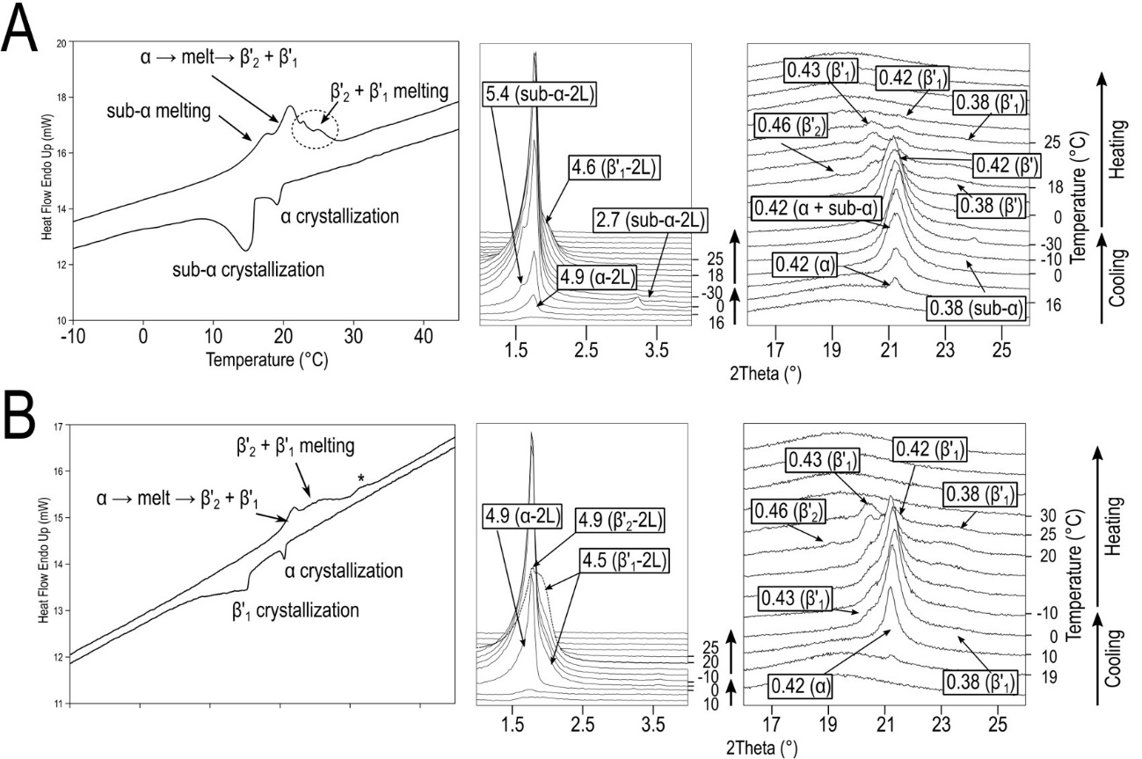
Figure S1. DSC thermograms (left) and XRD patterns (right) of pure cocoa butter cooled and subsequently heated at a) 2 °C·min⁻¹ and b) 0.5 °C·min⁻¹.

Table S1. Temperatures (°C) determined by DSC for the main polymorphic events occurring in CB, ShS, and their blends when cooled and subsequently heated at 2 °C·min⁻¹.
Sample |  | Cooling at 2 °C·min⁻¹ |  | Heating at 2 °C·min⁻¹
CB |  | α-2L (c) | sub-α-2L (c) | sub-α-2L (m) | α-2L → m → β'₂-2L + β'₁-2L |  |  |  |  | β'₂-2L + β'₁-2L (m)
CB | T_{onset} | 20.1 ± 0.6 | 15.9 ± 0.4 | 13.6 ± 0.3 | - |  |  |  |  | -
CB | T_{top} | 19.3 ± 0.5 | 14.8 ± 0.3 | 17.6 ± 0.3 | 20.9 ± 0.5 |  |  |  |  | 22.9 ± 0.3 |  |  | 24.9 ± 0.2
CB | T_{end} | 17.6 ± 0.6 | 9.6 ± 0.6 | - | - |  |  |  |  | 27.4 ± 0.2
70CB |  | α-2L (c) | sub-α-2L (c) | sub-α-2L → m → α-2L |  |  | α-2L → m → β'-2L + β'-3L |  |  |  | β'-2L + β'-3L (m)
70CB | T_{onset} | 20.8 ± 0.3 | 18.0 ± 0.3 | 14.9 ± 0.7 |  |  | - |  |  |  | -
70CB | T_{top} | 19.8 ± 0.3 | 16.4 ± 0.3 | 18.8 ± 0.3 |  |  | 21.5 ± 0.3 |  |  |  | 23.8 ± 0.2 |  |  |  | 26.0 ± 0.3
70CB | T_{end} | 17.2 ± 0.5 | 11.7 ± 0.6 | - |  |  | - |  |  |  | 29.5 ± 0.6
50CB |  | α-2L (c) | sub-α-2L (c) | sub-α-2L → m → α-2L |  |  | α-2L → m → β'-2L + β'-3L |  |  |  | β'-2L + β'-3L (m)
50CB | T_{onset} | 22.4 ± 0.4 | 19.1 ± 0.3 | 14.1 ± 0.2 |  |  | - |  |  |  | -
50CB | T_{top} | 21.4 ± 0.3 | 17.5 ± 0.3 | 18.2 ± 0.9 |  |  | 19.8 ± 1.0 |  |  |  | -
50CB | T_{end} | 18.5 ± 0.5 | 13.3 ± 0.5 | - |  |  | - |  |  |  | 32.2 ± 0.3
30CB |  | α-2L (c) | sub-α-2L (c) | sub-α-2L → m → α-2L |  | α-2L (m) |  | γ-3L + β'-2L + β'-3L (c) |  |  |  | β'-2L (m) |  |  |  | γ-3L + β'-3L (m)
30CB | T_{onset} | 23.7 ± 0.3 | 19.9 ± 0.3 | 15.3 ± 0.6 |  | - |  | - |  |  |  | - |  |  |  | -
30CB | T_{top} | 22.6 ± 0.5 | 18.5 ± 0.3 | 19.2 ± 0.6 |  | 22.2 ± 0.3 |  | 23.9 ± 0.6 |  |  |  | 26.8 ± 0.4 |  |  |  | 32.1 ± 0.4
30CB | T_{end} | 20.2 ± 0.6 | 14.8 ± 0.6 | - |  | - |  | - |  |  |  | - |  |  |  | 33.5 ± 0.4
ShS |  | α₂-2L (c) | sub-α-2L (c) | sub-α-2L → α₂-2L + α₁-2L/ α₂-2L + α₁-2L (m) |  |  |  |  | γ-3L (c) |  |  |  |  | γ-3L (m)
ShS | T_{onset} | 25.0 ± 0.6 | 21.4 ± 0.4 | 16.1 ± 0.4 |  |  |  |  | - |  |  |  |  | 29.4 ± 0.5
ShS | T_{top} | 23.6 ± 0.3 | 19.6 ± 0.6 | 19.5 ± 0.3 |  |  |  |  | 21.4 ± 0.3 |  |  |  |  | 33.1 ± 0.4
ShS | T_{end} | 21.0 ± 0.4 | 16.7 ± 0.7 | - |  |  |  |  | - |  |  |  |  | 34.7 ± 0.9
(-): the peak temperature could not be accurately determined. (c): crystallization; (m): melting.

Table S2. Temperatures (°C) determined by DSC for the main polymorphic events occurring in CB, ShS, and their blends when cooled and subsequently heated at 0.5 °C·min⁻¹.
Sample |  | Cooling at 0.5 °C·min⁻¹ |  |  | Heating at 0.5 °C·min⁻¹
CB |  | α-2L (c) | β'₁-2L (c) |  | α-2L → m → β'₂-2L + β'₁-2L |  |  |  | β'₂-2L + β'₁-2L (m)
CB | T_{onset} | 21.2 ± 1.0 | 16.1 ± 1.0 |  | 15.4 ± 0.7 |  |  |  | -
CB | T_{top} | 21.0 ± 0.9 | 15.5 ± 0.8 |  | 17.8 ± 0.3 |  |  |  | 25.5 ± 0.7
CB | T_{end} | 20.3 ± 0.7 | 9.8 ± 0.8 |  | - |  |  |  | -
70CB |  | α-2L (c) | β'-2L + sub-α-2L (c) |  | sub-α-2L (m) | α-2L → m → β'-2L + β'-3L |  |  |  |  | β'-2L+ β'-3L (m)
70CB | T_{onset} | 22.7 ± 1.2 | 18.5 ± 1.2 |  |  | - |  |  |  |  | 22.1 ± 0.9
70CB | T_{top} | 21.9 ± 0.8 | 17.4 ± 0.7 |  | - | 18.0 ± 0.6 |  |  |  |  | -
70CB | T_{end} | 20.8 ± 0.5 | 13.2 ± 0.9 |  |  | - |  |  |  |  | 32.9 ± 0.9
50CB |  | α-2L (c) | β'-3L + β'-2L + sub-α-2L (c) |  | α-2L → m → β'-2L + β'-3L |  |  | β'-2L (m) |  |  | β'-3L (m)
50CB | T_{onset} | 23.8 ± 0.6 | 19.2 ± 0.4 |  | - |  |  | 21.9 ± 0.6 |  |  | 27.8 ± 0.4
50CB | T_{top} | 23.1 ± 0.4 | 18.2 ± 0.4 |  | 18.2 ± 0.8 |  |  | 25.7 ± 0.6 |  |  | 31.8 ± 0.3
50CB | T_{end} | 21.5 ± 0.8 | 14.2 ± 0.8 |  | - |  |  | - |  |  | 32.9 ± 0.4
30CB |  | α-2L (c) | β'-3L + β'-2L + sub-α-2L (c) |  | α-2L → m → γ-3L + β'-2L + β'-3L |  |  |  |  | β'-2L (m) |  | γ-3L + β'-3L (m)
30CB | T_{onset} | 25.0 ± 0.3 | 20.0 ± 0.2 |  | - |  |  |  |  | 22.4 ± 0.6 |  | 29.4 ± 0.4
30CB | T_{top} | 24.4 ± 0.5 | 19.0 ± 0.3 |  | 17.8 ± 0.3 |  |  |  |  | 25.5 ± 0.7 |  | 33.1 ± 0.3
30CB | T_{end} | 23.1 ± 0.7 | 14.4 ± 0.4 |  | - |  |  |  |  | - |  | 33.9 ± 0.5
ShS |  | α₂-2L (c) | γ-3L + β'-3L (c) |  | α₂-2L (m) |  | γ-3L (m) |  | β'-3L (m)
ShS | T_{onset} | 27.5 ± 1.08 | 22.2 ± 0.6 | 20.5 ± 0.7 |  |  | 31.6 ± 0.6 |  | -
ShS | T_{top} | 26.6 ± 1.1 | 22.1 ± 0.8 | 18.9 ± 0.7 | - |  | 34.5 ± 0.9 |  | 35.8 ± 0.9
ShS | T_{end} | 25.9 ± 1.1 | - | 17.6 ± 0.8 |  |  | - |  | 36.2 ± 1.0
(-): the temperature could not be accurately determined, or no thermal signal was detected for the polymorphic event. (c): crystallization; (m): melting.

