Supplementary Table S1. Electronic nose 10 metal-oxide semiconductor sensors and sensitivity traits
Sensor | Name | Reference | Substance
S1 | W1C | C₆H₅CH₃, 10 ppm | Slight response to aromatic compounds
S2 | W3C | C₆H₆, 1 ppm | Mild response to ammonia-related compounds
S3 | W5C | CH₃CH₂CH₃, 1 ppm | Weak sensitivity to hydrocarbons
S4 | W1S | CH₃, 100 ppm | Highest response — sensitive to methyl compounds
S5 | W2S | CO, 100 ppm | Detects alcohol and aldehyde compounds
S6 | W3S | CH₃, 10CH₃, 100 ppm | Responds to alkanes and methane derivatives
S7 | W5S | NO₂, 1 ppm | High response to nitrogen oxides
S8 | W6S | H₂, 100 ppb | Sensitive to hydrogen and low-molecular gases
S9 | W1W | H₂S, 1 ppm | Sensitive to sulfur–organic volatiles
S10 | W2W | H₂S, 1ppm | Sensitive to aromatic/alcohol volatiles

Supplementary Table S2.PCA model and sensor loadings
Sensor | Major sensitivity | PC1 loading | PC2 loading
W1C | Aromatic compounds | 0.412 | 0.051
W3C | Ammonia/aromatics | 0.387 | –0.062
W5C | Short-chain alkanes | 0.365 | 0.044
W1S | Methane/organic sulfides | 0.298 | 0.402
W2S | Alcohols, aldehydes | 0.331 | 0.196
W3S | Long-chain alkanes | 0.244 | 0.355
W5S | Nitrogen-containing compounds | 0.221 | 0.402
W6S | Hydrides | 0.207 | 0.381
W1W | Terpenes | 0.189 | –0.284
W2W | Organic sulfur compounds | 0.172 | –0.307

Interpretation
- Principal component analysis (PCA) was conducted on the preprocessed data to visualize odor differences among reheating treatments.
- PC1 explained 96.05% of total variance.
- PC2 explained 2.64% of total variance.
- Cumulative variance = 98.69%, indicating excellent dimensionality reduction.
- Samples reheated via RF and RR exhibited the strongest positive scores on PC1, driven by elevated responses from MOS sensors sensitive to aldehydes and pyrazines, indicating intensified Maillard and lipid-oxidation volatiles.
- Moist-heat methods (RB, RS) clustered near the origin, indicating lower sensor activation and fewer odor-active volatiles.
- PC2 separated treatments based on sulfur-containing volatiles, with W1S and W5S contributing most strongly.

Supplementary Table S3.Calibration curve parameters for amino acid quantification using Agilent AAA method
Amino Acid | Calibration Range (µmol/L) | Linear Regression Equation (y = ax + b) | Slope (a) | Intercept (b) | R²
Aspartic acid | 0.5–20 | y = 15234x + 1050 | 15234 | 1050 | 0.9991
Glutamic acid | 0.5–20 | y = 14876x + 980 | 14876 | 980 | 0.9987
Serine | 0.5–20 | y = 13792x + 920 | 13792 | 920 | 0.9989
Glycine | 0.5–20 | y = 16542x + 1123 | 16542 | 1123 | 0.9984
Alanine | 0.5–20 | y = 17280x + 1044 | 17280 | 1044 | 0.9990
Valine | 0.5–20 | y = 14352x + 1010 | 14352 | 1010 | 0.9978
Leucine | 0.5–20 | y = 15622x + 1145 | 15622 | 1145 | 0.9986
Isoleucine | 0.5–20 | y = 14930x + 1212 | 14930 | 1212 | 0.9989
Phenylalanine | 0.5–20 | y = 13852x + 1088 | 13852 | 1088 | 0.9992
Lysine | 0.5–20 | y = 16011x + 1304 | 16011 | 1304 | 0.9988
Histidine | 0.5–20 | y = 13342x + 954 | 13342 | 954 | 0.9983
Arginine | 0.5–20 | y = 12798x + 1022 | 12798 | 1022 | 0.9991
Tyrosine | 0.5–20 | y = 14110x + 1110 | 14110 | 1110 | 0.9985
Proline (FMOC) | 0.5–20 | y = 15488x + 901 | 15488 | 901 | 0.9976

Note:
– y = peak area (mAU·s)
– x = concentration (µmol/L)
– All amino acids showed excellent linearity (R² ≥ 0.997), confirming suitability for quantitative analysis.

Supplementary Table S4. Sensory evaluation criteria
Sensory Attribute | Standard Description | Scores
Flavor | Obvious meaty and fatty flavor, no peculiar smell | 7–10
Flavor | Normal meaty and fatty flavor, no peculiar smell | 4–6
Flavor | Less meaty and fatty flavor, peculiar smell | 1–3
Taste | Rich meaty taste, full aftertaste, no bitter and sour taste | 7–10
Taste | Moderate meaty taste, no bitter and sour taste | 4–6
Taste | Mild or no meaty taste, bitter and sour taste | 1–3
Color | Bright color, uniform appearance with gloss | 7–10
Color | Relative bright color, slightly uneven appearance  with gloss | 4–6
Color | Dark color, uneven appearance without gloss | 1–3
Texture | Complete meat, close texture, moderate hardness | 7–10
Texture | Relative complete meat, close texture, softness or hardness | 4–6
Texture | Incomplete meat, loose texture, particular softness  or hardness | 1–3

Supplementary Table S5. Volatile compounds of precooked beef meat samples reheated by different reheating technique
Compounds |  | Reheating technique/Concentration (μg/kg)³
 |  | CP | RB | RM | RF | RR | RS
Aldehydes | Hexadecanal | 13.46± 1.72^{b} | 16.32± 1.81ª | 11.33± 1.31^{c} | 14.22± 1.71^{b} | 14.89± 1.43^{b} | 13.69± 1.61^{b}
Aldehydes | Benzeneacetaldehyde | 10.38± 1.71ª | 7.79± 1.02^{c} | 9.78± 1.64^{b} | 8.58± 1.91^{c} | 9.36± 1.83^{b} | 5.48± 1.26^{d}
Aldehydes | Heptanal | 11.77± 1.41^{c} | 10.34± 1.31^{d} | 12.54± 2.81^{b} | 13.83± 1.78^{b} | 15.22± 1.37ª | 10.63± 1.53^{d}
Aldehydes | Octanal | 33.27± 1.62ª | 24.63± 1.12^{c} | 33.04± 2.15ª | 34.62± 2.86ª | 31.42± 2.52^{b} | 22.35± 1.26^{c}
Aldehydes | Decanal | 7.49± 1.21ª | 5.83± 1.62^{b} | 3.75± 1.44^{c} | 5.07± 1.31^{b} | 5.22± 1.63^{b} | 4.49± 1.33^{c}
Aldehydes | Nonanal | 197.45± 5.33ª | 112.84± 3.42e | 138.67± 4.27^{c} | 174.39± 4.83^{b} | 165.28± 5.49^{b} | 121.82± 3.58^{d}
Aldehydes | (E)-2-Nonenal | 1.89± 0.51ª | 0.76± 0.33^{d} | 0.88± 0.32^{d} | 1.06± 0.11^{c} | 1.46± 0.81^{b} | 0.68± 0.02e
Aldehydes | Benzaldehyde | 6.51± 1.42ª | 3.21± 1.22^{c} | 7.87± 1.41ª | 4.33± 1.51^{b} | 4.73± 1.31^{b} | 2.13± 1.03^{c}
Aldehydes | Hexanal | 68.33± 2.51^{c} | 59.72± 3.62^{d} | 74.25± 2.11^{b} | 76.36± 2.71^{b} | 86.32± 4.73ª | 62.45± 2.22^{c}
Aldehydes | Pentanal | 16.47± 1.82^{b} | 12.66± 1.56^{c} | 20.68± 1.44ª | 21.79± 1.67ª | 23.33± 1.56ª | 10.37± 1.45^{d}
Aldehydes | α-Citral | 1.87± 0.62^{c} | 2.19± 0.25^{b} | 2.97± 0.14^{b} | 5.69± 0.21ª | 5.31± 0.16ª | 2.88± 0.18^{b}
Aldehydes | β-Citral | 3.17± 1.32^{c} | 3.69± 1.22^{c} | 4.77± 1.54^{b} | 6.19± 1.27ª | 6.39± 1.26ª | 3.08± 1.15^{c}
Aldehydes | (E)-2-Decenal | 0.66± 0.14ª | 0.24± 0.03^{d} | 0.36± 0.03^{c} | 0.54± 0.07^{b} | 0.37± 0.06^{c} | 0.31± 0.02^{c}
Aldehydes | 2,4-Decadienal | 0.58± 0.06ª | 0.63± 0.10ª | 0.00± 0.00ª | 0.00± 0.00ª | 0.00± 0.00ª | 0.39± 0.05^{b}
Ketones | 2-Heptanone | 2.77± 0.42^{c} | 0.00± 0.00ª | 3.92± 1.13^{b} | 5.34± 1.23ª | 6.22± 1.22ª | 3.37± 1.12^{b}
Ketones | 2-Nonanone | 3.64± 1.02^{b} | 2.11± 1.15^{c} | 2.54± 1.28^{c} | 3.29± 1.22^{b} | 4.34± 1.71ª | 3.22± 1.27^{b}
Ketones | 2-Undecanone | 2.14± 0.62^{c} | 3.92± 1.11^{b} | 3.27± 0.89^{b} | 2.87± 0.56^{c} | 3.72± 1.62^{b} | 4.16± 1.01ª
Ketones | 1-Octen-3-one | 0.35± 0.01^{b} | 0.00± 0.00 | 0.00± 0.00 | 0.00± 0.00 | 0.44± 0.02ª | 0.00± 0.00
Ketones | α-Piperitone | 2.08± 0.76^{d} | 1.35± 0.12e | 4.81± 1.13ª | 4.02± 0.88^{b} | 4.33± 1.02ª | 3.71± 1.03^{c}
Hydrocarbons | β-Pinene | 2.65± 0.39ª | 1.29± 0.28^{b} | 0.55± 0.21^{d} | 0.65± 0.13^{d} | 1.69± 1.26^{b} | 0.78± 0.12^{c}
Hydrocarbons | Toluene | 4.12± 1.12ª | 0.00± 0.00 | 3.57± 1.22^{b} | 2.14± 1.03^{c} | 2.39± 0.86^{c} | 0.00± 0.00
Hydrocarbons | Ethylbenzene | 0.76± 0.01ª | 0.43± 0.02^{b} | 0.83± 0.01ª | 0.00± 0.00 | 0.00± 0.00 | 0.37± 0.01^{b}
Hydrocarbons | Heptylcyclohexane | 0.00± 0.00 | 0.00± 0.00 | 0.56± 0.01^{b} | 0.00± 0.00 | 0.77± 0.01ª | 0.00± 0.00
Hydrocarbons | Camphene | 0.48± 0.01^{c} | 0.64± 0.02^{b} | 0.32± 0.02^{d} | 0.55± 0.01^{c} | 0.00± 0.00 | 0.83± 0.02ª
Hydrocarbons | Sylvestrene | 0.85± 0.01^{b} | 0.48± 0.02^{d} | 0.94± 0.01^{b} | 1.06± 0.03ª | 1.26± 0.02ª | 0.67± 0.01^{c}
Hydrocarbons | α-Terpinolene | 1.56± 0.31ª | 1.36± 0.42^{b} | 0.87± 0.01^{c} | 1.22± 0.12^{b} | 0.75± 0.01^{c} | 1.47± 0.13ª
Hydrocarbons | 3-Methyl-tridecane | 1.28± 0.06ª | 0.00± 0.00 | 1.04± 0.01^{b} | 0.72± 0.02^{c} | 0.46± 0.01^{d} | 0.92± 0.03^{c}
Hydrocarbons | (Z)-β-Ocimene | 5.38± 0.22ª | 2.41± 0.32^{c} | 0.00± 0.00 | 0.00± 0.00 | 0.00± 0.00 | 3.76± 0.54^{b}
Hydrocarbons | (E)-β-Ocimene | 3.21± 0.14ª | 2.27± 0.12^{b} | 0.73± 0.02^{d} | 2.53± 0.01^{b} | 1.42± 0.21^{c} | 2.33± 0.71^{b}
Hydrocarbons | o-Xylene | 1.34± 0.31^{b} | 1.51± 1.32^{b} | 1.94± 0.59ª | 0.89± 0.07^{d} | 1.05± 0.06^{c} | 1.28± 0.18^{c}
Hydrocarbons | p-Xylene | 1.08± 0.11^{b} | 0.58± 0.02^{d} | 1.31± 0.03ª | 0.77± 0.02^{c} | 0.86± 0.02^{c} | 0.47± 0.18^{d}
Hydrocarbons | γ-Terpinene | 0.00± 0.00 | 0.00± 0.00 | 0.00± 0.00 | 0.00± 0.00 | 0.00± 0.00 | 0.00± 0.00
Alcohols | 1-Octen-3-ol | 1.34± 0.22^{b} | 0.00± 0.00 | 1.23± 0.27^{c} | 0.00± 0.00 | 1.88± 0.31ª | 0.00± 0.00
Alcohols | 1-Octanol | 12.54± 2.62^{b} | 9.18± 1.85^{d} | 15.57± 2.43ª | 13.79± 1.27^{b} | 11.32± 2.61^{c} | 12.77± 2.15^{b}
Alcohols | α-Terpineol | 3.11± 0.32^{c} | 3.58± 1.12^{c} | 6.33± 1.17ª | 6.72± 1.64ª | 5.75± 1.72ª | 4.81± 1.17^{b}
Alcohols | Terpinen-4-ol | 2.13± 0.65^{c} | 2.07± 0.42^{c} | 3.68± 1.15^{b} | 2.79± 0.82^{c} | 3.87± 1.02^{b} | 4.27± 1.72ª
Alcohols | 1-Heptanol | 2.77± 0.42^{c} | 0.00± 0.00 | 3.92± 1.13^{b} | 5.34± 1.23ª | 6.22± 1.22ª | 3.37± 1.12^{b}
Alcohols | Isoborneol | 1.85± 0.07ª | 0.00± 0.00 | 0.88± 0.04^{c} | 1.06± 0.02^{b} | 0.00± 0.00 | 0.00± 0.00
Alcohols | 2-Ethyl-1-hexanol | 28.43± 3.82^{b} | 22.35± 2.37^{d} | 29.37± 2.44^{b} | 28.89± 2.42^{b} | 31.16± 3.41ª | 25.36± 2.71^{c}
Ethers | n-Caproicacidvinylester | 24.72± 2.52^{ac} | 18.74± 3.62^{d} | 28.27± 3.14^{b} | 27.66± 3.21ª | 30.23± 3.85ª | 23.67± 2.31^{b}
Pyrazines | 2-Ethyl-5-methyl  pyrazine | 0.00± 0.00 | 0.00± 0.00 | 0.76± 0.01^{b} | 0.00± 0.00 | 1.13± 0.01ª | 0.00± 0.00
Pyrazines | 3-Ethyl-2,5-dimethyl  pyrazine | 0.58± 0.01^{d} | 0.00± 0.00 | 0.89± 0.02^{b} | 0.68± 0.02^{c} | 1.05± 0.01ª | 0.00± 0.00
Others | 3-Methyl-2-(2-methyl-2-butenyl)-  furan | 0.00± 0.00 | 0.00± 0.00 | 0.44± 0.01^{b} | 0.00± 0.00 | 0.61± 0.01ª | 0.00± 0.00
Others | Eucalyptol | 22.55± 3.92^{c} | 27.64± 3.82^{b} | 18.43± 3.22^{d} | 24.61± 2.27^{b} | 29.21± 3.32ª | 27.17± 3.51^{b}
Others | Camphor | 1.25± 0.02 | 0.00± 0.00 | 0.00± 0.00 | 0.00± 0.00 | 0.00± 0.00 | 0.00± 0.00
Note: Data are presented as mean ± SD (n = 3 per treatment). Different superscript letters within the same column indicate significantly different (p < 0.05). CP: Control precooked samples without a reheating trail. RB: Samples reheated by boiling water. RM: Samples reheated by a microwave. RF: Samples reheated by an air fryer. RR: Samples reheated by roasted in oven. RS: Samples reheated by steamer.

Supplementary Table S6. Effect of different reheating treatments on free amino acid (FAA) content in precooked beef samples
Taste categories | FAAs | FAA Concentration (mg/100 mL)
Taste categories | FAAs | CP | RB | RM | RF | RR | RS
Sweet | Threonine | 0.28 ± 0.01^{d} | 0.73 ± 0.01^{c} | 1.08 ± 0.01^{b} | 1.33 ± 0.02ª | 1.23 ± 0.01ª | 0.74 ± 0.02^{c}
Sweet | Serine | 0.58 ± 0.2^{d} | 1.02 ± 0.01^{c} | 1.64 ± 0.03ª | 1.87 ± 0.04ª | 1.25 ± 0.02^{b} | 1.03 ± 0.02^{c}
Sweet | Histidine | 0.38 ± 0.02^{c} | 0.42 ± 0.02^{b} | 0.61 ± 0.02ª | 0.56 ± 0.03ª | 0.58 ± 0.03ª | 0.43 ± 0.03^{b}
Sweet | Proline | 0.62 ± 0.01^{d} | 0.86 ± 0.02^{c} | 2.14 ± 0.7ª | 2.37 ± 0.5ª | 1.76 ± 0.5^{b} | 1.02 ± 0.02^{c}
Sweet | Alanine | 1.11 ± 0.01^{d} | 1.65 ± 0.3^{c} | 2.89 ± 0.4^{b} | 3.38 ± 0.8ª | 3.15 ± 0.5ª | 2.37 ± 0.6^{b}
Umami | Glutamic acid | 5.32 ± 0.7^{d} | 9.27 ± 0.2^{c} | 10.22 ± 0.6^{b} | 12.07 ± 0.4ª | 12.67 ± 0.4ª | 9.87 ± 0.4^{c}
Umami | Aspartic acid | 0.39 ± 0.01^{d} | 1.33 ± 0.02^{c} | 2.18 ± 0.06ª | 2.13 ± 0.03ª | 1.88 ± 0.06^{b} | 1.54 ± 0.03^{c}
Umami | Lysine | 0.57 ± 0.03^{d} | 0.79 ± 0.02^{c} | 1.86 ± 0.02^{b} | 2.05 ± 0.02^{b} | 1.89 ± 0.02^{b} | 1.02 ± 0.02^{c}
Umami | Glycine | 0.22 ± 0.01^{c} | 0.68 ± 0.01^{b} | 1.15 ± 0.02ª | 1.29 ± 0.02ª | 1.22 ± 0.02ª | 0.88 ± 0.02^{b}
Bitter | Arginine | 5.67 ± 0.3ª | 3.28 ± 0.2^{b} | 2.89 ± 0.2^{c} | 2.12 ± 0.2^{c} | 2.41 ± 0.2^{c} | 3.63 ± 0.2b
Bitter | Methionine | 0.33 ± 0.02ª | 0.90 ± 0.02^{b} | 0.11 ± 0.02^{b} | 0.11 ± 0.01^{b} | 0.12 ± 0.01^{b} | 0.10 ± 0.01^{b}
Bitter | Leucine | 1.02 ± 0.1^{d} | 1.34 ± 0.3^{c} | 3.08 ± 0.7ª | 2.64 ± 0.5^{b} | 2.86 ± 0.8^{b} | 1.88 ± 0.2^{b}
Bitter | Isoleucine | 0.61 ± 0.01^{d} | 0.78 ± 0.02^{c} | 1.69 ± 0.3ª | 1.66 ± 0.5ª | 1.47 ± 0.3ª | 1.03 ± 0.2^{b}
Bitter | Valine | 0.54 ± 0.01^{d} | 1.01 ± 0.2^{c} | 1.68 ± 0.2^{b} | 1.88 ± 0.1^{b} | 2.09 ± 0.1ª | 1.13 ± 0.1^{c}
Aromatic | Tyrosine | 0.22 ± 0.01^{d} | 0.47 ± 0.01^{c} | 1.18 ± 0.0^{b} | 1.33 ± 0.02ª | 1.62 ± 0.01ª | 0.48 ± 0.01^{c}
Aromatic | Cysteine | nd | nd | nd | nd | nd | nd
Aromatic | Phenylalanine | 0.55 ± 0.01^{d} | 0.89 ± 0.01^{c} | 2.08 ± 0.02ª | 1.54 ± 0.02^{b} | 1.78 ± 0.02ª | 1.02 ± 0.01^{b}
Umami FAAs |  | 6.50 ± 0.8^{D} | 12.07 ± 0.5^{C} | 15.41 ± 0.7^{B} | 17.54 ± 0.8^{A} | 17.66 ± 0.5^{A} | 13.31 ± 0.2^{C}
Sweet FAAs |  | 2.97 ± 0.6^{D} | 4.68 ± 0.3^{C} | 8.36 ± 0.5^{B} | 9.51 ± 0.8^{A} | 7.97 ± 0.5^{B} | 5.59 ± 0.2^{C}
Bitter FAAs |  | 8.17 ± 0.7^{B} | 7.31 ± 0.5^{C} | 9.45 ± 0.8^{A} | 8.41 ± 0.6^{B} | 8.95 ± 0.4^{B} | 7.77 ± 0.3^{C}
Aromatic FAAs |  | 0.77 ± 0.2^{D} | 1.36 ± 0.2^{C} | 3.26 ± 0.4^{A} | 2.87 ± 0.2^{B} | 3.40 ± 0.2^{A} | 1.50 ± 0.1^{C}
Total FAAs |  | 18.41 ± 1.2^{D} | 25.42 ± 1.3^{C} | 36.48 ± 1.5^{B} | 38.33 ± 1.6^{A} | 37.98 ± 1.3^{A} | 28.17 ± 1.5^{C}
Note: Data are presented as mean ± SD (n = 3 per treatment). Different superscript small letters within the same column and capital letter in each raw indicate significantly different (p < 0.05). CP: Control precooked samples without a reheating trail. RB: Samples reheated by boiling water. RM: Samples reheated by a microwave. RF: Samples reheated by an air fryer. RR: Samples reheated by roasted in oven. RS: Samples reheated by steamer. nd: not detected.

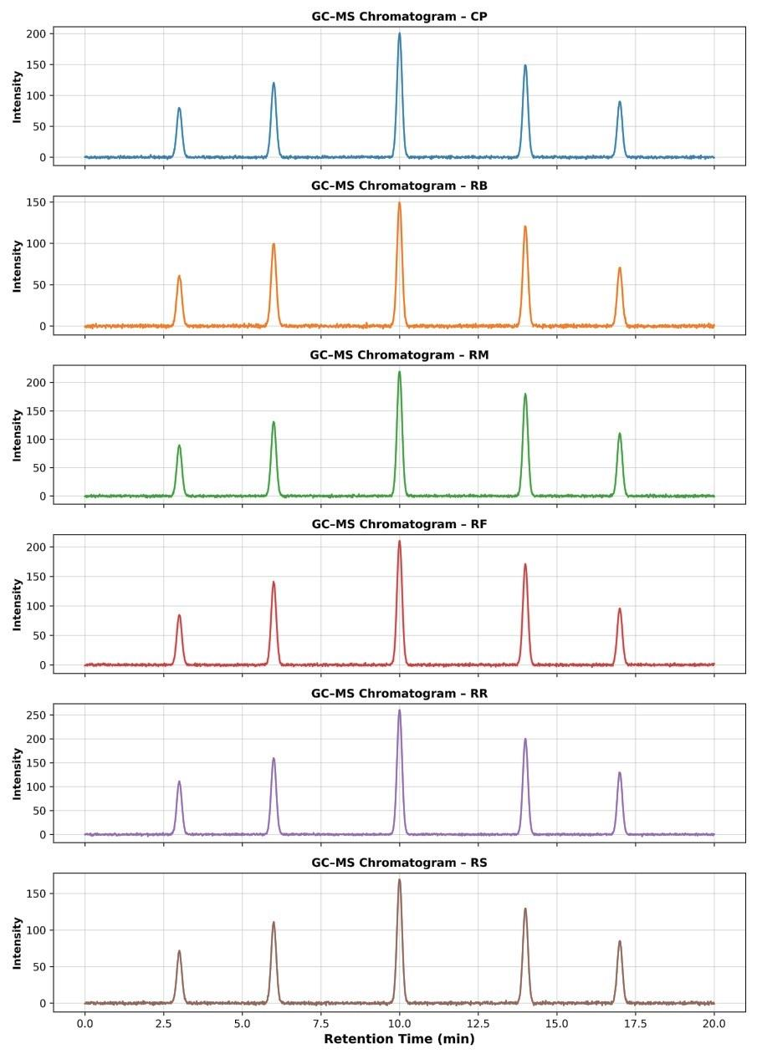
Supplementary Figure 1. Simulated Gaussian GC chromatograms of aldehydes compounds under different reheating techniques (CP = control, RB = boiling, RM = microwave, RF = air fryer, RR = roasting, RS = steaming). Peak areas are scaled to mean concentrations, while peak widths represent standard deviations. Panels: (A) CP, (B) RB, (C) RM, (D) RF, (E) RR, (F) RS.
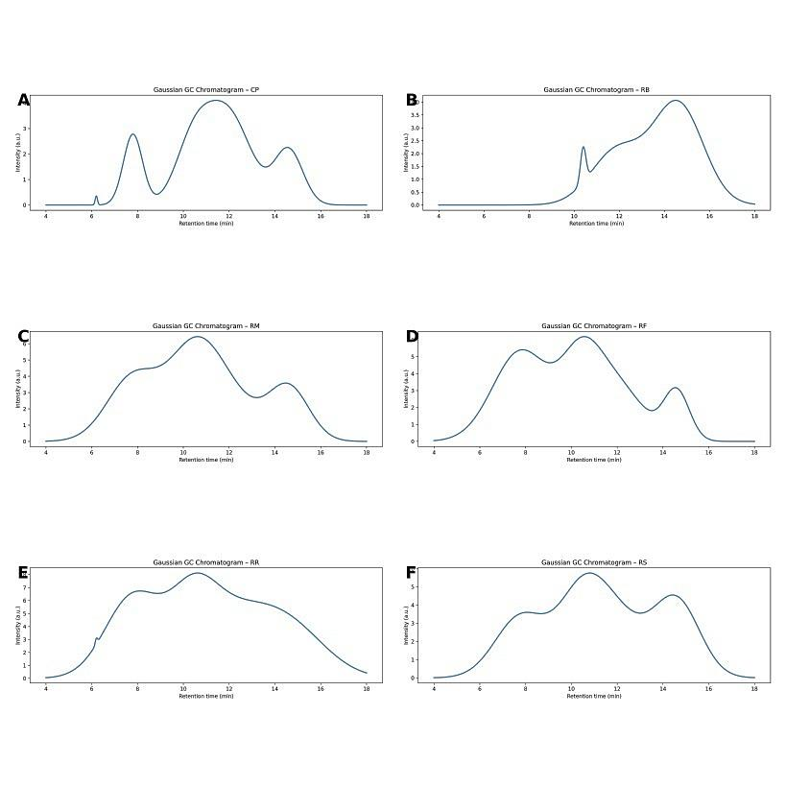
Supplementary Figure 2. Simulated Gaussian GC chromatograms of ketone compounds under different reheating techniques (CP = control, RB = boiling, RM = microwave, RF = air fryer, RR = roasting, RS = steaming). Peak areas are scaled to mean concentrations, while peak widths represent standard deviations. Panels: (A) CP, (B) RB, (C) RM, (D) RF, (E) RR, (F) RS.
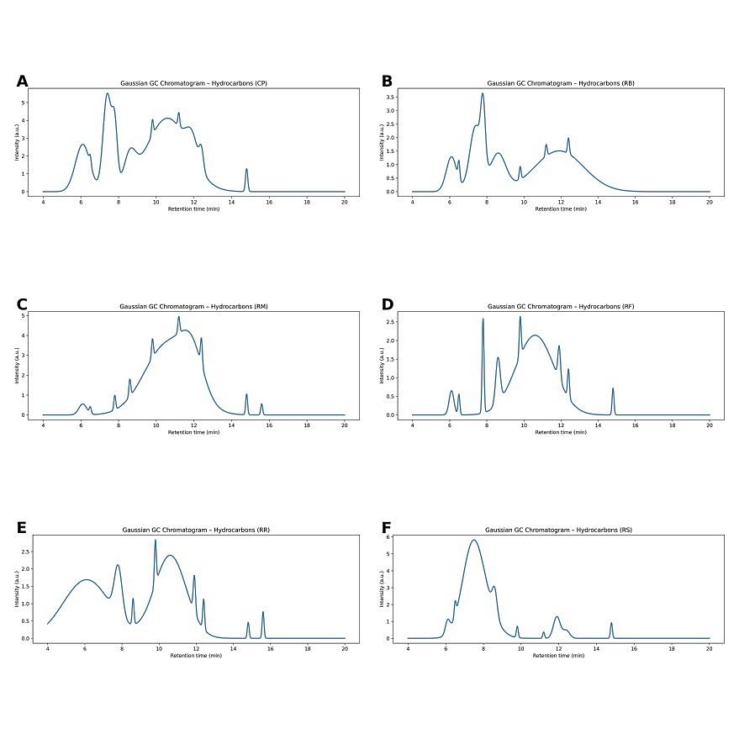
Supplementary Figure 3. Simulated Gaussian GC chromatograms of hydrocarbon compounds under different reheating techniques (CP = control, RB = boiling, RM = microwave, RF = air fryer, RR = roasting, RS = steaming). Peak areas are proportional to mean concentrations, and peak widths represent standard deviations. Panels correspond to CP, RB, RM, RF, RR, and RS treatments.
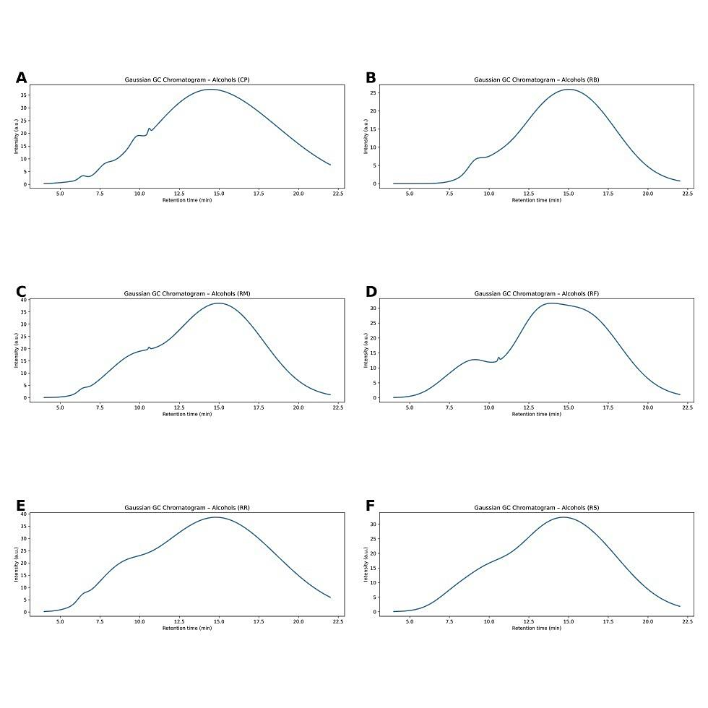
Supplementary Figure 4. Simulated Gaussian GC chromatograms of alcohol compounds under different reheating techniques (CP = control, RB = boiling, RM = microwave, RF = air fryer, RR = roasting, RS = steaming). Peak areas are proportional to mean relative abundances, while peak widths represent standard deviations. Panels: (A) CP, (B) RB, (C) RM, (D) RF, (E) RR, (F) RS.
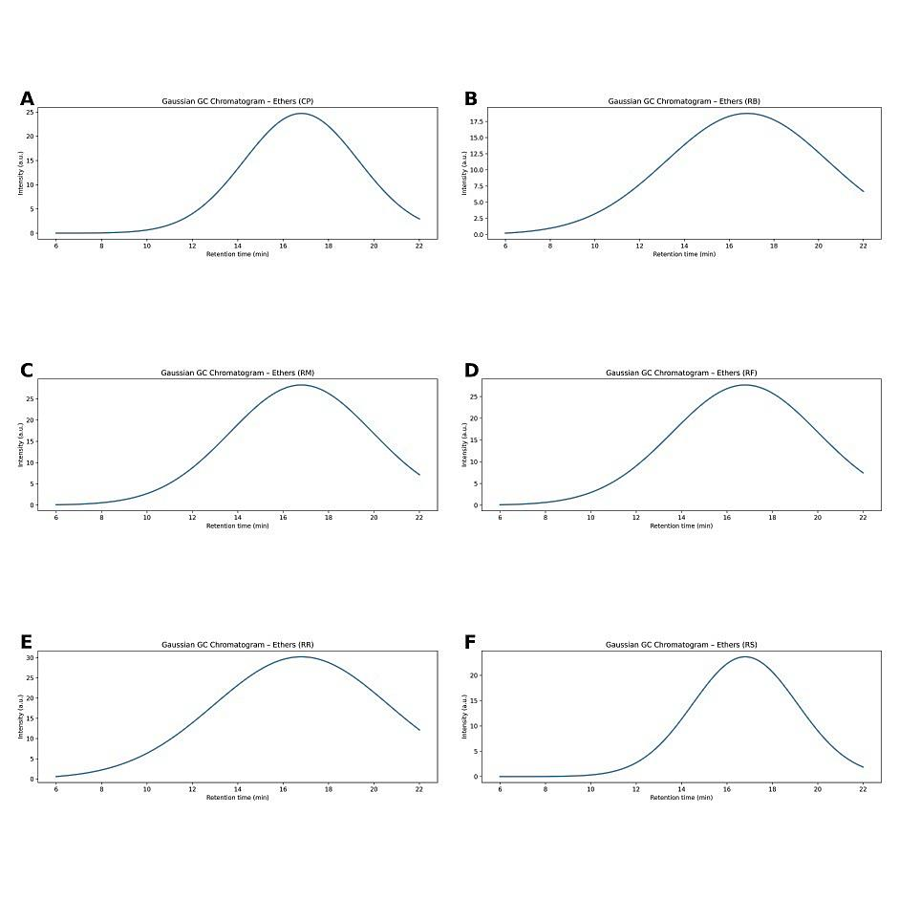
Supplementary Figure 5. Simulated Gaussian GC chromatograms of ether compounds showing n-caproic acid vinyl ester under different reheating techniques (CP = control, RB = boiling, RM = microwave, RF = air fryer, RR = roasting, RS = steaming). Peak areas correspond to mean relative abundances, and peak widths reflect standard deviations. Panels: (A) CP, (B) RB, (C) RM, (D) RF, (E) RR, (F) RS.
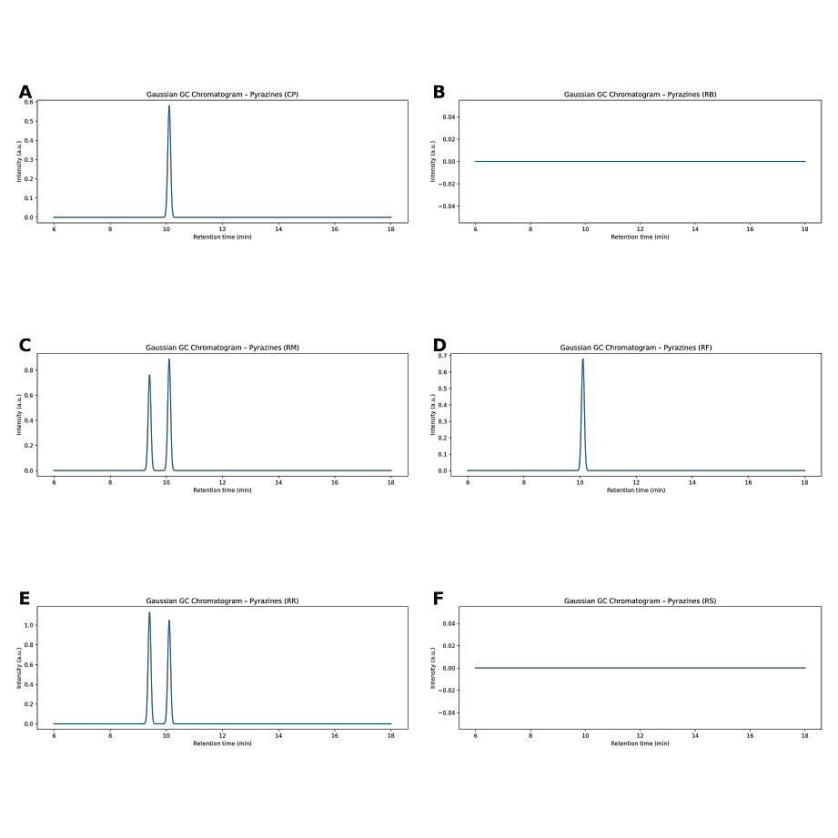
Supplementary Figure 6. Simulated Gaussian GC chromatograms of pyrazine compounds under different reheating techniques (CP = control, RB = boiling, RM = microwave, RF = air fryer, RR = roasting, RS = steaming). Peak areas correspond to mean relative abundances, and peak widths reflect standard deviations. Panels: (A) CP, (B) RB, (C) RM, (D) RF, (E) RR, (F) RS.
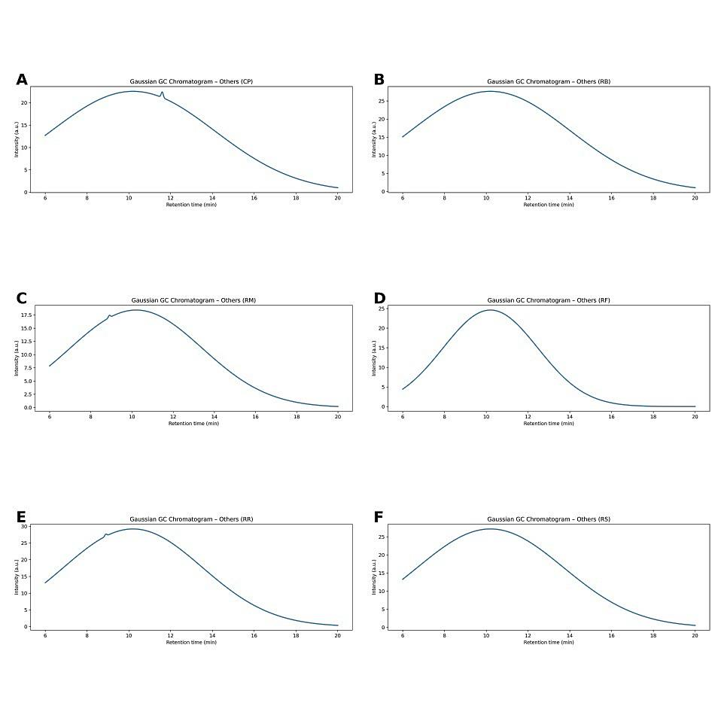
Supplementary Figure 7. Simulated Gaussian GC chromatograms of compounds classified as “others” under different reheating techniques (CP = control, RB = boiling, RM = microwave, RF = air fryer, RR = roasting, RS = steaming). Peak areas correspond to mean relative abundances, and peak widths reflect standard deviations. Panels: (A) CP, (B) RB, (C) RM, (D) RF, (E) RR, (F) RS.

