Supplementary Information

Microwave technology for detecting traumatic chest injuries in a porcine model

Philipp Seidel^{1, 2}, Nils Petter Oveland^{2, 3}, Marianne Oropeza‐Moe⁴, Linh Nguyen⁵, Andreas Fhager⁵, Mikael Persson⁵, Mikael Elam⁶ & Stefan Candefjord^{5,7}
¹Department of Intensive Care Medicine, Stavanger University Hospital, Stavanger, Norway
²Department of Quality and Health Technology, Faculty of Health Sciences, University of Stavanger, Stavanger, Norway.
³Department of Anesthesiology, Stavanger University Hospital, Stavanger, Norway.
⁴Department of Production Animal Clinical Sciences, Faculty of Veterinary Medicine, Norwegian University of Life Sciences, Sandnes, Norway.
⁵Department of Electrical Engineering, Chalmers University of Technology, Gothenburg, Sweden.
⁶Department of Clinical Neurophysiology, Sahlgrenska University Hospital, Gothenburg, Sweden.
⁷SAFER Vehicle and Traffic Safety Centre at Chalmers, Gothenburg, Sweden.

Corresponding author: Philipp Seidel, philipp.seidel@uis.no, (+47) 48505574

Figure S1. The relative change in magnitude from the baseline for all S-parameters, for all repetitive measurements and pigs, is shown for the PTX stages. The changes in magnitude (dB) are represented as the mean ± SD. Blue indicates antenna pairs on the right side and red indicates antenna pairs on the left side of the thorax. Green indicates antenna pairs measured across the thorax.
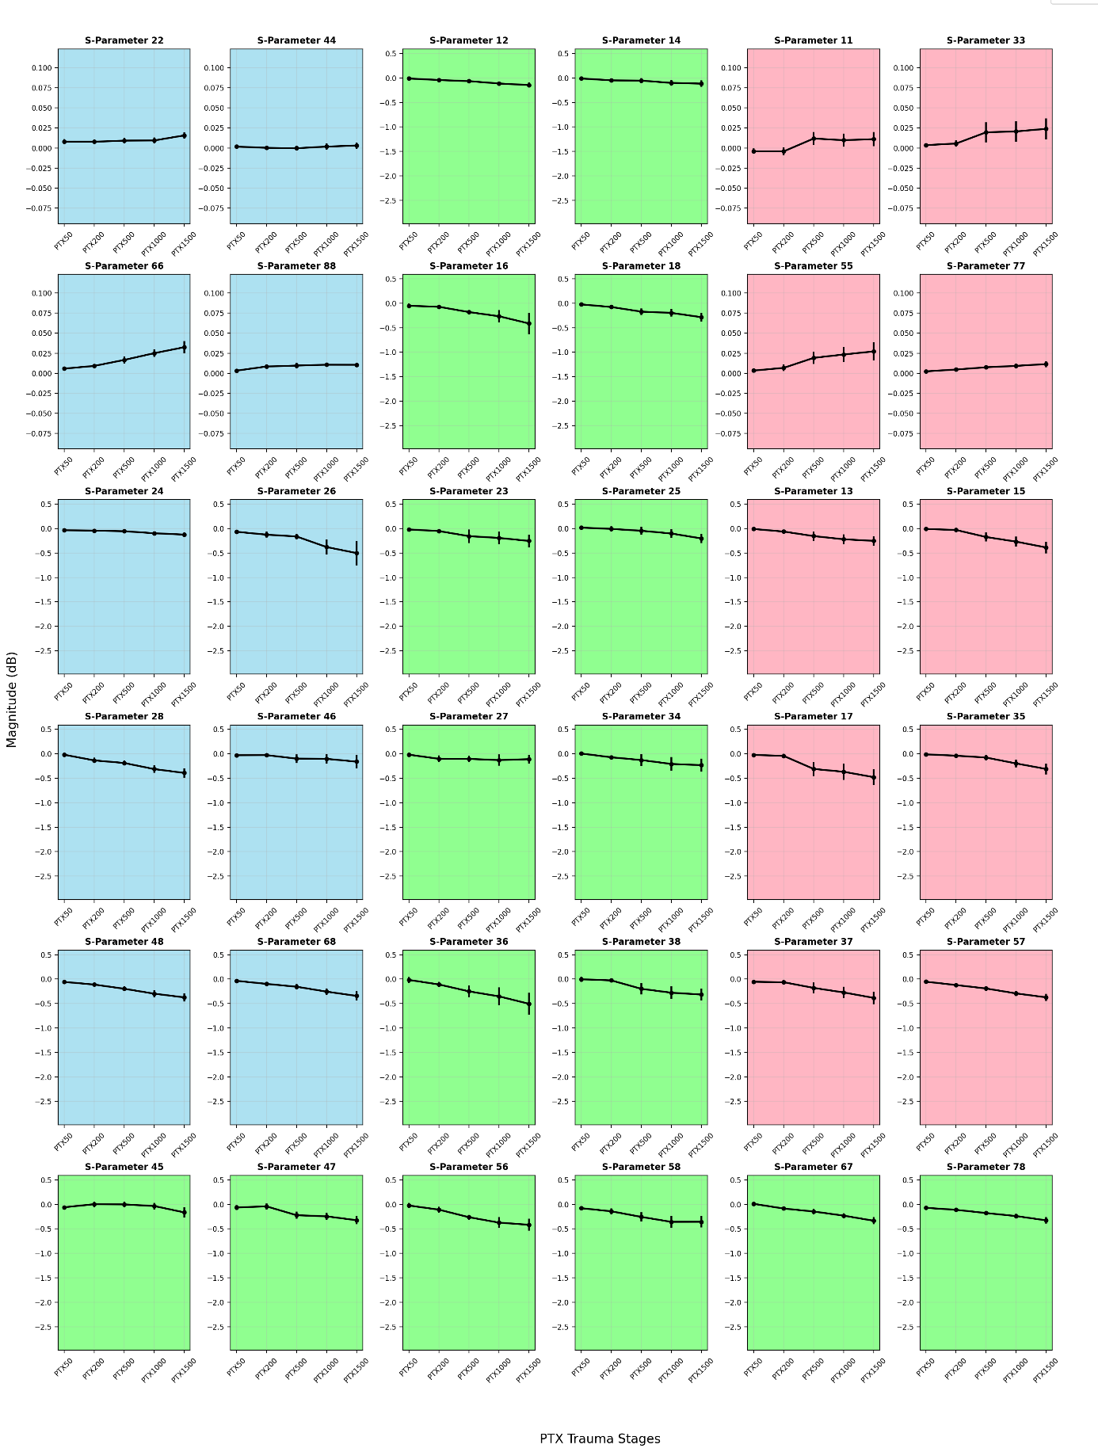
Figure S2. The relative change in magnitude from the baseline for all S-parameters, for all repetitive measurements and pigs, is shown for the HTX stages. The changes in magnitude (dB) are represented as the mean ± SD. Blue indicates antenna pairs on the right side and red indicates antenna pairs on the left side of the thorax. Green indicates antenna pairs measured across the thorax.
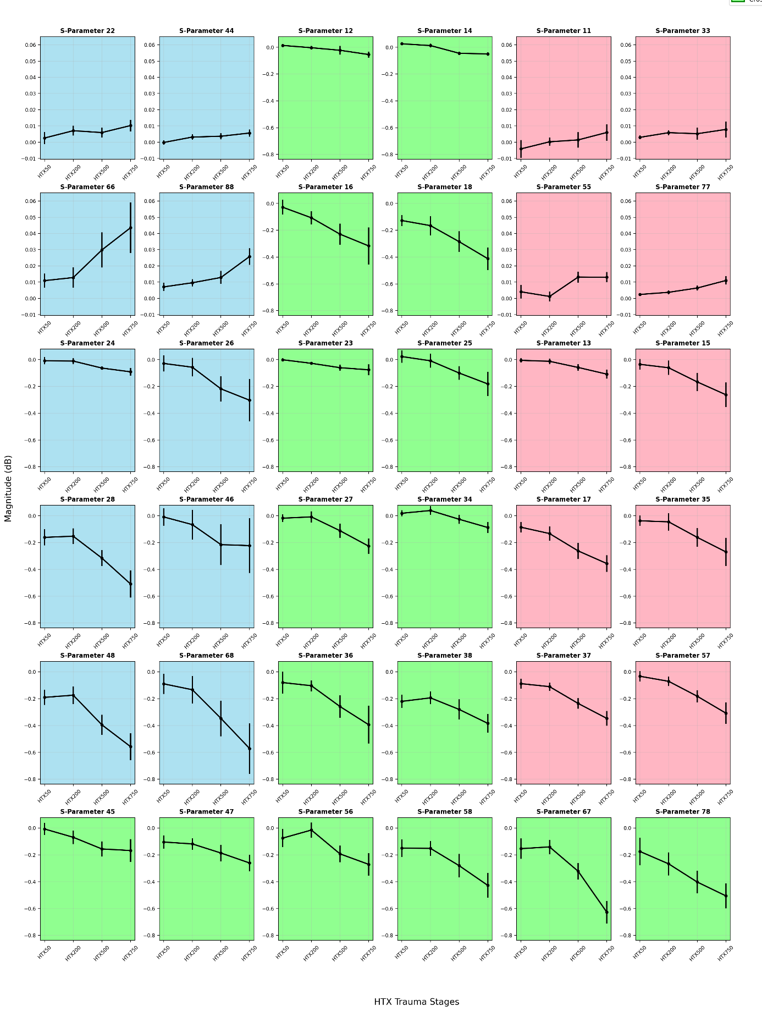

Figure S3. The relative change in magnitude from the baseline for all S-parameters, for all repetitive measurements and pigs, is shown for the HPTX stages. The changes in magnitude (dB) are represented as the mean ± SD. Blue indicates antenna pairs on the right side and red indicates antenna pairs on the left side of the thorax. Green indicates antenna pairs measured across the thorax.
