Supplementary Materials

In vitro comparison of the effects of imatinib and ponatinib on Chronic Myeloid Leukemia progenitor/stem cell features
Ignazia Tusa,^{1,*} Giulia Cheloni,^{1,*} Martina Poteti,¹ Angela Silvano,¹ Alessandro Tubita,¹ Zoe Lombardi,¹ Antonella Gozzini,² Roberto Caporale,³ Barbara Scappini,² Persio Dello Sbarba,^{1,§} and Elisabetta Rovida^{1,§}
¹ Department of Experimental and Clinical Biomedical Science, University of Florence, Viale GB Morgagni 50, 50134, Florence, Italy.
² Hematology Unit, AOU Careggi, Florence, Italy.
³ Dipartimento DAI Oncologico e di Chirurgia ad Indirizzo Robotico SOD Centro Diagnostico di Citofluorimetria e Immunoterapia, AOU Careggi, Florence, Italy
*These authors contributed equally to the work; §co-last authors.
Correspondence should be addressed to Elisabetta Rovida, elisabetta.rovida@unifi.it or to Persio Dello Sbarba, persio@unifi.it

Supplementary Materials includes:
Supplementary Table S1
Supplementary Figures S1-4

Supplementary Table S1 Primer sequences for Quantitative PCR

Target gene | primer sequence (5’-3’)
β-actin | forward GAAACTACCTTCAACTCCATCATG
 | reverse AGGAGGAGCAATGATCTTGATC
GAPDH | forward AACAGCCTCAAGATCATCAGCAA
 | reverse TCTGGGTGGCAGTGAT
c-MYC | forward GGTGCTCCATGAGGAGACA
 | reverse CCTGCCTCTTTTCCACAGAA
NANOG | forward ACCTTGGCTGCCGTCTCTGG
 | reverse AGCAAAGCCTCCCAATCCCAAACA
SOX2 | forward GAGCTTTGCAGGAAGTTTGC
 | reverse GCAAGAAGCCTCTCCTTGAA
OCT4 | forward TTTTGGTACCCCAGGCTATG
 | reverse GCAGGCACCTCAGTTTGAAT
KLF4 | forward GTGCCCCGAATAACAGCTCA  reverse TTCTCACCTGTGTGGGTTCG

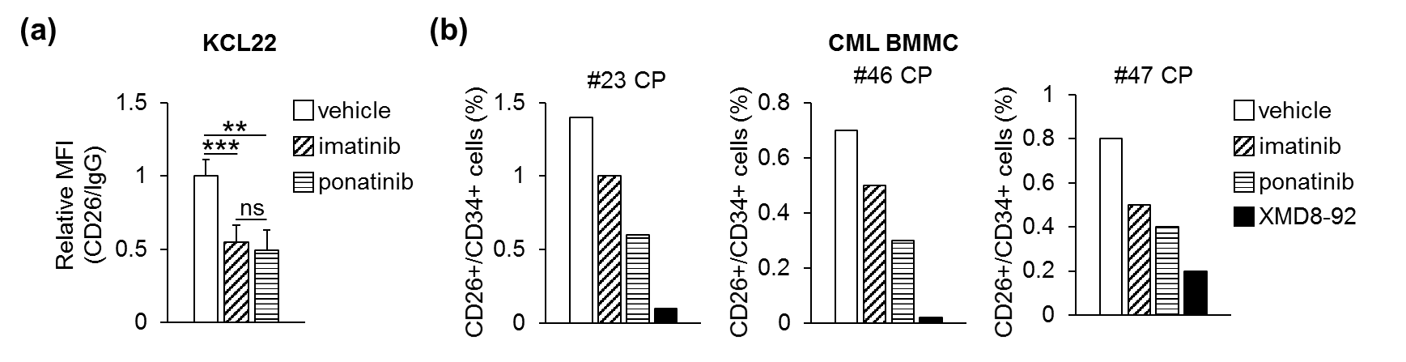
Supplementary Figure S1
Supplementary Fig. S1 Effects of TKi on CD26-expressing CML cells. The expression of viable CD26-expressing cells was evaluated by flow cytometry. (a) KCL22 cells (3x10⁵/mL) were treated with DMSO (vehicle), or 1 μM imatinib or 4 nM ponatinib (both dissolved in DMSO) at time 0 and incubated for 72 hours. Histograms relative to CD26 MFI values from three independent experiments (mean ± S.D.) are shown; **p < 0.01; ***p < 0.001; ns, not significant. (b) Patient-derived CML cells (3x10⁵/mL) were treated as in (a) or with 10 μM XMD8-92 (dissolved in DMSO) at time 0 and incubated for 72 hours. Histograms relative to the percentage of viable cells expressing CD26/CD34 from three experiments are shown.

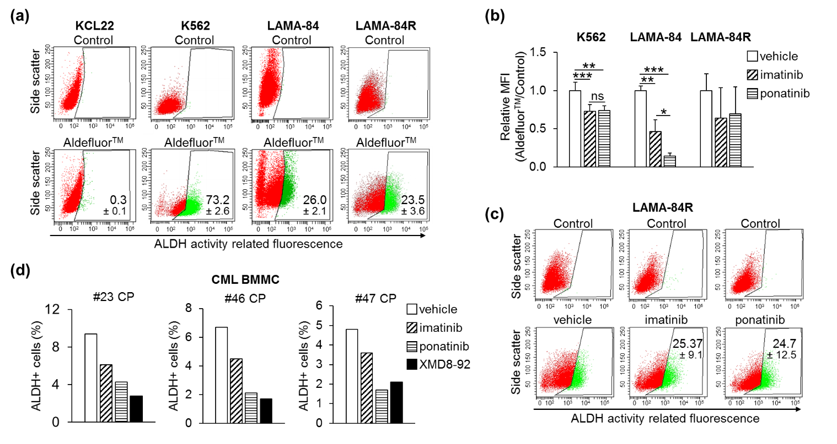
Supplementary Figure S2
Supplementary Fig. S2 Effects of TKi on CML cells endowed with ALDH activity. (a) ALDH enzymatic activity in routinely cultured cells was assessed by flow cytometry (lower graphs, AldefluorTM). Gating for negative cells (Control) was performed in the presence of the ALDH inhibitor DEAB (upper graphs). Plots from one representative experiment are shown. Values are mean ± S.D. percentages of positive cells obtained from three independent experiments. (b) K562, LAMA-84 and LAMA-84R cells (3x10⁵/mL) were treated with DMSO (vehicle), 1 μM imatinib or 4 nM ponatinib at time 0 and incubated for 72 hours. Histograms relative to AldefluorTM MFI values from three independent experiments (mean ± S.D.) are shown; *p < 0.05; **p < 0.01; ***p < 0.001; ns, not significant. (c) LAMA-84R cells (3x10⁵/mL) were treated and incubated like in (b). Plots from one representative experiment are shown. Values are mean ± S.D. percentages of positive cells obtained from three independent experiments. (d) patient-derived CML cells (3x10⁵/mL) were treated and incubated like in (b). Histograms relative to the percentage of viable cells expressing ALDH activity from three chronic phase (CP) patients are shown.
Supplementary Figure S3
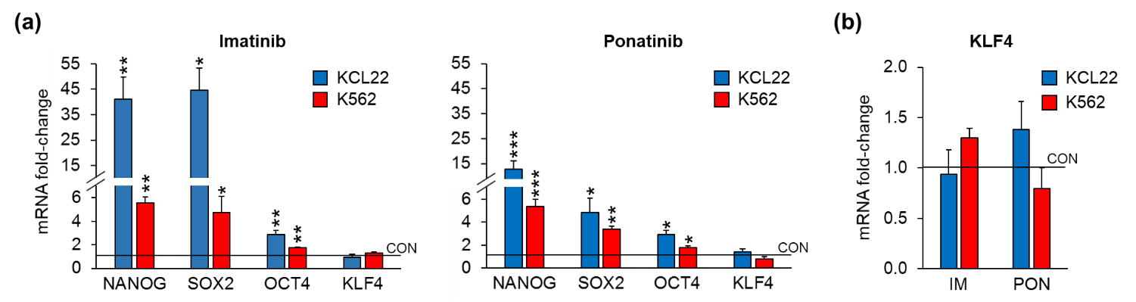
Supplementary Fig. S3 Effects of TKi on the expression of stem cell-related genes in CML cell lines. Cells (3x10⁵/mL) were treated with DMSO (CON), 2 μM imatinib (IM) or 8 nM ponatinib (PON) at time 0 and incubated for 24 hours. The expression of mRNA of the indicated genes was measured by Q-PCR. Data were normalized with respect to the mean of GAPDH and β-actin mRNA levels and expressed as fold-change with respect to the values obtained for DMSO-treated cells (CON). Values represent mean ± S.E.M. of three independent experiments, each carried out in triplicate. * p < 0.05; **p < 0.01; ***p < 0.001. (a) Overview of the effects of imatinib (left) or ponatinib (right) on the expression of stem cell-related genes. (b) Comparison of the effects of imatinib and ponatinib on the expression of KLF4.

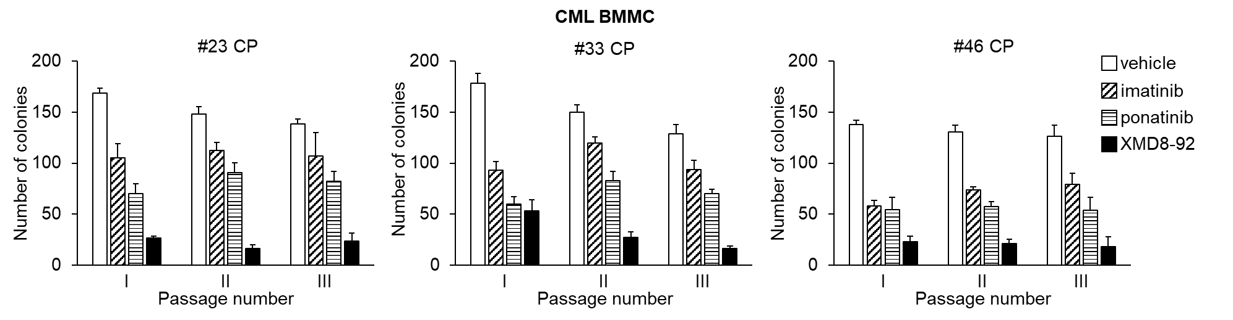
Supplementary Figure S4
Supplementary Fig. S4 Effects of TKi on serial CFA in patient-derived primary cells explanted from CML patients. Cells were incubated in semisolid medium and treated with DMSO (vehicle), 1 μM imatinib, 4 nM ponatinib or 10 μM XMD8-92 from time 0 of incubation until day seven (end of passage I). Colony cells were rescued and washed to remove drugs and replated weekly (passages II-III). Colonies were scored on day seven after each passage. Values are means ± S.D. of data from experiments performed in duplicate with cells recovered from three chronic phase (CP) CML patients.

