Search log

Major concepts
ICT strategies | AND | Adolescents | AND | ASRH + ASRHR | AND | Accountability

Initial search terms
Digital technology  Mobile phone  Cell phone use  Web-based intervention*  Social media  ICT  Internet  Digital media  DCT  Online | AND | Adolescent*  Youth  Young adult*  Girl*  AYA  Young people  Young person* | AND | Sexual reproductive health  SRH  Sexual health  Sexual right*  Sexual reproductive health right*  SRHR | AND | Accountability  Engagement  Participation  Empowerment  Activism  Digital activism  Digital network*  Participatory approaches  Engagement strateg*  Public engagement  Public representation  Social inclusion  Voice and agency  Social capital  Sense of control  Social cohesion  Collective action  Active citizenship  Independence

Database searching: Embase
 | Search strategy | Results | Comments
Date:  9/3/21 | 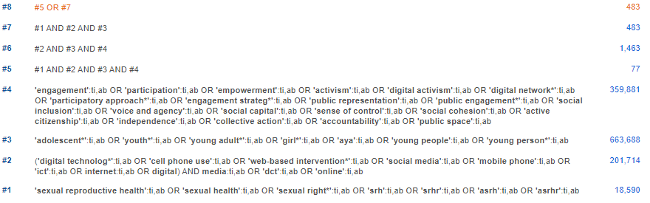 | 483 – 2 duplicates =  481 | #5 all included in #8, therefore keeping a larger result set for screening to include less obvious but relevant papers

Database searching: Web of Science
 | Search strategy | Results | Comments
Date: 8/3/21 | 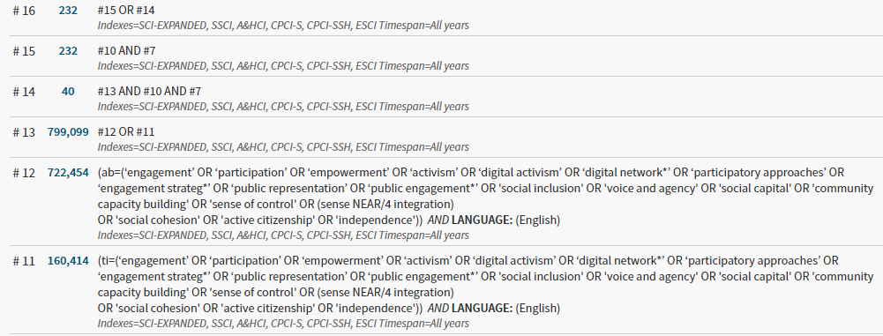  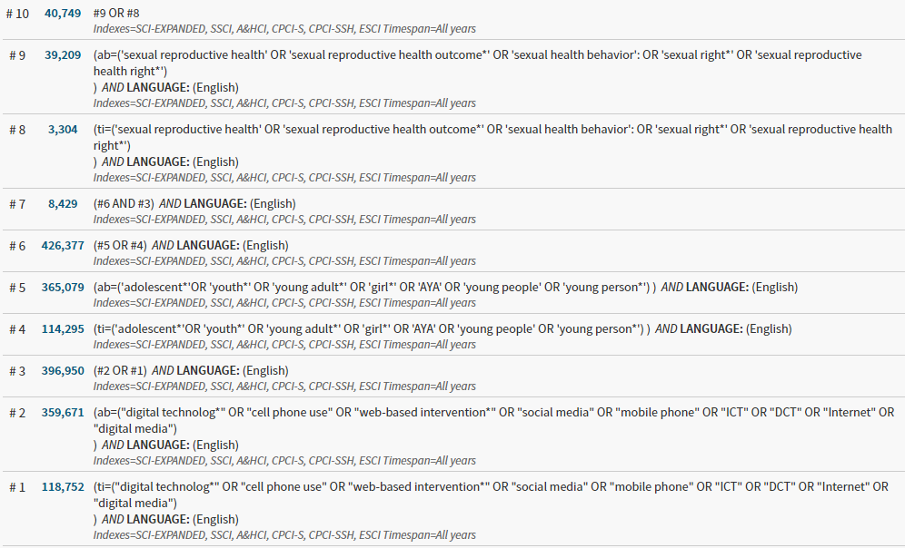 | 232

Database searching: Scopus
 | Search strategy | Results | Comments
Date:  8/3/21 | TITLE-ABS-KEY ( ( adolescent* ) OR ( youth* ) OR ( young AND adult* ) OR ( girl* ) OR ( aya ) OR ( young AND people ) OR ( young AND person* ) ) AND TITLE-ABS-KEY ( ( digital AND technolog* ) OR ( cell AND phone AND use ) OR ( web-based AND intervention ) OR ( social AND media ) OR ( mobile AND phone ) OR ( ict ) OR ( internet ) OR ( digital AND media ) OR ( dct ) ) AND TITLE-ABS-KEY ( ( sexual AND reproductive AND health ) OR ( sexual AND reproductive AND health AND outcome ) OR ( sexual AND health AND behavior ) OR ( sexual AND right* ) OR ( sexual AND reproductive AND health AND right* ) ) AND TITLE-ABS-KEY ( ( engagement ) OR ( participation ) OR ( empowerment ) OR ( activism ) OR ( digital AND activism ) OR ( digital AND network* ) OR ( participatory AND approaches ) OR ( engagement AND strateg* ) OR ( public AND representation ) OR ( public AND engagement* ) OR ( social AND inclusion ) OR ( voice AND agency ) OR ( social AND capital ) OR ( sense AND of AND control ) OR ( sense AND near/4 AND integration ) OR ( social AND cohesion ) OR ( active AND citizenship ) OR ( independence ) ) ) | 501

