SUPPLEMENTARY MATERIAL
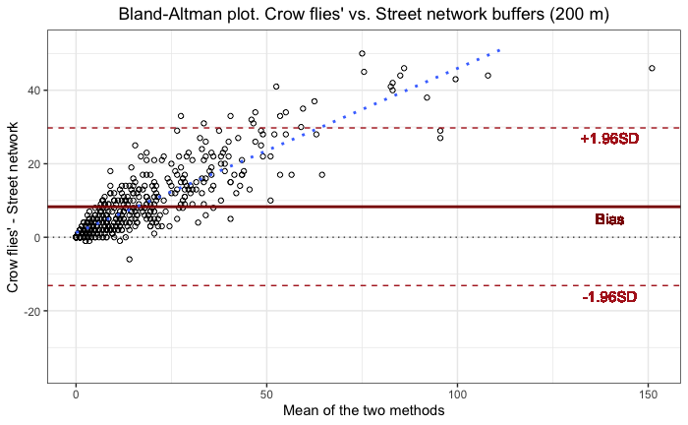
Supplemental Figure 1. Bland-Altman plot for the 200-meter buffers.

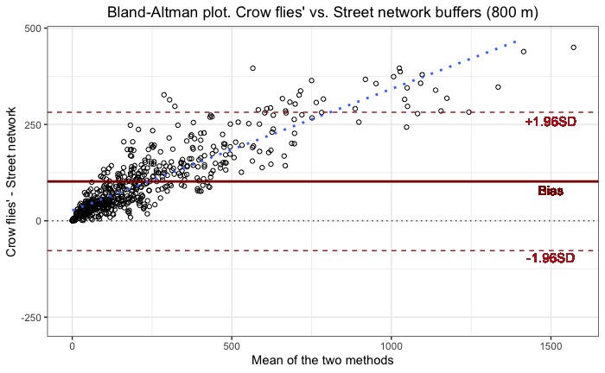
Supplemental Figure 2. Bland-Altman plot for the 800-meter buffers.

