SUPPLEMENTARY MATERIALS
Title: A Price Too High: Injury and Assault Among Delivery Gig Workers in New York City
Authors:
Zoey Laskaris¹, Mustafa Hussein², Jim P Stimpson³, Emilia F Vignola⁴, Zach Shahn⁵, Nevin Cohen², Sherry Baron¹
¹Barry Commoner Center for Health and the Environment, Queens College City University of New York, Queens, NY, USA
²Department of Health Policy and Management, City University of New York Graduate School of Public Health and Health Policy, NYC, NY, USA
³Peter O'Donnell Jr. School of Public Health, University of Texas Southwestern Medical Center, Dallas, TX, USA
⁴ Department of Epidemiology, University of Washington School of Public Health, Seattle, WA, USA
⁵ Department of Epidemiology and Biostatistics, City University of New York Graduate School of Public Health and Health Policy, NYC, NY, USA

Supplemental Figure I: Sample flow diagram
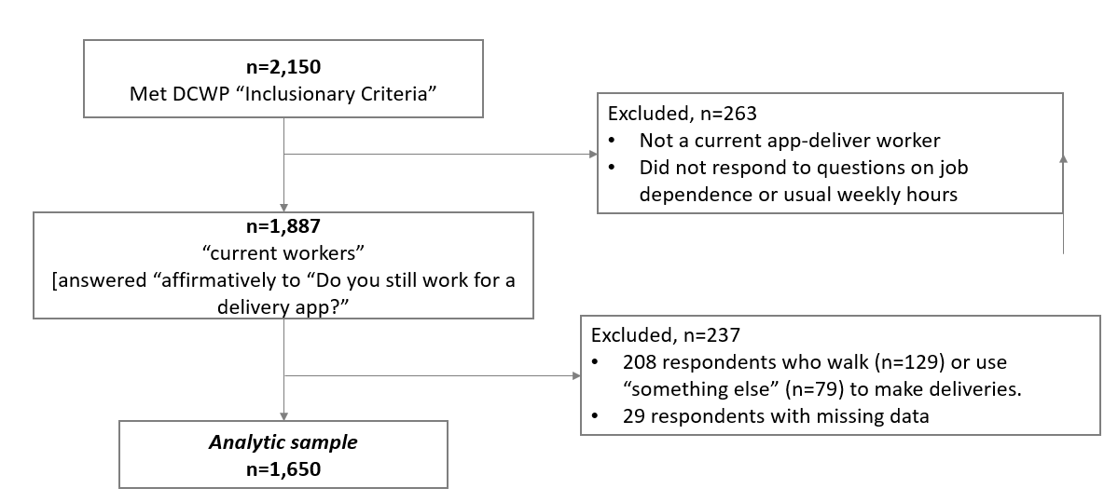

Supplemental Figure II: Balance plots for PSM models
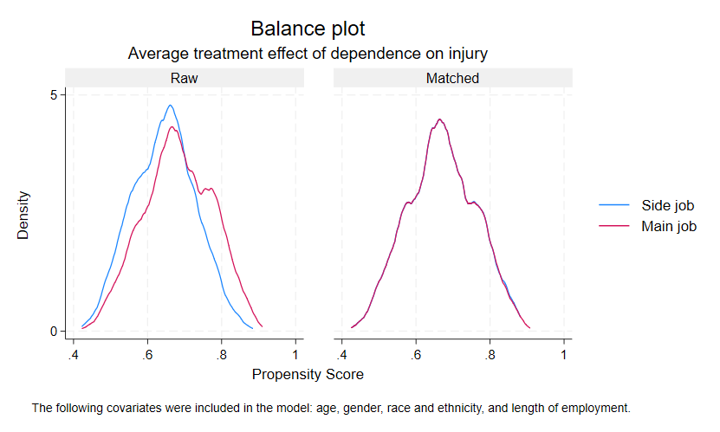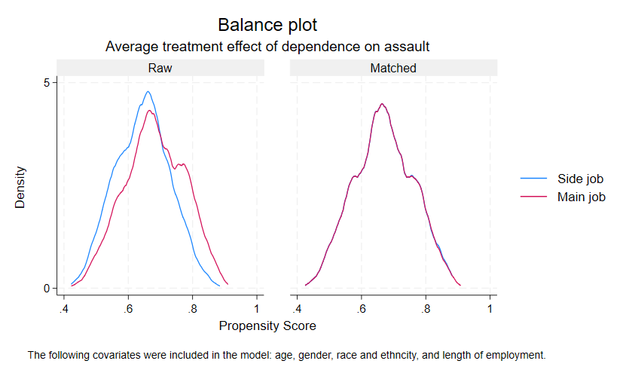

Supplemental Table I: Bivariable prevalence rate ratios for injury and assault from the NYC-DCWP survey (2022)
 |  | INJURY | ASSAULT
 |  | PR [95% CI] | PR [95% CI]
Dependence
 | Side job | 1 [1.00,1.00] | 1 [1.00,1.00]
 | Main job | 2.69*** [2.06,3.51] | 2.16*** [1.68,2.77]
Age (years)
 | 18-24 | 1 [1.00,1.00] | 1 [1.00,1.00]
 | 25-34 | 0.86 [0.66,1.11] | 0.96 [0.73,1.26]
 | 35-44 | 0.79 [0.60,1.04] | 0.92 [0.69,1.23]
 | 45 and older | 0.78 [0.57,1.08] | 0.75 [0.52,1.06]
Gender
 | Male | 1 [1.00,1.00] | 1 [1.00,1.00]
 | Female | 0.50*** [0.38,0.67] | 0.37*** [0.26,0.52]
Race & Ethnicity
 | Hispanic | 1.13 [0.77,1.64] | 1.3 [0.88,1.92]
 | White (non-Hispanic) | 1 [1.00,1.00] | 1 [1.00,1.00]
 | Black (non-Hispanic) | 0.89 [0.59,1.34] | 0.7 [0.45,1.10]
 | Asian | 1.38 [0.92,2.07] | 1.4 [0.91,2.14]
 | Other | 1.57 [0.89,2.79] | 1.31 [0.68,2.53]
English language ability
 | Proficient | 1 [1.00,1.00] | 1 [1.00,1.00]
 | Limited | 1.37** [1.13,1.65] | 2.16*** [1.80,2.59]
Length of employment
 | Less than 1 year | 1 [1.00,1.00] | 1 [1.00,1.00]
 | 1 to 2 years | 0.82 [0.59,1.15] | 1.02 [0.72,1.45]
 | 2 to 3 years | 1.47* [1.09,1.97] | 1.42* [1.02,1.97]
 | 3 to 4 years | 1.60** [1.14,2.25] | 1.87*** [1.31,2.67]
 | 4+ years | 1.55** [1.16,2.07] | 1.87*** [1.37,2.54]
Usual weekly hours
 | Less than 20 hrs | 1 [1.00,1.00] | 1 [1.00,1.00]
 | 20 - 39 hrs | 1.51** [1.16,1.96] | 1.23 [0.95,1.58]
 | 40 or more hrs | 2.82*** [2.22,3.57] | 2.07*** [1.64,2.61]
Mode of transport
 | Car | 1 [1.00,1.00] | 1 [1.00,1.00]
 | Moped, E-Bike | 2.82*** [2.32,3.43] | 2.78*** [2.28,3.40]
P value * <0.05 **<0.01 **<0.001
Footnote: Results were derived from unadjusted modified Poisson regression models with robust standard errors.

Supplemental Table II: Propensity score matching results
Propensity Score Matching model |  |  | INJURY |  | ASSAULT
 | Dependence |  | (1)  PD [95% CI]ª | (2)  PD [95% CI]^{b} | (3)  PD [95% CI]ª | (4)  PD [95% CI]^{b}
 |  | Side job | 0 [0.00, 0.00] | 0 [0.00, 0.00] | 0 [0.00, 0.00] | 0 [0.00, 0.00]
 |  | Main job | 0.16*** [0.11,0.20] | 0.13*** [0.08,0.18] | 0.11*** [0.07,0.15] | 0.10*** [0.05,0.15]
Linear Probability Model
 | Dependence
 |  | Side job | 0 [0.00, 0.00] | 0 [0.00, 0.00] | 0 [0.00, 0.00] | 0 [0.00, 0.00]
 |  | Main job | 0.15*** [0.11,0.19] | 0.11*** [0.08,0.15] | 0.10*** [0.06,0.13] | 0.07*** [0.03,0.10]
P value * <0.05 **<0.01 **<0.001
PD= Prevalence difference

Footnotes:
ª Matched covariates includes age, gender, race and ethnicity, survey language, and years of employment
^{b} Matched covariates include age, gender, race and ethnicity, survey language, years of employment, mode of transport

