Supplemental Fig. 1 Pre-Incarceration Period: Distribution of Cumulative Jail Days for all Prior Jail Incarcerations by Serious Mental Illness Status.
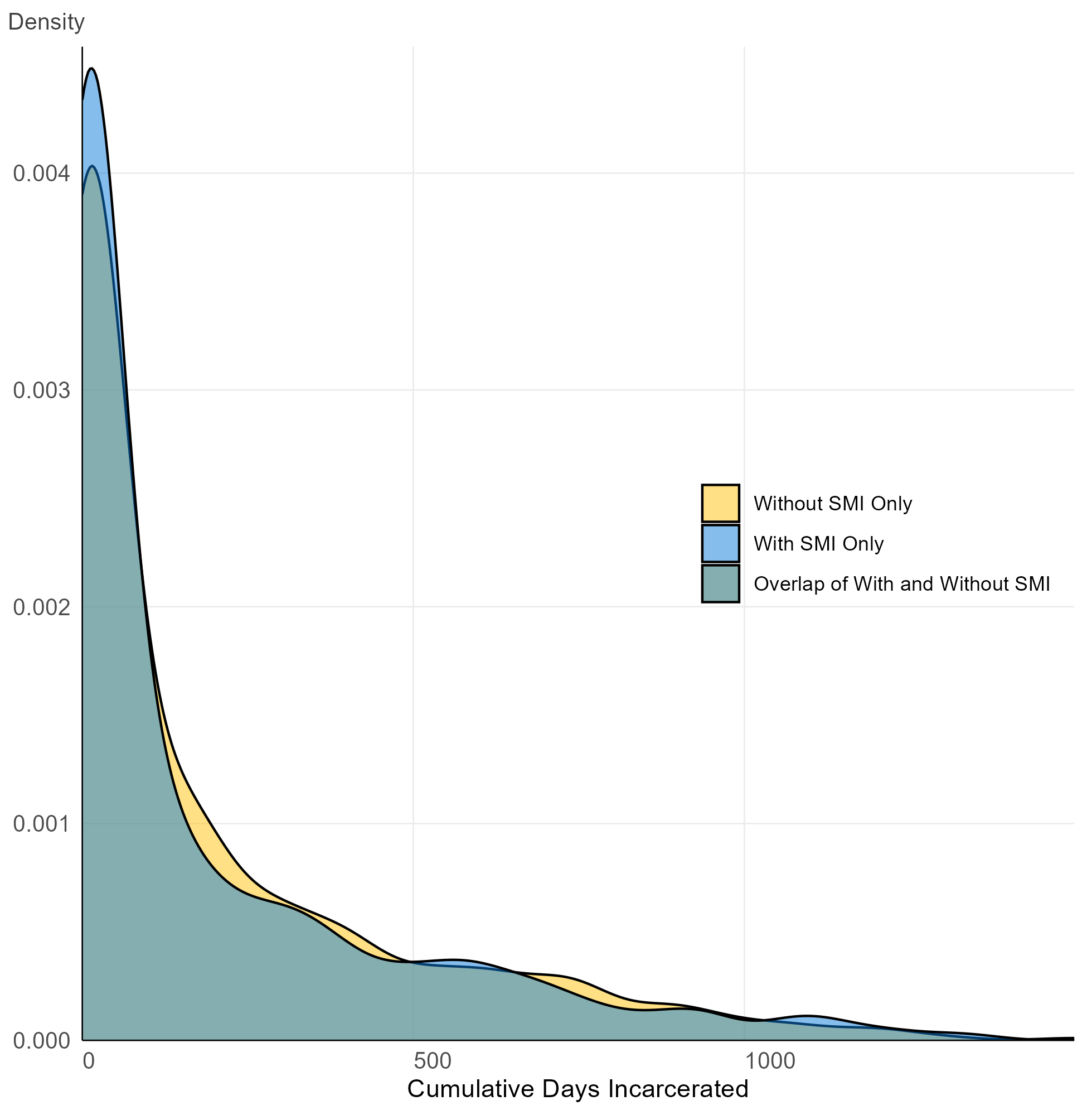
Density plot showing the distribution of total cumulative jail days for all incarcerations during the study period, stratified by serious mental illness status. Individuals with no prior booking history were excluded. Abbreviations: SMI, Serious Mental Illness

