Supplemental Fig. 4 Incarceration Period: Distribution of Longest Single Jail Incarceration by Serious Mental Illness Status
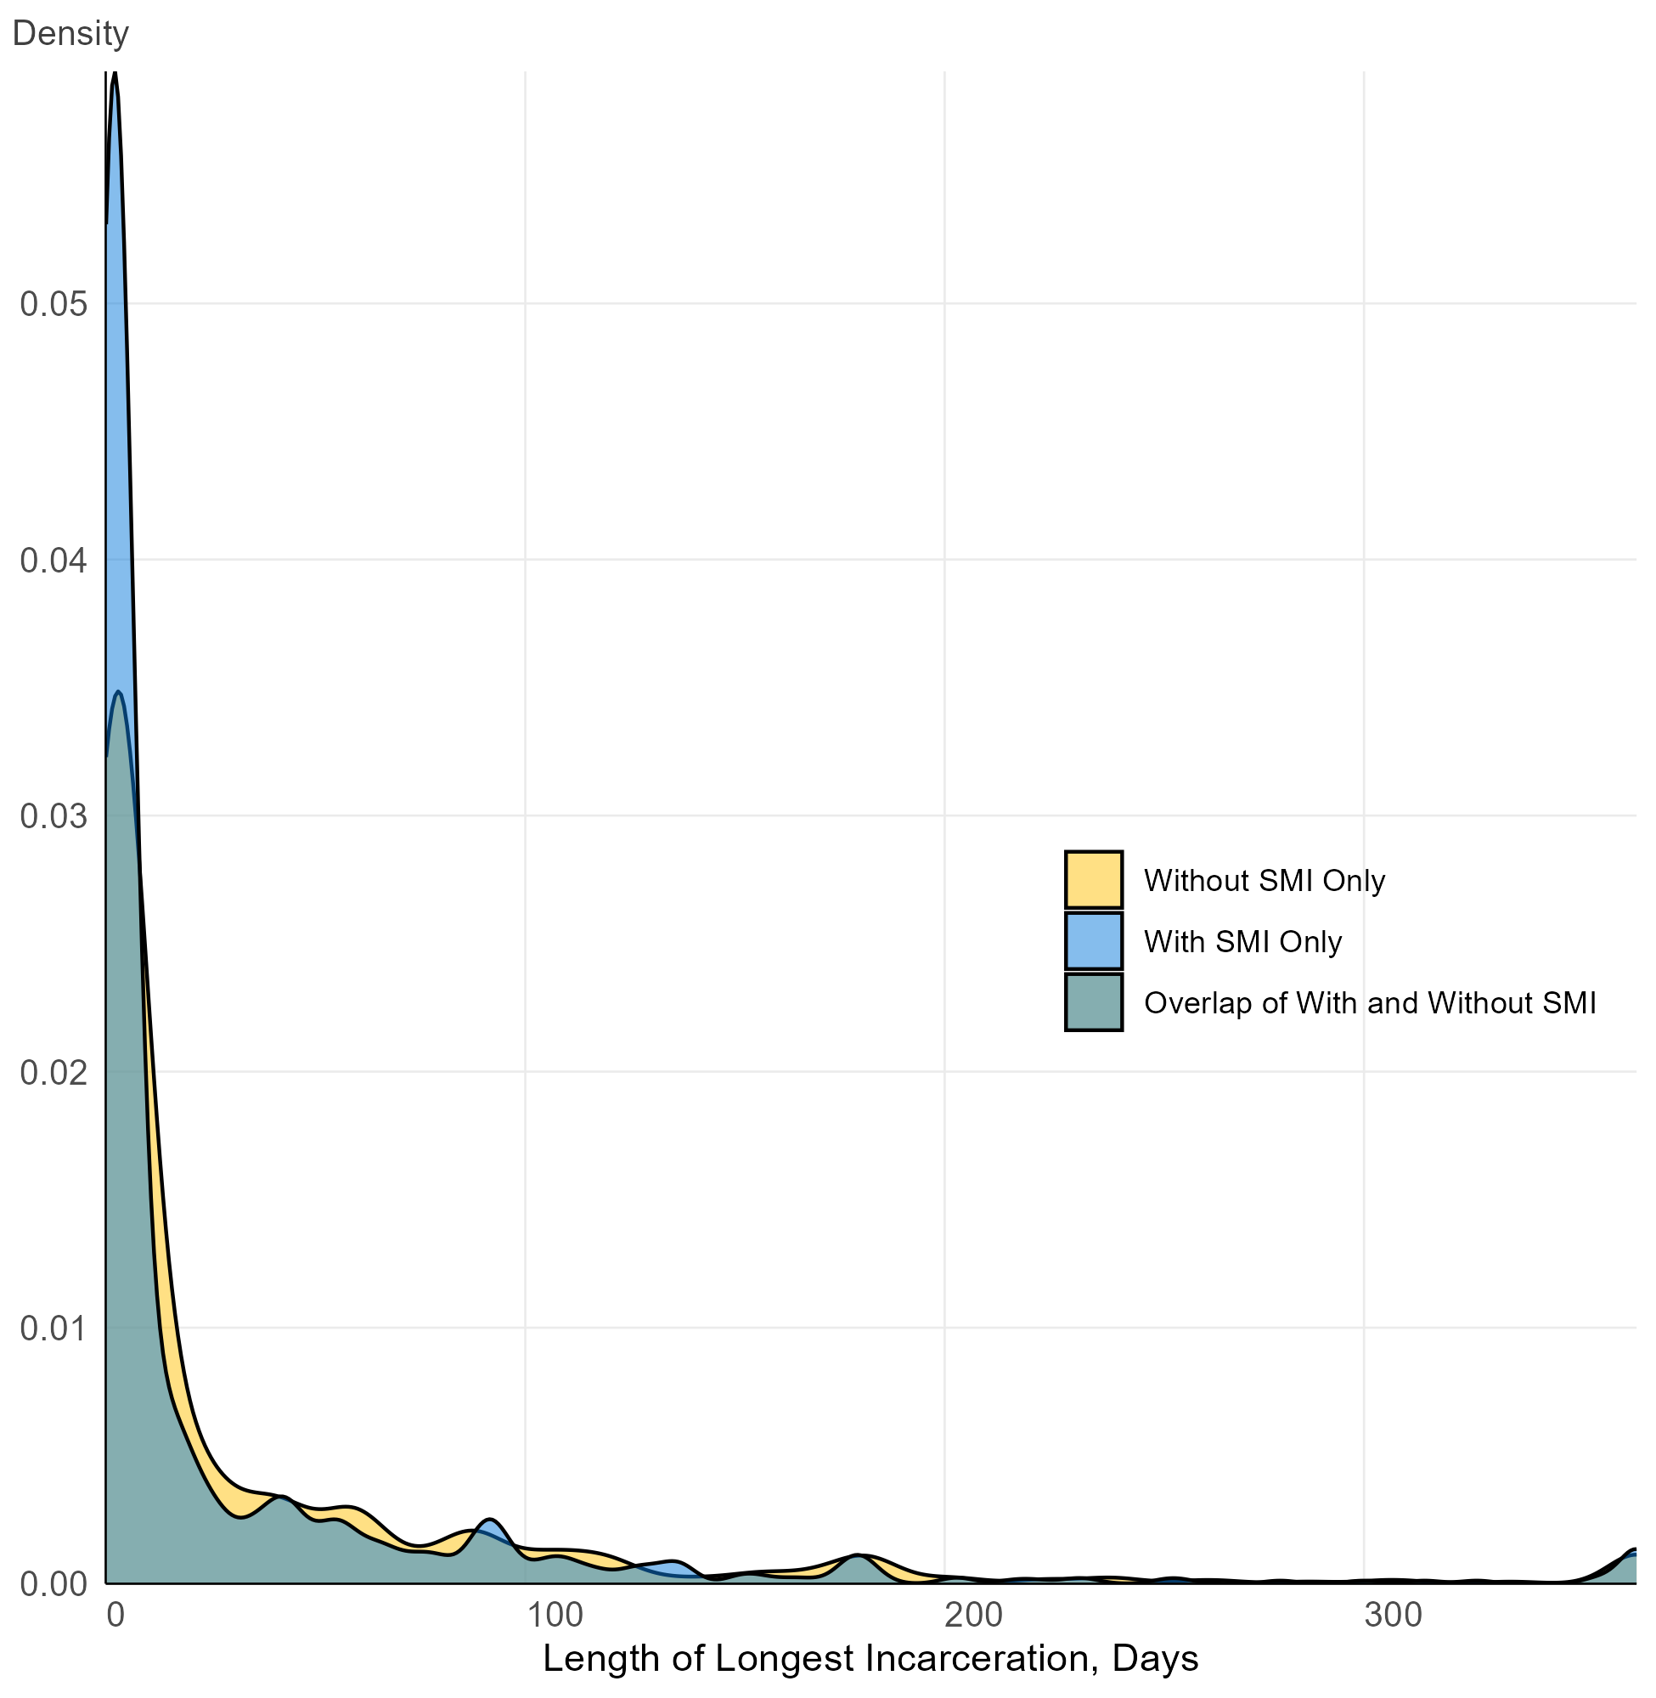
Density plot showing the distribution of the duration of individuals’ longest single incarceration episode, stratified by serious mental illness status. Abbreviations: SMI, Serious Mental Illness

