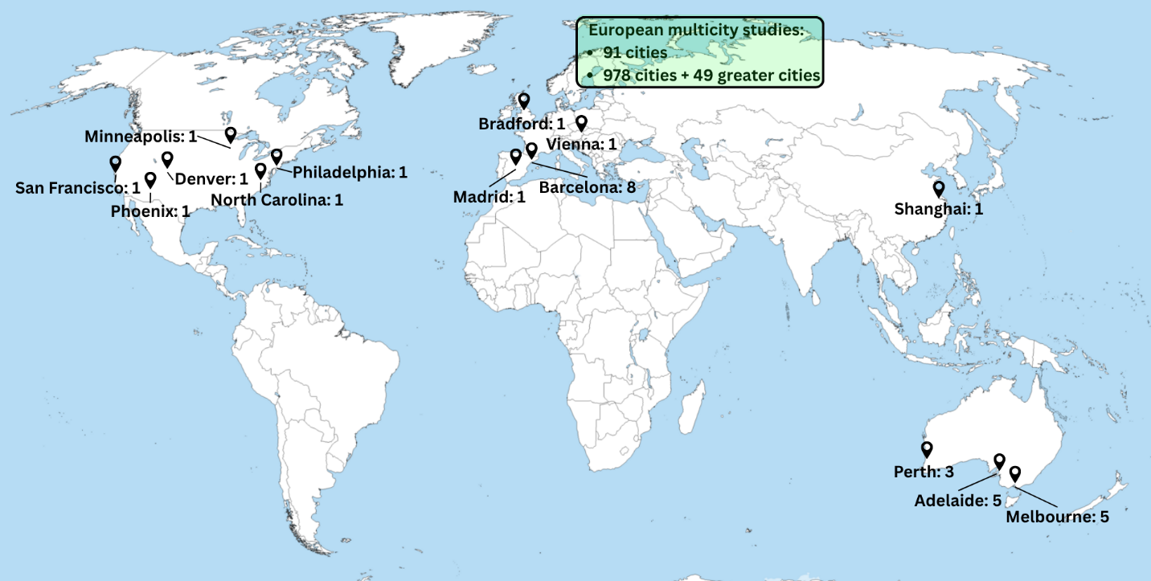
Supplementary Fig. 2 Geographical distribution of the included studies

