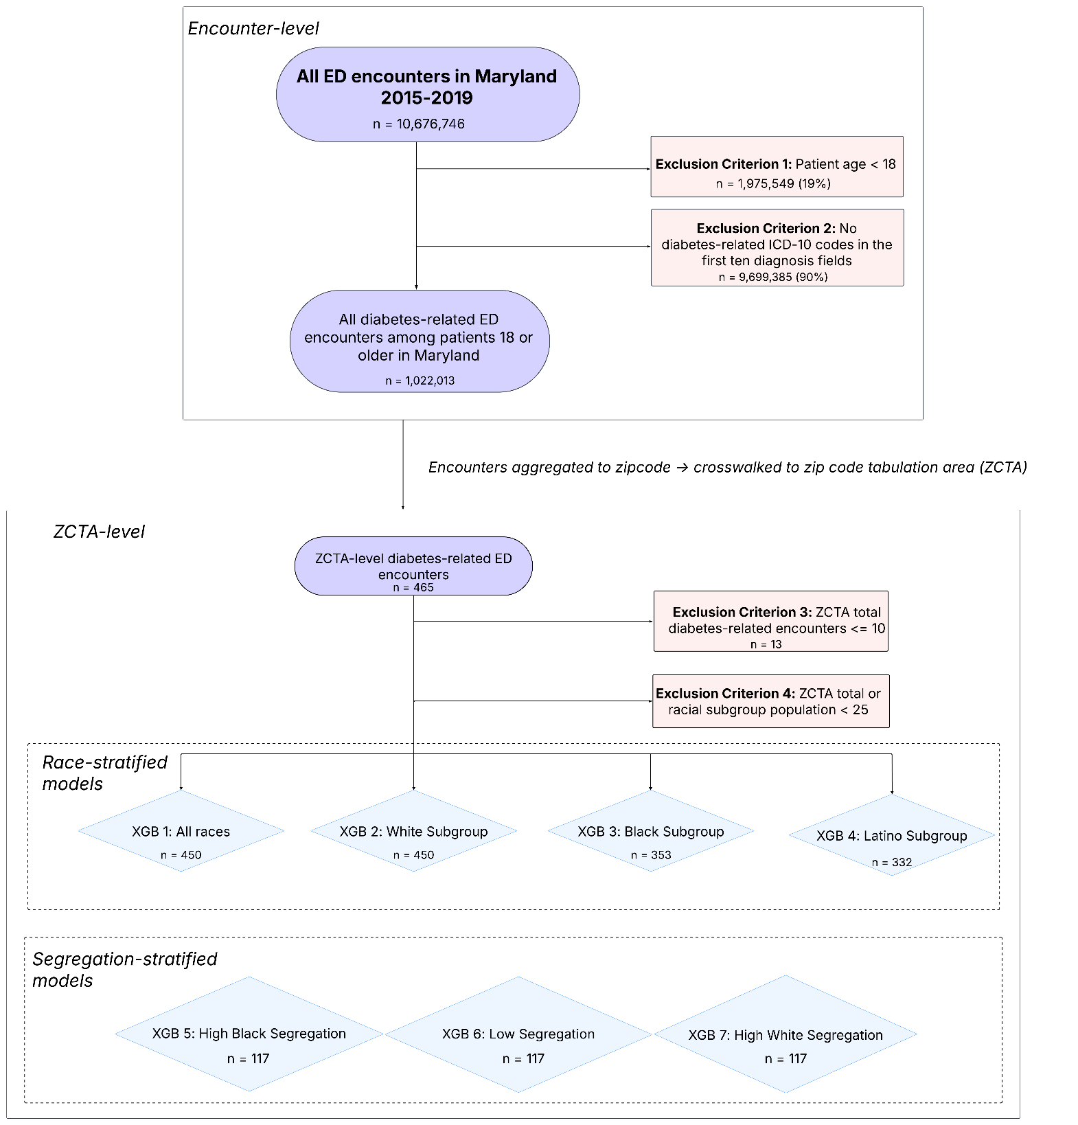
Figure S1: Exclusion criteria applied to ED data for XGBoost models.

Table S1: List of all covariates and their data sources and resolution.
Variable | Source | Spatial resolution
Residential Segregation
Entropy Index (evenness) | ACS 2015–2019 | ZCTA
Simpson’s Interaction Index (exposure/diversity) | ACS 2015–2019 | ZCTA
Centralization Index (Black centralization) | ACS 2015–2019 | ZCTA
Simpson’s Concentration Index | ACS 2015–2019 | ZCTA
Location Quotient (White, Black, Hispanic/Latino) | ACS 2015–2019 | ZCTA
ICE (Index of Concentration at Extremes) | ACS 2015-2019 | ZCTA
Built Environment
Vacant housing units | ACS 2015–2019 | ZCTA
>2 occupants per room | ACS 2015–2019 | ZCTA
Housing structures with ≥50 units | ACS 2015–2019 | ZCTA
Housing units without adequate plumbing | ACS 2015–2019 | ZCTA
Toxic Release Inventory (TRI) facilities | U.S. EPA | Count
Superfund sites | U.S. EPA | Count
Proportion of land designated for parks | NaNDA | ZCTA
Normalized Difference Vegetation Index (NDVI) | NaNDA | ZCTA
Land surface temperature (LST) | NaNDA | ZCTA
Proportion high-intensity developed land (impervious >79%) | NaNDA | ZCTA
Proportion open water | NaNDA | ZCTA
Total food stores per 1,000 people | NaNDA | ZCTA
Total food stores per square mile | NaNDA | ZCTA
Heavy traffic (proportion highways/arteries to all roads) | NaNDA | ZCTA
Primary road length | NaNDA | ZCTA
Transit steps per capita | NaNDA | ZCTA
Transit steps per square mile | NaNDA | ZCTA
Street link/node ratio | NaNDA | ZCTA
Street intersection density | NaNDA | ZCTA
Street network density | NaNDA | ZCTA
Block density and average block length | NaNDA | ZCTA
Average daily traffic volume/counts | NaNDA | ZCTA
Rural–Urban Commuting Area (RUCA) codes (primary, secondary) | NaNDA | ZCTA
Physician offices/clinics per 1,000 people | NaNDA | ZCTA
Physician offices/clinics per square mile | NaNDA | ZCTA
Socioeconomic Status
Racial composition | ACS 2015–2019 | ZCTA
Median household income | ACS 2015–2019 | ZCTA
Age distribution | ACS 2015–2019 | ZCTA
Educational attainment | ACS 2015–2019 | ZCTA
Households below poverty level | ACS 2015–2019 | ZCTA
Households receiving cash public assistance or SNAP | ACS 2015–2019 | ZCTA
Renter-occupied housing units | ACS 2015–2019 | ZCTA
Households with Black homeowners | ACS 2015–2019 | ZCTA
Gini index of income inequality | ACS 2015–2019 | ZCTA
Comorbidities
High blood pressure prevalence | CDC PLACES | ZCTA
High cholesterol prevalence | CDC PLACES | ZCTA
Chronic kidney disease prevalence | CDC PLACES | ZCTA
COPD prevalence | CDC PLACES | ZCTA
Coronary heart disease (CHD) prevalence | CDC PLACES | ZCTA
Depression prevalence | CDC PLACES | ZCTA
Diabetes prevalence | CDC PLACES | ZCTA
Obesity prevalence | CDC PLACES | ZCTA
Lack of health insurance | CDC PLACES | ZCTA
Routine checkup (past year) | CDC PLACES | ZCTA
Taking medicine for high BP (among adults with high BP) | CDC PLACES | ZCTA
Cholesterol screening | CDC PLACES | ZCTA
Older adults (≥65) up-to-date on core preventive services | CDC PLACES | ZCTA
Binge drinking | CDC PLACES | ZCTA
Cigarette smoking | CDC PLACES | ZCTA
No physical leisure-time activity | CDC PLACES | ZCTA
Fair or poor self-rated health | CDC PLACES | ZCTA

Table S2: Evaluation metrics for each model.
 | R² | MSE | RMSE | MAE
XGB1: All Races | 0.51 | 0.25 | 0.50 | 0.36
XGB2: White | 0.39 | 0.36 | 0.60 | 0.42
XGB3: Black | 0.63 | 0.50 | 0.71 | 0.47
XGB4: Latino | 0.41 | 1.14 | 1.07 | 0.73
XGB5: LOW ice | 0.59 | 0.26 | 0.51 | 0.31
XGB6: medium ice | 0.65 | 0.20 | 0.45 | 0.32
XGB7: high ice | 0.50 | 0.13 | 0.37 | 0.28

