Supplements:
Format-Preserving Reduction of Canonical Nonlinear Models

Eberhard O. Voit

The supplements contain parameter values and other information regarding the models presented in the Main Text, as well as additional figures. As in the Main Text, variables of the original models are denoted with indexed X variables, while the corresponding reduced variables are designated with indexed Ys.

Supplement Section S1: Model of Aspartate-Derived Amino Acid Synthesis
The metabolic reaction network of aspartate-derived amino acid synthesis [1] is shown in the Main Text (Figure 2). The original model was formulated with traditional rate functions, but Iwata and colleagues [2] converted it into an S-system and showed that the quality of this approximation was very good. They also added as explicit variables X₇ = [Ile] and X₈ = [Threonyl-tRNA]. In the original model, X₈ had no explicit efflux and therefore continued to accumulate without a steady state. Here, a default efflux term was added. The model structure is given in the Main Text. The parameter values are presented in Table S1; the value of the input variable, aspartate (X₀), was set to 1. The initial values correspond to the non-trivial steady state of the system.

Table S1. Parameter settings for the model of aspartate-derived amino acid synthesis
 | X₁ | X₂ | X₃ | X₄ | X₅ | X₆ | X₇ | X₈
Steady-State  Value | 0.3384 | 0.9691 | 70.05 | 0.9216 | 44.91 | 343.7 | 62.69 | 0.254
α | 12.6 | 15.2 | 124 | 5.76 | 7.37 | 0.0185 | 11.7 | 0.0919
β | 5 | 10 | 0.1 | 5 | 5 | 0.5 | 0.1 | 0.1
g | g₁₃ = -0.121  g₁₆ = -0.163 | g₂₁ = 0.398 | g₃₂ = 0.847  g₃₃ = -1.37 | g₄₂ = 0.0982  g₄₆ = -0.0251 | g₅₄ = 0.092 | g₆₅ = 1.02 | g₇₆ = 0.949  g₇₇ = -2.19 | g₈₆ = -0.22
h | h₁₁ = 0.5 | h₂₂ = 0.4 | h₃₃ = 0.3 | h₄₄ = 0.1 | h₅₅ = 0.1 | h₆₆ = 0.1 | h₇₇ = 0.3 | h₈₈ = 1

Supplement Section S2: Reduction of Lotka-Volterra Models
A Lotka-Volterra (LV) System with real-valued parameters can be written generically as
$${\dot{X}}_{i}=a_{i}X_{i}+\sum_{j=1}^{n}{b_{ij}{X_{i}X}_{j}} (S1)$$
The task at hand is reduction of variable X_{k}, assuming its nullcline equation ${\dot{X}}_{k}=0$ has a non-zero solution for X_{k}. Depending on a_{k} and b_{kk}, the reduction proceeds slightly differently or cannot be performed.

Case 1: a_{k} ≠ 0, b_{kk} ≠ 0
This case is discussed in Main Text, but details of the reduction follow below. Separating out the linear term of the k^{th} equation for ${\dot{X}}_{k}=0$ yields
$${-a}_{k}X_{k}=\left(\sum_{j=1,j≠k}^{n}{b_{kj}X_{j}}+ b_{kk}X_{k}\right)X_{k}. (S2)$$
Division by X_{k} simplifies this term to
$$-a_{k}=\left(\sum_{j=1,j≠k}^{n}{b_{kj}X_{j}}+ b_{kk}X_{k}\right) (S3)$$
and
$$-b_{kk}X_{k}=a_{k} + \sum_{j=1,j≠k}^{n}{b_{kj}X_{j}}, (S4)$$
which yields an algebraic term for X_{k}:
$$X_{k}={-a}_{k}b_{kk}^{-1}-\sum_{j=1,j≠k}^{n}{\frac{b_{kj}}{b_{kk}}X_{j} (S5)}$$
X_{k} is a linear function of the other X-variables. As an example, substitute it in the equation for X_{i}:
$${\dot{X}}_{i}=a_{i}X_{i}+\sum_{j=1,j≠k}^{n}{b_{ij}{X_{i}X}_{j}}+ b_{ik}X_{i} X_{k}. (S6)$$
Substitution of X_{k} yields
$${\dot{X}}_{i}=a_{i}X_{i}+\sum_{j=1,j≠k}^{n}{b_{ij}{X_{i}X}_{j}}+ b_{ik}X_{i} \left({-a}_{k}b_{kk}^{-1}-\sum_{j=1,j≠k}^{n}{\frac{b_{kj}}{b_{kk}}X_{j}}\right), (S7)$$
$${\dot{X}}_{i}=\left(a_{i }-{a_{k} b}_{ik}{ b}_{kk}^{-1} \right)X_{i}+\sum_{j=1,j≠k}^{n}{b_{ij}{X_{i}X}_{j}}- b_{ik}X_{i} \left(\sum_{j=1,j≠k}^{n}{\frac{b_{kj}}{b_{kk}}X_{j}}\right), (S8)$$
$${\dot{X}}_{i}=\left(a_{i }-{a_{k} b}_{ik}{ b}_{kk}^{-1} \right)X_{i}+\sum_{j=1,j≠k}^{n}{b_{ij}{X_{i}X}_{j}}- \left(\sum_{j=1,j≠k}^{n}{\frac{{b_{ik}b}_{kj}}{b_{kk}}{X_{i}X}_{j}}\right), (S9)$$
and finally
$${\dot{X}}_{i}=\left(a_{i }-{a_{k} b}_{ik}{ b}_{kk}^{-1} \right)X_{i}+\sum_{j=1,j≠k}^{n}{{(b}_{ij}- \frac{{b_{ik}b}_{kj}}{b_{kk}}){X_{i}X}_{j}}, (S10)$$
which is in the LV format
$${\dot{X}}_{i}={\tilde{a}}_{i}X_{i}+\sum_{j=1,j≠k}^{n}{{\tilde{b}}_{ij}{X_{i}X}_{j} (S11)}$$
with
$${\tilde{a}}_{i}=\left(a_{i }-{a_{k} b}_{ik}{ b}_{kk}^{-1} \right) (S12)$$
and
$${\tilde{b}}_{ij}= b_{ij}- \frac{{b_{ik}b}_{kj}}{b_{kk}} . (S13)$$

Case 2: a_{k} = 0, b_{kk} ≠ 0
For X_{k} ≠ 0, the nullcline equation ${\dot{X}}_{k}=0,$
$$0=\sum_{j=1}^{n}{b_{kj}{X_{k}X}_{j}}, (S14)$$
may be divided by X_{k}, which results in
$$0=\sum_{j=1}^{n}{b_{kj}X_{j}}. (S15)$$
Separating the term containing X_{k} yields
$$0=\sum_{j=1,j≠k}^{n}{b_{kj}X_{j}}+ b_{kk} X_{k}, (S16)$$
and thus
$$X_{k}= -\sum_{j=1,j≠k}^{n}{\frac{b_{kj}}{b_{kk}}X_{j}}, (S17)$$
which is substituted into all other ODEs, thereby retaining the LV format.

Case 3: a_{k} = 0, b_{kk} = 0
For X_{k} ≠ 0, the nullcline equation
$${\dot{X}}_{k}=a_{k}X_{k}+\sum_{j=1}^{n}{b_{kj}{X_{k}X}_{j}} =0 (S18)$$
reduces to
$$0=\sum_{j=1}^{n}{b_{kj}{X_{k}X}_{j}}, (S19)$$
$$0=\sum_{j=1}^{n}{b_{kj}X_{j}}, (S20)$$
and thus
$$0=\sum_{j=1,j≠k}^{n}{b_{kj}X_{j}}. (S21)$$
This equation cannot be solved for X_{k}. Expressed in words, if the ODE for X_{k} does not contain X_{k} itself, it cannot be reduced.

Supplements Section S3: Linear Pathway with Feedback
Successive reduction of the linear system with feedback ultimately leads to a system of only two equations. The Main Text demonstrated reduction of the 4th variable and substitution into the 5th ODE, yielding
${\dot{Y}}_{5} = β_{4} {({(\frac{β_{3}Y_{3}^{0.8}}{β_{4}})}^{2.5})}^{0.4}- β_{5}Y_{5}^{0.6}=β_{3}Y_{3}^{0.8}- β_{5}Y_{5}^{0.6}$. (S22)
Substituting Y₃ gives the nullcline equation
${\dot{X}}_{3} = β_{2}X_{2}^{0.5}- β_{3}X_{3}^{0.8}=0$ (S23)
which is solved as
$Y_{3} ={(\frac{β_{2}Y_{2}^{0.5}}{β_{3}})}^{1/0.8}$ (S24)
Substituting this expression in the equation for Y₅ leads to
${\dot{Y}}_{5} =β_{2}Y_{2}^{0.5}- β_{5}Y_{5}^{0.6}$ (S25)
Similarly, reducing X₂ and substituting Y₂ yields
${\dot{Y}}_{5} =β_{1}Y_{1}- β_{5}Y_{5}^{0.6}$ (S26)
Thus, the reduced system is
${\dot{Y}}_{1} =α_{1}Y_{1}Y_{5}^{g}- β_{1}Y_{1}$ (S27a)
${\dot{Y}}_{5} =β_{1}Y_{1}- β_{5}Y_{5}^{0.6}$ (S27b)
It indicates that, in this case, the low-level intermediates are simply "ignored."

Supplements Section S4: Bistable Systems
The first equation of the bistable system in the Main Text contains an expression in Hill-function format [3]. To convert it equivalently into a power-law equation, using the recasting technique [4], one defines the auxiliary variable
$X_{5}= 4^{4}+ X_{4}^{4}$. (S28)
Its derivative is
$${\dot{X}}_{5} = 4 X_{4}^{3} {\dot{X}}_{4} =4 X_{4}^{3} \left(3 X_{3} - 12 X_{4}^{0.75}\right),$$
$X_{5}\left(0\right)=4^{4}+ X_{4}^{4}\left(0\right)$ (S29)
which is in power-law format. Substituting X₅ (S28) into the equation of X₁ yields a GMA system.
This system could be recast further into an S-system, for instance, by replacing X₁ with the ratio of two auxiliary variables: X₁ = X₆/X₇ [4, 5]. X₁ is thereby eliminated from the system, leading to six S-system equations (X₂, …, X₇) instead of four in the original.
An interesting alternative is to approximate $F= 4+8 \frac{X_{4}^{4}}{4^{4}+ X_{4}^{4}}$ with a power-law term of the type ${α X}_{4}^{g}$. According to the principles of the power-law approximation [6], the kinetic order g is given as $g= \frac{dF}{dX_{4}}\frac{X_{4}}{F}$ and α as $F X_{4}^{-g};$ both are to be evaluated at an operating point. Here, one choose this point as the current value of X₄, thereby always computing a term ${α X}_{4}^{g}$ that is equivalent with F. The resulting system is
${\dot{X}}_{1} =α {X_{4}^{g} X}_{3}^{-0.5}- 0.5 X_{1}^{0.5}$ (S30a)
${\dot{X}}_{2} =X_{1}- 5 X_{2}^{0.5}$ (S30b)
${\dot{X}}_{3} =2 X_{2}- 3 X_{3}$ (S30c)
${\dot{X}}_{4} =3 X_{3}- 12 X_{4}^{0.75}$ (S30d)
where
$g =(32 \frac{X_{4}^{4} \left(4^{4}+ X_{4}^{4}- X_{4}^{3}\right)}{{\left(4^{4}+ X_{4}^{4}\right)}^{2}} / ( 4+8 \frac{X_{4}^{4}}{4^{4}+ X_{4}^{4}} )$ (S31)
and
$α= \left( 4+8 \frac{X_{4}^{4}}{4^{4}+ X_{4}^{4}}\right) X_{4}^{-g}$ (S32)
Note that $α$ and g in this formulation are not constant, as it is typical in BST, but functions of X₄ and thus of time.

Supplements Section S5: Limit Cycles
The Goodwin model [7, 8], expanded from three to four variables, has the form
${\dot{X}}_{1} =k_{1} \frac{K^{n}}{K^{n}+ X_{4}^{n}} - k_{2} X_{1}$ (S33a)
${\dot{X}}_{2} =k_{3}{ X}_{1} - k_{4} { X}_{2}$ (S33b)
${\dot{X}}_{3} =k_{5}{ X}_{2} - k_{6} { X}_{3}$ (S33c)
${\dot{X}}_{4} =k_{7}{ X}_{3} - k_{8} { X}_{4}$ (S33d)
where the first equation does not adhere to the power-law format. To convert ("recast" [4]) the model, one proceeds as in the previous section and defines the auxiliary variable
$X_{5}=K^{n}+ X_{4}^{n}.$ (S34)
Its derivative is
$${\dot{X}}_{5}=n X_{4}^{n-1} {\dot{X}}_{4}$$
$=n k_{7}{ X}_{3} X_{4}^{n-1} - n k_{8} X_{4}^{n},$
$X_{5}\left(0\right)=K^{n}+ X_{4}^{n}\left(0\right).$ (S35)
Furthermore, the ODE for X₁ becomes
${\dot{X}}_{1} =k_{1} {K^{n}X}_{5}^{-1} - k_{2} X_{1}.$ (S36)
All equations are now in power-law format, and the dynamics of X₁, …, X₄ is exactly the same as in the original system.
For n = 4, reducing X₁ or X₃ leads to substantial approximation errors, in the case of Y₃ essentially eliminating the oscillations (Fig. S1)
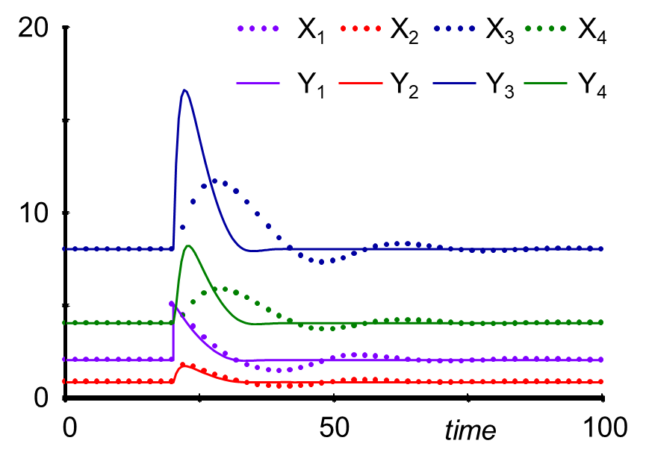
Fig. S1. Reduction of X₃ essentially eliminates the oscillations of the system.

For n = 18, the reduction of some variables retains a limit cycle (see Main Text), but that is not always the case. If X₂, X₃, X₄, or X₅ are reduced, the limit cycle disappears, and the system displays damped oscillations instead (Fig. S2).
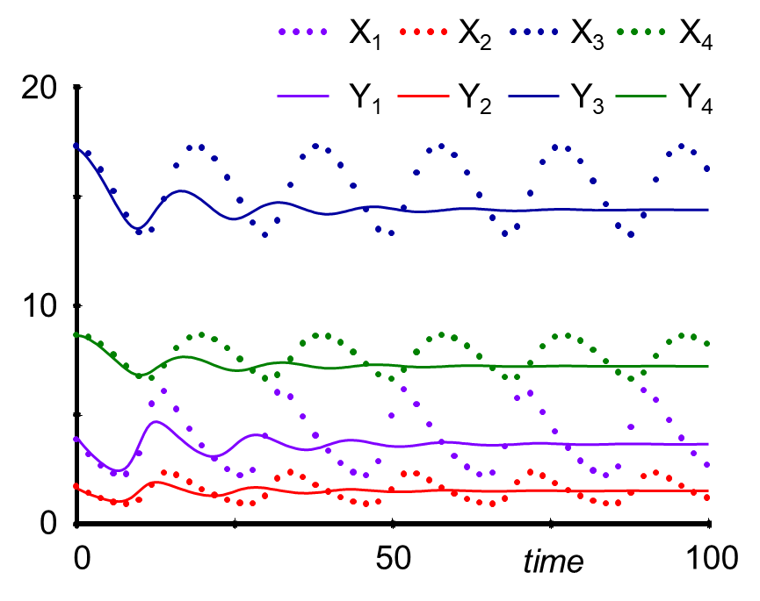
Fig. S2. Trajectories in response to the reduction of X₂. The solution is initiated directly on the limit cycle of the original system, as this system does not have a stable steady state.

Supplements Section S6: White-Rot Fungus Model
The model of biomass production in the white-rot fungus Phanerochaete chrysosporium follows the work of Hormiga and colleagues [9]. The model is in the format of a mass action system, which is augmented with regulatory signals and a two-variable delay, yielding a GMA system. In accordance with the base structure of a mass action system, including regulation, we formulate the model as follows.

Gluc: ${\dot{X}}_{1} =V_{in_Gluc} - V_{1} - V_{2}$
Biomass: ${\dot{X}}_{2} =V_{1} + V_{5} - V_{3}$
Dph: ${\dot{X}}_{3} =V_{in_Dph} - V_{4}$
Mph: ${\dot{X}}_{4} ={2 V}_{4}- V_{5}$
Delay 1: ${\dot{X}}_{10} =K (X_{1}- X_{10})$
Lip: ${\dot{X}}_{5} =V_{6} - V_{7} + V_{8} - V_{9}$
Lip*: ${\dot{X}}_{6} =- V_{8} + V_{9}$
H₂O₂: ${\dot{X}}_{8} = V_{10}- V_{11}$
Ox: ${\dot{X}}_{9} =V_{12}- V_{13}$
Delay 2: ${\dot{X}}_{11} =K (X_{10}- X_{11})$

(S37)
X₇ (O₂ and H₂O) and X₁₂ (veratryl alcohol) are constant, independent variables. The fluxes are defined as follows:

V_{in_Gluc} = 1
V_{in_Dph} = 1
V₁ = 0.3 X₁₁
V₂ = 0.1 X₁
V₃ = 0.3 X₂
V₄ = 0.4 X₃ X₆^{g1} X₁₂^{g2}
V₅ = 0.5 X₄
V₆ = 0.1 X₁^{g3} X₂ X₁₂^{g2}
V₇ = 0.1 X₅
V₈ = 0.2 X₆ X₃^{g5}
V₉ = 0.3 X₅ X₈^{g4}
V₁₀ = 0.2 X₇ X₉^{g6}
V₁₁ = 0.3 X₈ X₅^{g7}
V₁₂ = 0.1 X₁^{g3} X₂ X₁₂^{g2}
V₁₃ = 0.4 X₉

(S38)
If one replaces X₁₁ with X₁ in flux V₁, the time delay is eliminated.
Hormiga and collaborators performed a formal parameter estimation for a situation without the external supply of substrate inputs [9]. Because we are here considering an in vitro system with constant inputs, their parameter values only provide coarse guidance. For simplicity, all activation parameters (g₁, g₂, g₄, …, g₇) are set equal to 0.5 and the inhibition parameter g₃ to –1. Finally, we set the time delay parameter K = 0.2 and define the initial conditions as the steady-state values of the system:

X_{1ss} = 2.5
X_{2 ss} = 9.166667
X_{3ss} = 1.047034
X_{4ss} = 4
X_{5ss} = 4.490731
X_{6ss} = 3.800733
X_{7ss} = 1
X_{8ss} = 0.3333333
X_{9ss} = 1.122683
X_{10ss} = 2.5
X_{11ss} = 2.5
X_{12ss} = 1.5

(S39)
Effects of reducing delays
Reducing X₁₀, X₁₁, or both totally eliminates the oscillations caused by the time delay (Fig. S3).
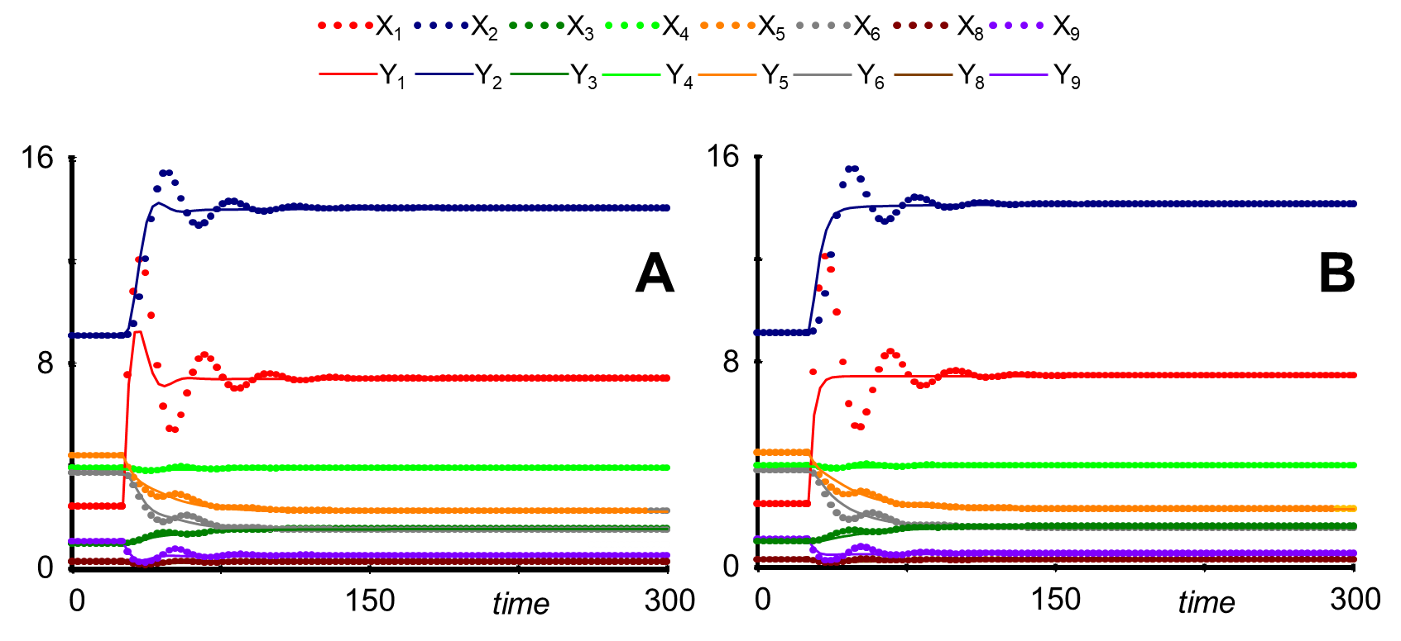
Fig. S3: A. Trajectories after reducing X₁₀; reducing X₁₁ results in trajectories that are visually the same.
B. Simultaneous reduction of X₁₀ and X₁₁. Note that X₇ is constant and therefore not shown.

Effects of reducing metabolite equations
Reduction of X₃ yields trajectories very close to those of the original model, except that Y₄ is very slightly off (Fig. S4).
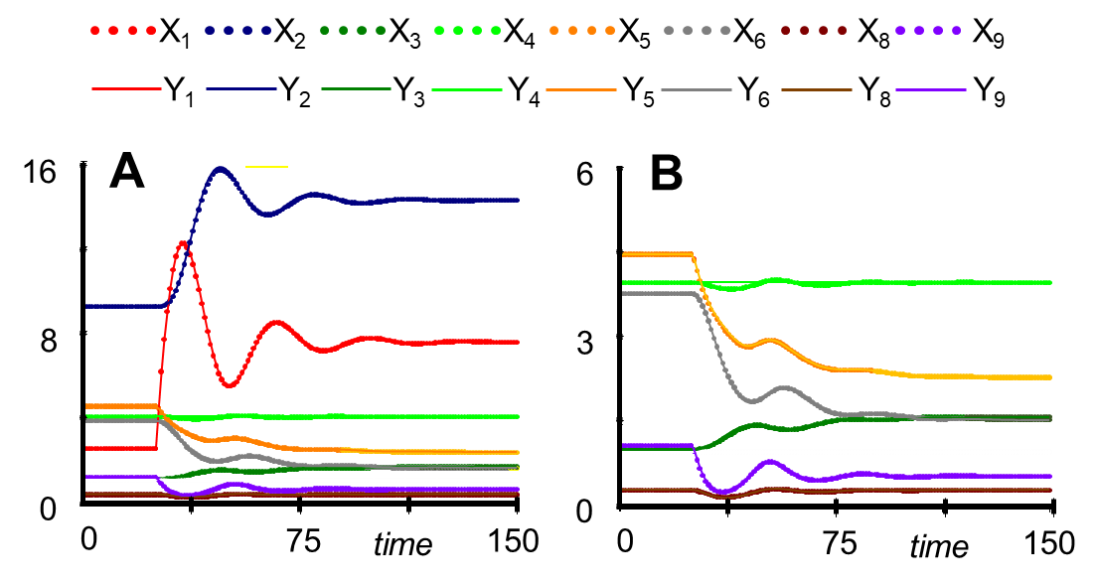
Fig. S4. Trajectories following reduction of X₃. A. All variables. B. Variables of smaller magnitude (indices 3 - 9).

Reduction of X₄ results in an essentially perfect match with the original (not shown). Reduction of X₅ primarily affects X₃ and X₅ (Fig. S5). It also slows down the simulation (see later discussion).
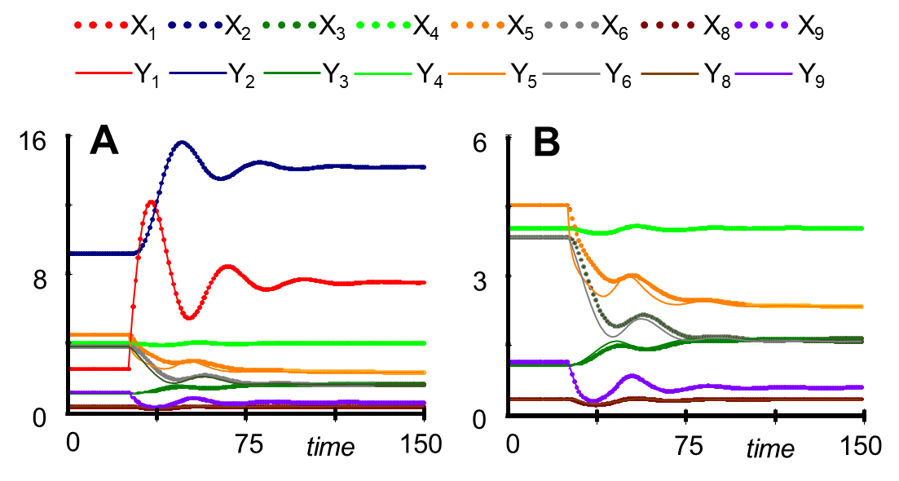
Fig. S5. Reducing X₅ essentially leaves the trajectories of glucose (Y₁) and biomass (Y₂) unaltered.
It does affect Y₃ and Y₅. A. All variables. B. Variables of smaller magnitude (indices 3 - 9).

Reducing X₆ results in rather substantial changes in oscillations, with Y₃ - Y₆ being affected most (Fig. S6).
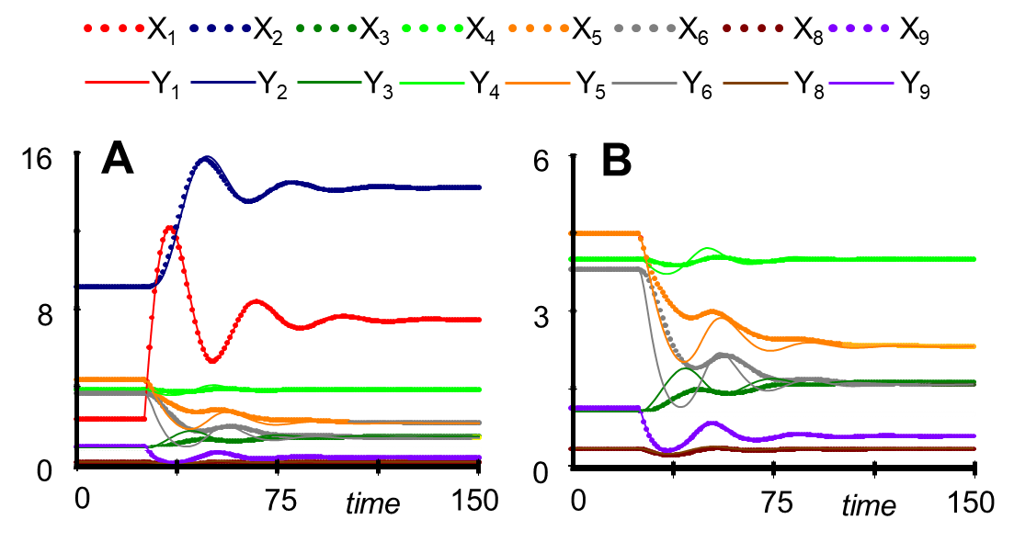
Fig. S6. Reduction of X₅ mostly affects variables associated with the diphenol pathway (Y₃ - Y₆).
A. All variables. B. Variables of smaller magnitude (indices 3 - 9).

X₇ is an independent variable that is not be reduced. Reduction of X₈ yields essentially perfect results (Fig. S7).
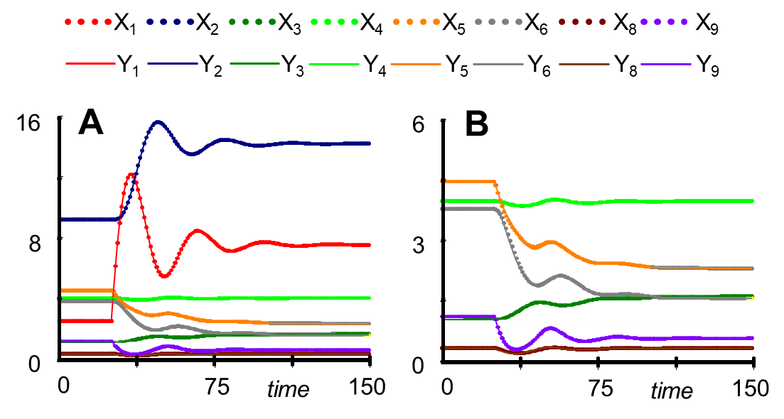
Fig. S7. Reduction of X₈ yields essentially perfect results. A. All variables.
B. Variables of smaller magnitude (indices 3 - 9).

Reducing X₉ does not affect the systems trajectories much, with the exception of Y₉ itself, which oscillates slightly faster. There are also minute deviations in Y₅ and Y₆ (Fig. S8).

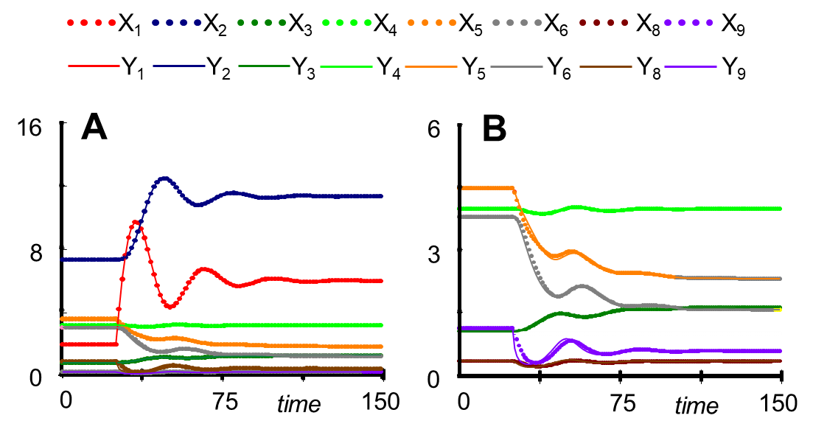
Fig. S8. Reduction of X₉ yields very good results. A. All variables.
B. Variables of smaller magnitude (indices 3 - 9).

Simultaneous reduction of several variables
For LV- and S-systems, reduction of an ODE results in the variable expressed, respectively, as a linear or a power-law term containing other variables. This term can be substituted directly into all remaining equations, thereby eliminating the variable. In cases of other formats, including GMA systems, the process is sometimes not quite as clean.
As an example, consider the simultaneous reduction of X₅ and X₆. The reduced equations are
$Y_{5}=\left(0.1 Y_{1}^{g_{3}} Y_{2}{ Y}_{12}^{g_{2}}+ 0.2 Y_{6}{ Y}_{3}^{g_{5}}\right) / (0.1+0.3 { Y}_{8}^{g_{4}})$ (S40)
and
$Y_{6}=0.3 Y_{5}{ Y}_{8}^{g_{4}} / (0.2 { Y}_{3}^{g_{5}}).$ (S41)
They show that Y₅ depends on Y₆ and vice versa. This mutual dependence can pose problems for the solution algorithm, starting with the initial value. The most effective solution to the issue is to manipulate the equations algebraically so that the mutual dependence is eliminated.
For the given case, it is useful to convert Y₅ into a sum of power-law terms, by representing the denominator $F=0.1+0.3 { Y}_{8}^{g_{4}}$ as a power-law of the type ${α Y}_{8}^{g}$. According to the principles of the power-law approximation, the kinetic order g is given as $g= \frac{dF}{dY_{8}}\frac{Y_{8}}{F}$ and α as $F Y_{8}^{-g};$ both are to be evaluated at an operating point. As before, we choose this point as the current value of Y₈, thereby computing a term ${α Y}_{8}^{g}$that is always equivalent with F, where $α$ and g are impicit functions of time via the involvement of Y₈. Thus, the definitions
$g=0.3 g_{4}{ Y}_{8}^{g_{4}} / (0.1+0.3 { Y}_{8}^{g_{4}})$ (S42)
$α= (0.1+0.3 { Y}_{8}^{g_{4}}){ Y}_{8}^{-g}$ (S43)
lead to a PL formulation that is equivalent to the Eq. (S40):
$Y_{5}=\left(0.1 Y_{1}^{g_{3}} Y_{2}{ Y}_{12}^{g_{2}}+ 0.2 Y_{6}{ Y}_{3}^{g_{5}}\right) / (α { Y}_{8}^{g})$ (S44)
Secondly, we solve Y₅ for Y₆. Simple algebraic manipulation of (S44) yields
$Y_{5} ∙α { Y}_{8}^{g}- 0.1 Y_{1}^{g_{3}} Y_{2}{ Y}_{12}^{g_{2}}=0.2 Y_{6}{ Y}_{3}^{g_{5}}$ (S45)
$Y_{6}=\left({ Y}_{5} ∙α { Y}_{8}^{g}- 0.1 Y_{1}^{g_{3}} Y_{2}{ Y}_{12}^{g_{2}}\right)/ (0.2{ Y}_{3}^{g_{5}})$ (S46)
The expression (S46) is now equated with the reduced equation for Y₆ in (S41). As a result, Y₆ is eliminated, and the solution for Y₅ is
$Y_{5}= 0.1 Y_{1}^{g_{3}} Y_{2}{ Y}_{12}^{g_{2}} / \left(α { Y}_{8}^{g}-0.3 { Y}_{8}^{g_{4}}\right)$ (S47)
The solution algorithm can now first evaluate Y₅ and subsequently Y₆ via (S41).

Results of simultaneous reductions
Simultaneous reduction of X₅ and X₆ leads to slight deviations in the trajectory of biomass but substantial changes with respect to most variables leading to biomass production from diphenol (Fig. S9).
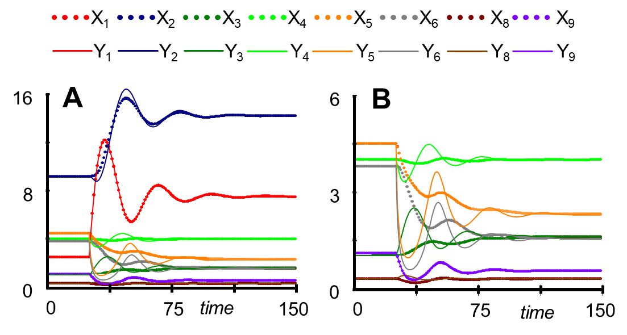
Fig. S9. Reduction of X₅ and X₆ causes slight changes in biomass dynamics and substantial alterations
of the trajectories of Y₃ – Y_{8.} A. All variables. B. Variables of smaller magnitude (indices 3 - 9).

If only biomass is of interest, X₃-X₉ can be reduced with relative accuracy (see Main Text). Reducing X₁₀ and X₁₁ as well eliminates overshoots and undershoots and speeds up the dynamics of all equations. In fact, the entire dynamics in this case is quite different (Fig S10).

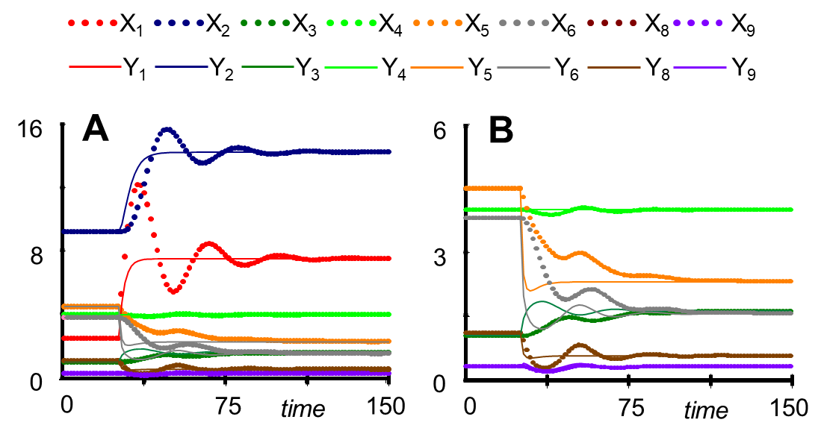
Fig. S10. Reduction of X₃ – X₁₁ leads to a dynamics that is very different from that of the original model.
A. All variables. B. Variables of smaller magnitude (indices 3 - 9).

Supplements Section S7: Competition Among Bacterial Populations
Davis and collaborators [10] analyzed data published by Piccardi et al. [11] with a four-variable Lotka-Volterra (LV) model. The data were experimentally obtained for four bacterial species coexisting in metal working fluids (see Main Text). This system is interesting because some components of these fluids are used as growth substrates, while some are toxic. The generic format of the model is
$${\dot{X}}_{i}=a_{i}X_{i}+ \sum_{j=1}^{4}{b_{ij}{X_{i}X}_{j}, i = 1, …, 4. (S48) }$$
The parameter values and initial conditions are presented in Table S2.
As explained in the Main Text, one of the species in Piccardi's experiment eventually disappeared, thereby creating a situation without non-trivial steady state (Table S2). However, changing just one growth rate (a₂) by 20%, the model achieves a stable steady state. In the Main Text, this implementation was used. The following contains comments on reductions of the original model of Davis [10].

Table S2. Parameter settings of a model of four competing bacterial species.
Variable | Species Name | Linear Term | Interaction Terms | Initial Value
X₁ | A. tumefaciens | a₁ = 0.0196 | b₁₁ = -1.82×10⁻¹⁰  b₁₂ = -5.51×10⁻¹²  b₁₃ = -2.51×10⁻¹¹  b₁₄ = 2.18×10⁻¹¹ | 1.0×10⁷
X₂ | C. testosteroni | Original:  a₂ = 0.0744  Steady-state model:  a₂ = 0.08928 | b₂₁ = -7.94×10⁻¹⁰  b₂₂ = -2.44×10⁻¹¹  b₂₃ = 1.79×10⁻¹¹  b₂₄ = 3.47×10⁻¹¹ | 0.8×10⁷
X₃ | M. saperdae | a₃ = 0.00542 | b₃₁ = 2.46×10⁻¹⁰  b₃₂ = -1.16×10⁻¹¹  b₃₃ = -3.54×10⁻¹⁰  b₃₄ = 7.28×10⁻¹¹ | 4.0×10⁷
X₄ | O. anthropi | a₄ = 0.0515 | b₄₁ = -4.88×10⁻¹¹  b₄₂ = 6.01×10⁻¹¹  b₄₃ = 6.22×10⁻¹¹  b₄₄ = -2.06×10⁻¹⁰ | 0.8×10⁷

At the beginning of the growth phase, the slopes of variables X₁, X₂, and X₄ are steep and thus quite distant from 0 (Fig. S11). This fact causes problems for most reductions. Attempting to reduce X₁ or X₂ yields unacceptable results (Fig. S12). In the latter case, even the initial conditions are far off and Y₂ precipitously crashes before the final time of the original simulation.
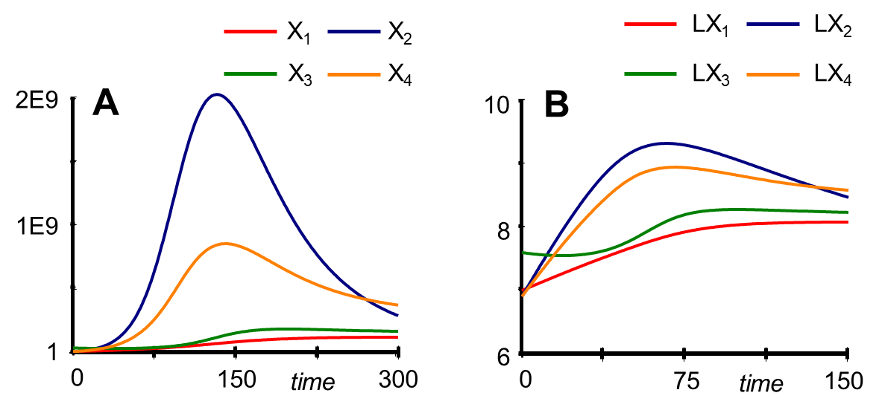
Fig. S11. Trajectories of all four species in Davis’ model [10].
A: Population abundances in Cartesian coordinates. B: Logarithms of abundances.

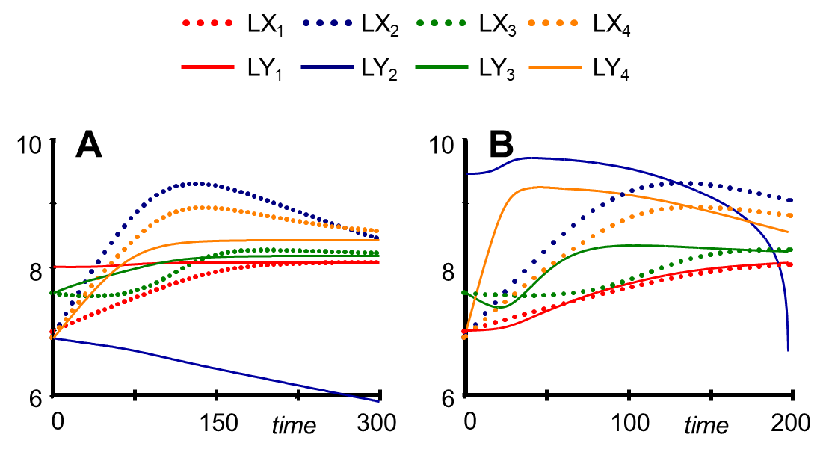
Fig. S12. Trajectories following reduction of X₁ (A) or X₂ (B) in logarithmic values.

Reduction of X₃ yields very different results, possibly because its slope at the beginning of the simulation is quite flat (Fig. S13A). Reduction of X₄ leads to trajectories that are acceptable for Y₁ and Y₂ although not for Y₃ and Y₄ (Fig. S13B). Reducing X₃ and X₄ simultaneously results in trajectories similar to Fig. S13B, with the trajectory of Y₃ further shifted up (not shown).
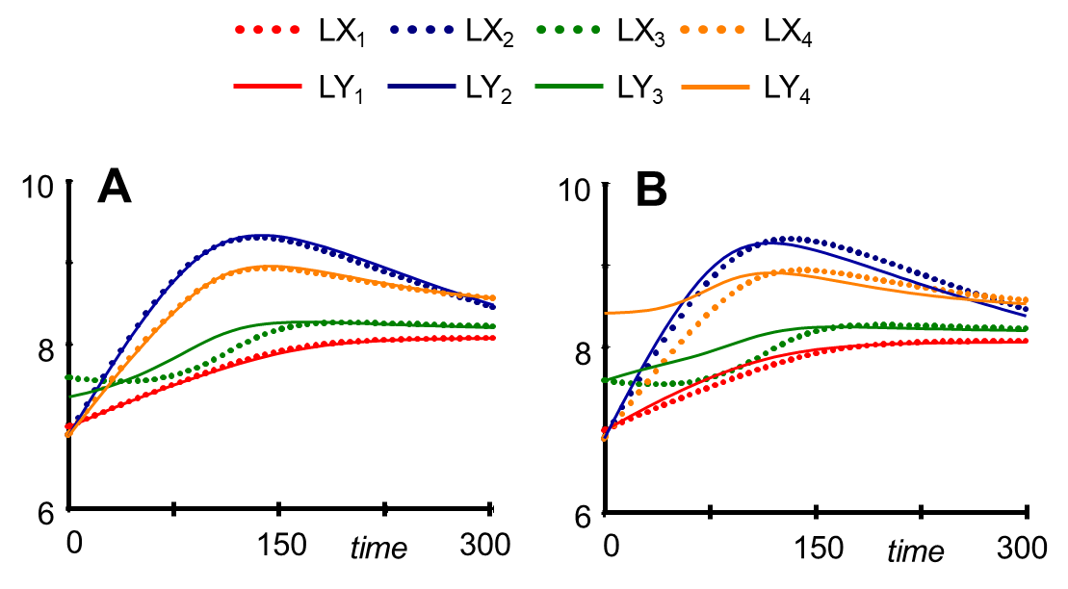
Fig. S13. Trajectories following reduction of X₃ (A) or X₄ (B) in logarithmic values.

After about 150 time units into the experiment, X₂ and X₄ are reaching their peaks, with slopes that are much closer to 0 than in the beginning of the experiment. If the simulation starts close to the high point of population abundance, with (X₁(t = 150), … X₄(t = 150)) = (8.415028×10⁷, 1.895268×10⁹, 1.55557×10⁸, 8.426012×10⁸), the reduction of X₁ is much improved, although still noticeably different from the original. A reduction of X₂ again fails, while reductions of X₃ and X₄ yield close to perfect results (Fig. S14). Taken together, X₂ cannot be reduced successfully, possibly identifying it as a key variable. However, caution is needed with this interpretation, as the system does not have a non-trivial steady state.
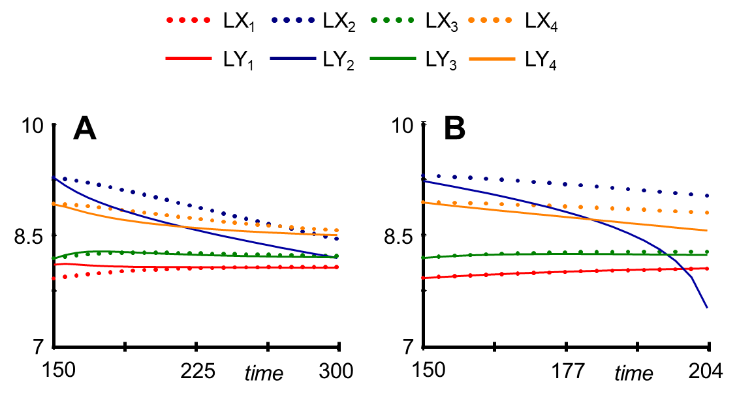
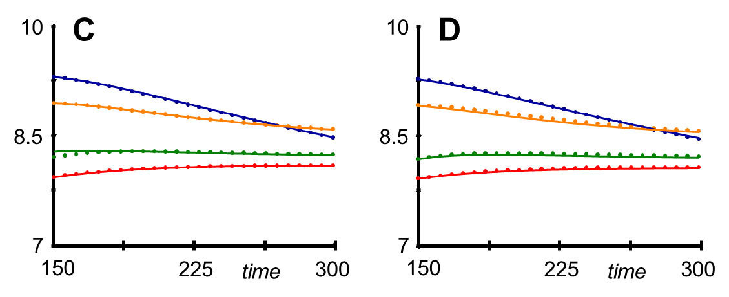
Fig. S14. Trajectories following reduction of X₁ (A), X₂ (B), X₃ (C), or X₄ (D),
when simulations are started at t = 150.

References
1. Curien, G., et al., Understanding the regulation of aspartate metabolism using a model based on measured kinetic parameters. Mol Syst Biol, 2009. 5: p. 271.
2. Iwata, M., F. Shiraishi, and E.O. Voit, Coarse but efficient identification of metabolic pathway systems. Int. J. Syst. Biol., 2013. 4(1): p. 57-72.
3. Hill, A.V., Possible effects of the aggregation of the molecules of haemoglobin on its dissociation curves. J. Physiol, 1910. 40: p. iv – viii.
4. Savageau, M.A. and E.O. Voit, Recasting nonlinear differential equations as S-systems: A canonical nonlinear form. Mathem Biosci, 1987. 87: p. 83-115.
5. Voit, E.O. and M.A. Savageau, Equivalence between S-Systems and Volterra Systems. Mathematical Biosciences, 1986. 78(1): p. 47-55.
6. Voit, E.O., Biochemical Systems Theory: A review. Int. Scholarly Res. Network (ISRN – Biomathematics), 2013. Article 897658: p. 1-53.
7. Goodwin, B.C., Oscillatory behavior in enzymatic control processes. Adv Enzyme Regul, 1965. 3: p. 425-38.
8. Gonze, D. and W. Abou-Jaoude, The Goodwin model: behind the Hill function. PLoS One, 2013. 8(8): p. e69573.
9. Hormiga, J.A., et al., Growth and ligninolytic system production dynamics of the Phanerochaete chrysosporium fungus: A modelling and optimization approach. Journal of Biotechnology, 2008. 137(1): p. 50-58.
10. Davis, J.D., et al., Methods of quantifying interactions among populations using Lotka-Volterra models. Front. Systems Biology, 2022. 2.
11. Piccardi, P., B. Vessman, and S. Mitri, Toxicity drives facilitation between 4 bacterial species. 2019. 116(32): p. 15979-15984.

