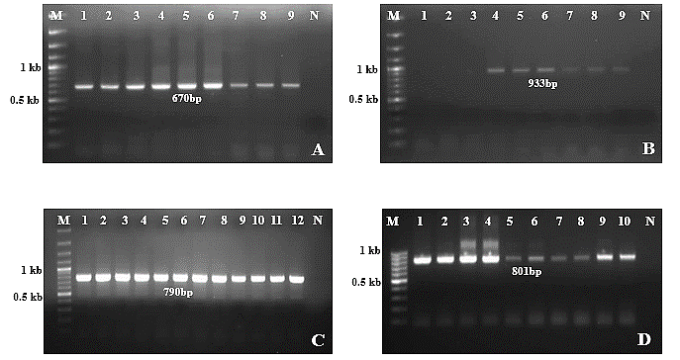
Figure 1. Agarose gel image showing amplification of the complete CP gene of two randomly selected isolates from multiplex PCR positive isolates (Each isolate is represented by half the number of bright bands); A: PLRV, B: PVS, C: PVX, D: PVY; M:100-3000bp marker; 1-12: Amplified positive samples; N: Negative control.

