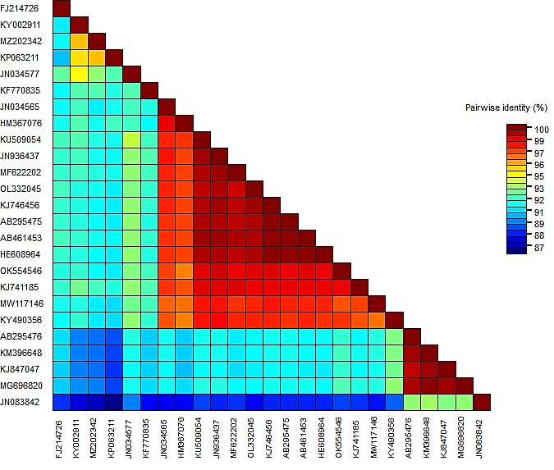
Supplementary Figure 1. Pairwise comparison of CP gene sequences of PVY isolates from this study (Bitlis 693 and Erzurum 391) and from various countries. Accession numbers OK554546 and OL332045 refer to Erzurum 391 and Bitlis 693 PVY isolates.

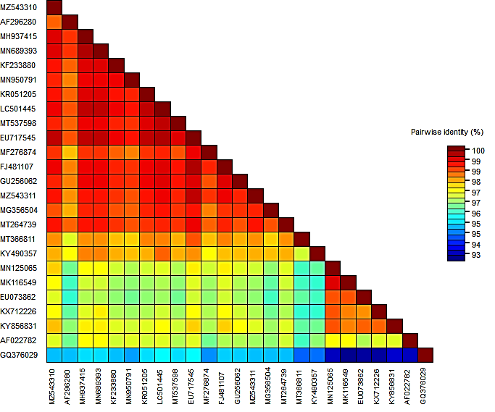
Supplementary Figure 2. Pairwise comparison of CP gene sequences of PLRV isolates from this study (Bitlis 534 and 581) and from various countries. Accession numbers MZ543310 and MZ543311 refer to Bitlis 581 and Bitlis 534 PLRV isolates.

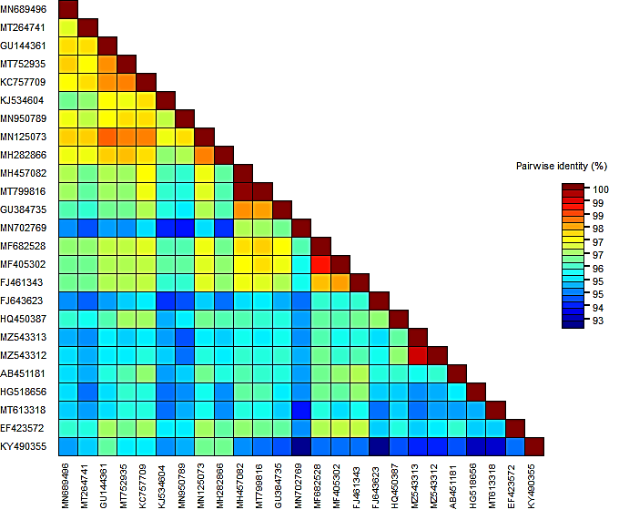
Supplementary Figure 3. Pairwise comparison of CP gene sequences of PVX isolates from this study (Erzurum 297 and Erzurum 291) and from various countries. Accession numbers MZ543312 and MZ543313 refer to Erzurum 291 and Erzurum 297 PVX isolates.

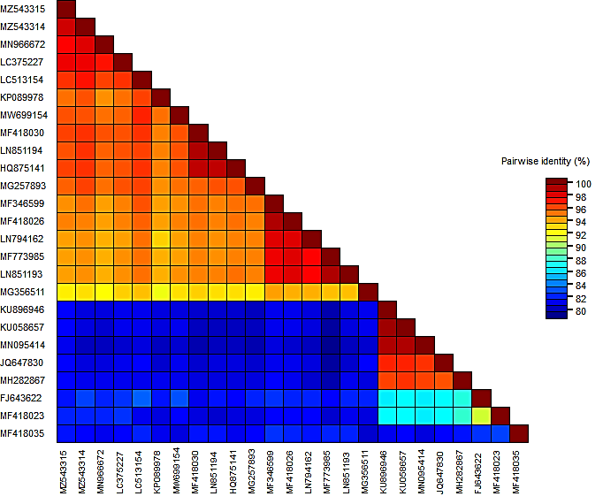
Supplementary Figure 4. Pairwise comparison of CP gene sequences of PVS isolates from this study (Bitlis 694 and Erzurum 388) and from various countries. Accession numbers MZ543314 and MZ543315 refer to PVS isolates from Erzurum 388 and Bitlis 694.

