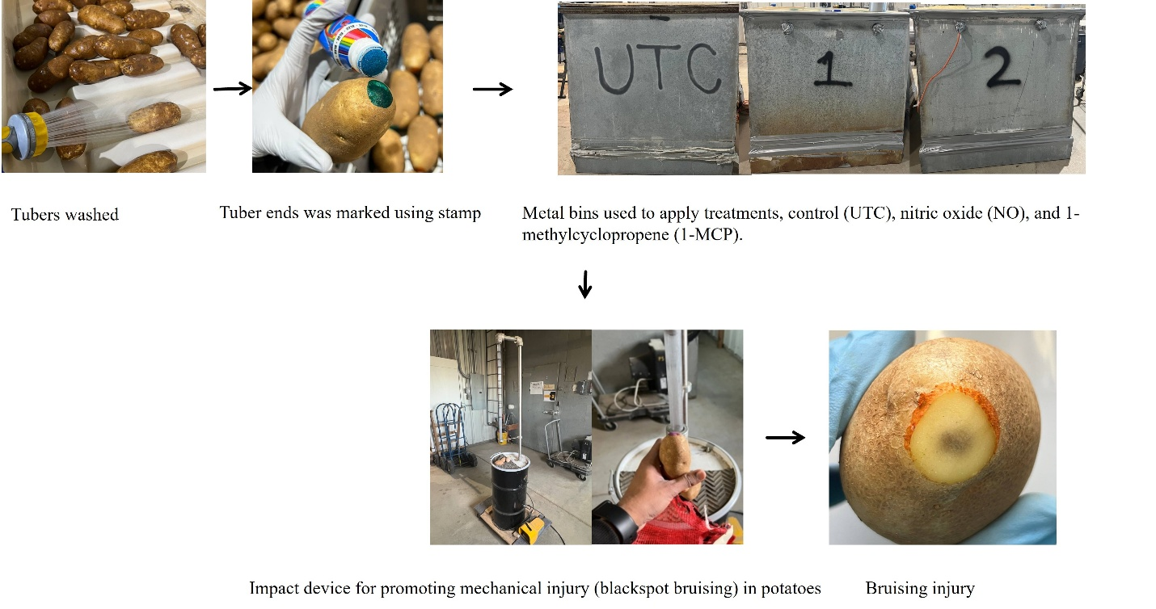
Fig. 1S. Methodology for inducing blackspot bruise in russet-type potatoes.

