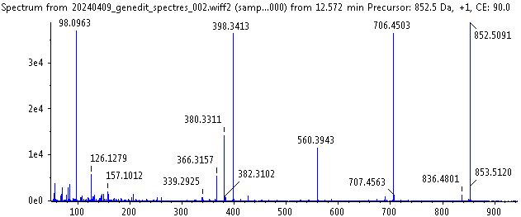 (1)
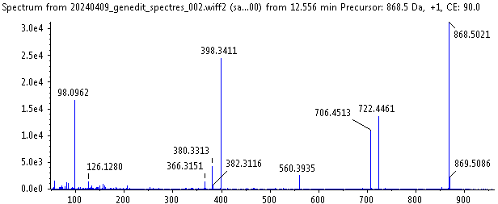 (2)
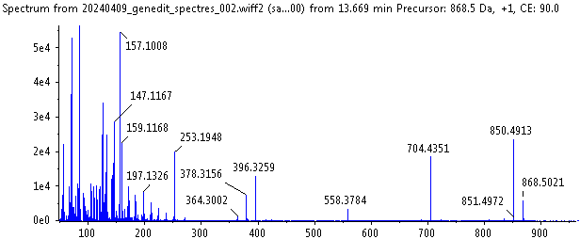(3a)
(3b)
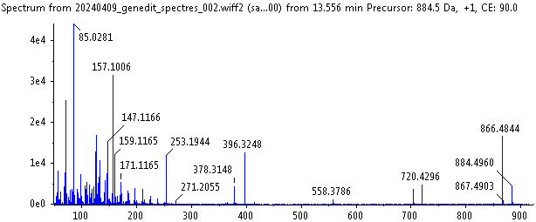(4a)
(4b)
(5a)
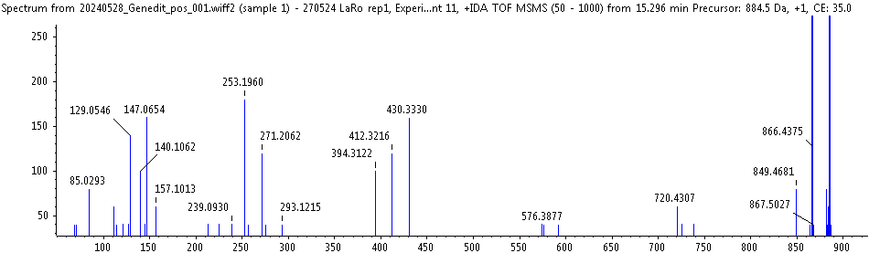(5b)
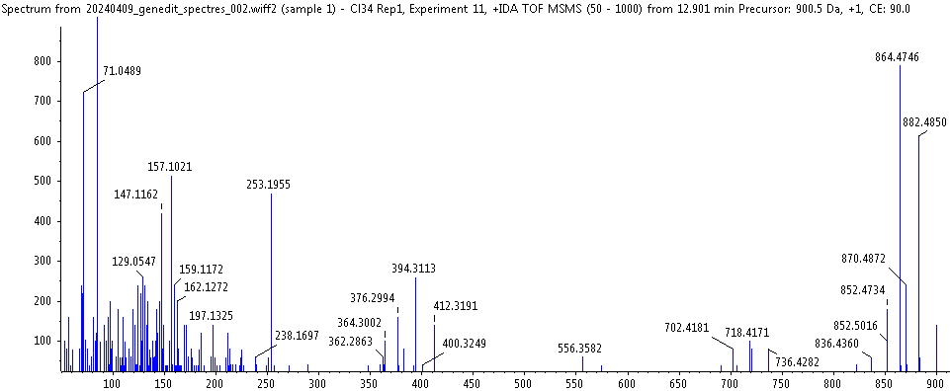(6)
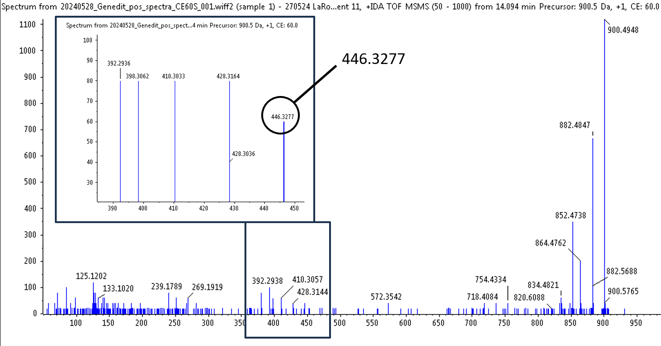 (7)
Figure S1 Major steroidal glycoalkaloid (SGAs) fragmentation spectrum with 90 v collision energy (CE),
(1) α-chaconine (m/z 852>706> 560> 398),
(2) solanine (m/z 868>722, 706>560>398),
(3a) ((3b) CE=60) solamargine (m/z 868>704* (722)>558* (576)> 396* (414),
(4a) ((4b) CE=60) solasonine (m/z 884>704* (722),720*(738)>558*(576)>396* (414),
(5a) ((5b) CE=35) solaverine I (m/z 884>704* (722)>558* (576)>394, 412* (430),
(6) solaverine II (m/z 900>736* (754)>556* (592)>394, 412* (430),
(7) with CE=35 solaverine III (m/z 900>754>572*(608)>392, 410, 428* (446),
* water loss (-18 Da).

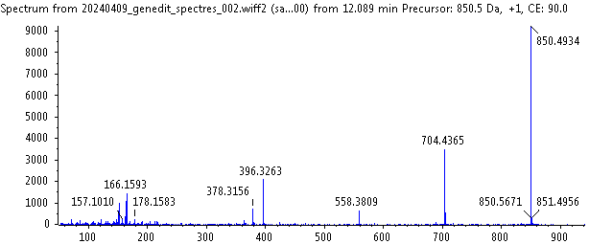 (1)
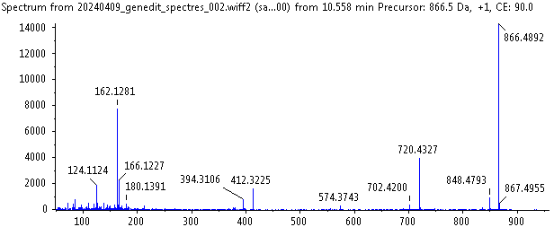 (2)
(3)
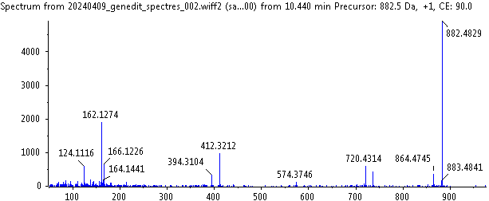 (4)
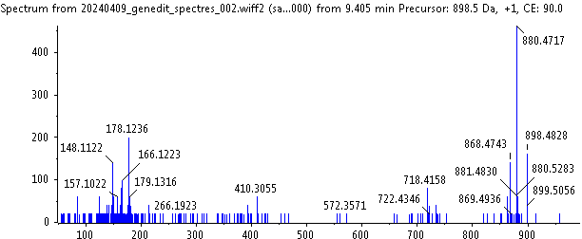 (5)
Figure S2 Low-abundance steroidal glycoalkaloid fragmentation spectrum with 90 v collision energy,
(1) m/z 850>704> 558> 396 (E1, E2, E3),
(2) m/z 866>720>574>412 (F1, F2),
(3) m/z 866>720, 704>558>396 (F3, F4) (specific ion 704 (Y-shaped trisaccharide with 2 hexoses)),
(4) m/z 882>736, 720>574>412 (G2, G3) (specific ion 720 (Y-shaped trisaccharide with 2 hexoses)),
(5) m/z 898>736>572*(590)>410*(428) (H1), * water loss.

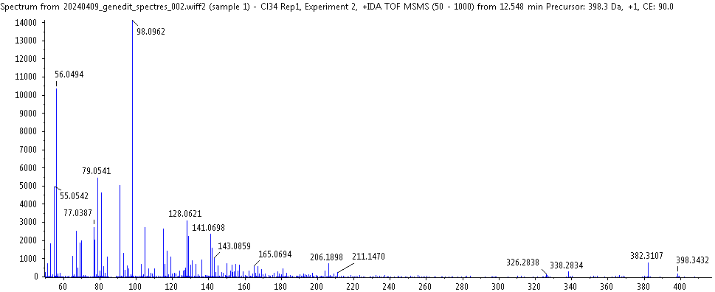 (1)
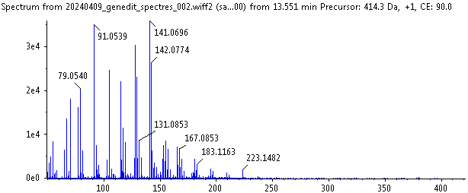 (2)
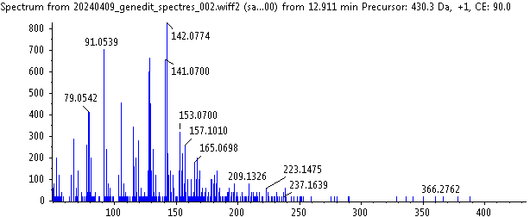 (3)
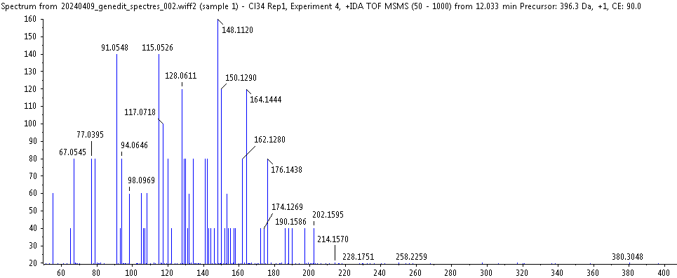 (4)
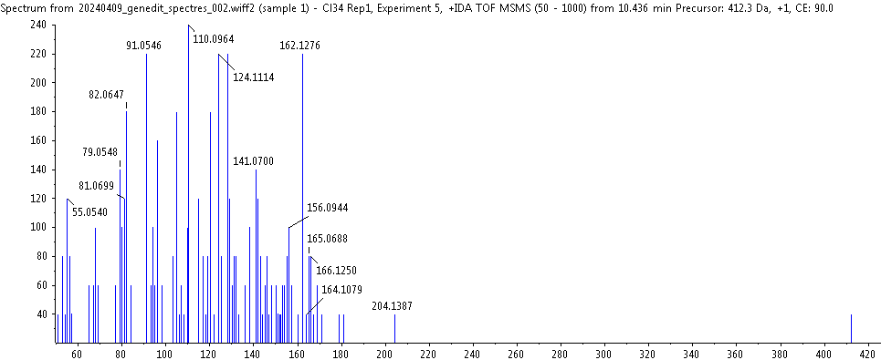 (5)
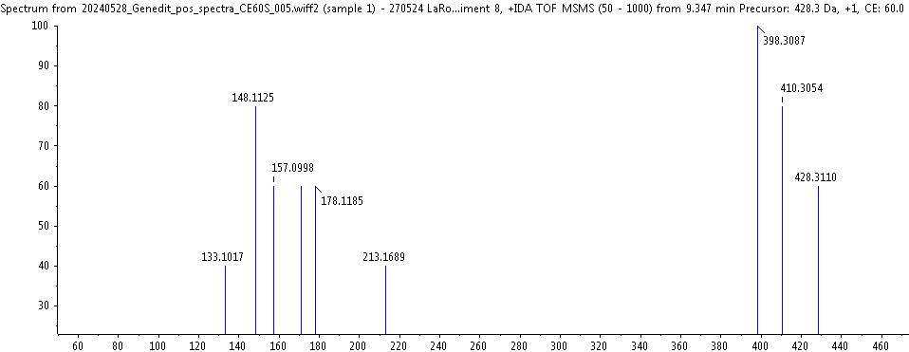 (6)
Figure S3 Alkaloids precursor of SGAs fragmentation spectrum with 90 v collision energy (CE)
(1) solanidine m/z 398 (I),  (3) solaverol A (III),  (5) m/z 412 (VI), | (2) solasodine m/z 414 (II),  (4) m/z 396 (V),  (6) m/z 428 (CE=60 v)

Figure S4 Relative signal contribution of total tri-glycoalkaloids (major SGAs and low-abundance) for the 3 varieties of Solanum tuberosum, Lady Rosetta, Charlotte and Bintje.

Table S1a Relative signal contribution (%) of each measured compound involved in major SAGs biosynthesis pathway for the 3 varieties of Solanum tuberosum, Lady Rosetta, Charlotte and Bintje. *Multiple Reaction Monitoring (MRM), with m/z parent ion triglyco-alkaloid and daughter ion of corresponding precursor alkaloid.
Table S1b Relative signal contribution (%) of precursor alkaloids involved in major SAGs biosynthesis pathway according to varieties of Solanum tuberosum, Lady Rosetta, Charlotte and Bintje.
Table S2a Relative signal contribution (%) of each measured compound involved in low abundance SAGs biosynthesis pathway for the 3 varieties of Solanum tuberosum, Lady Rosetta, Charlotte and Bintje. *Multiple Reaction Monitoring (MRM), with m/z parent ion triglyco-alkaloid and daughter ion of corresponding precursor alkaloid.

Table S2b Relative signal contribution (%) of precursor alkaloids involved in low abundance SAGs biosynthesis pathway according to varieties of Solanum tuberosum, Lady Rosetta, Charlotte and Bintje.

Figure S5
Alkaloids precursor solanidine C₂₇H₄₃NO (m/z 398) and SGAs corresponding are indicated in black, solasodine C₂₇H₄₃NO₂ (m/z 414) in red, solaverol A C₂₇H₄₃NO₃ (m/z 430) in bleu (Fig. 4) solaverol B in C₂₇H₄₃NO₄ (m/z 446) grey, solanid-16-en-3-one C₂₇H₄₁NO (m/z 396) in drak green and C₂₇H₄₁NO₂ (m/z 414) in light green. When for a compound analyzed many isomeric forms exist the compound ID (Table 3) is noticed in brackets. The developed formulas are extracted from Chemspider and Pubchem.

Alkaloids precursors of major SGAs
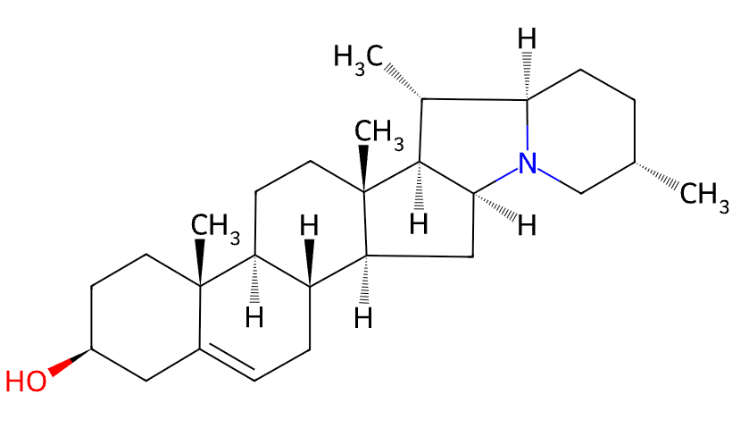  I solanidine C₂₇H₄₃NO (m/z 398) | 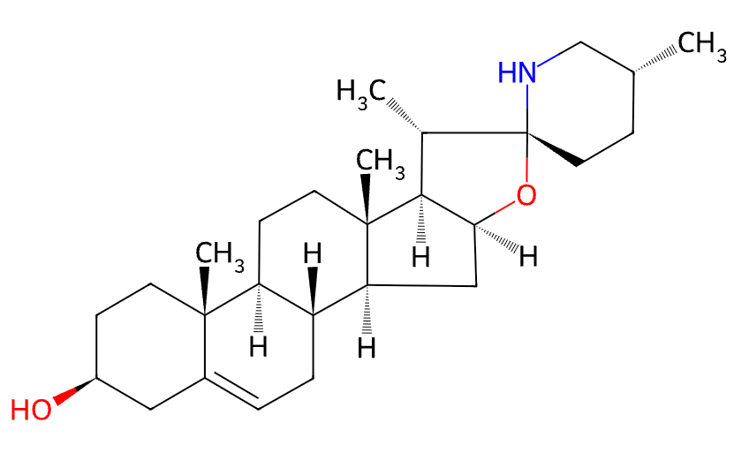  II (a) solasodine C₂₇H₄₃NO₂ (m/z 414)
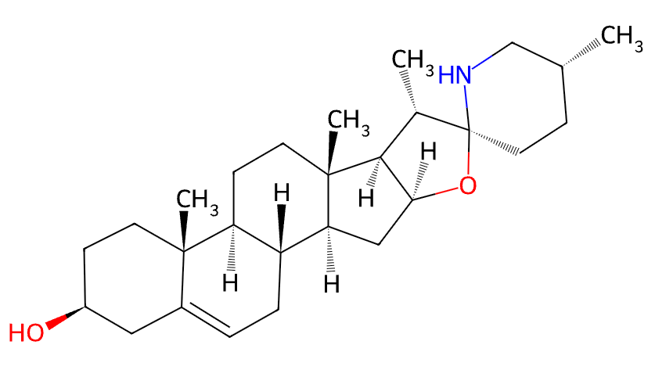 II (b) (3β,25R)-Spirosol-5-en-3-ol,  (solasodine isomer) C₂₇H₄₃NO₂ (m/z 414) | 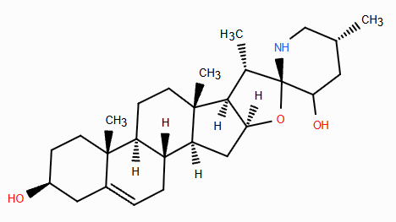  III solaverol A C₂₇H₄₃NO₃ (m/z 430)
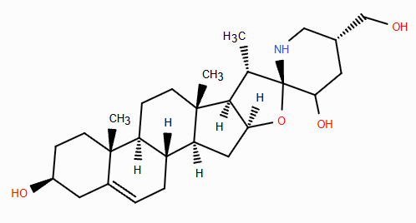
IV solaverol B C₂₇H₄₃NO₄ (m/z 446)

Alkaloids precursors of low abundance SGAs
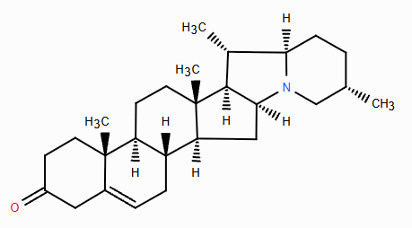 V solanid-16-en-3-one C₂₇H₄₁NO (m/z 396) |  | 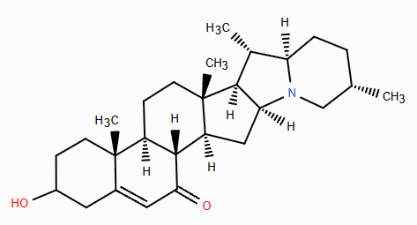VI C₂₇H₄₁NO₂ (m/z 412)
SGAs from major biosynthesis pathways
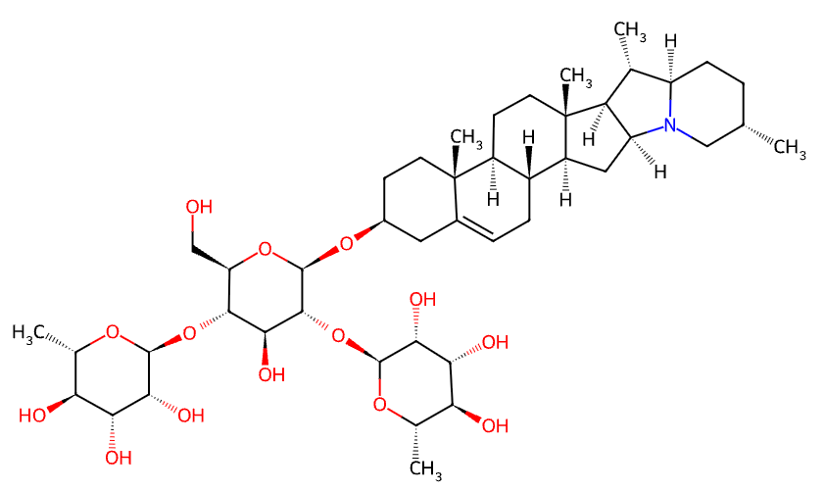  A α-chaconine C₄₅H₇₃NO₁₄ (m/z 852) | 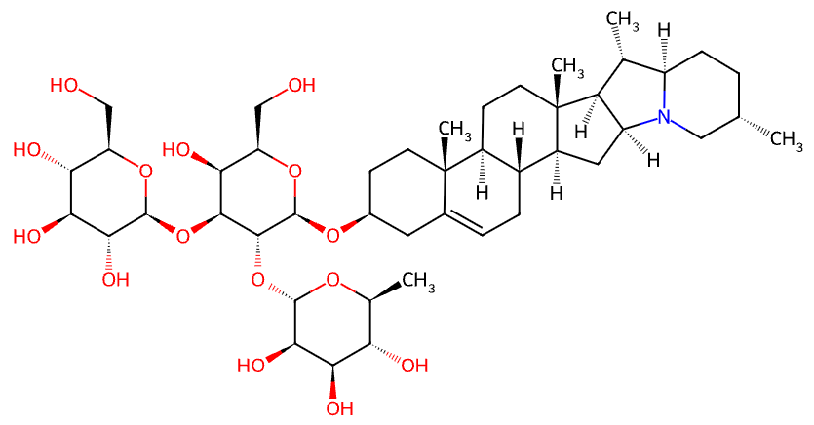  B4 solanine C₄₅H₇₃NO₁₅ (m/z 868)
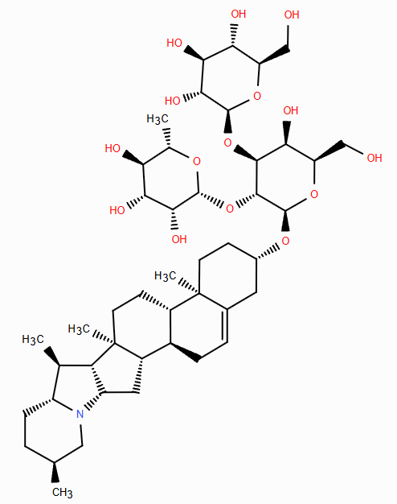  B5 α-solanine C₄₅H₇₃NO₁₅ (m/z 868) | 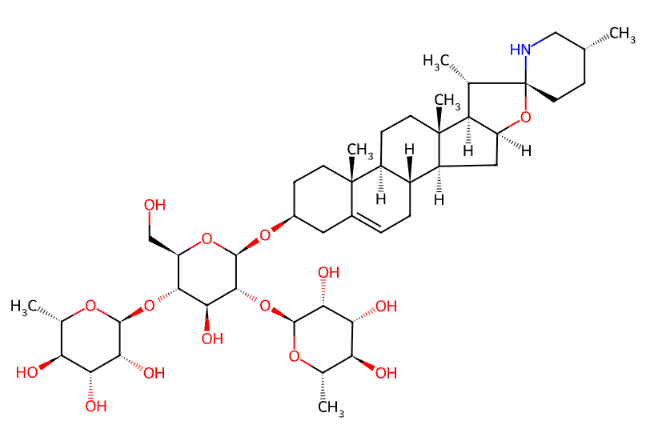  B7 (B6) α-solamargine C₄₅H₇₃NO₁₅ (m/z 868)
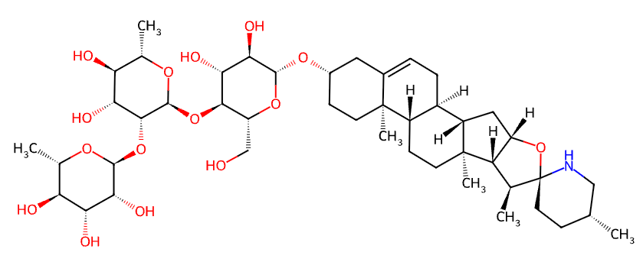  B1 (B2, B3) solamargine C₄₅H₇₃NO₁₅ (m/z 868) | 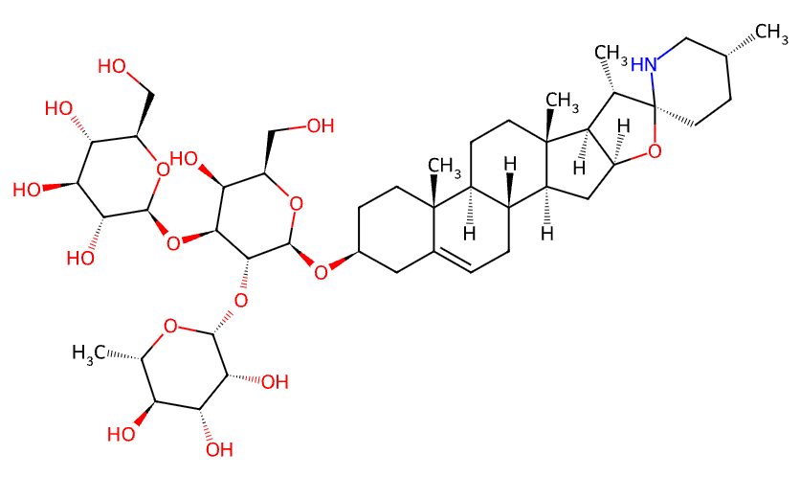  (C6, C5) solasonine C₄₅H₇₃NO₁₆ (m/z 884)
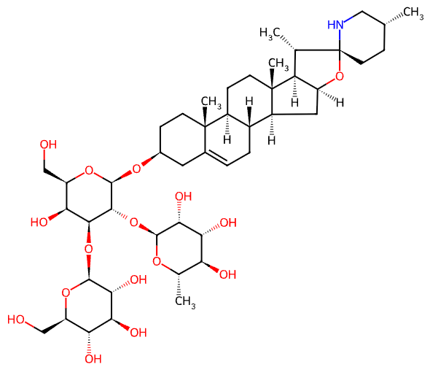(C5, C6) solasonine C₄₅H₇₃NO₁₆ (m/z 884) | 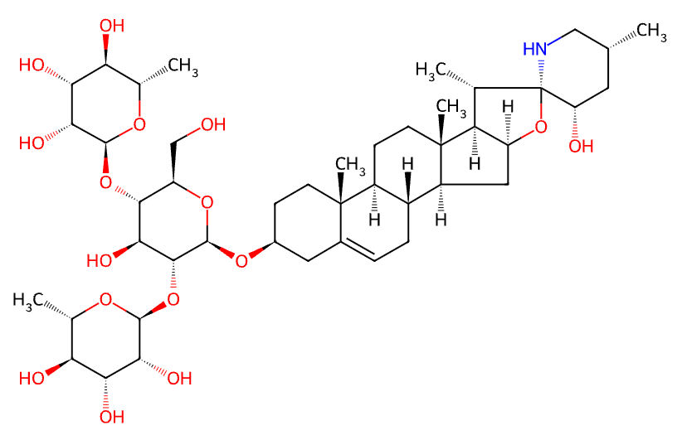  C7 (C4) solaverine I C₄₅H₇₃NO₁₆ (m/z 884)
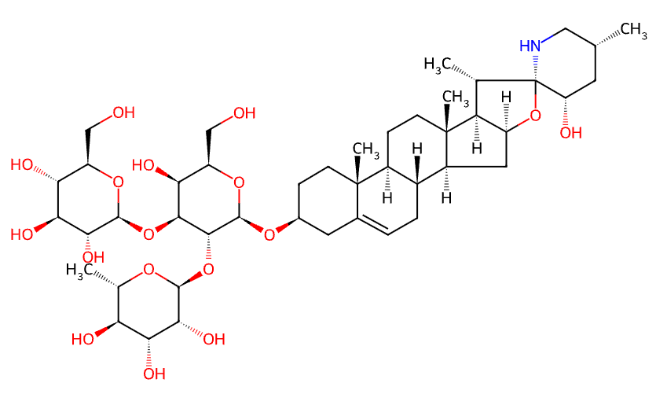  (D3, D5) solaverine II C₄₅H₇₃NO₁₇ (m/z 900) | 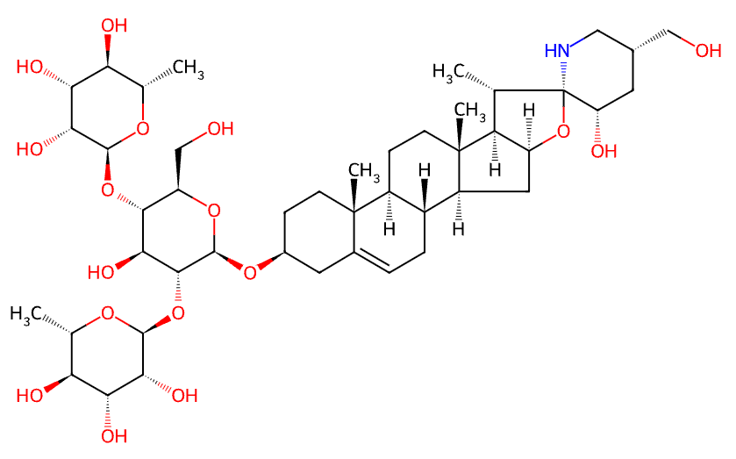  D4 solaverine III C₄₅H₇₃NO₁₇ (m/z 900)

SGAs from low abundance biosynthesis pathways
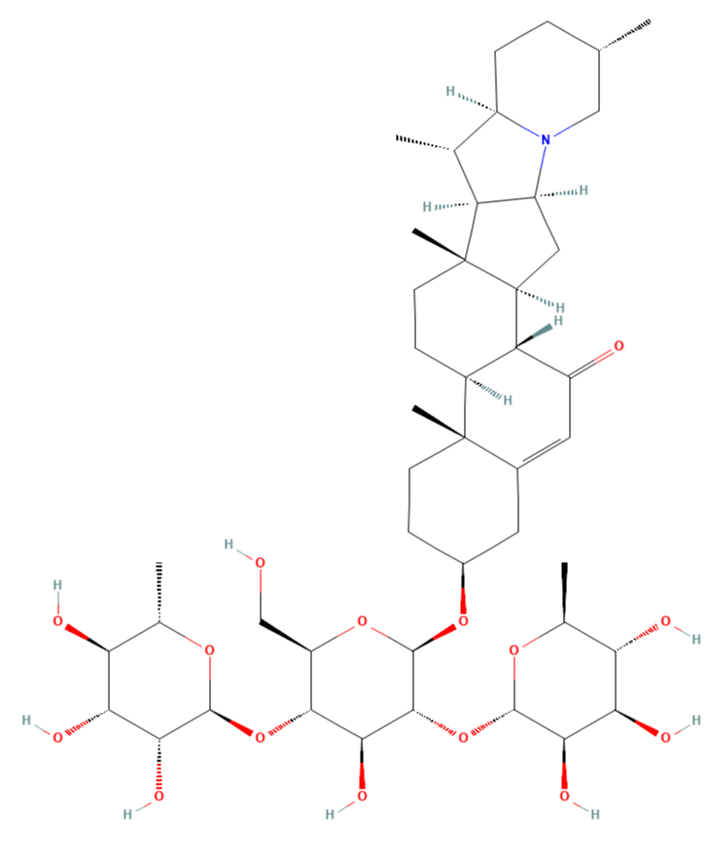  F5 C₄₅H₇₁NO₁₄ (m/z 866) | 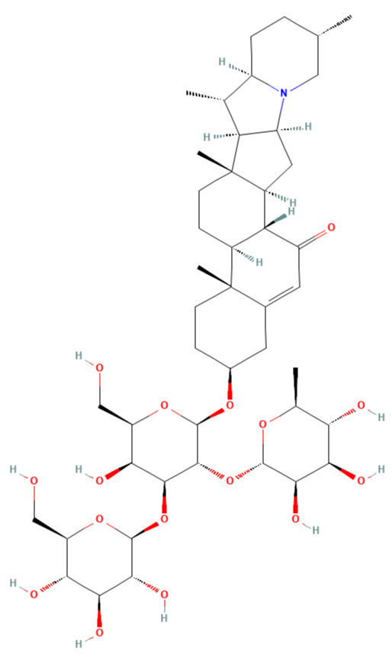  (G2, G3) C₄₅H₇₁NO₁₅ (m/z 882)

Figure S6
Dataset publicly available through XCMS Cloud. Figure generated using the XCMS Cloud platform.
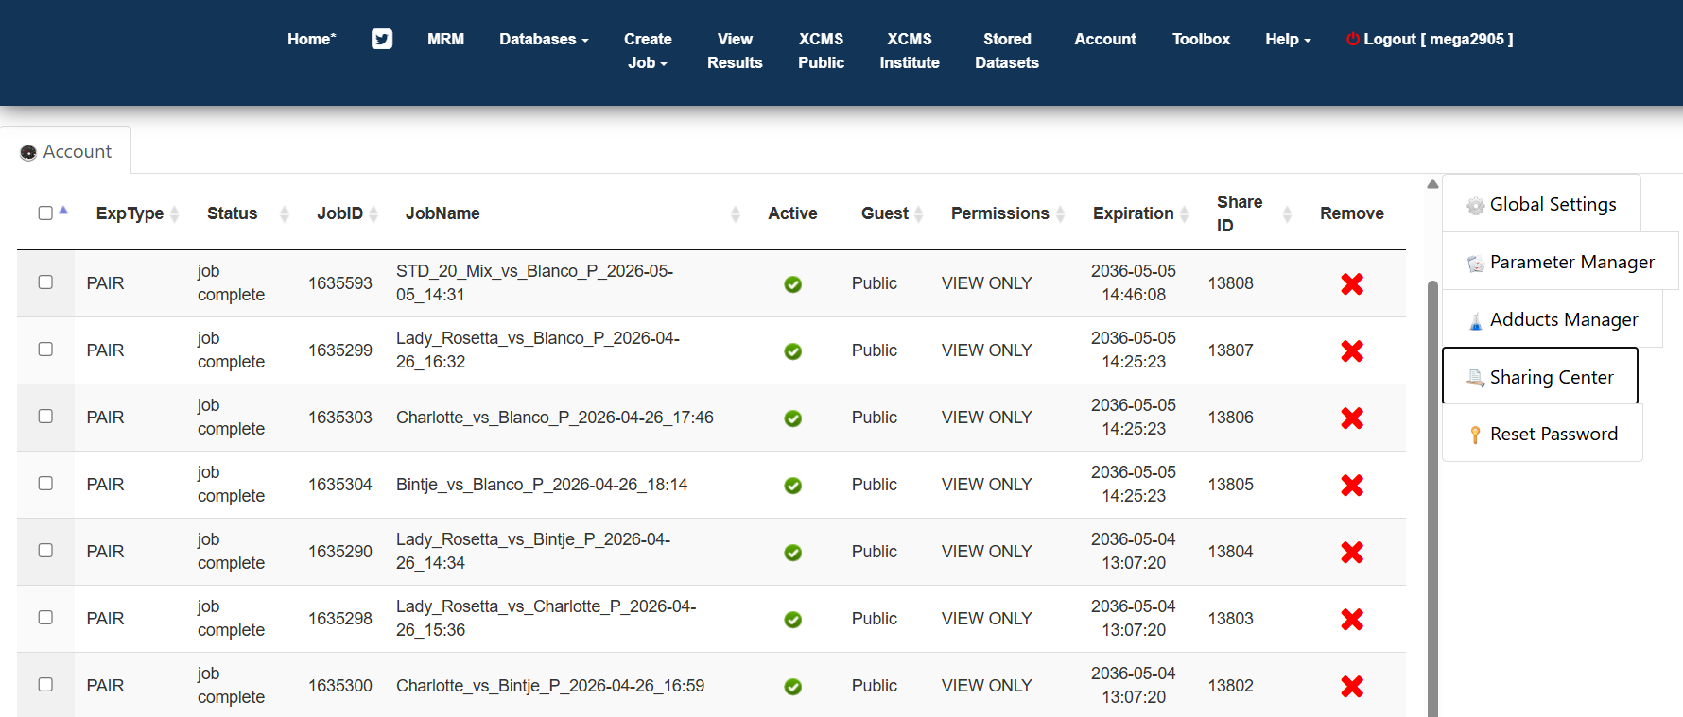

Figure S7
Comparison of Solanum tuberosum var. Lady Rosetta and Bintje leaf extracts. Compounds with a fold change >10 and a p-value <0.002 in Lady Rosetta are consistent with in-source fragmentation and highlight several SGAs in the metabolomic cloud plot visualization. Figure generated using the XCMS Cloud platform.
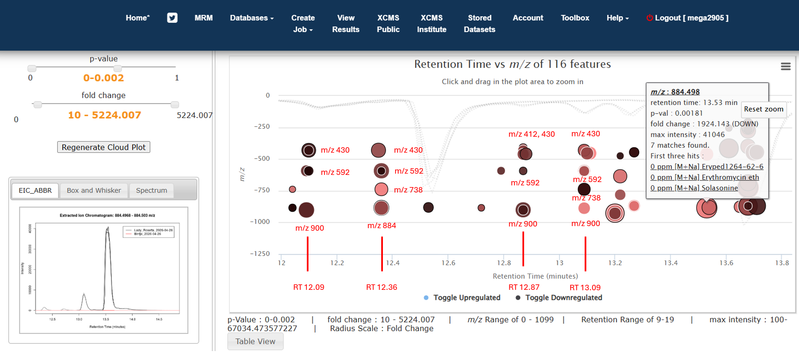

Figure S8
The Excel results table provides access to the complete dataset comparing Solanum tuberosum var. Lady Rosetta and Bintje leaf extracts. The screenshot shown here illustrates the dataset sorted by m/z, highlighting the structural diversity of SGAs detected at m/z 884, as reflected by their distinct retention times (RTs). Figure generated using the XCMS Cloud platform.
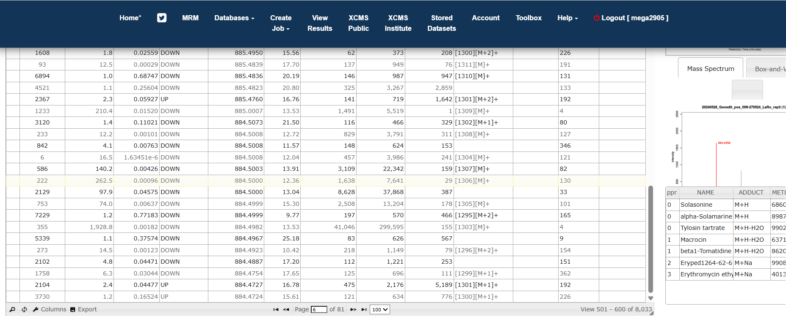

Figure S9
Representative chromatograms of Solanum tuberosum var. Lady Rosetta and Bintje leaf extracts before (original) and after (corrected) retention time alignment (see publicly available XCMS data). Figure generated using the XCMS Cloud platform.
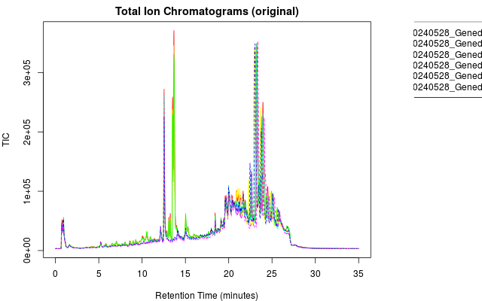
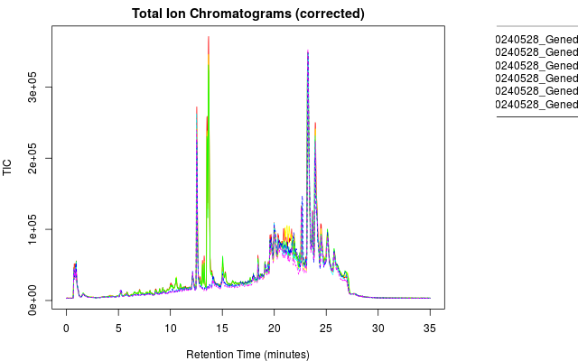

Figure S10
Retention time (RT) deviations between Solanum tuberosum var. Lady Rosetta and Bintje leaf extracts (9.4–15.3 min; mean deviation: 0.025 min). Deviations are reported relative to OBIwarp alignment (first sample, black line) and peak groups (median feature RT across samples). Figure generated using the XCMS Cloud platform.
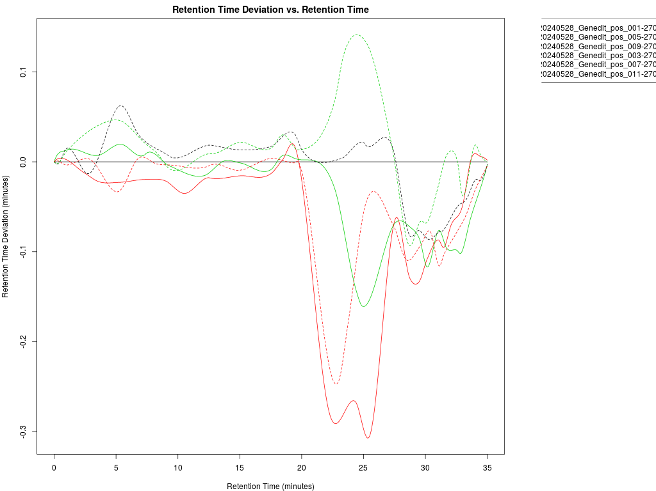

Figure S11
Calibration curves generated using analytical standards of α-solanine (CAS 20562-02-1) (c), α-chaconine (CAS 20562-03-2) (a), and α-solamargine (CAS 20311-51-7) (b) at concentrations of 20, 2, and 0.2 ng/mL. The corresponding chromatograms are provided in the accompanying .docx file (d)

(d)

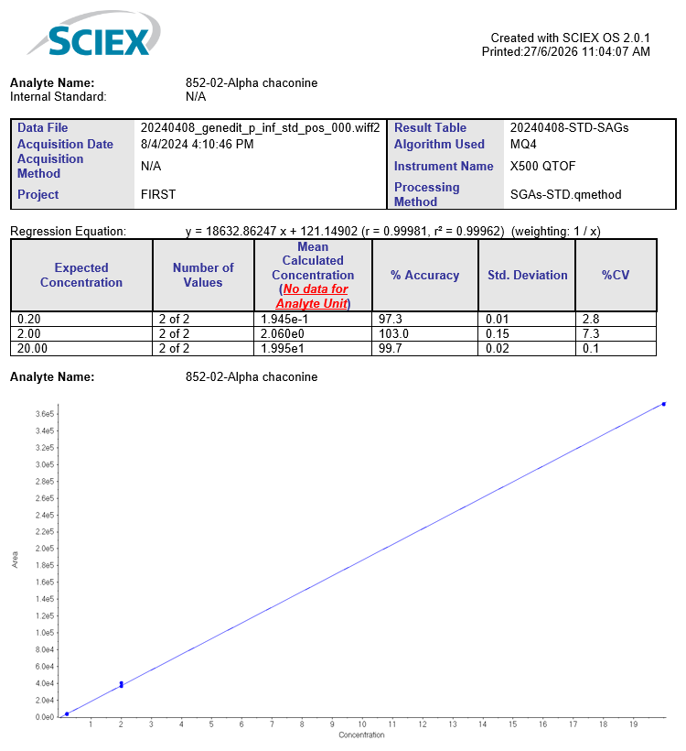 (a)

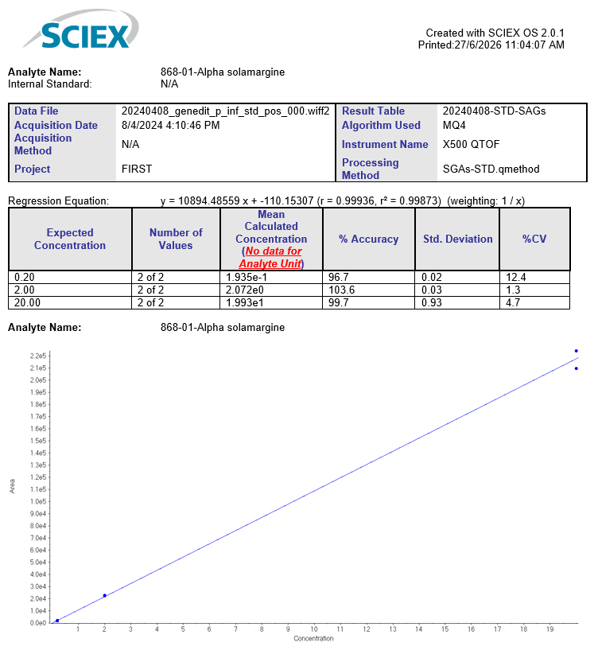 (b)

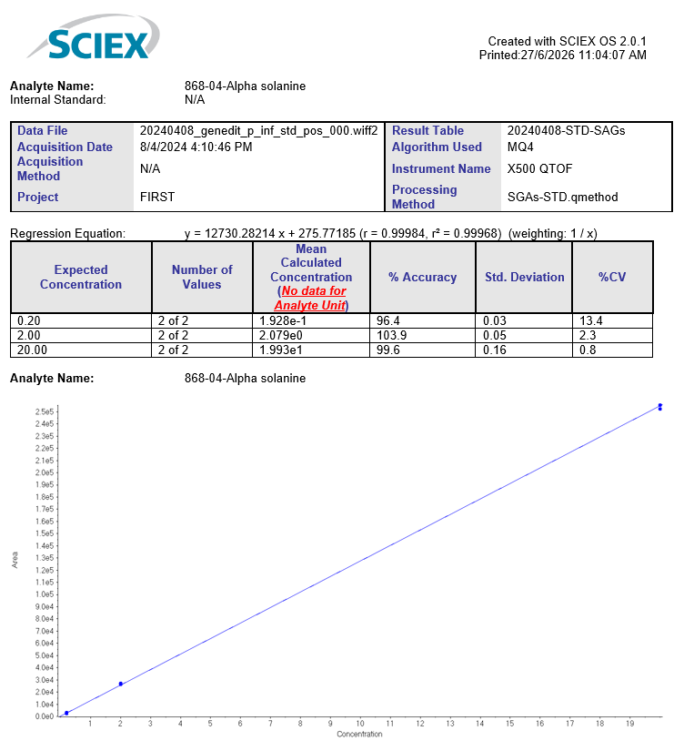 (c)

Figure S12
Excel (.xls) file containing targeted integration results for intact SGAs and the corresponding alkaloid precursors generated by the in-source loss of three sugar residues.

Figure S13
List of steroidal glycoalkaloids (SGAs) and their corresponding alkaloid precursors used in the targeted integration workflow for data processing and signal intensity quantification.

Figure S14 (Table 1) For each retention time (RT), the m/z values of compounds involved in the major SGA proposed biosynthetic model inferred from LC-MS/MS data detected in leaf extracts of Solanum tuberosum var. Lady Rosetta are reported, together with their fragmentation patterns. The presence of specific ions sharing the same RT and/or occurring within the same mass spectrum is indicated by a cross in the corresponding column. Only compounds yielding informative spectra with sufficient signal intensity were included in this table. In certain cases, compound identities were confirmed by comparison with analytical standards injected in solvent, showing identical retention times and mass spectra. Specifically, row A in the ID column corresponds to α-chaconine (m/z 852), row B4 to α-solanine (m/z 868), and row B7 to α-solamargine (m/z 868) confirmed at MSI level 1 using analytical standards.
(*) Fragment ions were considered after subtraction of 18 Da, corresponding to neutral loss of water.
“???” indicates entries for which information was not available or was uncertain.

Figure S15 (Table 2) For each retention time (RT), the m/z values of compounds involved in low abundance SGA proposed biosynthetic model inferred from LC-MS/MS data (not clearly identified) detected in leaf extracts of Solanum tuberosum var. Lady Rosetta are reported, together with their fragmentation patterns. The presence of ions sharing the same RT and/or occurring within the same mass spectrum is indicated by a cross in the corresponding column.
(*) Fragment ions were considered after subtraction of 18 Da, corresponding to neutral loss of water.
“???” indicates entries for which information was not available or was uncertain.

Figure S16 (Table 3)
List of compounds compatible with biosynthesis pathways of SGAs in Solanum tuberosum with in first column the ID corresponding to SGAs fragmentation spectrum and the alkaloids known (I to IV) like precursor in major proposed biosynthetic model inferred from LC-MS/MS data of SGAs and compounds potentially involved in low abundance proposed biosynthetic model inferred from LC-MS/MS data of SGAs (not identified). The isomeric forms are listed in parentheses in the ID column.
 |  | Alkaloids
ID | Source | ID source | Monoisotopic mass | Average mass | Formula | ACD/IUPAC Name | Link
I | ChemSpider | 59150 | 397.3345 | 397.636 | C27H43NO | Solanidine | http://www.chemspider.com/Chemical-Structure.59150.html
II (a) | ChemSpider | 391288 | 413.3294 | 413.636 | C27H43NO2 | Solasodine | http://www.chemspider.com/Chemical-Structure.391288.html
II (b) | ChemSpider | 24534156 | 413.3294 | 413.636 | C27H43NO2 | Solasodine | http://www.chemspider.com/Chemical-Structure.24534156.html
III | ChemSpider | 9114143 | 429.3243 | 429.635 | C27H43NO3 | Solaverol A | http://www.chemspider.com/Chemical-Structure.9114143.html
IV | Pubchem | 274035867 | - | 445.635 | C27H43NO4 | Solaverol B | https://pubchem.ncbi.nlm.nih.gov/substance/274035867
V | ChemSpider | 473852 | 395.318817 | 395.621 | C27H41NO | Solanid-16-en-3-one | https://www.chemspider.com/Chemical-Structure.473852.html
 |  | SGAs
ID | Source | ID source | Monoisotopic mass | Average mass | Formula | ACD/IUPAC Name | Link
A | ChemSpider | 391274 | 851.5031 | 852.059 | C45H73NO14 | α-chaconine | http://www.chemspider.com/Chemical-Structure.391274.html
B5 (B4) | ChemSpider | 7828094 | 867.4980 | 868.059 | C45H73NO15 | Solanine | http://www.chemspider.com/Chemical-Structure.7828094.html
B4 (B5) | ChemSpider | 28033 | 867.4980 | 868.059 | C45H73NO15 | α-Solanine | http://www.chemspider.com/Chemical-Structure.28033.html
B7 (B6) | ChemSpider | 66278 | 867.4980 | 868.059 | C45H73NO15 | α-Solamargine | http://www.chemspider.com/Chemical-Structure.66278.html
B1 (B2,B3) | ChemSpider | 52563678 | 867.4980 | 868.059 | C45H73NO15 | Solamargine | http://www.chemspider.com/Chemical-Structure.52563678.html
C6 (C5) | ChemSpider | 21468793 | 883.4929 | 884.058 | C45H73NO16 | Solasonine | http://www.chemspider.com/Chemical-Structure.21468793.html
C5 (C6) | ChemSpider | 106525 | 883.4929 | 884.058 | C45H73NO16 | Solasonine | https://www.chemspider.com/Chemical-Structure.106525.html
C7 (C4) | ChemSpider | 10270709 | 883.4929 | 884.058 | C45H73NO16 | Solaverine I | https://www.chemspider.com/Chemical-Structure.10270709.html
D3, D5 (D1,D2) | ChemSpider | 10270710 | 899.4879 | 900.058 | C45H73NO17 | Solaverine II | https://www.chemspider.com/Chemical-Structure.10270710.html
D4 | ChemSpider | 10270711 | 899.4879 | 900.058 | C45H73NO17 | Solaverine III | https://www.chemspider.com/Chemical-Structure.10270711.html
F5 | Pubchem | 71725993 | 865.4824 | 866.0 | C45H71NO15 | - | https://pubchem.ncbi.nlm.nih.gov/compound/71725993
G2 | Pubchem | 162997758 | 881.4773 | 882.0 | C45H71NO16 | - | https://pubchem.ncbi.nlm.nih.gov/compound/162997758
G3 | Pubchem | 162997759 | 881.4773 | 882.0 | C45H71NO16 | - | https://pubchem.ncbi.nlm.nih.gov/compound/162997759

