Supplementary Material

Table SI
Exercise Time Overview for Proband 1 with 2D-Endoscope
Session Number | Attempt Number |  | Exercise Number
 |  | 1 | 2 | 3
1 | 1 | 01:10 | 01:00 | 01:30
1 | 2 | 01:00 | 01:30 | 01:30
1 | 3 | 01:30 | 01:30 | 00:55
2 | 4 | 01:10 | 01:30 | 00:56
2 | 5 | 00:47 | 01:30 | 00:56
2 | 6 | 01:13 | 01:30 | 01:02
3 | 7 | 01:30 | 00:59 | 01:12
3 | 8 | 00:59 | 01:30 | 01:17
3 | 9 | 01:09 | 00:40 | 00:49

Table SII
Exercise Time Overview for Proband 2 with 2D-Endoscope
Session Number | Attempt Number |  | Exercise Number
 |  | 1 | 2 | 3
1 | 1 | 01:30 | 00:27 | 01:28
1 | 2 | 01:30 | 01:30 | 01:13
1 | 3 | 01:30 | 01:30 | 01:30
2 | 4 | 01:30 | 01:26 | 01:30
2 | 5 | 01:30 | 00:36 | 01:03
2 | 6 | 01:30 | 01:28 | 01:04
3 | 7 | 01:28 | 01:30 | 00:50
3 | 8 | 01:30 | 00:41 | 01:09
3 | 9 | 01:20 | 01:30 | 00:59

Table SIII
Exercise Time Overview for Proband 3 with 2D-Endoscope
Session Number | Attempt Number |  | Exercise Number
 |  | 1 | 2 | 3
1 | 1 | 01:18 | 01:30 | 01:30
1 | 2 | 01:30 | 01:30 | 01:30
1 | 3 | 01:30 | 00:50 | 01:17
2 | 4 | 01:17 | 01:30 | 01:30
2 | 5 | 01:05 | 00:53 | 01:30
2 | 6 | 01:00 | 01:30 | 01:17
3 | 7 | 01:01 | 00:49 | 01:30
3 | 8 | 00:36 | 01:30 | 00:59
3 | 9 | 00:57 | 01:30 | 00:55

Table SIV
Exercise Time Overview for Proband 4 with 2D-Endoscope
Session Number | Attempt Number |  | Exercise Number
 |  | 1 | 2 | 3
1 | 1 | 00:50 | 01:30 | 01:30
1 | 2 | 01:30 | 01:30 | 01:30
1 | 3 | 01:30 | 01:30 | 01:30
2 | 4 | 01:30 | 01:30 | 01:12
2 | 5 | 01:30 | 01:18 | 00:56
2 | 6 | 01:30 | 01:30 | 01:26
3 | 7 | 01:14 | 00:40 | 01:30
3 | 8 | 01:02 | 01:30 | 01:10
3 | 9 | 01:09 | 00:41 | 01:09

Table SV
Exercise Time Overview for Proband 5 with 2D-Endoscope
Session Number | Attempt Number |  | Exercise Number
 |  | 1 | 2 | 3
1 | 1 | 01:30 | 01:30 | 00:55
1 | 2 | 01:23 | 01:30 | 00:30
1 | 3 | 01:03 | 01:15 | 00:36
2 | 4 | 00:57 | 01:27 | 00:37
2 | 5 | 00:58 | 00:59 | 00:33
2 | 6 | 00:57 | 00:43 | 00:54
3 | 7 | 01:23 | 00:39 | 00:27
3 | 8 | 01:12 | 00:46 | 00:27
3 | 9 | 00:55 | 01:10 | 00:32

Table SVI
Exercise Time Overview for Proband 6 with 2D-Endoscope
Session Number | Attempt Number |  | Exercise Number
 |  | 1 | 2 | 3
1 | 1 | 00:47 | 01:25 | 00:38
1 | 2 | 00:40 | 00:48 | 00:34
1 | 3 | 00:54 | 01:03 | 00:31
2 | 4 | 00:48 | 00:52 | 00:35
2 | 5 | 00:43 | 00:55 | 00:29
2 | 6 | 00:53 | 01:06 | 00:28
3 | 7 | 00:43 | 01:12 | 00:34
3 | 8 | 01:22 | 01:15 | 00:35
3 | 9 | 00:46 | 00:43 | 00:29

Table SVII
Exercise Time Overview for Proband 7 with 2D-Endoscope
Session Number | Attempt Number |  | Exercise Number
 |  | 1 | 2 | 3
1 | 1 | 01:30 | 01:30 | 00:47
1 | 2 | 01:22 | 00:40 | 00:38
1 | 3 | 01:30 | 01:06 | 00:32
2 | 4 | 01:30 | 00:52 | 00:32
2 | 5 | 01:07 | 00:58 | 00:29
2 | 6 | 01:14 | 00:51 | 00:29
3 | 7 | 01:30 | 00:55 | 00:29
3 | 8 | 01:19 | 00:53 | 00:32
3 | 9 | 01:17 | 01:13 | 00:30

Table SVIII
Exercise Time Overview for Proband 1 with 3D-Endoscope
Session Number | Attempt Number |  | Exercise Number
 |  | 1 | 2 | 3
1 | 1 | 01:27 | 01:30 | 01:30
1 | 2 | 01:15 | 01:09 | 01:17
1 | 3 | 00:54 | 01:30 | 01:30
2 | 4 | 01:30 | 01:30 | 01:30
2 | 5 | 01:15 | 00:41 | 01:13
2 | 6 | 01:24 | 01:30 | 01:30
3 | 7 | 01:08 | 01:18 | 01:07
3 | 8 | 01:30 | 01:30 | 00:54
3 | 9 | 01:29 | 01:30 | 01:30

Table SIX
Exercise Time Overview for Proband 2 with 3D-Endoscope
Session Number | Attempt Number |  | Exercise Number
 |  | 1 | 2 | 3
1 | 1 | 01:30 | 01:30 | 01:12
1 | 2 | 01:05 | 01:30 | 01:03
1 | 3 | 01:30 | 00:27 | 01:07
2 | 4 | 01:14 | 01:30 | 01:03
2 | 5 | 00:59 | 01:08 | 00:57
2 | 6 | 00:57 | 01:29 | 00:53
3 | 7 | 01:14 | 01:01 | 00:50
3 | 8 | 01:13 | 01:03 | 00:49
3 | 9 | 00:56 | 01:24 | 00:59

Table SX
Exercise Time Overview for Proband 3 with 3D-Endoscope
Session Number | Attempt Number |  | Exercise Number
 |  | 1 | 2 | 3
1 | 1 | 01:25 | 01:26 | 01:01
1 | 2 | 01:30 | 01:01 | 00:36
1 | 3 | 01:05 | 01:15 | 00:43
2 | 4 | 00:50 | 00:58 | 01:30
2 | 5 | 00:52 | 00:44 | 00:35
2 | 6 | 00:56 | 00:48 | 01:07
3 | 7 | 01:25 | 01:06 | 00:37
3 | 8 | 00:56 | 01:21 | 00:37
3 | 9 | 00:54 | 00:42 | 00:32

Table SXI
Exercise Time Overview for Proband 4 with 3D-Endoscope
Session Number | Attempt Number |  | Exercise Number
 |  | 1 | 2 | 3
1 | 1 | 01:30 | 01:30 | 01:30
1 | 2 | 01:30 | 01:30 | 01:30
1 | 3 | 01:20 | 01:30 | 01:30
2 | 4 | 01:30 | 01:30 | 01:30
2 | 5 | 01:30 | 00:47 | 01:30
2 | 6 | 01:28 | 01:30 | 01:30
3 | 7 | 01:15 | 01:30 | 01:12
3 | 8 | 01:17 | 01:30 | 01:16
3 | 9 | 01:11 | 00:49 | 01:25

Table SXII
Exercise Time Overview for Proband 5 with 3D-Endoscope
Session Number | Attempt Number |  | Exercise Number
 |  | 1 | 2 | 3
1 | 1 | 00:50 | 00:45 | 00:30
1 | 2 | 00:52 | 00:44 | 00:34
1 | 3 | 00:45 | 01:10 | 00:43
2 | 4 | 00:41 | 00:38 | 00:24
2 | 5 | 00:44 | 00:33 | 00:26
2 | 6 | 00:55 | 00:26 | 00:28
3 | 7 | 00:36 | 01:03 | 00:24
3 | 8 | 00:41 | 00:34 | 00:31
3 | 9 | 00:38 | 00:38 | 00:26

Table SXIII
Exercise Time Overview for Proband 6 with 3D-Endoscope
Session Number | Attempt Number |  | Exercise Number
 |  | 1 | 2 | 3
1 | 1 | 00:50 | 00:55 | 00:32
1 | 2 | 00:37 | 00:48 | 00:34
1 | 3 | 00:35 | 00:55 | 00:31
2 | 4 | 00:40 | 00:41 | 00:33
2 | 5 | 00:40 | 01:05 | 00:35
2 | 6 | 00:37 | 00:49 | 00:42
3 | 7 | 00:51 | 00:45 | 00:35
3 | 8 | 00:37 | 00:40 | 00:29
3 | 9 | 00:32 | 00:40 | 00:25

Table SXIV
Exercise Time Overview for Proband 7 with 3D-Endoscope
Session Number | Attempt Number |  | Exercise Number
 |  | 1 | 2 | 3
1 | 1 | 00:51 | 01:20 | 00:32
1 | 2 | 00:56 | 00:38 | 00:32
1 | 3 | 00:53 | 00:45 | 00:23
2 | 4 | 00:42 | 00:35 | 00:25
2 | 5 | 00:49 | 00:52 | 00:26
2 | 6 | 00:54 | 00:54 | 00:16
3 | 7 | 00:37 | 00:35 | 00:21
3 | 8 | 00:45 | 00:41 | 00:20
3 | 9 | 00:35 | 00:29 | 00:20

Table SXV
Exercise Time Overview for Proband 8 with 3D-Endoscope
Session Number | Attempt Number |  | Exercise Number
 |  | 1 | 2 | 3
1 | 1 | 01:24 | 01:25 | 00:45
1 | 2 | 01:04 | 00:45 | 00:37
1 | 3 | 01:11 | 01:02 | 00:36
2 | 4 | 01:10 | 00:51 | 00:33
2 | 5 | 01:04 | 00:44 | 00:44
2 | 6 | 01:28 | 00:52 | 00:27
3 | 7 | 01:01 | 00:46 | 00:30
3 | 8 | 00:54 | 00:36 | 01:30
3 | 9 | 00:57 | 00:31 | 00:34

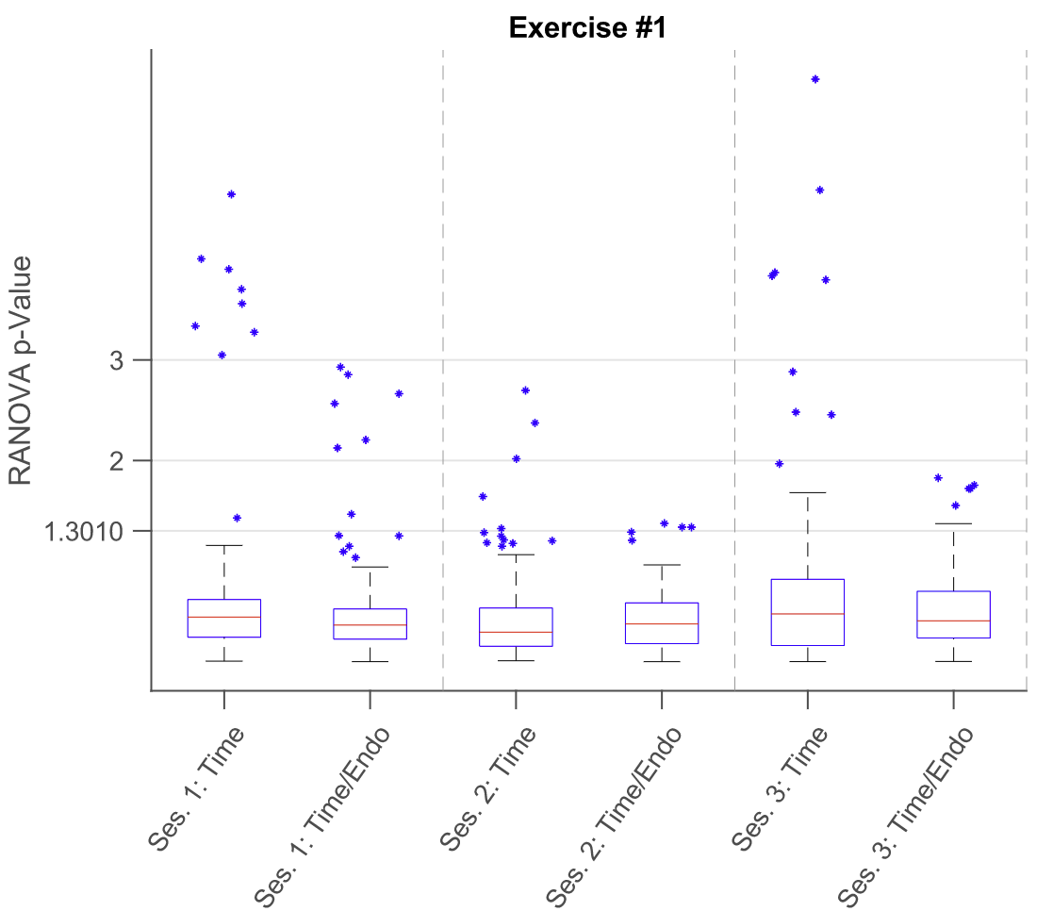
Fig. S1. Boxplots representing RANOVA p-Value calculation results for each session of exercise 1 converted to negative logarithmic (base 10) counter-part values, representing significance depending on time and the combination of time and the used endoscope type; ticks of the Y-axis mark the p-Value threshholds 0.05%, 0.01% and 0.001% (converted values being 1.3010, 2 and 3 respectively)

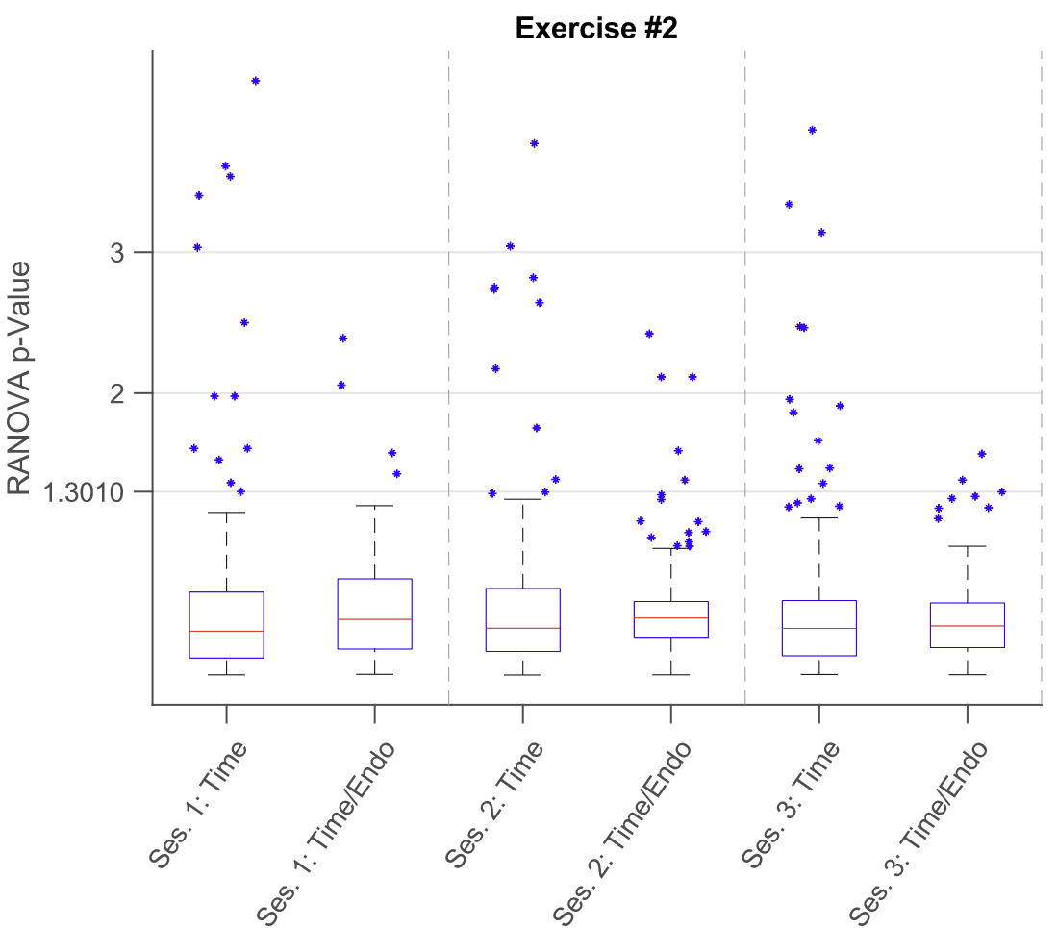
Fig. S2. Boxplots representing RANOVA p-Value calculation results for each session of exercise 2 converted to negative logarithmic (base 10) counter-part values, representing significance depending on time and the combination of time and the used endoscope type; ticks of the Y-axis mark the p-Value threshholds 0.05%, 0.01% and 0.001% (converted values being 1.3010, 2 and 3 respectively)

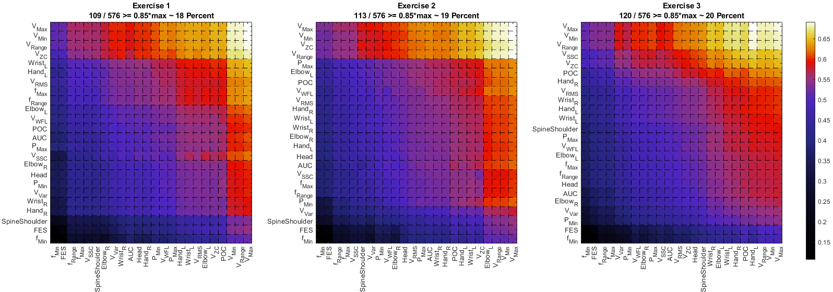 Fig. S3. Overview of the heatmaps visualizing the averaged Euclidean distances between 2D values and 3D values of the features for each exercise dataset; Y-Axis contains the averaged 2D metric-specific feature vector which were used for element-wise comparison with the 3D metric-specific feature vector; each exercise dataset is designated in the title with an additional percentage calculation of features, that are within 15% of the highest average distance

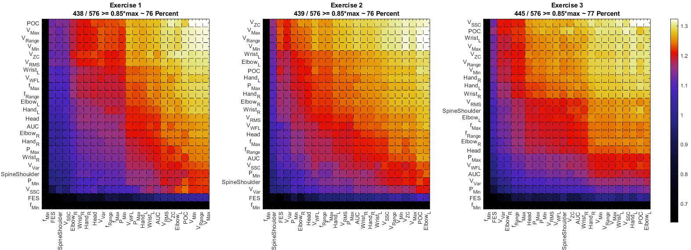Fig. S4. Overview of the heatmaps visualizing the averaged Mahalanobis distances between 2D values and 3D values of the features for each exercise dataset; Y-Axis contains the averaged 2D metric-specific feature vector which were used for element-wise comparison with the 3D metric-specific feature vector; each exercise dataset is designated in the title with an additional percentage calculation of features, that are within 15% of the highest average distance

