Supplemental Material
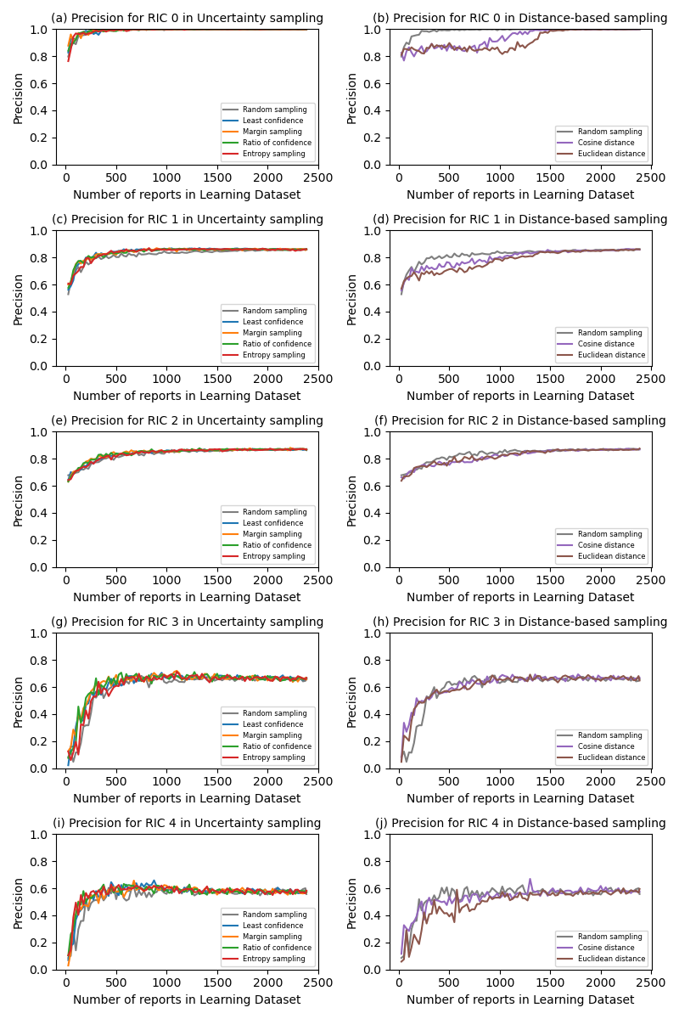
Figure S1 Transition of precision for each category

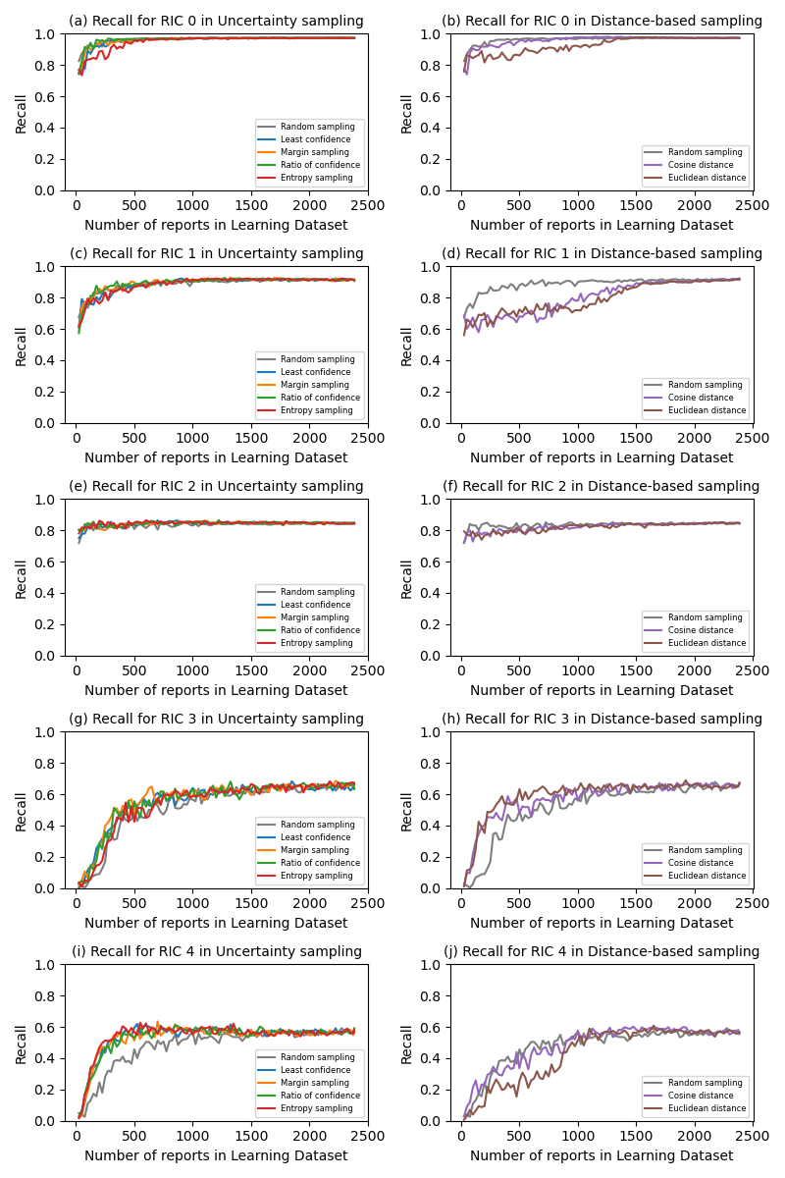
Figure S2 Transition of recall for each category

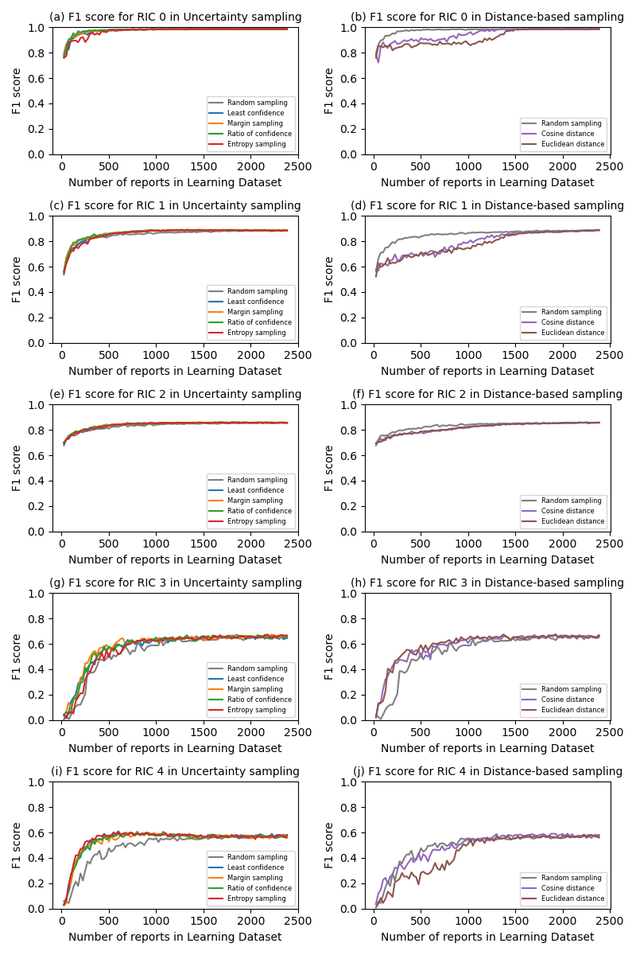
Figure S3 Transition of F1 score for each category

