Online Resource 2 (Supplementary): Deep-Motion-Net: GNN-based volumetric organ shape reconstruction from single-view 2D projections

Article Title | Deep-Motion-Net: GNN-based volumetric organ shape reconstruction from single-view 2D projections
Conference Name | International Conference on Information Processing in Computer-Assisted Interventions
Journal Name | International Journal of Computer Assisted Radiology and Surgery
Affiliation | University of Leeds
Email Address | isurusuranga.wijesinghe@gmail.com

Real kV Evaluation – animation – Second scan series - GNN (Patient 1)
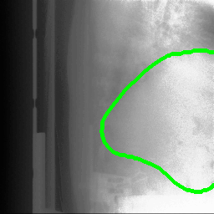

Animation for full-scan-series with predicted contours overlaid on corresponding real kV images

Real kV Evaluation – animation – Second scan series - GNN (Patient 2)
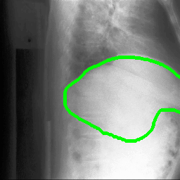
Animation for full-scan-series with predicted contours overlaid on corresponding real kV images

