Online Resource 1

Taxonomic characterisation of the Regianum clade (genus Tuber), and the trait evolution of spore size among true truffles

Péter Cseh*¹, Zsolt Merényi², Lilla Bóna¹, Torda Varga³, Károly Bóka⁴, István Nagy¹, Vasileios Kaounas⁵, Josep Maria Vidal⁶, Aurelia Paz⁷, Zoltán Bratek¹

¹ Department of Plant Physiology and Molecular Plant Biology, Eötvös Loránd University, Pázmány Péter lane 1/C, Budapest H-1117, Hungary.
² Synthetic and Systems Biology Unit, Institute of Biochemistry, Biological Research Centre, Szeged, Hungary.
³ Comparative Fungal Biology, Royal Botanic Gardens, Kew, Richmond, TW9 3AE, United Kingdom.
⁴ Department of Plant Anatomy, Eötvös Loránd University, Pázmány Péter lane 1/C, Budapest H-1117, Hungary.
⁵ Sokratous 58, TK-19016 Artemis Attika, Greece.
⁶ C/ Massaballs 10, E-17118 Sant Sadurní de l’Heura, Girona, Spain.
⁷ Apdo. de correos 6, C/ Vall Ter 791, Urbanització Llac del Cigne, E-17455 Caldes de Malavella, Girona, Spain.

Table S1 List of species used in ASR analysis, the name of Tuber clades or lineages (CL), GenBank Accession numbers for each loci (EFα, ITS, LSU, RPB2), six morphological characters, origin and references. The six morphological characters are: Ornamentation – ORN (a: alveolate-reticulate, b: spiny, c: spino-reticulate, d: smooth, e: verrucose), Surface of peridium – SURF (a: warty, b: papillate or verrucose, c: smooth, glabrous, roughened, pubescens, scurfy or felty), Maximum number of spores per asci – MAX SP, Average length of spores (μm) – L_SP, Average length of asci (μm) – L_ASC, Maximum size of ascoma (cm) – S_FB. Abbrevations of clades: AES: Aestivum, EXC: Excavatum, GEN: Gennadii, GIB: Gibbosum, LAT: Latisporum, MAC: Maculatum, MACR: Macrosporum, MEL: Melanosporum, MUL: Multimaculatum, PUB: Puberulum. REG: Regianum, RUF: Rufum, TUR: Turmericum, lab: Labyrinthomyces lineage, cho: Choiromyces sp., geo: Geomorium spp. Abbreviation of taxa basal to Tuber: Dingleyasp1: Dingleya sp., Labsp3: Labyrinthomyces sp., Redsp5: Reddellomyces sp., Nottha: Nothojafnea thaxteri, Chome: Choiromyces meandriformis, Geoaus: Geomorium australianum, Geoech: Geomorium echinulatum. Accessions of taxa sequenced by us are in boldface
SPECIES | CL | EF1α | ITS | LSU | RPB2 | ORN | SURF | MAX SP | L_SP | L_ASC | S_FB | ORIGIN | REFERENCES
aestivum | AES | JX022565 | HM485340 | JQ925679 | JQ954488 | a | a | 6 | 27.5 | 90 | 7 | Sweden/Italy | Montecchi & Sarasini 2000
magnatum | AES | JX022591 | JQ925645 | JQ925700 | JQ954512 | a | c | 4 | 26 | 65 | 4 | Italy | Montecchi & Sarasini 2000
malenconii | AES | - | FM205597 | - | - | a | a | 8 | 24 | 70 | 4 | Spain | Montecchi & Sarasini 2000
mesentericum | AES | JX022595 | HM485375 | JQ925704 | JQ954516 | a | a | 6 | 30.5 | 95 | 3 | Sweden | Montecchi & Sarasini 2000
panniferum | AES | - | HM485380 | FJ809846 | - | b | c | 8 | 24.5 | 68.4 | 5 | Spain | Montecchi & Sarasini 2000
pulchrosporum | AES | - | MK113982 | - | - | a | b | 8 | 30.9 | 87 | 7 | Bulgaria | Polemis et al. 2019
sinoaestivum | AES | - | KY081688 | - | - | a | a | 7 | 30.5 | 71.5 | 3 | nd | Zhang et al. 2013
badium | EXC | - | NR155922 | NG059731 | - | a | b | 5 | 35.5 | 109.5 | 3 | China | Wan et al. 2017
depressum | EXC | - | KX904890 | KY013653 | - | a | b | 5 | 32.25 | 102.5 | 3 | China | Wan et al. 2017
excavatum | EXC | - | FJ748899 | FJ809825 | - | a | b | 5 | 40 | 95 | 3 | Spain | Montecchi & Sarasini 2000
fulgens | EXC | JX022580 | HM485358 | JQ925691 | - | a | b | 4 | 37 | 99.9 | 4 | Italy | Montecchi & Sarasini 2000
neoexcavatum | EXC | - | KY013627 | KY013640 | - | a | b | 4 | 38.75 | 87.5 | 4 | China | Fan et al. 2013a
sinoexcavatum | EXC | - | JX458717 | - | - | a | b | 4 | 42.5 | 100 | 3 | China | Fan et al. 2011
verrucosivolvum | EXC | - | KX904888 | KY013651 | - | a | b | 4 | 34.5 | 105 | 1.5 | China | Wan et al. 2017
gennadii | GEN | JX022581 | HM485361 | - | JQ954502 | a | c | 4 | 42.5 | 145 | 4 | Italy/Spain | Montecchi & Sarasini 2000
lacunosum | GEN | - | JN392213 | JN392287 | - | a | c | 4 | 47.5 | 115 | 4 | Spain | Alvarado et al. 2012a
bellisporum | GIB | - | FJ809855 | FJ809855 | - | a | c | 5 | 28 | 68.5 | 2 | USA | Bonito et al. 2010
castellanoi | GIB | - | FJ809860 | FJ809860 | JQ954499 | a | c | 5 | 27.5 | 65 | 3 | USA | Bonito et al. 2010
gibbosum | GIB | JX022584 | FJ809862 | FJ809862 | JQ954505 | a | c | 6 | 29.25 | 86.5 | 4 | USA | Montecchi & Sarasini 2000
oregonense | GIB | JX022599 | JQ925647 | JQ925706 | JQ954519 | a | c | 5 | 31.75 | 72.5 | 5 | USA | Bonito et al. 2010
alboumbilicum | LAT | - | KJ742702 | - | - | a | c | 3 | 35 | 119.5 | 1 | China | Li et al. 2014
elevatireticulatum | LAT | - | MF540621 | LC425123 | - | a | c | 4 | 28.75 | 67.75 | 1.5 | Taiwan | Lin et al. 2018
caoi | LAT | KP276217 | KP276182 | KP276198 | - | a | c | 4 | 28.75 | 71.25 | 2.6 | China | Fan et al. 2016a
latisporum | LAT | KP276205 | KP276189 | KP276204 | - | a | c | 4 | 27.5 | 77.5 | 2.5 | China | Chen & Liu 2007
panzhihuanense | LAT | - | JQ978655 | - | - | a | c | 4 | 31.5 | 67.5 | 13 | China | Deng et al. 2013
parvomurphium | LAT | KP276215 | KP276185 | KP276191 | - | a | c | 4 | 27.5 | 72.5 | 1.9 | China | Fan et al. 2016a
pseudosphaerosporum | LAT | KP276210 | KF744063 | KP276194 | - | a | c | 4 | 31.25 | 70 | 4.5 | China | Fan & Yue 2013
thailandicum | LAT | - | KP196331 | - | - | a | c | 4 | 24 | 58.75 | 3.5 | Thailand | Suwannarach et al. 2015
arnoldianum | MAC | - | KU186923 | - | - | a | c | 5 | 27 | 65 | 1.1 | USA | Healy et al. 2016
aztecorum | MAC | - | NR159044 | - | - | a | b | 5 | 30.5 | 78.5 | 2.3 | Mexico | Guevara-Guerrero et al. 2018
beyerlei | MAC | JX022570 | HM485408 | JF419286 | - | a | b | 4 | 27.5 | 70 | 2 | USA | Guevara et al. 2013a
bomiense | MAC | - | - | KY174959 | - | a | b | 5 | 28.7 | 70.5 | 2 | China | Su et al. 2014
brennemanii | MAC | MH159203 | MF611779 | KY565252 | MH084658 | a | c | 4 | 33.5 | 70 | 2.6 | USA | Grupe et al. 2018
castilloi | MAC | - | NR119865 | NG059939 | - | a | b | 4 | 35.5 | 70 | 2.5 | Mexico | Guevara et al. 2013a
floridanum | MAC | - | MF611781 | KY565259 | - | a | c | 5 | 31.5 | 75 | 2.8 | USA | Grupe et al. 2018
foetidum | MAC | - | FN568055 | - | - | a | b | 4 | 32 | 80 | 3 | Finland | Montecchi & Sarasini 2000
guevarai | MAC | - | HM485405 | JF419305 | - | a | b | 5 | 26 | 41 | 1.1 | Mexico | Guevara et al. 2013a
hubeiense | MAC | - | KT067688 | NG059582 | - | a | c | 4 | 28.75 | 60 | 0.9 | China | Fan et al. 2016b
lauryi | MAC | - | HM485365 | JF419314 | - | a | b | 4 | 30 | 75 | 1.3 | USA | Guevara et al. 2013a
linsdalei | MAC | - | HM485370 | - | - | a | b | 3 | 30.7 | 68.5 | 2 | USA | Gilkey 1954; Healy et al. 2016
maculatum | MAC | - | AJ969627 | AJ969627 | - | a | c | 5 | 32.5 | 110 | 3 | Denmark | Montecchi & Sarasini 2000
mexiusanum | MAC | JX022602 | HM485411 | JF419293 | - | a | b | 5 | 26 | 60 | 1.4 | Mexico | Guevara et al. 2013a
microverrucosum | MAC | KT067726 | - | KT067696 | - | a | b | 6 | 28.75 | 87.5 | 2.2 | China | Fan et al. 2013c
miquihuanense | MAC | - | HM485414 | JF419292 | - | a | b | 5 | 25.5 | 77.5 | 3 | Mexico | Guevara et al. 2013a
pseudomagnatum | MAC | KT067711 | KT067686 | KT067693 | - | a | b | 4 | 28.75 | 87.5 | 2 | China | Fan & Cao 2012
rapaeodorum | MAC | - | JF261378 | JF261342 | - | a | c | 6 | 30.5 | 85 | 2.5 | Hungary | Halász et al. 2005
scruposum | MAC | - | JF261393 | JF261364 | - | a | b | 4 | 32.5 | 62.5 | 0.6 | Hungary | Badalyan et al. 2005
shearii | MAC | - | HM485389 | JF419280 | JQ954521 | a | c | 3 | 45.5 | 60 | 3 | USA | Chu-Chou & Grace 1981
walkeri | MAC | - | JF419258 | JF419308 | - | a | b | 5 | 28.5 | 59.5 | 1.2 | USA | Guevara et al. 2013a
whetstonense | MAC | - | HM485392 | JF419304 | - | a | b | 5 | 35 | 65 | 1.5 | USA | Frank et al. 2006
wumengense | MAC | KT067716 | KT067683 | KT067709 | - | a | c | 4 | 31.25 | 66.25 | 2.7 | China | Fan et al. 2016b
calosporum | MACR | - | KT444600 | - | - | a | b | 3 | 89 | 125.5 | 2.3 | China | Wan et al. 2016
canaliculatum | MACR | JX022575 | JQ925643 | FJ809841 | JQ954497 | a | b | 4 | 46 | 100 | 3.2 | USA | Guevara et al. 2013b
glabrum | MACR | - | NR153217 | - | - | a | c | 2 | 86.25 | 110 | 3 | China | Fan et al. 2014
macrosporum | MACR | JX022590 | HM485373 | FJ809838 | - | a | a | 4 | 82 | 105 | 5 | Italy | Montecchi & Sarasini 2000
sinomonosporum | MACR | - | KF002729 | - | - | a | c | 2 | 67.5 | 98.75 | 2.5 | China | Fan et al. 2014
brumale | MEL | - | KF551022 | KF581091 | JQ954494 | b | a | 7 | 29.5 | 60 | 6 | Italy | Merényi et al. 2017b
cryptobrumale | MEL | - | KF551011 | KF581105 | - | b | a | 7 | 27.9 | 62.1 | 2.7 | Hungary | Merényi et al. 2017b
himalayense | MEL | AB553537 | AB553388 | AB553517 | AB553557 | c | a | 5 | 28.5 | 62.5 | 2.5 | Japan | Zhang & Minter 1988
indicum | MEL | JX022588 | - | JQ925696 | JQ954509 | c | a | 5 | 26 | 62.1 | 3 | USA | Montecchi & Sarasini 2000
longispinosum | MEL | AB553538 | AB553414 | AB553518 | AB553558 | b | a | 6 | 24 | 65.5 | 7 | Japan | Kinoshita et al. 2018
melanosporum | MEL | JX022594 | - | JQ925703 | JQ954515 | b | a | 5 | 30 | 75 | 5 | Italy | Montecchi & Sarasini 2000
petrophilum | MEL | - | HG810886 | - | - | b | a | 6 | 32.6 | 45 | 1.6 | Serbia | Milenković et al. 2016
pseudobrumale | MEL | - | KJ742703 | - | - | c | a | 7 | 24.25 | 61.5 | 4 | China | Li et al. 2014
pseudoexcavatum | MEL | - | HM485381 | FJ809816 | - | c | a | 8 | 26 | 72.5 | 3.5 | China | Wang et al. 1998
sinense | MEL | - | GU979061 | GU979117 | - | c | a | 4 | 23.75 | 62.1 | 10 | China | Wang et al. 2006
regimontanum | MEL | JX022600 | EU375838 | EU375838 | JQ954520 | b | a | 4 | 44 | 62.1 | 4 | Mexico | Guevara et al. 2008
formosanum | MEL | LC312289 | - | - | - | c | a | 5 | 29 | 55 | 8 | Taiwan | Qiao et al. 2013
multimaculatum | MUL | JX022596 | HM485377 | JQ925705 | - | a | c | 2 | 58.5 | 203 | 6 | Spain | Alvarez et al. 1992
anniae | PUB | JX022567 | HM485338 | JQ925680 | - | a | c | 3 | 29.5 | 94.5 | 1.2 | USA | Páez et al. 2018
asa | PUB | JX022569 | HM485341 | - | - | a | c | 5 | 27.5 | 80 | 5 | Italy | Montecchi & Sarasini 2000
bonitoi | PUB | - | KT897473 | KT897473 | - | a | c | 4 | 28.5 | 91 | 4.7 | Mexico | Guevara-Guerrero et al. 2015
borchii | PUB | - | - | - | JQ954493 | a | c | 4 | 32.5 | 80 | 3 | Italy | Montecchi & Sarasini 2000
brunneum | PUB | - | KT897479 | KT897479 | - | a | c | 5 | 28 | 100 | 1.7 | Mexico | Guevara-Guerrero et al. 2015
californicum | PUB | JX022574 | HM485346 | JQ925685 | JQ954496 | a | c | 4 | 36.5 | 77 | 0.9 | USA | Hawker 1968
cistophilum | PUB | - | JN392233 | JN392296 | - | a | c | 4 | 44 | 107.5 | 2 | Spain | Alvarado et al. 2012a
dryophilum | PUB | - | HM485354 | JQ925688 | JQ954501 | a | c | 4 | 50 | 80 | 3 | Italy | Montecchi & Sarasini 2000
huizeanum | PUB | - | JQ910651 | NG059991 | - | a | c | 4 | 52.5 | 97.5 | 2 | China | Fan et al. 2013c
incognitum | PUB | - | MH447961 | - | - | a | c | 5 | 36 | 94 | 1.5 | Mexico | Páez et al. 2018
jinshajiangense | PUB | - | KX575841 | KX575846 | - | a | c | 4 | 27.5 | 67.5 | 1 | China | Fan et al. 2016a
lijiangense | PUB | KP276206 | KP276188 | KP276203 | - | a | c | 3 | 33.75 | 75 | 3 | China | Fan et al. 2011
liui | PUB | - | DQ898182 | - | - | a | c | 4 | 69 | 86.5 | 3.5 | China | García-Montero et al. 2010
liyuanum | PUB | KT067719 | JQ771193 | - | - | a | c | 4 | 42.5 | 86.25 | 8 | China | Fan & Cao 2012
microsphaerosporum | PUB | KP276207 | KF805726 | - | - | a | c | 7 | 22.5 | 86.25 | 2 | China | Fan et al. 2012b
oligospermum | PUB | - | JN392260 | JN392324 | - | a | c | 4 | 31 | 95 | 4 | Spain | Montecchi & Sarasini 2000
pacificum | PUB | - | EU837241 | KT968651 | - | a | c | 4 | 33 | 77.5 | 0.9 | USA | Trappe & Castellano 2000
pseudoseparans | PUB | - | KT897480 | KT897480 | - | a | c | 5 | 30.5 | 86.5 | 1.2 | Mexico | Guevara-Guerrero et al. 2015
puberulum | PUB | - | JF261381 | JF261344 | - | a | c | 4 | 30 | 86.5 | 5 | Hungary | Montecchi & Sarasini 2000
separans | PUB | - | KU186911 | - | - | a | c | 4 | 52 | 77.5 | 1.2 | USA | Gilkey 1939
shidianense | PUB | - | KT444595 | KY174960 | - | a | c | 4 | 26.25 | 84 | 2 | China | Wan et al. 2016
shii | PUB | - | KX555453 | KX555464 | - | a | c | 4 | 42.75 | 87.5 | 3.5 | China | Wang et al. 2016
sinoniveum | PUB | - | KX904882 | KY050590 | - | a | c | 4 | 27.5 | 95 | 1.5 | China | Xu et al. 2017
sinopuberulum | PUB | - | JQ690073 | - | - | a | c | 5 | 28.75 | 90 | 2.5 | China | Fan et al. 2013d
sinosphaerosporum | PUB | KP276211 | JX092087 | KP276196 | - | a | c | 4 | 31.25 | 100 | 5.5 | China | Fan et al. 2013e
sphaerospermum | PUB | - | JN392242 | JN392307 | - | a | c | 4 | 37.5 | 85 | 5 | Spain | Alvarado et al. 2012a
sphaerosporum | PUB | JX022609 | FJ809853 | FJ809853 | - | a | c | 4 | 37.5 | 85 | 2.5 | USA | Fan & Yue 2013
tequilanum | PUB | - | KT897487 | KT897487 | - | a | c | 5 | 30 | 79.5 | 2 | Mexico | Guevara-Guerrero et al. 2015
vesicoperidium | PUB | - | JQ690072 | JQ690069 | - | a | c | 5 | 27.75 | 80 | 4 | China | Fan et al. 2013d
xuanhuaense | PUB | - | KP276179 | - | - | a | c | 4 | 30 | 82.5 | 0.9 | China | Fan et al. 2016a
zhongdianense | PUB | KT067721 | KT067680 | KT067702 | - | a | c | 4 | 56.5 | 86.5 | 1.5 | China | García-Montero et al. 2010
bernardinii | REG | - | - | KY420112 | KY420131 | a | c | 8 | 20.5 | 52.5 | 3 | Italy | Gori 2003
magentipunctatum | REG | - | JQ288909 | KY420113 | KY420128 | a | b | 8 | 18.1 | 56.3 | 1.6 | Hungary | Merényi et al. 2017a
regianum | REG | - | KY420098 | KY420106 | KY420124 | a | b | 8 | 16.5 | 60 | 3 | Slovakia | Montecchi & Sarasini 2000
candidum | RUF | - | JN022527 | - | - | b | b | 7 | 30.5 | 72.5 | 5 | USA | Gilkey 1939
crassitunicatum | RUF | - | MH115295 | - | - | c | b | 5 | 27 | 60 | 1.8 | China | Yan et al. 2018
furfuraceum | RUF | - | GU979034 | GU979090 | - | c | b | 5 | 44.5 | 45 | 2.5 | China | García-Montero et al. 2010
huidongense | RUF | - | MH115294 | MH115301 | - | c | b | 5 | 31.5 | 56 | 2.5 | China | Deng et al. 2009
lannaense | RUF | - | KT758730 | KU207732 | - | c | b | 5 | 24.75 | 60 | 3.5 | Thailand | Suwannarach et al. 2016
liaotongense | RUF | JX022589 | HM485369 | FJ809813 | - | c | b | 4 | 34.5 | 70.5 | 2 | China | Wang et al. 2007
lishanense | RUF | - | MH115313 | MH115314 | - | b | b | 5 | 27.25 | 57.5 | 2.5 | China | Yan et al. 2018
lyonii | RUF | - | FJ748910 | JQ925699 | JQ954511 | c | c | 4 | 21.5 | 85 | 5.5 | USA | Trappe et al. 1996
malacodermum | RUF | JX022593 | - | - | JQ954514 | c | c | 5 | 22.5 | 65 | 2 | Spain | Leonardi et al. 2019
piceatum | RUF | - | MH115320 | MH115321 | - | b | c | 6 | 27.75 | 70 | 0.7 | China | Yan et al. 2018
quercicola | RUF | - | MK169365 | - | - | b | b | 5 | 32.5 | 71 | 3 | USA | Frank et al. 2006
ferrugineumA | RUF | - | MT351077 | MT270600 | - | b | b | 6 | 25 | 70.5 | 2.4 | Hungary | own data
lucidumB | RUF | - | MT351083 | MT270606 | - | b | b | 5 | 24 | 70.5 | 2.9 | Spain | own data
rufumC | RUF | - | MT351082 | MT270605 | - | b | c | 5 | 22.4 | 70.5 | 1.3 | Italy | own data
rufumD | RUF | - | MT351085 | MT270608 | - | b | b | 5 | 23.25 | 70.5 | 2 | Spain | own data
melosporum | RUF | - | JX402095 | JN392202 | - | d | b | 5 | 42.5 | 88.5 | 2 | Spain | Alvarado et al. 2012b
rufumF | RUF | - | MT351084 | MT270607 | - | d | b | 4 | 28.8 | 70.5 | 2 | Spain | own data
nitidumG | RUF | - | MT351081 | MT270604 | - | b | c | 5 | 25.75 | 70.5 | 2.2 | Hungary | own data
rufumH | RUF | - | MT351079 | MT270602 | - | b | b | 5 | 26.75 | 70.5 | 1 | Spain | own data
pustulatum | RUF | - | MW077451 | MW076943 | - | c | b | 6 | 32 | 100 | 3.1 | Spain | Leonardi et al. 2019
rufumJ | RUF | - | MT351076 | MT270599 | - | b | b | 5 | 24.6 | 70.5 | 1.7 | Hungary | own data
rufumK | RUF | - | MT351075 | MT270598 | - | b | b | 6 | 30.6 | 70.5 | 2.5 | Hungary | own data
rufumL | RUF | - | MT351078 | MT270601 | - | b | b | 6 | 26.75 | 70.5 | 1.9 | Hungary | own data
rufumM | RUF | - | MT351080 | MT270603 | - | b | b | 6 | 30.2 | 70.5 | 2.5 | Slovakia | own data
rufumN | RUF | - | MT351086 | - | - | b | c | 5 | 28.8 | 70.5 | 2 | Hungary | own data
rufumO | RUF | - | FN433159 | FJ809807 | - | b | c | 3 | 28.8 | 70.5 | 1 | Spain | own data
sinoalbidum | RUF | - | MH115298 | MH115299 | - | c | b | 5 | 31.25 | 52.5 | 4.5 | China | Fan et al. 2012a
spinoreticulatum | RUF | JX022608 | FJ809884 | FJ809815 | JQ954527 | c | b | 4 | 32.5 | 66 | 2.5 | USA | Uecker & Burdsall 1977
subglobosum | RUF | - | KF002728 | MH115324 | - | c | b | 4 | 26.25 | 87.5 | 2 | China | Fan et al. 2013b
taiyuanense | RUF | - | GU979033 | - | - | c | b | 4 | 30.25 | 70.5 | 1.5 | China | Wang et al. 2007
theleascum | RUF | - | MK211284 | MK211313 | - | c | b | 6 | 22 | 76.5 | 2 | Mexico | Leonardi et al. 2019
texense | RUF | - | HM485391 | - | - | c | c | 6 | 28 | 88 | 5.5 | USA | Hanlin et al. 1989
umbilicatum | RUF | - | GU979032 | GU979088 | - | c | b | 6 | 28 | 66.5 | 1.9 | China | Chen et al. 2005
wenchuanense | RUF | - | JX267044 | MH115327 | - | c | c | 5 | 35 | 80 | 1 | China | Fan et al. 2013b
flavidosporum | TUR | AB553540 | AB553446 | AB553520 | AB553560 | a | c | 2 | 39 | 83.5 | 2 | Japan | Kinoshita et al. 2016
japonicum | TUR | AB553539 | AB553434 | AB553519 | AB553559 | a | c | 3 | 35 | 104 | 4 | Japan | Kinoshita et al. 2016
turmericum | TUR | - | KT758837 | - | - | a | c | 2 | 38.75 | 75 | 4.5 | China | Fan et al. 2015
xanthomonosporum | TUR | - | KJ162156 | - | - | a | c | 1 | 42 | 60 | 3 | China | Qing et al. 2015
Labsp3 | lab |  | HM485335 | JQ925670 | JQ954480 | e | c | 8 | 21.5 | 322.5 | 3.5 | Australia | Trappe et al. 1992
Nottha | lab | JX022561 | JQ925638 | JQ925673 | JQ954482 | e | c | 8 | 24.9 | 320 | 3 | Argentina | Gamundi 1971
Redsp5 | lab | JX022563 | HM485337 | JQ925678 | JQ954486 | e | c | 5 | 37.5 | 240 | 8 | Australia | Trappe at al. 1991
Dingleyasp1 | lab | JX022553 | JQ925628 | - | - | e | a | 8 | 22.5 | 315 | 5 | Australia | Trappe at al. 1992
Chome | cho | JX022550 | HM485330 | FJ809794 | JQ954471 | b | c | 8 | 20 | 96.25 | 10 | USA | Hosseini 2013
Geoaus | geo | JX022555 | JQ925629 | JQ925663 | JQ954475 | b | c | 8 | 26.5 | 275 | 2.5 | Australia | Zhang & Minter 1989
Geoech | geo | - | JQ925630 | JQ925664 | - | b | c | 8 | 20.25 | 310 | 1.5 | Australia | Zhang & Minter 1989

Table S2 Materials invoved in the morphological studies. Species names according to phylogeny and morphology, basis of identification, herbarium vouchers, taxon name by the original identification, location of origin, host plants
Species | Basis of identification | Collection | Original identification | Country | Host
T. bernardinii | ITS | M23 / 2172 | T. regianum | Italy | Fagus sylvatica
T. bernardinii | ITS | M45 | T. regianum | Italy | Fagus sylvatica
T. bernardinii | LSU | M44 | T. regianum | Italy | Fagus sylvatica
T. bernardinii | morphology | M42 / B17 | T. bernardinii | Italy | Betula sp., Castanea sp.
T. bernardinii | morphology | M37 / 2542 | T. bernardinii | Italy | Castanea sativa, Betula pendula
T. bernardinii | morphology | M34 / 2318 | T. regianum | Italy | -
T. magentipunctatum | ITS | ZB4299 | T. regianum | Hungary | Quercus robur
T. magentipunctatum | ITS | M35 / MO793 | T. regianum | Italy | Ostrya carpinifolia
T. magentipunctatum | ITS | M36 / MO689 | T. regianum | Italy | Ostrya carpinifolia
T. magentipunctatum | ITS | ZB1303 | T. regianum | Romania | Quercus sp., Carpinus betulus
T. magentipunctatum | ITS | ZB3044 | T. regianum | Slovakia | C. betulus, Corylus avellana, Q. petraea
T. magentipunctatum | ITS | ZB3657B | T. regianum | Romania | -
T. magentipunctatum | ITS | ZB4290 | T. regianum | Hungary | Corylus avellana, Populus x canescens
T. magentipunctatum | ITS | ZB4297 | T. regianum | Hungary | Picea abies
T. magentipunctatum | ITS | ZB4559 | Tuber sp. | Hungary | Fagus sylvatica, Carpinus betulus
T. magentipunctatum | ITS | ZB4293 | T. regianum | Hungary | Corylus colurna, Tilia tomentosa
T. magentipunctatum | ITS | ZB5221 | Tuber sp. | Hungary | Quercus robur
T. magentipunctatum | ITS | ZB5224 | Tuber sp. | Hungary | Quercus cerris
T. magentipunctatum | ITS | AQUI 5946 | Tuber sp. | Italy | Fagus sylvatica
T. magentipunctatum | ITS | ZB5307 | Tuber sp. | Hungary | Quercus robur
T. magentipunctatum | ITS | ZB5312 | Tuber sp. | Hungary | Quercus cerris
T. magentipunctatum | ITS | ZB5318 | Tuber sp. | Hungary | Quercus robur
T. magentipunctatum | morphology | ZB5320 | Tuber sp. | Hungary | Quercus robur
T. magentipunctatum | ITS | ZB3657C | T. regianum | Romania | -
T. regianum | ITS | ZB3081 | T. regianum | Slovakia | Fagus sylvatica
T. regianum | ITS | M43 / IGM235 | T. regianum | Italy | Fagus sylvatica
T. regianum | ITS | M46 / Asturias JC | T. regianum | Spain | Fagus sylvatica
T. regianum | LSU | M40 / JMV980925-1 | T. regianum | Italy | Fagus sylvatica
T. regianum | ITS | M22 / JMV20011012-4 | T. regianum | Spain | Fagus sylvatica
T. regianum | ITS | M3 / erd-2590 | T. regianum | Spain | Fagus sylvatica
T. regianum | ITS | M38 / IC13071106 | T. regianum | Spain | Fagus sylvatica, Corylus avellana
T. regianum | morphology | M41 / IC13080704 | T. regianum | Spain | Fagus sylvatica, Corylus avellana
T. regianum | morphology | M39 / AM408 | T. regianum | Italy | Fagus sylvatica

Table S3 List of species, herbarium vouchers, GenBank accession numbers and references of PKC sequences analysed in the phylogenetic study (Online Resource 1 Fig. S1). Own sequences are in boldface
Species | Collection | PKC | Origin | References
T. aestivum | Taes-eu05 | DQ336322 | France | Wang et al. 2006
T. aestivum | Taes-eu04 | DQ336321 | France | Wang et al. 2006
T. bernardinii | M45 | KY420119 | Italy | This study
T. bernardinii | M44 | KY420118 | Italy | This study
T. brumale | ZB4520p3 | KF581116 | Greece | Merényi et al. 2014
T. brumale | ZB4515L3 | KF581119 | Poland | Merényi et al. 2014
T. cryptobrumale | ZB2942 | KF581129 | Hungary | Merényi et al. 2014
T. cryptobrumale | ZB3435 | KF581127 | Romania | Merényi et al. 2014
T. excavatum | Texc-eu01 | DQ336325 | France | Wang et al. 2006
T. excavatum | Texc-eu02 | DQ336326 | France | Wang et al. 2006
T. indicum | Tind-yn02 | DQ336330 | China | Wang et al. 2006
T. indicum | Tind-yn30 | DQ336333 | China | Wang et al. 2006
T. magentipunctatum | ZB4293 * | KY420120 | Hungary | This study
T. magentipunctatum | ZB5221 | KY420122 | Hungary | This study
T. magentipunctatum | ZB4559 | KY420121 | Hungary | This study
T. magnatum | - | AJ245438 | Italy | Ambra and Macino 2000
T. pseudoexcavatum | Tpse-yn02 | DQ336335 | China | Wang et al. 2006
T. pseudoexcavatum | Tpse-yn01 | DQ336334 | China | Wang et al. 2006
* Holotype specimen

Table S4 Pairwise nucleotide difference (P-distance) values of the three species of Regianum clade, calculated with PAUP for each locus. Average (Avg), Standard Deviation (StDev), Minimum and Maximum values are listed

Pairing of clades | Loci | Avg | StDev | Min | Max
T. regianum – T. regianum | ITS | 1.55% | 1.01% | 0.00% | 2.94%
T. regianum – T. regianum | LSU | 0.40% | 0.44% | 0.00% | 0.80%
T. regianum – T. regianum | PKC | - | - | - | -
T. regianum – T. regianum | RPB2 | 0.13% | 0.00% | 0.13% | 0.13%
T. magentipunctatum – T. magentipunctatum | ITS | 0.25% | 0.18% | 0.00% | 0.68%
T. magentipunctatum – T. magentipunctatum | LSU | 0.40% | 0.31% | 0.00% | 0.80%
T. magentipunctatum – T. magentipunctatum | PKC | 0.17% | 0.07% | 0.13% | 0.25%
T. magentipunctatum – T. magentipunctatum | RPB2 | 0.05% | 0.07% | 0.00% | 0.13%
T. bernardinii – T. bernardinii | ITS | 0.35% | 0.00% | 0.35% | 0.35%
T. bernardinii – T. bernardinii | LSU | 0.00% | 0.00% | 0.00% | 0.00%
T. bernardinii – T. bernardinii | PKC | 0.25% | 0.00% | 0.25% | 0.25%
T. bernardinii – T. bernardinii | RPB2 | 0.00% | 0.00% | 0.00% | 0.00%
T. regianum – T. magentipunctatum | ITS | 24.64% | 0.34% | 24.21% | 25.47%
T. regianum – T. magentipunctatum | LSU | 9.75% | 0.21% | 9.40% | 10.10%
T. regianum – T. magentipunctatum | PKC | - | - | - | -
T. regianum – T. magentipunctatum | RPB2 | 2.40% | 0.09% | 2.31% | 2.56%
T. regianum – T. bernardinii | ITS | 22.64% | 0.54% | 21.51% | 23.35%
T. regianum – T. bernardinii | LSU | 10.52% | 0.21% | 10.30% | 10.90%
T. regianum – T. bernardinii | PKC | - | - | - | -
T. regianum – T. bernardinii | RPB2 | 3.91% | 0.07% | 3.85% | 3.98%
T. magentipunctatum – T. bernardinii | ITS | 26.91% | 0.14% | 26.74% | 27.21%
T. magentipunctatum – T. bernardinii | LSU | 11.30% | 0.15% | 11.10% | 11.50%
T. magentipunctatum – T. bernardinii | PKC | 7.29% | 0.23% | 6.98% | 7.60%
T. magentipunctatum – T. bernardinii | RPB2 | 3.75% | 0.05% | 3.72% | 3.85%

Supplement figures

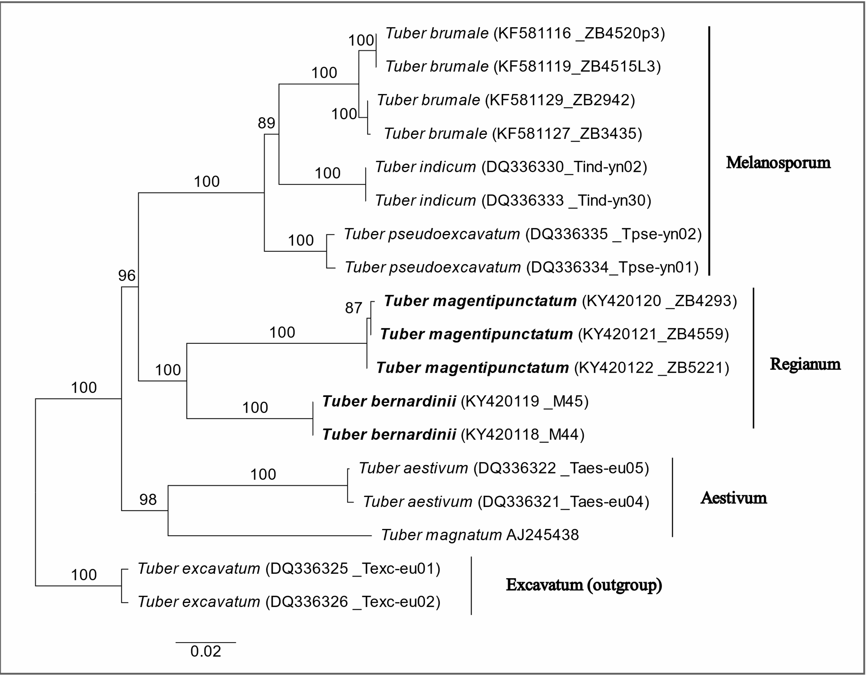
Fig. S1 Maximum Likelihood (ML) phylogenetic tree of Regianum clade and other Tuber species from Melanosporum, Aestivum and Excavatum clades based on PKC region. Analysis was performed with RAxML HPC2 on XSEDE under GTR+GAMMA model. The species of Regianum clade are in boldface, GenBank accessions and herbarium vouchers in brackets. Two Tuber excavatum sequences (DQ336355 and DQ336326) were involved as outgroup. ML bootstrap values were obtained from 100 replicates and values > 70% were indicated on the branches. The scale bar represents 0.02 expected nucleotide changes per site. The matrices of the alignment were deposited in TreeBASE under submission 30716

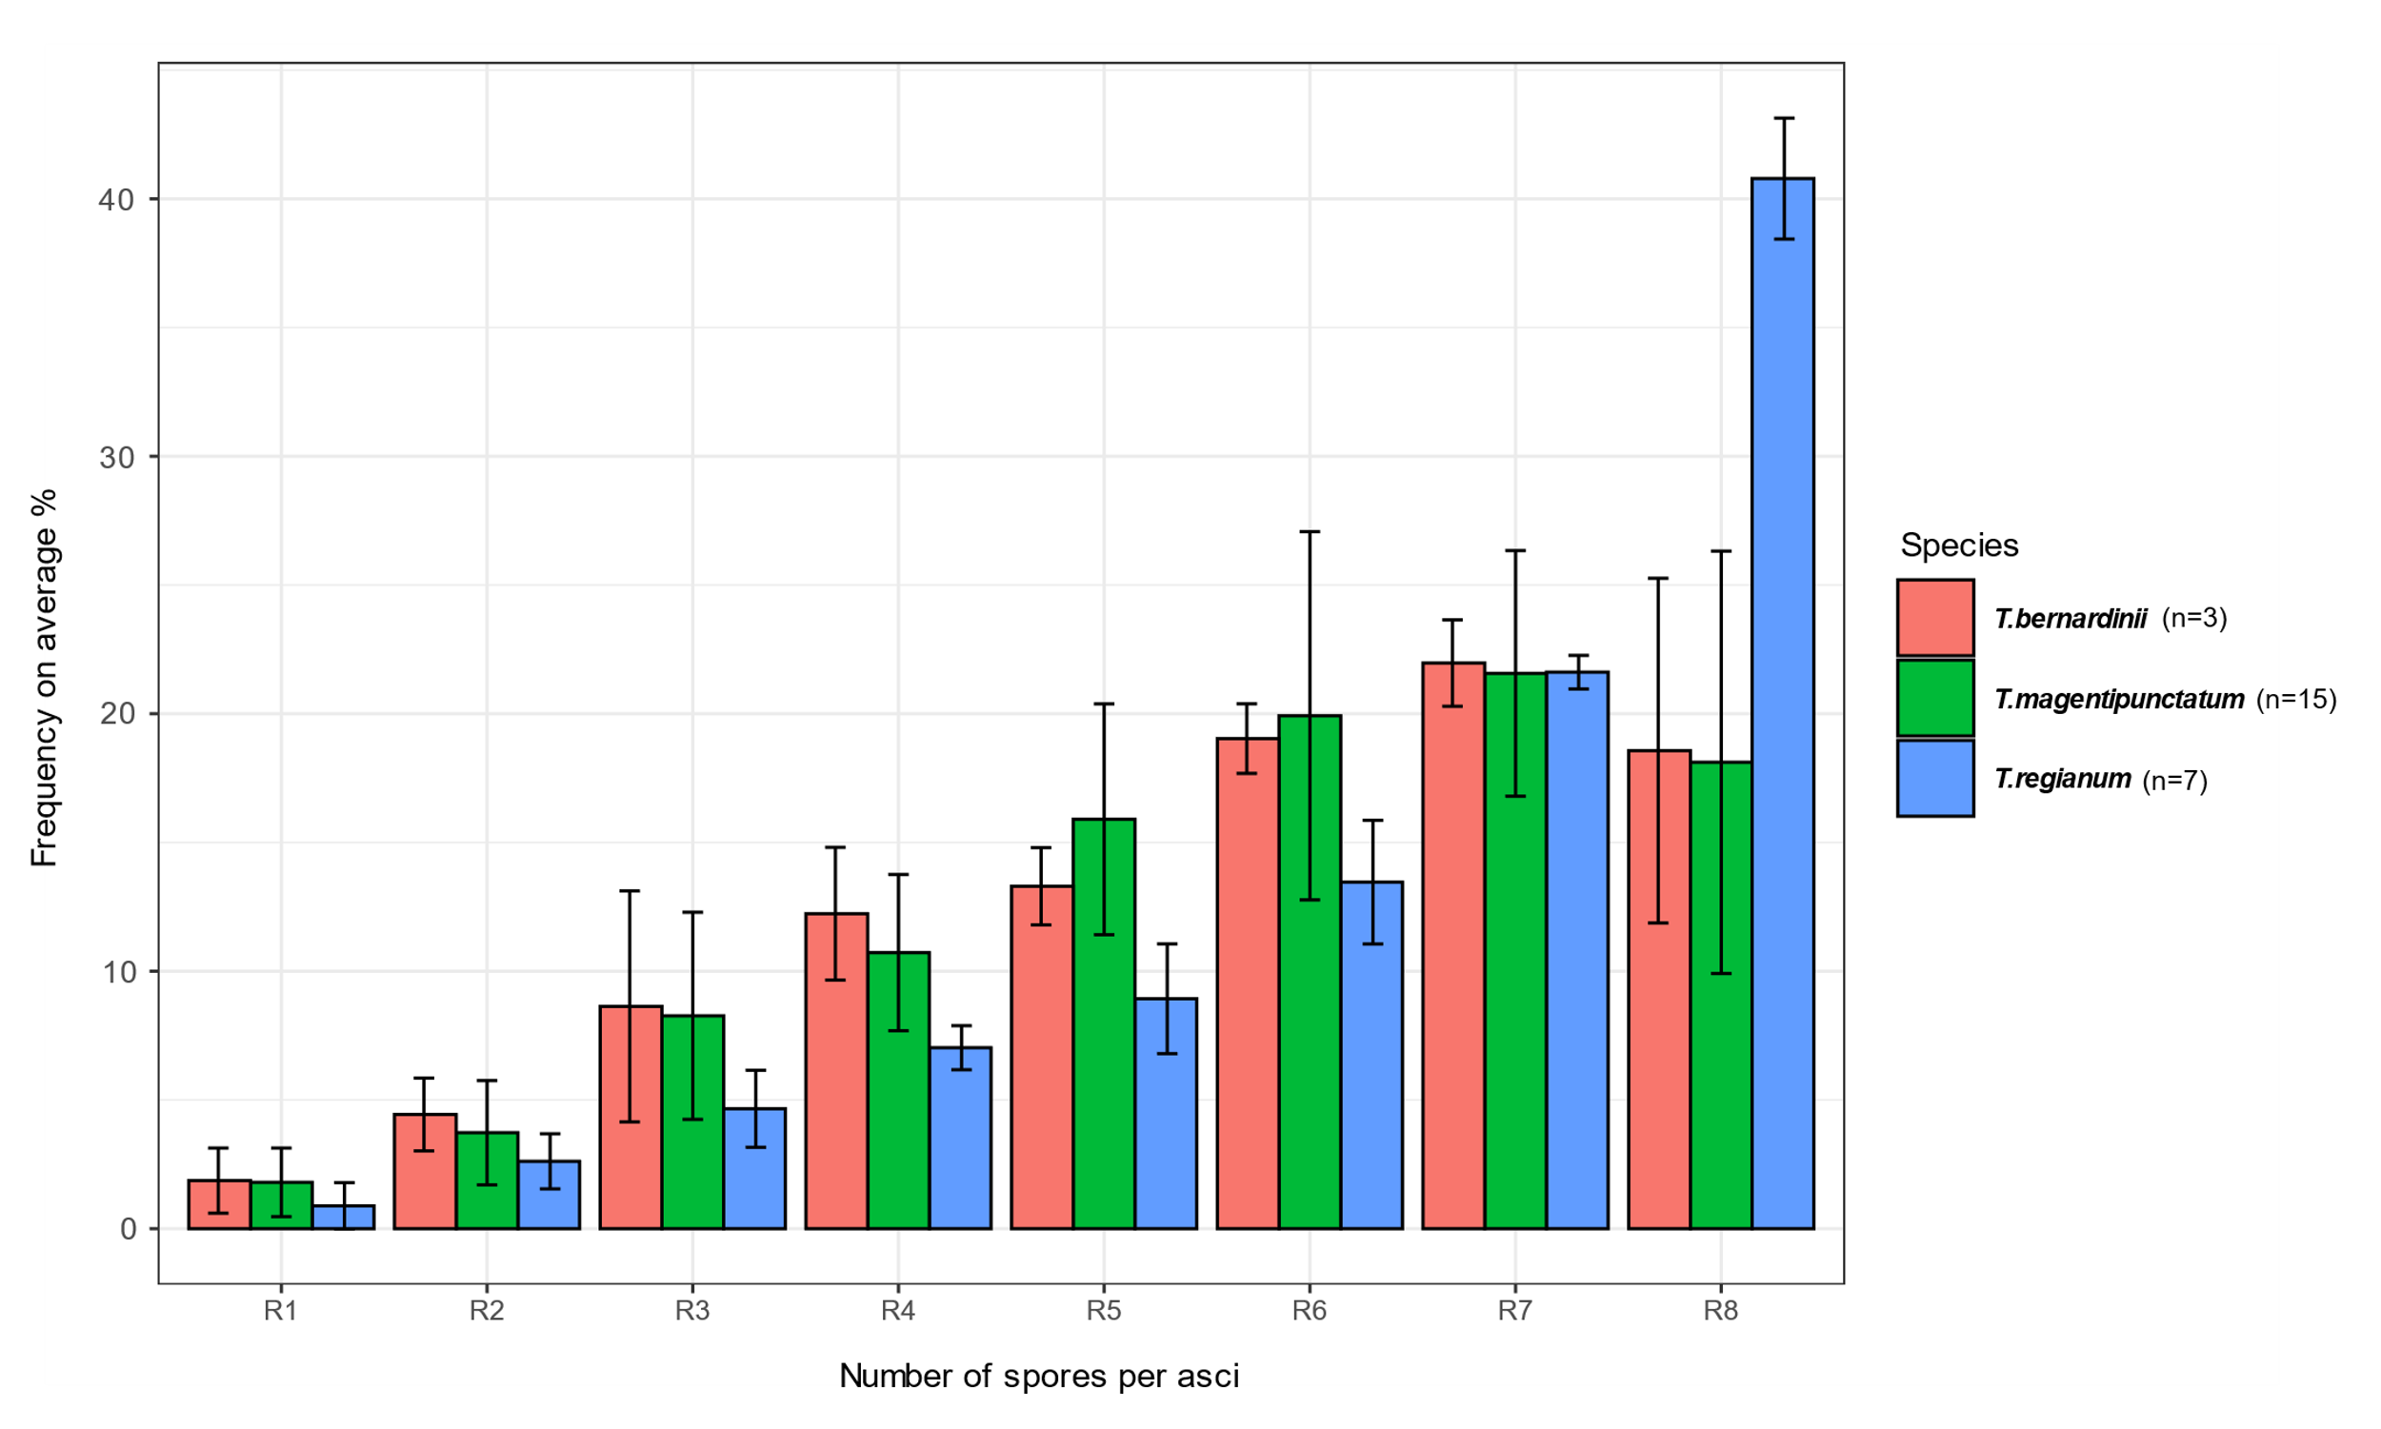
Fig. S2 Relative frequencies of ascospores per ascus (frequency of: R1 one-, R2 two-, R3 three-, R4 four-, R5 five-, R6 six-, R7 seven-, R8 eight-spored asci) of the three studied species, T. bernardinii (n=3), T. magentipunctatum (n=15) and T. regianum (n=7). At least one hundred asci were involved for each sample

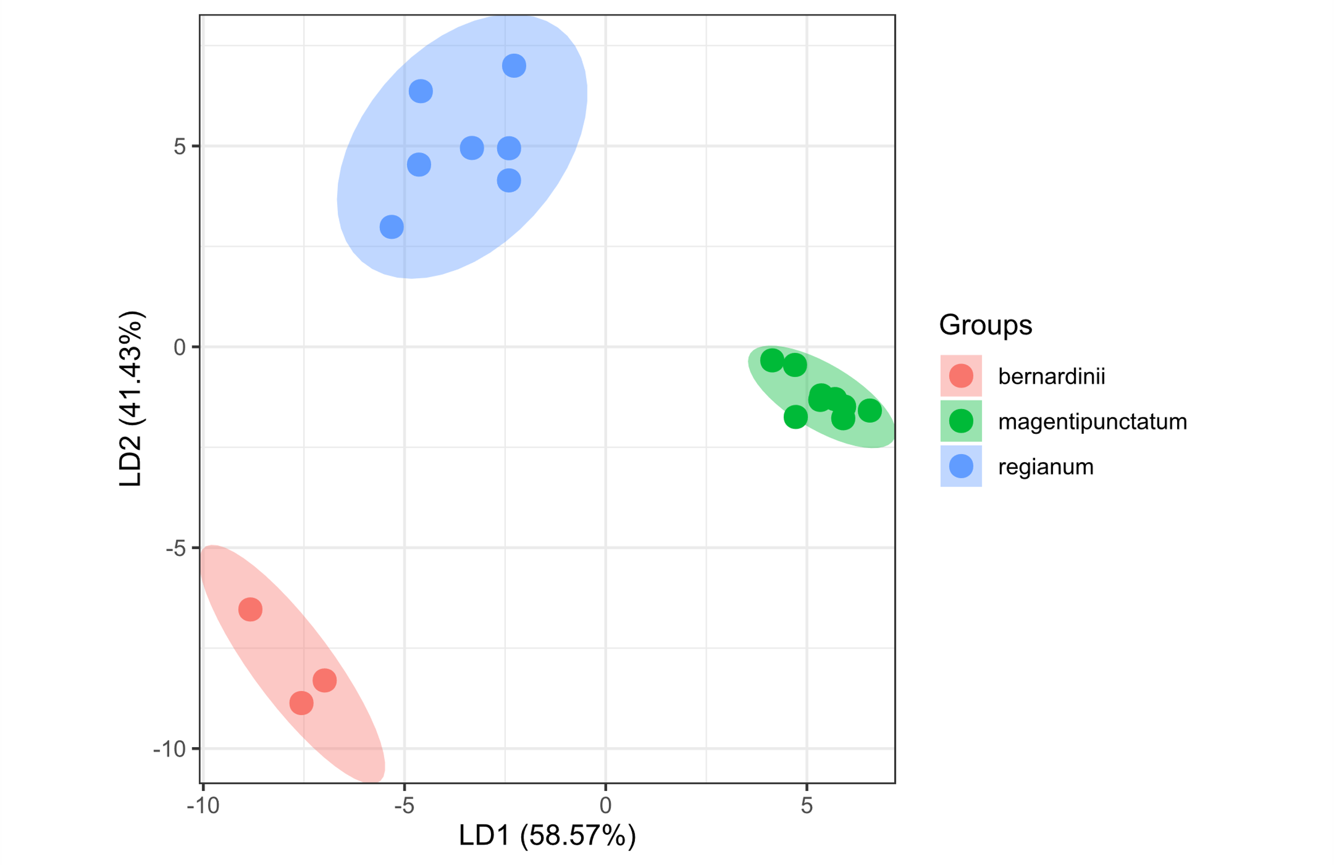
Fig. S3 Linear Discriminant Analysis (LDA) based on eleven morphological variables of the three species of the Regianum clade, the spore volume (μm³), (the spore ornamentation) mesh diameter (μm), the mesh height (μm) values and the ratio of 1–8 spored asci given as percentage (R1, R2, R3, R4, R5, R6, R7, R8) and visualisation by a plot using the MASS, klaR and ggord packages of the R 4.3.2. software. In terms of the spore volume, the mesh height and the mesh diameter, the spores of 8-spored asci were included. Average values per sample (herbarium material) were used. Axis labels include the percentage separation achieved by the linear discriminant functions (LD). The decision rules of LDA model with the predictor variables are: LD1 = 3.07 × spore volume –1.90 × mesh height –1.65 × mesh diameter –5.29 × R1 –3.24 × R2 –4.09 × R3 –5.28 × R4 –4.38 × R5 –4.29 × R6 –4.61 × R7 –4.51 × R8; LD2 = –7.04 × spore volume + 2.08 × mesh height –1.71 × mesh diameter –3.81 × R1 –2.14 × R2 –2.63 × R3 –3.58 × R4 –2.53 × R5 –3.03 × R6 –2.76 × R7 –2.87 × R8. According to the prediction, 100 % of the included samples expected to be correctly identified

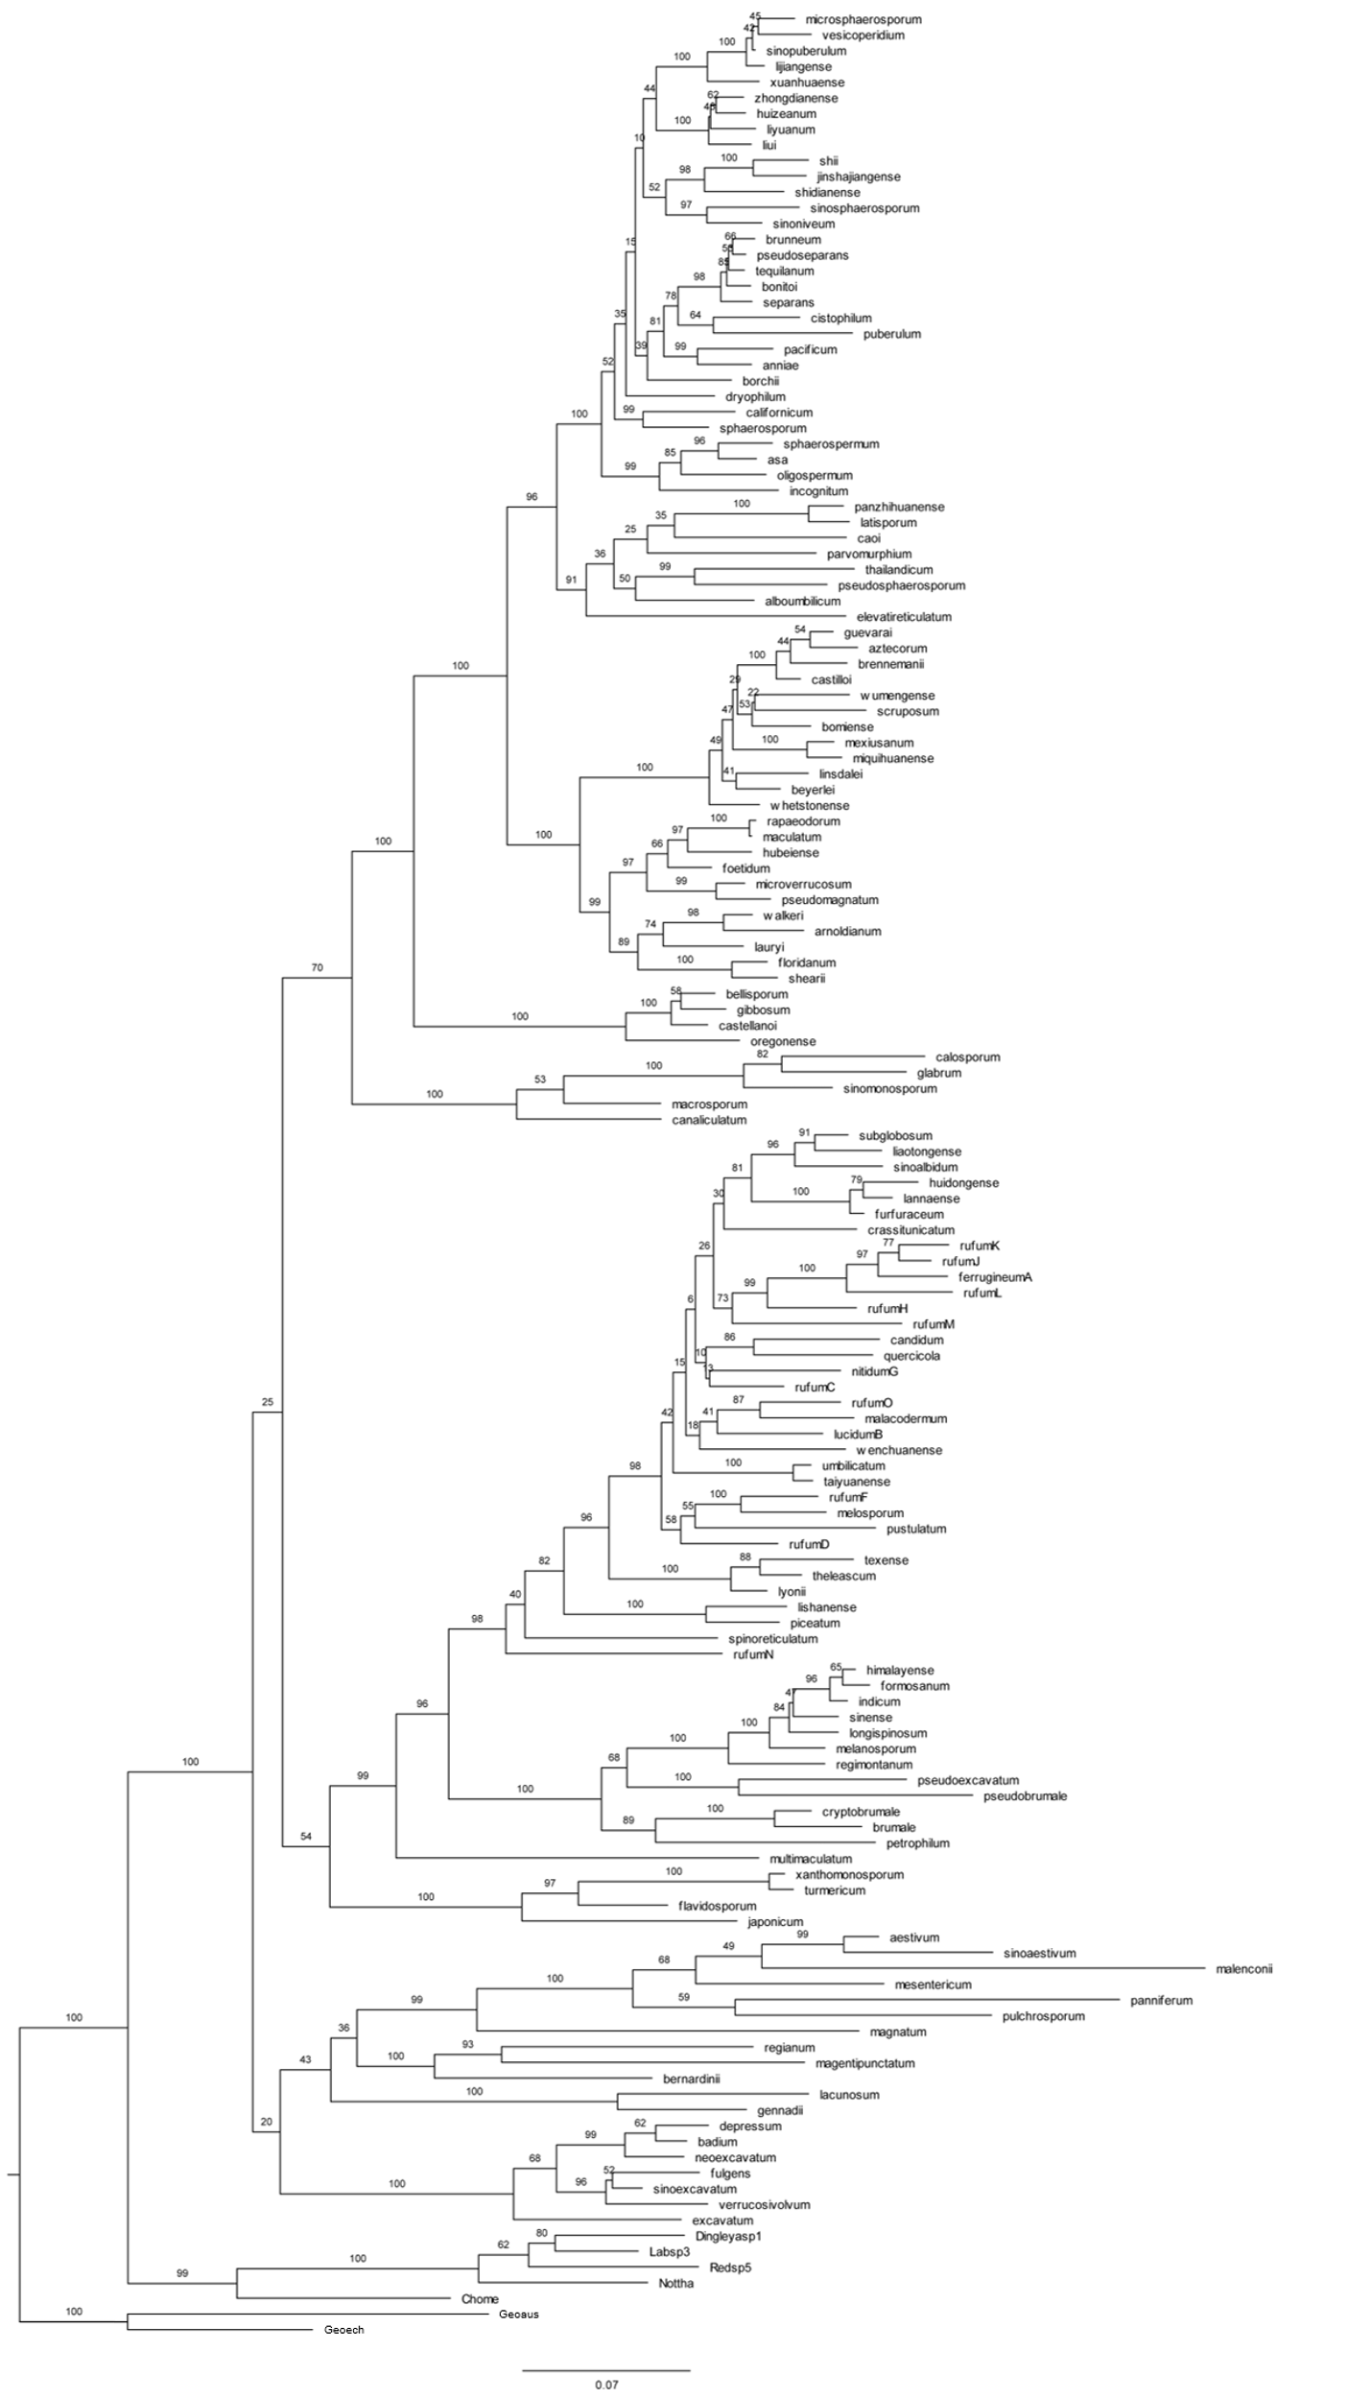
Fig. S4 The genus-wise EF1α-ITS-LSU-RPB2 ML species tree used in ASR analyses. The Maximum Likelihood bootstrap (BS) support values are shown on the branches. The scale bar represents 0.07 expected nucleotide changes per site. The analysis was performed with RAxML under GTR+GAMMA model

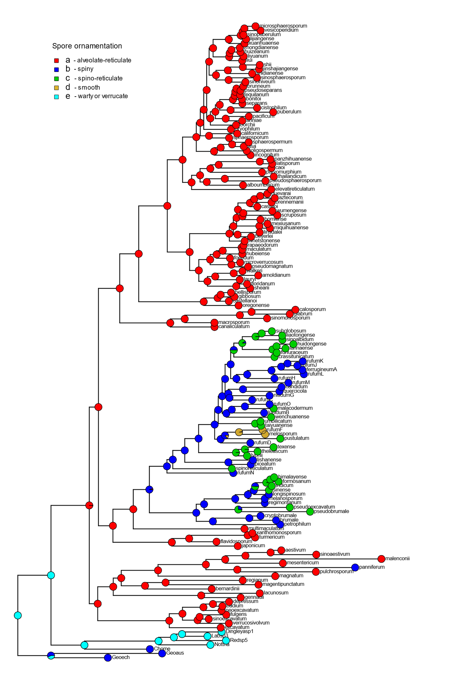
Fig. S5 Results of Ancestral State Reconstruction (stochastic character mapping) of genus Tuber, on a discrete character: spore ornamentation of the currently examined Tuber species and estimated states of ancestral taxa (a: alveolate-reticulate; b: spiny; c: spino-reticulate; d: smooth; e: warty or verrucate). The analysis was performed with Simmap command of phytools R package under ARD model, simulated 100 times

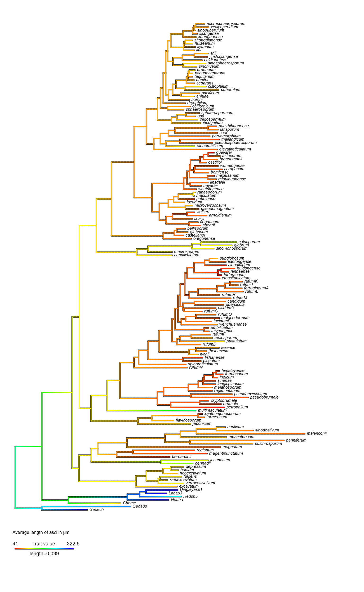
Fig. S6 Results of Ancestral State Reconstruction of genus Tuber, on a continuous character: the average length of asci (μm) of the currently examined Tuber species and estimated states of ancestral taxa. The analysis was performed with fastAnc function of phytools R package

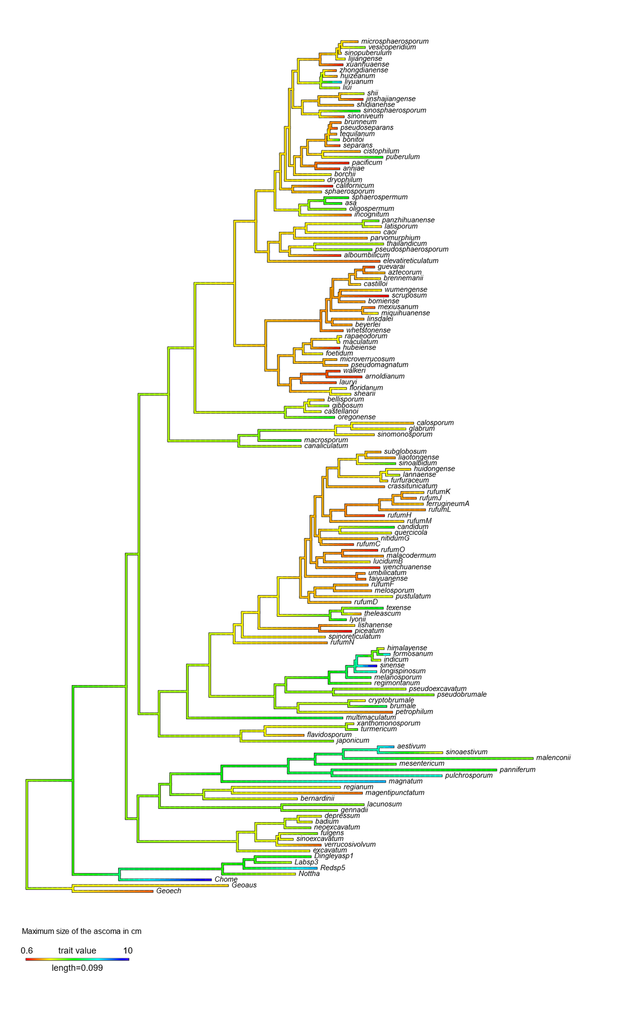
Fig. S7 Results of Ancestral State Reconstruction of genus Tuber, on a continuous character: the maximum size of ascomata (cm) of the currently examined Tuber species and estimated states of ancestral taxa. The analysis was performed with fastAnc function of phytools R package

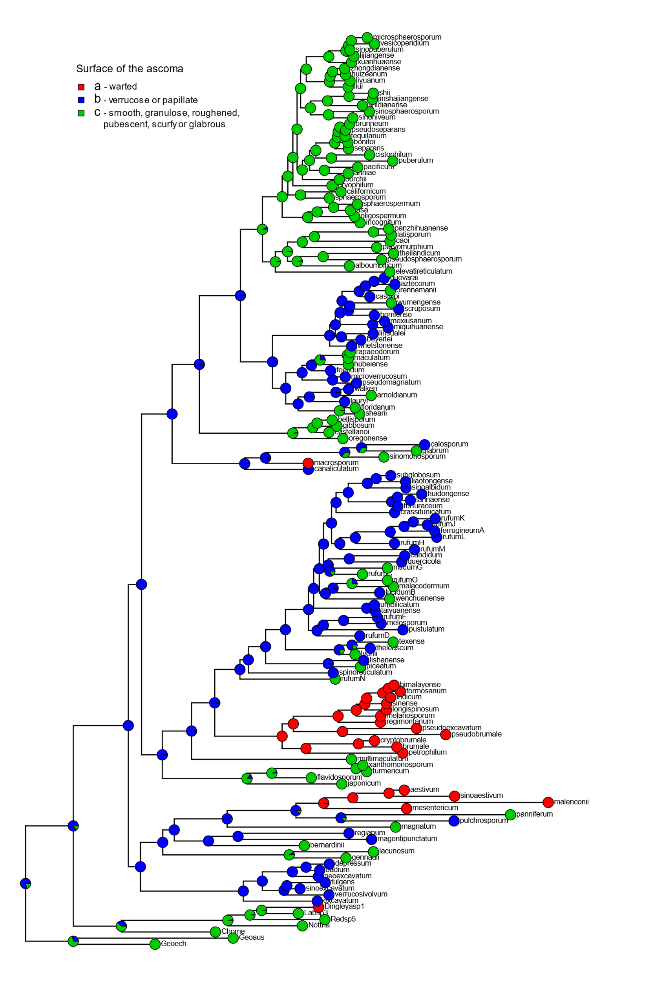
Fig. S8 Results of Ancestral State Reconstruction (stochastic character mapping) of genus Tuber, on a discrete character: surface of the ascomata of the currently examined Tuber species and estimated states of ancestral taxa (a: warted; b: verrucose or papillate; c: smooth, granulose, roughened, pubescent, scurfy or glabrous). The analysis was performed with Simmap command of phytools R package under ARD model, simulated 100 times

References
Alvarado P, Moreno G, Manjón JL (2012a) Comparison between Tuber gennadii and T. oligospermum lineages reveals the existence of the new species T. cistophilum (Tuberaceae, Pezizales). Mycologia 104(4):894–910. https://doi:10.3852/11-254
Alvarado P, Moreno G, Manjón JL (2012b) A new Tuber without spore ornamentation. Tuber melosporum comb. nov. Boletín de la Sociedad Micológica de Madrid 36:194
Alvarez IF, Parladé J, Trappe JM (1992) Loculotuber gennadii gen. et comb. nov. and Tuber multimaculatum sp. nov. Mycologia 84(6):926–929. https://doi.org/10.1080/00275514.1992.12026228
Ambra R, Macino G (2000) Cloning and characterization of PKC-homologous genes in the truffle species Tuber borchii and Tuber magnatum. FEMS microbiology letters 189(1):45–53. https://doi.org/10.1111/j.1574-6968.2000.tb09204.x
Badalyan SM, Hovsepyan RA, Iotti M, Zambonelli A (2005) On the presence of truffles in Armenia. Flora Mediterranea 15:683–692
Bonito G, Trappe JM, Rawlinson P, Vilgalys R (2010) Improved resolution of major clades within Tuber and taxonomy of species within the Tuber gibbosum complex. Mycologia 102(5):1042–1057. https://doi.org/10.3852/09-213
Chen J, Liu PG, Wang Y (2005) Tuber umbilicatum, a new species from China, with a key to the spinose-reticulate spored Tuber species. Mycotaxon 94:1–6
Chen J, Liu PG (2007) Tuber latisporum sp. nov. and related taxa, based on morphology and DNA sequence data. Mycologia 99(3):475–481. http://dx.doi.org/10.1080/15572536.2007.11832572
Chu-Chou M, Grace LJ (1981) Tuber sp., a mycorrhizal fungus of Douglas fir in New Zealand. Transactions of the British Mycological Society 77(3):652–654
Deng XJ, Chen J, Yu FQ, Liu PG (2009) Notes on Tuber huidongense (Tuberaceae, Ascomycota), an endemic species from China. Mycotaxon 109(1):189–199
Deng X J, Liu PG, Liu CY, Wang Y (2013) A new white truffle species, Tuber panzhihuanense from China. Mycological Progress 12:557–561. https://doi.org/10.1007/s11557-012-0862-6
Fan L, Cao JZ, Liu YY, Li Y (2011) Two new species of Tuber from China. Mycotaxon 116(1):349–354. http://doi: 10.5248/116.349
Fan L, Hou CL, Cao JZ (2012a) Tuber sinoalbidum and T. polyspermum—new species from China. Mycotaxon 118(1):403–410. http://dx.doi.org/10.5248/118.403
Fan L, Cao JZ, Li Y (2012b) Tuber microsphaerosporum and Paradoxa sinensis spp. nov. Mycotaxon 120(1):471–475. http://dx.doi.org/10.5248/120.471
Fan L, Cao JZ, Li Y (2013a) A reassessment of excavated Tuber species from China based on morphology and ITS rDNA sequence data. Mycotaxon 124(1):155–163. http://dx.doi.org/10.5248/124.155
Fan L, Cao JZ, Hou CL (2013b) Tuber subglobosum and T. wenchuanense–two new species with spino-reticulate ascospores. Mycotaxon 123(1):95–101. http://dx.doi.org/10.5248/123.95
Fan L, Hou CL, Li Y (2013c) Tuber microverrucosum and T. huizeanum two new species from China with reticulate ascospores. Mycotaxon 122(1):161–169. http://dx.doi.org/10.5248/122.161
Fan L, Cao JZ, Yu J (2013d) Tuber in China: T. sinopuberulum and T. vesicoperidium spp. nov. Mycotaxon 121(1):255–263. http://dx.doi.org/10.5248/121.255
Fan L, Cao JZ, Li Y (2013e) Tuber sinosphaerosporum sp. nov. from China. Mycotaxon 122(1):347–353. http://dx.doi.org/10.5248/122.347
Fan L, Feng S, Cao JZ (2014) The phylogenetic position of Tuber glabrum sp. nov. and T. sinomonosporum nom. nov., two Paradoxa-like truffle species from China. Mycological Progress 13:241–246. https://doi.org/10.1007/s11557-013-0908-4
Fan L, Liu X, Cao J (2015) Tuber turmericum sp. nov., a Chinese truffle species based on morphological and molecular data. Mycological Progress 14:1–6. https://doi: 10.1007/s11557-015-1134-z
Fan L, Han L, Zhang PR, Yan XY (2016a) Molecular analysis of Chinese truffles resembling Tuber californicum in morphology reveals a rich pattern of species diversity with emphasis on four new species. Mycologia 108(2):344–353. https://doi.org/10.3852/14-343
Fan L, Zhang PR, Yan XY, Li Y (2016b) Phylogenetic analyses of Chinese Tuber species that resemble T. borchii reveal the existence of the new species T. hubeiense and T. wumengense. Mycologia 108(2):354–362. https://doi.org/10.3852/14-349
Fan L, Cao J (2012) Two new species of white truffle from China. Mycotaxon 121:297–304. http://dx.doi.org/10.5248/121.297
Fan L, Yue SF (2013) Phylogenetic divergence of three morphologically similar truffles: Tuber sphaerosporum, T. sinosphaerosporum, and T. pseudosphaerosporum sp. nov. Mycotaxon 125(1):283–288. http://dx.doi.org/10.5248/125.283
Frank JL, Southworth D, Trappe JM (2006) NATS truffle and truffle-like fungi 13: Tuber quercicola and T. whetstonense, new species from Oregon, and T. candidum redescribed. Mycotaxon 95:229–240
Gamundí IJ (1971) Algunos discomycetes de Chile. Bol. Soc. Argent. Bot. 13:260–289
García-Montero LG, Díaz P, Di Massimo G, García-Abril A (2010) A review of research on Chinese Tuber species. Mycological Progress 9:315–335. https://doi.org/10.1007/s11557-009-0647-8
Gilkey HM (1939) Tuberales of North America (Vol. 1). Oregon State College
Gilkey HM (1954) North American Flora. Series II.: Part 1: Tuberales: Bibliography: Index: Tuberales. New York Botanical Garden
Gori L (2003) Tuber bernardinii. Rivista di Micologia 46(3):232
Grupe AC, Sulzbacher MA, Grebenc T, Healy R, Bonito G, Smith ME (2018). Tuber brennemanii and Tuber floridanum: two new Tuber species are among the most commonly detected ectomycorrhizal taxa within commercial pecan (Carya illinoinensis) orchards. Mycologia 110(4):780–790. https://doi.org/10.1080/00275514.2018.1490121
Guevara G, Bonito G, Cázares E, Rodríguez J, Vilgalys R, Trappe JM (2008) Tuber regimontanum, una nueva especie de trufa de México. Revista mexicana de micología 26:17–20
Guevara G, Bonito G, Trappe JM, Cázares E, Williams G, Healy RA, Schadt C, Vilgalys R (2013a) New North American truffles (Tuber spp.) and their ectomycorrhizal associations. Mycologia 105(1):194–209. https://doi.org/10.3852/12-087
Guevara G, Bonito G, Cázares E (2013b) Revisión del género Tuber (Tuberaceae: Pezizales) de México. Revista mexicana de biodiversidad 84:39–49. https://doi.org/10.7550/rmb.31981
Guevara-Guerrero G, Bonito G, Cázares-González E, Healy R, Vilgalys R, Trappe J (2015) Novel Tuber spp. (Tuberaceae, Pezizales) in the Puberulum Group from Mexico. Ascomycete.org 7:367–374
Guevara-Guerrero G, Bonito G, Smith ME, Healy R, Grupe II AC, Cázares E, Castellano MA, Trappe JM (2018) Tuber aztecorum sp. nov., a truffle species from Mexico belonging to the Maculatum clade (Tuberaceae, Pezizales). MycoKeys 30:61–72. https://doi.org/10.3897/mycokeys.30.22887
Halász K, Bratek Z, Szegő D, Rudnóy S, Rácz I, Lásztity D, Trappe JM (2005) Tests of species concepts of the small, white, European group of Tuber spp. based on morphology and rDNA ITS sequences with special reference to Tuber rapaeodorum. Mycological Progress 4:281–290. https://doi.org/10.1007/s11557-006-0132-6
Hanlin RT, Wu M, Brenneman TB (1989) The occurrence of Tuber texense in Georgia. Mycotaxon 34(1):387-394
Healy RA, Zurier H, Bonito G, Smith ME, Pfister DH (2016) Mycorrhizal detection of native and non-native truffles in a historic arboretum and the discovery of a new North American species, Tuber arnoldianum sp. nov. Mycorrhiza 26:781–792. https://doi.org/10.1007/s00572-016-0713-4
Hawker LE (1968) Hypogeous ascomycetes from Idaho. Journal of the Elisha Mitchell Scientific Society 248–253.
Hosseini SZ (2013) New record of Choiromyces meandriformis from Khorramabad, Iran. In: The second international conference on agriculture and natural resources. December 2013. Razi University, Kermanshah, Iran pp 25–26
Kinoshita A, Sasaki H, Nara K (2016) Two new truffle species, Tuber japonicum and Tuber flavidosporum spp. nov. found from Japan. Mycoscience 57(5):366–373. https://doi.org/10.1016/j.myc.2016.06.006
Kinoshita A, Nara K, Sasaki H, Feng B, Obase K, Yang ZL, Yamanaka T (2018) Using mating-type loci to improve taxonomy of the Tuber indicum complex, and discovery of a new species, T. longispinosum. PLoS One 13(3):p.e0193745. https://doi.org/10.1371/journal.pone.0193745
Leonardi M, Paz-Conde A, Guevara G, Salvi D, Pacioni G (2019) Two new species of Tuber previously reported as Tuber malacodermum. Mycologia 111(4):676–689. https://doi.org/10.1080/00275514.2019.1603777
Li SH, Zheng LY, Liu CY, Wang Y, Li L, Zhao YC, Zhang XL, Yang M, Xiong HK, Qing Y, Wang L (2014) Two new truffles species, Tuber alboumbilicum and Tuber pseudobrumale from China. Mycological Progress 13:1157–1163. https://doi.org/10.1007/s11557-014-1004-0
Lin CL, Tsai MJ, Fu CH, Chang TT, Li HT, Wong KF (2018) Tuber elevatireticulatum sp. nov., a new species of whitish truffle from Taiwan. Botanical studies 59:1–10. https://doi.org/10.1186/s40529-018-0241-y
Merényi Z, Varga T, Geml J, Orczán ÁK, Chevalier G, Bratek Z (2014) Phylogeny and phylogeography of the Tuber brumale aggr. Mycorrhiza 24:101–113. https://doi.org/10.1007/s00572-014-0566-7
Merényi Z, Nagy I, Bratek Z, Stielow JB (2017a) Tuber magentipunctatum Merényi, Nagy, Stielow & Bratek, sp. nov. Fungal Planet description sheets: 558–624. Persoonia 38:380–381. https://doi.org/10.3767/003158517X698941
Merényi Z, Varga T, Hubai AG, Pitlik P, Erős Á, Trappe JM, Bratek Z (2017b) Challenges in the delimitation of morphologically similar species: A case study of Tuber brumale agg. (Ascomycota, Pezizales). Mycological Progress 16:613–624. https://doi.org/10.1007/s11557-017-1296-y
Milenković M, Grebenc T, Marković M, Ivančević B (2016) Tuber petrophilum, a new truffle species from Serbia. Mycotaxon 130(4):1141–1152. http://dx.doi.org/10.5248/130.1141
Montecchi A, Sarasini M (2000) Funghi Ipogei d'Europa. Associaazione Micologi ca Bresadola – Fondacione centro Studi Micologici, Trento-Vicenza
Páez CP, Bonito GM, Guevara-Guerrero G, Castellano MA, Garibay-Orijel R, Trappe JM, Rámirez RP (2018) Description and distribution of Tuber incognitum sp. nov. and Tuber anniae in the Transmexican Volcanic Belt. MycoKeys (41):17–27. https://doi.org/10.3897/mycokeys.41.28130
Polemis E, Konstantinidis G, Fryssouli V, Slavova M, Tsampazis T, Nakkas V, Assyov B, Kaounas V, Zervakis GI (2019) Tuber pulchrosporum sp. nov., a black truffle of the Aestivum clade (Tuberaceae, Pezizales) from the Balkan peninsula. MycoKeys (47):35–51. https://doi.org/10.3897/mycokeys.30.22887
Qiao P, Liu PG, Hu HT, Wang Y (2013) Typification of Tuber formosanum (Tuberaceae, Pezizales, Ascomycota) from Taiwan, China. Mycotaxon 123:293–299. https://doi.org/10.5248/123.293
Qing Y, Li SH, Liu CY, Li L, Yang M, Zhang XL, Li XL, Zheng LY, Wang Y (2015) Tuber xanthomonosporum, a new Paradoxa-like species from China. Mycotaxon 130(1):61–68. http://dx.doi.org/10.5248/130.61
Su KM, Xiong WP, Wang Y, Li SH, Xie R, Baima D (2014) Tuber bomiense, a new truffle species from Tibet, China. Mycotaxon 126(1):127–132. http://dx.doi.org/10.5248/126.127
Suwannarach N, Kumla J, Lumyong S (2015) A new whitish truffle, Tuber thailandicum from northern Thailand and its ectomycorrhizal association. Mycological Progress 14:1–12. https://doi.org/10.1007/s11557-015-1107-2
Suwannarach N, Kumla J, Vadthanarat S, Raspé O, Lumyong S (2016) Morphological and molecular evidence support a new truffle, Tuber lannaense, from Thailand. Mycological Progress 15:827–834. https://doi: 10.1007/s11557-016-1212-x
Trappe JM, Castellano MA (1991) Keys to the genera of truffles (Ascomycetes). McIlvanea 10:47–65
Trappe JM, Castellano MA, Malajczuk N (1992) Australasian truffle-like Fungi, II.* Labyrinthomyces, Dingleya and Reddellomyces gen. nov. (Ascomycotina). Australian Systematic Botany 5(5):597–611
Trappe JM, Jumpponen AMJ, Cazares E (1996) NATS truffle and truffle-like fungi. 5. Tuber lyonii (= T. texense), with a key to the spiny-spored Tuber species groups. Mycotaxon 60:365–372
Trappe JM, Castellano MA (2000) New sequestrate Ascomycota and Basidiomycota covered by the Northwest Forest Plan. Mycotax 75:153–179
Uecker FA, Burdsall Jr HH (1977) Tuber spinoreticulatum, a new truffle from Maryland. Mycologia 69(3):626–630
Wan SP, Wang XH, Zheng Y, Yu FQ (2016) Tuber shidianense and T. calosporum, two new truffle species from southwest China. Mycoscience 57(6):393–399. http://dx.doi.org/10.1016/j.myc.2016.06.007
Wan S, Xu W, Tan N, Wang Y, Zheng Y, Yu F (2017) Three Excavatum species Tuber badium, T. depressum and T. verrucosivolvum from Sichuan Province, China. Phytotaxa 296(3):228–238. https://doi.org/10.11646/phytotaxa.296.3.2
Wang Y, Moreno G, Riousset LJ, Manjón JL, Riousset G, Fourre G, Di Massimo G, García-Montero LG, Díez J (1998) Tuber pseudoexcavatum sp. nov. A new species from China commercialised in Spain, France and Italy with additional comments on Chinese truffles. Cryptogamie, Mycologie 19(1–2):113–120
Wang Y, Tan ZM, Zhang DC, Murat C, Jeandroz S, Le Tacon F (2006) Phylogenetic relationships between Tuber pseudoexcavatum, a Chinese truffle, and other Tuber species based on parsimony and distance analysis of four different gene sequences. FEMS Microbiology Letters 259(2):269–281. https://doi.org/10.1111/j.1574-6968.2006.00283
Wang YJ, Tan ZM, Murat C, Jeandroz S, Le Tacon F (2007) Molecular taxonomy of Chinese truffles belonging to the Tuber rufum and Tuber puberulum groups. Fungal Diversity 24:301–328
Wang Y, Li X, Fan L (2016) Tuber shii sp. nov., a sister species of T. jinshajiangense from China in Puberulum group. Phytotaxa 269(4):279–286. http://dx.doi.org/10.11646/phytotaxa.269.4.3
Xu W, Wan S, Huang L, Zheng Y, Gong H, Yu F (2017) Tuber sinoniveum, a new white Chinese truffle species from Yunnan, China. Phytotaxa 298(3):253–260. https://doi.org/10.11646/phytotaxa.298.3.4
Yan X, Cao J, Fan L (2018) Four new Tuber species added to the Rufum group from China based on morphological and molecular evidence. Mycologia 110(4):771–779. https://doi.org/10.1080/00275514.2018.1490120
Zhang JP, Liu PG, Chen J (2013) Tuber sinoaestivum sp. nov., an edible truffle from southwestern China. Mycotaxon 122:73–82. http://dx.doi.org/10.5248/122.73
Zhang BC, Minter DW (1988) Tuber himalayense sp. nov. with notes on Himalayan truffles. Transactions of the British mycological society 91(4):593–597
Zhang BC, Minter DW (1989) Gymnohydnotrya: a new hypogeous ascomycete genus from Australia. Mycological Research 92(2):192–198

* Corresponding author: petcseh01@gmail.com

