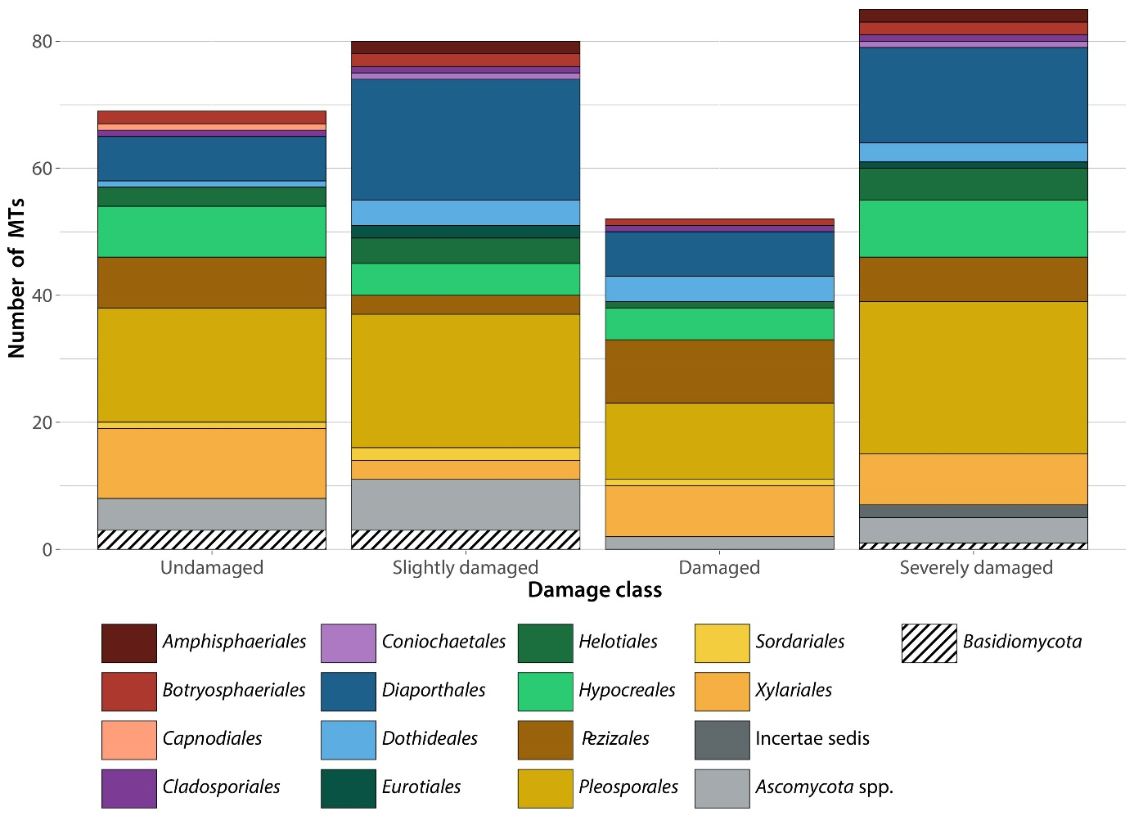
Suppl. mat. Figure 1: Number of endophytic morphotypes obtained from the various Ascomycota orders (with colour) and Basidiomycota (with hatching) differentiated according to the different damage classes of the test trees from which they were isolated. “Ascomycota spp.” summarises morphotypes of Ascomycota that could not be determined at order level.

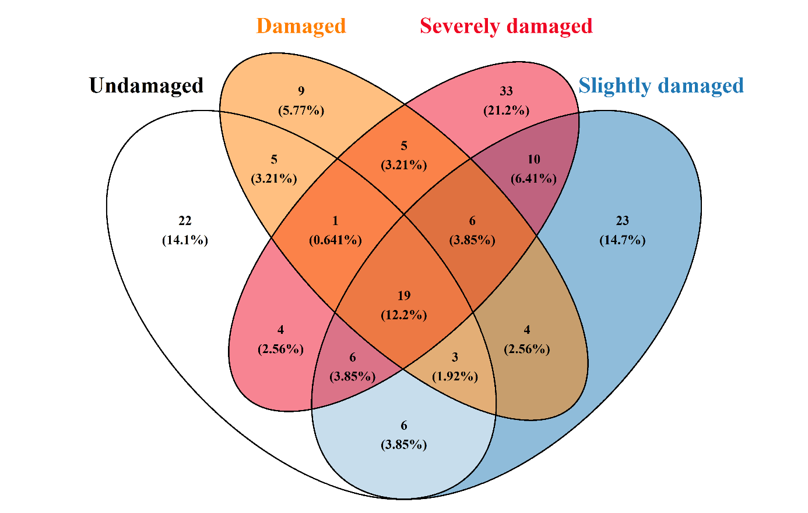
Suppl. mat. Figure 2: Number of endophytic, ascomycetaceous morphotypes obtained differentiated according to the different damage classes of the test trees from which they were isolated with all possible overlaps.

